LAB Logbook-2443834

Lab 1

Code:

1. a=np.arange(00,34)

print(a)

1. a=a.reshape(1,-1)

a

1. print(a.shape)

Githublink: <https://github.com/Nauman7861/Log-book/blob/c7f384d4e79525a0be2297ba2ac925b8cc8680cf/Lab_1.ipynb>

Lab 2

Screenshots:

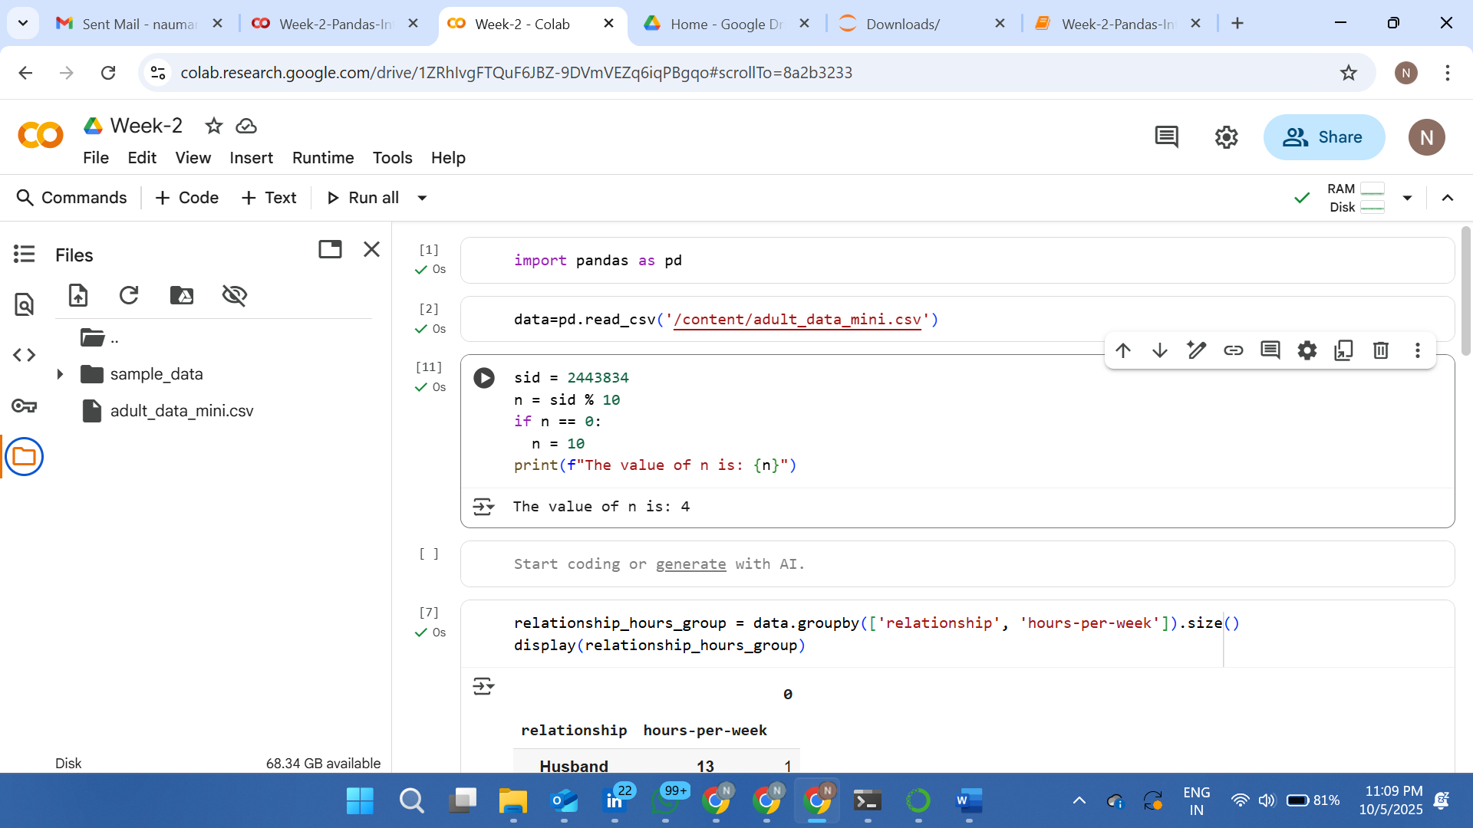

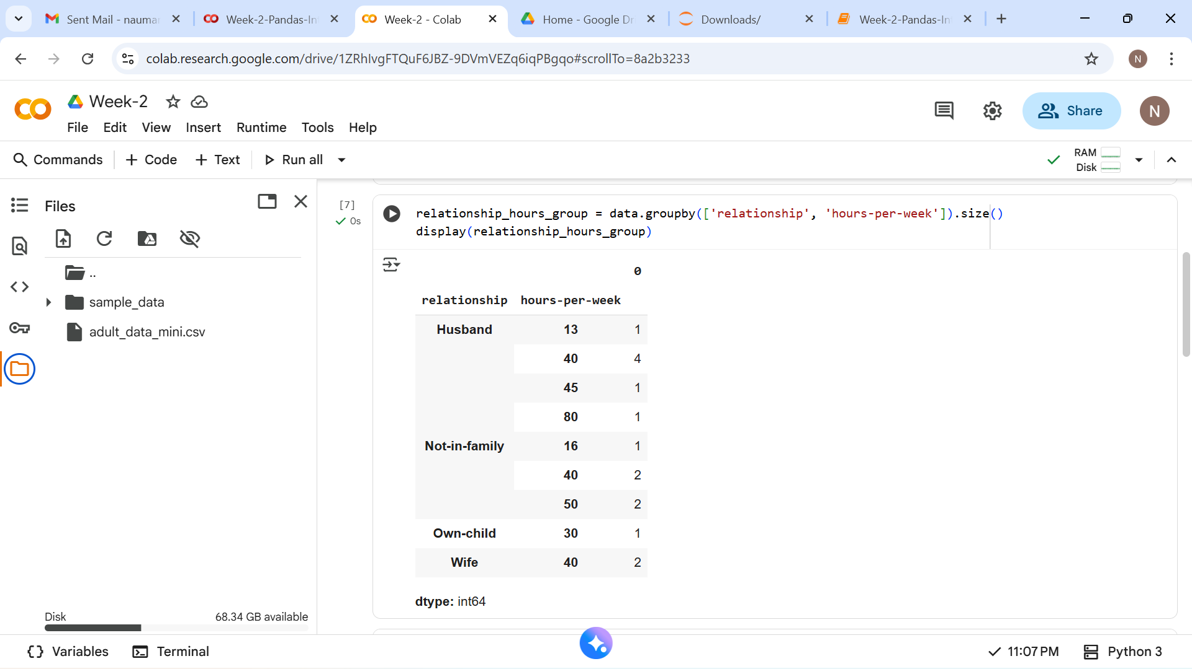

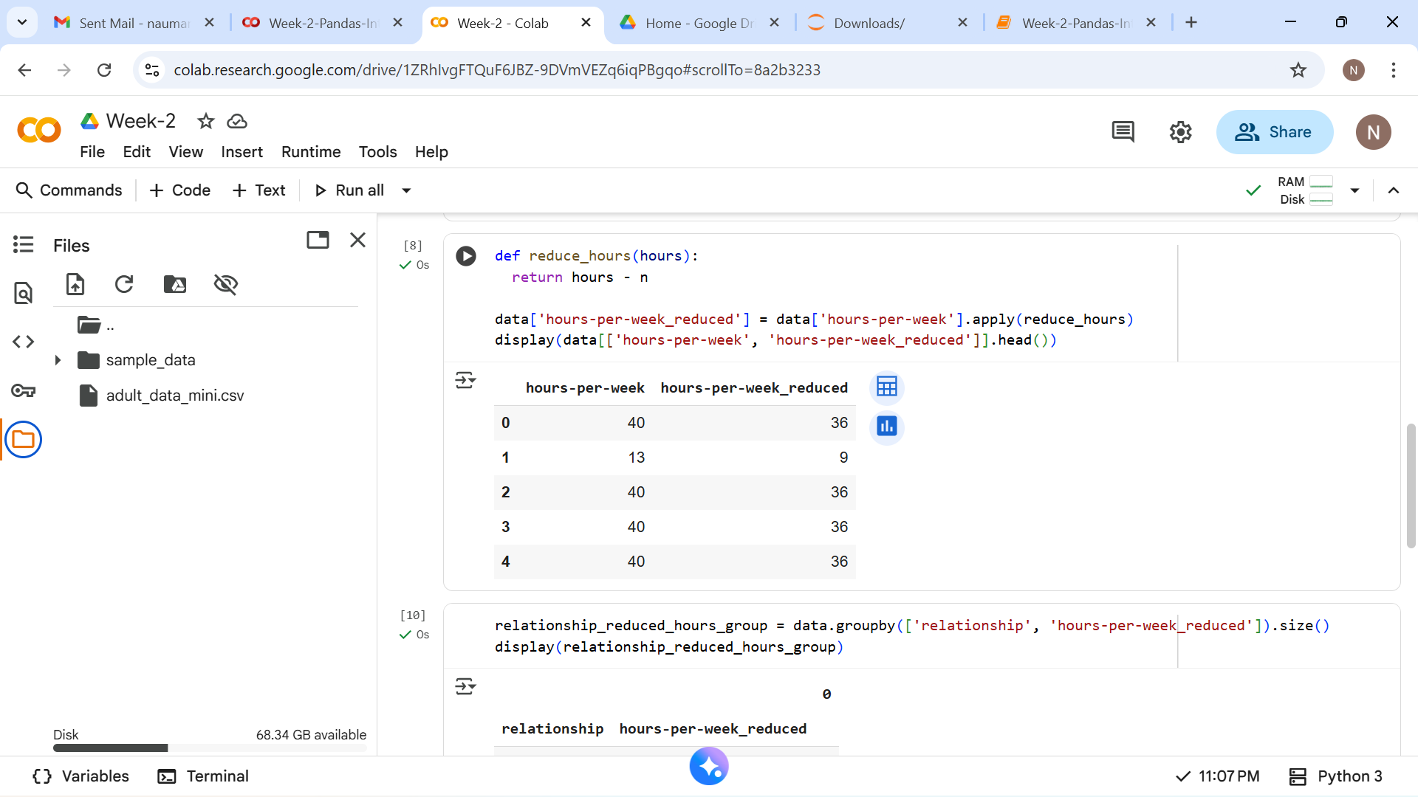

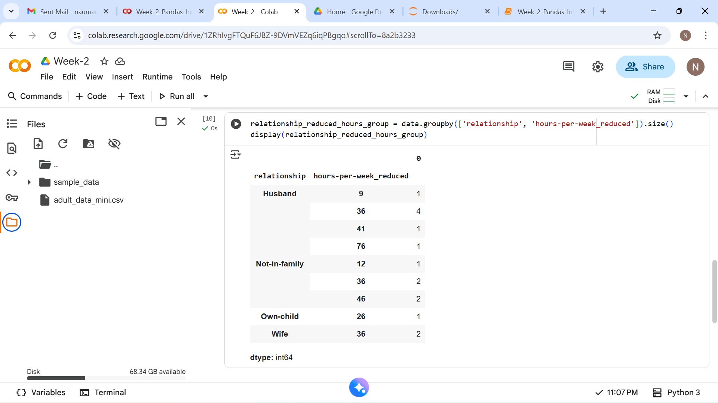

Code:

1. sid = 2443834

n = sid % 10

if n == 0:

  n = 10

print(f"The value of n is: {n}")

1. relationship_hours_group = data.groupby(['relationship', 'hours-per-week']).size()

display(relationship_hours_group)

1. def reduce_hours(hours):

return hours - n

data['hours-per-week_reduced'] = data['hours-per-week'].apply(reduce_hours)

display(data[['hours-per-week', 'hours-per-week_reduced']].head())

1. relationship_reduced_hours_group = data.groupby(['relationship', 'hours-per-week_reduced']).size()

display(relationship_reduced_hours_group)

<https://github.com/Nauman7861/Log-book/blob/main/Week_2.ipynb>

Lab 3

Lab 4

Lab 5

Lab 6

Lab 7

Lab 8

Lab 9

Lab 10

Lab 11

Lab 12