**1. INTRODUCTION**

* 1. **Our purpose:**

Visually impaired people find difficulties detecting obstacles in front of them, during walking in the street, which makes it dangerous. The smart stick comes as a proposed solution to enable them to identify the world around

Blind stick is an innovative stick designed for visually disabled people for

improved navigation. We here propose an advanced blind stick that allows visually challenged people to navigate with ease using advanced technology. The blind stick is integrated with ultrasonic sensor along with light and water sensing.

* 1. **Proposed System:**

We have many reasons to design smart stick for blind; firstly, the blind to feel free, isn't surrounded by wires as in belt and its content. Secondly, is easy to use because it is familiar and affordable. Thirdly, to be able to detect obstacles that exist on the ground (this is not available in glasses), which he walks indoor and outdoor is faced by obstacles such as stairs, puddles and sidewalk.

* 1. **Scope:**

The main scope is to provide voice-based assistance to blind people. In this technology-controlled world, where people strive to live independently, this project proposes an ultrasonic stick for blind people to help them gain personal independence. Since this is economical and not bulky, one can make use of it easily.

**2. LITERATURE REVIEW**

**2.1 Smart Walking Stick Using Ultrasonic Sensors and Arduino.**

This project was developed by (M.H. Mahmud, R. Saha and S. Islam). The author proposes a function of a microcontroller that have code protected so its security bridge cannot be override except the vendor or owner. It produces different Pulse Width Modulation (PWM) based on the sensors output to operate pager motor. The author focused on the easy way to use the stick and it’s maintain, cheap and it is very comfortable to use for blind people. The author approach with subsystems fundamentally sensor based with integral scheme is designed with a circuitry fundament on a PIC microcontroller. The power consumption is low and can be operated easily. The stick is very economic over the conventional one. The Smart Stick acts as a basic platform for the coming generation of more aiding devices to help the visually impaired to navigate safely both indoor and outdoor. It is effective and affordable. It leads to good results in detecting the obstacles on the path of the user in a range of three meters. This system offers a low-cost, reliable, portable, low power consumption and robust solution for navigation with obvious short response time.

M.H. Mahmud, R. Saha and S. Islam (February 2015)

**2.2 A computerized Travel aid for the Active Guidance for the Blind Pedestrians**.

The author convinced a stick which allowed a sighted assistant to steer the Guide Cane remotely. A sightless subject would then walk with the Guide Cane, “steered” by the assistant radio-control joystick. The author focused on how to steer the stick so the sensor head is mounted on a steerable with two unpowered wheeled steering axle. The author approach with the ultrasonic sensors that detect any obstacle in a 120o wide sector ahead of the user. Using UM’s previously developed, patented obstacle avoidance technique called “Vector Field Histogram” (VFH) in combination with UM’s patented “Error Eliminating Rapid Ultrasonic Firing” (EERUF) method for firing the sonars, allows for travel at fast walking speeds.

Johann Bornstein and Yoram Koren (April 21-27)

**2.3 Obstacle Detection, Artificial vision and Real-time assistance via GPS.**

The author convinced the Global Positioning System (GPS) is to identify the position and orientation and location of the blind person any of those solutions rely on GPS technology. The author focused on the GPS to make use of the data stored to compare with the destination location of the user. By this it can trace out the distance from the destination and produce an alarm to alert the user in advance. The author conclude The proposed combination of various working units makes a real-time system that monitors position of the user and provides dual feedback making navigation more safe and secure. The author approach with Microcontroller that intergrated using Global Positioning System (GPS).

Dambhare, Shruti and A.Sakhare (2011)

**2.4 Implementation of Microcontroller Based Mobility Aid for Visually Impaired People.**

The author convinced the proposed that LDR gives a very high resistance value ranging up to 2MΩ and in the day time or when there is sun light it give a low resistance ranging to 100Ω and sometimes below. From the voltage divider network at day time the voltage from the LDR is lower there by making pin 2 lower than pin 3 of the comparator giving an output voltage of 0V and at night the VLDR is high making pin 2 greater and the comparator output 5V. The author focused on how LDR can function on white cane with the proper circuit. The system consists of an ultrasonic sensor for obstacle detection, a and a light dependent resistor for dark detection. Each sensor is differentiated from one another through pattern of sounds.

E. J. Chukwunazo and G. M. Onengiye (2015).

**3. Project Objective:**

* 1. To develop a prototype hardware for modern blind stick.
  2. To help the blind people navigate the route at their best.
  3. To reduce the risk of injuries and lost for the visually impaired person
  4. To creating a suitable software for the visually impaired person

**5. PROJECT METHODOLOGY**

**5.1 BACKGROUND:**

The methodology is the general research strategy that outlines the way in which research is to be undertaken and among other things, identifies the methods to be used in it. These methods, described in the methodology, define the means or modes of data collection or, sometimes how a specific result is to be calculated.

For our project the information about the visually impaired people has been collected throughout every source that leads to our project. All of this information has been used to do our project which is smart blind stick of blind people.

**5.2 PROJECT PLANING:**

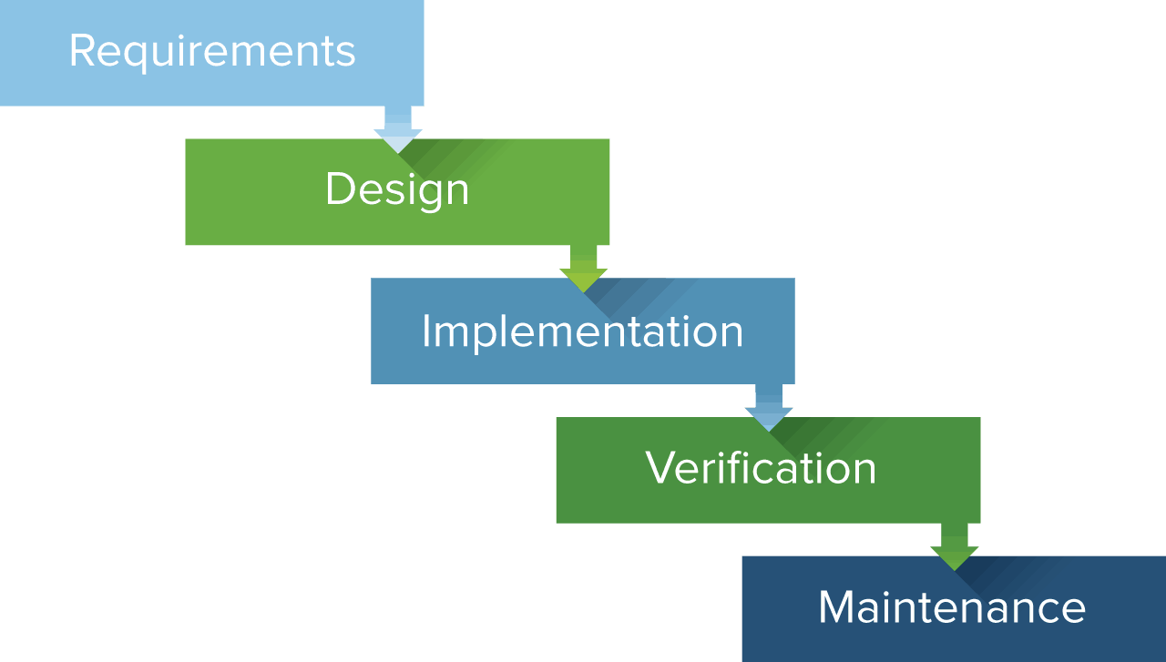

# Fig. 5.2 project planning chart

### Requirements:

### All possible requirements of the system to be developed are captured in this phase and documented in a requirements specification document.

Design:

The requirement specification from first phase are studied in this phase and the system design is prepared. This system design helps in specifying hardware and system requirements and helps in defining the overall system architecture.

### Implementation:

With inputs from the system design, the system is first developed in small programs called units, which are integrated in the next phase. Each unit is developed and tested fir its functionality, which is referred to as unit testing.

### Verification:

All the units developed in the implementation phase are integrated into a system after testing of each unit. Post integration the entire system is tested for any faults and failures

.

### Maintenance:

There are some issues which come up in the client environment. To fix those issues, patches are released. Also to enhance the product some better versions are released. Maintenance is done to deliver these changes in the customer environment.

### **5.3 Project Plan Table:**

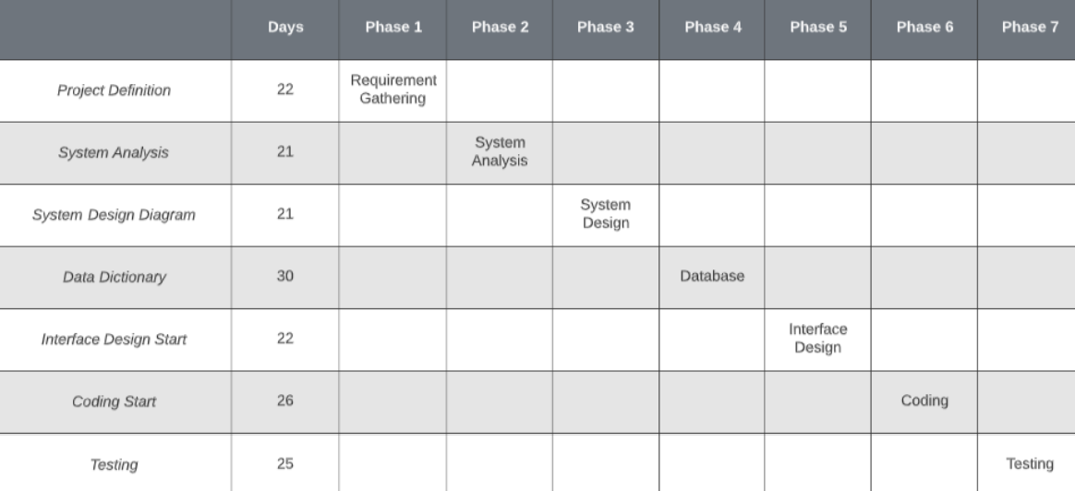

Fig. 5.3 project planning table

## **2.3 Milestones:**

When planning for the project series of milestones established. These milestones are endpoint for software activity. It may be in form of report some milestones which occurred in my project are discussed in below.

**6. TECHNICAL CHARACTERISTIC**

**6.1 Component of Project:**

### ARDUINO NANO:

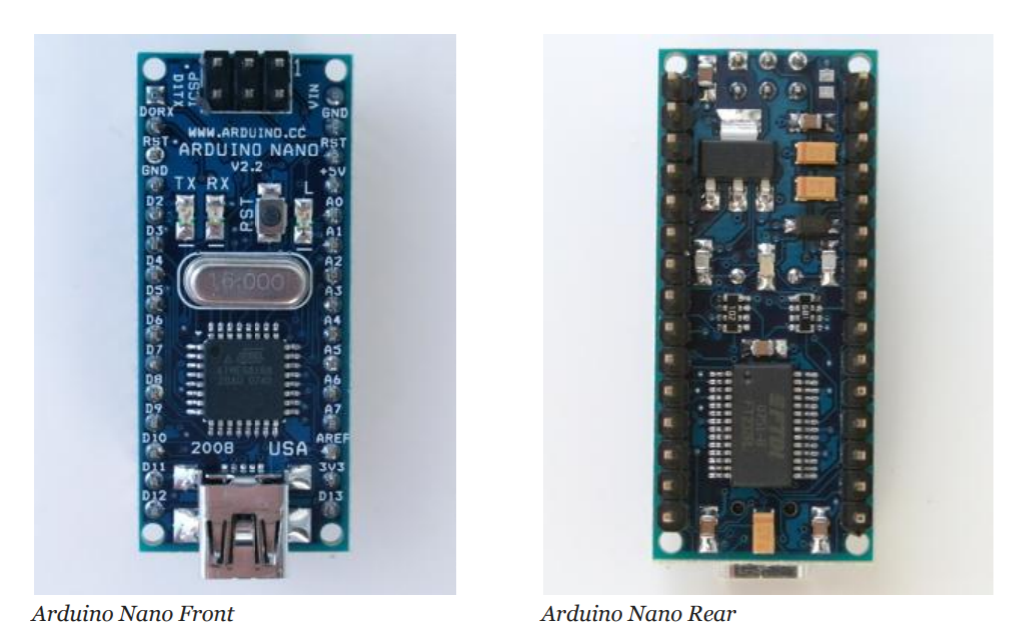

Fig. 6.1.1 Arduino nano

* The Arduino Uno is a microcontroller board based on the ATmega328 .
* It has 14 digital input/output pins (of which 6 can be used as PWM outputs), 6 analog inputs, a 16 MHz crystal oscillator, a USB connection, a power jack, an ICSP header, and a reset button.
* The Arduino Uno can be powered via the USB connection or with an external power supply. The power source is selected automatically.
* Each of the 14 digital pins on the Uno can be used as an input or output, using pinMode0,digital Write0 and digitalReadO functions.
* The Arduino Uno has a number of facilities for communicating with a computer, another Arduino, or other microcontrollers.
* The ATmega328 provides ART TTL (5V) serial communication, which is available on digital pins 0 (RX) and 1 (TX).
* An ATmega8U2 on the board channels this serial communication over USB and appears as a virtual com port to software on the computer.
* The Arduino software includes a serial monitor which allows simple textual data to be sent to and from the Arduino board.
* The RX and TX LEDs on the board will flash when data is being transmitted via the USB-to serial chip and USB connection to the computer.

Features of Arduino UNO:

* The operating voltage is 5V
* The recommended input voltage will range from 7v to 12V
* The input voltage ranges from 6v to 20V
* Digital input/output pins are 14
* Analog input pins are 6
* DC Current for each input/output pin is 40 mA
* DC Current for 3.3V Pin is 50 mA
* Flash Memory is 32 KB
* SRAM is 2 KB
* EEPROM is 1 KB
* CLK Speed is 16 MHz

Buzzer:

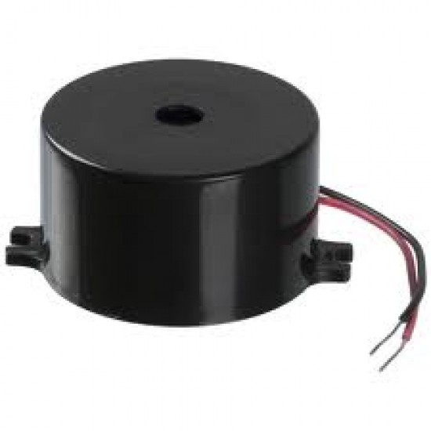

Fig. 6.1.2 buzzer

A buzzer is a small yet efficient component to ad sound features to our project/system. It is very small and compact 2-pin structure hence can be easily used on breadboard, Perf Board and even on PCB which makes this a widely used component in most electronic applications. This Buzzer can be used by simply powering it using DC power supply ranging from 4V to 9V. A simple 9V battery can also be used, but it is recommended to use a regulated +5V or +6V DC supply.

Buzzer Features and Specifications

* Resonant Frequency: ~2300 Hz.
* Small and neat sealed package.
* Breadboard and Perf board friendly.
* Rated Voltage: 6V DC.
* Operating Voltage: 4-9V DC.
* Rated current: <30mA.

### 9 VOLT BATTERY:

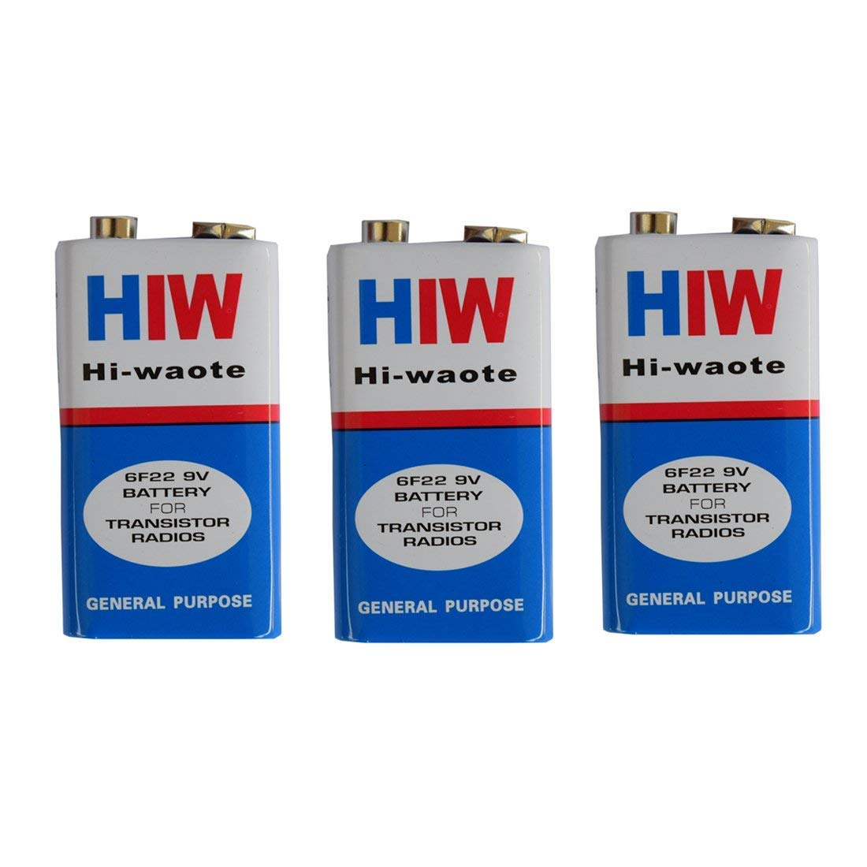

Fig. 6.1.3 9 volt battery

The nine-volt battery, or 9-volt battery, is a common size of battery that was introduced for early transistor radios. It has a rectangular prism shape with rounded edges and a polarized snap connector at the top. This type is commonly used in smoke detectors, gas detectors, clocks, walkie-talkies, electric guitars and effects units.

### BATTERY CLIP:

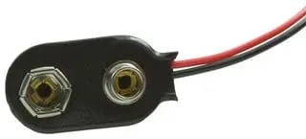

Fig. 6.1.4 battery clip

The 233 is a Battery Strap for use with PP3 (9V) batteries. Rigid construction insulated and nickel-plated male and female contacts. Wires have tinned copper conductors, PVC insulation and are stripped for easy connections. Wire leads soldered for increased reliability.

### WATER SENSOR:

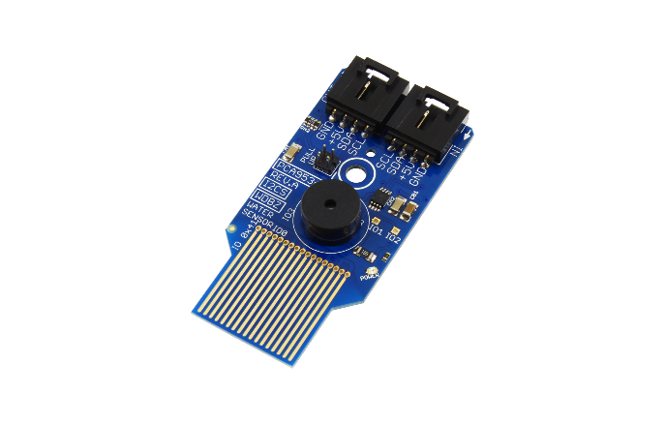

Fig. 6.1.5 water sensor

Water sensors detect the presence of water and, when placed in locations where water should not be present. So, it will detect the water for blind person.

### SMOKE SENSOR:

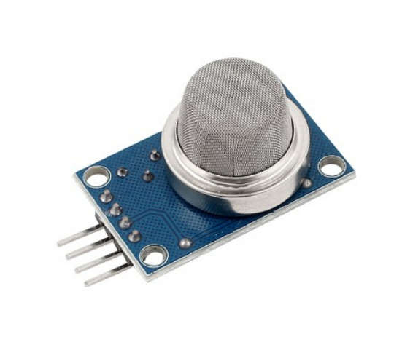

Fig. 6.1.6 smoke sensor

A smoke sensor is a device fitted to smoke alarms. A smoke alarm is designed to detect the presence of smoke in a home to alert the occupants that a fire has broken out.

### ULTRASONIC SENSOR:

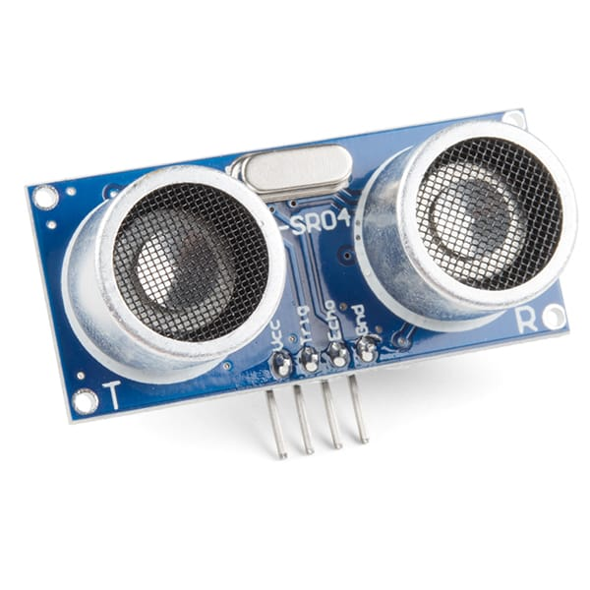

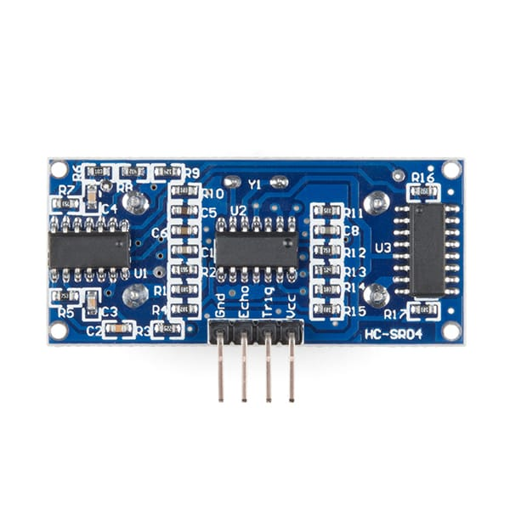

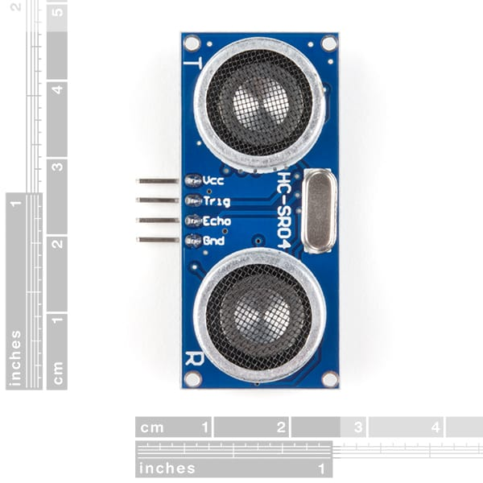

Fig. 6.1.7 ultrasonic sensor

This is the HC-SR04 ultrasonic distance sensor. This economical sensor provides 2cm to 400cm of non-contact measurement functionality with a ranging accuracy that can reach up to 3mm. Each HC-SR04 module includes an ultrasonic transmitter, a receiver and a control circuit.

There are only four pins that you need to worry about on the HC-SR04: VCC (Power), Trig (Trigger), Echo (Receive), and GND (Ground). You will find this sensor very easy to set up and use for your next range-finding project!

This sensor has additional control circuitry that can prevent inconsistent "bouncy" data depending on the application.

An Ultrasonic sensor is a device that can measure the distance to an object by using sound waves.

It measures distance by sending out a sound wave at a specific frequency and listening for that sound wave to bounce back.

By recording the elapsed time between the sound wave being generated and the sound wave bouncing back, it is possible to calculate the distance between the sonar sensor and the object.

Light Dependent Resistor(LDR) Module

The LDR Sensor Module is used to detect the presence of light / measuring the intensity of light. The output of the module goes high in the presence of light and it becomes low in the absence of light. The sensitivity of the signal detection can be adjusted using potentiometer.

Specification:

• Input Voltage: DC 3.3V to 5V

• Output: Analog and Digital

• Sensitivity adjustable

**6.2 GPS System:**

### GPS

* It is a worldwide radio navigation system formed from a constellation of 24 satellites andtheir ground stations.
* GPS uses these "man-made star" as reference points to calculate positions accurate to a matter of meters.
* Advanced forms of GPS make measurements to better than a centimeter. It was devised by the U.S. Department of Defense for fleet management, navigation, etc. Although the U.S. military developed and implemented this satellite network as a military Navigation system, it soon opened it up to everybody else.
* A GPS receiver's job is to locate four or more of these satellites, figure out the distance to
* each, and use this information to deduce its own location. This operation is based on a
* simple mathematical principle called triangulation or trilateration.

Working of GPS:

* GPS satellites circle the earth twice a day in a very precise orbit ax transmit signal information to earth.
* GPS receivers take this information and use triangularation to calculate the users exact location, Essentially, the GPS receivers compares the time a signal was transmitted by a satellite with the time it was received.
* The time difference tells the GpS receiver how far away the satellite is. Now. with distance measurements from a few more satellites, the receiver can determine the users position and display it on the units electronic maps
* A GPS receiver must be locked on to the signal of at least three satellites to calculate a 2D position (latitude and longitude) and track movement. With four or more satellites in view, the receiver can determine the users 30 position (latitude, Jongitude and altitude ).
* Once the users position has been determined the GPS unit can calculate the information, such as speed, bearing, track, trip distance, distance to destination, sunrise and sunset time and more.
* When people talk about “GPS” they usually means GPS.

### GSM:

* GSM is the pan European Mobile Telephony Standard specified by European Telecommunication Standards Institute, i.e. ETSI and provides common standard, thus cellular subscribers can use their mobile telephones all over Europe.
* GSM is used to receive SMS from the user and of the vehicle through a SMS.
* In this module we will be making use of certain algorithm for GPS, GSM based system.
* It is used for transmitting mobile voice and data services. International roaming capability is available. Encryption capability for information security and privacy matters.
* Better security against fraud (through terminal validation and user authentication).

**6.3 Circuit Diagram:**

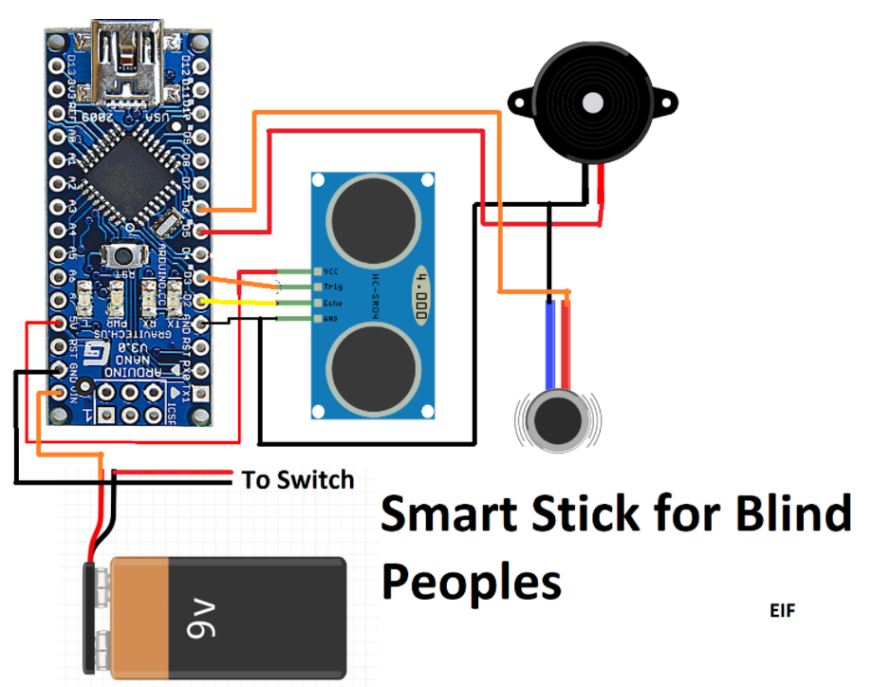

Fig. 6.3 circuit diagram

**6.4 MODEL DESIGN:**

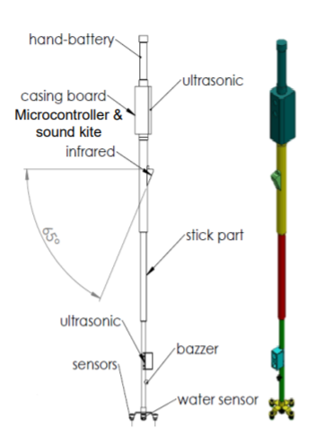

Fig. 6.4 model design

**6.5 BLOCK DIAGRAM:**

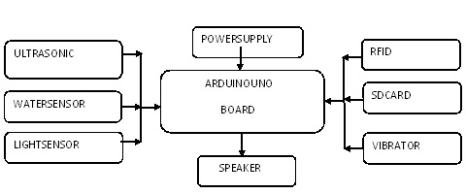

Fig. 6.5 block diagram

**6.6 FLOW CHART:**

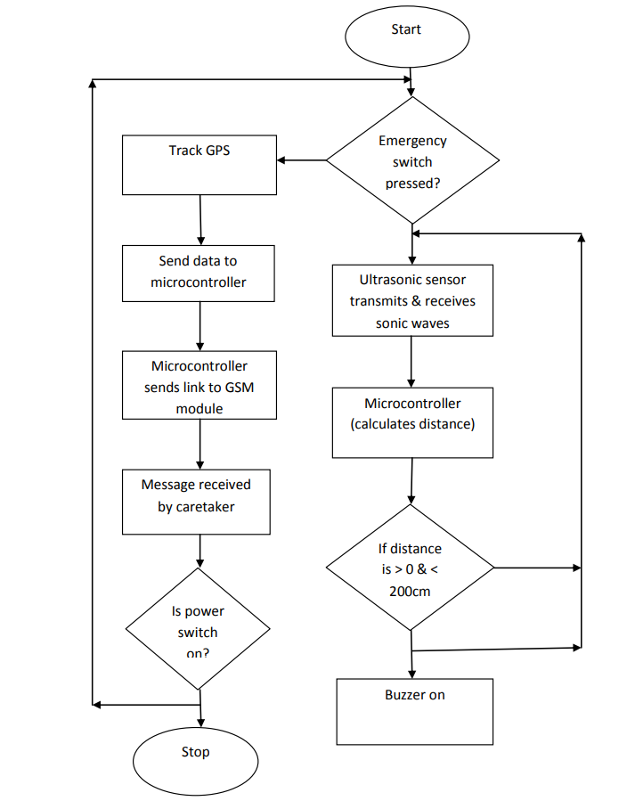

Fig. 6.6.1 flowchart 1

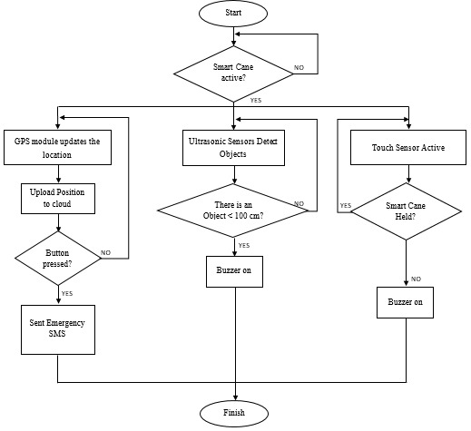

Fig. 6.6.2 flowchart 2

**7.FINAL PRODUCT:**

**7.1 Final Product Photograph**

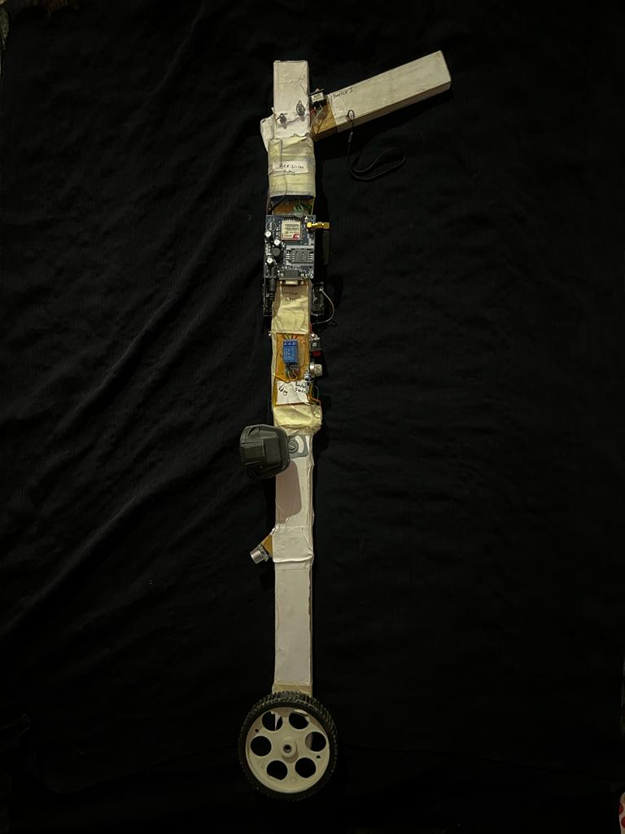

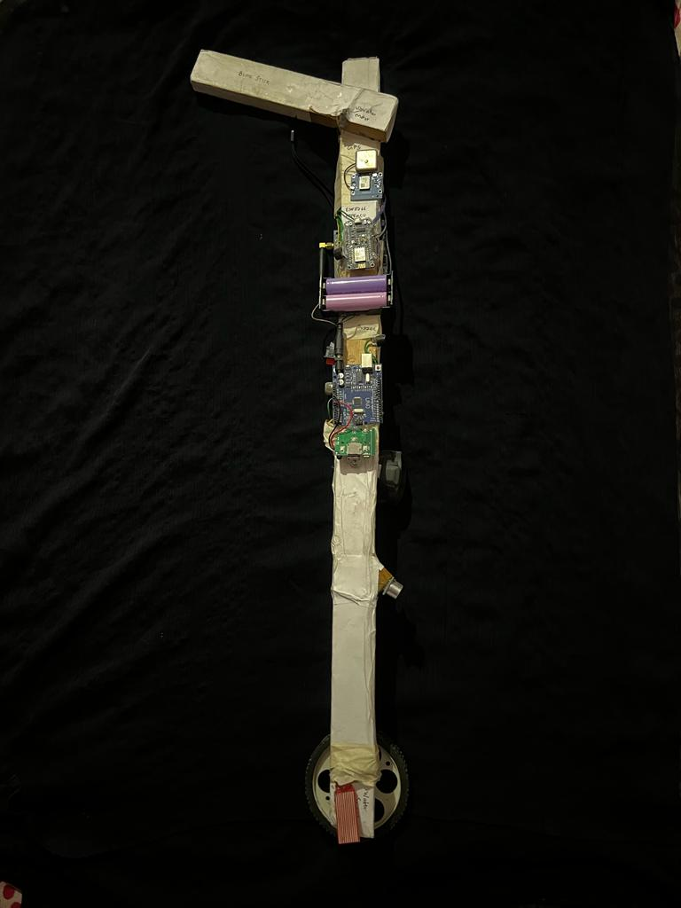

Fig. 7.1 final product photograph

**7.2 Parts Of Smart Stick:**

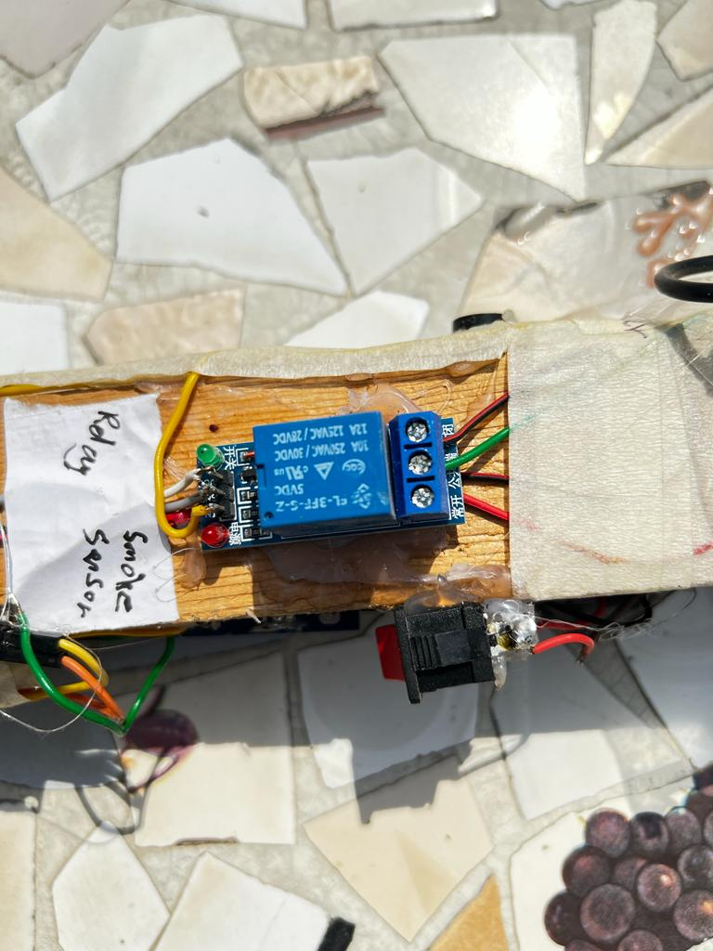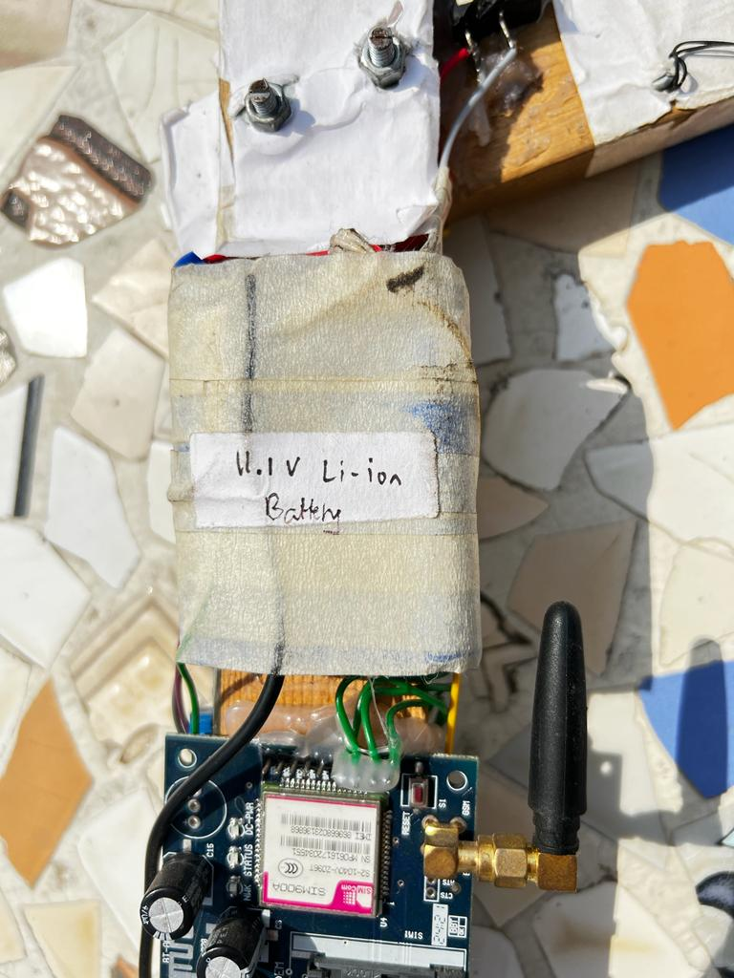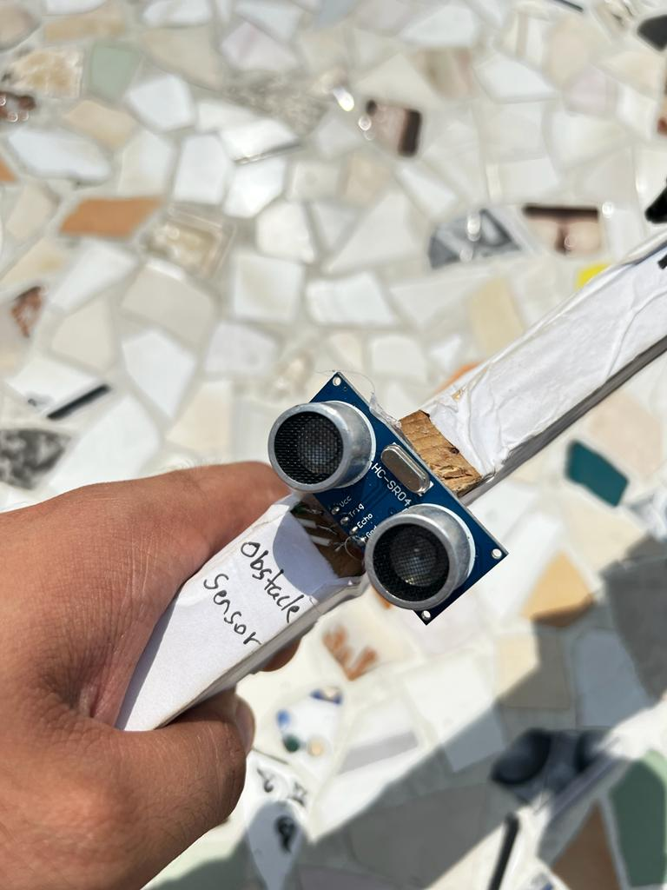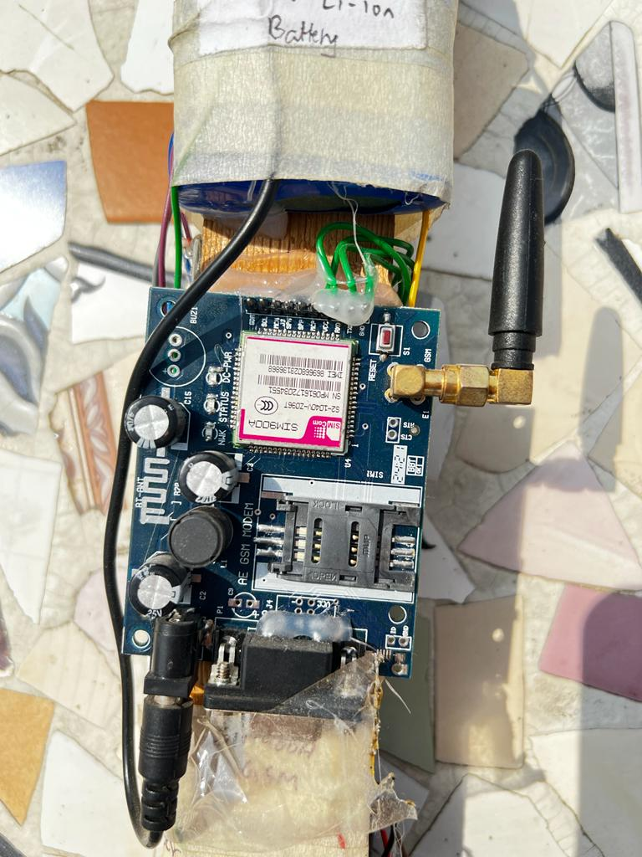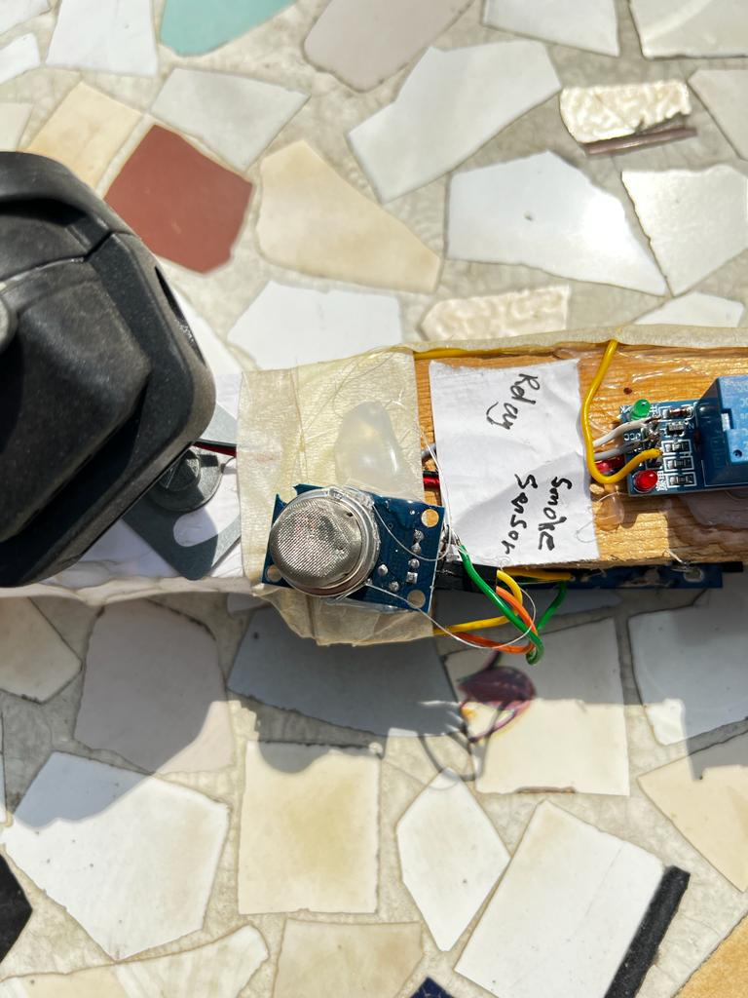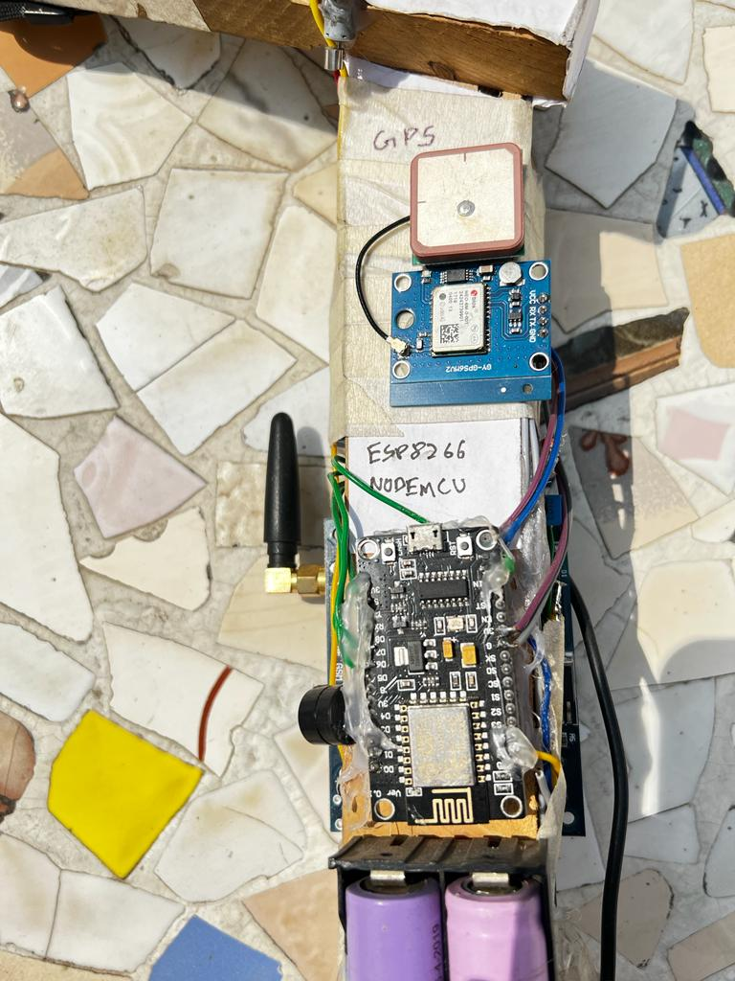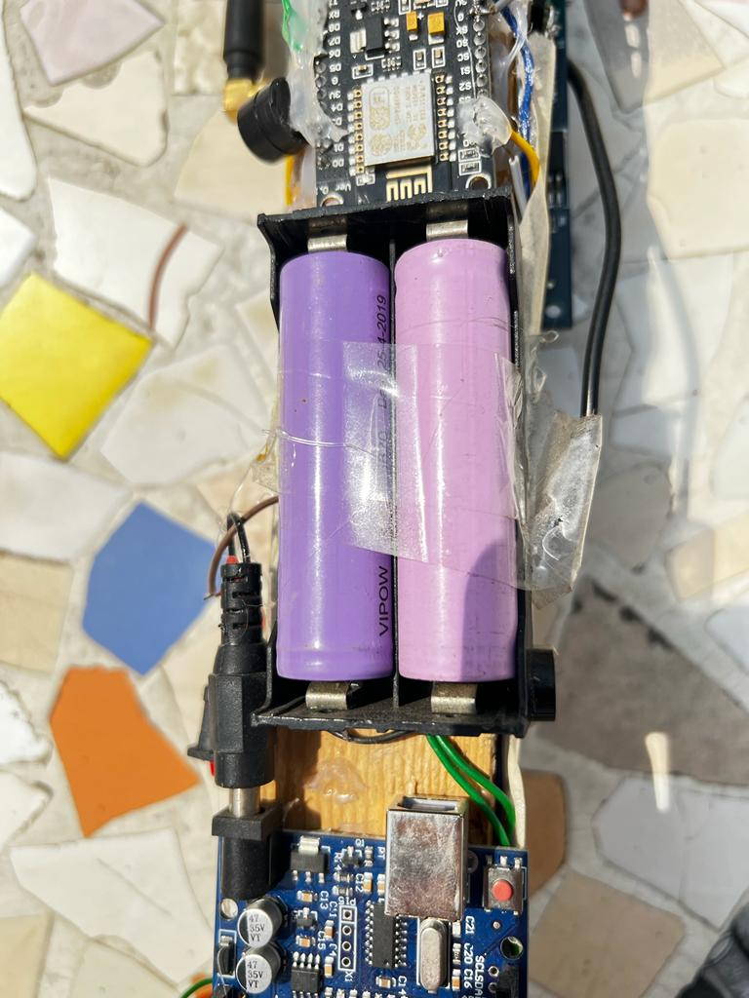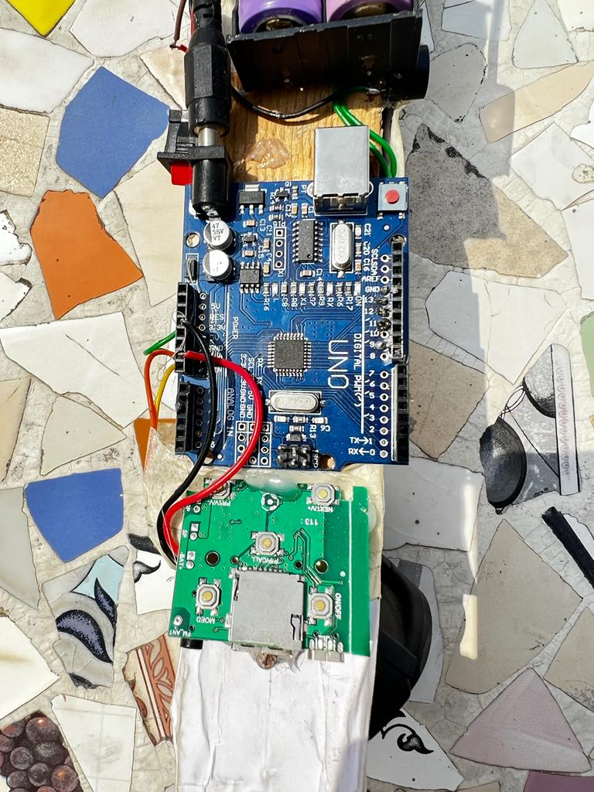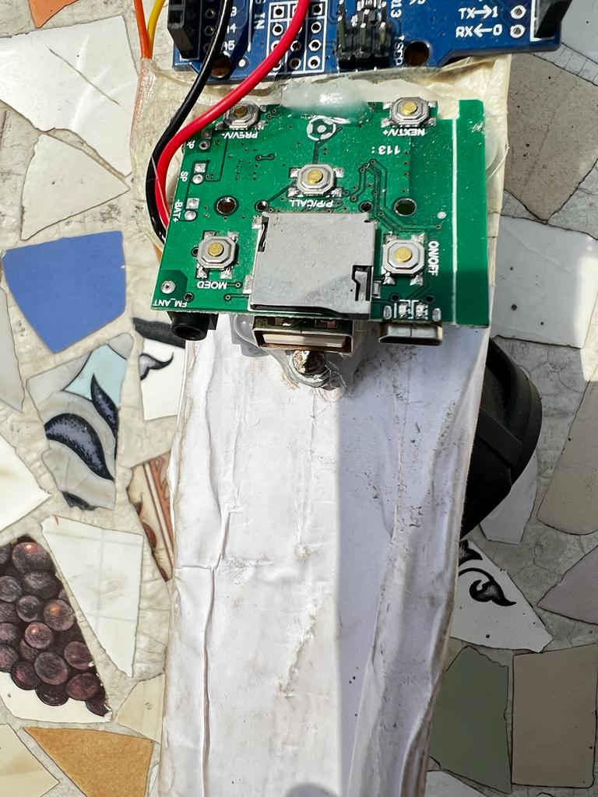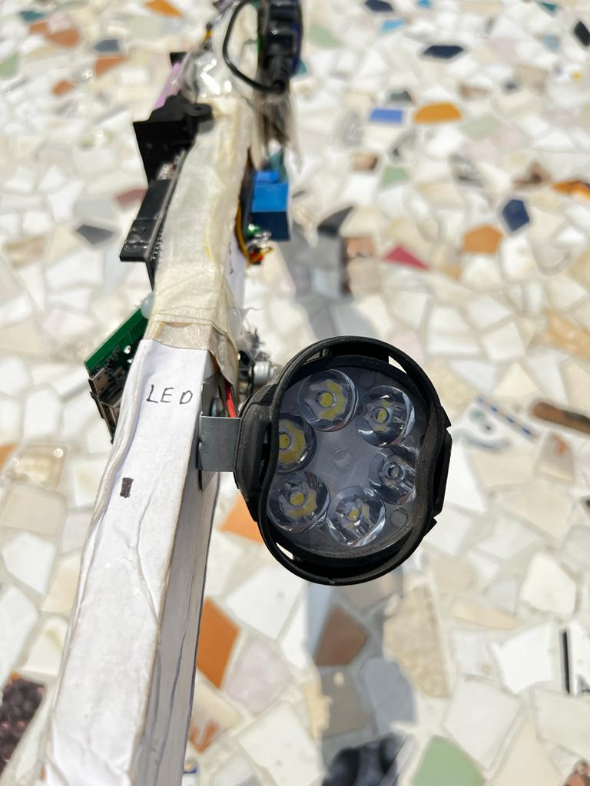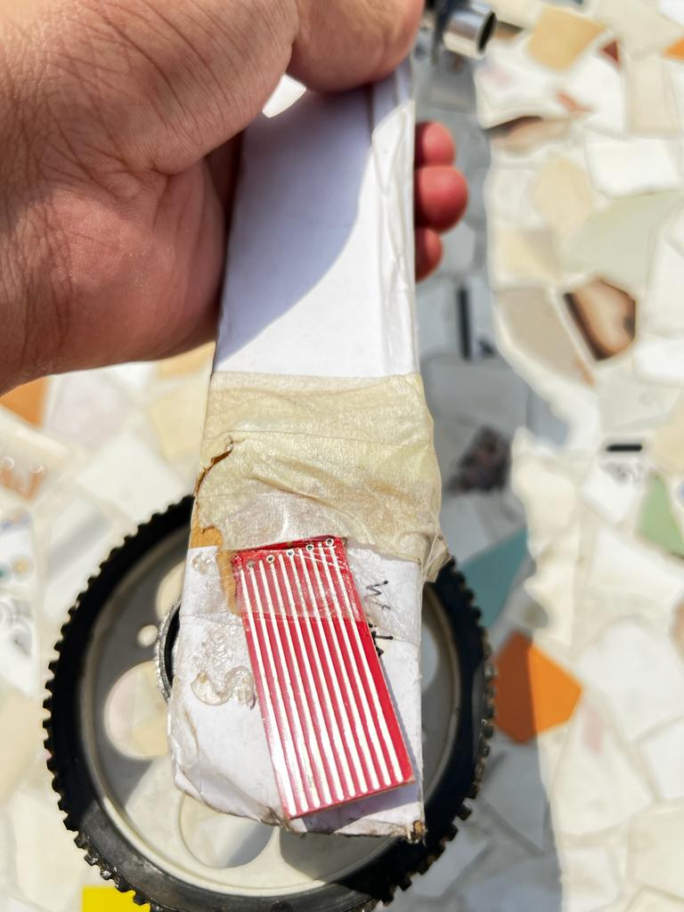

Fig. 7.2 parts of blind stick

**8. SUMMARY**

**8.1 Overview:**

The purpose of this project is to detecting the obstacle and route by using ultrasonic sensor that can detect a hole or stair with maximum range about 2 meter. With our idea, we want to help this kind of people to live their life freely. This modern blind stick have a several feature that surely can help this blind people to navigate and detect an obstacle that surely can make their life routines easier. The user just need to use the blind the normal blind stick , the different is , visually impaired person can detect a hole or stair more faster and easily. Besides that, guardian or parent can locate the location of the stick user using GPS and GSM module by sending SMS to the stick.

**8.2 Advantages:**

* + To prevent and reduce the risk of injuries and lost of the visually impaired person.
  + This gadget will operate to help all the blind people in the world to make them easier to walk everywhere they want. And the navigation system helps them with voice command.
  + Simple to use.
  + Obstacles detection

**CONCLUSION**

The Smart Stick acts as a basic platform for the coming generation of more aiding devices to help the visually impaired to be safer. It is effective and afford. It leads to good results in detecting the obstacles lying ahead of the user in a range of four meters, detecting stairs and water pits.

This system offers a low-cost, reliable, portable, low power consumption and robust solution for navigation with obvious short response time. Though the system is hard-wired with sensors and other components, it's light in weight.

The proposed combination of various working units makes a real-time system that monitors position of the user and provides dual feedback making navigation more safe and secure. The smart stick detects objects or obstacles in front of users and feeds warning back, in the form of voice messages rather than vibration.

It is worth mentioning at this point that the aim of this study which is the design and implementation of a smart walking stick for the blind has been fully achieved.

The Smart Stick acts as a basic platform for the coming generation of more aiding devices to help the visually impaired to navigate safely both indoor and outdoor. It is effective and affordable.

It leads to good results in detecting the obstacles on the path of the user in a range of three meters. This system offers a low-cost, reliable, portable, low power consumption and robust solution for navigation with obvious short response time.

Though the system is hard-wired with sensors and other components, it's light in weight. Further aspects of this system can be improved via wireless connectivity between the system components, thus, increasing the range of the ultrasonic sensor and implementing a technology for determining the speed of approaching obstacles.

While developing such an empowering solution, visually impaired and blind people in all developing countries were on top of our priorities.

The device constructed in this work is only capable of detecting obstacles and moisture. Holes cannot be detected using this device nor the nature of obstacle.

Therefore, a better device can be constructed using ultrasonic sensors, arduino Uno and other devices that employ audio commands to alert the user of what is in his path of movement.

A vibrator may also be added for ease of use and convenience. In the future, further modifications to enhance the performance of the system will be added.

These include: A global positioning method to find the position of' the user using the GPS, and GSM modules to communicate the location to a relative or care giver.

It should also accommodate wide varying grips for flexible handling.

**REFERENCES**

https://www.researchgate.net/publication/272080365_The_Prevalence_and_Causes_of_Visual Impairment_and_Blindness_Among_Older_Adults_in_the_City_of_Lodz_Poland

<https://pdfs.semanticscholar.org/8919/29ae290dcacc84f0b0002ea101eac63c11e2.pdf>

<http://www.mecs-press.net/ijisa/ijisa-v6-n8/v6n8-6.html>

<https://www.semanticscholar.org/paper/Smart-stick-for-Blind%3A-Obstacle-Detection%2Cvision-Dambhare>

<https://pdfs.semanticscholar.org/35a4/74e95b193963f2bb4dbca220a76af40a13ee.pdf>

<https://store.arduino.cc/usa/arduino-uno-rev3>

<https://randomnerdtutorials.com/guide-for-relay-module-with-arduino/>

<https://en.wikipedia.org/wiki/Light-emitting_diode>

https://components101.com/buzzer-pinout-working-datasheet

<https://www.tutorialspoint.com/arduino/arduino_ultrasonic_sensor.htm>

https://www.mybotic.com.my/products/SIM900A-GSM-GPRS-Module/1783

.