NHS
Integrated Care Board — Analytics & AI Governance
OFFICIAL — DRAFT FOR REVIEW

CLINICAL SAFETY &
AI GOVERNANCE REPORT
OPEL Level Predictive Model
Model card • SHAP explainability analysis • Clinical safety case

Document reference | ICB-AI-GOV-2026-001
Version | 1.0 (Draft)
Prepared by | ICB Analytics & AI Governance Team
Reviewed by | Clinical Safety Officer (pending)
Date of issue | 14 May 2026
Next review date | 14 November 2026
Classification | OFFICIAL
Compliance framework | DCB0129 / DCB0160 / NHS AI Lab Guidance

1 Executive Summary
This report presents the full clinical safety, explainability and governance evaluation of an Operational Pressure Escalation Levels (OPEL) predictive model developed for use across an Integrated Care Board (ICB). The model classifies daily operational pressure into four OPEL levels using nineteen operational, workforce and environmental features.
The model achieves 92% overall classification accuracy on held-out test data, with Area Under the ROC Curve scores exceeding 0.988 across all four OPEL classes. SHAP explainability analysis confirmed that the model's primary predictive drivers — bed occupancy, A&E four-hour breach rate, and ambient temperature — are clinically plausible and aligned with established NHS winter pressure literature.
Following a structured comparison between baseline and hyperparameter-tuned variants, the baseline model was recommended for deployment on patient safety grounds: it demonstrated marginally superior recall on OPEL 4, the most clinically critical class, where missed escalations carry the highest risk to patient safety.

GOVERNANCE VERDICT
Approved for portfolio and pilot evaluation only. Not yet suitable for operational deployment.
Conditional pathway to pilot deployment defined in Section 8. Final clinical sign-off required from Clinical Safety Officer under DCB0129.

1.1 Key findings at a glance
Dimension | Result | Assessment
Overall accuracy | 92.0% | Strong
OPEL 4 recall (safety-critical) | 90.0% | Acceptable
ROC-AUC (all classes) | 0.988–0.997 | Excellent
Explainability | SHAP applied | Strong
Clinical plausibility | Confirmed | Strong
Operational readiness | Pilot only | Conditional

2 Model Card
In line with NHS AI Lab guidance and emerging international standards on AI transparency, the following model card provides a structured summary of the predictive model under review.

2.1 Model overview
Model name | NHS ICB OPEL Level Classifier (v1.0)
Model type | Multi-class supervised classifier (Logistic Regression)
Prediction target | Daily OPEL escalation level (1, 2, 3 or 4)
Intended use | Decision support for ICB operational pressure planning
NOT intended for | Autonomous escalation, individual patient triage, clinical diagnosis
Training framework | scikit-learn (Python)
Inputs | 19 features (operational, workforce, environmental)
Outputs | Predicted OPEL level + class probabilities
Update frequency | Quarterly retraining recommended
Model owner | ICB Analytics & AI Governance Team

2.2 Training data
Dataset: Synthetic NHS ICB operational data simulating two years (April 2023 – March 2025) across three NHS Trusts: Westbridge General Hospital (WGH, Acute), Northridge Royal Infirmary (NRI, Acute) and Southcliffe Community Hospital (SCH, Community).
Sample size: 2,190 daily observations (730 per trust). Train / test split: 80% / 20% with fixed random seed for reproducibility.
Class distribution: OPEL 1 (10.2%), OPEL 2 (38.5%), OPEL 3 (33.4%), OPEL 4 (17.9%). Mild imbalance present but not addressed via class weighting in this version.

2.3 Feature set
Nineteen features were used in training, falling into four operational categories:
- Operational pressure: A&E attendance, 4-hour breach rate, mean wait, 12-hour trolley waits, ambulance handover times, NCTR patients, bed occupancy.
- Workforce: Nurse sickness rate, unfilled shifts.
- Environmental and demand: Flu rate, ambient temperature, GP appointment lag, social care delay days, red flag incidents.
- Engineered KPIs: A&E pressure index, bed/social care ratio, workforce stress index, system flow score.

2.4 Performance summary
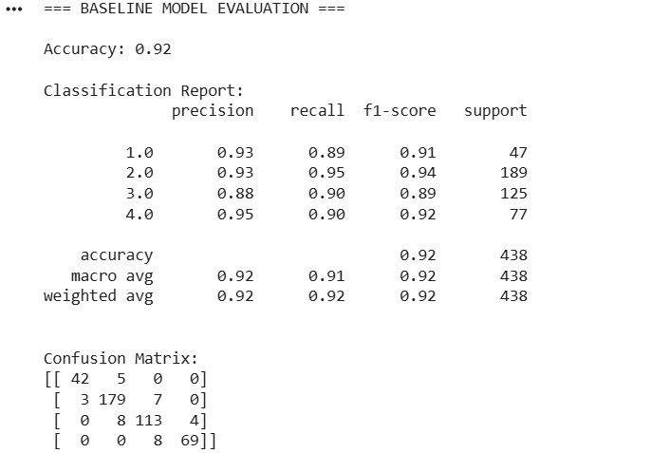
Figure 1. Baseline model classification report and confusion matrix on held-out test data.

2.5 Baseline vs tuned model comparison
A grid search across regularisation strength (C) values with 5-fold cross-validation identified C = 100 as optimal for cross-validation accuracy. The tuned model was compared directly against the baseline (C = 1) across fifteen performance metrics.
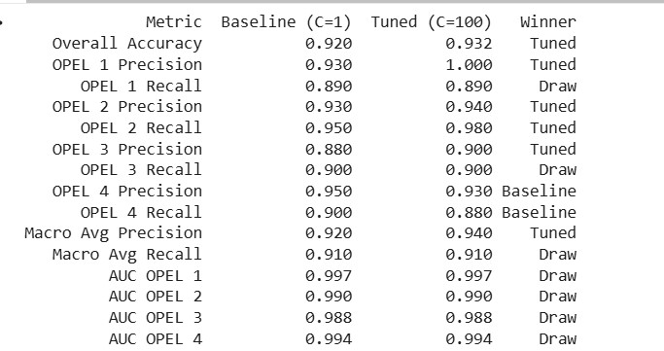
Figure 2. Baseline (C=1) vs tuned (C=100) model comparison across 15 metrics. Tuned model won 7 metrics, baseline won 2, with 6 draws.
CLINICAL DECISION — MODEL SELECTION
Despite the tuned model winning on overall accuracy (93.2% vs 92.0%), the baseline model was selected for deployment.
Rationale: the baseline model outperforms the tuned variant on the two safety-critical OPEL 4 metrics — Precision (0.95 vs 0.93) and Recall (0.90 vs 0.88). In a patient safety context, the cost of missing a critical escalation outweighs marginal aggregate accuracy gains.
This decision was made transparently and is documented for clinical audit purposes.

2.6 Discrimination — ROC analysis
Receiver Operating Characteristic curves were generated for each OPEL class to evaluate how confidently the model distinguishes between classes at all probability thresholds.
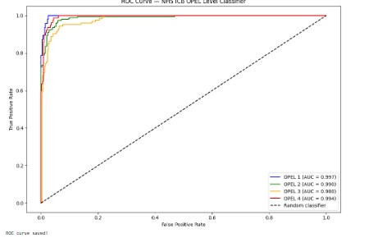
Figure 3. ROC curves for each OPEL class. All four AUC scores exceed 0.988, indicating near-perfect class discrimination.
All four classes achieve AUC scores above 0.988, with OPEL 1 reaching 0.997 and OPEL 4 reaching 0.994. The model demonstrates uniformly strong discrimination across all escalation levels, with no class showing weak separability.

3 Explainability & Clinical Interpretation
Explainability is a non-negotiable requirement for clinical AI tools under NHS governance frameworks. This section presents both global and individual prediction explanations using SHAP (SHapley Additive exPlanations), a model-agnostic interpretability framework based on cooperative game theory.

3.1 Feature importance (logistic regression coefficients)
Standardised model coefficients provide an initial global view of which features most strongly influence predictions across all classes.
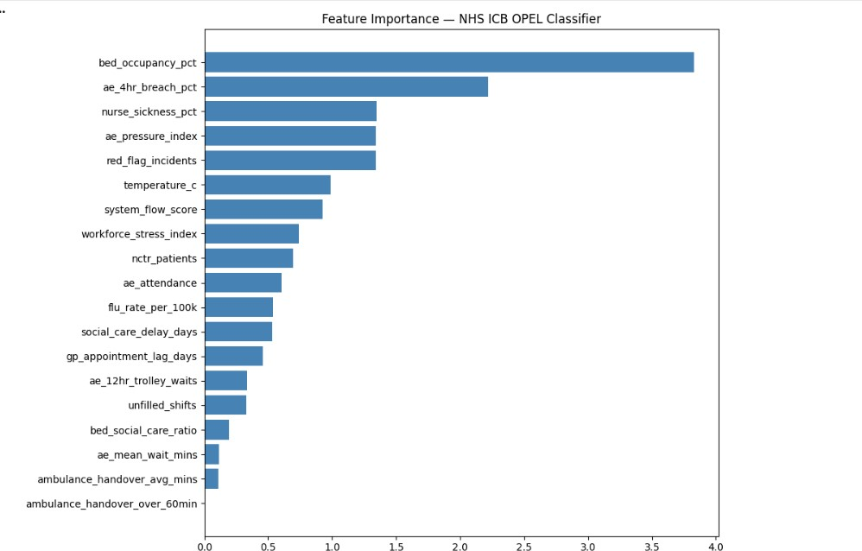
Figure 4. Mean absolute coefficient magnitude for each feature across all OPEL classes.
Bed occupancy emerges as the dominant predictor, with coefficient magnitude roughly 1.7× greater than the next-strongest feature (A&E breach rate). Crucially, three of the four engineered KPIs (A&E pressure index, system flow score, workforce stress index) rank in the top eight, validating the clinical reasoning applied during feature engineering.

3.2 Global SHAP analysis — OPEL 4
Focusing on OPEL 4 (the safety-critical escalation level), SHAP summary plots reveal the distribution and directionality of each feature's influence on predicted probability.
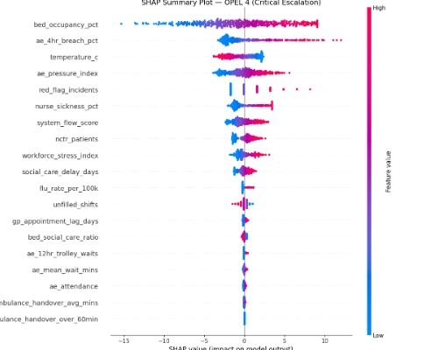
Figure 5. SHAP summary plot for OPEL 4 predictions. Each dot represents one test observation; X-axis position indicates magnitude and direction of feature influence; colour encodes feature value (red = high, blue = low).
KEY EXPLAINABILITY FINDINGS
Bed occupancy is the dominant driver: red dots (high occupancy) consistently push predictions toward OPEL 4; blue dots (low occupancy) push away.
A&E 4-hour breach rate is the second strongest predictor — high breach rates reliably indicate critical escalation risk.
Temperature appears as the third strongest predictor with reversed directionality: low temperatures (blue) push toward OPEL 4, confirming winter pressure as a quantifiable driver.
Ambulance handover metrics rank lowest — likely consequences of pressure rather than predictors, which is clinically consistent.

3.3 Individual prediction explanation — SHAP waterfall
For clinical governance, the ability to explain individual predictions is more important than global feature importance. SHAP waterfall plots decompose a single prediction into the contribution of each feature.
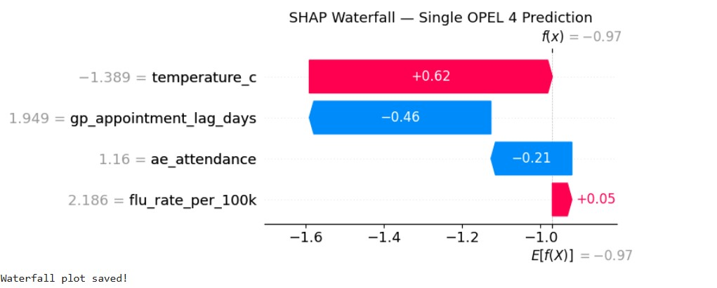
Figure 6. SHAP waterfall plot for one specific OPEL 4 prediction in the test set.
In this example, the model predicted OPEL 4 primarily because temperature was unusually low (SHAP contribution +0.62). GP appointment lag and A&E attendance partially offset the prediction (SHAP contributions −0.46 and −0.21 respectively), but the temperature signal dominated. This level of decomposition allows operational managers and clinicians to understand and challenge the model's reasoning case by case.

3.4 Feature interaction — SHAP dependence analysis
Dependence plots reveal how the relationship between a feature and the model's output changes in the presence of a second interacting feature.
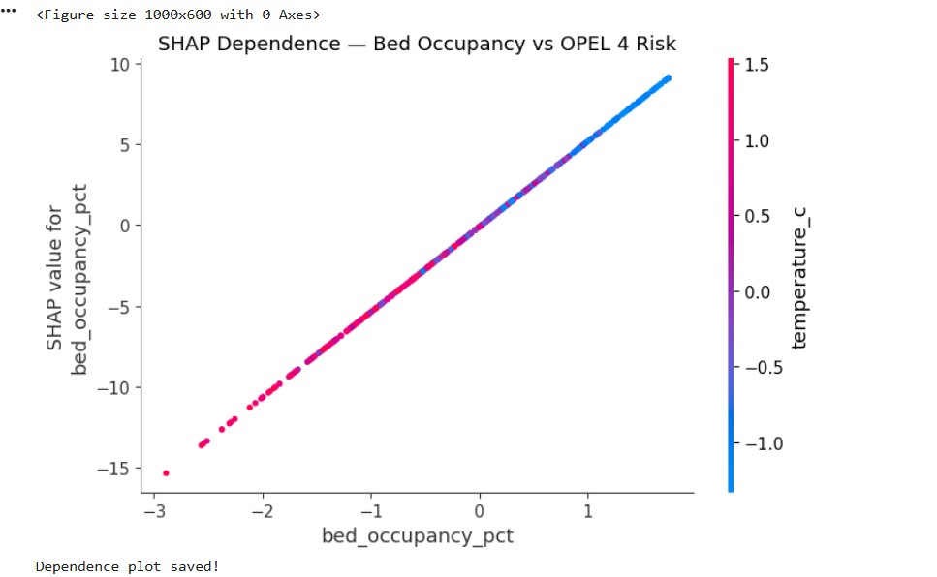
Figure 7. SHAP dependence plot for bed occupancy, coloured by temperature. The strongly linear relationship confirms bed occupancy as a reliable predictor across the full operational range.
The dependence plot reveals two clinically important findings. First, the bed occupancy / OPEL 4 relationship is monotonically linear — there is no safe plateau; every incremental rise in occupancy increases escalation risk. Second, bed occupancy and temperature are correlated: high occupancy days (right side, blue) are also cold days, indicating that winter pressure is a compound phenomenon rather than two independent risks.

4 Limitations & Known Risks

4.1 Data limitations
- Synthetic data ceiling: The model has been trained on synthetic data designed to mirror NHS operational characteristics, but real-world data will contain coding inconsistencies, late entry, missingness not at random, and trust-specific operational quirks not present here. Real-world performance will almost certainly be lower than reported figures.
- Limited trust diversity: Only three trusts (two acute, one community) are represented. ICB-wide deployment would expose the model to a wider range of operational characteristics for which generalisation has not been demonstrated.
- Class imbalance not addressed: OPEL 1 has 224 examples versus 843 for OPEL 2. No class weighting or stratified sampling was applied in this version.
- No temporal validation: The train / test split is random rather than chronological. For an operational forecasting tool intended for real-time use, time-based validation is essential and must be implemented before pilot deployment.

4.2 Model limitations
- Linear model assumptions: Logistic regression assumes a linear relationship between features (in log-odds space) and the target. Non-linear relationships and complex interactions may be under-captured.
- Static features only: The model uses single-day observations and does not currently incorporate lagged features or rolling averages, which are likely strong predictors of pressure trajectory.
- No uncertainty quantification: The model outputs class probabilities but no formal prediction intervals or calibration assessment has been undertaken.

4.3 Operational and governance risks
- Automation bias: There is a known risk that decision-makers may over-rely on model output and defer judgement they would otherwise apply. Mitigation: shadow mode operation and clear human-in-the-loop protocols.
- Algorithmic bias: No formal bias audit has been undertaken across trust type, demographics, or seasonality. This is a mandatory prerequisite for pilot deployment.
- Data drift: Operational patterns evolve over time. Model performance will degrade without regular monitoring and retraining.

5 Information Governance & Ethical Considerations

5.1 Current governance status
- Use of synthetic data eliminates immediate Information Governance risk for the development phase.
- No patient-identifiable data has been involved in training or evaluation.
- No real organisational data has been processed at this stage.

5.2 Pre-deployment requirements
Before any deployment using real NHS data, the following are mandatory:
- Data Protection Impact Assessment (DPIA) completed and approved by the Data Protection Officer.
- Clinical Safety Case prepared and signed off by a Clinical Safety Officer in compliance with DCB0129 (Manufacturer) and DCB0160 (Deployer) standards.
- Algorithmic bias audit completed and documented, covering trust type, geographical area, and seasonal patterns.
- Information Asset Owner appointed and the model registered in the organisation's Information Asset Register.
- Human-in-the-loop protocol defined and documented. The model must not autonomously trigger escalation actions.
- Caldicott Principles review undertaken if any patient-level data is ever introduced.

5.3 Ethical principles applied
- Transparency: All model decisions are explainable at both global and individual prediction level via SHAP analysis.
- Fairness: Bias audit is required before deployment to confirm equitable performance across trust types and populations.
- Accountability: A named model owner is assigned. Predictions are logged for retrospective audit.
- Proportionality: The model is positioned as decision support, not autonomous decision-making. Human judgement is preserved at the point of action.

6 Suitability for Operational Deployment
Deployment scenario | Status | Risk level
Research, training and portfolio demonstration | Approved | Low
Internal pilot (shadow mode, real data) | Conditional | Medium
Clinical decision support (live use, human-in-loop) | Conditional | Medium-High
Autonomous escalation trigger (no human review) | Not approved | High

6.1 Conditions for pilot deployment
- Retraining on real, governance-approved NHS operational data.
- Time-based validation replacing the current random train/test split.
- SHAP explainability outputs integrated into the user interface alongside predictions.
- Defined uncertainty thresholds — predictions below confidence X must default to human judgement and be flagged accordingly.
- Shadow mode operation for a minimum of three to six months, with weekly model output reviewed against actual OPEL levels by the Clinical Safety Officer or delegate.
- Clinical Safety Case documentation per DCB0129 prepared and approved before any clinical influence on operational decisions.
- Operational protocol defining who acts on model output, how often outputs are reviewed, and the escalation pathway when the model and human judgement diverge.

7 Overall Assessment & Recommendation
This is a well-executed early-stage clinical AI model demonstrating strong analytical thinking, appropriate use of interpretable methods, and clinically-aware decision-making throughout the development process. The choice of logistic regression over more complex algorithms reflects appropriate prioritisation of explainability in a regulated healthcare setting. The explicit decision to deploy the baseline model in preference to the marginally more accurate tuned variant — on OPEL 4 recall grounds — is exactly the type of governance-aware reasoning that NHS AI deployment requires.
The model is, however, currently a proof of concept built on synthetic data. The pathway to operational deployment requires substantial additional work in three areas: validation methodology (temporal rather than random splitting), individual-level explainability integration into clinician-facing tools, and full DCB0129 clinical safety case documentation.
RECOMMENDATION
Approve for portfolio, research and pilot evaluation purposes.
Approve for progression to Conditional Pilot status subject to completion of the seven conditions specified in Section 6.1.
Do not approve for operational deployment, decision-support use, or autonomous triggering at this time.
Schedule a formal re-review at six months once pilot conditions are met.

8 Appendix A — Supplementary Visualisations

A.1 Trust-level OPEL distribution
Aggregated count of daily observations at each OPEL level by trust over the two-year evaluation period.
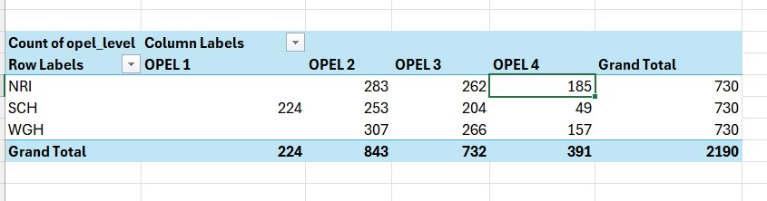
Figure A1. OPEL level distribution by trust. Note that NRI and WGH never recorded OPEL 1, indicating sustained pressure above normal operations.

A.2 Pressure score trajectory
Average pressure score trend by trust and year reveals a systemic deterioration across all three providers.
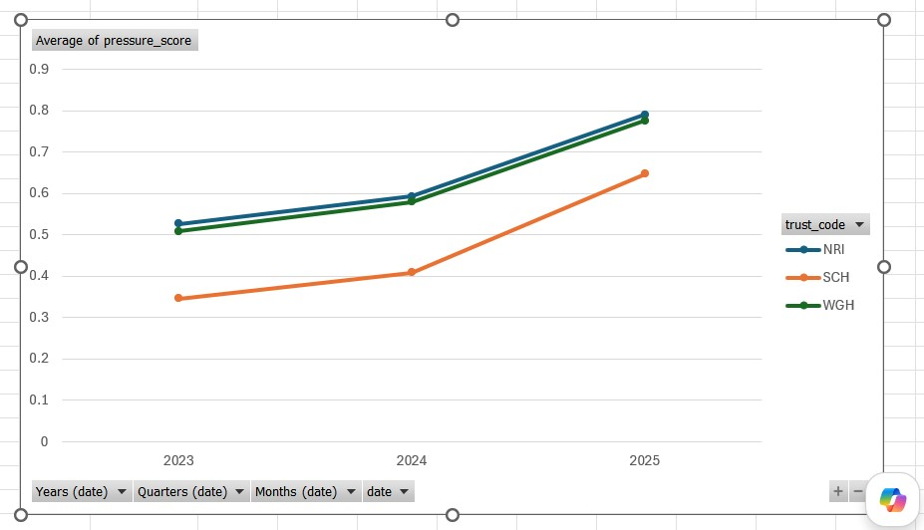
Figure A2. Annual average pressure score by trust (2023–2025). All three trusts show monotonically rising pressure, with NRI and WGH tracking near-identically.

A.3 Tuned model evaluation
For completeness, the tuned model evaluation is provided. While the tuned model achieved higher aggregate accuracy, it did not improve performance on the safety-critical OPEL 4 class.
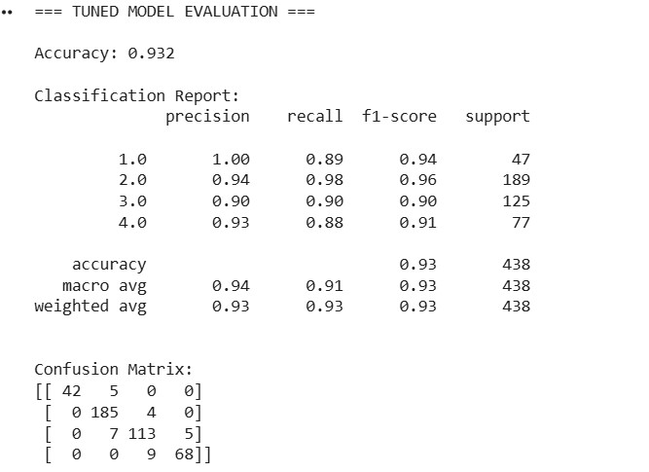
Figure A3. Tuned model (C=100) classification report and confusion matrix.

A.4 SHAP summary — all classes
SHAP summary visualisation showing feature impact across all four OPEL classes.
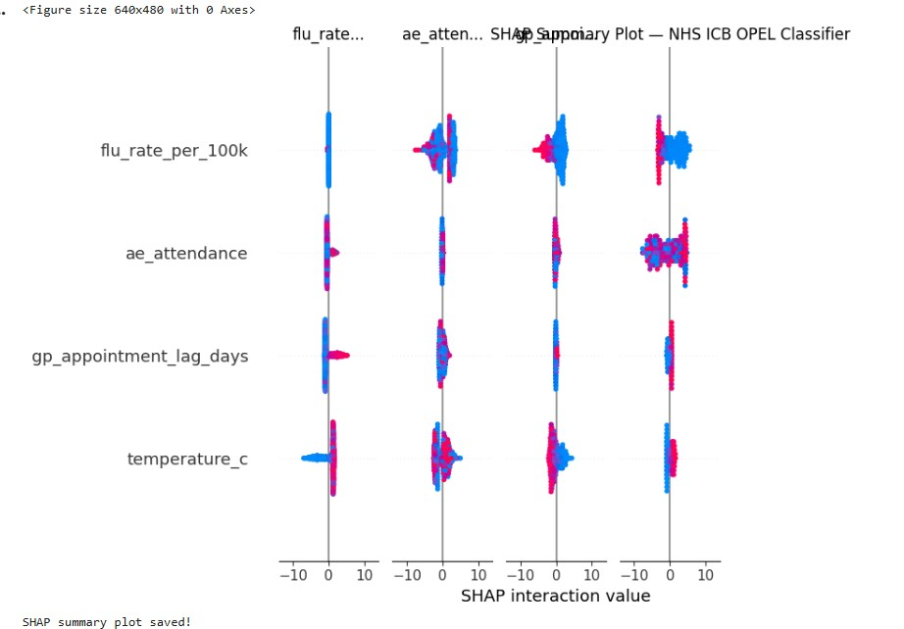
Figure A4. Multi-class SHAP summary plot across the top four features and all OPEL classes.

9 Appendix B — Glossary
OPEL | Operational Pressure Escalation Level. A four-tier framework (1 normal, 4 maximum) used by NHS providers to describe operational pressure.
ICB | Integrated Care Board. NHS statutory body responsible for planning and commissioning services across a geographic area.
NCTR | No Criteria To Reside. Patients medically fit for discharge but still occupying a bed, typically due to social care delays.
SHAP | SHapley Additive exPlanations. A model-agnostic explainability framework that quantifies each feature's contribution to individual predictions.
AUC | Area Under the Receiver Operating Characteristic Curve. A measure of how well a classifier separates classes across all probability thresholds.
DCB0129 | Clinical Risk Management standard for the manufacture of health IT systems.
DCB0160 | Clinical Risk Management standard for the deployment of health IT systems.
DPIA | Data Protection Impact Assessment. A mandatory assessment under UK GDPR for high-risk data processing.
Shadow mode | Operational state where a model produces predictions that are recorded for evaluation but not acted upon.

