Nauman Liaqat

Bscs5C

132045

Advanced programming

Lab 3

**Assumption:**

Someone wants to buy any car for his daily use. He has some requirement constraints to be fulfilled. His requirements can be miles per gallon, displacement, horse power etc. After checking for these constraints, he came to get the results which are best for him for his daily use. He will buy the car which will be in the best range of his requirements

Graph:1



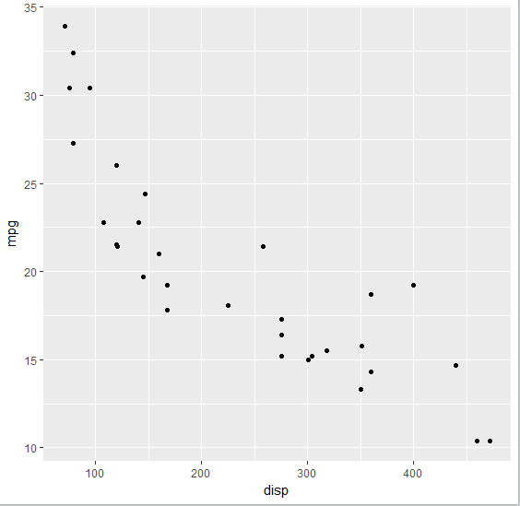

Graph:2



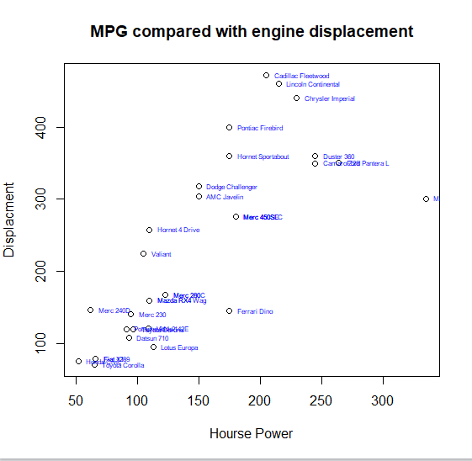

Graph:3



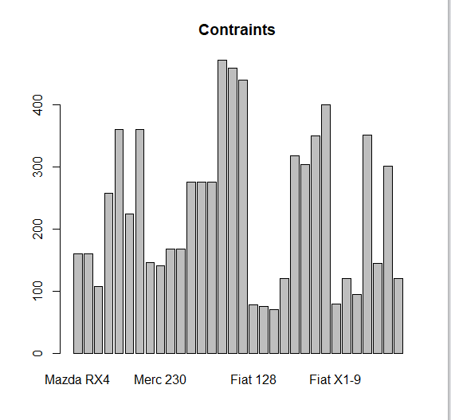

Github Link:

https://github.com/NaumanLiaqat/lab3