Prototype Report

Multi-Tenant System for Sales and Distribution

Prepared by:
Usman Khan 2016-CS-114
Nauman Malik 2016-CS-306
Numan Arshad 2016-CS-311
Usama Zulfiqar 2016-CS-320

Submitted to:
Ma’am Sahar Waqar (Advisor)
Samyan Wahla (Co-Advisor)

Version History
Date | Author | Version | Changes made | Rationale
07/14/19 | UK, NA, NM, UZ | 1.0 | - Original Prototype | - Initial draft is built with the use of Justin mind.

Table of Contents
Prototype Report i
Version History ii
Table of Contents iii
Table of Tables iv
Table of Figures v
1. Introduction 1
1.1 Purpose of the prototype report 1
3. Prototype 3

Table of Tables
Table 1: SuperAdmin-Login 3
Table 2: SuperAdmin-Dashboard 3
Table 3: SuperAdmin-CreatePackage 3
Table 4: SuperAdmin-SaleOrder 3
Table 5: UserSite-ViewPlan 3
Table 6: UserSite-Register 3

Table 7: UserSite-UserInfo 3
Table 8: UserSite-Confirmation 3
Table 9: UserSite-CustomizeTheme 3
Table 10: UserSite-Payment 3
Table 11: UserSite-Payment(JAZZCASH) 3
Table 12: UserSite-Payment(EASYPAISA) 3
Table 13: UserSite-Payment(DEBITCARD) 3
Table 14: Distributor-FieldManagement-SalesPJP 3Table 15: Distributor-FieldManagement-DeliveryPJP 3Table 16: Distributor-FieldManagement-JourneyPlan 3Table 17: Distributor-AgentManagement-FieldAgent 3Table 18: Distributor-FieldManagement-AddFieldAgent 3Table 19: Distributor-FieldManagement-AgentLocation 3Table 20: Distributor-FieldManagement-SaleTarget 3Table 21: Distributor-SalesOrderManagement-SalesOrder 3Table 22: Distributor-FieldManagement-ReturnOrder 3Table 23: Distributor-FieldManagement-ReplacementOrder 3 Table 24: Distributor-Distributions-ViewDistributor 3 Table 25: Distributor-Distributions-AddDistributor 3 Table 26: Distributor-PaytmentandCollection-PaymentRecieved 3Table 27: Distributor-PaytmentandCollection-ReturnOrderPayment 3Table 28: Distributor-InventoryManagement-PurchaseOrder 3Table 29: Distributor-InventoryManagement-WarehouseStock 3 Table 30: Distributor-InventoryManagement-CustomerStock 3Table 31: Distributor-InventoryManagement-StockRegister 3Table 32: Distributor-InventoryManagement-StockTransfer 3Table 33: Distributor-ProductManagement-ViewProduct 3
Table 34: Distributor-ProductManagement-AddProduct 3Table 35: Distributor-SchemaandPromotiont 3Table 36: Distributor-Merchandising-Planograms 3Table 37: Distributor-Merchandising-CustomerComplaint 3Table 38: Distributor-Merchandising-Survey 3Table 39: Distributor-Reports-DailySaleReport- 3Table 40: Distributor-Reports-OrderDeliveryReport- 3Table 41: Distributor-Reports-BookingReport- 3Table 42: Distributor-Reports-OrderReturnReport- 3Table 43: Distributor-Reports-ProductClaimReport- 3Table 44: Distributor-Reports-ProfitReport- 3Table 45: Distributor-Reports-CustomerOfDistributorReport- 3Table 46: Distributor-Reports-SaleAgentandDistributor- 3Table 47: Customer-Login 3Table 48: Customer-Dashboard 3Table 49: Customer-ViewProduct 3Table 50: Customer-PlaceOrder 3Table 51: Customer-ShoppingCart 3Table 52: Customer-ConfirmOrder 3Table 53: Customer-PaymentNow 3Table 54: Customer-PaymentLater 3Table 55: Customer-Payment(JAZZCASH) 3Table 56: Customer-Payment(EASYPAISA) 3Table 57: Customer-Payment(DEBITCARD) 3Table 58: Customer-OutstandingBalance 3Table 59: Customer-ViewAllOrders 3Table 60: Customer-ReturnOrder 3Table 61: SaleAgent-Login 3Table 62: SaleAgent-Dashboard 3Table 63: SaleAgent -Login 3Table 64: SaleAgent -ViewOrder 3Table 65: SaleAgent -OrderDelivery 3Table 66: SaleAgent -CustomerContact 3

Table 67: SaleAgent -Login 3
Table 68: SaleAgent -DeliveredFailure 3
Table 69: SaleAgent -UpdateDeliveryStatus 3

Table of Figures
Figure 1: SuperAdmin-Login 3
Figure 2: SuperAdmin-Dashboard 3
Figure 3: SuperAdmin-CreatePackage 3
Figure 4: SuperAdmin-SaleOrder 3
Figure 5: UserSite-ViewPlan 3
Figure 6: UserSite-Register 3

Figure 7: UserSite-UserInfo 3
Figure 8: UserSite-Confirmation 3
Figure 9: UserSite-CustomizeTheme 3
Figure 10: UserSite-Payment 3
Figure 11: UserSite-Payment(JAZZCASH) 3
Figure 12: UserSite-Payment(EASYPAISA) 3
Figure 13: UserSite-Payment(DEBITCARD) 3
Figure 14: Distributor-FieldManagement-SalesPJP 3Figure 15: Distributor-FieldManagement-DeliveryPJP 3Figure 16: Distributor-FieldManagement-JourneyPlan 3Figure 17: Distributor-AgentManagement-FieldAgent 3Figure 18: Distributor-FieldManagement-AddFieldAgent 3Figure 19: Distributor-FieldManagement-AgentLocation 3Figure 20: Distributor-FieldManagement-SaleTarget 3Figure 21: Distributor-SalesOrderManagement-SalesOrder 3Figure 22: Distributor-FieldManagement-ReturnOrder 3Figure 23: Distributor-FieldManagement-ReplacementOrder 3 Figure 24: Distributor-Distributions-ViewDistributor 3 Figure 25: Distributor-Distributions-AddDistributor 3 Figure 26: Distributor-PaytmentandCollection-PaymentRecieved 3Figure 27: Distributor-PaytmentandCollection-ReturnOrderPayment 3Figure 28: Distributor-InventoryManagement-PurchaseOrder 3Figure 29: Distributor-InventoryManagement-WarehouseStock 3 Figure 30: Distributor-InventoryManagement-CustomerStock 3Figure 31: Distributor-InventoryManagement-StockRegister 3Figure 32: Distributor-InventoryManagement-StockTransfer 3Figure 33: Distributor-ProductManagement-ViewProduct 3
Figure 34: Distributor-ProductManagement-AddProduct 3Figure 35: Distributor-SchemaandPromotiont 3Figure 36: Distributor-Merchandising-Planograms 3Figure 37: Distributor-Merchandising-CustomerComplaint 3Figure 38: Distributor-Merchandising-Survey 3Figure 39: Distributor-Reports-DailySaleReport- 3Figure 40: Distributor-Reports-OrderDeliveryReport- 3Figure 41: Distributor-Reports-BookingReport- 3Figure 42: Distributor-Reports-OrderReturnReport- 3Figure 43: Distributor-Reports-ProductClaimReport- 3Figure 44: Distributor-Reports-ProfitReport- 3Figure 45: Distributor-Reports-CustomerOfDistributorReport- 3Figure 46: Distributor-Reports-SaleAgentandDistributor- 3Figure 47: Customer-Login 3Figure 48: Customer-Dashboard 3Figure 49: Customer-ViewProduct 3Figure 50: Customer-PlaceOrder 3Figure 51: Customer-ShoppingCart 3Figure 52: Customer-ConfirmOrder 3Figure 53: Customer-PaymentNow 3Figure 54: Customer-PaymentLater 3Figure 55: Customer-Payment(JAZZCASH) 3Figure 56: Customer-Payment(EASYPAISA) 3Figure 57: Customer-Payment(DEBITCARD) 3Figure 58: Customer-OutstandingBalance 3Figure 59: Customer-ViewAllOrders 3Figure 60: Customer-ReturnOrder 3Figure 61: SaleAgent-Login 3Figure 62: SaleAgent-Dashboard 3Figure 63: SaleAgent -Login 3Figure 64: SaleAgent -ViewOrder 3Figure 65: SaleAgent -OrderDelivery 3Figure 66: SaleAgent -CustomerContact 3

Figure 67: SaleAgent -Login 3
Figure 68: SaleAgent -DeliveredFailure 3
Figure 69: SaleAgent -UpdateDeliveryStatus 3

Introduction
Sales refers to the exchange of goods or services for an amount of money or its equivalent thing as selling goods in the market helps the company to achieve its goals and targets for doing this people introduce sales and distribution systems as it is the way to digitalize the market in order to fulfill the its demands. On a side note for this system, we have the distributors connected to some well-known companies in that particular field to get the supply for stock for the distribution channel, now the simple customer can place the order through his application and request will be entertained by the distributor manager through his sale agents.

Purpose of the prototype report
The purpose of a distribution channel is to make the right quantities of the right product/service available at the right place, at the right time. By performing these functions, it helps the company to achieve its goals and targets for doing this people introduce sales and distribution systems as it is the way to digitalize the market in order to fulfill the its demands.

Prototype

Table 1: Super Admin-login
Description | This is about the super admin login that has premium plan.
Pre-condition | Nothing
Post condition | The post screen after it is to be dashboard for the Super Admin.

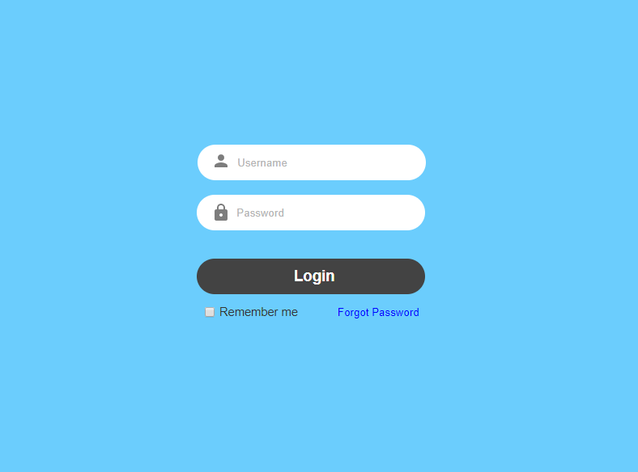
Figure 1: Super Admin-login

Table 2: Super Admin-Dashboard
Description | This is about the super admin Dashboard that has premium plan, basic and standard plans as well.
Pre-condition | Login
Post condition | Create Package for Users of the system.
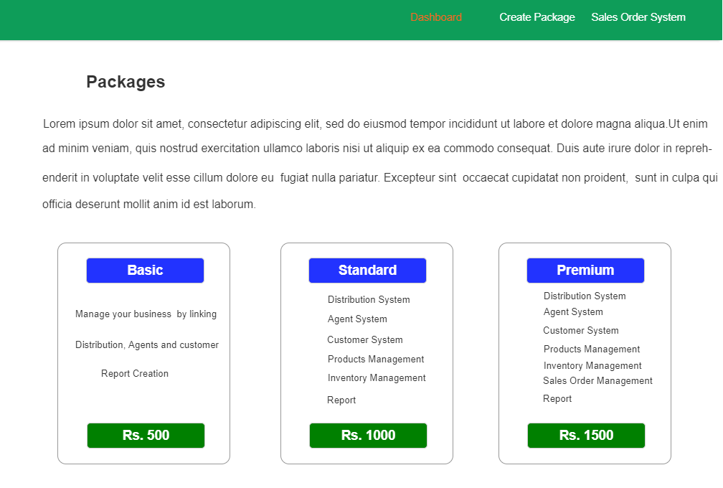
Figure 2: Super Admin-Dashboard

Table 3: Super Admin Create Plan
Description | The Creation of plan.
Pre-condition | Dashboard
Post condition | Sales Order Management.

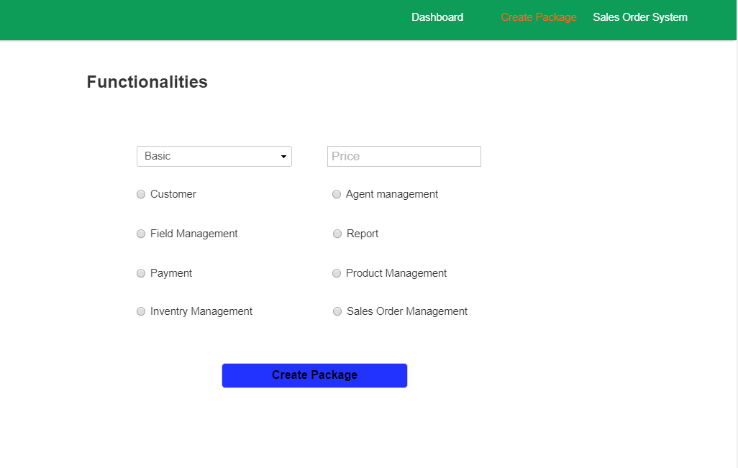
Figure 3: Super Admin –Create Plan

Table 4: User Site
Description | This is the user view at some other domain or sub domain which tells him about our resources and plans
Pre-condition | Create Plan
Post condition | User Registration.
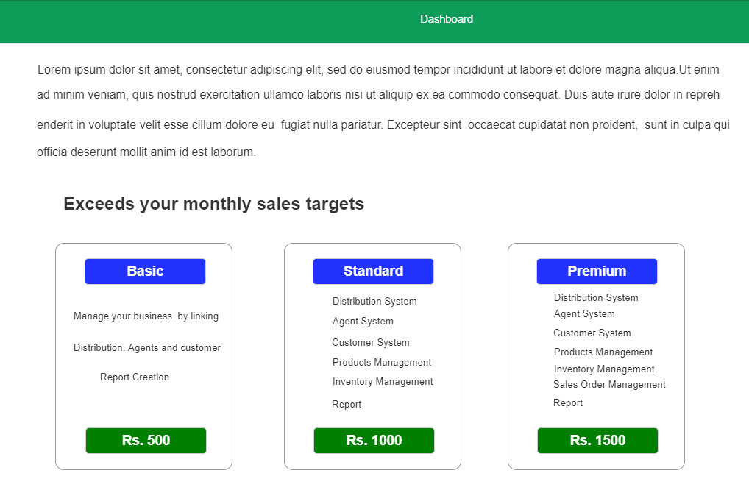
Figure 4: User Site

Table 5: User site Registration
Description | User(Distributor) can register. By fulfilling the credential System asks him about yourself
Pre-condition | Visit User Site
Post condition | User site--Info
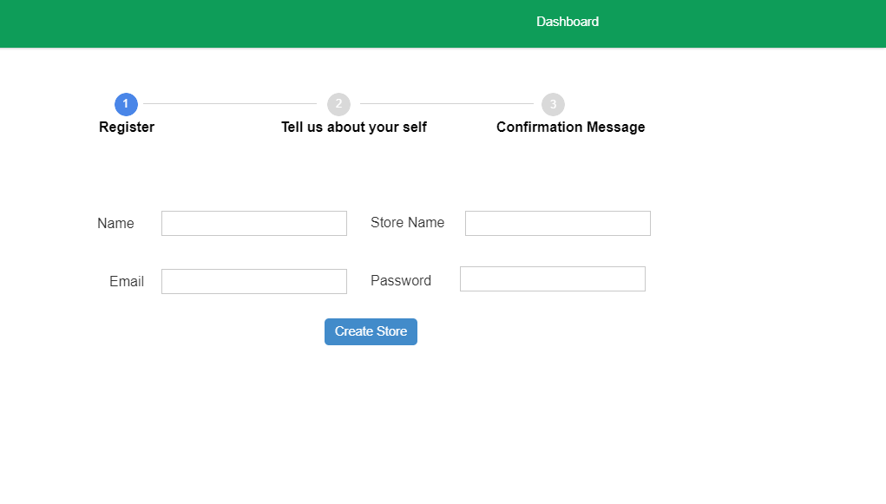
Figure 5: User Site—Registration

Table 6: User site Info
Description | For this you have to tell about yourself.
Pre-condition | Registration
Post condition | User site—confirm message screen.
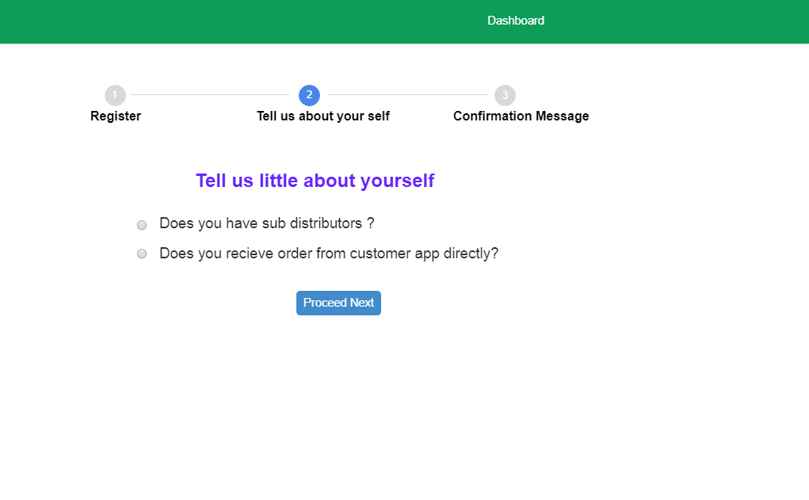

Figure 6: User site – Info

Table 7: User site Confirmation
Description | This will let you know about your legality
Pre-condition | Personal Info
Post condition | User site—Customization screen

Figure 7: Confirmation Message Screen

Table 8: User site Theme Customization
Description | From it user has access to the basic credentials of customizing theme or profiles.
Pre-condition | Confirmation message screen
Post condition | Payment Methods screen.

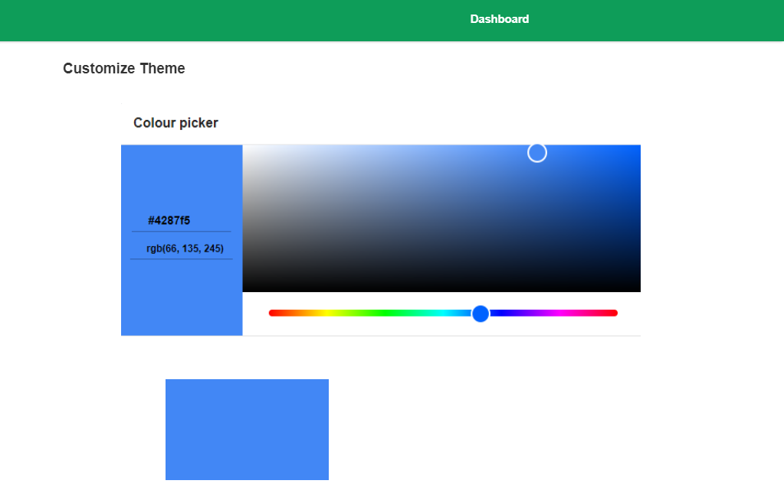

Figure 8: Customize Theme

Table 9: User site Payment Jazzcash
Description | User can pay through the jazz cash within the Pakistan.
Pre-condition | Customize Theme Screen
Post condition | Easy Paisa Screen.

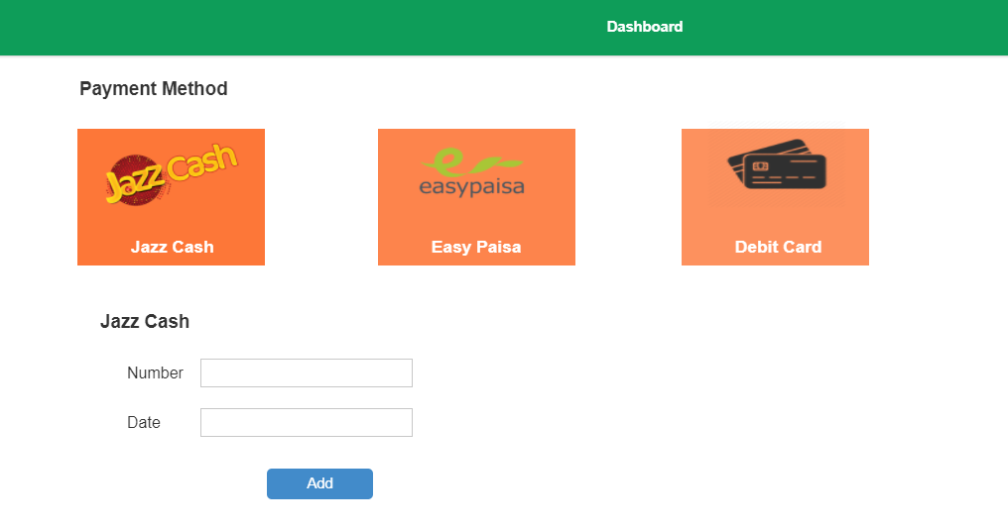

Figure 9: User Site-Payment-JazzCash

Table 10: User site Payment Easy Paisa
Description | User can pay through the easy paisa within the Pakistan.
Pre-condition | Jazz cash screen
Post condition | Debit Card Screen

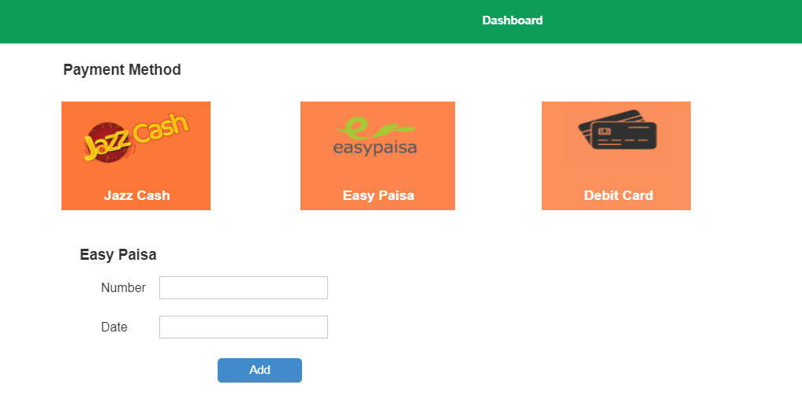

Figure 10: User Site-Payment-Easy Paisa
Table 11: User site Payment Debit Card
Description | User can pay through the Debit Card within the Pakistan.
Pre-condition | Easy Paisa
Post condition | Distributor’s Dashboard

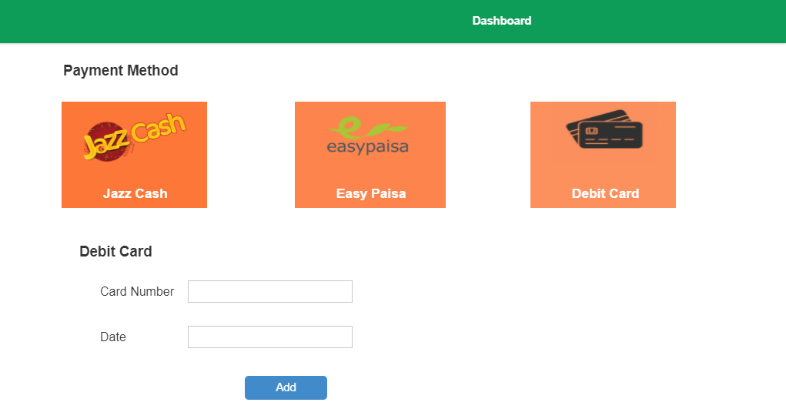 Figure 11: User site Payment Debit Card

Table 12: Distributor’s Dashboard
Description | This is to be the distributor’s dashboard
Pre-condition | Debit Card Screen
Post condition | Field Management-Sales PJP

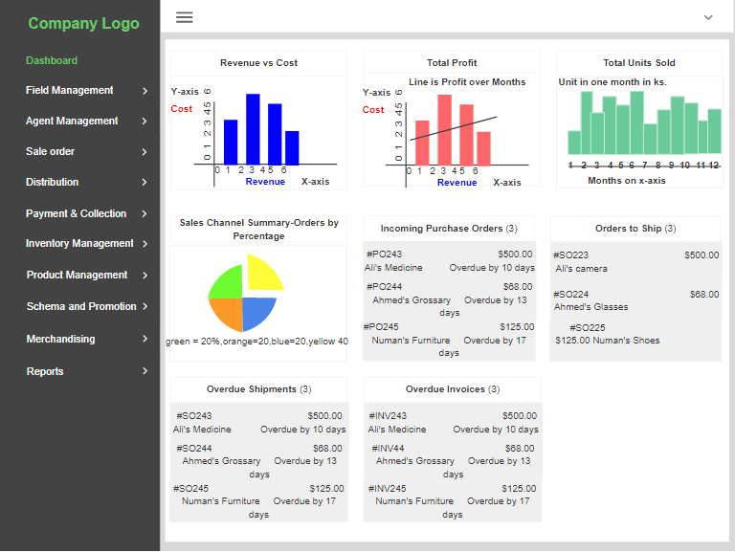

Figure 12 – Distributor’s Dashboard

Table 13: Field Management(CreateSalesPJP)
Description | Field Management’s module Create Sales PJP
Pre-condition | Distributor’s Dashboard
Post condition | Delivery PJP

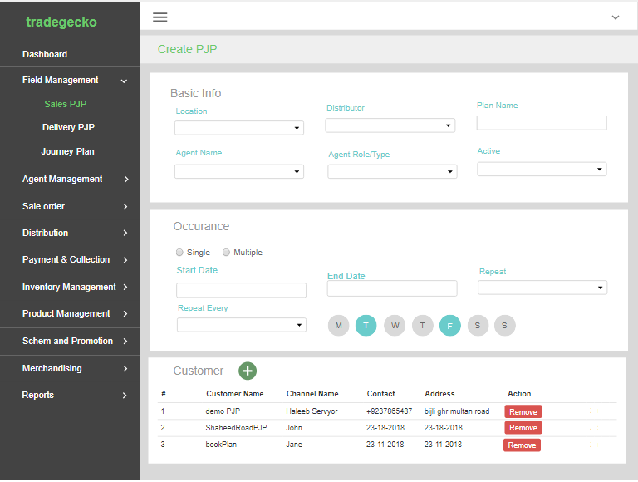

Figure 13: Field Management—Create Sales PJP

Table 14: Field Management(deliveryPJP)
Description | Field Management’s module Delivery PJP
Pre-condition | Create PJP
Post condition | Show Sales Screen

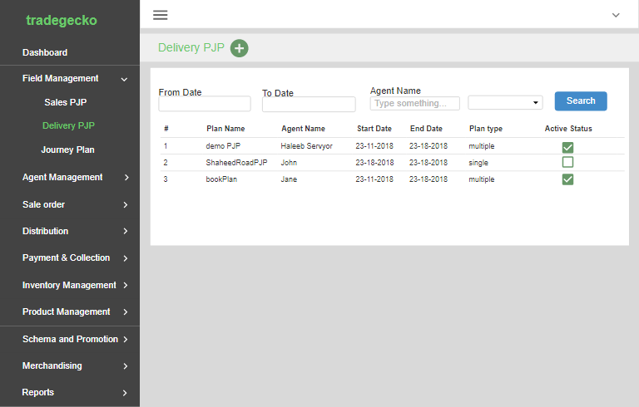

Figure 14: Field Management—Delivery PJP

Table 15: Field Management(showSalesPJP)
Description | Field Management’s module Show Sales PJP
Pre-condition | Delivery PJP
Post condition | Inventory Management Create Store Stock

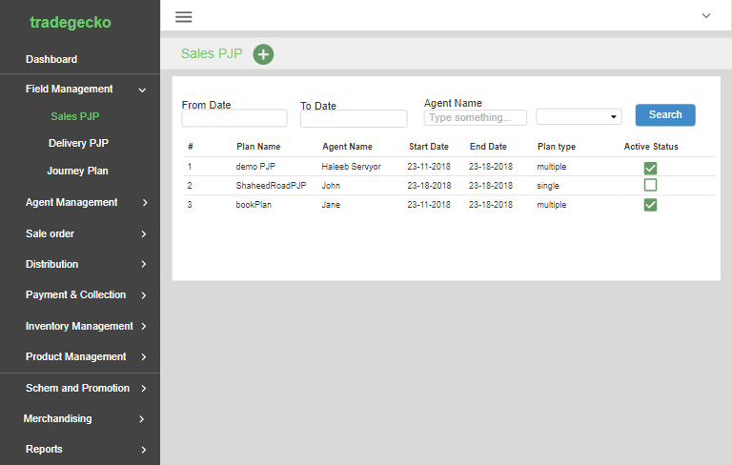

Figure 15: Field Management—Show Sales PJP

Table 16: Inventorymanagemen(CreateStockRegister)
Description | Inventory Management’s module Create Stock register
Pre-condition | Show Sales PJP
Post condition | Inventory Management (customer)

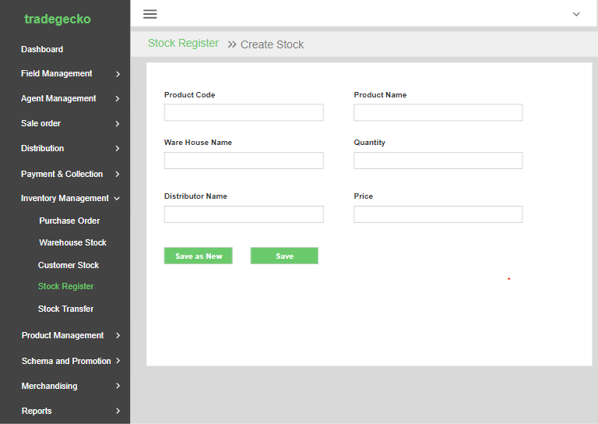

Figure 16: Inventory Management—Create Store Stock
Table 17: Inventorymanagemen(Customer)
Description | Inventory Management’s module Create Stock register
Pre-condition | Create Store Stock
Post condition | inventory management(PO)

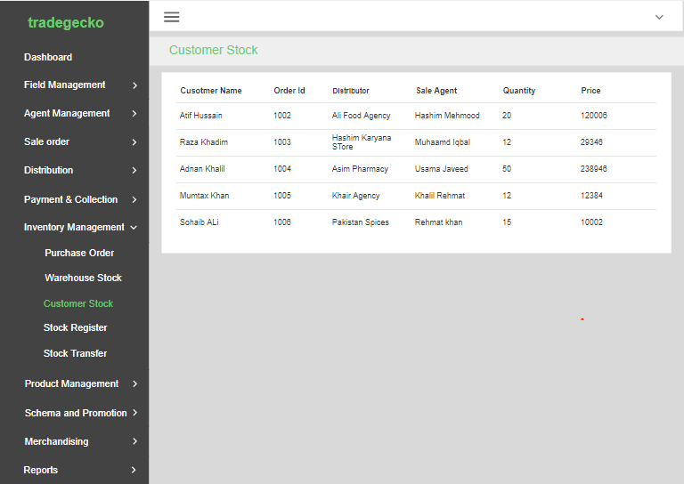

Figure 16: Inventory Management—Customer

Table 17: Inventory management(PO)
Description | Inventory Management’s module PO
Pre-condition | Inventory Management—Customer
Post condition | inventory management(Stock Register)
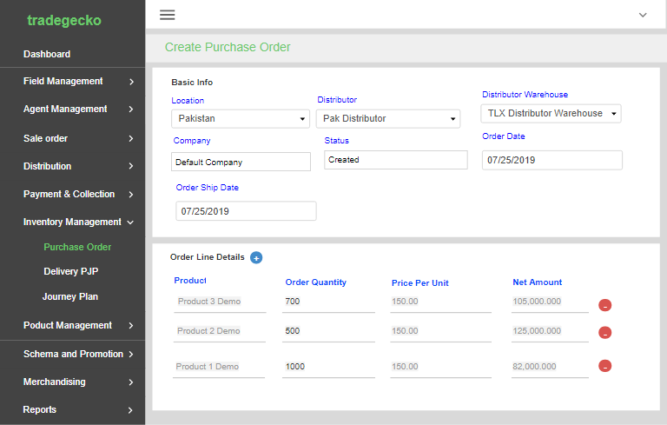

Figure 17: Inventory Management—(PO)

Table 18: Inventory management (Stock Register)
Description | Inventory Management’s module Stock register
Pre-condition | Inventory Management—PO
Post condition | inventory management warehouse

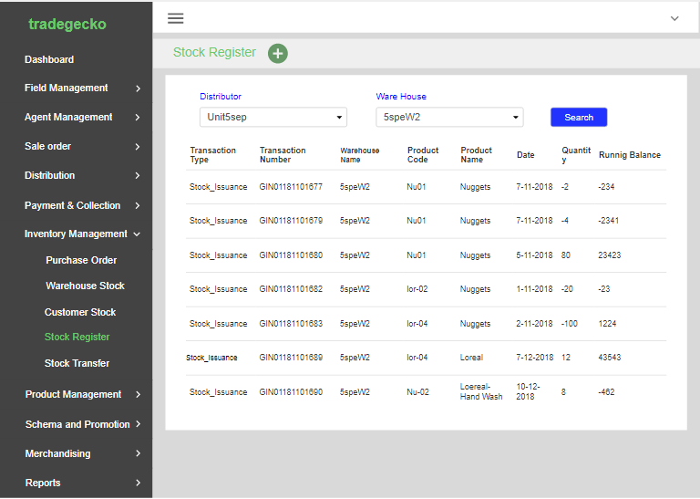

Figure 18: Inventory Management— (Stock Register)

Table 19: Inventory management (warehouse)
Description | Inventory Management’s module Ware House
Pre-condition | Inventory Management—Stock Register
Post condition | inventory management warehouse

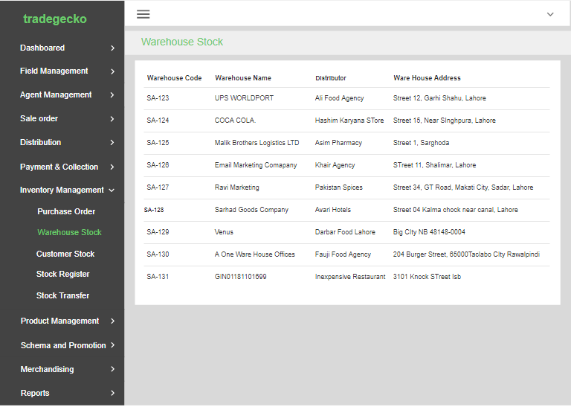

Figure 19: Inventory Management— (Ware House)

Table 20: Payment Collection(PaymentRecieved)
Description | Payment received module of payment collection part.
Pre-condition | Inventory Management—ware house
Post condition | payment Collection(returnOrderPayment)

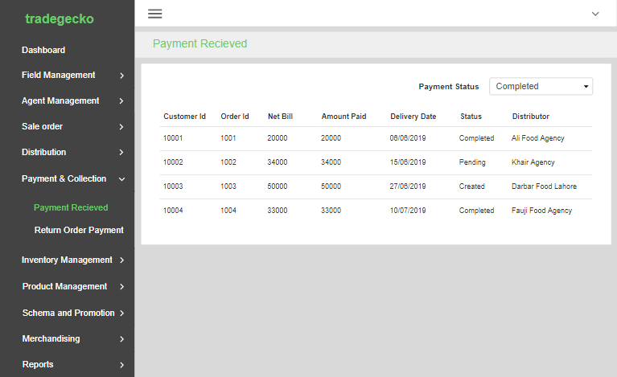

Figure 20: Payment and Collection— (Payment Received)

Table 21: Payment Collection(returnOrderPayment)
Description | Payment order management module of payment collection part.
Pre-condition | Payment Collection(PaymentRecieved)
Post condition | Product Management(Add Product)

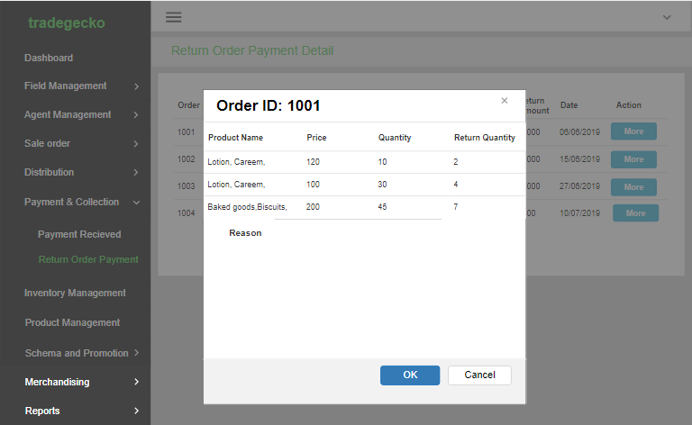

Figure 21: Payment and Collection— (Payment Order Management)

Table 22: Payment Collection (Add Product)
Description | Add Product module of payment collection part.
Pre-condition | Payment Collection(Product Order Management)
Post condition | productManagement(viewProduct)
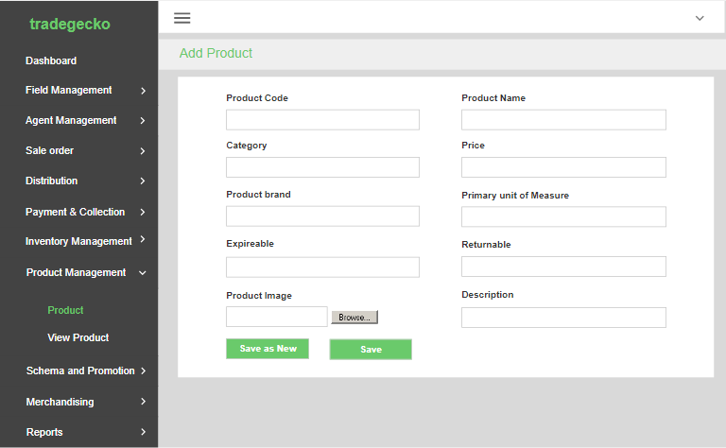

Figure 22: Payment and Collection— (Product Add)

Table 23: Payment Collection (View Product)
Description | View Product module of payment collection part.
Pre-condition | Payment Collection(Product Order Management)
Post condition | AgentManagent(Field Agent)

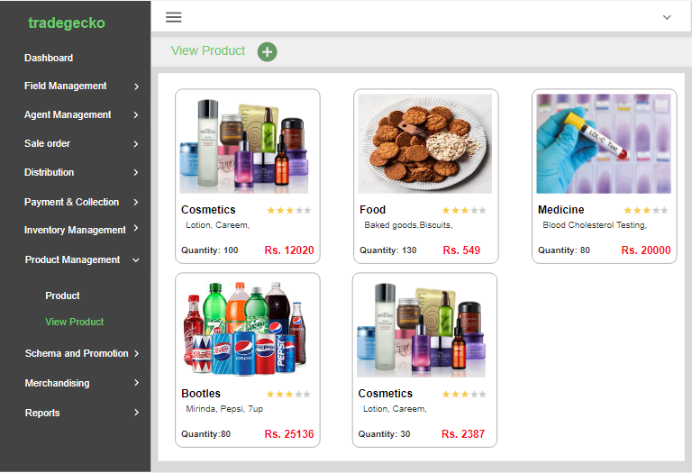

Figure 23: Payment and Collection— (Product View)

Table 24: AgentManagent (Field Agent)

Description | Field Agent is module of Agent Management
Pre-condition | Payment Collection(Product View)
Post condition | agentManagent(sales Target)

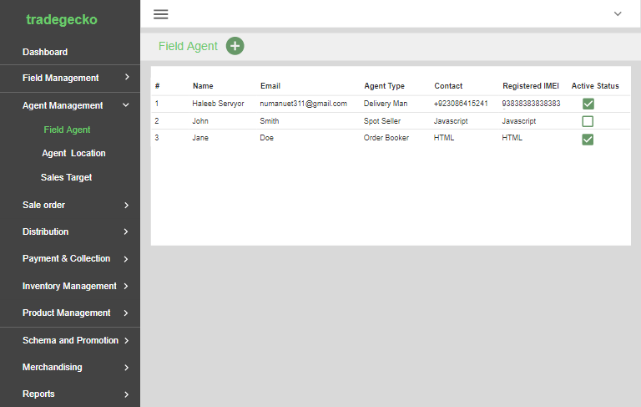

Figure 24: Agent Management (filed Agent)

Table 25: Agent Management (sales Target)

Description | Sales target is of Agent Management
Pre-condition | AgentManagent (Field Agent)
Post condition | agentManagent(Agent Location)

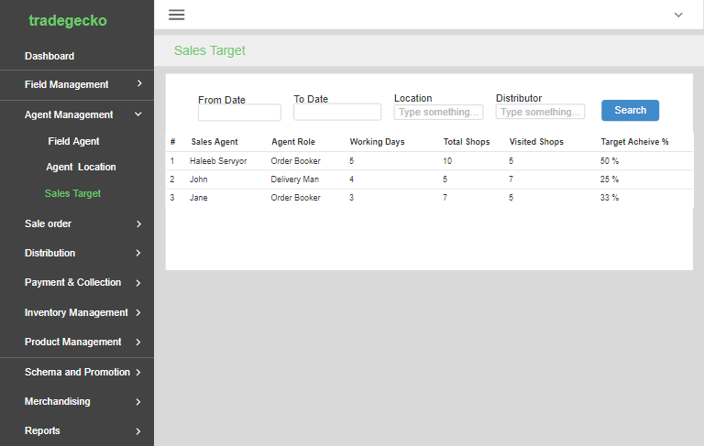

Figure 25: Agent Management (sales Target)

Table 26: Agent Management (Agent Location)

Description | Agent Location is of Agent Management
Pre-condition | Agent Management (sales Target)
Post condition | create Distributor

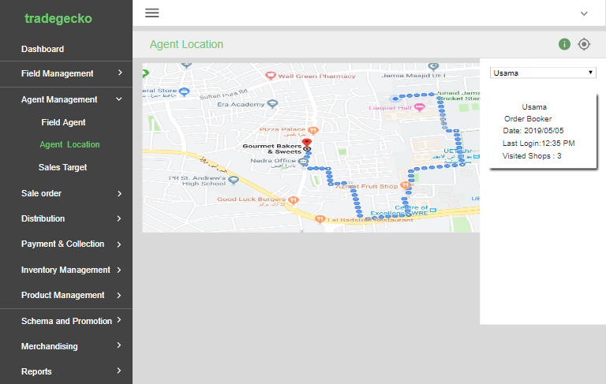

Figure 26: Agent Management (Agent Location)

Table 27: Create Distributor

Description | Create distributor is of Distribution
Pre-condition | Agent Management (Agent Location)
Post condition | Scheme And Promotion

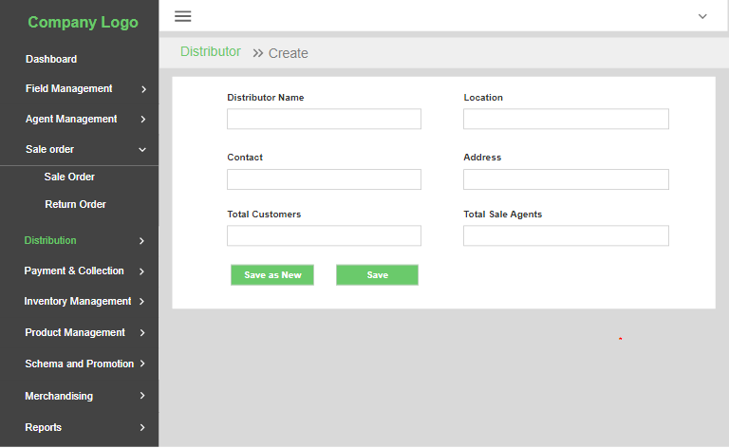

Figure 27: Create Distributor

Table 28: Scheme and Promotion

Description | Scheme and promotion is module of scheme and promotion
Pre-condition | Create Distributor
Post condition | Sales and Order Management(Create Sales Order)

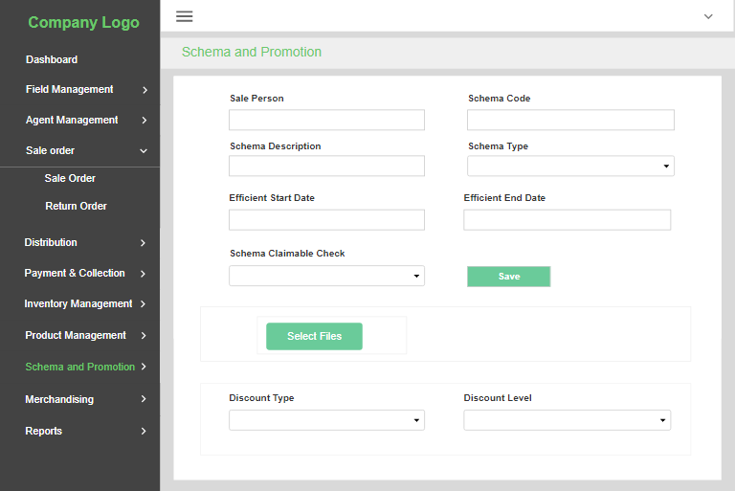

Figure 28: Scheme and Promotion

Table 29: Sales and Order Management(Create Sales Order)

Description | Create Sales Order is module of Sales Order management System
Pre-condition | Scheme and Promotion
Post condition | SalesOrderManage( ViewSaleOrder)

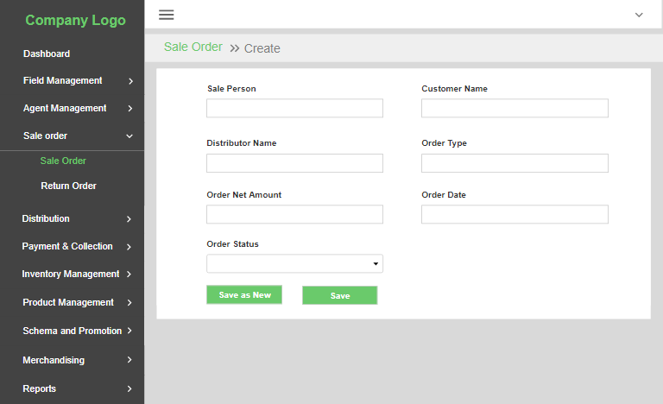

Figure 29: Sales and Order Management (Create Sales Order)

Table 30: Sales and Order Management (View Sales Order)

Description | View Sales Order is module of Sales Order management System
Pre-condition | Create Sales Order Management
Post condition | SalesOrderManagement( return Order)

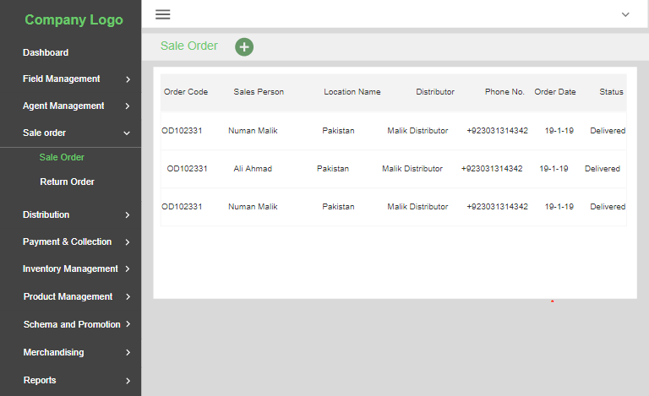

Figure 30: Sales and Order Management (View Sales Order)

Table 31: Sales and Order Management (Return Sales Order)

Description | Return Sales Order is module of Sales Order management System
Pre-condition | SalesOrderManagement( return Order)
Post condition | journey Plan
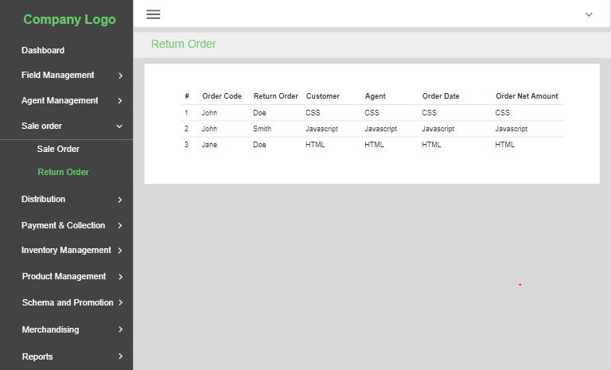

Figure 31: Sales and Order Management (Return Sales Order)

Table 32: Journey Plan

Description | Journey Plan is module of Sales Order management System
Pre-condition | Sales and Order Management (Return Sales Order)
Post condition | Map

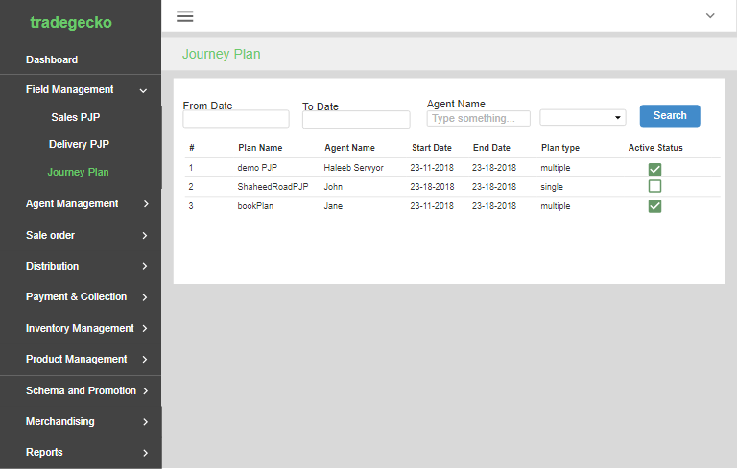

Figure 32: Journey Plan

Table 33: Map

Description | Map is used for tracking agent’s location
Pre-condition | Journey Plan
Post condition | Order Delivery Report
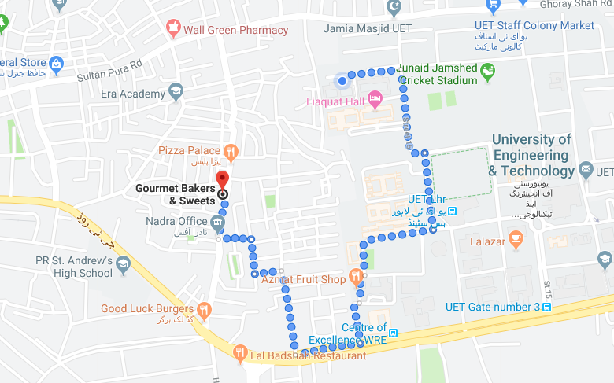
Figure 33: Map

Table 34: Order Delivery Report

Description | Order Delivery Report for the project.
Pre-condition | Map
Post condition | Return Order Report

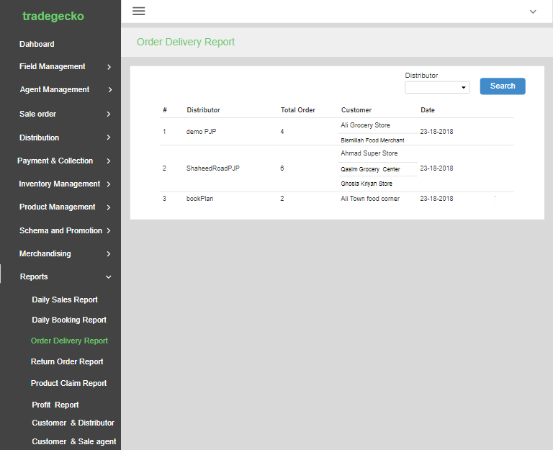

Figure 34: Orders Delivery Report

Table 35: Return Orders Report

Description | Order Return Report for the project.
Pre-condition | Orders Delivery Report
Post condition | Booking Report

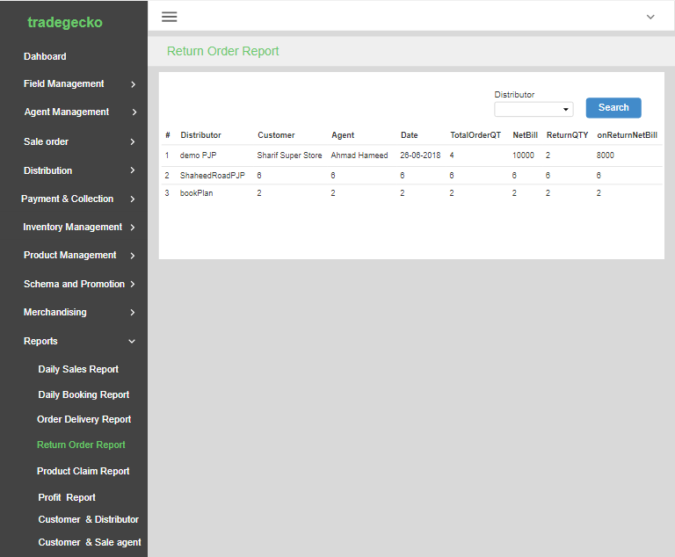

Figure 35: Return Orders Report

Table 36: Booking Report

Description | Order Return Report for the project.
Pre-condition | Return Orders Report
Post condition | Daily Report
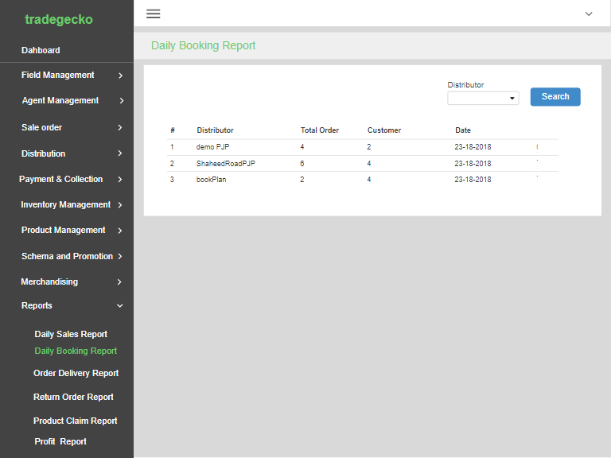

Figure 36: Booking Order

Table 37: Daily Sales Report

Description | Order Return Report for the project.
Pre-condition | Booking Order
Post condition | Agent Distributor Report

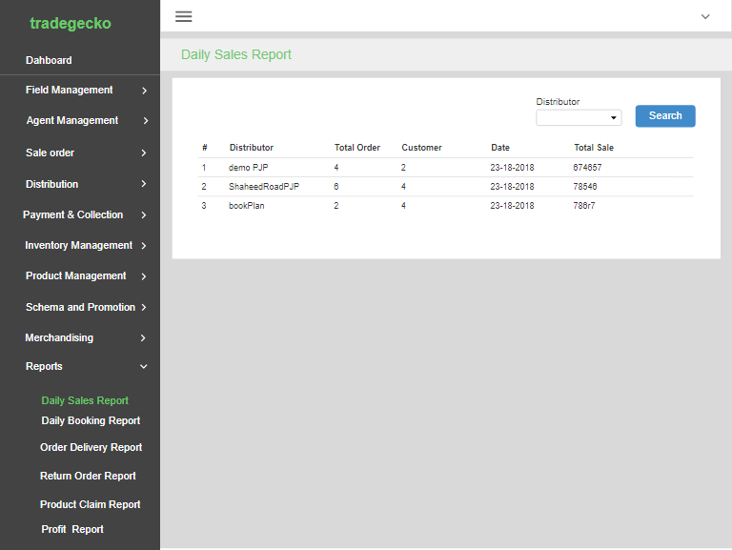

Table 37: Daily Sales Report

Table 38: Agent Distributor Report

Description | Order Return Report for the project.
Pre-condition | Booking Order
Post condition | Further Reports May be.
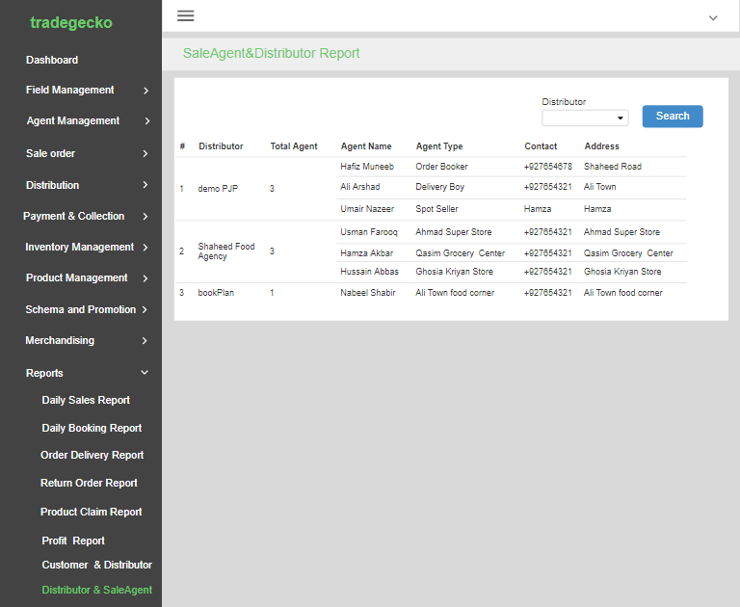

Figure 38: Agent Distributor Report

Table 47: Customer_Login
Description | Customer will be login from this page.
Pre-condition | Customer must have been verified or registered his device by relevant distributor.
Post condition | On Clicking login button dashoard will be open.
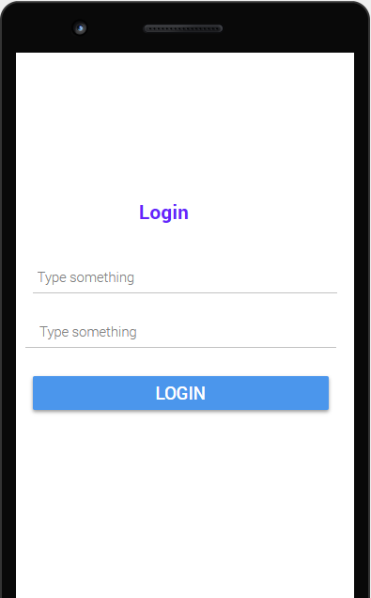
Figure 47: Customer_Login

Table 48: Customer dashboard

Description | Dashboard show multiple option i.e. view product, place order and outstanding balance
Pre-condition | Customer must be login to app to show dashboard.
Post condition | On clicking card customer will be able to show relevant screen.i.e on clicking track agent he can track agent by google map or contact.
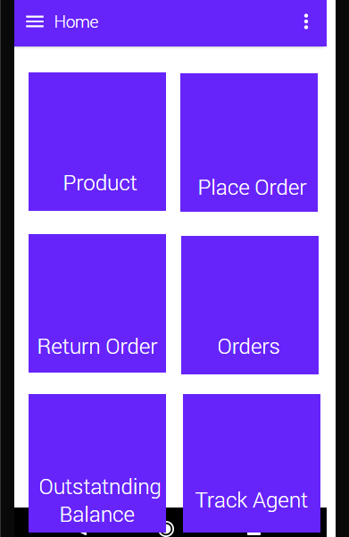
Figure 48: Customer Dashboard

Table 49: Customer_ViewProduct

Description | This page show product with detail i.e. price, brand
Pre-condition | Customer must be click on view product in dashboard.
Post condition | None.
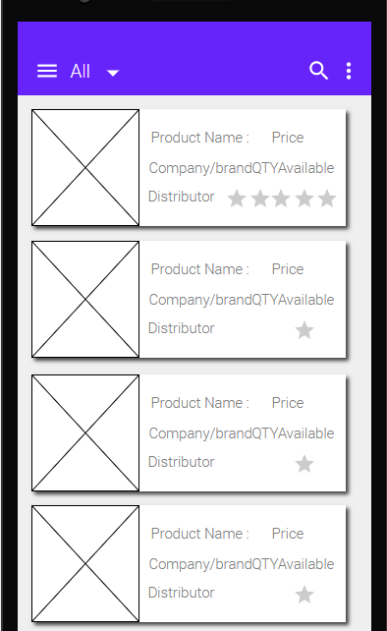
Figure 49:Customer_ViewProduct

Table 50:Customer_placeOrder

Description | This page show items which can be select with their quantity to add into cart
Pre-condition | Customer must be click on place Order in dashboard.
Post condition | By clicking on cart customer can preview his order if he select any product for sale
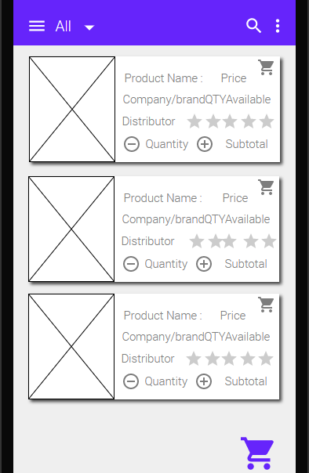
Figure 50:Customer_placeOrder

Table 51:Customer_shoppingCart

Description | This page show the product in cart selected by customer for purchase
Pre-condition | Customer must be select a product with its quantity .
Post condition | By clicking on confirm order he can confirm order and can cancel by clicking on cancel order button
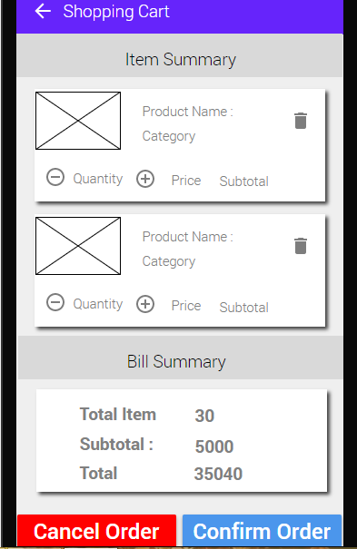
Figure 51:Customer_shoppingCart

Table 52:Customer_ConfirmOrder

Description | This screen show notification of success of place order.
Pre-condition | Customer must be confirm order on placing order .
Post condition | By clicking on payment now he can pay order amount on the spot and on clicking skip he can pay later.
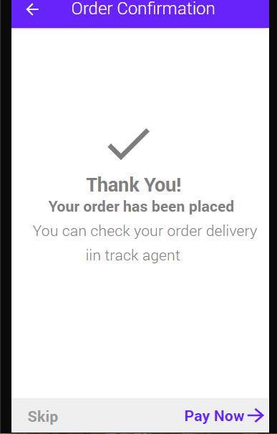
Figure 52:Customer_ConfirmOrder

Table 53:Customer_PaymentNow

Description | This screen show option of payment of order by different method i.e jazzcash, easypaise.
Pre-condition | Customer must be click on payment now in confirmOrder screen .
Post condition | By clicking on any method like jazzcash he will be able to pay amount by his jazzcash account.
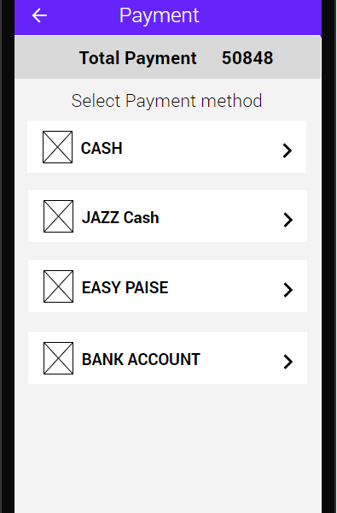
Figure 53:Customer_ Payment Now

Table 54:Customer_PaymentLater

Description | This screen show the payment later on clicking skip and he can pay later
Pre-condition | Customer must be confirm place Order and choose amount to paid later .
Post condition | By clicking skip his order amount will be added to his outstanding balance.
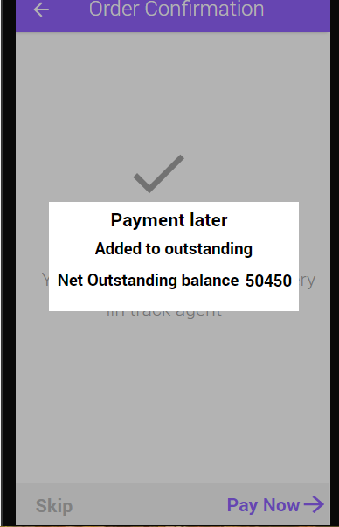
Figure 54: Customer_ Payment Later

Table 55: Customer Payment(JAZZCASH)

Description | This screen shows the payment method by jazz cash account of customer.
Pre-condition | Customer must be select JAZZ CASH method
Post condition | Customer must have his jazz cash account
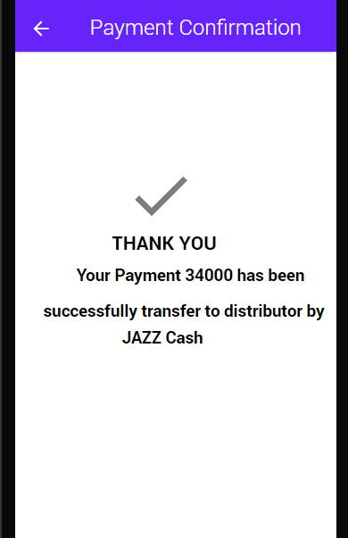

Figure 55: Customer_ Payment(JAZZCASH)

Table 56:Customer_Payment(EASYPAISE)

Description | This screen show the payment method by easy Paisa account of customer.
Pre-condition | Customer must be select EASYPAISE method
Post condition | Customer must have his easy paisa account
Figure 56:Customer_ Payment(EASYPAISE)

Table 57:Customer_Payment(DEBITCARD)

Description | This screen show the payment method by DEBITCARD of customer.
Pre-condition | Customer must be select DEBITCARD method and have DEBIT CARD.
Post condition | Customer must enter his debit card detail ie. PIN
Figure 57:Customer_ Payment(DEBITCARD)

Table 58:Customer_OutstandingBalance

Description | This screen show the outstanding balance which is total payment to be paid by customer.
Pre-condition | Customer must be select option payment later on confirm order for outstanding balance.
Post condition | On clicking right arrow button on appbar screen open for payment of outstanding balance
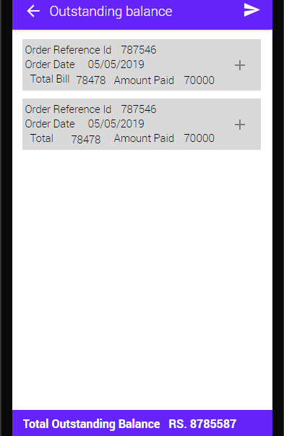
Figure 58: Customer Outstanding Balance

Table 59: Customer View All Order

Description | This screen show the all order record he has order with their detail.
Pre-condition | Customer must be place at least one order and select option View Order in dashboard screen.
Post condition | On clicking any order he can view detail of his order
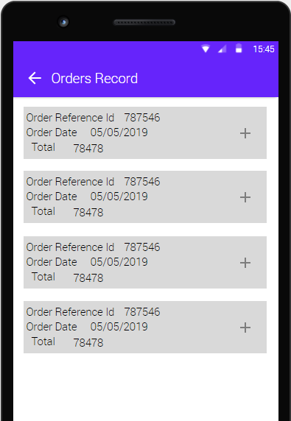
Figure 59: Customer View All Order

Table 60: Customer Return Order

Description | This screen shows the all order which Is place recently and show option to select product which is to be return with their amount.
Pre-condition | Customer must place at least one order.
Post condition | On confirming return order after product inputs which is to be return, OrderNetBill update depending upon product return.
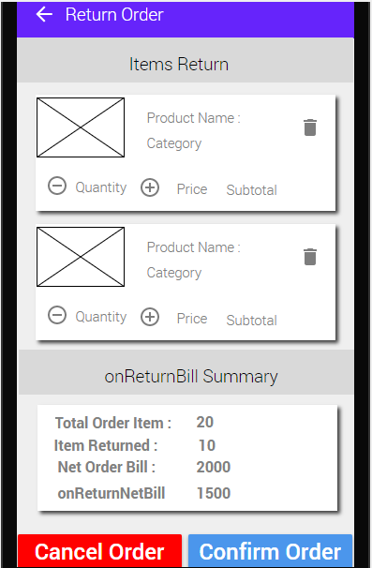
Figure 60: Customer Return Order

Table 61: Sales agent Login
Description | The sales agent login to the system providing some credential.
Pre-condition | Sales agent should open the system and Should have internet access.
Post condition | After logging to the system, sale agent should be able to see the dashboard with all functionalities.

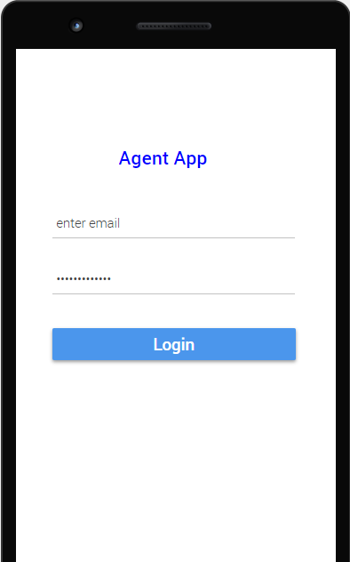
Figure 61: Sales agent Login

Table 62: SaleAgent-Dashboard

Description | On the dashboard, Sale agent can start his day can end day. He can view order which are assigned by distributor. Here he can plan call and see all status.
Pre-condition | Sales agent should login to the system.
Post condition | Sales agent can deliver order to the customer.

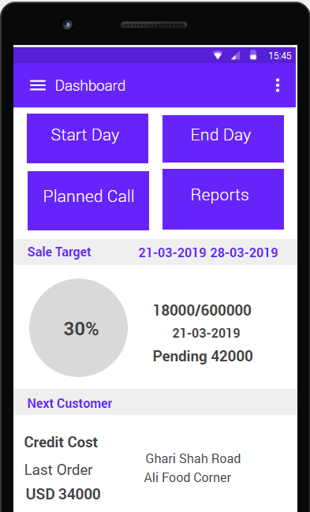
Figure 62: SaleAgent-Dashboard

Table 63: SaleAgent -View Order

Description | The sales agent can view all order that are assigned by distributor. He can see its details.
Pre-condition | He should have order in their stock.
Post condition | The sales agent can deliver the order to the customer.

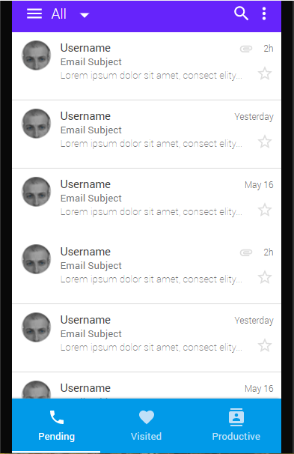
Figure 63: SaleAgent –View Order

Table 64: SaleAgent -Order Delivery

Description | The Sale agent can deliver his order by seeing location of customer deliver them.
Pre-condition | He should have order to deliver.
Post condition | He can see customer contact and details about shop.

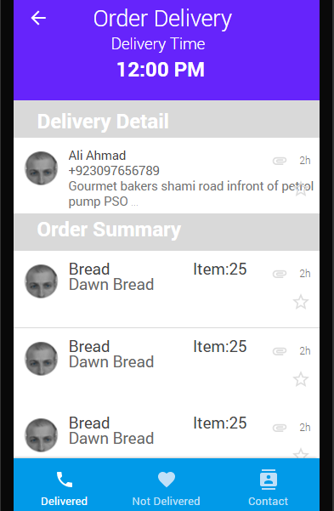
Figure 64: SaleAgent –Order Delivery

Table 65: SaleAgent -Customer Contact

Description | By selecting order, Sale agent can view customer contact and his location .
Pre-condition | Sale agent should have order in their queue.
Post condition | He can check his order status.

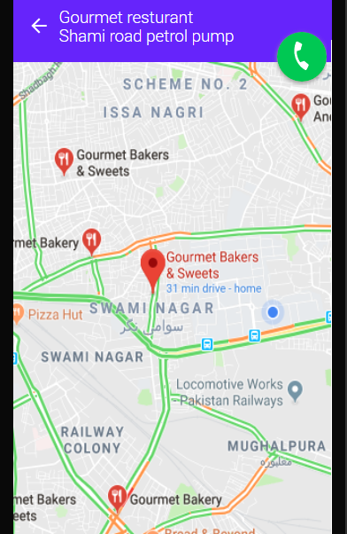
Figure 65: SaleAgent –Customer Contact

Table 66: SaleAgent -Delivered Failure

Description | Sale agent can check order status either it is completed or failure. Failure due to some reason.
Pre-condition | He should have order delivered but canceled due to some reason.
Post condition | He can see his status.

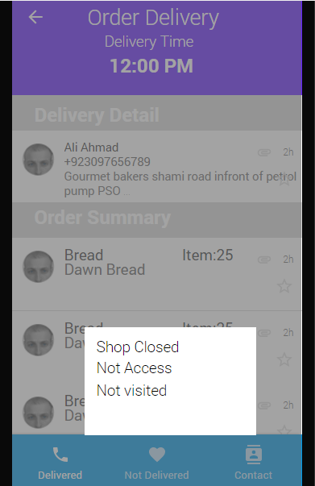
Figure 66: SaleAgent –Delivered Failure

Table 67: SaleAgent -UpdateDeliveryStatus

Description | Sale agent can update delivery status by deliver the failure product successfully.
Pre-condition | Sale agent should have failure order which are not completed due to some reason.
Post condition | Sale agent can move to the dashboard.

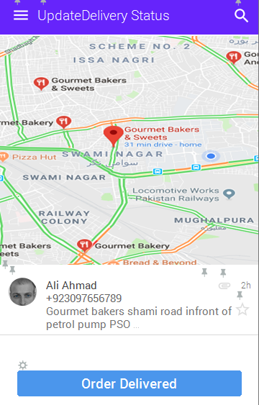
Figure 67: SaleAgent -UpdateDeliveryStatus

