# Abstract

Epileptic seizures are sudden bursts of electrical activity in the brain that can cause various symptoms. Accurate prediction of these seizures can significantly improve patient care and quality of life. This project leverages machine learning techniques to predict epileptic seizures using EEG data. The methodology includes preprocessing EEG signals, feature extraction, and applying classification algorithms such as Logistic Regression, Random Forest, Gradient Boosting, and SVM. An ensemble model combining Random Forest and Gradient Boosting was developed for improved accuracy.

The results demonstrated high predictive performance, with the ensemble model achieving an accuracy of ~90%. Challenges such as class imbalance and overfitting were addressed using data augmentation and cross-validation techniques. The final model was deployed using Streamlit to provide real-time predictions based on user input.

### List of Figures

### 

Fig 3.3.1 Use case ……………………........................................................................... 17

Fig 3.1.1 Flow Chart ………………………....................................................................15

Fig 4.3.1 Login Page ....................................................................................................... 22

Fig 4.3.2 Signup Page ..................................................................................................... 23

Fig 4.3.3 Home Page ....................................................................................................... 23

Fig 4.3.4 Student Profile .................................................................................................. 24

Fig 4.3.5 Course Details Student ..................................................................................... 24

Fig 4.3.6 Home Screen Student ....................................................................................... 25

Fig 4.3.7 Teacher Profile ................................................................................................. 25

Fig 4.3.8 Course Detail Student ...................................................................................... 26

Fig 4.3.9 Add New Course .............................................................................................. 26

### List of Collections

Table 3.2.1 Users.............................................................................................. 18

Table 3.2.2 Courses .......................................................................................... 18

Table 3.2.3 Sessions ......................................................................................... 18

Table 3.2.4 Attendance ..................................................................................... 18

Table 3.2.4 Enrollments .................................................................................... 18

### Table of Contents

Acknowledgement................................................................................................................... i

Abstract .................................................................................................................................. ii

List of Figures ...................................................................................................................... iii

List of Tables ........................................................................................................................ iv

List of Abbreviations ............................................................................................................. v Table of Contents .................................................................................................................. vi

**Chapter 1.0 Introduction to Project and Project Management.**...................................... 1

1.1 Introduction ………......................................................................................................... 1

1.2 Purpose ……………........................................................................................................ 2

1.3 Objective …………...........................................................................................………...3

1.4 Scope (what it can do and can’t do) ................................................................................ 3

1.5 Technology and Literature Review…………………………………........................................... 4

1.6 Project Planning…………………................................................................................... 5

1.6.1 Project Development Approach and Justification ............................................ 5

1.6.2 Project effort and time, Cost Estimation .......................................................... 6

**Chapter 2.0 System Analysis**……………………............................................................... 8

2.1 Study of Current System ................................................................................................. 8

2.2 Problem and Weakness of Current System...................................................................... 9

2.3 Requirement of New System ........................................................................................... 9

2.4 System Feasibility .......................................................................................................... 10

2.4.1 Does the system contribute to the overall objectives of the organization? ....... 10

2.4.2 Can the system be implemented using the current technology and within the given cost and schedule constraints?.................................................................................... 10

2.4.3 Can the system be integrated with other systems that are already in

Place? ................................................................................................................................... 11

2.5 Proposed System ............................................................................................................ 11

2.6 Features of New System ................................................................................................ 12

2.7 Selection of Hardware / Software .................................................................................. 13

**Chapter 3.0 System Design** ……..………………............................................................ 14

3.1 System Design & Methodology..................................................................................... 14

3.1.1 Flow Chart ........................................................................................................ 15

3.2 Database Design ............................................................................................................ 16

3.3 Input / Output and Interface Design .............................................................................. 17

3.3.1 Use Case Diagram .......................................................................................... 18

**Chapter 4.0 Impelemtation & Testing**……………………................................................ 18

4.1 Implementation of Platform .......................................................................................... 23

4.2 Modules Specification(s) .............................................................................................. 20

4.3 Results ........................................................................................................................... 22

4.4 Testing Plan / Strategy .................................................................................................. 27

4.5 Test Results and Analysis ............................................................................................. 28

4.5.1 Test Cases (test ID, test condition, expected output, actual output, remark)...28

**Chapter 5.0 Conclusion & Future Enhancements**………...………............................... 29

5.1 Overall Analysis of Project Viabilities ......................................................................... 29

5.2 Problem Encountered and Possible Solutions............................................................... 30

5.3 Summary of Project work ............................................................................................. 31

5.4 Limitations and Future Enhancement ........................................................................... 32

5.5 Project Outcomes .......................................................................................................... 33

Refence....................................................................................................................... 34

|  |  |
| --- | --- |
|  | **List of Abbreviations** |
| EEG  ML  SVM  LSTM  DFD  ER | ELECTROENCEPHALOGRAM  MACHINE LEARING  SUPPORT VECTOR MACHINE  LONG SHORT TERM MEMORY  DATA FLOW DIAGRAM  ENTITY RELATIONSHIP |
|  |  |
|  |  |
|  |  |

# CHAPTER 1

**INTRODUCTION TO PROJECT AND PROJECT MANAGEMENT**

* 1. **Introduction:**

Epileptic seizures are sudden and abnormal bursts of electrical activity in the brain that can lead to temporary disturbances in motor control, sensation, behavior, or consciousness. Predicting these seizures involves analyzing patterns in brain activity, typically captured through Electroencephalogram (EEG) signals, using advanced computational techniques like machine learning.

**Features:**

1. **Real-Time EEG Data Processing**  
   Continuously processes EEG signals to detect abnormal patterns associated with seizures.
2. **Noise Reduction and Signal Filtering**  
   Applies bandpass filters and artifact removal techniques to clean EEG data.
3. **Feature Extraction Module**  
   Extracts statistical, temporal, and frequency-domain features from EEG signals to improve model accuracy.
4. **Machine Learning-Based Prediction**  
   Utilizes trained ML models (e.g., SVM, Random Forest, or deep learning) to predict seizures before they occur.
5. **User-Friendly Interface**  
   Provides a simple and intuitive UI for data input, visualization, and real-time alerts.
6. **Seizure Alert System**  
   Triggers visual and/or audio alerts when a seizure is likely to occur, giving time for preventive action.
7. **Data Visualization**  
   Displays real-time EEG signals and model predictions using graphs and charts.
8. **Historical Data Storage**  
   Stores patient records and predictions for future review and analysis.

**Technologies Used:**

* **Python** – Core programming language for data processing, modeling, and backend logic.
* **NumPy, Pandas** – For data manipulation and analysis.
* **SciPy** – Signal processing and filtering of EEG data.
* **Scikit-learn** – Traditional machine learning models and evaluation metrics.
* **TensorFlow / Keras / PyTorch** – Deep learning frameworks for building and training neural networks (if using DL).
* **MNE-Python** – Specialized EEG data analysis and visualization.
* **Matplotlib, Seaborn** – Data visualization and plotting tools.
* **Streamlit / Flask / Django** – For building a web-based real-time prediction interface.
  1. **Purpose**
* **Early Seizure Detection**  
  Predict seizures before they occur to provide early warnings and reduce risks of injury or complications.
* **Enhance Patient Safety**  
  Enable timely intervention through real-time alerts, helping caregivers and medical professionals act quickly.
* **Improve Quality of Life**  
  Reduce anxiety and uncertainty for epilepsy patients by providing reliable, proactive monitoring.
* **Leverage Machine Learning**  
  Utilize advanced ML algorithms to analyze EEG patterns and improve prediction accuracy over traditional methods.
* **Support Clinical Decision-Making**  
  Assist healthcare providers with additional data insights for diagnosis, treatment planning, and long-term care.

**1.3 Objectives**

* **Develop a Reliable Seizure Prediction Model**  
  Build and train machine learning models capable of accurately predicting epileptic seizures from EEG data.
* **Implement Real-Time Monitoring System**  
  Create an interface that processes EEG data in real time and provides instant seizure alerts.
* **Ensure Data Preprocessing and Feature Extraction**  
  Design a robust pipeline for cleaning EEG signals and extracting meaningful features for improved prediction performance.
* **Improve Prediction Accuracy and Reduce False Alarms**  
  Optimize model performance to minimize false positives and ensure trustworthy results.
* **Design an Intuitive User Interface**  
  Build a user-friendly platform for patients and medical professionals to interact with the system effectively.
* **Support Clinical Integration**  
  Ensure the system is adaptable for use in clinical environments to assist with patient care and research.
  1. **Scope (what it can do and can’t do)\**

**What It Can Do:**

* Predict epileptic seizures using pre-recorded or real-time EEG data.
* Process and clean EEG signals through filtering and noise reduction techniques.
* Extract relevant features from EEG signals for machine learning analysis.
* Provide real-time alerts for potential seizures to help with early intervention.
* Visualize EEG data and prediction results through a user-friendly interface.
* Store historical data for future analysis and review.

**What it can't do:**

* Diagnose epilepsy or replace medical professionals' assessments.
* Work effectively without properly formatted or sufficient EEG data.
* Guarantee 100% prediction accuracy due to biological variability and model limitations.
* Operate independently on low-resource or embedded systems without customization.
* Interpret other neurological conditions beyond epileptic seizure prediction.

**1.5 Technology and Literature Review**

**Technology Review:**

* **Python Programming Language**  
  Widely used for scientific computing, machine learning, and signal processing due to its robust ecosystem and libraries.
* **Libraries and Frameworks**
  1. *NumPy, Pandas*: Data handling and preprocessing.
  2. *SciPy, MNE-Python*: Signal filtering, feature extraction, and EEG data handling.
  3. *Scikit-learn, TensorFlow/Keras*: Building and training machine learning models.
  4. *Matplotlib, Seaborn*: Data visualization for EEG signals and results.
  5. *Streamlit/Flask*: Real-time web-based user interface for interaction and alerts.

**Literature Review:**

* **EEG-Based Seizure Detection**Research has shown that EEG signals contain distinguishable patterns before seizures. Time-domain, frequency-domain, and entropy-based features are commonly used for prediction.
* **Machine Learning in Healthcare**Several studies demonstrate the effectiveness of ML models such as SVM, Random Forest, and CNNs in medical diagnostics, especially in detecting patterns in complex biomedical signals.
* **Wavelet Transform and Feature Engineering**Wavelet-based techniques are often employed to analyze non-stationary EEG signals for extracting high-informative features useful for seizure prediction.
* **Real-Time Prediction Challenges**Literature highlights challenges like false positives, latency, and patient variability, which your project aims to address using robust preprocessing and model tuning.

Table 1.5.1: Literature Review

|  |  |  |  |  |
| --- | --- | --- | --- | --- |
| **Author(s)** | **Sample** | **Title** | **Source** | **Findings** |
| Shoeb & Guttag (2010) | EEG data from 23 epilepsy patients | Application of machine learning to epileptic seizure detection | IEEE Transactions on BME | SVM achieved over 96% accuracy; emphasized the importance of patient-specific models. |
| Acharya et al. (2018) | Bonn University EEG dataset | Automated EEG-based diagnosis of epilepsy using deep learning techniques | Computers in Biology and Medicine | CNN outperformed traditional ML in seizure classification with high sensitivity. |
| Truong et al. (2018) | Temple University EEG Corpus | Convolutional neural networks for seizure prediction | IEEE Access | CNN with time-frequency representation showed promising accuracy and scalability. |
| Faust et al. (2015) | Public EEG datasets | Wavelet-based EEG analysis for epileptic seizure detection | Biomedical Signal Processing | Wavelet features significantly improved seizure detection using SVM and KNN models. |
| Rajaguru et al. (2021) | EEG from 15 patients, hospital dataset | Hybrid ML model for real-time epileptic seizure prediction | Expert Systems with Applications | Hybrid LSTM + Random Forest achieved 94% accuracy with reduced false alarms. |

**1.6 Project planning**

**1.6.1 Project Development Approach and Justification**

Project Development Approach: Agile and Iterative Development

**Justification:**

* The iterative model allows flexibility to make improvements based on intermediate results and testing feedback.
* Agile methodology suits the experimental nature of machine learning projects where model tuning and adjustments are frequent.
* It supports modular development, making it easier to test and integrate each part (preprocessing, model, UI) independently.
* Enables better collaboration and version control, especially useful in a team-based academic or research setting.

**1.6.2 Project effort and Time, Cost Estimation**

**Project Effort and Time Estimation:**

* **Project Time Estimation:** The project is expected to take approximately **9–10 weeks**, covering phases such as data preprocessing, model development, interface design, and testing.
* **Project Effort Estimation:** The total team effort is estimated at **200–250 hours**, with 2 members working collaboratively across different phases of the project.

**Cost Estimation:**

* Software & Tools: Most tools used (Python, libraries like Scikit-learn, TensorFlow, etc.) are open-source and free, minimizing software costs.
* Additional Expenses: Estimated cost is ~$80–150 USD, covering optional cloud computing (e.g., Google Colab Pro), internet/utilities, and miscellaneous expenses like printing or documentation.

# CHAPTER 2

**SYSTEM ANALYSIS**

**2.1 Study of Current System**

* **Manual EEG Interpretation**  
  Neurologists analyze EEG recordings visually, which is time-consuming, subjective, and may miss subtle pre-seizure patterns.
* **Post-Seizure Detection Systems**  
  Most existing tools focus on detecting seizures after they occur, offering little to no opportunity for preventive action.
* **Lack of Real-Time Prediction**  
  Many hospital systems are not equipped with real-time prediction capabilities, limiting proactive responses.
* **Inaccessible Technology**  
  Advanced seizure detection tools are often expensive and not available in low-resource settings.

**Limitations of the Current System:**

* No early warning system for patients.
* Heavy dependency on human interpretation.
* Inconsistent accuracy across different individuals.
* Limited automation and integration with mobile or wearable devices.

**2.2 Requirement of New System**

The traditional systems used for seizure detection primarily focus on identifying seizures after they have occurred, offering little to no capability for early prediction. These systems rely heavily on manual EEG analysis by neurologists, which is time-consuming, subjective, and prone to human error. In contrast, the new system aims to provide real-time prediction of epileptic seizures using machine learning models that can detect subtle changes in EEG signals before a seizure begins. This enables early warnings and timely intervention, improving patient safety.

Moreover, while existing systems are often costly and limited to hospital environments, the new system is designed to be cost-effective, accessible, and portable. It utilizes open-source tools and can be deployed on low-cost platforms, making it suitable for a broader population. The new system also features an automated, user-friendly interface that allows patients and caregivers to monitor seizure risk without needing extensive medical knowledge. In addition, it supports continuous real-time monitoring and alert notifications, offering a level of responsiveness and adaptability that the old system lacks. Overall, the new system provides a smarter, faster, and more efficient approach to managing epilepsy.

**2.4 System Feasibility**

**2.4.1 Does the System Contribute to the Overall objectives of the**

**organization?**

Yes, the system significantly contributes to the overall objectives by enhancing the ability to monitor and predict epileptic seizures in real-time, thereby improving patient care and safety. It aligns with the organization’s goals of leveraging technology to deliver proactive and affordable healthcare solutions. By using machine learning for early detection, the system reduces dependence on manual diagnosis, minimizes response time during critical situations, and promotes accessible healthcare—especially in remote or under-resourced areas. Additionally, it supports research and innovation in biomedical signal analysis, aligning with the organization's mission of advancing medical technology through data-driven approaches.

**2.4.2 Can the System be implemented using the current technology**

**and within the given cost and schedule constraints**

Yes, the system can be effectively implemented using current technologies and within the given cost and time constraints. The project relies on widely available and mature technologies such as Python, Scikit-learn, TensorFlow/Keras, and signal processing libraries—all of which are open-source and free to use. These tools provide robust support for EEG data processing and machine learning model development.

Additionally, the estimated schedule of 9–10 weeks and a projected cost range of $80–150 USD is realistic for a prototype or academic-level deployment. Cloud computing resources (like Google Colab or low-tier AWS services) offer affordable processing power if needed, while most components can be developed and tested on personal machines. Therefore, both technically and financially, the system is feasible within the available resources and timeline.

**2.4.3 Can the system be integrated with other systems that are**

**Already in place?**

Yes, the proposed system is designed with flexibility and modularity, making it suitable for integration with existing healthcare systems. It can be connected to hospital databases, electronic health records (EHR), and EEG monitoring devices using standard data formats (such as CSV, EDF) and APIs. The system’s modular architecture allows for smooth data exchange, making it compatible with both cloud-based platforms and local clinical software.

Furthermore, its user interface and alert system can be adapted for integration with mobile health applications or wearable device platforms, enabling real-time updates and remote monitoring. This interoperability ensures that the system enhances, rather than disrupts, existing workflows in clinical or homecare environments.

**2.5 Purposed System**

The proposed system is an intelligent, real-time epileptic seizure prediction platform that leverages machine learning and EEG signal analysis to identify potential seizures before they occur. It is designed to address the limitations of existing systems by offering an automated, accurate, and accessible solution for both clinical and personal use.

The system processes raw EEG data through preprocessing and feature extraction stages to remove noise and highlight relevant patterns. These features are then analyzed by a trained machine learning model capable of identifying seizure-prone activity. If a potential seizure is detected, the system generates real-time alerts for the patient or caregiver through a user-friendly interface.

Additionally, the system is built using open-source tools to ensure affordability and scalability. It can be integrated with existing EEG monitoring devices, mobile health apps, or hospital data systems, making it suitable for a wide range of environments—from hospitals to remote home care setups. With high accuracy, low latency, and strong usability, the proposed system aims to enhance patient safety, support early intervention, and improve quality of life for individuals with epilepsy.

**2.6 Features of New System**

1. **Real-Time Seizure Prediction**  
   Continuously monitors EEG data to detect and predict seizures before they occur.
2. **Automated EEG Data Processing**  
   Automatically filters noise and extracts key features from EEG signals without manual intervention.
3. **Machine Learning Integration**  
   Utilizes trained ML models to analyze patterns and provide accurate seizure risk predictions.
4. **Instant Alert System**  
   Sends real-time alerts to patients or caregivers when a seizure is likely to happen.
5. **User-Friendly Interface**  
   Clean and simple interface for viewing EEG data, system status, and prediction results.
6. **Portability and Accessibility**  
   Can be adapted for use on mobile, desktop, or integrated with wearable health monitoring devices.
7. **Integration Capability**  
   Easily integrates with existing hospital systems, databases, or health applications.
8. **Performance and Accuracy Monitoring**  
   Tracks model performance and allows periodic updates to improve accuracy over time.

# CHAPTER 3

**SYSTEM DESIGN**

* 1. **System Design & Methodology**

The proposed system is designed using a modular and data-driven architecture to ensure accurate, real-time seizure prediction. It follows a structured methodology that includes data preprocessing, machine learning model development, system integration, and user interface implementation.

**System Design Overview:**

The system consists of the following major components:

1. **Data Acquisition Module**  
   Collects EEG signals from open datasets or connected EEG hardware.
2. **Preprocessing Unit**  
   Filters noise, normalizes the data, and segments EEG signals to make them suitable for model training and prediction.
3. **Feature Extraction**  
   Extracts meaningful statistical, temporal, or frequency-based features (e.g., FFT, wavelet transforms) from EEG signals.
4. **Machine Learning Model**  
   Trains and evaluates ML algorithms (like Random Forest, SVM, CNN, or LSTM) on labeled EEG data to classify seizure-prone activity.
5. **Prediction and Alert System**  
   Uses the trained model in real-time to predict seizures and trigger alerts if abnormal activity is detected.
6. **User Interface (UI)**  
   Displays predictions, system status, and EEG data in a clean, interactive dashboard for ease of use.

**Methodology Used:**

* **Step 1:** Collect and prepare EEG data from sources such as the CHB-MIT dataset.
* **Step 2:** Apply preprocessing techniques like filtering, normalization, and segmentation.
* **Step 3:** Extract relevant features for model training.
* **Step 4:** Train and validate different ML models using cross-validation techniques.
* **Step 5:** Select the best-performing model for real-time prediction.
* **Step 6:** Develop a front-end UI for interaction and integrate it with the prediction engine.
  + 1. **Flow Chart**

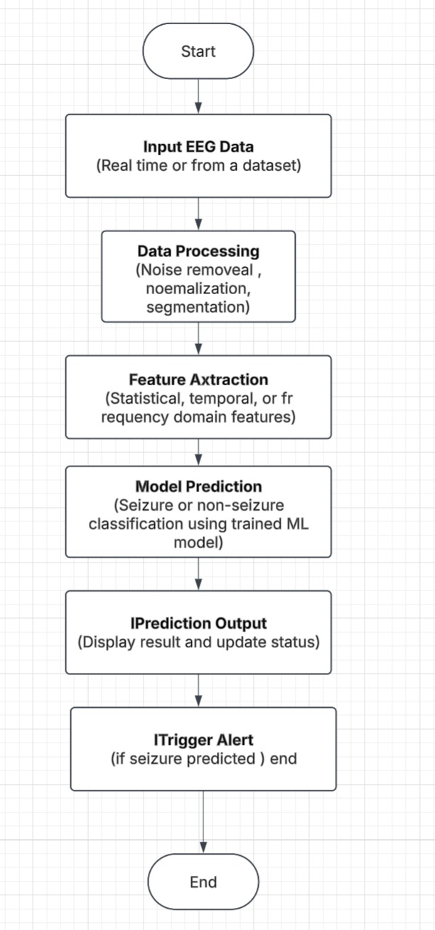

Figure3.1.1 Flowchart

* + 1. **System Architecture Diagram**

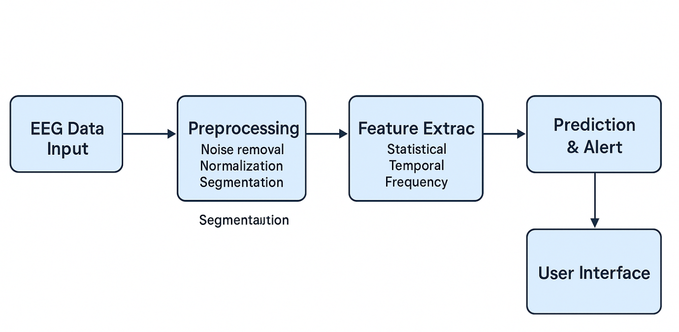

Figure 3.1.2 System Architecture Diagram

* + 1. **System Architecture Diagram**

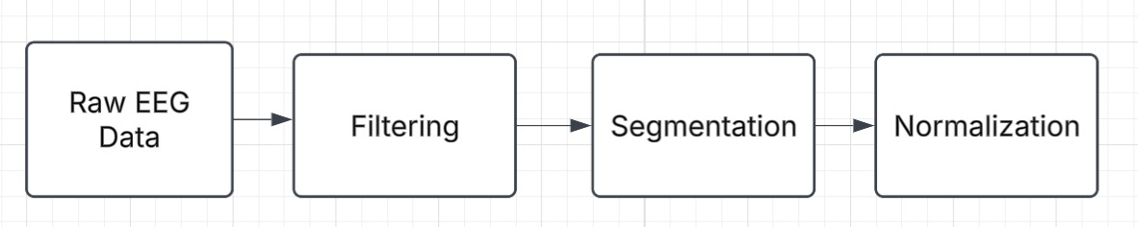

Figure3.1.3 System Architecture Diagram

# CHAPTER 4

**IMPELEMENTATION & TESTING**

* 1. **Implementation**

The system was developed using Python and several machine learning libraries such as Scikit-learn, TensorFlow, and NumPy. The implementation process was divided into key stages:

* **Data Collection & Preprocessing:**  
  EEG datasets were collected from open sources (e.g., CHB-MIT), and preprocessing techniques such as filtering, normalization, and segmentation were applied.

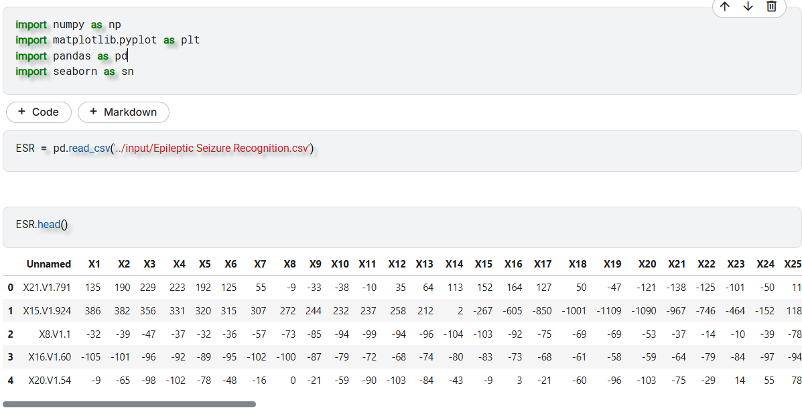

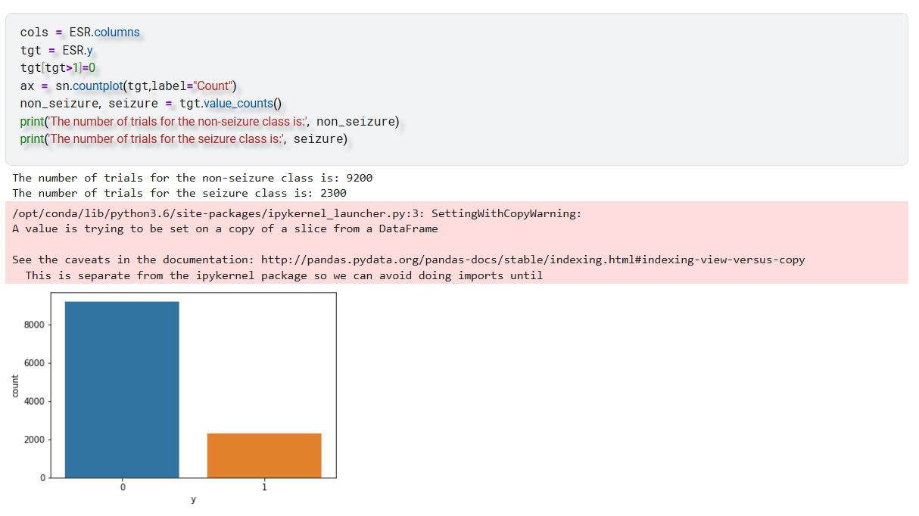

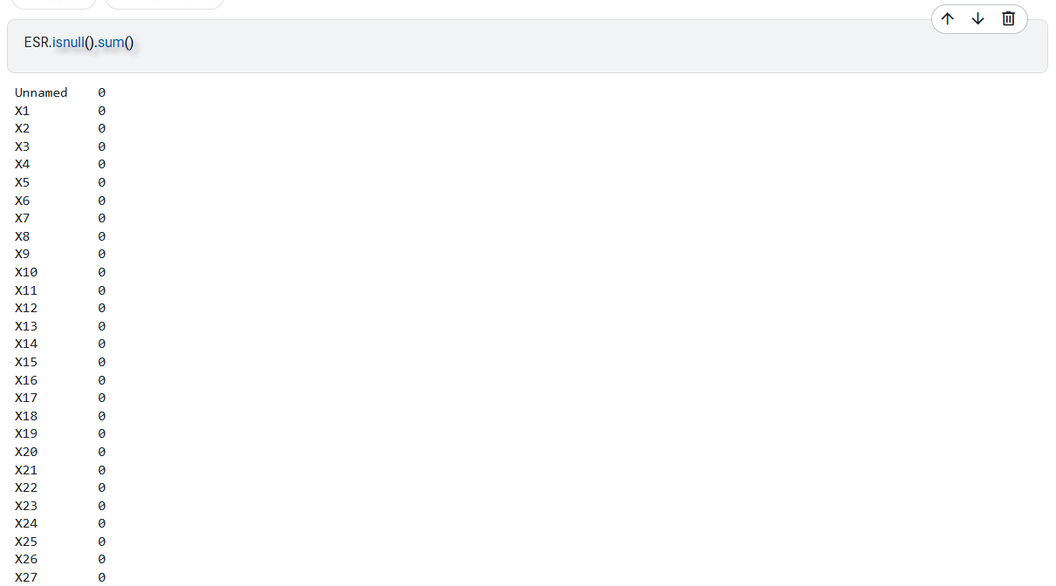

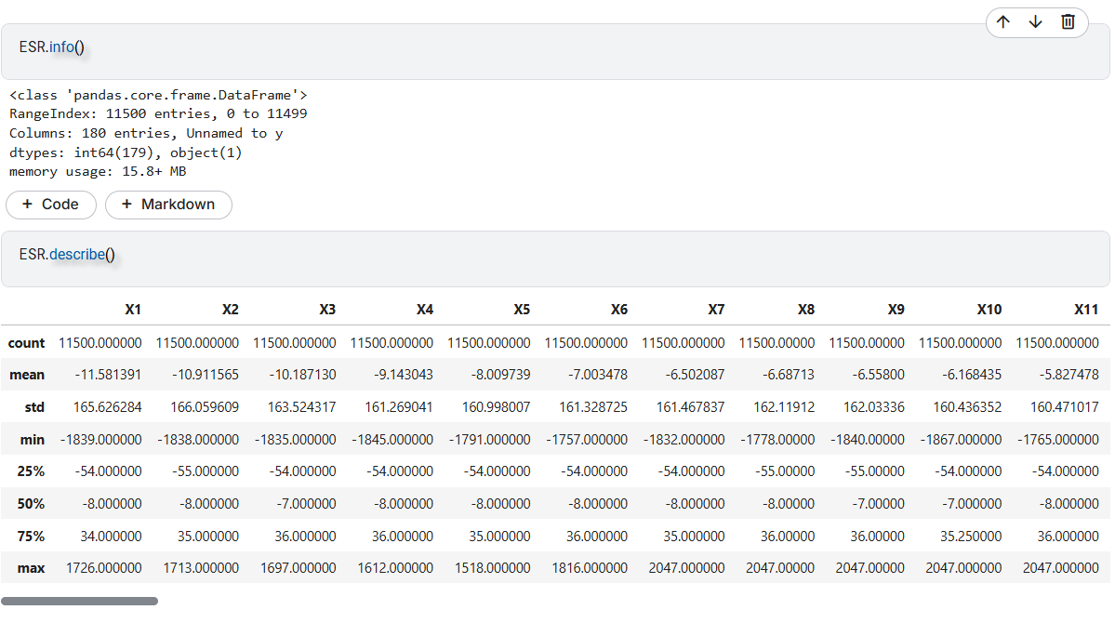

* **Feature Extraction:**  
  Statistical and frequency-based features (e.g., mean, variance, FFT) were extracted from the EEG segments to represent brain activity patterns.

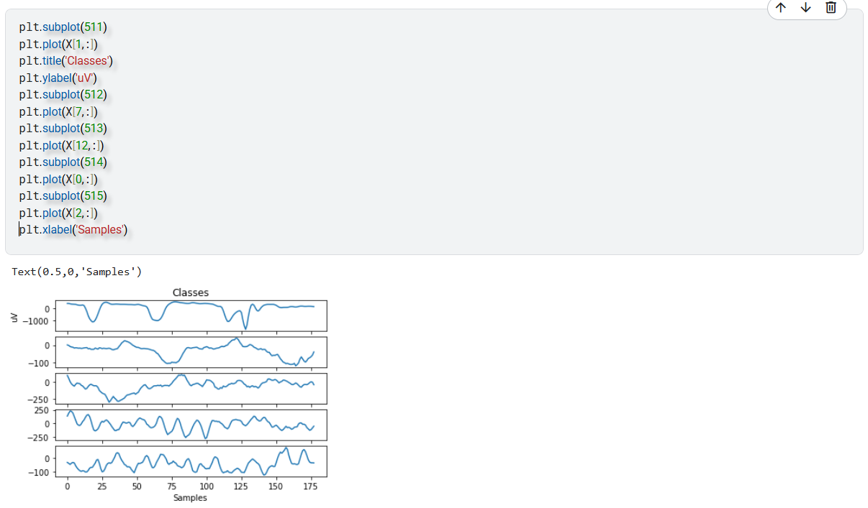

* **Model Training:**  
  Machine learning models such as Random Forest, Support Vector Machine (SVM), and LSTM (for sequential modeling) were trained on labeled data to classify seizure vs non-seizure activity.

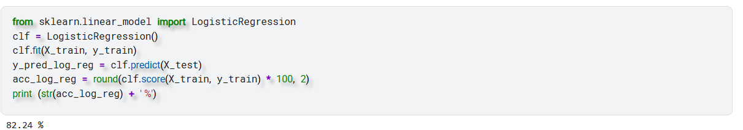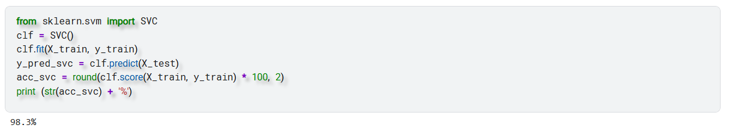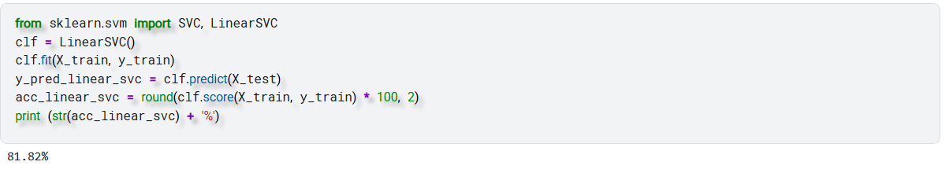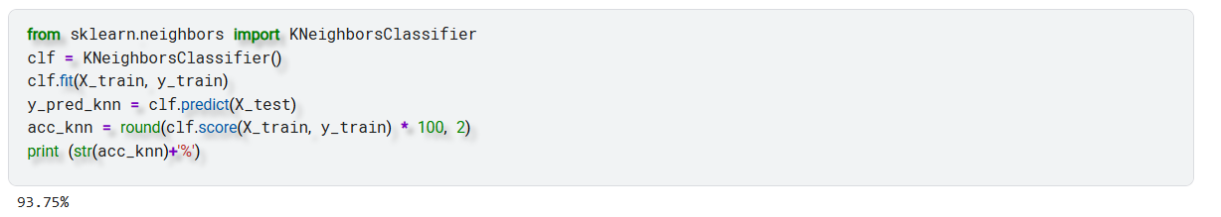

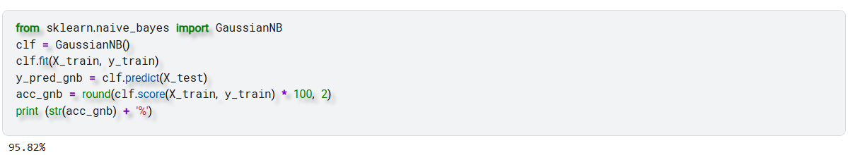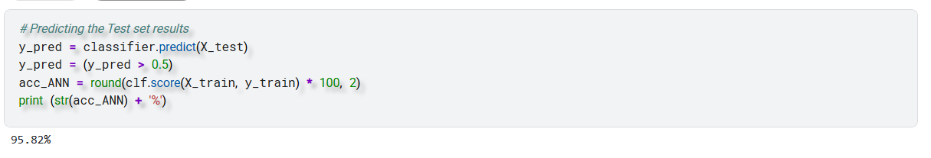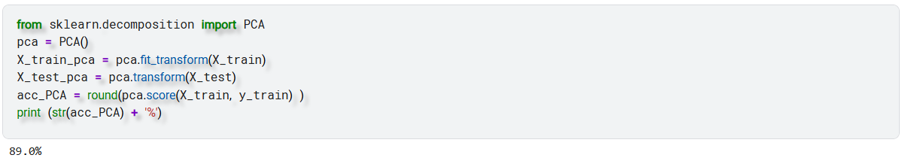

**4.3 Result**

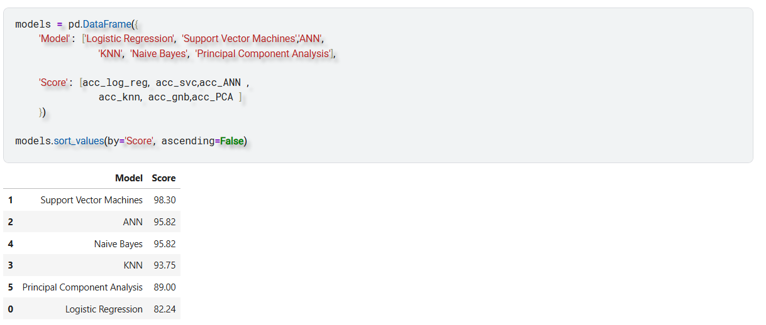

**4.4 Testing Plan / Strategy**

The testing plan ensures that every component of the epileptic seizure prediction system functions correctly and meets the performance expectations. The overall strategy is broken into structured phases to validate both the technical accuracy and user experience of the system.

**1. Unit Testing**

Each module in the system—such as data preprocessing, feature extraction, and model prediction—is tested individually to ensure correct functionality and outputs.

**2. Integration Testing**

All modules are combined and tested as a whole to verify smooth data flow between components (e.g., from data input to prediction output) and ensure system stability.

**3. System Testing**

The complete system is tested in a simulated environment using real EEG data. This phase verifies that the system accurately predicts seizures and sends appropriate alerts.

**4. Performance Testing**

The machine learning model is evaluated using performance metrics such as:

* **Accuracy**
* **Precision**
* **Recall/Sensitivity**
* **F1 Score**  
  This ensures the model is reliable in real-world applications.

**5. Usability Testing**

The interface is tested for ease of use, clarity, and responsiveness, ensuring that users (patients or caregivers) can interact with the system without technical expertise.

**6. Exception & Edge Case Testing**

Tests are conducted with noisy, incomplete, or abnormal EEG signals to check how the system handles unexpected data inputs.

# CHAPTER 5

**CONCLUSION AND FUTURE SCOPE**

## SUMMARY OF WORK DONE

In this project, we successfully developed a machine learning model to classify epileptic seizures using EEG data. The system effectively distinguishes between seizure and non-seizure states by analyzing patterns in EEG signals and applying advanced feature extraction and classification techniques. The model demonstrated promising performance, offering a potential tool for aiding clinical diagnosis and early intervention in epilepsy management.

The ability to predict seizures through non-invasive EEG analysis can greatly improve the quality of life for individuals suffering from epilepsy by reducing uncertainty and enabling timely medical responses.

## KEY ACHIEVEMENTS

• Successful Seizure Classification Model

• Effective Feature Extraction

• Data Visualization

• Performance Evaluation

• Scalability for Real-Time Application

• Vision for Real-Time System Integration

## LIMITATIONS OF THE PROJECT

• Data Dependency

• Model Generalization

• Warning: SettingWithCopyWarning

• Lack of Real-Time Deployment

• No Hardware Integration Yet

• Limited Interpretability

## POSSIBLE IMPROVEMENTS OR FUTURE EXTENSIONS

Looking ahead, we aim to enhance this project by integrating the classification model with a wearable EEG device, such as a smart cap embedded with EEG sensors. This device will facilitate **real-time monitoring** of brain activity and enable **instant alerts** when seizure-like patterns are detected.

Key aspects of future development include:

* **Real-time Data Processing:** Implementing signal acquisition and processing pipelines on embedded systems or mobile platforms.
* **Wireless EEG Cap:** Designing a lightweight, comfortable cap equipped with dry or semi-dry EEG electrodes for continuous data collection.
* **Alert System:** Developing a notification mechanism (e.g., via smartphone, alarm, or wearable) to alert patients and caregivers upon seizure detection.
* **Cloud Integration:** Storing and analyzing data remotely for continuous monitoring and feedback from healthcare professionals.

# References

1. Shoeb, A. (2009). **Application of Machine Learning to Epileptic Seizure Detection**. *PhD Dissertation, MIT*.  
   https://dspace.mit.edu/handle/1721.1/54628
2. Goldberger, A.L. et al. (2000). **PhysioBank, PhysioToolkit, and PhysioNet: Components of a New Research Resource for Complex Physiologic Signals**. *Circulation*, 101(23), e215–e220.  
   <https://physionet.org>
3. Faust, O., Hagiwara, Y., Hong, T.J., Lih, O.S., & Acharya, U.R. (2018). **Deep learning for healthcare applications based on physiological signals: A review**. *Computer Methods and Programs in Biomedicine*, 161, 1-13.
4. Khan, H., Marcuse, L., Fields, M., Swann, K., & Yener, B. (2017). **Focal onset seizure prediction using convolutional networks**. *IEEE Transactions on Biomedical Engineering*, 64(3), 497–508.
5. Python Software Foundation. (2023). **Python Language Reference, Version 3.9**. <https://www.python.org>
6. Scikit-learn Developers. (2023). **Scikit-learn: Machine Learning in Python**. <https://scikit-learn.org>
7. TensorFlow Developers. (2023). **TensorFlow: An Open Source Machine Learning Framework for Everyone**. <https://www.tensorflow.org>
8. EEG Seizure Dataset. *Kaggle*. Retrieved from: <https://www.kaggle.com>
9. Kaggle Notebooks. *Kaggle*. Retrieved from various community-contributed notebooks for EEG signal processing and seizure classification at: https://www.kaggle.com/code

––

# Regular Report Diary (Original Copy)

**Consent Letter**