
CEZERI BILIM VE TEKNOLOJI OKULLARI
2026 – 2027 Academic Year
First Quarter Examination
Grade 11 Physics — AS Level
Class: | 11 / ______ | Name: | ________________________
Course: | Physics — Grade 11 (AS Level) | Date: | ________________________
Version: | A | Duration: | 75 minutes

PART | MARKS | GRADE
Section A — Multiple choice (Questions 1–15) | 15 | ______ / 15
Section B — Structured questions (Questions 16–19) | 25 | ______ / 25
Section C — Practical skills (Question 20) | 10 | ______ / 10
TOTAL MARKS | 50 | ______ / 50
Instructions
- Answer all 20 questions in Sections A, B and C.
- Section A (Paper 1 style): for each question, circle ONE letter, A to D, and show any working in the space provided.
- Section B (Paper 2 style): write your answers and your full working in the spaces provided.
- Section C (Paper 3 style): complete the table and the graph, then answer the questions.
- The number of marks for each question or part is shown in brackets [ ].
- Calculators are allowed. Give numerical answers with units, to an appropriate number of significant figures.
- You are advised to spend about 20 minutes on Section A, 35 minutes on Section B and 20 minutes on Section C.
Academic integrity: any attempt at cheating automatically cancels the exam, without prior notice.

Constants
Quantity | Value
acceleration of free fall near the Earth’s surface | g = 9.81 m s⁻²
permittivity of free space | ε₀ = 8.85 × 10⁻¹² F m⁻¹
Coulomb constant, 1/(4πε₀) | k = 8.99 × 10⁹ N m² C⁻²
elementary charge | e = 1.60 × 10⁻¹⁹ C
1 μC = 1 × 10⁻⁶ C; 1 km = 1000 m; 1 h = 3600 s

Formulae
Quantity | Formula
average speed | speed = distance ÷ time
average velocity | velocity = displacement ÷ time
acceleration | a = (v − u) ÷ t
uniformly accelerated motion | v = u + at; s = ut + ½at²
components of a vector F at angle θ to the horizontal | F_{x} = F cos θ; F_{y} = F sin θ
resultant of two perpendicular components | R = √(F_{x}² + F_{y}²); tan θ = F_{y} ÷ F_{x}
Coulomb’s law | F = kQ₁Q₂ ÷ r²

Section A — Multiple choice
Answer all questions. Circle one letter, A, B, C or D, and show your working in the space provided.
1 Which quantity is a vector? [1]
A distance
B speed
C time
D displacement

2 An athlete runs exactly one lap of a 400 m track, starting and finishing at the same point, as shown. The lap takes 80 s.  What are the athlete’s average speed and average velocity for the lap? [1] | 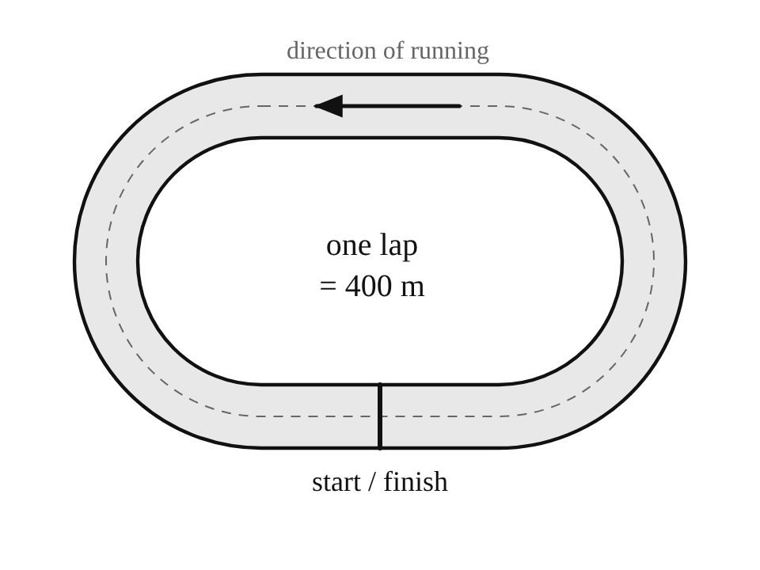
   | average speed / m s⁻¹ | average velocity / m s⁻¹
  A | 5.0 | 0
  B | 0 | 5.0
  C | 5.0 | 5.0
  D | 0 | 0

3 A student walks 400 m due east and then 300 m due west along the same straight path, as shown.  What are the total distance travelled and the final displacement from the start? [1] | 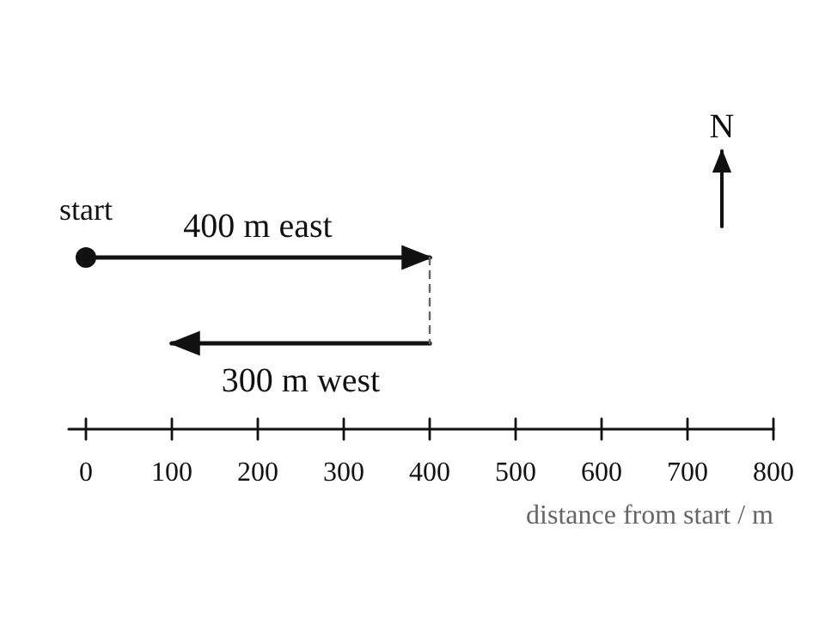
   | distance | displacement
  A | 100 m | 700 m east
  B | 700 m | 100 m east
  C | 700 m | 700 m east
  D | 100 m | 100 m east

4 The displacement–time graph shows the motion of a toy car along a straight track. It has three sections, P, Q and R.  What is the velocity of the car during section R? [1]  A −4.0 m s⁻¹  B −3.0 m s⁻¹  C 0  D +4.0 m s⁻¹ | 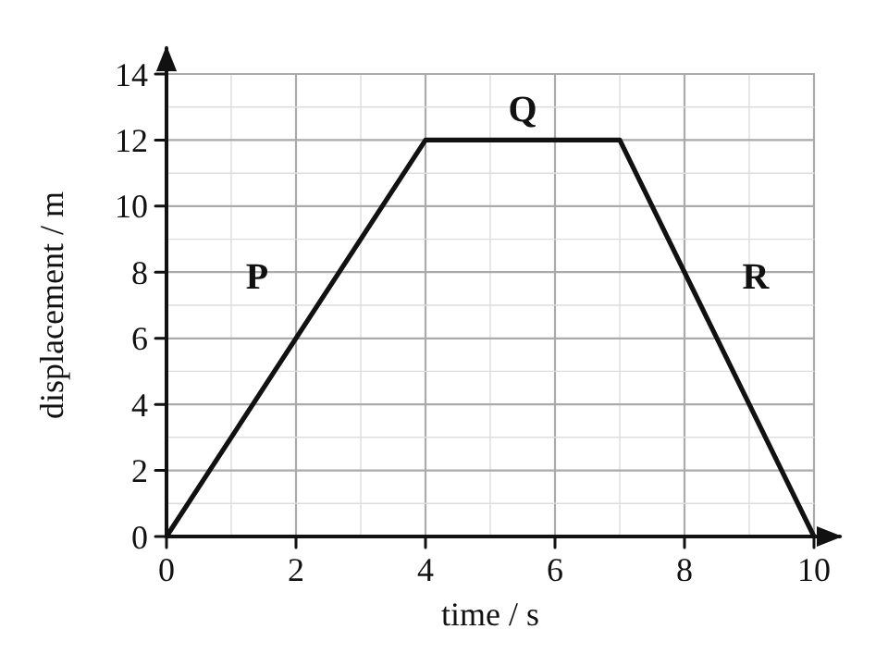

5 A car accelerates uniformly from 5.0 m s⁻¹ to 25 m s⁻¹ in 8.0 s, as shown.  What is the acceleration of the car? [1]  A 0.40 m s⁻²  B 2.5 m s⁻²  C 3.1 m s⁻²  D 3.8 m s⁻² | 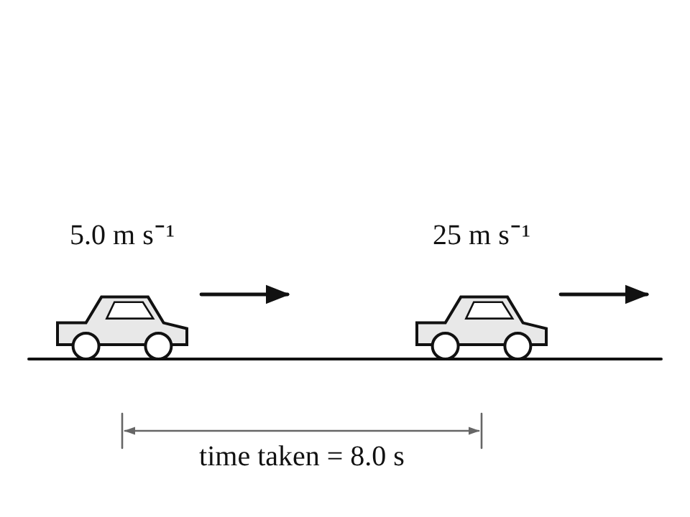

6 The graphs show how the displacement s or the velocity v of four objects changes with time t.  Which graph shows an object moving with a constant, non-zero acceleration? [1]  A graph A  B graph B  C graph C  D graph D | 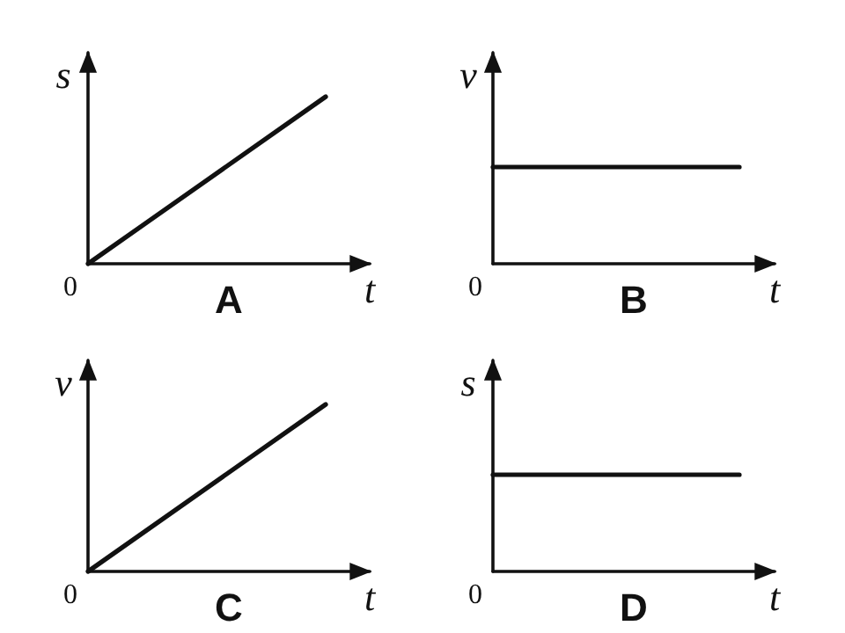

7 A car travels 30 km from A to B in 0.50 h and then a further 30 km from B to C in 1.0 h.  What is the average speed of the car for the whole journey from A to C? [1]  A 30 km h⁻¹  B 36 km h⁻¹  C 40 km h⁻¹  D 45 km h⁻¹ | 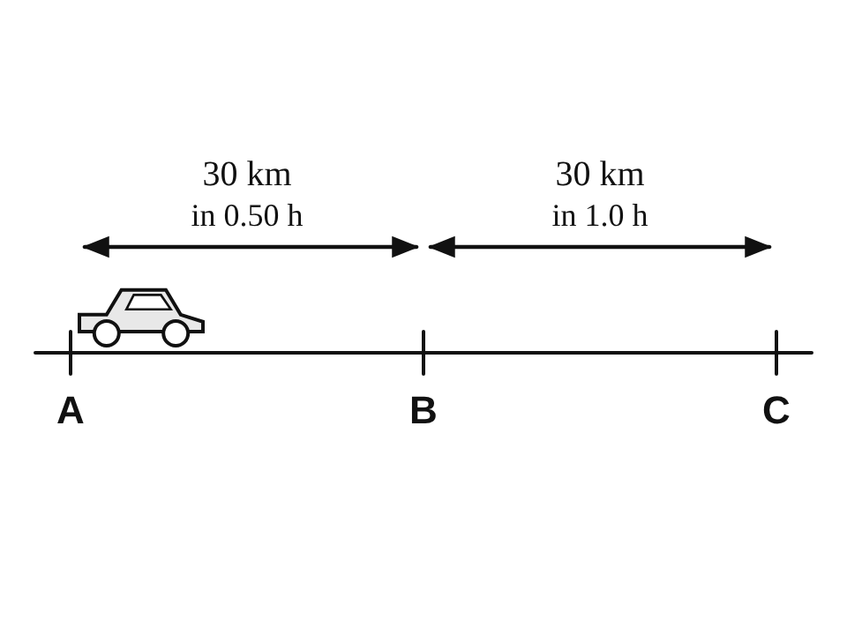

8 A force F acts at an angle θ to the vertical, as shown.  Which row gives the horizontal and vertical components of F? [1] | 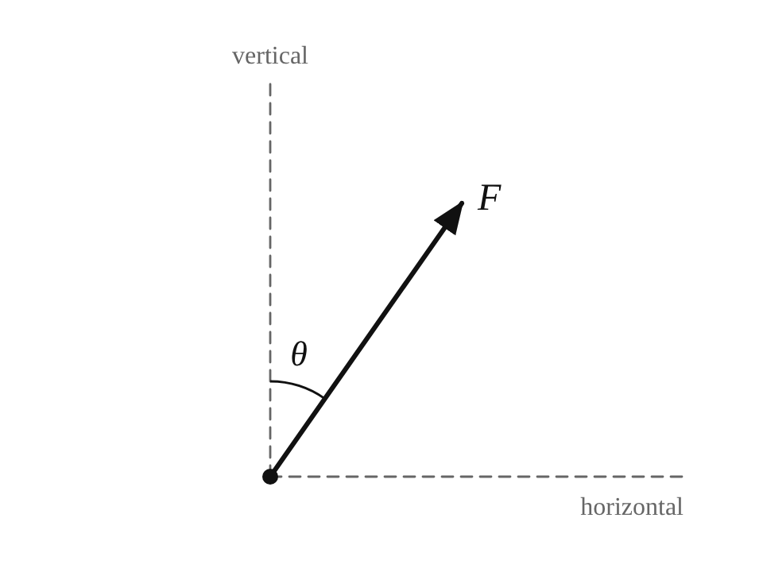
   | horizontal component | vertical component
  A | F sin θ | F cos θ
  B | F cos θ | F sin θ
  C | F tan θ | F
  D | F cos θ | F cos θ

9 Two forces of 5.0 N and 8.0 N act at right angles on a point O, as shown.  What is the magnitude of the resultant force? [1]  A 3.0 N  B 6.5 N  C 9.4 N  D 13 N | 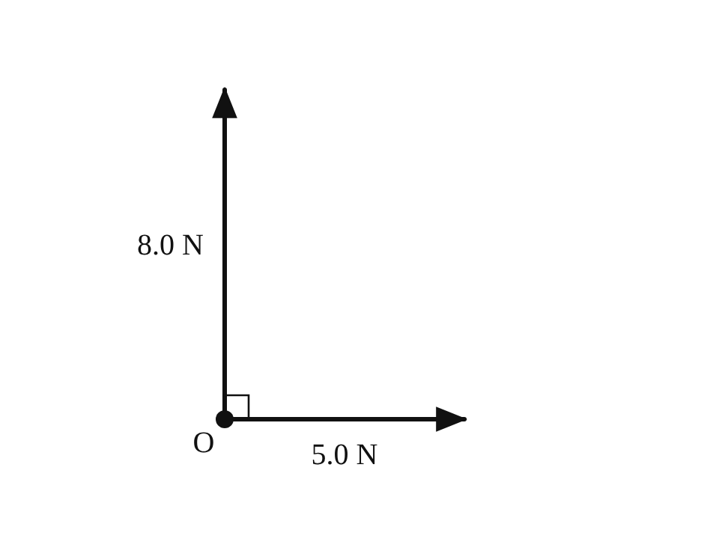

10 A ball moves with a velocity of 15 m s⁻¹. The vertical component of this velocity is 9.0 m s⁻¹, as shown.  What is the horizontal component of the velocity? [1]  A 6.0 m s⁻¹  B 12 m s⁻¹  C 17.5 m s⁻¹  D 24 m s⁻¹ | 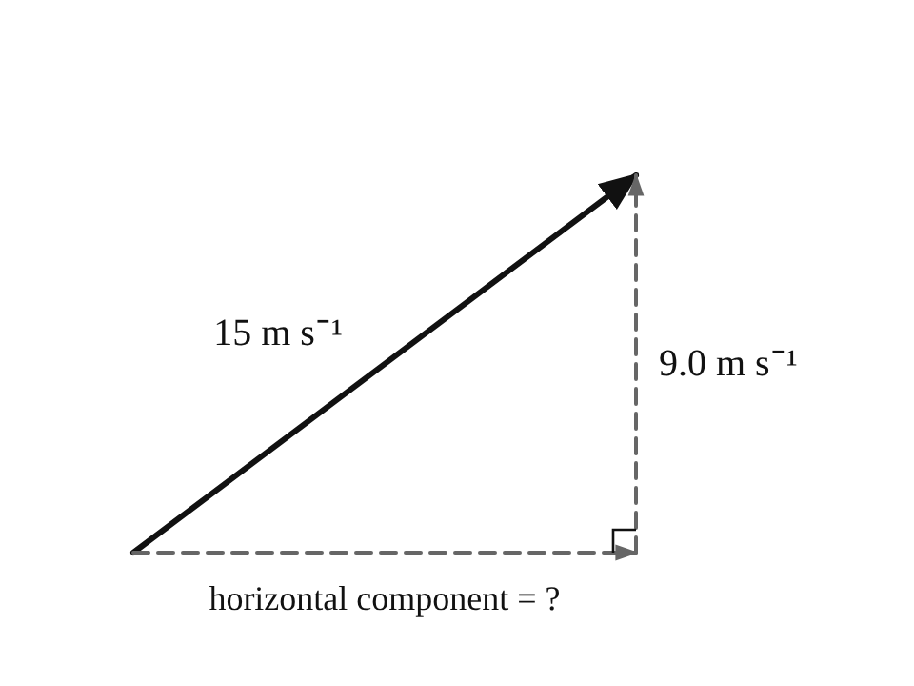

11 Two forces of 5.0 N and 12 N act at the same point. The angle θ between them can be changed.  Which value cannot be the magnitude of their resultant? [1]  A 7.0 N  B 13 N  C 17 N  D 19 N | 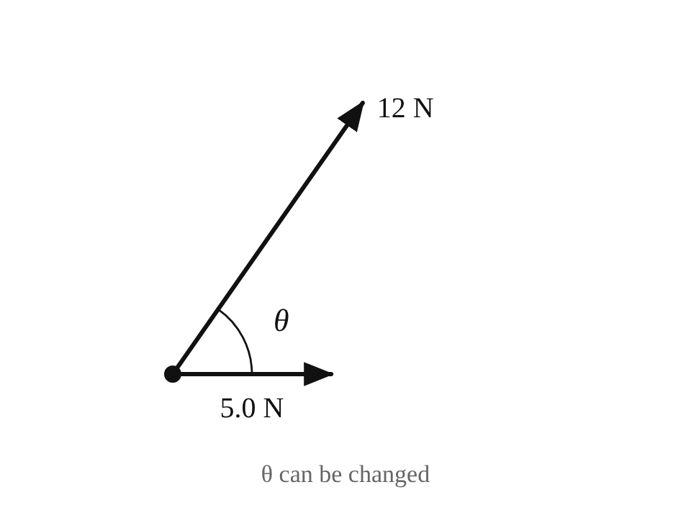

12 Two point charges Q₁ and Q₂ exert a force F on each other when they are a distance r apart. Q₁ is doubled and the distance is increased to 2r.  What is the new force between the charges? [1]  A F/4  B F/2  C F  D 2F | 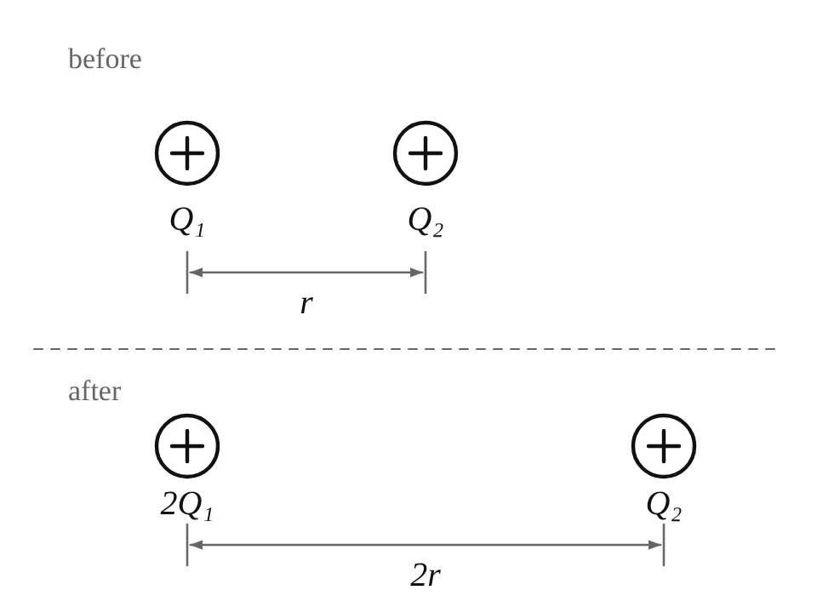

13 Two point charges of +2.0 μC and −3.0 μC are placed 0.30 m apart in air.  What are the magnitude and type of the force between them? [1] | 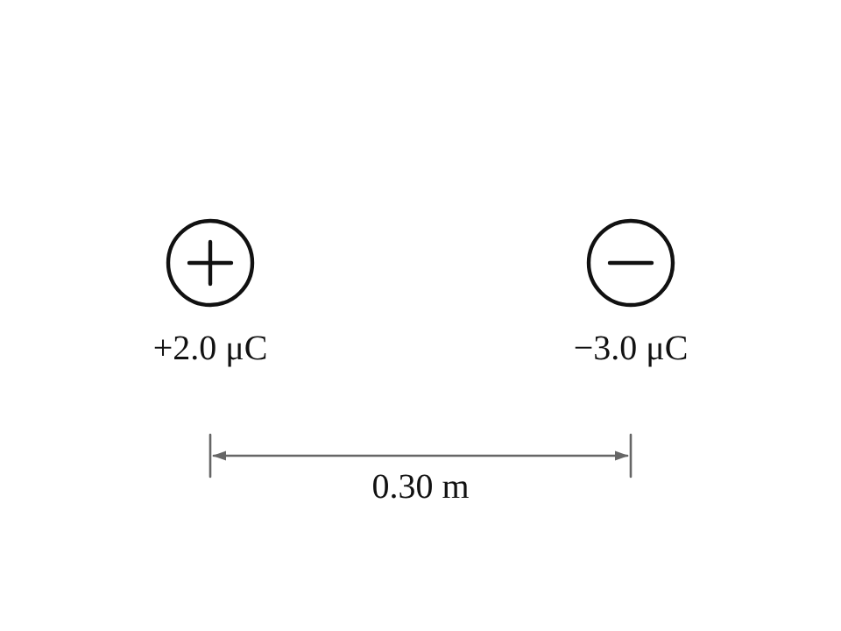
   | magnitude of force | type of force
  A | 0.60 N | repulsive
  B | 0.18 N | attractive
  C | 0.18 N | repulsive
  D | 0.60 N | attractive

14 Two equal positive charges +Q are fixed at X and Y. A small positive charge +q is placed at M, exactly halfway between them on the line XY.  What is the resultant electrostatic force on +q? [1]  A zero  B towards X  C towards Y  D at right angles to XY | 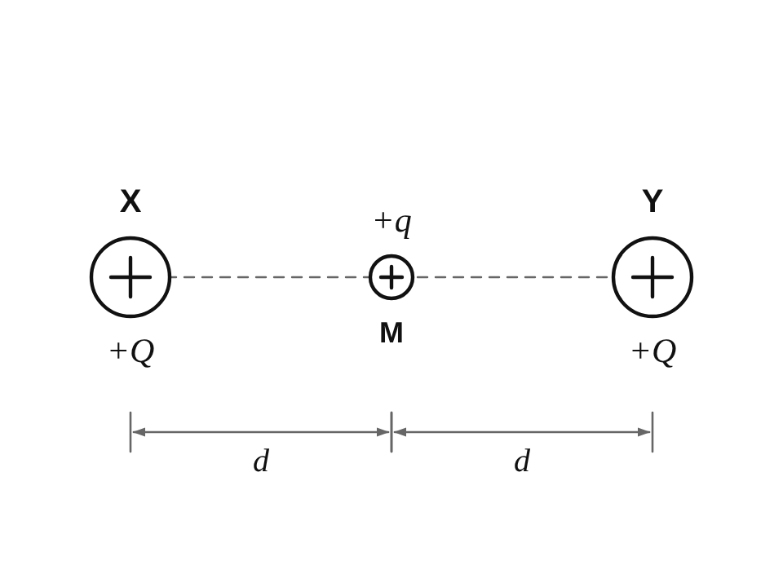

15 Three charges are placed at the corners of a right-angled triangle. Each charge +Q is a distance r from +q, and on its own exerts a force of magnitude F on +q.  What is the magnitude of the resultant force on +q? [1]  A 0  B F  C √2 F  D 2F | 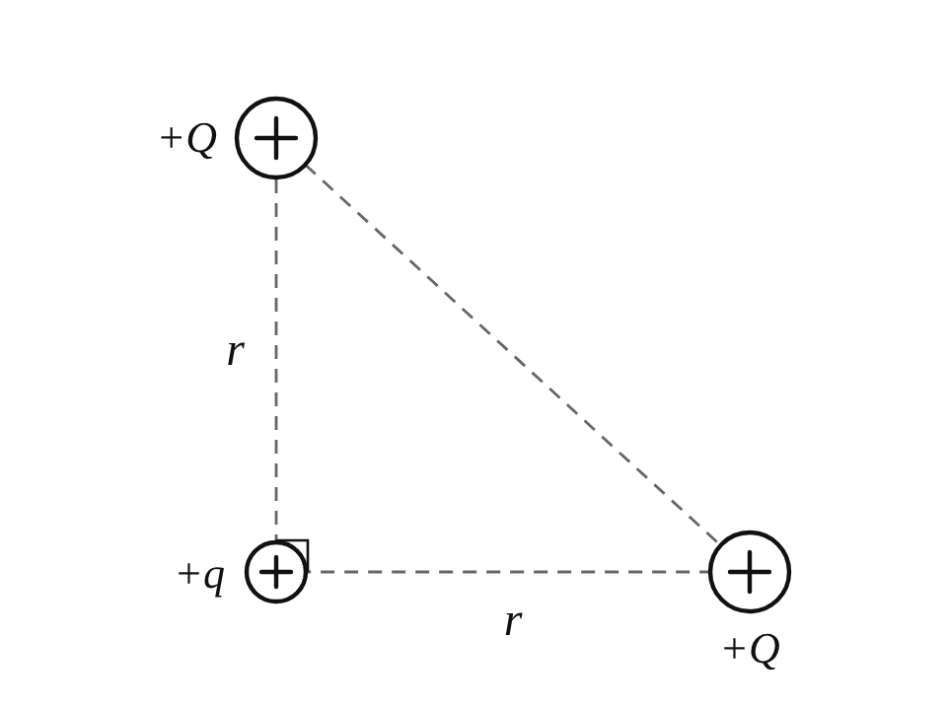

Section B — Structured questions
Answer all questions. Show your working in the space provided.
16 A cyclist rides from P to Q and then from Q to R along the two straight roads shown on the map. The road PQ points due east and the road QR points due north.  The distance and the time taken for each stage are shown on the map. | 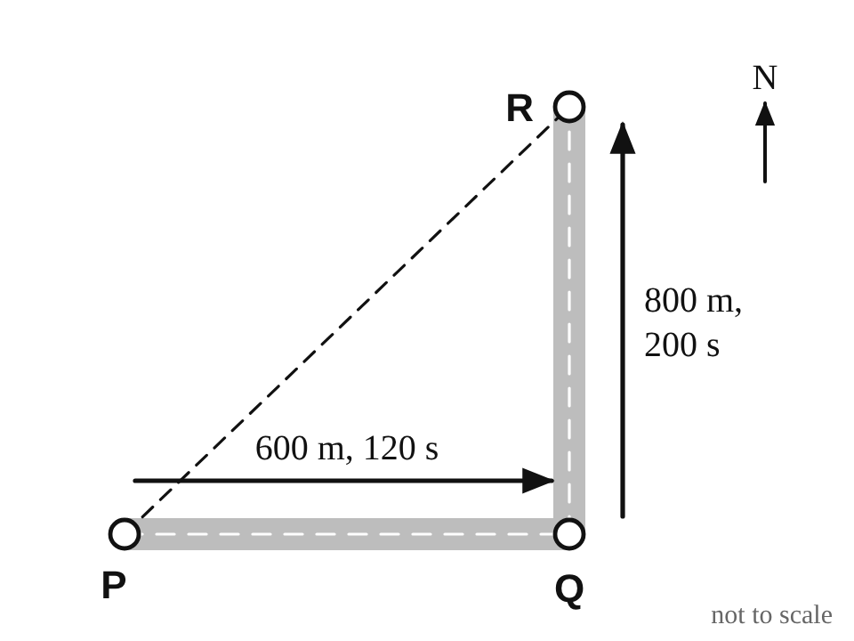
(a) State one difference between distance and displacement. [1]

(b) Calculate the total distance travelled by the cyclist from P to R.

distance = ______________________ m [1]
(c) Calculate the magnitude and the direction of the cyclist’s displacement from P to R. Give the direction as an angle measured from due east.

magnitude = ______________________ m
direction = ______________________ ° north of east [2]
(d) For the whole journey from P to R, calculate
(i) the average speed,

average speed = ______________________ m s⁻¹ [1]
(ii) the magnitude of the average velocity.

average velocity = ______________________ m s⁻¹ [1]

17 A car waits at traffic lights. When the lights turn green, the car accelerates uniformly from rest at 2.5 m s⁻² for 6.0 s. It then travels at a constant velocity for 20 s. Finally it brakes and comes to rest in 5.0 s, travelling 37.5 m while braking. | 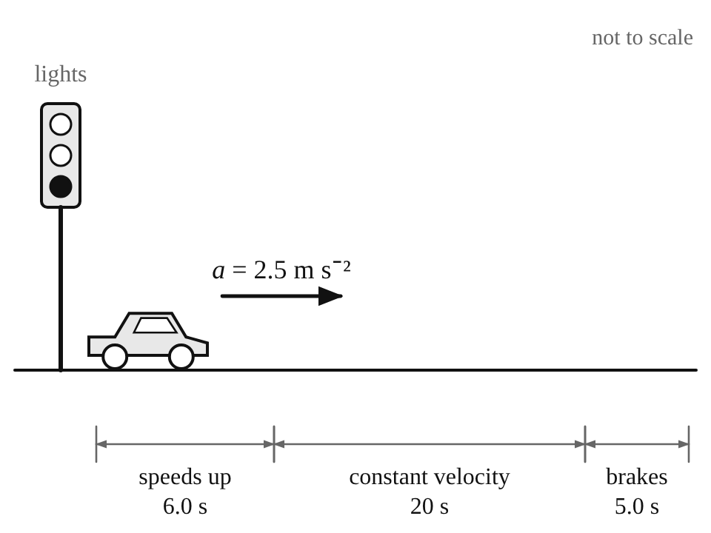
(a) Calculate the velocity of the car at the end of the first 6.0 s.

velocity = ______________________ m s⁻¹ [1]
(b) Calculate the distance travelled by the car in the first 6.0 s.

distance = ______________________ m [1]
(c) Calculate the distance travelled by the car while it moves at constant velocity.

distance = ______________________ m [1]
(d) Calculate the acceleration of the car while it is braking.

acceleration = ______________________ m s⁻² [1]
(e) Calculate the average speed of the car for the whole journey.

average speed = ______________________ m s⁻¹ [2]

18 Vectors can be resolved into components and components can be combined into a resultant.
(a) State the difference between a scalar quantity and a vector quantity. [1]

(b) A child pulls a loaded sledge across level snow using a rope. The tension in the rope is 50 N and the rope makes an angle of 35° with the horizontal, as shown.  Calculate | 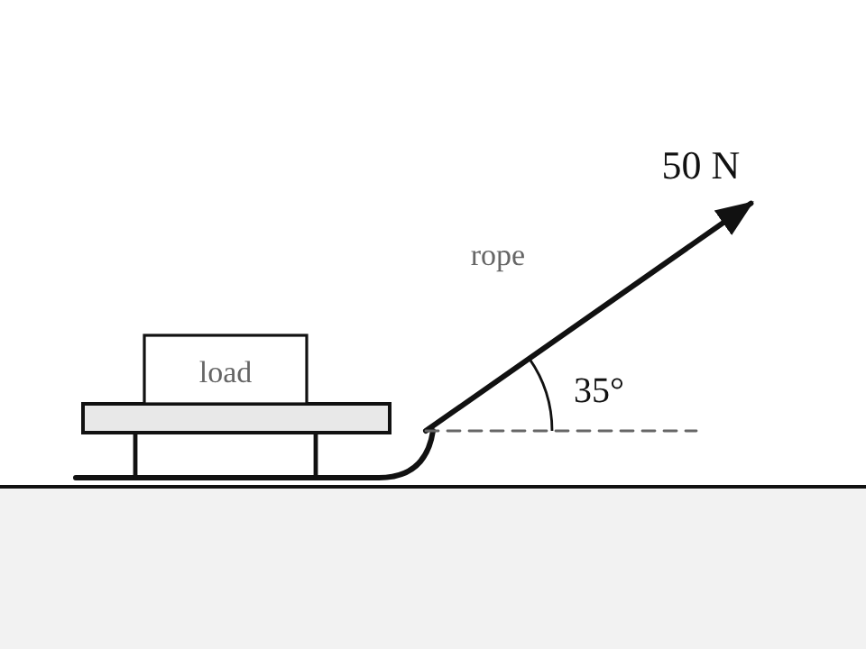
(i) the horizontal component of the tension,

horizontal component = ______________________ N [1]
(ii) the vertical component of the tension.

vertical component = ______________________ N [1]
(c) A drone moves with a horizontal velocity component of 15 m s⁻¹ and a vertical (upward) velocity component of 6.0 m s⁻¹, as shown.  Combine the two components to find the resultant velocity of the drone. Give its magnitude and the angle it makes with the horizontal. | 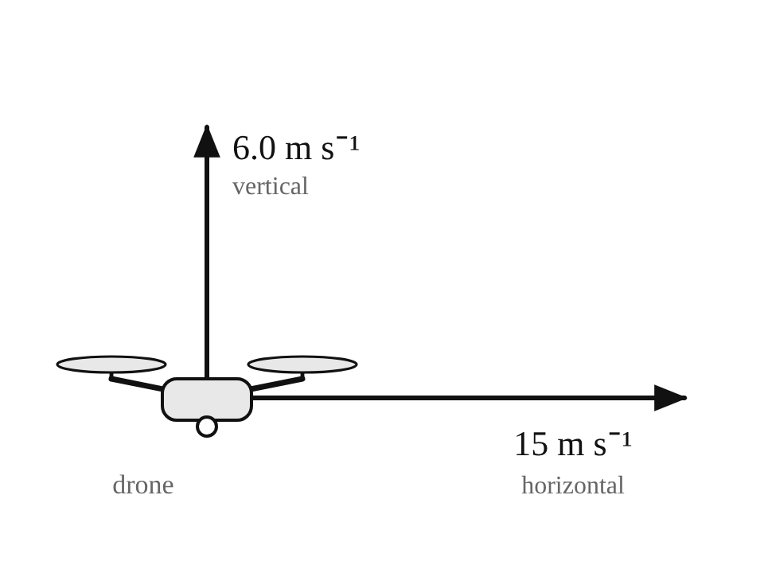

magnitude = ______________________ m s⁻¹
angle to the horizontal = ______________________ ° [3]

19 Three point charges A, B and C are fixed in a straight line, as shown. | 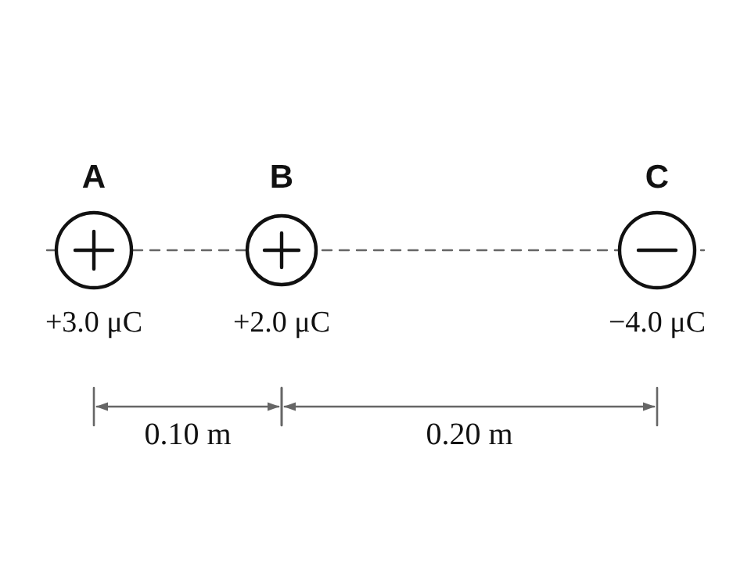
(a) State whether the force on B due to C is attractive or repulsive. Give a reason for your answer. [1]

(b) Calculate
(i) the magnitude of the force on B due to A,

force due to A = ______________________ N [1]
(ii) the magnitude of the force on B due to C.

force due to C = ______________________ N [1]
(c) Determine the magnitude and the direction of the resultant force on B.

resultant force = ______________________ N
direction: ______________________________ [1]
(d) Three point charges are fixed at the corners X, O and Y of a right-angled triangle, as shown. The angle at O is 90°. | 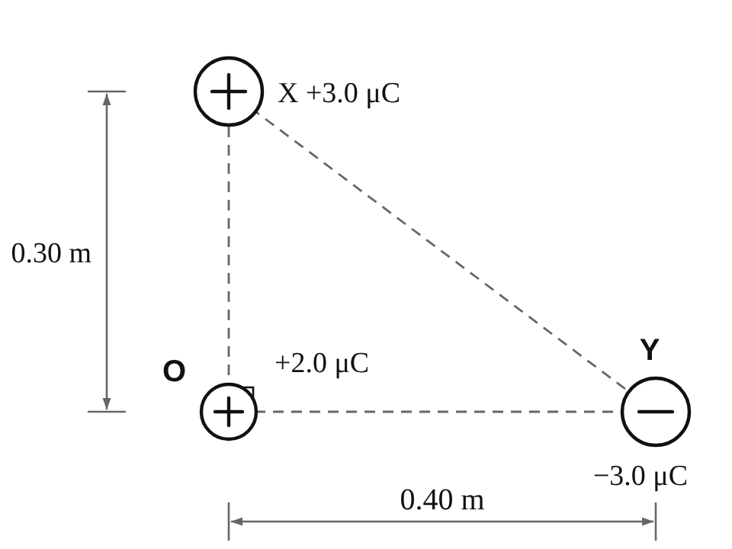
(i) Calculate the force on the charge at O due to the charge at X, and the force on the charge at O due to the charge at Y.

force due to X = ______________________ N
force due to Y = ______________________ N [1]
(ii) The two forces are at right angles. Determine the magnitude of the resultant force on the charge at O and the angle it makes with the line OY.

resultant force = ______________________ N
angle with OY = ______________________ ° [2]

Section C — Practical skills
Answer all parts. Use the results in Table 20.1 and the grid provided.
20 A student investigates a toy car moving at a constant speed along a straight track. She uses a metre rule to mark distances d along the track and a stopwatch to measure the time t the car takes to travel each distance.  Her results are shown in Table 20.1. | 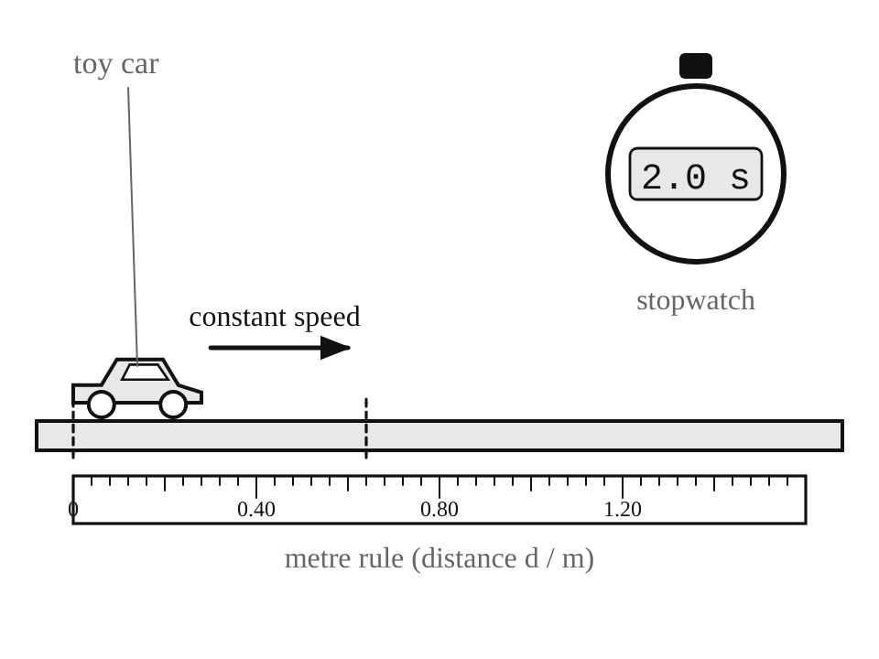

d / m | t / s | speed = d ÷ t / m s⁻¹
0.40 | 1.0 | 0.40
0.80 | 2.0 | 0.40
1.20 | 3.1 | 0.39
1.60 | 4.0
2.00 | 5.0
Table 20.1
(a) Name the measuring instrument used to measure
(i) the distance d, [1]

(ii) the time t. [1]

(b) Complete Table 20.1 by calculating the speed for d = 1.60 m and for d = 2.00 m. [2]

(c) On the grid below, plot the points of d (y-axis) against t (x-axis). Draw a straight line of best fit through your points. [2]
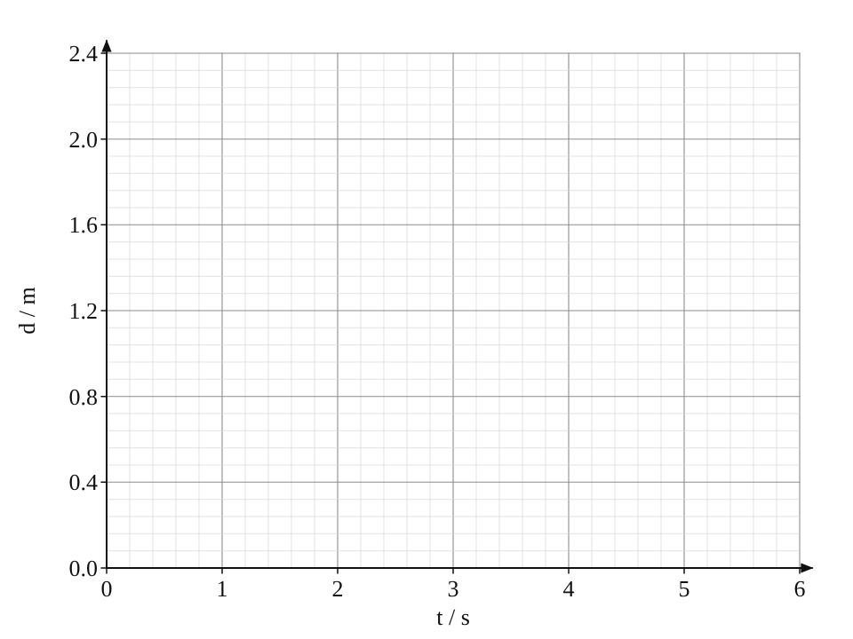
(d) Use your graph to find the distance travelled by the car after 2.5 s.

distance = ______________________ m [1]
(e) Find the gradient of your line. The gradient is equal to the speed of the car.

gradient = ______________________ m s⁻¹ [1]
(f) The line is straight and passes through the origin. What does this tell you about the speed of the car? [1]

(g) Suggest one way to make the measurements of time more reliable. [1]

END OF EXAMINATION

