**CE-712: Digital Image Processing of Remotely Sensed Data**

**Laboratory Exercise #**

|  |  |  |  |
| --- | --- | --- | --- |
| **Name:-** | **P R Sarbajit**  **Nautatava Navlakha** | **Roll No:-** | **160040094**  **160040007** |
| **Department** | **Civil Engineering** | **Program:-** | **B.Tech** |

**Statistics (Mean, Standard deviation, Min and Max) for each training set**

|  |  |  |  |  |  |  |
| --- | --- | --- | --- | --- | --- | --- |
|  | Bands | Water | Vegetation | Built-up | Mangroove | Sea |
| Mean | 2 | 8482.9202 | 8768.2793 | 9267.6013 | 9657.7778 | 8500.6646 |
| 3 | 7460.4858 | 7961.1245 | 8526.2165 | 8912.5425 | 7758.5475 |
| 4 | 6722.0727 | 7178.5585 | 7606.99 | 8915.4575 | 6932.3354 |
| 5 | 6061.2123 | 12595.366 | 5940.1109 | 10155.941 | 13159.446 |
| 6 | 5336.1268 | 7919.134 | 5264.676 | 10639.248 | 7731.0854 |
| Standard Deviation | 2 | 89.11547 | 24.7549 | 24.21514 | 275.71969 | 47.46166 |
| 3 | 160.28157 | 40.12141 | 42.07587 | 349.20556 | 69.09291 |
| 4 | 156.16131 | 26.59049 | 142.50802 | 470.13341 | 84.41051 |
| 5 | 150.33359 | 377.4453 | 36.09531 | 834.26339 | 549.05287 |
| 6 | 45.45819 | 65.28234 | 11.50903 | 1147.4742 | 364.51418 |
| Minimum | 2 | 8327 | 7260 | 6515 | 5868 | 5139 |
| 3 | 8684 | 7621 | 7197 | 7006 | 6076 |
| 4 | 8371 | 7526 | 6718 | 10897 | 5632 |
| 5 | 8702 | 7877 | 7117 | 11769 | 6089 |
| 6 | 9141 | 8352 | 7291 | 5838 | 5116 |
| Maximum | 2 | 8760 | 7882 | 7122 | 7272 | 5781 |
| 3 | 10282 | 7621 | 10266 | 11753 | 13558 |
| 4 | 8619 | 7526 | 7224 | 14348 | 8273 |
| 5 | 8844 | 7877 | 7270 | 13991 | 8098 |
| 6 | 9323 | 8352 | 7983 | 6065 | 5299 |

**2.**

**Spectral Angle Mapping**

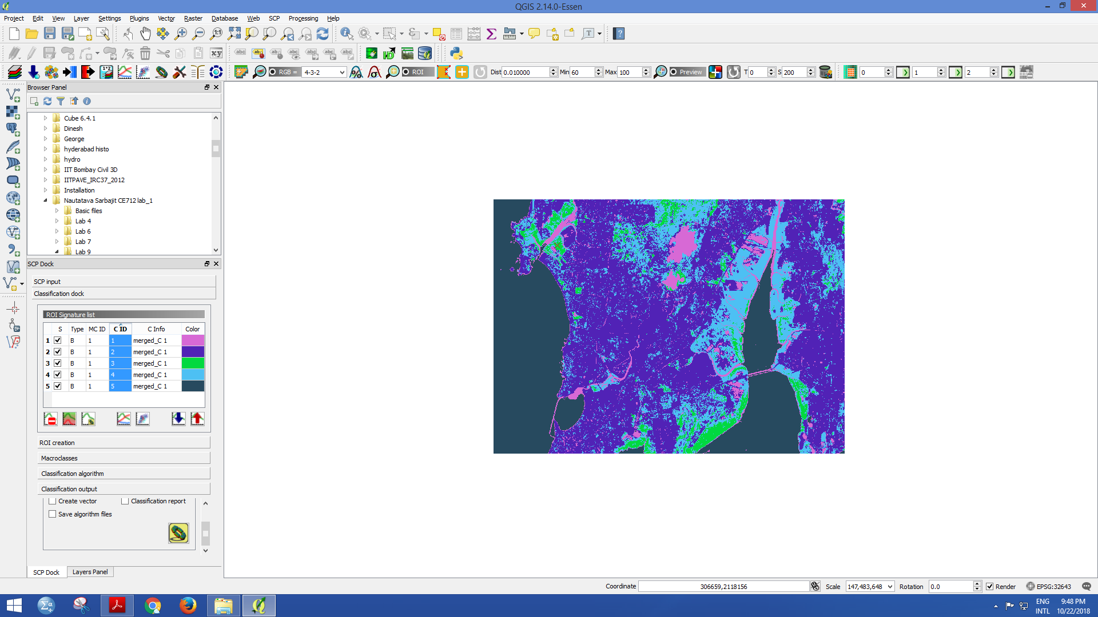

Number of pixels, total area, and percentage of a particular class in the Image

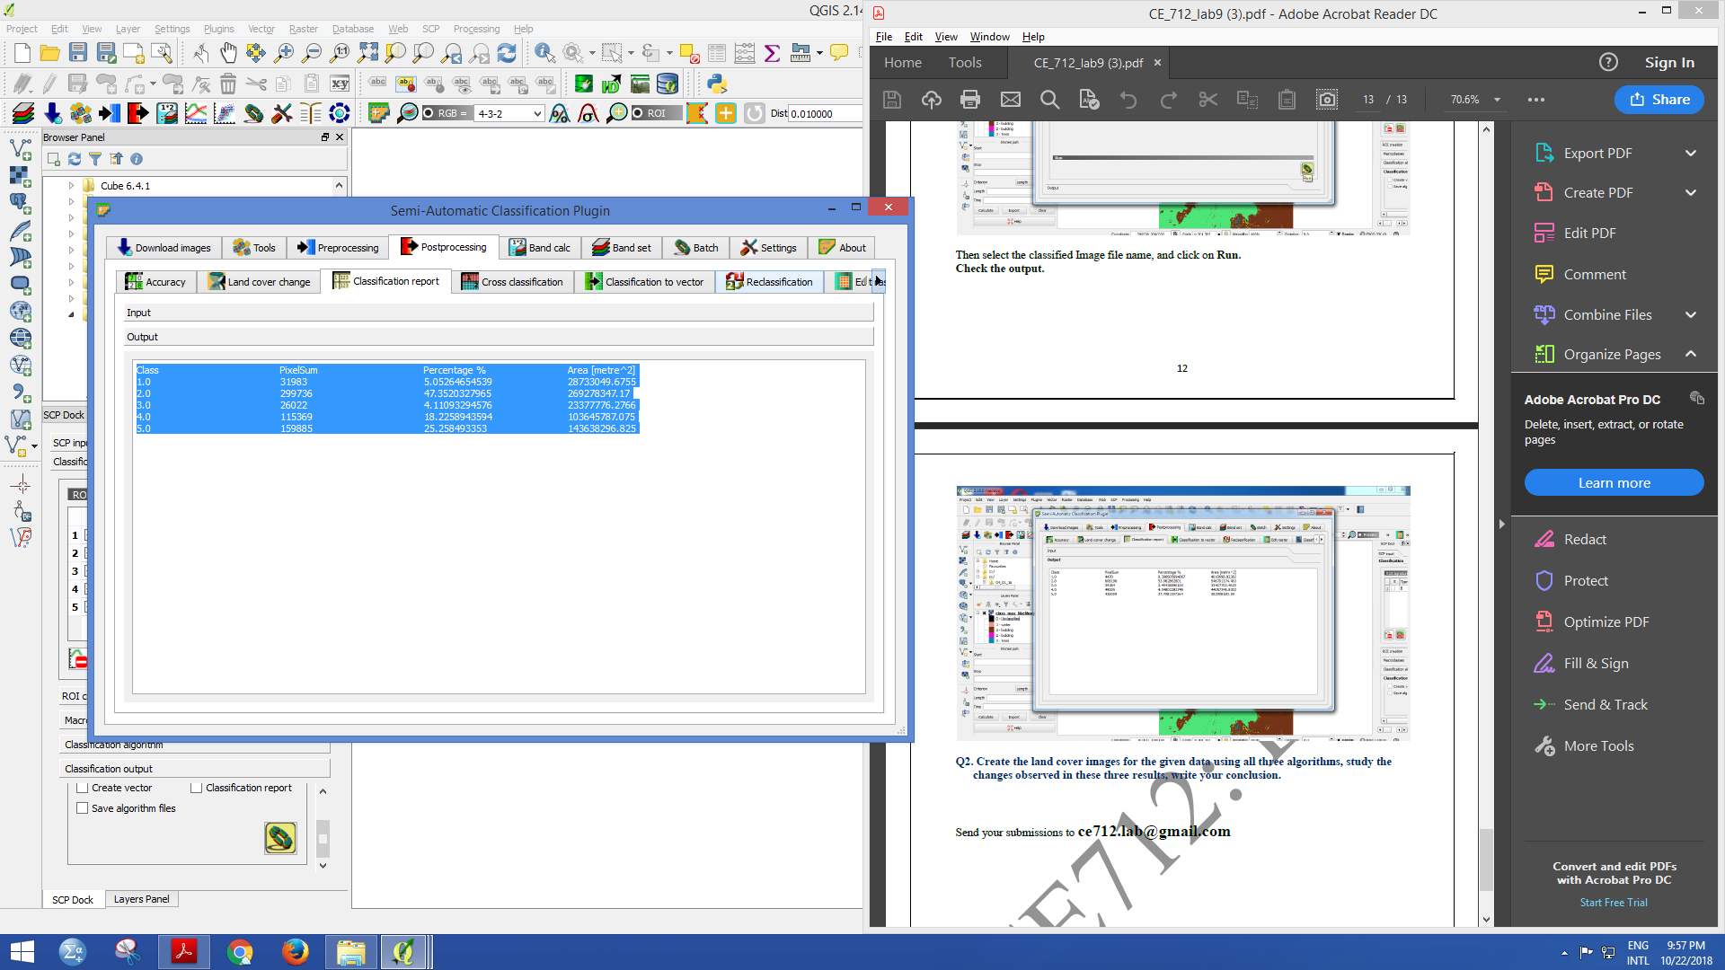

**Minimum Distance Method**

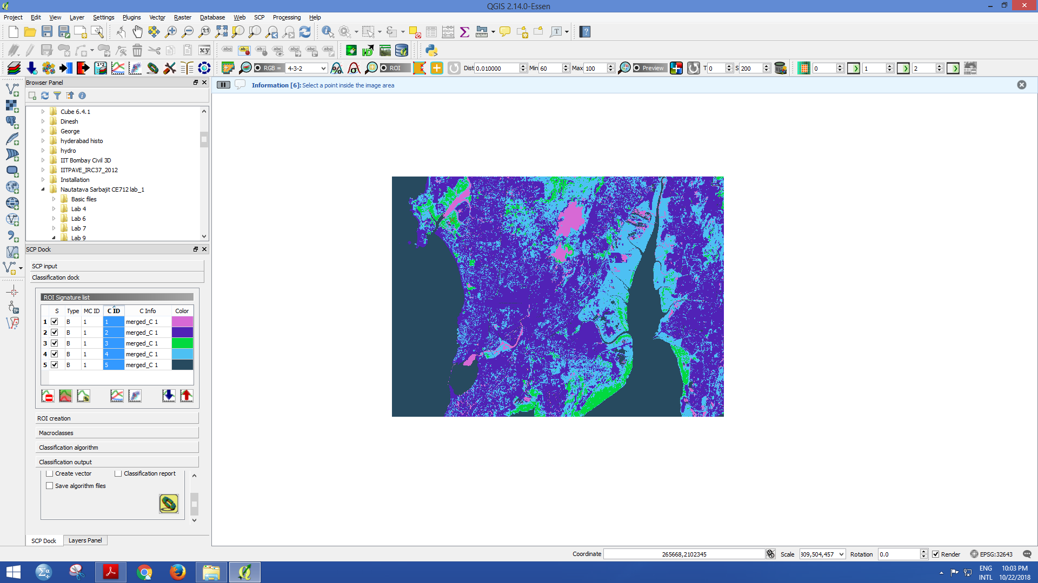

Number of pixels, total area, and percentage of a particular class in the Image

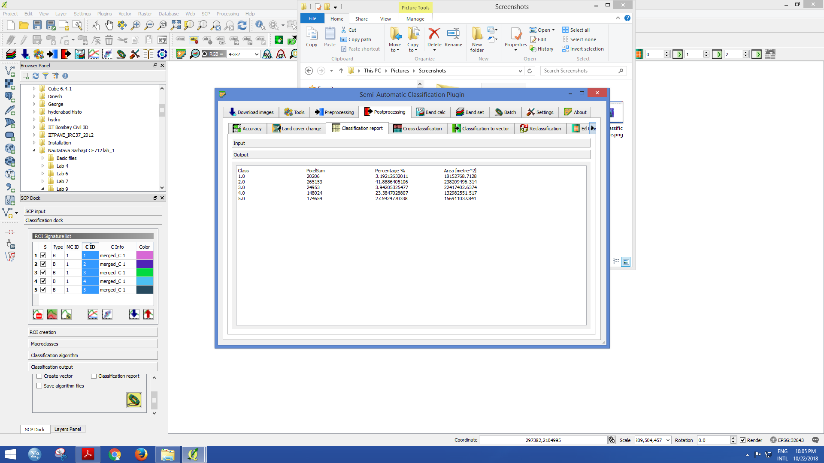

**Maximum Likelihood**

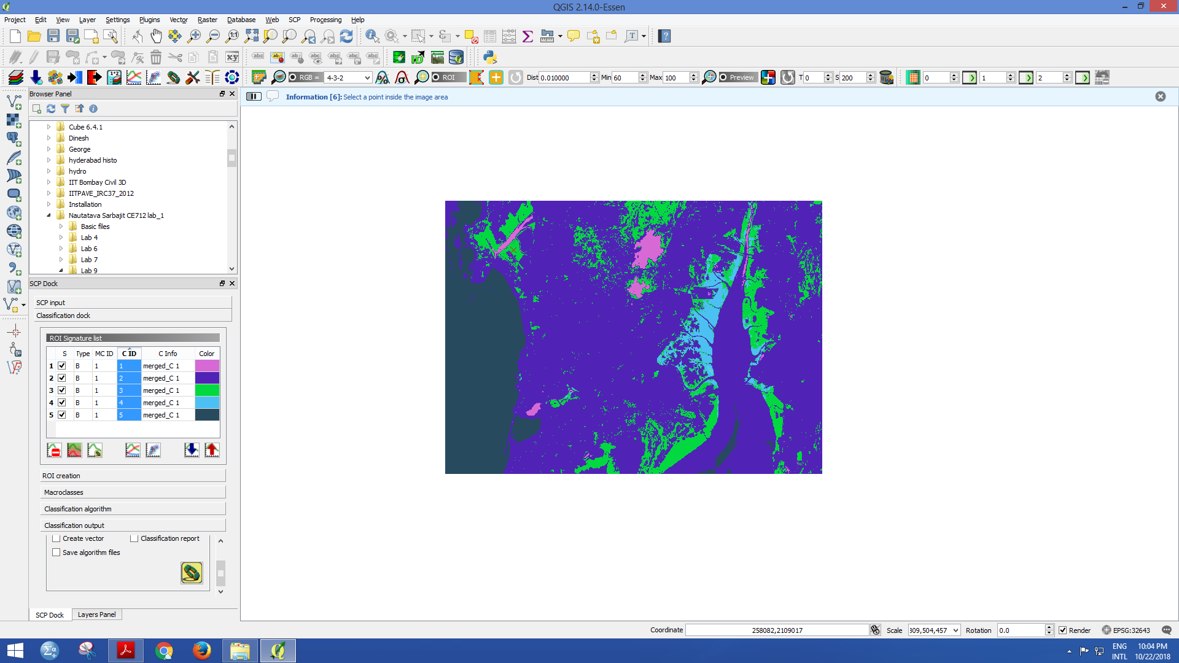

Number of pixels, total area, and percentage of a particular class in the Image

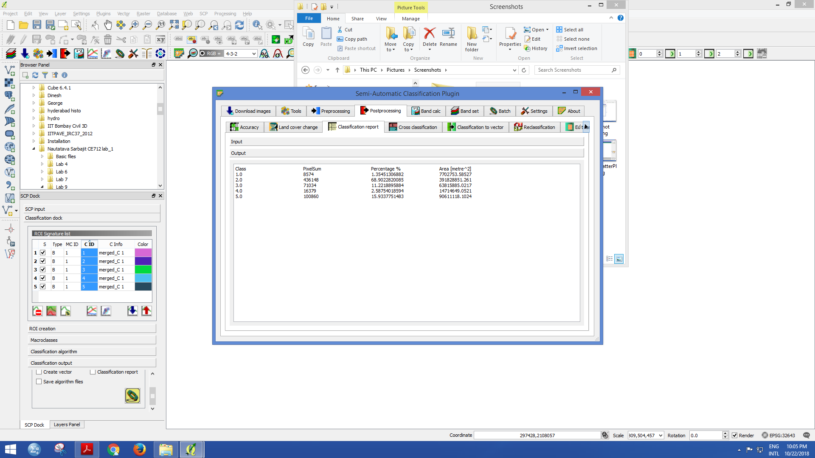

The Classified Image obtained through Spectral Angle Mapping Algorithm and that of Minimum Distance Algorithm are more similar to each other( percentage distribution of each class is similar) whereas classified image of Maximum Likelihood algorithm is quite different. The accuracy of the Maximum likelihood algorithm can be identified to be lowest(most of the pixels are assigned to class of Built-up). Minimum distance algorithm and Spectral angle mapping has good accuracy. The functioning of each algortithms are briefly explained in conclusion.

**CONCLUSION**

Image classification can be considered as a form of pattern recognition which involves identifying

the pattern associated with each pixel position in an image in terms of the characteristics of the

objects that are present at the corresponding point on the Earth’s surface.

**Image classification essentially consists of two stages:**

1. Recognition of real world objects[ For DIP, it can be woodlands, water bodies, grasslands, built up area, etc depending upon thegeographical scale and nature of study]

2. Labelling of the pixels

It refers to the task of extracting information classes from a [multiband](http://desktop.arcgis.com/en/arcmap/latest/manage-data/raster-and-images/raster-bands.htm#GUID-203F9D69-BEAB-4FF3-8153-336B5029F33E) raster image. The resulting raster from image classification can be used to create thematic maps.

In the Tutorial we got to learn about how to do **land cover classification using the Semi-Automatic Classification (SCP)in QGIS.** The SCP plugin has three algorithms; they are **minimum distance method**, **maximum likelihood method** and **Spectral Angle Mapping Algorithm.**

**Training Data** for each Class involves assembling statistics which closely describe the spectral response pattern of each land class type can be collected using Training polygons

**Spectral Angle Mapping**

The algorithm determines the spectral similarity between two spectra by calculating the angle between the spectra and treating them as vectors in a space with dimensionality equal to the number of bands.

**Minimum Distance Classifier Algorithm**

From the training data, the mean vector is calculated.To perform a minimum distance classification, a program must calculate the distance to each mean vector fromeach unknown pixel.

Many minimum-distance algorithms let the analyst specify a distance or threshold from the class mean beyond which a pixel will not be assigned to a category even though it is nearest to the mean of that category

**It is insensitive to different degrees of variance in the spectral response data.**

**Maximum Likelihood classifier Algorithm**

The maximum likelihood classifier evaluates both the variance and covariance while classifying. The probability density function is calculated for each class. It is assumed that the distribution of the cloud of points (i.e., DN numbers) forming the training data is Gaussian (normally distributed).

The probability of a pixel value belonging to each class is then calculated. The probability density functions are used to classify an unidentified pixel.