**KISAAN-NETRA**

**A Synopsis**

Submitted for the requirement of

**InnoTech – 2020**

*Submitted by*

Naveen Garg (Roll No: 02414504418)

Prateek Khanduri (Roll No: 02814504418)

Sarthak Avlash (Roll No: 03814504418)

*Under the guidance of*

Dr. Rekha Gupta

*(Associate Professor(Sr.))*



**Lal Bahadur Shastri Institute of Management (LBSIM)**

# **Dwarka, New Delhi**

**(2019)**

# **Contents**

**1. Introduction**

**2. Body of Proposal**

2.1 Objectives

2.2 Methodology & Modules

2.3 Requirements

2.3.1 Operating System

2.3.2 Technologies Used

2.3.3 Software Requirements

2.3.4 Hardware Requirements

**3. Advantages & Applications**

**4. Project Planning**

4.1 Use-Case Diagram

**References**

# **1. Introduction**

This project is aimed at providing weather advisory services to farmers based on the best available weather and climate information at their specific location to help improve the quality and quantity of food production in a sustainable manner.

Awareness of what the end user needs from a weather forecast and communicating it effectively is very important.

Although this project is for general use, but it is mainly being developed to aid the farmers in rural and remote areas of our country who does not have access to daily weather forecasts on television/radio.

**2. Body of Proposal**

**2.1 Objectives**

* To send **SMS Alerts** on Weather conditions and other advisory services..
* To send **Audio message/notification** for illiterate people.
* Provide notifications regarding the availability of seeds, grain, pulses and fertilizers/pesticides in government warehouses.

**2.2 Methodology & Modules**

* Providing the Weather and other advisory services to farmers based on the precise information at their location to help improve the quality and quantity of food production in a sustainable manner.
* Project is being developed for the **Farmers.** As most of the farmers live in the rural part of the country, hence retaining important information with respect to the weather and other pertinent issues such as what Manures, Fertilizers and Biocides to use is difficult.
* We will be notifying the farmers concerning all the relevant information, and making their life a little easier.

**2.3 Requirements**

**2.3.1 Operating System:**

* Microsoft Windows or MAC OS
  + 1. **Technologies Used:**
* Front End: HTML, CSS
* Back End: PHP
  + 1. **Software Requirements:**
* WampServer
* APACHE HTTP Server
  + 1. **Hardware Requirements:**
* Intel Pentium IV processor or equivalent or higher
* 512MB RAM or Higher
* 20GB HDD or Higher
* Network Connectivity

**3. Advantages & Applications**

* Our services will assist farmers with determining the best dates to plant, spray, irrigate or harvest.
* Expert consultants via our app will educate farmers regarding the usage of fertilisers and pesticides in right proportion.

**4. Project Planning**

**4.1 Use-Case Diagram**

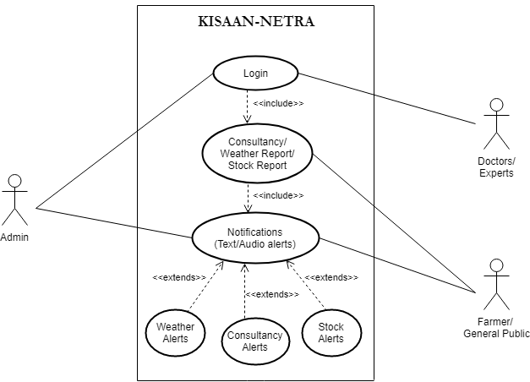

**References**

[1] “City Weather”, [online] http://www.imd.gov.in/pages/city_weather_main.php

[2] “Farmer’s Portal”, [online] https://farmer.gov.in/