Javascript Exercise

1. Prompt for amount, interest rate and no. of years and calculate simple interest.
Sol:-
Program File – ques1.html
var rate = prompt("Enter Interest rate","0");
var amt = prompt("Enter Amount", "0");
var year = prompt("Enter Number. Of Year", "0");

var simple_interest = (rate*amt*year)/100;
document.write("Simple Interest = "+ simple_interest);

Output:-

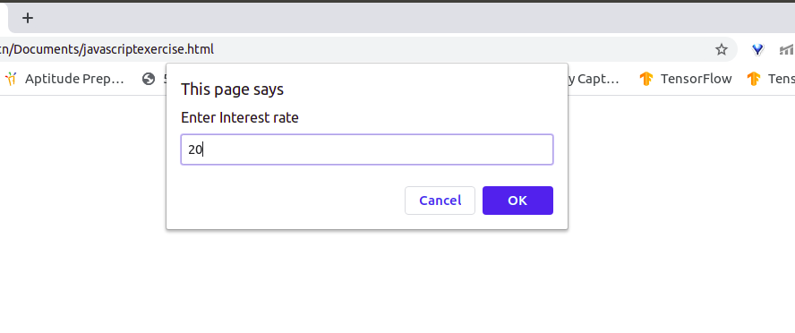
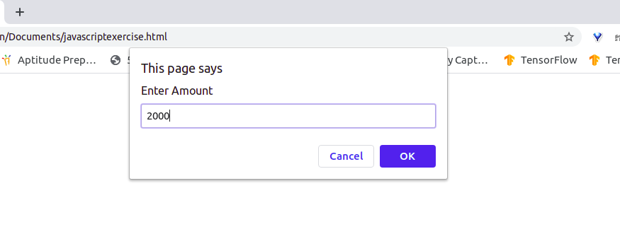
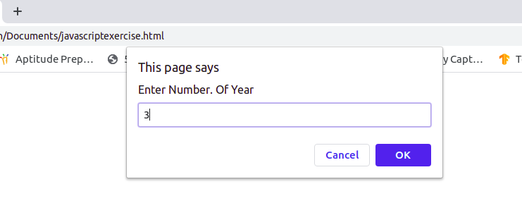
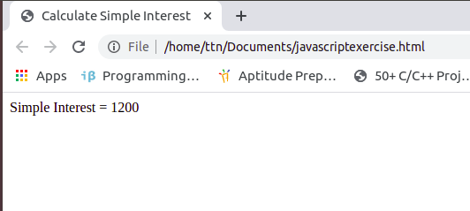

2. Is palindrome string
Sol:-
Program File – ques2.html

function checkPalindrome(str) {

const len = string.length;

for (let i = 0; i < len / 2; i++) {

if (string[i] !== string[len - 1 - i]) {
return 'It is not a palindrome';
}
}
return 'It is a palindrome';
}

const string = prompt('Enter a string: ');

const value = checkPalindrome(string);

document.write(value);

Output:-
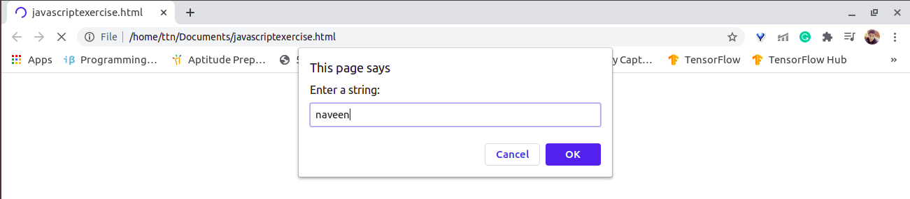

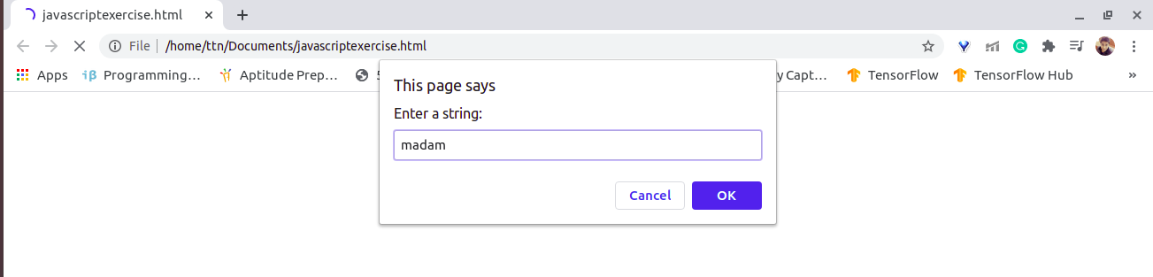
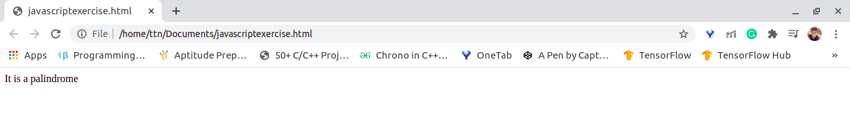
3. Area of circle
Sol:-
Program File – ques3.com
<html>
<head>
<title>Find the area and circumference of a circle</title>
</head>
<body>
<script language="JavaScript">
function CalculateArea(){
var radius =document.form1.txtRadius.value;
document.write("<P>The area of the circle is " + (radius * radius * Math.PI) + "</p>");
}
</script>
<form name=form1>
Enter the radius of circle:
<input type="text" name="txtRadius" size=10>
<br>
<input type="button" value="Calculate" onClick='CalculateArea();'>
</form>
</script>
</body>
</html>

Output:-
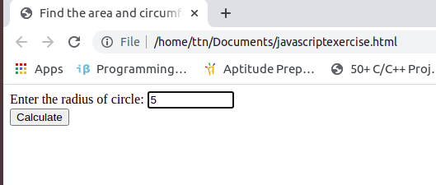
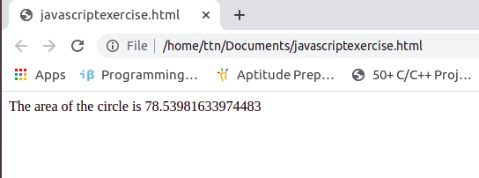

4. Copy information of one object to another and log it to console.
Sol:-
Program File – ques4.html
In javascript three way to copy information of one objet to another
1) Object.assign({}, sourceObj);
var sourceObj = {
age :1,
gender: 'male',
hobbies: ['cricket', 'carrom', 'chess']
}

var copiedObj = Object.assign({}, sourceObj);
copiedObj.age = '100';
copiedObj.hobbies[0] = 'Coding';
console.log(copiedObj, sourceObj)
Output:-
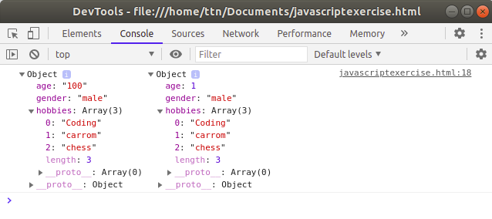
2) Spread operator{...Obj}
var sourceObj1 = {
age :1,
gender: 'male',
hobbies: ['cricket', 'carrom', 'chess']
}
var spreadObj = {...sourceObj1};
spreadObj.age = '100';
spreadObj.hobbies[0] = 'dancing';
console.log(spreadObj, sourceObj1)
Output:-
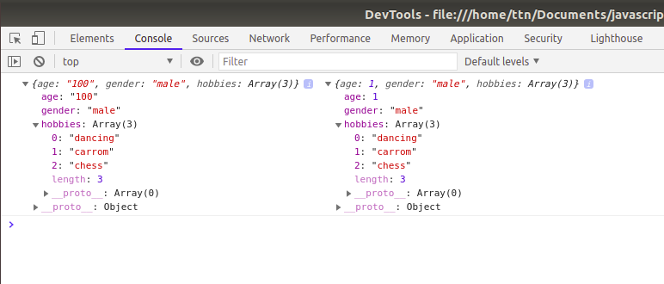
3) JSON.parse(JSON.sringify(Array1));
var sourceObj2 = {
age :1,
gender: 'male',
hobbies: ['cricket', 'carrom', 'chess']
}
var parseObj = JSON.parse(JSON.stringify(sourceObj2))
parseObj.age = '100';
parseObj.hobbies[0] = 'Singing';
console.log(parseObj, sourceObj2)
Output:-
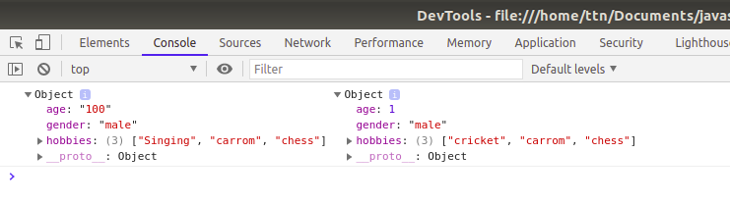

5. create a list of objects of Employee with info as follow :
a) Name, age, salary ,DOB
b) filter all employees with salary greater than 5000
c) group employee on the basis of their age
d) fetch employees with salary less than 1000 and age greater than 20. Then give them an increment 5 times their salary.
Sol:-
Program File – ques5.html

Output:-
a)
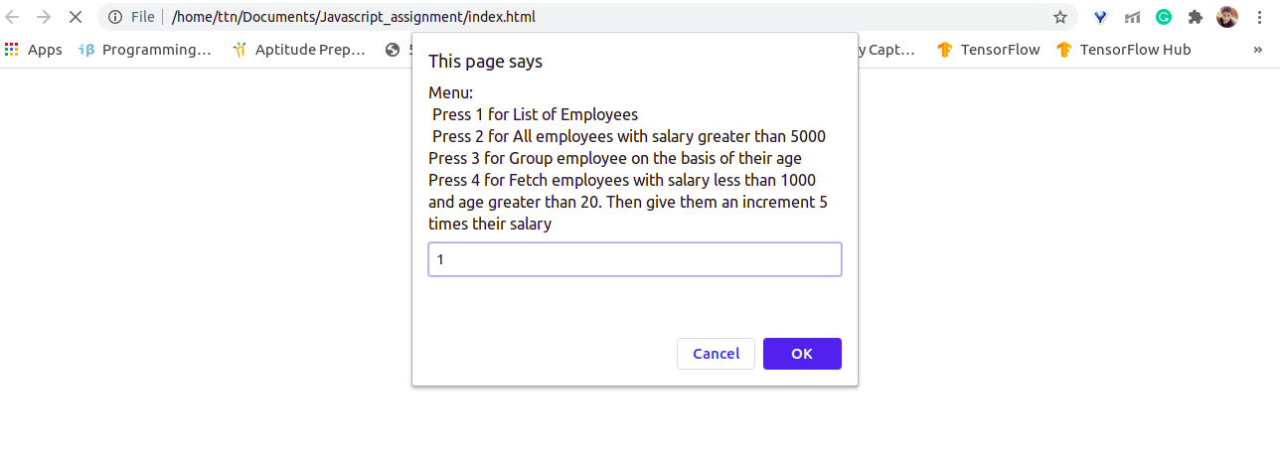
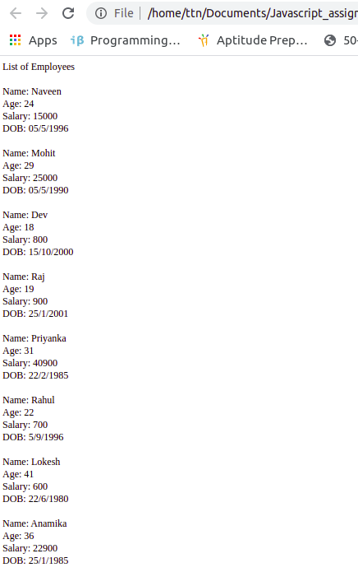

b) 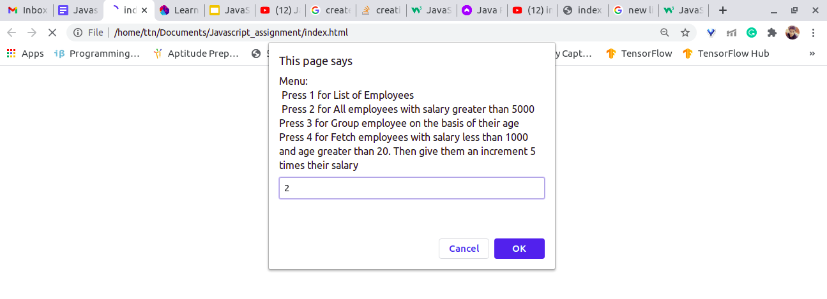
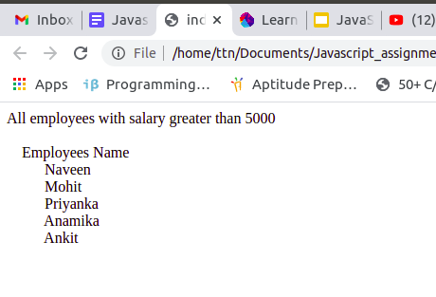
c)
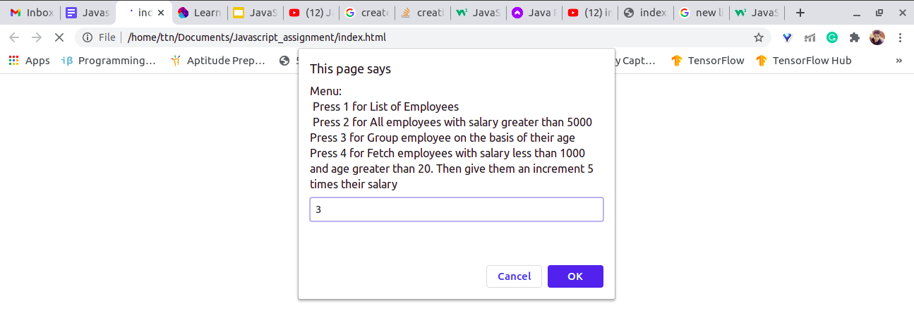
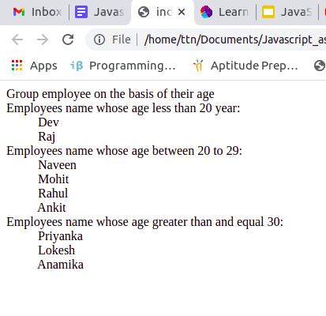
d)
