HTML Exercise

1.How are inline and block elements different from each other?
Sol;-
Inline Elements
An inline element does not start on a new line. An inline element only takes up as much
width as necessary.
This is a <span> element inside paragraph.

Example -
<!DOCTYPE html>
<html>
<body>
<p>This is an inline span <span style="border: 1px solid black">Hello World</span>
element inside a
paragraph.</p>
<p>The SPAN element is an inline element, and will not start on a new line.</p>
</body>
</html>
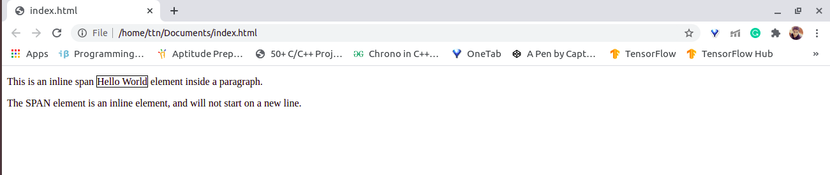

Block-level Elements
A block-level element always starts on a new line.
A block-level element always takes up the full width available (stretches out to the left
and right as far as it can).
A block level element has a top and a bottom margin, whereas an inline element does not.
The <div> element is a block-level element.
Example-
<!DOCTYPE html>
<html>
<body>
<div style="border: 1px solid black">Hello World</div>
<p>The DIV element is a block element, and will always start on a new line.</p>
</body>
</html>
Output-
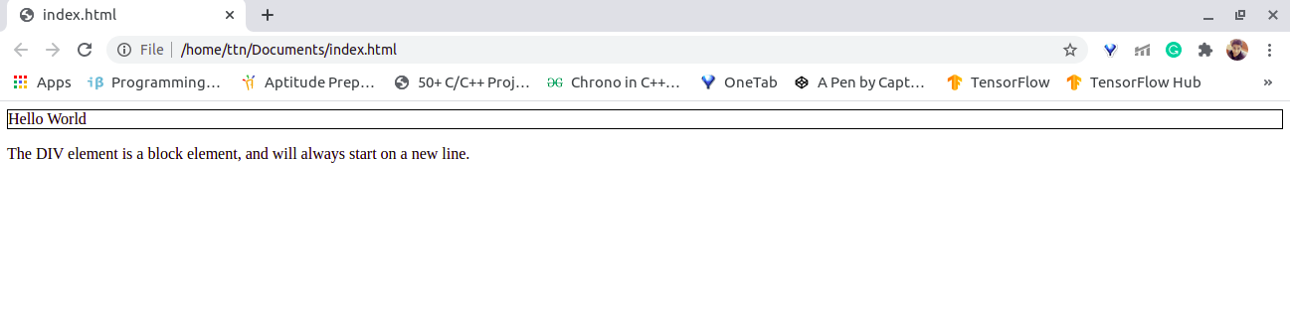

2.Explain the difference between visibility:hidden and display:none
Sol:-
visibility: hidden
The visibility: hidden property also hides an element, but affects the layout i.e. takes up
space.
Example:
<!DOCTYPE html>
<html>
<head>
<style>
h3 {
visibility: hidden;
}
</style>
</head>
<body>
<h2>This heading is visible</h2>
<h3>This is a hidden heading</h3>
<p>The hidden heading takes up space even after hiding it.</p>
</body>
</html>

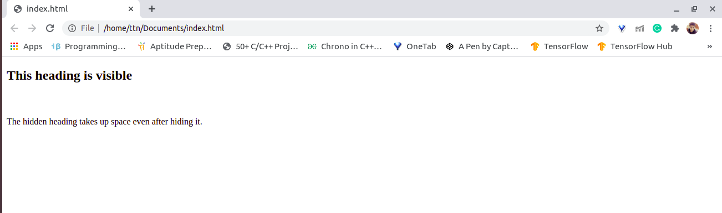

display: none

The display: none property is used to hide elements without deleting them. It does not
take up any space.

Example:-
<!DOCTYPE html>
<html>
<head>
<style>
h3 {
display: none;
}
</style>
</head>
<body>
<h2>This heading is visible</h2>
<h3>This is a hidden heading</h3>
<p>The hidden heading does not take up space even after hiding it since we have used
display: none;.</p>
</body>
</html>

Output:
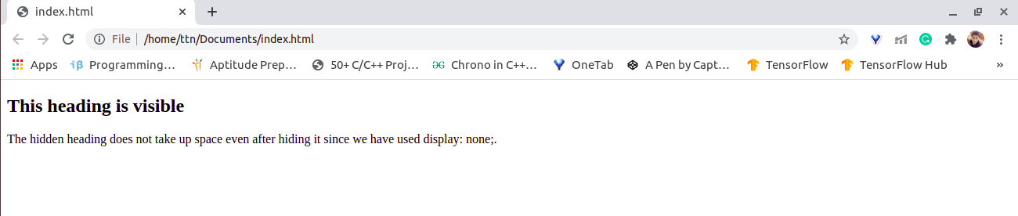

3. Explain the clear and float properties.
Sol:-
The clear Property
The clear property specifies what elements can float beside the cleared element and on
which side.
The clear property can have one of the following values:
- none - Allows floating elements on both sides. This is default
- left - No floating elements allowed on the left side
- right- No floating elements allowed on the right side
- both - No floating elements allowed on either the left or the right side
- inherit - The element inherits the clear value of its parent
Example:
<!DOCTYPE html>
<html>
<head>
<style>

.div1 {
float: left;
width: 100px;
height: 50px;
margin: 10px;
border: 3px solid #73AD21;
}
.div2 {
border: 1px solid red;
clear: left;
}
</style>
</head>
<body>
<h2>With clear</h2>
<div class="div1">div1</div>
<div class="div2">div2 - Here, clear: left; moves div2 down below the floating div1. The
value "left" clears
elements floated to the left. You can also clear "right" and "both".</div>
</body>
</html>
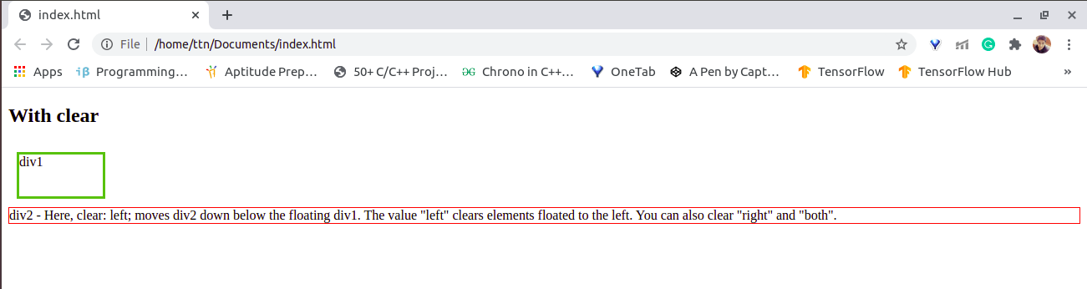

The float Property
The float property is used for positioning and formatting content e.g. let an image float
left to the text in a container.
The float property can have one of the following values:
- left - The element floats to the left of its container
- right - The element floats to the right of its container
- none - The element does not float (will be displayed just where it occurs in the text). This is default
- inherit - The element inherits the float value of its parent
Example
<!DOCTYPE html>
<html>
<head>
<style>
img {
float: right;
}
</style>
</head>
<body>

<h2>Float Right</h2>

<p>In this example, the image will float to the right in the paragraph, and the text in the
paragraph will wrap around the image.</p>
<p><img src="images.jpeg" alt="ttn"
style="width:170px;height:170px;margin-left:15px;">
TO THE NEW is a digital technology company providing digital transformation and
product engineering services to ISVs, Consumer Internet, and large enterprises across the
globe.We design & build digital platforms and products with Cloud and Data at the focal
point by working
on cutting-edge technologies.</p>
</body>
</html>

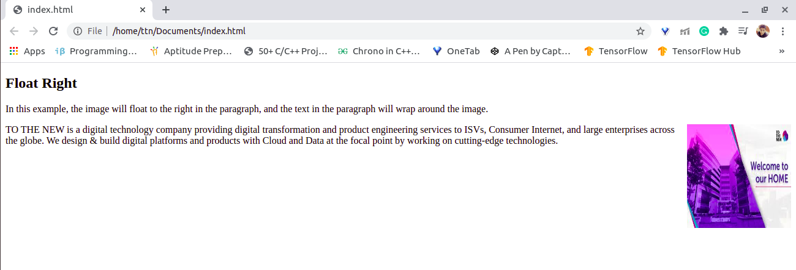

4. Explain difference between absolute, relative,fixed and static.
Sol:-
Absolute
An element with position: absolute; is positioned relative to the nearest positioned
ancestor (instead of positioned relative to the viewport, like fixed).
However; if an absolute positioned element has no positioned ancestors, it uses the
document body, and moves along with page scrolling.

Relative
An element with position: relative; is positioned relative to its normal position.
Setting the top, right, bottom, and left properties of a relatively-positioned element will
cause it to be adjusted away from its normal position. Other content will not be adjusted
to fit into any gap left by the element.

Ex-
<!DOCTYPE html>
<html>
<head>
<style>
div.relative {
position: relative;
width: 400px;
height: 200px;
border: 3px solid #73AD21;
}
div.absolute {
position: absolute;
top: 80px;
right: 0;
width: 200px;
height: 100px;
border: 3px solid #73AD21;
}
</style>
</head>
<body>
<h2>position: absolute; position: relative;</h2>
<p>An element with position: absolute; is positioned relative to the nearest positioned
ancestor (instead of positioned relative to the viewport, like fixed):</p>
<div class="relative">This div element has position: relative;
<div class="absolute">This div element has position: absolute;</div>
</div>
</body>
</html>
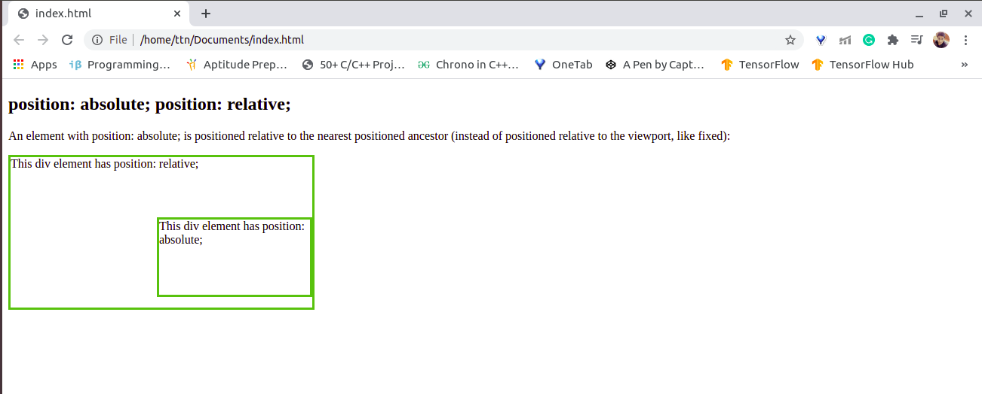

Static
HTML elements are positioned static by default.
Static positioned elements are not affected by the top, bottom, left, and right properties.
An element with position: static; is not positioned in any special way; it is always
positioned according to the normal flow of the page:

Example
<!DOCTYPE html>
<html>
<head>
<style>
div.static {
position: static;
border: 3px solid #73AD21;
}
</style>
</head>
<body>
<h2>position: static;</h2>
<p>An element with position: static; is not positioned in any special way; it is
always positioned according to the normal flow of the page:</p>
<div class="static">
This div element has position: static;
</div>
</body>
</html>
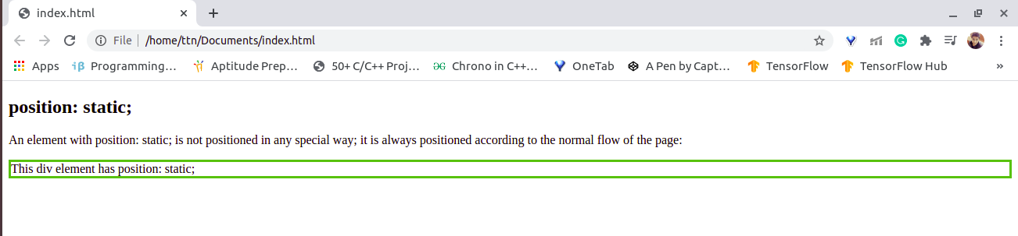

Fixed
An element with position: fixed; is positioned relative to the viewport, which means it
always stays in the same place even if the page is scrolled. The top, right, bottom, and left
properties are used to position the element.
A fixed element does not leave a gap in the page where it would normally have been
located.
Example
<!DOCTYPE html>
<html>
<head>
<style>
div.fixed {
position: fixed;
bottom: 0;
right: 0;
width: 300px;
border: 3px solid #73AD21;
}
</style>
</head>
<body>

<h2>position: fixed;</h2>

<p>An element with position: fixed; is positioned relative to the viewport, which means
it always stays in the same place even if the page is scrolled:</p>

<div class="fixed">
This div element has position: fixed;
</div>

</body>
</html>

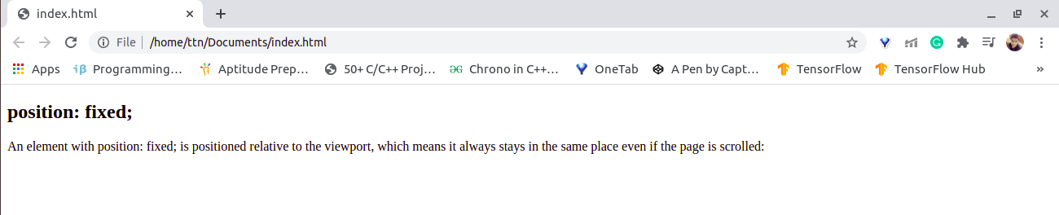

5. Write the HTML code to create a table in which there are 4 columns( ID ,
Employee Name, Designation, Department) and at least 6 rows. Also do some styling
to it.

<!DOCTYPE html>
<html>
<head>
<style>
table, th, td {
border: 1px solid black;
border-collapse: collapse;
}
th, td {
padding: 5px;
text-align: left;
}
</style>
</head>
<body>

<h2>Database</h2>

<table style="width:100%">
<tr>
<th>ID</th>
<th>Employee Name</th>
<th>Designation</th>
<th>Department</th>
</tr>
<tr>
<td>1245</td>
<td>Bill Gates</td>
<td>SDE</td>
<td>development</td>
</tr>
<tr>
<td>1248</td>
<td>Mukul</td>
<td>SDET</td>
<td>Testing</td>
</tr>
<tr>
<td>1425</td>
<td>Raj</td>
<td>SDE</td>
<td>IT</td>
</tr>
<tr>
<td>1545</td>
<td>Naveen Garg</td>
<td>SDE-1</td>
<td>Development</td>
</tr>
<tr>
<td>1645</td>
<td>Rahul</td>
<td>HR</td>
<td>HR Development</td>
</tr>
<tr>
<td>1345</td>
<td>Bill</td>
<td>CEO</td>
<td>Management</td>
</tr>
<tr>
<td>1447</td>
<td>Mohit</td>
<td>SDET</td>
<td>Testing</td>
</tr>
</table>

</body>
</html>
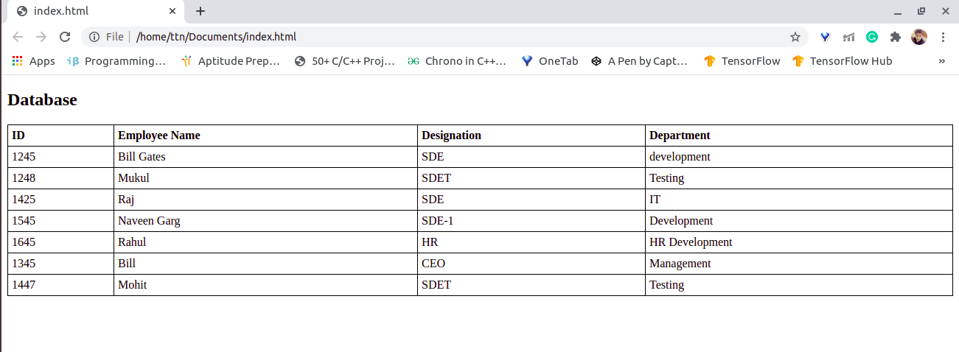

6. Why do we use meta tags?
Sol-
HTML lets you specify metadata - additional important information about a document in
a variety of ways. The meta elements can be used to include name/value pairs
describing properties of the HTML document, such as author, expiry date, a list of
keywords, document author etc.
The meta tag is used to provide such additional information. This tag is an empty
element and so does not have a closing tag but it carries information within its
attributes.

7. Explain box model.
Sol-
Box model is a container which contains multiple properties including borders, margin,
padding and the content itself. It is used to create the design and layout of web pages. It
can be used as a toolkit for customizing the layout of different elements. The web
browser renders every element as a rectangular box according to the CSS box model.
Box-Model has multiple properties in CSS. Some of them are given below:
- borders
- margins
- padding
- Content
Example:-
<!DOCTYPE html>
<html>
<head>
<style>
div {
background-color: lightgrey;
width: 300px;
border: 15px solid green;
padding: 50px;
margin: 20px;
}
</style>
</head>
<body>

<h2>Demonstrating the Box Model</h2>

<p>The CSS box model is essentially a box that wraps around every HTML element. It
consists of:
borders, padding, margins, and the actual content.</p>

<div>This text is the content of the box. We have added a 50px padding, 20px margin
and a 15px green border.</div>

</body>
</html>

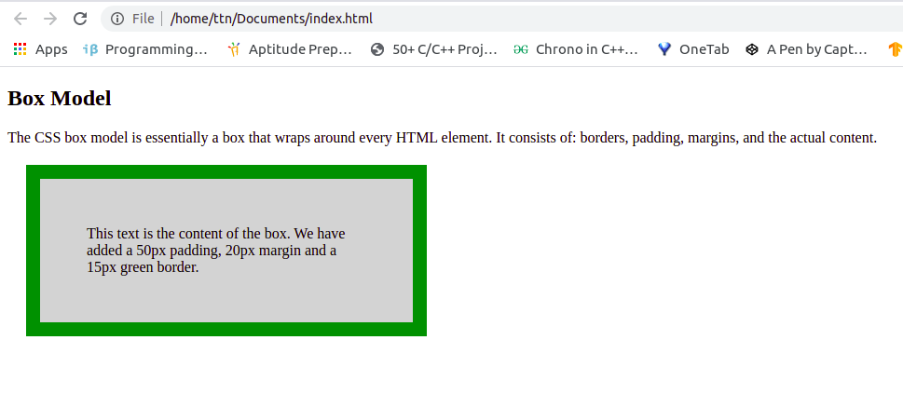

8. What are the different types of CSS Selectors?
CSS selectors are used to select the content you want to style. Selectors are the part of
CSS rule set. CSS selectors select HTML elements according to its id, class, type,
attribute etc.

There are several different types of selectors in CSS.
1.CSS Element Selector
The element selector selects the HTML element by name.
2.CSS Id Selector
The id selector selects the id attribute of an HTML element to select a specific element. An id is always unique within the page so it is chosen to select a single, unique element.
It is written with the hash character (#), followed by the id of the element.

3.CSS Class Selector
The class selector selects HTML elements with a specific class attribute. It is used with a
period character . (full stop symbol) followed by the class name.

4.CSS Universal Selector
The universal selector is used as a wildcard character. It selects all the elements on the
pages.

5. CSS Group Selector
The grouping selector is used to select all the elements with the same style definitions.
Grouping selector is used to minimize the code. Commas are used to separate each
selector in grouping.

9. Define Doctype.
Sol-
A doctype or document type declaration is an instruction that tells the web browser about
the markup language in which the current page is written. The Doctype is not an element
or tag, it lets the browser know about the version of or standard of HTML or any other
markup language that is being used in the document.
Declaration of a Doctype: A DOCTYPE declaration appears at the top of a web page
before all other
elements.
The DOCTYPE for HTML5 is case-insensitive and can be written as shown below:
< !DOCTYPE html >

10. Explain 5 HTML5 semantic tags.
Sol-
1. section tag
The <section>element defines a section in a document.
According to W3C's HTML documentation: "A section is a thematic grouping of content,
typically with a heading."
A web page could normally be split into sections for introduction, content, and contact
information.

2. article tag
The <article>element specifies independent, self-contained content.
An article should make sense on its own, and it should be possible to distribute it
independently from the rest of the web site.
Examples of where an <article> element can be used:
- Forum post
- Blog post
- Newspaper article

3. header tag
The <header>element represents a container for introductory content or a set of
navigational links.
A <header>element typically contains:
- one or more heading elements (<h1> - <h6>)
- logo or icon
- authorship information

4. footer tag
The <footer>element defines a footer for a document or section.
A <footer>element typically contains:
- authorship information
- copyright information
- contact information
- sitemap
- back to top links
- related documents

5. nav tag
The <nav>element defines a set of navigation links.

11. Create HTML for web-page.jpg
Sol- Program file - ques11(webp.html and Style.css )
Output-
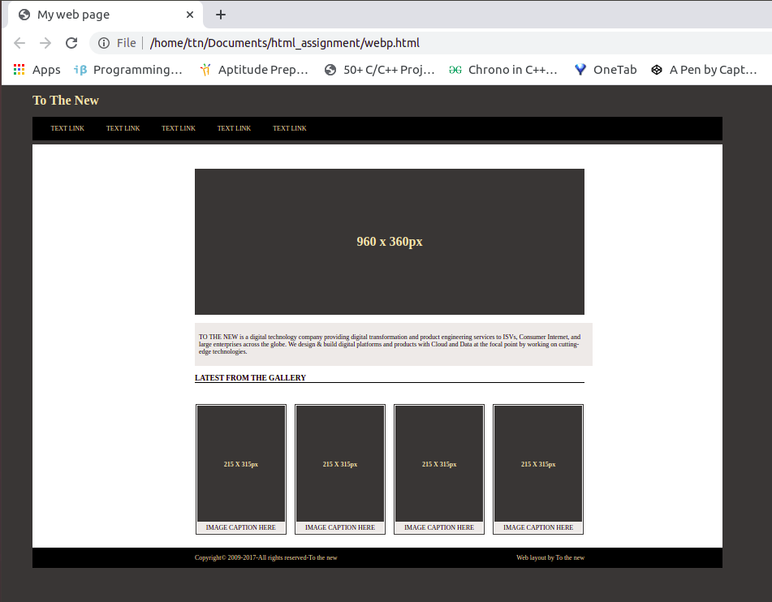

12. Create HTML for form.png
Sol-
Program file - ques12 (index.html and style.css page)

Output:-
