Collections Exercise

1. Write Java code to define List . Insert 5 floating point numbers in List, and using an iterator, find the sum of the numbers in List.
Sol – Program File Folder name – program1

import java.util.*;

class Ques1
{
public static void main(String args[])
{
List<Float> al = new ArrayList<Float>();
al.add(10.4f);
al.add(20.5f);
al.add(30.1f);
al.add(40.7f);
al.add(50.4f);
al.add(60.3f);

System.out.println("Floating values in the list:");
float sum = 0f;
Iterator i = al.iterator();
while(i.hasNext())
{
float x = (float)i.next();
System.out.println(x);
sum = sum + x;
}

System.out.println("Total Sum: "+ sum);
}
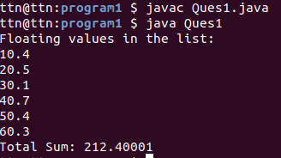

2.Write a method that takes a string and returns the number of unique characters in the string.
Sol – Program File Folder name – program2
import java.util.*;

public class Ques2 {
public static int uniqueChar(String s1){
StringBuffer sb = new StringBuffer(s1);
for (int i = 0; i < sb.length(); i++) {
int count = 0;
for (int j = i + 1; j < sb.length(); j++) {
if (sb.charAt(i) == sb.charAt(j)) {
sb.deleteCharAt(j);
j--;
count++;
}
}
if (count >= 1) {
sb.deleteCharAt(i);
i--;
}
}
int val = sb.length();
return val;
}

public static void main(String[] args){
Scanner sc = new Scanner(System.in);
System.out.println("Enter String:");
String str = sc.nextLine();
int v = uniqueChar(str);
System.out.println("Number of unique characters in the string: "+ v);
}
}
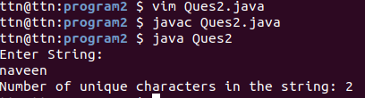

3.Write a method that takes a string and print the number of occurrence of each character characters in the string.
Sol – Program File Folder name – program3
import java.util.*;
class Ques3 {
static final int MAX_CHAR = 256;

static void occuringChar(String str)
{
int count[] = new int[MAX_CHAR];
int len = str.length();
for (int i = 0; i < len; i++)
count[str.charAt(i)]++;

char ch[] = new char[str.length()];
for (int i = 0; i < len; i++) {
ch[i] = str.charAt(i);
int find = 0;
for (int j = 0; j <= i; j++) {
if (str.charAt(i) == ch[j])
find++;
}

if (find == 1)
System.out.println("Number of Occurrence of "+ str.charAt(i)+ " is:" + count[str.charAt(i)]);
}
}

public static void main(String[] args)
{
Scanner sc = new Scanner(System.in);
System.out.println("Enter String:");
String str = sc.nextLine();
occuringChar(str);
}
}
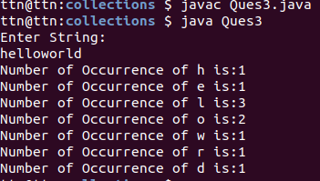

4. Write a program to sort Employee objects based on highest salary using Comparator. Employee class{ Double Age; Double Salary; String Name
Sol – Program File Folder name – program4
import java.util.ArrayList;
import java.util.Collections;
import java.util.List;
import java.util.Comparator;

class Employee {
public int empAge;
public String empName;
public double empSalary;

public Employee(int empAge, String empName, double empSalary) {
this.empAge = empAge;
this.empName = empName;
this.empSalary = empSalary;
}

}

class EmployeeSortBySalary implements Comparator < Employee > {
public int compare(Employee emp1, Employee emp2) {
int value = 0;
if (emp1.empSalary > emp2.empSalary)
value = 1;
else if (emp1.empSalary < emp2.empSalary)
value = -1;
else if (emp1.empSalary == emp2.empSalary)
value = 0;

return value;
}
}

public class ques4 {

public static void main(String[] args) {
List <Employee> employees = new ArrayList <Employee> ();
employees.add(new Employee(22, "Dinesh", 18000));
employees.add(new Employee(24, "Pankaj", 19000));
employees.add(new Employee(28, "Mayur", 14000));
employees.add(new Employee(32, "Pravin", 22000));

System.out.println("Sort By Employee Salary");
Collections.sort(employees, new EmployeeSortBySalary());

printEmployees(employees);
}

public static void printEmployees(List <Employee> employees) {
for (Employee e: employees) {
System.out.println("Age:" + e.empAge + " Name:" + e.empName + " Salary:" + e.empSalary);
}
}

}
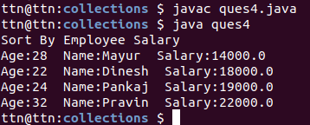

5. Write a program to sort the Student objects based on Score , if the score are same then sort on First Name . Class Student{ String Name; Double Score; Double Age
Sol – Program File Folder name – program5
import java.util.*;
import java.util.ArrayList;
import java.util.Collections;
import java.util.List;
import java.util.Comparator;

class Student{
public double age;
public String fname;
public double score;
public Student(double age, String fname, double score) {
this.age = age;
this.fname = fname;
this.score = score;
}
}

class StudentSortByScore implements Comparator < Student > {
public int compare(Student s1, Student s2) {
if(s2.score>s1.score){
return 1;
}else if(s2.score<s1.score){
return -1;
}
return s1.fname.compareTo(s2.fname);
}
}

public class Ques5
{
public static void main(String[] args){
List<Student> studentList = new ArrayList<Student>();

studentList.add(new Student(22, "Naveen", 190.5));
studentList.add(new Student(22, "Dinesh", 180.4));
studentList.add(new Student(24, "Pankaj", 190.5));
studentList.add(new Student(28, "Rahul", 140.0));
studentList.add(new Student(32, "Ankit", 175.3));
System.out.println("Sort the Student objects based on Score , if the score are same then sort on First Name");

Collections.sort(studentList, new StudentSortByScore());

printEmployees(studentList);
}

public static void printEmployees(List <Student> studentList) {
for (Student s: studentList) {
System.out.println("Age:" + s.age + " Name:" + s.fname + " Salary:" + s.score);
}

}
}
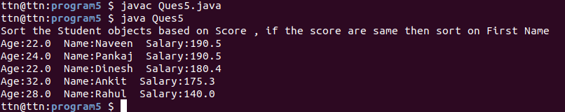
6.Print the elements of an array in the decreasing frequency if 2 numbers have same frequency then print the one which came first.
Sol – Program File Folder name – program6
import java.util.*;

public class Ques6 {
public static void main(String[] args)
{
int[] array = { 4, 4, 2, 2, 2, 2, 3, 3, 1, 1, 7, 7, 5,10 };

Map<Integer, Integer> map = new HashMap<>();
List<Integer> outputArray = new ArrayList<>();

for (int current : array) {
int count = map.getOrDefault(current, 0);
map.put(current, count + 1);
outputArray.add(current);
}

SortComparator comp = new SortComparator(map);
Collections.sort(outputArray, comp);
for (Integer i : outputArray) {
System.out.print(i + " ");
}
System.out.print("\n");
}
}

class SortComparator implements Comparator<Integer> {
private final Map<Integer, Integer> freqMap;

SortComparator(Map<Integer, Integer> tFreqMap)
{
this.freqMap = tFreqMap;
}

public int compare(Integer k1, Integer k2)
{
int freqCompare = freqMap.get(k2).compareTo(freqMap.get(k1));
int valueCompare = k1.compareTo(k2);

// If frequency is equal, then just compare by value, otherwise compare by the frequency
if (freqCompare == 0)
return valueCompare;
else
return freqCompare;
}
}
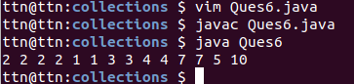

7.Design a Data Structure SpecialStack that supports all the stack operations like push(), pop(), isEmpty(), isFull() and an additional operation getMin() which should return minimum element from the SpecialStack. (Expected complexity O(1))
Sol – Program File Folder name – program7
import java.util.*;

class SpecialStack
{
Stack<Integer> s;
Integer minEle;

SpecialStack() {
s = new Stack<Integer>();
}

void getMin()
{
if (s.isEmpty())
System.out.println("Stack is empty");

else
System.out.println("Minimum Element in the " +
" stack is: " + minEle);
}

void peek()
{
if (s.isEmpty())
{
System.out.println("Stack is empty ");
return;
}

Integer t = s.peek();
System.out.print("Top Most Element is: ");

if (t < minEle)
System.out.println(minEle);
else
System.out.println(t);
}

// Removes the top element
void pop()
{
if (s.isEmpty())
{
System.out.println("Stack is empty");
return;
}

System.out.print("Top Most Element Removed: ");
Integer t = s.pop();

if (t < minEle)
{
System.out.println(minEle);
minEle = 2*minEle - t;
}

else
System.out.println(t);
}

void push(Integer x)
{
if (s.isEmpty())
{
minEle = x;
s.push(x);
System.out.println("Number Inserted: " + x);
return;
}

if (x < minEle)
{
s.push(2*x - minEle);
minEle = x;
}

else
s.push(x);

System.out.println("Number Inserted: " + x);
}
};

public class Ques7
{
public static void main(String[] args)
{
SpecialStack s = new SpecialStack();
s.push(21);
s.push(50);
s.push(15);
s.push(34);
s.getMin();
s.push(20);
s.push(4);
s.getMin();
s.pop();
s.getMin();
s.pop();
s.peek();
}
}
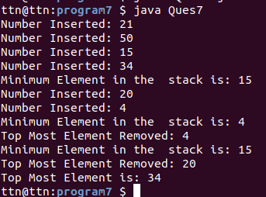

8. Write a program to format date as example "21-March-2016"
Sol – Program File Folder name – program8
import java.text.ParseException;
import java.text.SimpleDateFormat;
import java.util.Date;
import java.util.Locale;

public class Ques8 {
public static void main(String[] args) {
Date date = new Date();
SimpleDateFormat formatter = new SimpleDateFormat("MM/dd/yyyy");
String strDate = formatter.format(date);
System.out.println("Date Format with MM/dd/yyyy : "+strDate);

formatter = new SimpleDateFormat("dd-MMMM-yyyy");
strDate = formatter.format(date);
System.out.println("Date Format with dd-MMMM-yyyy : "+strDate);

formatter = new SimpleDateFormat("dd-M-yyyy hh:mm:ss");
strDate = formatter.format(date);
System.out.println("Date Format with dd-M-yyyy hh:mm:ss : "+strDate);

formatter = new SimpleDateFormat("dd MMMM yyyy");
strDate = formatter.format(date);
System.out.println("Date Format with dd MMMM yyyy : "+strDate);

formatter = new SimpleDateFormat("dd MMMM yyyy zzzz");
strDate = formatter.format(date);
System.out.println("Date Format with dd MMMM yyyy zzzz : "+strDate);

formatter = new SimpleDateFormat("E, dd MMM yyyy HH:mm:ss z");
strDate = formatter.format(date);
System.out.println("Date Format with E, dd MMM yyyy HH:mm:ss z : "+strDate);
}
}
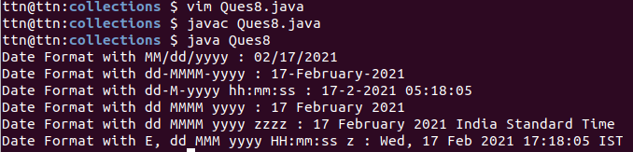
9.Write a program to display times in different country format.
Sol – Program File Folder name – program9
import java.text.DateFormat;
import java.text.SimpleDateFormat;
import java.util.Date;
import java.util.TimeZone;

public class Ques9{

public static void main(String args[]) {

Date today = new Date();
DateFormat df = new SimpleDateFormat("dd-MM-yy HH:mm:SS z");

df.setTimeZone(TimeZone.getTimeZone("Asia/Kolkata"));
String IST = df.format(today);
System.out.println("Date in Indian Timezone (IST) : " + IST);

df.setTimeZone(TimeZone.getTimeZone("America/Los_Angeles"));
String PST = df.format(today);
System.out.println("Date in PST Timezone : " + PST);

df.setTimeZone(TimeZone.getTimeZone("Australia/Sydney"));
String AET = df.format(today);
System.out.println("Date in AET Timezone : " + AET);

df.setTimeZone(TimeZone.getTimeZone("Africa/Cairo"));
String ART = df.format(today);
System.out.println("Date in ART Timezone : " + ART);

df.setTimeZone(TimeZone.getTimeZone("Europe/Paris"));
String ECT = df.format(today);
System.out.println("Date in ECT Timezone : " + ECT);

df.setTimeZone(TimeZone.getTimeZone("Asia/Tokyo"));
String JST = df.format(today);
System.out.println("Date in JST Timezone : " + JST);

}

}
