Java: Unit testing & Clean Code Exercise

OrderTest.java

import org.junit.jupiter.api.Test;

import static org.junit.jupiter.api.Assertions.*;

class OrderTest {

private Order order = new Order(2, "Pen", 200.50);
@Test
void testGetQuantity() {
int expected = 2;
assertTrue(order.getQuantity() == expected);
}

@Test
void testSetQuantity() {
int expected = 2;
assertTrue(order.getQuantity() == expected );
}

@Test
void testSetItemName() {
String expected = "Pen";
String actual = order.getItemName();
assertEquals(expected, actual);
}

@Test
void testGetItemName() {
String expected = "Pen";
String actual = order.getItemName();
assertTrue(expected.equals(actual));
}

@Test
void testGetPrice() {
Double expected = 200.5;
Double actual = order.getPrice();
assertEquals(expected, actual);
}

@Test
void TestSetPrice() {
Double expected = 300.5;
Double actual = order.getPrice();
assertNotEquals(expected, actual);
}

@Test
void TestGetPriceWithTex() {
Double expected = 307.75;
Double actual = 300.75;
assertNotEquals(expected, actual);
}

@Test
void setPriceWithTex() {
Double expected = 300.75;
Double actual = 300.75;
assertTrue(expected.equals(actual));
}

}

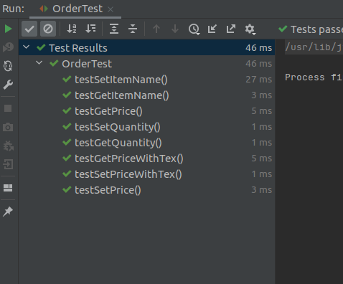

EmailServiceTest.java

import org.junit.jupiter.api.Test;
import org.junit.jupiter.api.function.Executable;

import static org.junit.jupiter.api.Assertions.*;

class EmailServiceTest {

Order order = new Order();
EmailService email=new EmailService();

@Test
void testGetInstance()
{
assertTrue(EmailService.getInstance() instanceof EmailService);
}

@Test
void testSendEmail()
{

Executable executable=()->email.sendEmail(order);
assertThrows(RuntimeException.class,executable);
}

@Test
void testSendEmailWithString()
{
assertTrue(email.sendEmail(order,"Mobile"));
}

}

