Introduction to Java 1 Exercise

Q1. Write a program to replace a substring inside a string with other string ?

Sol – Program Files Folder name – program1

public class Program1 {
public static void main(String args[]) {
String str="Naveen Garg";
System.out.println("Original String: " + str );
System.out.println("str.replace() function use: "+ str.replace( 'N','G' ) );
System.out.println("str.replaceFirst() function use: "+ str.replaceFirst("a", "e") );
System.out.println("str.replaceAll() function use: "+ str.replaceAll("a", "y") );
}
}
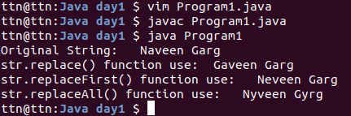

Q2. Write a program to find the number of occurrences of the duplicate words in a string and print them ?

Sol – Program File Folder name – program2

public class DuplicateWords {
public static void main(String[] args) {
String string = "Naveen Garg is employee of ttn naveen good morning ttn is a IT company naveen hello naveen";
int count;
string = string.toLowerCase();
String words[] = string.split(" ");

System.out.println("Number of occurrences of the duplicate words in a given string : ");
for(int i = 0; i < words.length; i++) {
count = 1;
for(int j = i+1; j < words.length; j++) {
if(words[i].equals(words[j])) {
count++;
words[j] = "0";
}
}
if(count > 1 && words[i] != "0")
System.out.println("Word: " + words[i] + "\nNo. of occurrences is "+ count + "\n");
}
}
}
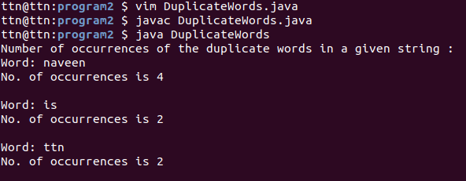
Q3. Write a program to find the number of occurrences of a character in a string without using loop?

Sol – Program File Folder name – program3

class CharacterOccurrences
{
public static void main(String[] args)
{
String str = "naveen Garg naveen";
int count = str.length() - str.replace("e", "").length();
System.out.println("Number of occurances of 'e' in "+ str +" = "+count);
}
}
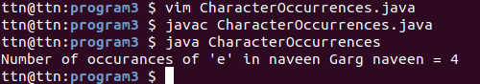

Q4. Calculate the number & Percentage Of Lowercase Letters,Uppercase Letters, Digits And Other Special Characters In A String

Sol – Program File Folder name – program4

import java.io.*;

class NoAndPercentage
{
public static void main(String args[])
{
String str = "Ind:354/2, Overs:48";
int total_length = str.length();
int upper = 0, lower = 0, number = 0, special = 0;

for(int i = 0; i < str.length(); i++)
{
char ch = str.charAt(i);
if (ch >= 'A' && ch <= 'Z')
upper++;
else if (ch >= 'a' && ch <= 'z')
lower++;
else if (ch >= '0' && ch <= '9')
number++;
else
special++;
}

double upperPercentage = (upper*100.0)/total_length;
double lowerPercentage = (lower*100.0)/total_length;
double numberPercentage = (number*100.0)/total_length;
double specialPercentage = (special*100.0)/total_length;

System.out.println("Number of Lower case letters : " + lower + " and Percentage is " + lowerPercentage);
System.out.println("Number of Upper case letters : " + upper + " and Percentage is " + upperPercentage);
System.out.println("Number of Digits : " + number + " and Percentage is " + numberPercentage);
System.out.println("Number of Special characters : " + special + " and Percentage is "+ specialPercentage);
}
}

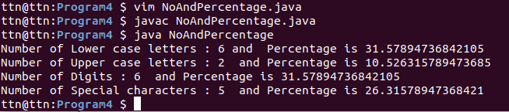

Q5. Find common elements between two arrays.

Sol – Program Files Folder name – program5

import java.io.*;
import java.util.*;

class CommomElement{
public static void FindCommonElements(int[] arr1, int[] arr2)
{
Set<Integer> set1 = new HashSet<Integer>();
Set<Integer> set2 = new HashSet<Integer>();
for (int i : arr1)
{
set1.add(i);
}

for (int i : arr2)
{
set2.add(i);
}

set1.retainAll(set2); // find common elements
System.out.println("Common elements- " + set1);
}

public static void main(String[] args)
{
int[] arr1 = { 1, 2, 3, 4, 5, 2 };

int[] arr2 = { 5, 4, 2, 1, 7, 8 };

System.out.println("Array 1: "+ Arrays.toString(arr1));
System.out.println("Array 2: "+ Arrays.toString(arr2));
FindCommonElements(arr1, arr2);
}
}

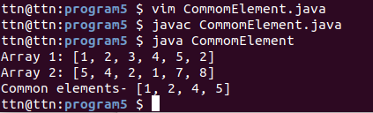

Q6. There is an array with every element repeated twice except one. Find that element

Sol – Program Files Folder name – program6

class FindSingleElement
{
public static void main (String[] args)
{
int ar[] = {2, 3, 1, 4, 1, 3, 4};
int n = ar.length;
int val = ar[0];
for (int i = 1; i < n; i++)
val = val ^ ar[i];
System.out.println("Element occurring once is " + val);
}
}
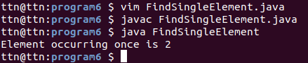

Q7. Write a program to print your Firstname,LastName & age using static block,static method & static variable respectively

Sol – Program Files Folder name – program7

class StaticProgram
{
static int age = 24;
static void lname()
{
System.out.println("Last Name: Garg");
}
static
{
System.out.println("First Name: Naveen");
}

public static void main(String args[])
{
lname();
System.out.println("Age: "+ age);
}
}
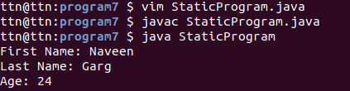

Q8. Write a program to reverse a string and remove character from index 4 to index 9 from the reversed string using String Buffer

Sol – Program Files Folder name – program8

import java.lang.*;
public class ReverseAndDelete {
public static void main(String[] args)
{
String str = "Naveen Garg";
StringBuffer sbr = new StringBuffer(str);
sbr.reverse();
System.out.println("Reverse String: " + sbr);
sbr.delete(4, 10);
System.out.println("After deletion string is = " + sbr);
}
}
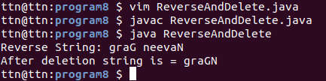

Q9.Write a program to display values of enums using a constructor & getPrice() method (Example display house & their prices)

Sol – Program Files Folder name – program9

enum House {
House101(900000),House103(150000),House105(5000000),House111(356000),House114(1000002);
int price;
House(int p)
{
price = p;
}
int getPrice()
{
return price;
}
}
public class Const {
public static void main(String args[]){
System.out.println("All House prices:");
for (House c : House.values())
System.out.println(c + " costs " + c.getPrice() + " Rupees.");
}
}
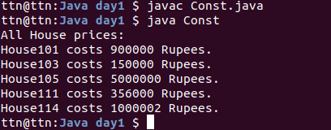

Q10.Write a single program for following operation using overloading
A) Adding 2 integer number
B) Adding 2 double
C) multiplying 2 float
D) multiplying 2 int
E) concate 2 string
F) Concate 3 String

Sol – Program Files Folder name – program10

import java.util.Scanner;

public class OverloadingUse {
public int add(int a, int b)
{
return a+b;
}
public double add(double a,double b)
{
return a+b;
}
public float multiply(float a,float b)
{
return a*b;
}
public int multiply(int a, int b)
{
return a*b;
}
public void stringAdd(String a,String b)
{
String str = a+b;
System.out.println("Concatenation of two Strings : "+ str);
}
public void stringAdd(String a,String b,String c)
{
String str = a+b+c;
System.out.println("Concatenation of three Strings : "+ str);
}
public static void main(String[] args) {
OverloadingUse obj = new OverloadingUse();
Scanner sc = new Scanner(System.in);

int result = obj.add(23,35);
System.out.println("Addition of two integer : "+ result);

double result2 = obj.add(234563.212,355678.32);
System.out.println("Addition of two double : "+ result2);

double result3 = obj.multiply(4.6f, 5.6f);
System.out.println("Multiplication of two integer : "+ result3);

int result4 = obj.multiply(45,20);
System.out.println("Multiplication of two integer : "+ result4);

obj.stringAdd("Hello ","World! ");
obj.stringAdd("Hello ","World! ","This is Ques10");

}
}
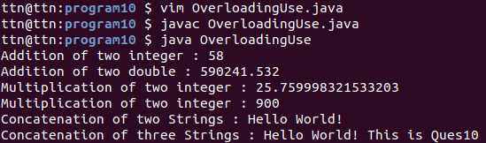

Q11.Create 3 sub class of bank SBI,BOI,ICICI all 4 should have method called getDetails which provide there specific details like rateofinterest etc,print details of every banks

Sol – Program Files Folder name – program11

class Bank{
int getRateOfInterest(){
return 0;
}
}

class SBI extends Bank{
int getRateOfInterest(){
System.out.println("Branch Address: Delhi");
return 8;
}
}

class BOI extends Bank{
int getRateOfInterest()
{
System.out.println("Branch Address: Mumbai");
return 7;
}
}

class ICICI extends Bank{
int getRateOfInterest(){
System.out.println("Branch Address: Kolkata");
return 9;
}
}

class BankDetail{
public static void main(String args[]){
SBI s=new SBI();
ICICI i=new ICICI();
BOI b=new BOI();
System.out.println("SBI Rate of Interest: "+s.getRateOfInterest() +"%"+ "\n");
System.out.println("BOI Rate of Interest: "+b.getRateOfInterest()+"%"+"\n");
System.out.println("ICICI Rate of Interest: "+i.getRateOfInterest()+"%"+"\n");
}
}
