**Test Cases for Login Functionality of Swag Labs** - <https://www.saucedemo.com/>

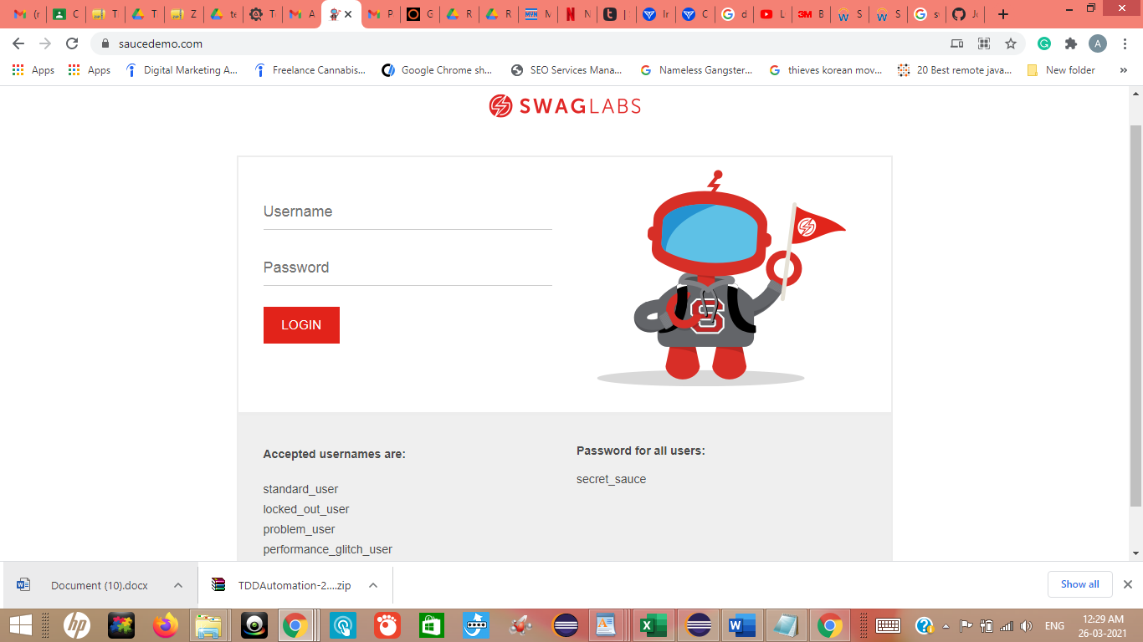

* Verify if a user will be able to login with a valid username and valid password.
* Verify if a user cannot login with a valid username and an invalid password.
* Verify the login page for both when the field is blank and login button is clicked.
* Verify if a user cannot login with a valid username and an invalid password.
* Verify the messages for invalid login.
* Verify if a user cannot login with a invalid username and an invalid password.
* Verify if the data in password field is either visible as asterisk or bullet signs.
* Verify if a user can login with a new password only after he/she has changed the password.
* Verify if the login page allows to log in simultaneously with different credentials in a different browser.
* Verify if the ‘Enter’ key of the keyboard is working correctly on the login page.
* Verify the time taken to log in with a valid username and password.
* Verify the login page and all its controls in different browsers.
* Verify if a user cannot enter the characters more than the specified range in each field of Username and Password.
* Verify if a user cannot enter the characters less than the specified range in each field (Username and Password).
* Verify the login page by pressing ‘Back button’ of the browser. It should not allow you to enter the system once you log out.
* Verify the timeout functionality of the login session.
* Verify if a user should not be allowed to log in with different credentials from the same browser at the same time.
* Verify if a user should be able to login with the same credentials in different browsers at the same time.

**Note:** There should be more test cases if there are more related functions available like forget password button on the login page, Cross(x) to remove the text from text field and many more.