VendorLens
Automated KYB & Vendor Due Diligence Platform

Product Requirements Document
For Procurement & Compliance Teams
Field | Value
Version | 1.0
Last Updated | June 2025
Target Completion | Q3 2025
Classification | Internal Confidential
Document Owner | Product & Architecture Team
Review Cycle | Before each sprint planning

This document is for internal use only. Do not distribute outside of authorised teams.

1. What Problem Are We Solving?
Procurement and compliance teams today run vendor due diligence across disconnected tools — one for sanctions screening, another for company registry lookups, another for news searches — and then manually piece together a risk picture. The result is slow, inconsistent, and impossible to audit at scale.

1.1 Current Pain Points
Pain Point | Impact
Manual checks take 2–3 days per vendor | Delays commercial operations; creates bottlenecks
No unified risk view across tools | Analysts miss cross-source signals; incomplete picture
Inconsistent results between analysts | Same vendor may receive different risk assessments
No audit trail for adverse findings | Cannot defend decisions under regulatory scrutiny
Scrapers break with website changes | Requires constant engineering maintenance overhead

1.2 What Success Looks Like
- Any vendor screened in under 15 minutes, end to end
- Single risk report with source evidence for every finding
- Consistent, policy-aligned risk scores regardless of which analyst runs the check
- Full audit log with timestamps for every scan performed
- API-first architecture — no scrapers to break or maintain

2. What VendorLens Does
VendorLens is an automated due diligence platform built for procurement teams. Given a company name and website, it queries authoritative public data sources in parallel, then uses an AI analyst to synthesise raw data into a structured risk report. Only adverse findings are stored — clean signals are discarded immediately.

Core promise: For any company name and domain globally, produce an automated, evidence-backed adverse risk report in under 15 minutes — storing only confirmed negative findings, surfaced in a clear dashboard requiring zero manual data hunting.

2.1 Strategic Principles
Principle | What It Means in Practice
API-first, no scrapers | All data sourced from official APIs — zero maintenance overhead from website changes
Store only negatives | Minimal storage footprint; every database row is an actionable risk item
AI as analyst, not classifier | Large language model synthesises raw data flexibly without retraining
Multi-layer entity screening | Entity + directors + beneficial owners all screened in a single workflow
Jurisdiction-agnostic | Works for companies in any country using global public data sources

3. How a Vendor Check Works — Step by Step
Every scan follows a three-stage pipeline. All data collection runs in parallel across eight intelligence sources, then an AI layer synthesises and deduplicates the results, and the final report is stored and surfaced to the reviewer.

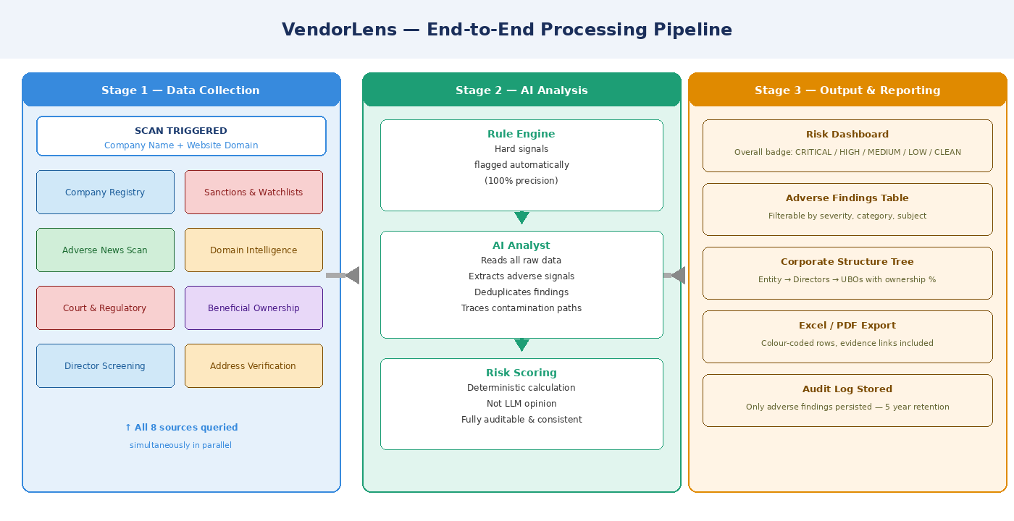
Figure 1: End-to-end VendorLens processing pipeline — Stage 1 queries run simultaneously before Stage 2 begins

3.1 Stage 1 — Data Collection (All Queries Run Simultaneously)
When a scan is triggered, eight groups of queries fire in parallel:
- Company registry lookup — verifies legal existence, status, and incorporation date
- Sanctions & watchlist screening — cross-checks against OFAC, UN, EU, and UK lists
- Domain intelligence — WHOIS registration date and SSL certificate validity
- Adverse news scan — searches global media indices for legal and crime keywords
- Court & regulatory records — checks court databases, SEC, and Justice.gov
- Beneficial ownership mapping — resolves UBOs and full ownership chains
- Director screening — individual sanctions, PEP, and adverse media checks per person
- Address verification — detects known shell company address clusters

All eight source groups are queried simultaneously. The system waits for all to complete before proceeding to AI analysis. This parallel architecture delivers the sub-15-minute turnaround.

3.2 Stage 2 — AI Analysis
Step | What Happens | Why It Matters
Rule engine | Hard signals (exact sanctions matches, domain age mismatch) flagged automatically with 100% precision | Ensures hard red flags are never missed regardless of AI output
AI analyst | LLM reads all raw data, extracts adverse signals, deduplicates across sources, and traces contamination paths | Handles nuanced multi-source interpretation that rule engines cannot
Risk scoring | Mathematical formula computes final score from finding severity and category weights — not LLM judgment | Keeps the score auditable, consistent, and defensible

3.3 Stage 3 — Output & Reporting
- Risk dashboard — overall risk badge (CRITICAL / HIGH / MEDIUM / LOW / CLEAN)
- Adverse findings table — filterable by severity, category, and subject name
- Corporate structure tree — entity with linked directors and UBOs and ownership percentages
- Excel and PDF export — colour-coded by severity with embedded evidence links
- Audit log — all adverse findings stored for 5 years for compliance evidence

4. Two Screening Tiers
The platform offers two levels of depth, allowing teams to run fast checks for low-risk vendors and forensic-grade diligence for high-risk or high-value engagements. Tier 1 can run independently; Tier 2 builds on Tier 1 results.

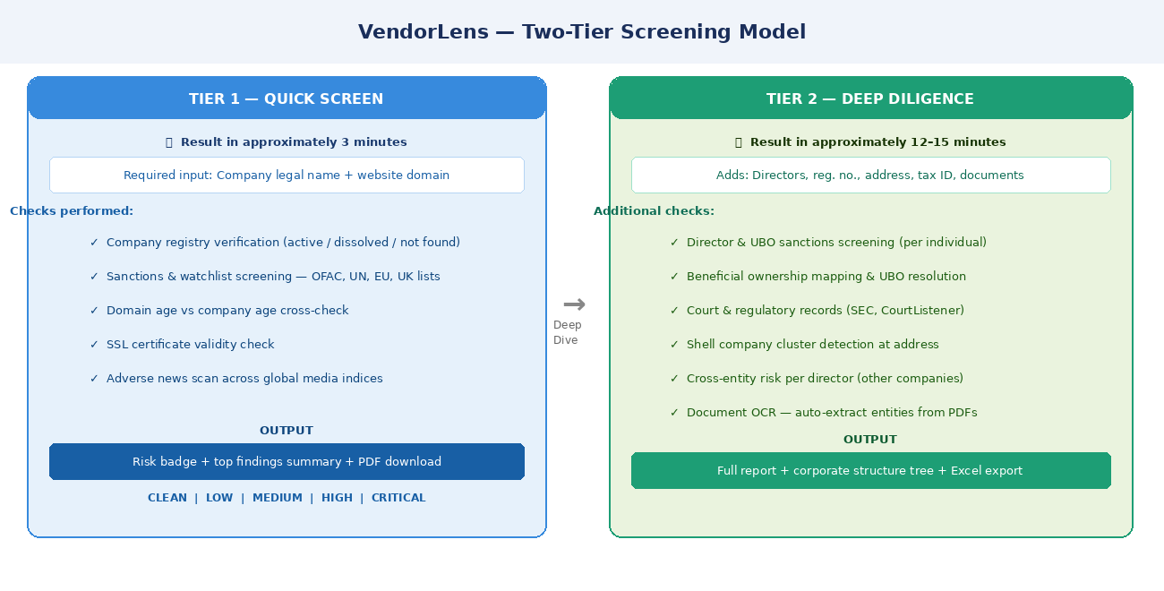
Figure 2: Side-by-side comparison of Tier 1 Quick Screen and Tier 2 Deep Diligence

4.1 Tier 1 — Quick Screen (~3 minutes)
Attribute | Detail
Inputs required | Company legal name + website domain only
Checks performed | Registry verification · Sanctions screening · Domain age & SSL · Adverse news scan
Output | Risk badge + top findings summary + PDF download option
Use case | Initial screening, existing vendor refresh, low-risk suppliers

4.2 Tier 2 — Deep Diligence (~12–15 minutes)
Attribute | Detail
Inputs required | Everything in Tier 1, plus: director names, registration number, address, tax ID, optional document uploads
Additional checks | Director/UBO sanctions · Ownership mapping · Court records · Shell address detection · Cross-entity director risk
Output | Full adverse findings report + corporate structure tree + Excel export (colour-coded by severity)
Use case | New high-value supplier onboarding, escalated reviews, forensic diligence

4.3 Document Upload & OCR (Tier 2 Only)
Reviewers can upload vendor-provided documents — GST certificates, trade licences, invoices — directly into the platform. The system automatically extracts key fields including registration number, legal name, address, and signatory name.
- Supported formats: PDF, JPG, PNG
- Extracted fields auto-populate the form; reviewers can correct before submission
- All uploaded documents permanently deleted within 24 hours of extraction completing

Privacy note: Documents are processed locally and deleted automatically. They are never shared with third parties and are never stored beyond 24 hours.

5. What Data Is Collected
The platform accepts structured inputs across four categories. Tier 1 requires only two fields; Tier 2 unlocks the full input schema.

5.1 Category A — Primary Identifiers (Tier 1, Required)
Field | What It Is | Used For
Company legal name | The full registered legal name of the entity | Registry lookup, sanctions screening, news scan
Website domain | Official website domain only (e.g. acme.com) | Domain age check, SSL verification, WHOIS lookup

5.2 Category B — Regulatory & Corporate Identifiers (Tier 2)
Field | Examples | Purpose
Registration number | CIN (India), EIN (US), CRN (UK), HRB (Germany) | Confirm company status with the official registry
Country / jurisdiction | IN, US, GB, AE | Determines which registry API to query
Tax identifier | GSTIN, PAN, VAT, TIN | Verify tax registration is active and current
Registered address | Full address string | Shell company cluster detection

5.3 Category C — Key Personnel (Tier 2)
Field | Notes | Purpose
Director names | Up to 10 individuals | Sanctions screening, adverse media, PEP check per individual
Director ID numbers | DIN (India-specific) | Cross-entity risk — detect if director is on defaulted companies
Founder / CEO name | Primary individual for enhanced check | PEP check, Wikidata profile lookup

5.4 Category D — Digital Footprint (Tier 2)
Field | Notes | Risk Signal
Social handles | LinkedIn, Twitter/X, Facebook | Bot inflation patterns, complaint cluster analysis
Corporate email domain | e.g. @acme.com | Free email provider (Gmail, Outlook) = MEDIUM flag
Uploaded documents | GST cert, invoice, trade licence | OCR extracts entities for automated cross-verification

6. Where the Data Comes From
All intelligence is sourced from official, authoritative public APIs — no web scraping. Each source category targets a specific risk dimension.

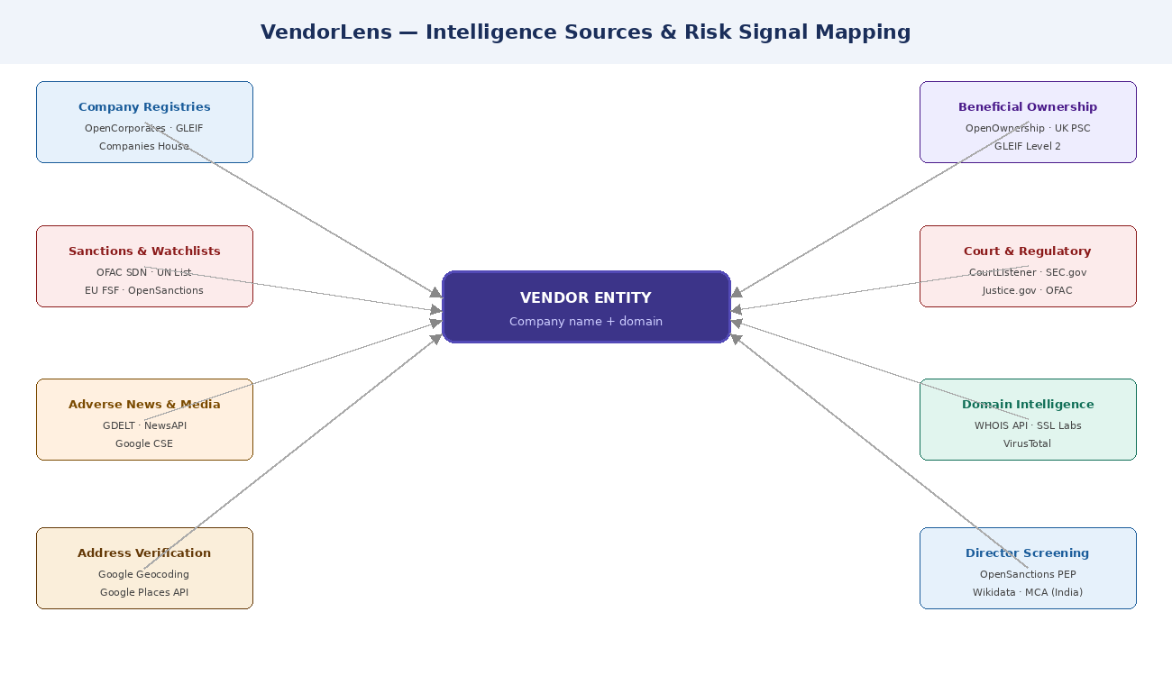
Figure 3: Intelligence sources mapped to the vendor entity — all seven categories queried simultaneously

6.1 Source-to-Risk Signal Mapping
Source | Category | Key Risk Signals
OpenCorporates | Entity integrity | Dissolved / struck off / new entity (< 12 months old)
GLEIF | Entity integrity | Lapsed LEI; branch entity flag; missing international records
OpenSanctions | Sanctions & watchlists | Score > 0.85 = CRITICAL; score 0.60–0.85 = HIGH (possible match)
OFAC XML | Sanctions & watchlists | Direct SDN list match = always CRITICAL; overrides all other scores
WHOIS API | Domain anomaly | Domain registered years after claimed company founding date
SSL Labs | Domain anomaly | Expired, self-signed, or missing SSL certificate on commercial domain
GDELT | Adverse media | Negative-tone articles containing legal keywords (fraud, arrested, etc.)
NewsAPI | Adverse media | Fraud and corruption mentions in Tier-1 media outlets (Reuters, AP, BBC)
Google CSE | Court & regulatory | Results from CourtListener, SEC.gov, Justice.gov, OFAC.treas.gov
OpenOwnership | Director/UBO risk | Circular ownership chains; nominee director on 30+ companies
Google Geocoding | Entity integrity | Registered address matches known shell company address clusters

7. How Risk Is Assessed
Risk assessment happens in two layers: a deterministic rule engine flags hard signals with 100% precision, followed by the AI analyst that reads all raw data and extracts nuanced findings. The final risk score is computed mathematically — ensuring it is auditable and consistent.

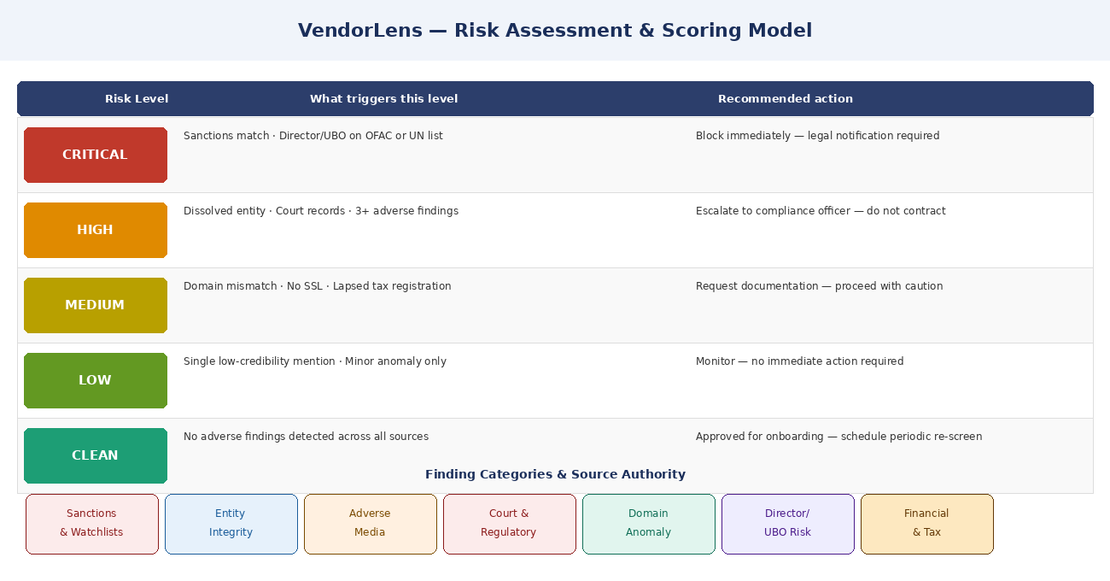
Figure 4: Risk level decision matrix — triggers and recommended actions per level

7.1 Risk Level Definitions
Level | What Triggers It | Recommended Action
CRITICAL | Sanctions match on any major list; director or UBO on OFAC or UN list | Block immediately — legal notification required
HIGH | Dissolved entity; court or regulatory record; 3+ adverse findings | Escalate to compliance officer; do not contract until resolved
MEDIUM | Domain age mismatch; missing SSL; lapsed tax registration | Request documentation from vendor; proceed with caution
LOW | Single low-credibility mention; minor anomaly only | Monitor; no immediate action required
CLEAN | No adverse findings detected across all sources | Approved for onboarding — schedule periodic re-screening

Important: Any single CRITICAL finding overrides the computed score. The overall risk level is always CRITICAL if any one finding is, regardless of other signals present in the scan.

7.2 Finding Categories
Category | What It Covers | Key Sources
Sanctions & watchlists | Matches on OFAC, UN, EU FSF, UK OFSI sanction programmes | OpenSanctions, OFAC XML, UN Consolidated List
Entity integrity | Dissolved status, new entity, shell address, circular ownership | OpenCorporates, GLEIF, OpenOwnership
Adverse media | Fraud, corruption, arrest, lawsuit mentions in news coverage | GDELT, NewsAPI, Google CSE
Court & regulatory | Litigation records, SEC filings, court judgements | CourtListener, SEC.gov, Justice.gov
Domain anomaly | Domain age vs company age; missing SSL; unregistered domain | WHOIS API, SSL Labs, VirusTotal
Director / UBO risk | Sanctioned individuals, PEP status, nominee director patterns | OpenSanctions, MCA (India), Wikidata
Financial & tax | Lapsed tax registration, missing financial filings | GST API, Companies House, GLEIF

7.3 How the Contamination Path Works
A key feature is tracing how a risk finding attaches to the vendor entity, even when the finding is about a connected individual or subsidiary. The system records this contamination path explicitly in every finding.

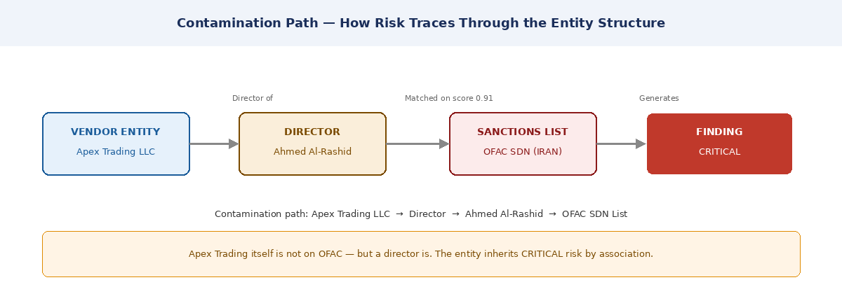
Figure 5: Contamination path example — risk traces from a director back to the vendor entity

7.4 Confidence Scoring
Score | Source Type
10 | Official government source, verified court record, confirmed sanctions database
8–9 | Tier-1 news outlet (Reuters, AP, BBC, Bloomberg), official company registry
6–7 | Tier-2 news outlet, minor regulatory body, unverified breach database
4–5 | Single-source finding, forum or social media, circumstantial signal
1–3 | Weak signal, speculative, no corroboration from other sources

8. Sample Adverse Finding
Each finding stored in the system follows a consistent structure with full evidence tracing. Below is a representative example of what a CRITICAL sanctions finding looks like in the generated report.

CRITICAL Sanctions & Watchlist Confidence Score: 9 / 10
Finding ID: F001
Title: Director match on OFAC Specially Designated Nationals list
Subject: Ahmed Al-Rashid (Director, Apex Trading LLC)
Contamination path: Apex Trading LLC → Director → Ahmed Al-Rashid → OFAC SDN
Detail: Ahmed Al-Rashid, listed as a director since March 2021, appears on the OFAC Specially Designated Nationals list (programme: IRAN) with a match confidence score of 0.91. The match was corroborated by the OpenSanctions verified dataset. Engagement constitutes a compliance violation under OFAC regulations.
Evidence source: OFAC SDN List via OpenSanctions — finding date 2024-11-15
Recommended action: BLOCK — Immediately halt engagement; legal notification required.

9. Data Storage & Privacy
VendorLens uses a "store only negatives" data model. Clean signals are never written to the database. Only adverse findings are persisted, keeping every database row meaningful and the storage footprint minimal.

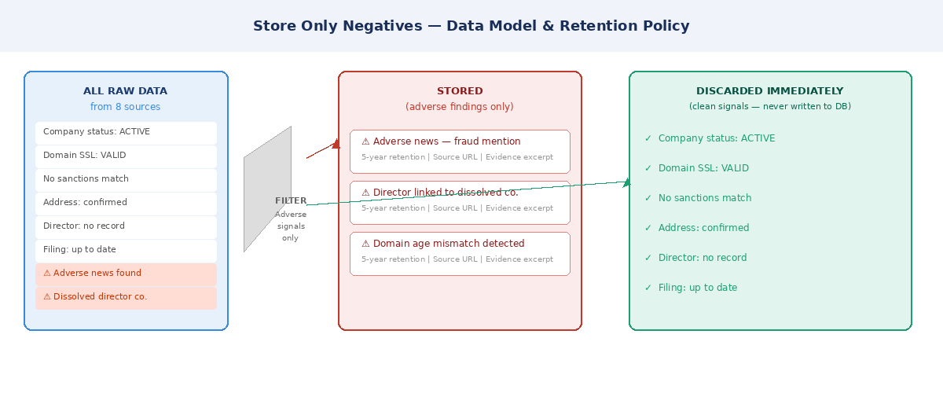
Figure 6: Store-only-negatives model — clean signals are discarded immediately after AI synthesis

9.1 Data Retention Policy
Data Type | What Is Stored | Retention | Rationale
Scan metadata | Company name, timestamp, risk level, score | 5 years | Audit trail
Adverse findings | All negative findings with full evidence trails | 5 years | Compliance evidence
Directors / UBOs | People discovered during the scan | 5 years | Relationship mapping
Raw API responses | NOT stored — discarded after synthesis | Immediate | Privacy + storage minimisation
Clean signals | NOT stored anywhere | Immediate | Store-only-negatives principle
Uploaded documents | Deleted after OCR extraction | 24 hours maximum | Privacy by design

9.2 Compliance Notes
- GDPR Article 22: System outputs are advisory only. Human review is required before any adverse action is taken against a vendor.
- Right to explanation: Every finding includes a source URL and verbatim excerpt from the original source data.
- Data minimisation: Raw API responses are never stored. Only synthesised adverse findings are persisted.
- Security: All API keys are stored in environment variables, never in code or the database. Database connections via SSL only.

10. Performance Targets
Operation | Target SLA
Tier 1 Quick Scan (end to end) | < 3 minutes
Tier 2 Deep Diligence (end to end) | < 15 minutes
API response to scan initiation | < 500 milliseconds
Status polling endpoint | < 100 milliseconds
Excel report generation | < 5 seconds
Dashboard page load | < 2 seconds

Scalability: The system must handle 50 concurrent deep scans without performance degradation. Task workers auto-scale from 4 to 20 under increased load.

11. Open Decisions Requiring Stakeholder Input
# | Question | Owner | Priority
1 | Which AI provider — Anthropic Claude or OpenAI GPT-4o — at scale cost/latency tradeoff? | Architecture | HIGH
2 | OpenCorporates free tier: 10 req/min limit. Do we need a paid plan at launch volume? | Product | HIGH
3 | GDELT returns articles in 100+ languages — translation layer before AI synthesis? | Engineering | MEDIUM
4 | India MCA DIN API has no official public endpoint — scraper needed or skip for v1? | Engineering | MEDIUM
5 | Who owns and maintains the known shell address blocklist going forward? | Compliance | HIGH
6 | Google Custom Search pricing at 10K+ queries/month — budget approval needed | Finance | MEDIUM
7 | Re-screening cadence — how often should approved vendors be re-screened? | Compliance | LOW
8 | Multi-tenant isolation model — one schema per org or row-level security? | Architecture | HIGH

11.1 Out of Scope for v1.0
Feature | Rationale for Deferral
Paid data vendors (Refinitiv World-Check, Dow Jones) | Public data first; deferred to v2
Real-time monitoring and re-screening alerts | Deferred to v2
Custom ML fraud classifier | LLM prompt covers this without model retraining
Mobile application | Web-only for v1
API access for external consumers | Internal tool only for v1
Dark web monitoring | Requires specialised vendor; outside public-data scope

Document Owner: Product & Architecture Team | Review Cycle: Before each sprint planning | Next Review: Prior to Engineering Kickoff

