### **Navneet Kaur (8622734)**

**Assignment 2**

### **Part 1: Basic queries with SELECT**

1. **Using the order_details table, find the revenue (price * quantity) earned on each order.**

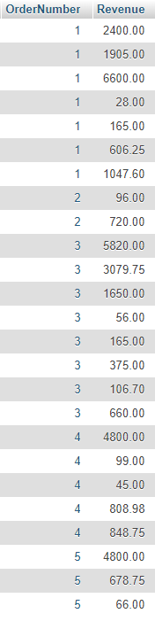

1. **Using the employees table, find the age of each employee in years and order from youngest to oldest. NOTE: You do not have to account for leap years.**

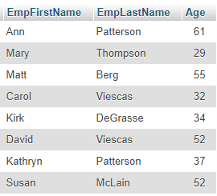

### **Part 2: Conditional queries**

1. **Using the employees table, find all employees with a first name that contains an 'r' and a last name that does not contain a 'q'.**

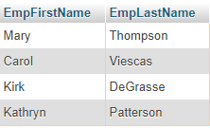

### **Part 3: Database Design**

1. **Explain what is wrong with the following table and how you would fix it.**

|  |  |  |  |  |
| --- | --- | --- | --- | --- |
| CompanyName | Address | Email | Products | Phone |
| Telle. Co | 12 Dirk St | Rep@telle.com | Computer, Phone, Power cables | 519-555-4410 |
| Barba. Co | 133 Shep St | Rep@barb.com | Hair care, Shampoo, Dye, Combs | NULL |

**Answer :** This Table is not in first normal form

***To make it in first normal form it should look like:***

**CompanyName** **Address** **Email** **Products** **Phone**

Telle. Co 12 Dirk St [Rep@telle.com](mailto:Rep@telle.com) Computer 519-555-4410

Telle. Co 12 Dirk St [Rep@telle.com](mailto:Rep@telle.com) Phone 519-555-4410

Telle. Co 12 Dirk St [Rep@telle.com](mailto:Rep@telle.com) Power Cables 519-555-4410

Barba.Co 133 Shep St [Rep@barb.com](mailto:Rep@barb.com) Hair Care NULL

Barba.Co 133 Shep St [Rep@barb.com](mailto:Rep@barb.com) Shampoo NULL

Barba.Co 133 Shep St [Rep@barb.com](mailto:Rep@barb.com) Dye NULL

Barba.Co 133 Shep St [Rep@barb.com](mailto:Rep@barb.com) Combs NULL

***To make the table in second normal form it should be displayed as following:***

Here is in Products Table Company_ID is a Foreign Key

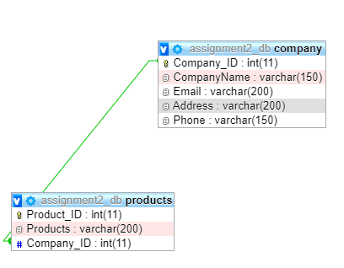

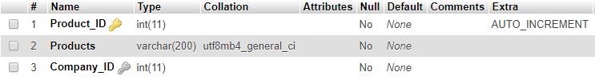

### **Part 4: Joins**

1. **Find the first name and phone number of all customers who have ever ordered a helmet. HINT: Use the keyword** **DISTINCT.**

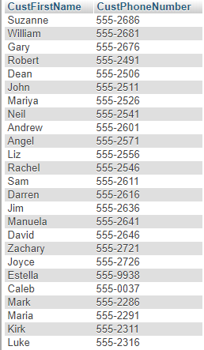

1. **Display the first name of all customers who have the same first name as an employee.**



### **Part 5: Aggregate Functions**

1. **Find the combined total value (QuantityOrdered*QuotedPrice*2) of all orders made by customers from the state of 'OR’.**

