CUupdateTool — User Manual
incadea / BC-NAV v14 cumulative-update merge tool
User Manual and Rules Index

Contents

Audience: developers and managers using the tool for the first time.
What it is: a tool that carries a customer's C/AL customisations forward onto a new incadea (idealer) cumulative update. It performs the mechanical majority of the merge automatically and hands every genuine judgement call back to the developer for manual review.
This manual is task-oriented. Read sections 1 to 6 to run a job. Section 7 describes what is inside the application. Section 8 is the Rules Index by object type — the reference that explains, for each object type, what the tool carries forward, what it sends to manual review, and why.

1. What the tool does

1.1 The problem it solves
incadea / BC-NAV version 14 customers run idealer (the incadea standard application) together with their own local customisations and localisations. When incadea ships a new cumulative update, every customised object must be carried forward onto the new vendor version by hand, one object at a time, in TortoiseMerge. This takes weeks for each customer, and most of that time is spent on mechanical work — transplanting the customer's code, updating the version list, and stamping the date and changelog — rather than on genuine judgement.
The tool performs the mechanical work automatically and routes only the genuine judgement calls to the developer.

1.2 The A / B to C model
Every merge involves three objects:
- A is the customer's current object: the previous vendor version together with the customer's own code.
- B is the new cumulative update, or vendor-standard, object (idealer 2026Q1). It contains vendor code only, with no customer changes.
- C is the merged object the tool produces: the vendor content of B together with the customer content of A, placed correctly into the new context of B.
C is not simply "B with a few changes." A and B are equal inputs. The tool finds where each piece of customer content belongs in B, takes that content from A, and writes both into C. B itself is never altered — it is one of two read-only inputs.

1.3 What the tool does not do
- It does not reconstruct a clean previous vendor object. It works only from A and B.
- It does not translate. Where the customer has a localisation language layer, the tool's goal is that the merged object compiles; translation accuracy remains the developer's responsibility.
- It does not make judgement calls. Anything the tool is not confident about is returned to the developer as a complete object, never partially merged.

1.4 The safety rule that governs everything: the whole-object gate
An object is merged automatically only if every customer change within it is a confident, mechanical carry. If even one change is uncertain, the entire object is sent to manual review unchanged. The tool never produces a partially merged object. This is why an automatically merged object can be trusted, and why the developer only needs to merge by hand the objects the tool has flagged.

2. Starting the tool

2.1 The application
The tool is a single Windows application, CUupdate.exe. The machine it runs on does not need any additional software installed — everything required is contained within the application.
- Copy CUupdate.exe to the machine, or run it from where it is stored.
- Double-click it.
- The CU Update — batch merge window opens.
There is nothing to configure the first time it is run.
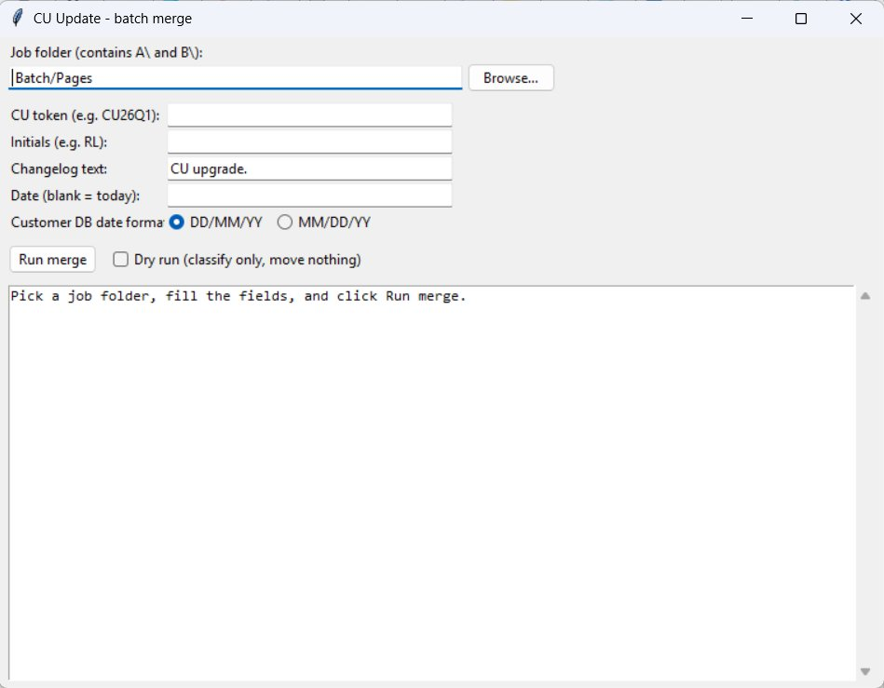
The CU Update window when it first opens.

2.2 The window
Field | Purpose
Job folder | The folder that contains the A\ and B\ sub-folders for this job.
CU token | The cumulative update being upgraded to, for example CU26Q1. It is recorded in the merge.
Initials | The developer's initials, for example RL. They are recorded in the changelog.
Changelog text | The standard text for the changelog entry. The default is CU upgrade.
Date | Leave blank to use today's date.
Customer DB date format | DD/MM/YY (the default) or MM/DD/YY. See section 4.3.
Run merge | Starts the job.
Dry run | Classifies the objects and produces the report, but writes and moves nothing. See section 5.1.

The customer tags are determined by the tool automatically and are not entered by hand. See section 4.4.

3. Preparing a job folder
The tool works on exported, language-stripped C/AL text files arranged in a fixed structure. This is prepared once for each job.

3.1 The required folder structure
<job folder>\
A\
<Type>\
EX-<stem>.txt (the customer object, A)
B\
<Type>\
CU-<stem>.txt (the cumulative-update / vendor object, B)
- <Type> is the object-type folder name, for example Table, Page, Codeunit or Report. For a given object, A and B must use the same <Type> folder name.
- <stem> is the object-type letter followed by the object number:
Object type | Letter | Example object | Stem | A file | B file
Codeunit | C | Codeunit 80 | C80 | EX-C80.txt | CU-C80.txt
Table | T | Table 14 | T14 | EX-T14.txt | CU-T14.txt
Page | P | Page 21 | P21 | EX-P21.txt | CU-P21.txt
Report | R | Report 790 | R790 | EX-R790.txt | CU-R790.txt

- The EX- prefix identifies the customer (export) object. The CU- prefix identifies the cumulative-update / vendor object.
- Objects are paired by stem: EX-T14.txt pairs with CU-T14.txt.
A complete example:
C:\jobs\CustomerX\
A\Table\EX-T14.txt
A\Page\EX-P21.txt
B\Table\CU-T14.txt
B\Page\CU-P21.txt

3.2 Strip the language layer before export
The comparison must run on language-normalised text, so that the customer localisation layer (for example, ENZ) does not interfere with the comparison.
In the normal workflow the language layer is stripped within the NAV / GUI development environment before the objects are exported to text files. Export the customer objects with the customer language layer already removed, so that the files placed into A\ and B\ are already language-stripped. Keep a copy of the customer language layer, because it is re-applied after the merge (see section 6.4).
For reference, the equivalent dev-shell cmdlets are:
- Export-NAVApplicationObjectLanguage — to keep a copy of the customer language layer for re-application later.
- Remove-NAVApplicationObjectLanguage — to remove the customer layer, leaving the development language, for a clean comparison.
The point to remember is that the tool's input files must already be language-stripped.

3.3 What to leave out of a job
- Customer-range objects (object numbers 50000 to 99999) belong to the customer's own licence range. They are not vendor objects being upgraded, so they are not included in a job. (Note that incadea's own 5025xxx objects are a different range and are included. Note also that a customer field (not object) added inside a vendor object — for example field 50090 inside Table 36 — is carried forward; that is a customisation of a vendor object, not a customer-range object.)
- "Killme" objects — objects whose name contains the word kill — are retired by the tool automatically if they are present.

4. Running a merge

4.1 Steps
- Double-click CUupdate.exe.
- Next to Job folder, click Browse… and select the folder that contains the A\ and B\ sub-folders.
- Enter the CU token (for example CU26Q1) and your Initials (for example RL). These two fields are required.
- Leave Changelog text as CU upgrade. unless different text is required.
- Leave Date blank to use today's date.
- Set Customer DB date format to match the customer database. See section 4.3.
- For the first pass, tick Dry run. See section 5.1.
- Click Run merge.
- Read the report in the lower panel. If the dry run is satisfactory, remove the Dry run tick and click Run merge again to perform the merge.

4.2 What "Run merge" does
For each A and B pair in the job, the tool:
- Determines the customer tags from the version lists of the A objects (section 4.4).
- Compares A and B, classifies every difference, and decides for each object whether it can be merged automatically or must go to manual review.
- For each automatically merged object, builds C, writes it out, and moves the source files aside.
- For each manual object, leaves the source files in place and reports the reason.
While the tool is working, the window shows a progress indicator. It then prints the full report and a summary line in the form --- N auto-merged, M left for manual review ---.
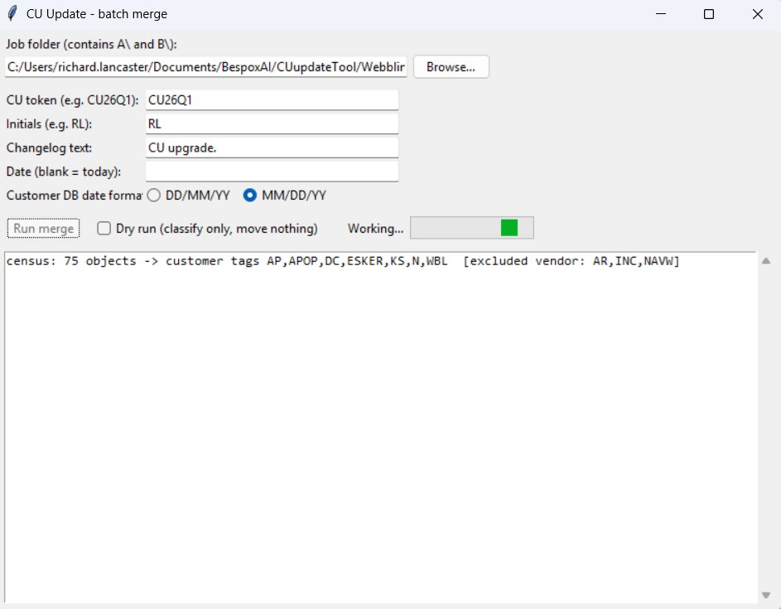
A merge in progress. The first line of the report shows the customer tags the tool determined from the version lists.

4.3 The two date formats
NAV records an object's header Date= value in the locale of the source database. The Customer DB date format option tells the tool which locale the customer database uses:
- DD/MM/YY — the default, used by New Zealand and most incadea customers.
- MM/DD/YY — used by some customers.
This setting affects only the header Date= value. The changelog (documentation trigger) date is always written as DD.MM.YY, regardless of this setting, because that is the incadea convention and is independent of locale. The tool manages this distinction; the developer only declares the header locale.

4.4 The customer tags are determined automatically
The tool determines the customer tags itself. On every run it reads the version list in the header of each A object, extracts the tag prefixes, removes the known vendor prefixes, and uses the remaining prefixes as the customer tag set. The first line of the report shows what was found, for example:
census: 75 objects -> customer tags AP,APOP,DC,ESKER,KS,N,WBL [excluded vendor: AR,INC,NAVW]
The customer tags are not entered by hand.

5. Reading the results

5.1 Use Dry run first
The Dry run option classifies every object and prints the full report without writing or moving any files. Use it to preview a job: it shows which objects will be merged automatically and which will be left for manual review, before anything is changed. When the preview is satisfactory, remove the tick and run the merge.

5.2 Where the files go after a merge
Outcome | Result
Merged automatically | C is written to <job>\Merged\<Type>\Merged-<stem>.txt. The two source files are moved to <job>\AautoMerged\<Type>\ and <job>\BautoMerged\<Type>\.
Manual review | The A and B files are left in place in A\ and B\.
Error or unmatched | The files are left in place and listed in the report. One faulty object never stops the batch.

This means that, after a merge, whatever remains in A\ and B\ is exactly the manual TortoiseMerge worklist. Everything that merged automatically has been moved aside.
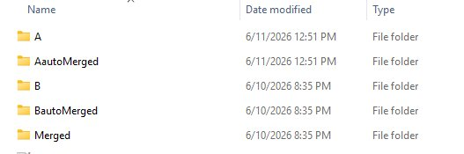
A job folder after a merge. The automatically merged objects are in Merged, with their sources in AautoMerged and BautoMerged. Whatever remains in A and B is the manual worklist.

5.3 The manual-review report
For each object sent to manual review, the report identifies it in plain language — by the field and the line number — so that it can be found quickly in TortoiseMerge. An object with a single item to merge is shown on one line. An object with several items lists each one, with a count so that the amount of work is clear. For example:
MANUAL REVIEW / DEV (17): (left in A/ and B/)
P21 4 blocks need manual merge:
- vendor-deletion change in field 7 at line 1592
- vendor-deletion change in field 9 at line 1606
- vendor-deletion change in field 13 at line 1660
- vendor-deletion change in field 14 at line 1675
P232 4 blocks need manual merge:
- customer field 1101353000 in field 1101353000 at line 113
- customer code block 'AP001662' at line 124
P279 untagged-A-only change in field 1101353000 at line 119 - needs manual merge
Each line states precisely what the tool was not confident enough to merge automatically. The meaning of each kind of item is described in section 8.
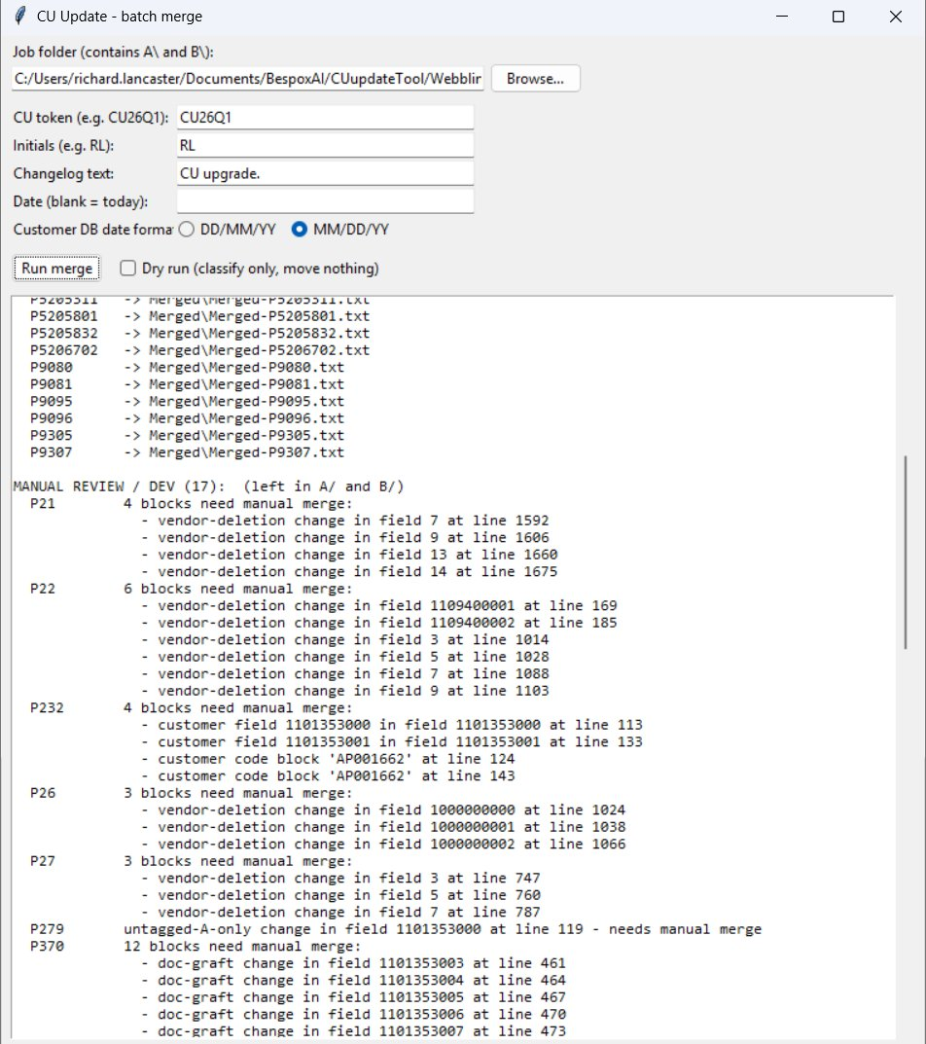
A completed run showing the automatically merged objects and the manual-review report beneath them.

5.4 What the report tells you about the customer tags
The first line of the report (section 4.4) shows the customer tags the tool determined from the version lists. The version list is the curated, authoritative source for these tags, so this is the correct set in normal use. The customer tags affect only whether a customer code block is recognised; caption, option, field and changelog carries do not depend on them. The report records the tags used so that the run is documented and auditable.

6. After the merge

6.1 The automatically merged objects
The files in Merged\<Type>\Merged-<stem>.txt are completed merges, in language-stripped form. They reproduce what a correct hand merge would produce for the cases the tool handles. They may be spot-checked, but they are not part of the manual workload.

6.2 The manual objects
Work through whatever remains in A\ and B\ in TortoiseMerge in the usual way, using the report (section 5.3) to go directly to each flagged item. This is the genuine-judgement subset, and is typically a small proportion of the objects.

6.3 Join the objects by type
Combine the merged objects — both the automatically merged objects and those merged by hand — by object type, into the import files normally produced.

6.4 Re-apply the language layer, then compile
The merged objects are language-stripped. Re-apply the customer language layer that was kept in section 3.2, then import and compile. In the normal workflow this is done within the NAV / GUI development environment, as part of the usual import and compile steps. The tool's responsibility is that the object compiles cleanly after the language layer is re-applied; any translation gaps are corrected as normal development work.
For reference, the equivalent dev-shell cmdlet is Import-NAVApplicationObjectLanguage.

7. Inside the application
The tool is normally used only through the window described above. This section describes what is contained within the application, for background.
The application is built from a small set of Python modules, which are bundled together into the single CUupdate.exe file. No part of this is required at run time other than the application itself.
Component | Responsibility
Launcher | The window: collects the inputs, runs the merge, and shows the report.
Census | Determines the customer tags from the version lists of the A objects.
Batch driver | Runs the whole job, object by object.
Difference engine | Compares A and B and classifies every difference.
Anchor scorer | Decides whether a customer code block can be transplanted with confidence.
Executor | Builds the merged object C and performs the header and changelog bookkeeping.

The application is produced once, on a Windows machine, from the project source. It is then distributed as the single CUupdate.exe file. End users are given the finished application and do not build it themselves.

8. Rules Index by object type
This section is the reference for what the tool carries forward, what it sends to manual review, and why. Each rule names the object it was validated against, so that the reasoning can be checked.
The tool always works difference-first: it compares A against B to find every change, and then justifies each change by its tag layer and its content. It never searches by tag first, because that would miss changes that are untagged or unusually shaped. For each change it produces one of three outcomes:
- CARRY — take the customer's content into C. This is mechanical and safe to automate.
- TAKE B — keep the vendor's content. This is a vendor upgrade that the customer did not change.
- MANUAL — send to manual review. This is a genuine judgement call.
The whole-object gate applies above all of these: if any change in an object is MANUAL, the entire object goes to manual review.

8.0 Object-type dispatch (all object types)
The tool reads the object type from the first line of the object body (OBJECT <Type> <ID> <Name>). This is authoritative; the file name and folder are not used to determine the type. If A and B disagree on the type, or the header cannot be read, the object is sent to manual review (a type mismatch). The tool never merges two objects of different types.
Each object type has its own handler. The current status is:
Object type | Status | What runs
Table | Merges automatically | field graft, code transplant, caption and option carry, description-tag carry, variable-declaration carry, changelog carry, header bookkeeping
Codeunit | Merges automatically | code transplant, changelog carry, header bookkeeping (no field rules)
Page | Merges automatically | control-add graft, caption and option carry with a vendor-rename guard, variable-declaration carry, changelog carry
Report | Manual review only | the whole object is sent to manual review until a handler is built
XMLport | Manual review only | the whole object is sent to manual review until a handler is built

An object type that is not yet validated sends the whole object to manual review before any rule runs, so that no rule written for one type can ever be applied wrongly to another.

8.1 Table
A table is a hybrid object. It contains tagged C/AL code, in its triggers, and structure, in its FIELDS section, where a customer field can be added with no code block at all. The full set of rules applies.

8.1.1 Customer field added to a vendor table — CARRY (field graft)
A field present in A, absent from B, and justified as a customer addition — either by a customer description tag on the field, or by a changelog entry that names it — is grafted as a whole into the FIELDS section of B, after the sibling field that still exists in B. The field's own code travels with it; the code inside a new field's trigger is part of the field, not a separately scored block.
- Validated on Table 14: customer field 50000 grafts cleanly. This is the basic and most common case.
- Validated on Table 36: the customer added fields 50090, 50091, 50096 and 50097, untagged, recorded in the changelog as "Added Consignment fields". These are carried forward, not dropped, because they are customisations of a vendor object — even though their numbers fall in the customer range. (The rule to exclude object numbers 50000 to 99999 applies to whole whole customer objects, not to customer fields added inside a vendor object.)

8.1.2 A changelog entry takes priority over a misleading vendor tag — CARRY
If a field that exists only in A carries a vendor-looking description tag, but a customer changelog entry clearly identifies it as a customer addition, the changelog entry takes priority and the field is carried forward.
- Validated on Page 5025649: a field carried a vendor description tag (PA038441), but the changelog entry "Add External Document No." was the true justification, so the field was carried rather than treated as a vendor deletion.

8.1.3 A whole field, present only in A, with no tag and no changelog entry — MANUAL
A field that is present in A but not in B, with neither a customer tag nor a changelog entry, is ambiguous: it could be a vendor deletion or a customer addition. Because a whole missing field can fail quietly, it is sent to manual review rather than guessed.
- Validated on Table 38: field 70000, "RUID", is sent to manual review.

8.1.4 A customer code block inside a changed shared field or trigger — the scorer decides
A customer-tagged code block (in the // Start <TAG> … // Stop <TAG> form, or the brace form) inside a shared node is passed to the anchor scorer. The scorer decides between CARRY (transplant) and MANUAL, according to whether the block's insertion point still exists, in a coherent position, in B. There are three content classes:
- Pure addition — added lines only. Transplanted if the insertion point survives.
- Vanilla modification — a commented-out original vendor line together with a replacement. Transplanted only on a high score, and only when the overridden original still survives at the anchored position; otherwise sent to manual review. (In practice, all real vanilla modifications have been sent to manual review.)
- Vanilla suppression — a vendor line commented out with no replacement (the customer disabled vendor logic). Always sent to manual review, because re-suppressing vendor logic on the upgraded object is a human decision.
- Validated on Codeunit 80: a vanilla modification (a commented-out TESTFIELD override) is sent to manual review. This object also carries incadea's own tag defects (for example // Srop PA035804) identically in A and B; the tool must not stop on the vendor's own typing errors.
- Validated on Table 39 and Report 790: vanilla suppressions ("Remove short VIN check", a commented-out END;) are sent to manual review.
- Validated on Table 80: a CASE-branch code block in a field trigger transplants correctly once the insertion point is chosen as the closest valid pair of anchors.

8.1.5 A caption or option change — CARRY (always take the customer value)
On any difference in CaptionML, OptionCaptionML or OptionString, the customer value is carried forward. No tag is required. This is low-risk and easy to verify in testing, so it is always taken. The field's Description= tag list is carried with it, but only when the vendor's tags are a subset of the customer's, so that a vendor-added tag is never lost.
- Validated on Table 36: fields 11 and 100, where the customer caption "Customer Order No." differs from the cumulative-update caption "Your Reference". The customer caption is kept.
- Validated on Table 77 (Report Selections): field 1, "Usage", where the customer had appended Direct Credit options to the option string and option caption. These are carried forward. (An earlier version of the tool incorrectly took the vendor value here.)
A non-blocking warning is raised, but the carry still proceeds, if the vendor also changed the options in the middle of the list (that is, the vendor's option string is not a leading part of the customer's). A mid-list vendor change can shift the option ordinals, so the item is flagged for the developer to check.

8.1.6 A field with both a code change and an option change — both are carried
A field can have both a customer code block in its trigger and an extended option or caption. These are not treated as alternatives. The tool produces a scorer-routed code item and a caption carry for the same field.
- Validated on Table 80: field 9, "Type", had both a CASE branch and an extended option string, option caption and description tag. Both are carried.

8.1.7 Customer variable declarations — CARRY (keep rather than delete)
A variable declared in the VAR section of A — either the object-level (global) section, or a procedure-level (local) section — but absent from the matching section of B, is carried forward. The justification is compile-safety alone: a variable that is referenced but not declared fails to compile, whereas a variable that is declared but unused is harmless. The tool therefore never drops a declaration. The carry is performed silently and recorded, because it only ever adds. A variable declaration carries no tag, so there is no source information to reason from; the rule is simply to keep it.
- Validated on Table 81: a global variable, VendBankAccG, used by carried code, was being dropped. It is now carried forward so that the merged object compiles.

8.1.8 A customer-extended option-string variable — CARRY
A variable present in both A and B, where both values are quoted text and the vendor's value is a leading part of the customer's value (that is, the customer appended options), takes the customer's value. A rename or a re-ordering is not a leading part of the value, so it fails this test and is sent to the whole-object manual-review gate; the tool does not guess at it.
- Validated on Page 347: the customer's extension of the ReportUsage2 option list is carried forward.

8.1.9 Header and changelog bookkeeping (every automatic merge)
When the tool builds C, it also performs the mechanical bookkeeping a hand merge would:
- Header: it sets Date= to the merge date, in the declared database locale; reasserts Modified=Yes; preserves the Time value from B unchanged; and appends the CU token to the version-list tokens of A (A carries the customer tokens; B is the standard vendor object).
- Placement: customer content is inserted after the corresponding vendor content, which matches the established TortoiseMerge habit.
- Changelog (documentation trigger): the tool keeps B's entries, including the newest vendor entries; then appends the customer entries from A that are not already present in B, matched by exact line, so that this is independent of any tag prefix; then appends a single CU stamp line last, at the standard six-space indent. This is a combined list: it loses neither the vendor's new entries nor the customer's entries.

8.1.10 Differences in tag spelling are standardised
A difference in tag spelling between the version list and the body (for example, WBL-009 in the body against WBL009 in the version list) is matched without regard to hyphens or full stops, and the version-list spelling is treated as the standard form. The difference is flagged, and the merged object is written with the standard tag, so that the next upgrade reads a clean tag. A plain WBL with no identifier is left as it is; the tool never invents an identifier.

8.2 Codeunit
A codeunit contains code only. It has no field nodes, so the field-graft, caption and option rules do not apply; they are explicitly disabled, so that they can never be applied wrongly. What runs is:
- Customer code blocks — passed to the scorer, exactly as in section 8.1.4 (pure addition, vanilla modification or vanilla suppression; CARRY or MANUAL according to whether the insertion point survives).
- Customer variable declarations — carried, as in section 8.1.7.
- Changelog carry and header bookkeeping — as in section 8.1.9.
- An untagged region where A differs from B — TAKE B. For code objects, tag discipline is reliable, so an untagged code difference is most likely the vendor's own change. This is the one remaining case where vendor content is taken without an explicit signal; it is accepted deliberately, and is confined to code objects, where tag discipline holds. It does not apply to pages or reports.
- Validated on Codeunit 80 (Sales-Post): customer vanilla modifications are sent to manual review; the vendor's own tag defects, present identically in A and B, are tolerated rather than stopped on.

8.3 Page
A page is a structure-bearing object: it consists of a tree of controls, captions and layout, and is often untagged, because there is frequently no natural place for an inline code tag. The absence of tags is therefore never read as "unchanged"; the tool works from the structural comparison and the changelog. The page handler is validated: it merges confident cases automatically and sends uncertain ones to manual review.

8.3.1 A control added by the customer — CARRY (graft)
A control present in A, absent from B, and justified either by a changelog entry that names it or by a customer tag, is grafted into the controls of B after the control that still exists in B. This is structurally the same as a table field graft, with page spacing (pages separate sibling controls with a blank line).
- Validated on Page 14: the customer added an "E-Mail" control, justified only by the changelog entry "Added E-Mail field", with no tag on the control itself. It is grafted after its anchor, the "Phone No." control, identically to the hand merge.
- Validated on Page 21 (tagged version): the four customer FactBoxes, carrying a customer tag, merge automatically as confident grafts, in the correct order even when several share one anchor.

8.3.2 A vendor caption rename — TAKE B (do not carry the outdated customer caption)
If a caption or option difference exists, and B carries a vendor tag that A does not, the change is vendor-driven: the vendor renamed it. The tool takes the vendor value, and does not carry the customer's now-outdated value. This guard prevents the table-era rule of always carrying the customer caption from overwriting a vendor rename.
- Validated on Page 21: controls where the vendor renamed "Quick Customer" to "New Quick Customer" and added a new vendor tag in B. The vendor value is taken.

8.3.3 A control present only in A, carrying only a vendor tag — MANUAL
A control present only in A that carries only a vendor description tag is ambiguous: it could be a genuine vendor deletion, or a customer-added control that happens to carry a vendor tag. From the control alone, the tool cannot tell which, so it sends the object to manual review rather than risk dropping a customer control.
- Validated on Page 21: FactBoxes recorded under a customer changelog entry but each carrying a vendor description tag are sent to manual review. When the same FactBoxes are given a customer tag (the tagged version of the page), the same object merges automatically, as in section 8.3.1. The customer tag is what resolves the ambiguity.

8.3.4 A customer change to a property on a shared control — MANUAL
A customer change to a property on a control that exists in both A and B — for example, changing
Visible — is a modification, not a clean addition, and is sent to manual review.
- Validated on Page 5025440: the customer changed Visible from FALSE to true on a shared control. The object is sent to manual review.

8.3.5 Caption capture on a page stops at the closing brace
On a page, a single-value caption can be the last property before the control's closing brace, with no trailing semicolon (for example, CaptionML=ENU=General }). The tool stops reading the caption value at the brace as well as at the semicolon, so that the brace is not read as part of the value. (A table caption always ends at a semicolon, so this applies to pages only.)
The page handler also performs the variable-declaration carry (sections 8.1.7 and 8.1.8) and the changelog and header bookkeeping (section 8.1.9).

8.4 Report and XMLport
Both report and XMLport objects are recognised but not yet validated. The whole object is sent to manual review before any rule runs. The report describes this in plain language ("object type not yet auto-merged by the tool — manual merge").
This is deliberately safe. It means that there is no path by which a report can be merged incompletely. In particular, the RDLC layout case — for example, a report whose change is "Add header and footer", where the change is held in a layout block that the comparison does not read — is covered by the whole-object gate, not missed. A report or XMLport object will be merged automatically only once its handler is built and validated against a real object.

8.5 Rules that apply to all object types
- Killme objects are retired. An object whose name contains the word kill is retired and is never written to the merged set. It is identified by its name, not by its version list or body tags.
- Modified = No means take B. If the header of A records that the customer never modified the object, the vendor object is taken.
- An identical object means take B. After the header bookkeeping, whitespace, line endings and language layer are normalised, if A is identical to B, there is nothing to carry.
- Integrity is assessed by layer. A malformed tag in a customer block stops the merge, because the block cannot be transplanted safely. A malformed tag in a vendor block is a warning only, because incadea ships its own tag defects (for example // Srop PA035804) identically in A and B, and the tool must not stop on the vendor's own errors.
- Transplant is verbatim. Customer blocks are inserted exactly as written, including their original indentation; the tool does not re-indent them. (A hand merge sometimes re-indents an inner END;; the tool's verbatim form still compiles, and can be tidied later.)
- Encoding. Files are in cp1252 / Latin-1 encoding. TortoiseMerge artefacts — carriage returns, trailing whitespace, and stray tabs in the changelog — are normalised.

9. Quick reference
To run a job: double-click CUupdate.exe; select the folder that contains A\ and B\; enter the CU token and your initials; tick Dry run; click Run merge; review the report; remove the tick; click Run merge again.
After a merge: the Merged\ folder holds the completed objects; whatever remains in A\ and
B\ is the manual TortoiseMerge worklist; the report gives the field and line of each flagged item.
Then: join the objects by type; re-apply the language layer in the development environment; import and compile.
Merges automatically at present: Table, Codeunit and Page (confident cases).
Always manual at present: Report, XMLport, and any object containing a vanilla modification or suppression, an ambiguous control carrying only a vendor tag, a property modification, or anything the tool is not confident about.
The guarantee: if the tool is not confident, it returns the whole object unchanged. It never merges an object incompletely.

