**ENERGY AUDITING THROUGH MACHINE LEARNING**

*Submitted by*

*G. NAVA BHARGHAV*

*B. MOHAN SAI*

*K. HEMANTH KUMAR*

Department of Electrical and Electronics Engineering

In

Raghu Engineering College

Dakamarri, Visakhapatnam

May 2020

# ABSTRACT

Day by day, energy demand keeps rising so that it is essential to reduce energy consumption for that energy conservation is needed. For conservation of energy the best option is energy audit. Energy audit is a process to determine when, where, why and how energy is used in a plant, industry or a building. Collection of these information helps to identify the situation where there is need to improve energy efficiency and decrease production cost. Normally, an energy audit is carried out by certified energy auditors. By conducting energy audit process in industry, employees begin considering energy as a manageable expense and try to conserve it in day-to-day action. However, Energy auditing can be more efficiently done with the help of an external source or a software with the help of Machine Learning. In this current technology-driven world, Machine Learning is a prominent area which makes our machine or electronic device intelligent. Machine Learning is an efficient way of working with machines which involves training and developing intelligent machines. The main objective of this project is to perform energy auditing through machine learning. In this project we develop and train a system for which, for only some certain defined inputs energy auditing is performed. Finally based upon the user or the consumer requirements the system utilities in a building or in an industry are operated and an efficient way of energy auditing can be observed. The future implementation for this method which involves machine learning is by developing an app or a software which is suitable for installing at system utilities and can be operated efficiently, and this creates an eco-friendly environment which can handle energy conservation and access data about the system utilities efficiently.

# INTRODUCTION

An Energy Audit, sometimes referred to as an energy survey or an energy inventory, is an examination of the total energy used in a particular property. The analysis is designed to provide a relatively quick and simple method of determining not only how much energy is being consumed but where and when. The energy audit will identify deficiencies in operating procedures and in physical facilities. Once these deficiencies have been identified, it will be apparent where to concentrate efforts in order to save energy. The energy audit is the beginning of and the basis for an effective energy-management programme.

Energy Audits are an excellent way to learn about energy management in a particular industry or in a building. Auditing also gives a clear-cut idea on how their activities impact the cost of energy directly or indirectly and also gives an idea on how to reduce greenhouse gas emission, thus making their business more environmentally friendly.

The following are the methods which are implemented and being implemented by some experts across the globe, the methods are:

1. Bench Marking
2. Walk-through Audit
3. Detailed Audit
4. Investment-grade audit
5. Energy Diagnosis

Most of the Energy Auditing methods are Theoretically proved and yet need to be proved practically. Hence there is a need of a new efficient method which can Audit the System utilities and can conserve the energy for future generations. As connected utilities are dynamic in nature, this may result in erroneous auditing. Hence, A real-time auditing is required that consider weather and other priority factors. In this work, a novel method of energy auditing is proposed that uses machine learning techniques to classify running loads and identify energy wastage. There is an enormous need for Energy Auditing, the following are the reasons which explains the need of Energy conservation:

1. To reduce the Energy Consumption and hence the Electricity Bill.
2. To reduce the transmission and Distribution Losses and to increase the system efficiency.
3. To extend the life of the System utilities for effective life cycle.
4. It reduces the cost of production in Industrial output.
5. To reduce the use of Fossil fuels, thus creates an impact and awareness on the proper utilization of renewable sources.

**Actual Load**

**Load measurements (Watt, Pf, I, F)**

**Load Classification**

**Look-Up Table (List)**

**Updating of newly detected utility**

**Assessment**

**Rescheduling**

**Audit Report**

**Figure 1: overall flowchart**

# METHODOLOGY

As connected utilities are dynamic in nature, this may result in erroneous auditing. Hence, A real-time auditing is required that consider weather and other priority factors. In this work, a novel method of energy auditing is proposed that uses machine learning techniques to classify running loads and identify energy wastage. There is an enormous need for Energy Auditing. The following algorithms clearly explains us to reach our goal.

**ALGORITHM:**

**Figure 2: ALOGRITHM SHOWING LOAD CLASSIFICATION**

**STEP 1:** Input the defined parameters.

**STEP 2:** A function generates all n bit gray codes and prints the generated codes.

**STEP 3:** if n<=0; this condition is called as the base case condition.

**STEP 4:** Create a list to generate codes.

**STEP 5:** We append ‘0’ and then ‘1’, to start with one-bit pattern, and every iteration of this loop generates 2*i codes from previously generated I codes.

**STEP 6:** Now enter the previously generated codes again in the list in reverse order and append ‘0’ to the first half.

**STEP 7:** Append ‘1’ to the first half of the code and save the contents in the list. Now the list contains the gray codes.

**STEP 8:** Check the correct combination and then compare the measured power with the instantaneous power.

**STEP 9:** If it not matches, then get the difference power and then compare it with the data base. If the same utility contains in the data base then print the value with its name.

**STEP 10:** If it not exists then increment the value of ‘n’. n=n+1 and also sore this as a new device in the data base.

**ALGORITHM:**

Figure 3: ALGORITHM SHOWING ASSESSMENT AND RESCHEDULING

**STEP1:** The received data from gray code is fed to this algorithm.

**STEP2:** We create a new set of lists to import the data from excel sheet. Utility data from the excel sheet is taken as data, each column as a new list.

**STEP3:** We do import open pyxl to create an excel sheet as shown below,

“from openpyxl import load_workbook

workbook = load_workbook(filename="book.xlsx")”

We import a load_workbook as shown above and the name for that workbook is “book.xlsx”. here our utility data is stored manually thus which is used in our code for importing and handling of utility data. Thus, we have to activate the data base i.e. our excel sheet.

“spreadsheet = workbook.active”

**STEP4:** To detect whether a new device is detected or not, we take to compare the lengths of the list. The first list is out utility names data and the other is our utility wattage data.

**STEP5:** If the lengths are equal then there is no problem, it means that there is no new utility found.

**STEP6:** In case from **STEP4,** if the lengths are not equal then it means that a new utility is found and now there are again two cases involved in it.

**STEP7:** If the new utility found is already existing in our data base, then the count of that particular utility doubles.

**STEP8:** If in case from **STEP6,** if the new utility found doesn’t exist in our data base then we have to give a new name to our new utility and update the both lists, which were the different columns of our data base.

**STEP9:** Now after this step we have to completely update the entire system utilities data in lists and also in the data base which is our excel sheet.

**STEP10:** Now for the data existing we have to plot accordingly for the existing data, in case of the data where new utility exists then we have to apply the method of clustering to easily identify and plot the data.

**ALGORITHM:**

**STEP1:** Data received from the saved workbook and the newly updated lists.

**STEP2:** Importing of matplotlib and also the skfuzzy for plotting and for the purpose of clustering of the utilities data.

“import matplotlib.pyplot as plt”

“import skfuzzy as fuzz”

**STEP3:** For clustering and for plotting for the ‘n’ utilities present in the data base we run a loop and we also create a new list which has colours within it.

“colors = ['b', 'orange', 'g', 'r', 'c', 'm', 'y', 'k', 'Brown', 'Forest Green']

“for i in range(0,n):

“ax0.plot(y[i], q1[i], ‘.’, color=colors[i])”

The colors is a name of list which is a combination of a group of lists which consists of different colours names for the clustering. In clustering each group has a different colour. The loop runs for all the ‘n’ utilities present the data base and each utility is plotted for its respective range.

**STEP4:** Finally, we apply the membership function for the further classification of the plot which have been clustered.

Figure 4: ALGORITHM FOR AUDIT REPORT

# RESULTS

Electricity is the most important commodity we use in these present day-to-day lives. Without power there is no development. Energy plays an important role for the development so, to save this energy we use different methods for the conservation of energy for future generations.

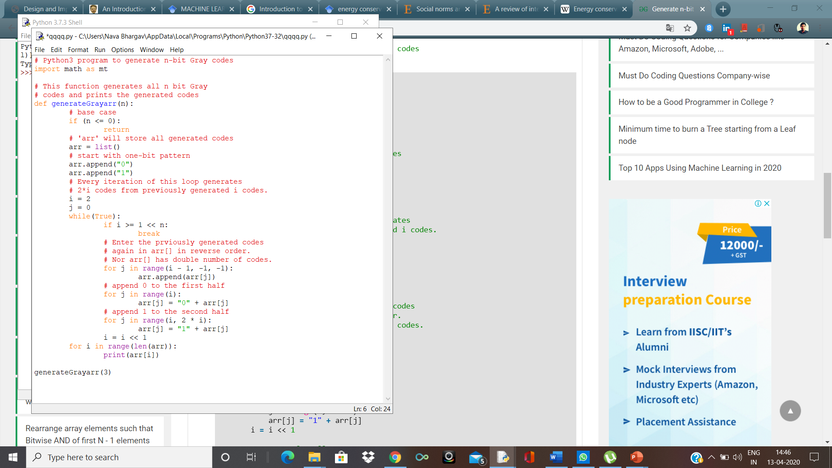

**Figure 5:Figure showing a python code which can generate a 'nth' order gray code.**

In the above code, generateGray(3) is the function and directly it is inputted as n=3. For different we can give different value of ‘n’. These combinations start from [000]-[111]. Thus, from this gray code we can easily identify and obtain our required sequence which we are required for.

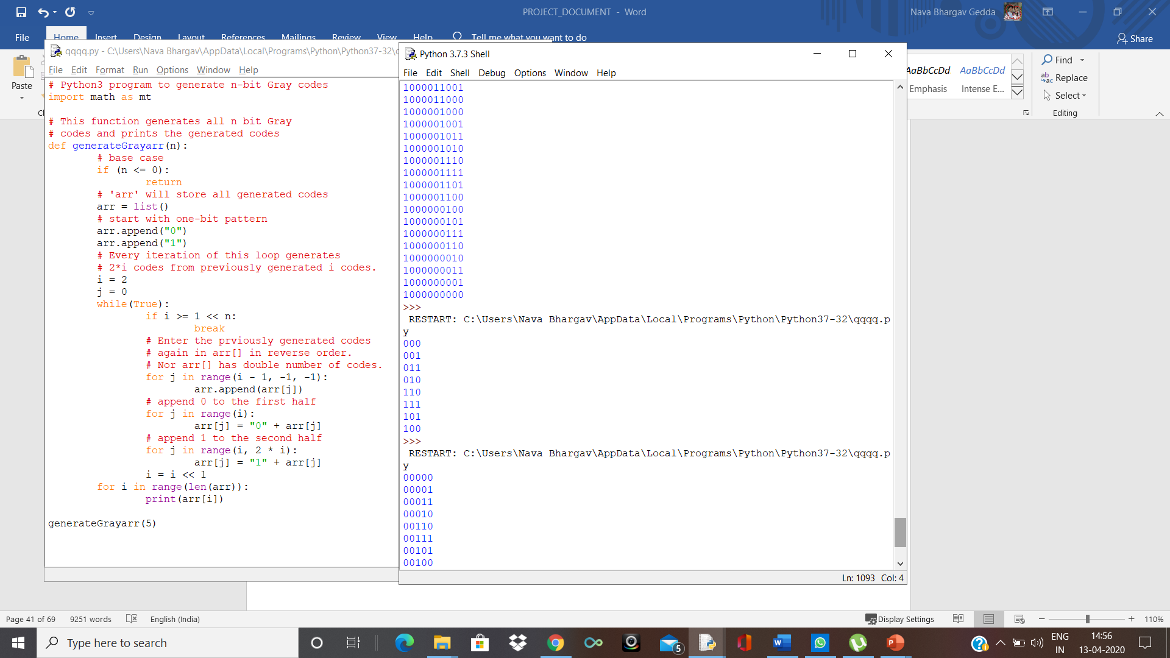

**Figure 6: The output of a 3(n=3), digit gray code.**

The updating of the data with its respective examples in different cases is shown and explained below:

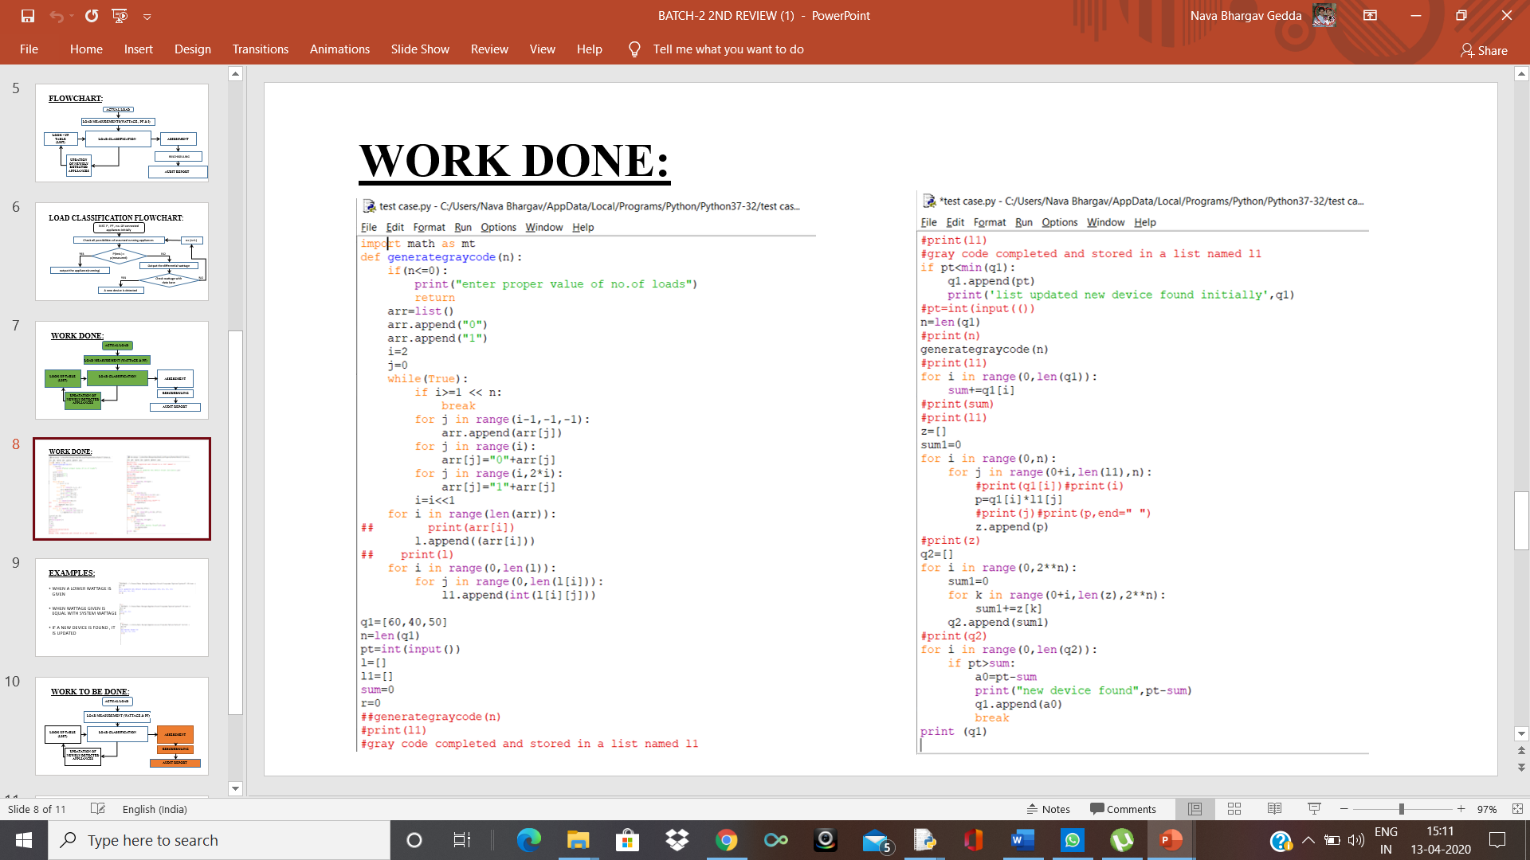

**Figure 7: Load classification and updation of data to look-up table in pyhton.**

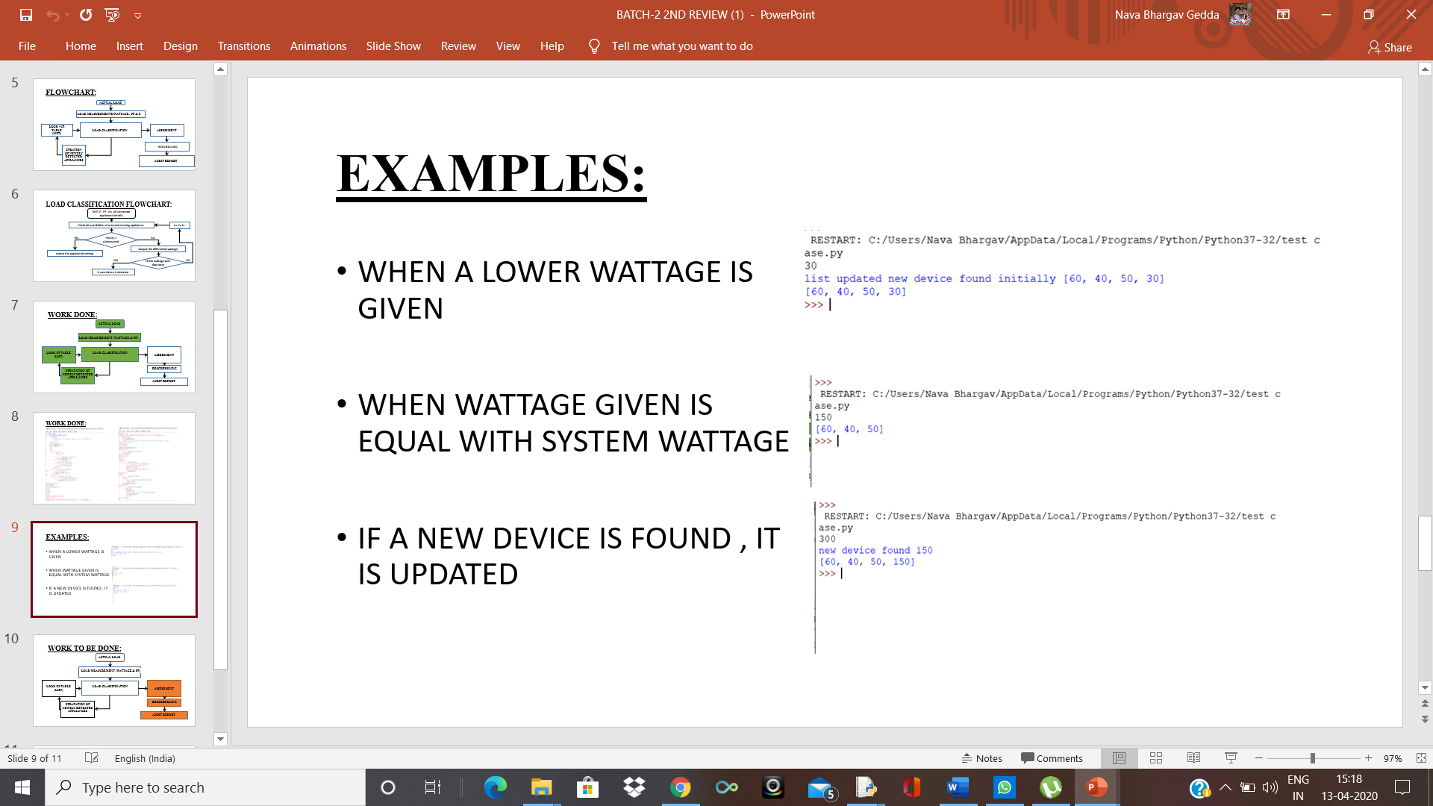

**Figure 8: : Case 1 [load classification]**



**Figure 9: Case 2 [load classification]**



**Figure 10: Case 3[load classification]**

The data of entire utilities are stored in our data base in a excel sheet as shown in the figure below. We take this data for data handling and update the excel accordingly based upon the changes defined for the utilities respectively.

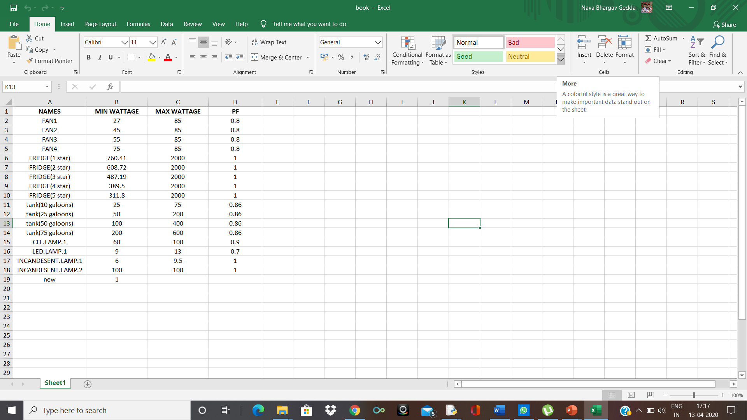

**Figure 11: Excel sheet showing data of some utilities.**

For the above data we define a graph to plot by using mathplotlib which can help us visualize the work done in a graphical representation. Which can be easy to handle, access and help to understand and justify the difference between the utilities.

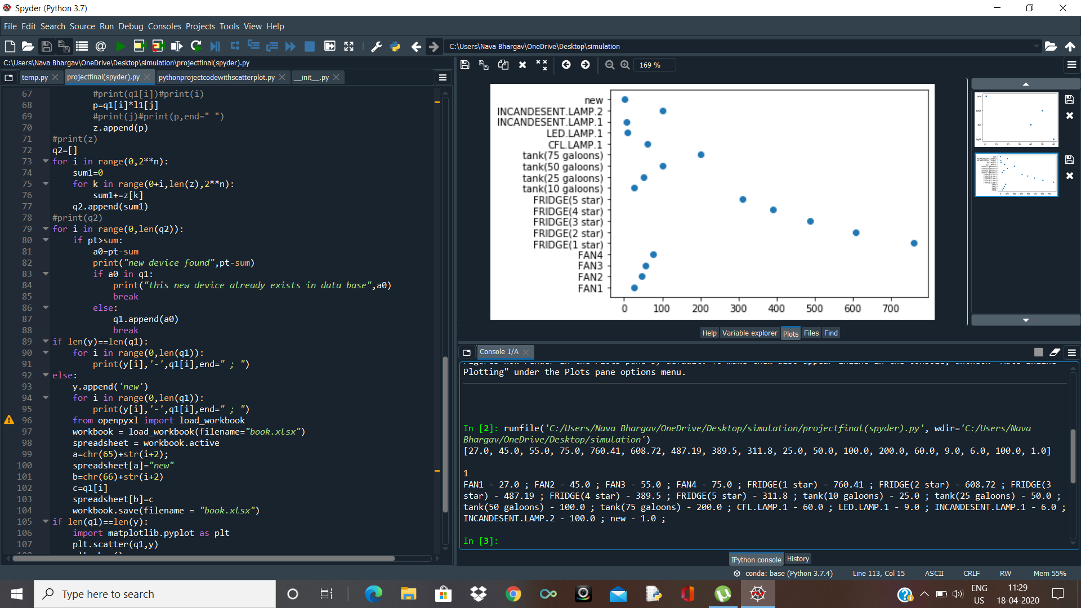

**Figure 12: Representation of the utilities based on their consumption (utility vs Wattage)**

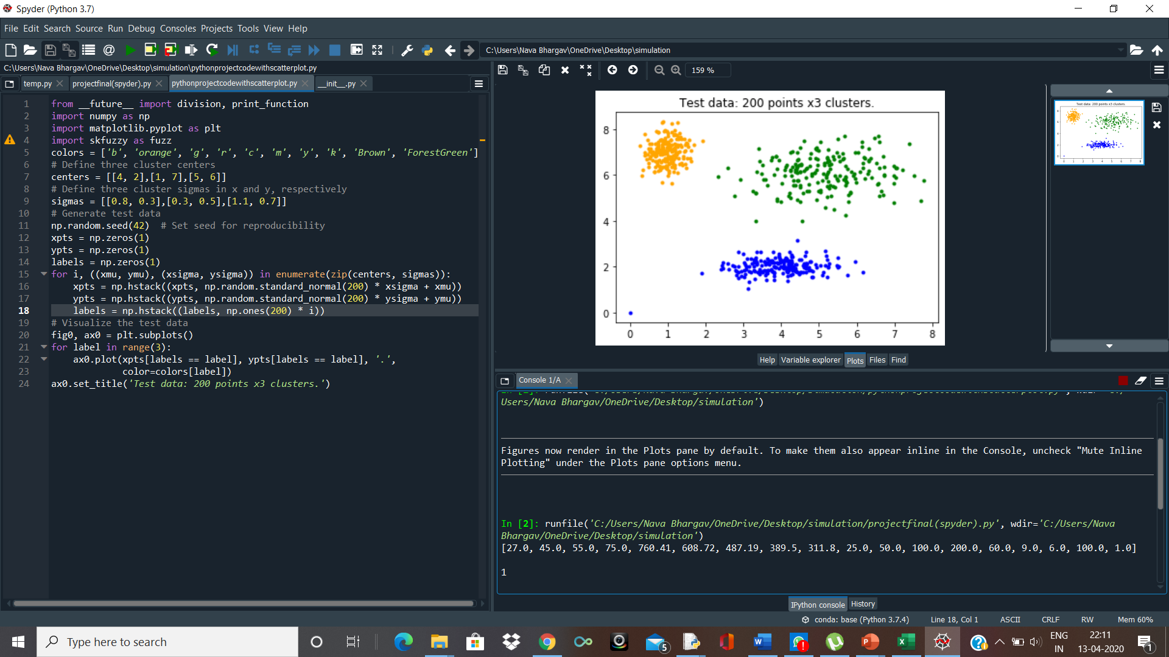

**Figure 13: Representation of a three utility clustered data**

# CONCLUSION

Thus, this proposed project deals with all the above explained methods and techniques. The energy can be easily audited through this process and we can develop an efficient way to conserve energy. Since there is a very need to conserve energy for the future. The future application of this proposed project might be developing a software kit or an app which is easily installed and can be easily operated. By installing this app or kit we can monitor data based upon hourly bases or daily. Thus, we can even add home automation as an additional feature where the devices automatically turn-off and turn-on based upon the customers usage and his previous data or even based upon his preferences.

This, method can be more effective if the control of the software or app is within the hands of government. So, that government can generate power effectively and accordingly. Through this auditing i.e.; by plotting we can use the plots to study each and every appliance which is in use and even there is an already developed software which can detect the cases of hacking based upon these graphs. There is a lot more things which we can use these graphs effectively for many purposes and develop a conserve situation, which can easily fulfil the imbalances occurring now and can be observed that these imbalances can be overcome and every individual can have a chance to fulfil his dreams accordingly.