DeepAR:-

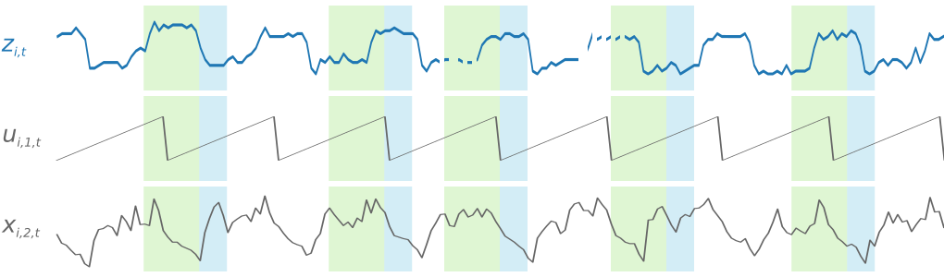

Figure 1 Input-Output

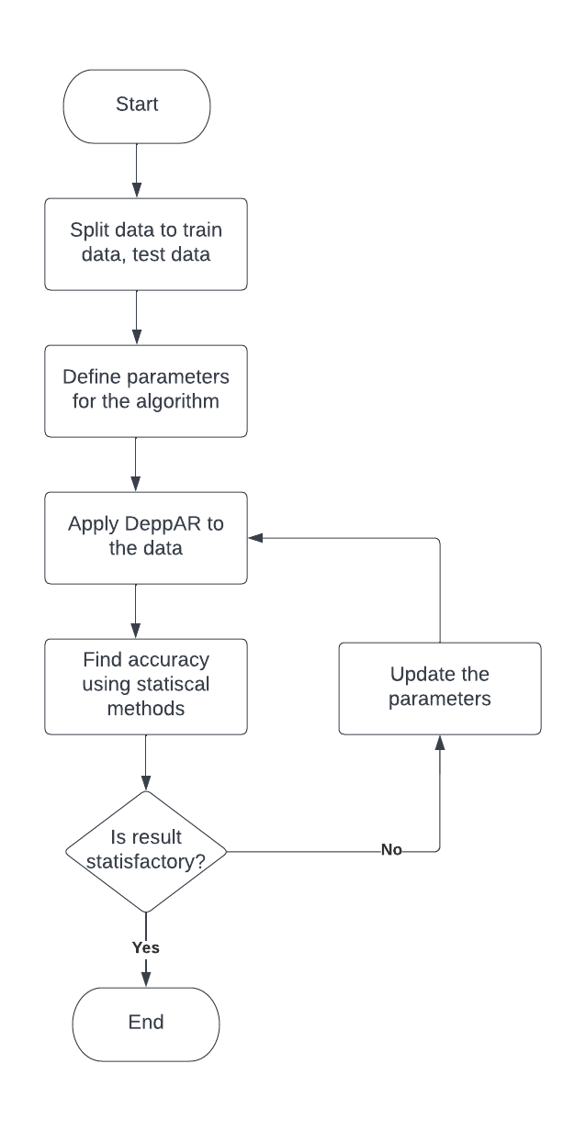

Figure Flowchart

Pros and cons:-

DeepAR has the advantage of training several hundred or thousands of time-series simultaneously, potentially offering significant model scalability. It also has the following technical benefits:

* Minimal Feature Engineering: The model requires minimal feature engineering, as it learns seasonal behaviour on given covariates across time series.
* Monte Carlo Sampling: It is also possible to compute consistent quantile estimates for the sub-ranges of the function, as DeepAR implements Monte Carlo sampling. This could, for instance, be useful when deciding on safety stock.
* Built-in item supersession: It can predict on items with little history items by learning from similar items
* Variety of likelihood functions: DeepAR does not assume Gaussian noise, and likelihood functions can be adapted to the statistical properties of the data allowing for data flexibility.

Reference:

1) <https://towardsdatascience.com/prophet-vs-deepar-forecasting-food-demand-2fdebfb8d282>

2) <https://docs.aws.amazon.com/sagemaker/latest/dg/deepar_how-it-works.html>