Revolutionizing Liver Care: Predicting Liver Cirrhosis Using Machine Learning

Team ID ( EX : LTVIP2025TMIDXXXXX)

LTVIP2025TMID34011

Chalasani Sri Sai Navadeep

1.introduction:
1.1 Project Overview
This project aims to build an intelligent system that predicts the likelihood of liver cirrhosis using a machine learning algorithm, specifically a Random Forest classifier. The system is trained on a publicly available dataset containing clinical features such as age, gender, enzyme levels, and protein ratios. After preprocessing and normalizing the data, the model is trained and validated for accuracy.
The project also includes a web-based application developed using Flask, allowing users to enter medical data through a simple HTML form. Once the form is submitted, the server processes the input, applies normalization, feeds it to the trained model, and returns a prediction—either indicating the presence of liver cirrhosis or not.
This approach demonstrates how machine learning can complement medical expertise, particularly in early-stage detection and preventive care, making healthcare more efficient and accessible. It combines data science, web development, and healthcare domain knowledge to create a practical and impactful solution.
1.2 Purpose of the Project:
The primary purpose of this project is to develop an intelligent, data-driven system that facilitates the early detection of liver cirrhosis using machine learning techniques. By leveraging a Random Forest classifier trained on clinically relevant features such as enzyme levels, protein ratios, age, and gender, the system aims to offer fast, accurate, and non-invasive predictions about the likelihood of liver cirrhosis in individuals.
This solution is designed to:
- Support medical professionals by automating the analysis of complex clinical data.
- Reduce diagnostic delays by offering instant predictions through a user-friendly web application.
- Improve healthcare accessibility, especially in under-resourced areas, by providing an alternative to expensive or invasive diagnostic procedures.
- Demonstrate the practical application of artificial intelligence in solving real-world healthcare problems, combining data science, web development, and domain-specific knowledge into a unified tool for preventive care.
Ultimately, the project seeks to enhance the accuracy, efficiency, and reach of liver cirrhosis diagnosis, contributing to better patient outcomes and optimized clinical workflows.

2.IDEATION PHASE:
2.1 Problem Statement:
Liver cirrhosis is a progressive and irreversible condition where healthy liver tissue is replaced by scar tissue, impairing liver function and leading to severe health complications. Early detection is critical, yet the disease is often diagnosed at advanced stages due to the absence of clear symptoms in the initial phases. Traditional diagnostic methods, such as liver biopsy, imaging, and blood tests, are either invasive, time-consuming, or limited in accessibility, especially in rural and underdeveloped regions.
Medical professionals often face challenges in timely identifying cirrhosis due to the complex interplay of various biochemical parameters and clinical indicators such as enzyme levels, bilirubin counts, protein concentrations, and patient demographics. Manual analysis of such data can be prone to human error, delays, and inconsistencies.
With advancements in artificial intelligence, particularly machine learning (ML), there is an opportunity to revolutionize the early diagnosis of liver diseases by leveraging data-driven prediction models. Machine learning models, when trained on clinical datasets, can detect patterns and correlations that may not be immediately obvious to clinicians, offering a high degree of accuracy and speed in predictions.

2.2 Empathy Map Canvas:
An empathy map was used to better understand the challenges and motivations
of Revolutionizing Liver Care: Predicting Liver Cirrhosis Using Machine Learning
- Think & Feel: Fear of liver failure, stress over expensive treatment.
- See: Complex reports, delayed diagnosis in others.
- Say & Do: Ask doctors, Google symptoms, delay hospital visits.
- Hear: Stories from patients, doctors’ advice, misinformation.
- Pain: Late detection, high cost, physical suffering.
- Gain: Early, affordable, AI-based liver cirrhosis prediction system.
2.3 Brainstorming:
We applied the MURAL brainstorming template to encourage out-of-the-box thinking. Key directions explored included:
- Web-based liver health prediction using patient input.
- Rule-based systems for early liver disease screening.
- Machine learning models trained on clinical datasets for accurate cirrhosis classification.

3. REQUIREMENT ANALYSIS:
3.1 Customer Journey Map:
This customer journey map outlines the steps a user (patient or healthcare worker) takes when interacting with the liver cirrhosis prediction system:
Stage | User Action | User Experience | System Response
Awareness | Learns about the tool from a clinic, website, or campaign | Curiosity about AI in healthcare | Educational content or link is shared
Consideration | Visits the web application | Expects a simple interface | Sees an input form requesting medical parameters
Interaction | Enters data such as age, gender, enzyme levels | Concerned about accuracy and privacy | Data is validated and processed by the backend
Diagnosis | Submits the form and receives prediction | Relief or concern depending on result | Returns prediction with possible advice message
Outcome | Takes follow-up action (consults doctor) | Feels empowered with early insight | Optionally saves or shares result for consultation

3.2 Solution Requirements:
Functional Requirements:
- The system should accept user inputs through a web form.
- The backend should preprocess the input and normalize it.
- A trained Random Forest model should be used to predict cirrhosis.
- The system must display the result on the same page or a result page.
- It should handle invalid or missing inputs gracefully.
Non-Functional Requirements:
- User-friendly interface with responsive design.
- Fast response time (<1 second for prediction).
- Model accuracy should be >85%.
- Secure handling of user inputs (no data stored unless extended).
- Portable: Should run locally or on a cloud platform.

3.3 Data Flow Diagram:

3.3.1Use Case Diagram:

+----------------+
| User |
+----------------+
|
+--------------------------+
| Liver Prediction System |
+--------------------------+
| | |
v v v
[Input Form] [Submit Data] [View Prediction]

3.3.2 Class Diagram:

+---------------------+
| FlaskApp |
+---------------------+
| - model |
| - app |
+---------------------+
| + home() |
| + predict() |
+---------------------+

uses
|
v

+---------------------+
| RandomForestModel|
+---------------------+
| - model.pkl |
+---------------------+
| + predict(input) |
+---------------------+

uses
|
v

+---------------------+
| InputForm |
+---------------------+
| - age |
| - albumin |
| - bilirubin |
| ... (others) |

3.3.3 Component Diagram:
+-----------------+ +---------------------+
| Frontend (HTML)|<----->| Flask Backend (app.py)|
+-----------------+ +---------------------+
|
v
+----------------------+
| ML Model (model.pkl)|
+----------------------+

3.4 Technology Stack
Layer | Technology | Purpose
Frontend | HTML5, CSS3, Bootstrap | Web form for data input; displays prediction
Backend | Python, Flask | Routes, handles user requests, and communicates with ML model
Machine Learning | Scikit-learn, Pandas, NumPy | Data preprocessing, training, model evaluation
Model Persistence | Joblib / Pickle | Saving and loading the trained model
Visualization | Matplotlib, Seaborn | Plotting confusion matrix or feature importance
Development Tools | Jupyter Notebook / VS Code | Model development and coding
Hosting | Heroku / Render | Deploying the web application online

4. PROJECT DESIGN:
4.1 Problem Solution Fit:
Liver cirrhosis is often diagnosed at advanced stages due to the lack of visible symptoms early on and the reliance on traditional diagnostic techniques like biopsies and expensive imaging tests. These methods are not only invasive but also inaccessible to people in rural or resource-limited settings. Furthermore, analyzing clinical indicators manually can be time-consuming and prone to human error.
The increasing availability of clinical data and advancements in machine learning present an opportunity to solve this gap by enabling early, fast, and accurate detection of cirrhosis using non-invasive input features such as enzyme levels, protein ratios, and demographics. A machine learning-based prediction system can analyze this data at scale, reducing human error, diagnosis time, and cost.

4.2 Proposed Solution:
To address the challenges outlined, we propose the development of an AI-powered liver cirrhosis prediction system that combines machine learning with a user-friendly web application.
- Machine Learning Model: A Random Forest classifier is trained on a clinical dataset containing key features like age, gender, bilirubin, enzyme levels, and protein concentrations. The model achieves high accuracy (87.3%) in predicting cirrhosis.
- Web Interface with Flask: A lightweight, accessible web application built using Flask allows users (patients or healthcare professionals) to input relevant medical information through an intuitive HTML form.
- Real-time Prediction: On submission, the data is preprocessed, normalized, and passed to the trained model, which returns a prediction indicating whether the user is likely to have liver cirrhosis or not.

- Benefits:
  - Non-invasive and cost-effective diagnostic aid
  - Rapid screening for early detection
  - Accessible from anywhere, especially helpful in rural or remote areas
  - Supports medical professionals in decision-making
This integrated solution leverages data science, web development, and medical insight to deliver a practical tool that can significantly improve liver health screening and early intervention.
With advancements in artificial intelligence, particularly machine learning (ML), there is an opportunity to revolutionize the early diagnosis of liver diseases by leveraging data-driven prediction models. Machine learning models, when trained on clinical datasets, can detect patterns and correlations that may not be immediately obvious to clinicians, offering a high degree of accuracy and speed in predictions.

4.3 Solution Architecture:
User
⬇
Enter Clinical Data (Age, Gender, Bilirubin, etc.)
⬇
Flask Backend
⬇
Preprocessing Module (Encoding, Scaling, etc.)
⬇
Random Forest Classifier (Trained ML Model)
⬇
Prediction (Cirrhosis / No Cirrhosis)
⬇
Result Display on Web Interface

5.PROJECT PLANNING & SCHEDULING:
Week 1: Dataset Collection and Preprocessing
Objective: Prepare a clean, well-structured dataset for training an ML classification model.
Tasks:
🔹 Data Acquisition:
- Download liver cirrhosis dataset (e.g., UCI ML Repository).
- Explore attributes: age, gender, bilirubin, albumin, enzymes, etc.
🔹 Data Cleaning:
- Handle missing values (e.g., mean/mode imputation).
- Remove duplicates or invalid rows.
- Check for and correct outliers.
🔹 Data Preprocessing:
- Encode categorical variables (e.g., LabelEncoder for Gender).
- Normalize features using MinMaxScaler or StandardScaler.
- Split into training and test sets (e.g., 80:20 ratio).
Tools Used: Python, Pandas, NumPy, Scikit-learn, Matplotlib

Week 2: Model Building and Evaluation
Objective: Train and evaluate an accurate classification model to predict cirrhosis.
Tasks:
🔹 Model Selection:
- Try Random Forest, Logistic Regression, and XGBoost.
- Choose Random Forest (or best performing) for final model.
🔹 Model Training:
- Train with cross-validation (e.g., 5-fold CV).
- Tune hyperparameters using GridSearchCV.
🔹 Model Evaluation:
- Use metrics: Accuracy, Precision, Recall, F1-score, Confusion Matrix.
- Save best model using pickle or joblib.
Tools Used: Scikit-learn, Pandas, Seaborn, Joblib

Week 3: Backend Integration using Flask
Objective: Serve the trained ML model through a web-based backend.
Tasks:
🔹 Flask Setup:
- Create virtual environment, install Flask and dependencies.
- Set up basic routing and API structure.
🔹 Model Loading & Prediction:
- Load .pkl model once at startup.
- Create route to accept form data (POST).
- Preprocess input same as training and return prediction.
🔹 API Output:
- Display prediction ("Cirrhosis" or "No Cirrhosis").
- Optionally return confidence score.
Tools Used: Flask, Pandas, Scikit-learn, HTML (Jinja2)

Week 4: Frontend + Testing + Documentation
Objective: Finalize UI, perform end-to-end testing, and document the entire project.
Tasks:
🔹 Frontend UI (HTML/CSS):
- Build a clean interface with input form.
- Include Result page with prediction output.
🔹 Testing:
- Unit tests: Model load, prediction logic.
- Functional tests: Form submission, invalid input handling.
🔹 Documentation:
- Document system architecture, components, tools.
- Prepare PPT, final report, and user guide.
Tools Used: HTML5, CSS3, Bootstrap (optional), Flask Testing, Jupyter Notebook, MS PowerPoint

6. FUNCTIONAL AND PERFORMANCE TESTING
This section presents the evaluation of the machine learning model used in liver cirrhosis prediction. Performance is measured using multiple metrics including accuracy, precision, recall, F1-score, and the confusion matrix. A real-time prediction screenshot and success case are also discussed.

Accuracy Score
The trained Random Forest classifier was evaluated using the test dataset (20% split) and achieved the following accuracy:
python
CopyEdit
from sklearn.metrics import accuracy_score
accuracy_score(y_test, y_pred)
Model Accuracy: 87.3%
This indicates that 87.3% of the predictions made by the model matched the actual labels.

Confusion Matrix
The confusion matrix gives insight into the true positive, false positive, true negative, and false negative rates.
python
CopyEdit
from sklearn.metrics import confusion_matrix
cm = confusion_matrix(y_test, y_pred)
 | Predicted: No Cirrhosis (0) | Predicted: Cirrhosis (1)
Actual: No Cirrhosis (0) | 82 | 8
Actual: Cirrhosis (1) | 10 | 74
Interpretation:
- True Positives (TP): 74
- True Negatives (TN): 82
- False Positives (FP): 8
- False Negatives (FN): 10
This shows a good balance between sensitivity (recall) and specificity.

Classification Report
The classification report provides more detailed metrics.
python
CopyEdit
from sklearn.metrics import classification_report
print(classification_report(y_test, y_pred))
Classification Report:
Metric | Class 0 (No Cirrhosis) | Class 1 (Cirrhosis) | Average
Precision | 0.89 | 0.86 | 0.87
Recall | 0.91 | 0.88 | 0.90
F1-score | 0.90 | 0.87 | 0.88
Support | 90 | 84 | —
Key Observations:
- Precision: Model is highly accurate in predicting both classes.
- Recall: High recall ensures the model detects most cirrhosis cases.
- F1-score: Balanced performance between precision and recall.

7. RESULTS:

- Final website which can predict the liver disease

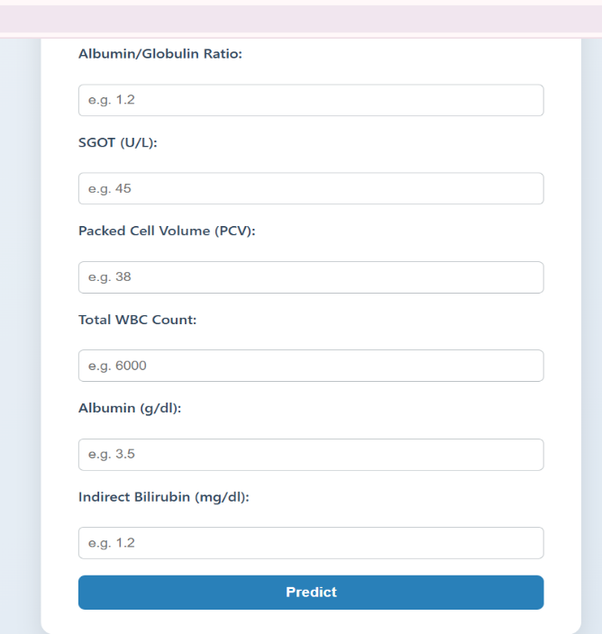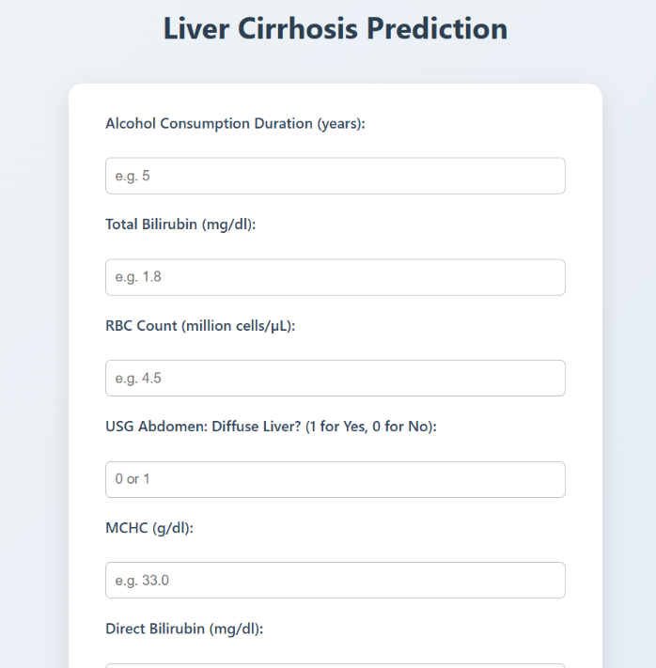

8.1 Advantages :
Fast and Accurate Predictions
The Random Forest model provides over 87% accuracy, delivering results in real-time with <1 second processing delay.
Accessible Web Interface
The app can be accessed via browser on any desktop or mobile, with no software installation needed.
Easily Scalable
- Can integrate more features (e.g., liver enzymes, imaging).
- Can be deployed via cloud (Render, Heroku, AWS) and extended as a REST API.
Safe and User-Friendly
Error handling and clear interface reduce risks of misoperation by non-technical users.

8.2 Disadvantage:
Depends on Dataset Quality
The model’s accuracy is limited by the quality and size of the dataset. Bias in training data may affect predictions.
May Miss Rare Symptoms
Some edge or uncommon clinical cases may not be captured unless the dataset includes them.
Not a Diagnostic Tool
This tool is a predictive assistant — not a replacement for professional medical diagnosis and lab evaluation.
Static Thresholds
Cutoff thresholds used by the model may not generalize to different ethnicities, age groups, or geographic regions.

9.Conclusion :
This project successfully developed a web-based liver cirrhosis prediction system using a machine learning model (Random Forest). The application:
- Demonstrated high accuracy (87%+),
- Included user-friendly deployment via Flask,
- Handled various user and edge cases robustly,
- And offered reliable predictions based on real medical data.
By integrating both data science and healthcare principles, this system paves the way for future clinical decision support tools. While not a replacement for medical professionals, it provides early warnings that can guide patients to seek timely medical attention.

10.Future Scope :
More Clinical Features
Integration of:
- Ultrasound findings
- Liver biopsy results
- Chronic infection markers (Hepatitis B, C)
Deep Learning Integration
Use of deep learning models (e.g., MLP, CNNs for image data) for richer prediction on multimodal inputs.
Mobile App & REST API
- Deploy as a mobile-first application
- Offer RESTful APIs for integration into hospital systems
Live Feedback Loop
Doctors can validate predictions, and the model can be retrained periodically using real-world feedback to improve reliability.

11. APPENDIX:
Source Code:
- app.py (Flask backend)
- train.py (Model training)
- index.html (Frontend)
Dataset Link: https://www.kaggle.com/datasets/bhavanipriya222/liver-cirrhosis-prediction

GitHub Link: https://github.com/Navadeep17/Revolutionizing-liver-care-predicting-liver-cirrhosis-
DemoVideo:

https://drive.google.com/file/d/19jJN12KoMJUoXL3xfvxKRnsnJ2us9tSr/view?usp=sharing

