SIMATS ENGINEERING

ASSESSMENT TOOL 3 – Assignment 2

COURSE NAME: STATISTICS WITH R PROGRAMMING COURSE CODE: ITA04

COURSE OUTCOME COVERED

CO3: Construct and manipulate data frames using reshaping, merging, and file I/O operations in R to prepare structured datasets for analysis. (BL3, BL5)

Assessment Tool Weightage: 20%

QUESTIONS: 5 Total Marks: 100

Annexure Assignment 2

Code of Conduct:

I K. Navadeep Reddy (192311305) certify that this submission is my original work and that I have adhered to the guidelines specified for this assessment.
I understand that any violation of academic integrity rules will result in disciplinary action.

Signature of the student:

K. Navadeep

Assignment 2:
- Generate 5 Questions for your Capstone Project module

- Apply the formulae and use the relevant graph to visualize it

- Upload the file in Github link

- Save the 5 Questions and Gihub link in the Excell sheet

Hospital Readmission Analysis to Identify Factors Associated with Patient Readmission
Module-1: Patient Data Collection and Preprocessing

Question-1: What percentage of values is missing in each attribute of the dataset, and which attributes should be removed or imputed?

Formula Used and Explanation
Missing Percentage (%) = (Number of missing values in a column ÷ Total number of records) × 100
Data collection from hospital systems is rarely complete. In this dataset the symbol “?” represents a missing value, so the first step is to read the file with na.strings so that R treats “?” as NA. The formula above is then applied to every column using colSums(is.na(data)).
Columns with a very high missing percentage (such as weight, payer_code and medical_specialty) carry too little information to be reliable and are removed. Columns with only a small missing percentage (such as race) are retained and the gaps are labelled as “Unknown”, so that no patient records are lost.
A bar chart is used because it compares the missing percentage of each attribute side by side and makes the worst columns easy to identify.

R Program
# Q1 - Missing value analysis library(dplyr) library(ggplot2)

data <- read.csv("diabetic_data.csv", na.strings = c("?", ""), stringsAsFactors = FALSE)
cat("Rows:", nrow(data), " Columns:", ncol(data), "\n")

missing_pct <- colSums(is.na(data)) / nrow(data) * 100 missing_df <- data.frame(Variable = names(missing_pct),
Missing_Percent = round(missing_pct, 2), row.names = NULL) %>%
filter(Missing_Percent > 0) %>% arrange(desc(Missing_Percent))
print(missing_df)

# Graph: horizontal bar chart
ggplot(missing_df, aes(x = reorder(Variable, Missing_Percent),
y = Missing_Percent)) +
geom_bar(stat = "identity", fill = "steelblue", color = "black") + geom_text(aes(label = paste0(Missing_Percent, "%")), hjust = -0.1) + coord_flip() + ylim(0, 110) +
labs(title = "Percentage of Missing Values per Attribute", x = "Attribute", y = "Missing Percentage (%)") +
theme_minimal()

# Treatment: drop heavily missing columns, label race as Unknown data_clean <- data %>%
select(-weight, -payer_code, -medical_specialty) %>% mutate(race = ifelse(is.na(race), "Unknown", race))
cat("Columns after cleaning:", ncol(data_clean), "\n")

Graph for Visualization
Graph type: Horizontal bar chart. Each bar shows the missing percentage of one attribute, sorted from highest to lowest.

Output
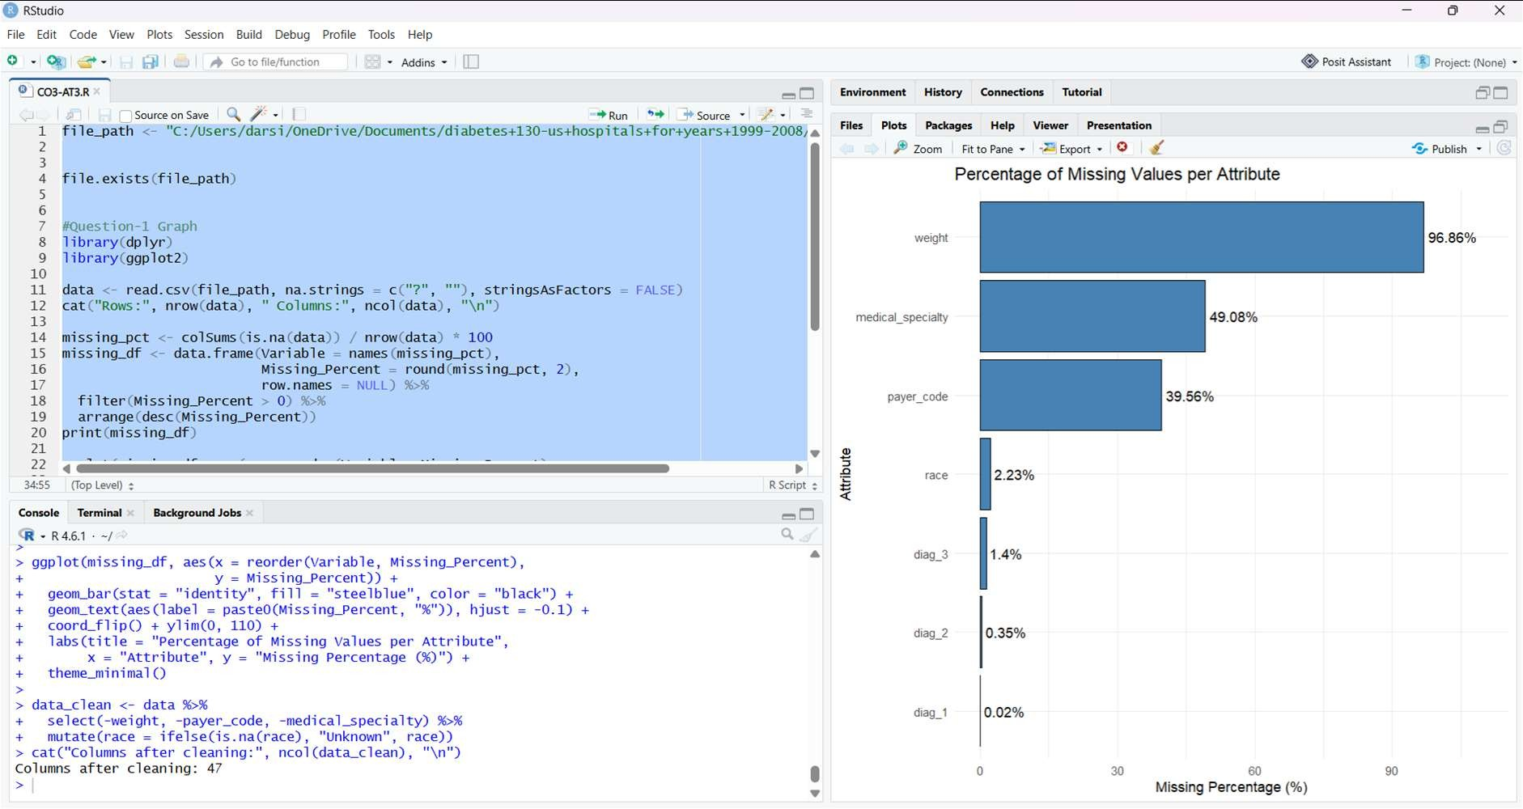

Question-2: How many repeat encounters exist for the same patient, and how can the dataset be reduced to one independent record per patient?

Formula Used and Explanation
Repeat Encounter Percentage (%) = ((N − U) ÷ N) × 100 where N = total encounters and U = unique patients (patient_nbr)
The dataset is stored at encounter level, so one patient can appear many times. If all rows are used for model building, the same patient is counted repeatedly and the records are no longer independent, which makes the results over-optimistic.
The program counts total encounters (N) and distinct patients (U), applies the formula, and plots how many encounters each patient has. To prepare the data, only the first encounter of each patient is kept. Records where the patient expired or was sent to hospice (discharge_disposition_id = 11, 13, 14, 19, 20, 21) are also removed, because these patients cannot be readmitted.

R Program
# Q2 - Duplicate / repeat encounter analysis library(dplyr)
library(ggplot2)

data <- read.csv("diabetic_data.csv", na.strings = c("?", ""), stringsAsFactors = FALSE)
N <- nrow(data)
# total encounters
U <- n_distinct(data$patient_nbr) # unique patients repeat_pct <- (N - U) / N * 100
cat("Total encounters :", N, "\n") cat("Unique patients :", U, "\n")
cat("Repeat encounters:", round(repeat_pct, 2), "%\n")
cat("Duplicate encounter IDs:", sum(duplicated(data$encounter_id)), "\n") enc_per_patient <- data %>% count(patient_nbr, name = "encounters")
# Graph: histogram
ggplot(enc_per_patient, aes(x = encounters)) + geom_histogram(binwidth = 1, fill = "orange", color = "black") + coord_cartesian(xlim = c(0, 15)) +
labs(title = "Number of Hospital Encounters per Patient",
x = "Encounters per Patient", y = "Number of Patients") + theme_minimal()

# Keep first encounter of each patient; remove expired/hospice cases data_unique <- data %>%
arrange(encounter_id) %>% distinct(patient_nbr, .keep_all = TRUE) %>%
filter(!discharge_disposition_id %in% c(11, 13, 14, 19, 20, 21)) cat("Records after removing repeats and expired cases:",
nrow(data_unique), "\n")

Graph for Visualization
Graph type: Histogram. The x-axis shows the number of encounters per patient and the y-axis shows the number of patients.

Output
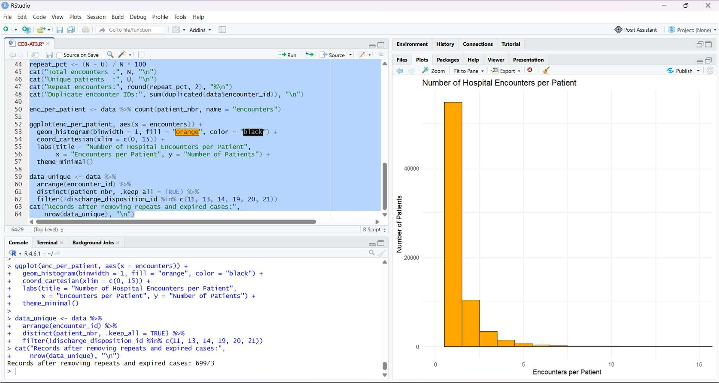

Question-3: Which numerical attributes contain outliers, and how many records fall outside the acceptable range?

Formula Used and Explanation
IQR = Q3 − Q1
Lower Fence = Q1 − 1.5 × IQR Upper Fence = Q3 + 1.5 × IQR A value is an outlier if x < Lower Fence or x > Upper Fence
Q1 is the 25th percentile and Q3 is the 75th percentile of a variable. The interquartile range (IQR) measures the spread of the middle 50% of the data. Any value beyond 1.5 times the IQR from the quartiles is flagged as an outlier.
The program calculates the fences and the number of outliers for time_in_hospital, num_lab_procedures and num_medications. Because these are real clinical values, they are not simply deleted; instead, extreme values are capped at the upper fence (winsorizing) so that they do not dominate the analysis.
A box plot is used because it shows the median, quartiles and outliers of each variable.

R Program
# Q3 - Outlier detection using the IQR method library(dplyr)
library(tidyr) library(ggplot2)

data <- read.csv("diabetic_data.csv", na.strings = c("?", ""), stringsAsFactors = FALSE)
num_vars <- c("time_in_hospital", "num_lab_procedures", "num_medications")

outlier_table <- do.call(rbind, lapply(num_vars, function(v) { x <- data[[v]]
Q1 <- unname(quantile(x, 0.25)) Q3 <- unname(quantile(x, 0.75))
IQR_v <- Q3 - Q1
lower <- Q1 - 1.5 * IQR_v upper <- Q3 + 1.5 * IQR_v
n_out <- sum(x < lower | x > upper)
data.frame(Variable = v, Q1 = Q1, Q3 = Q3, IQR = IQR_v, Lower = lower, Upper = upper, Outliers = n_out,
Outlier_Percent = round(n_out / length(x) * 100, 2))
}))
print(outlier_table)
# Graph: box plots (one panel per variable) long_df <- data %>%
select(all_of(num_vars)) %>%
pivot_longer(everything(), names_to = "Variable", values_to = "Value")

ggplot(long_df, aes(x = Variable, y = Value)) + geom_boxplot(fill = "lightblue", outlier.colour = "red") + facet_wrap(~ Variable, scales = "free") +
labs(title = "Box Plots for Detecting Outliers", x = "", y = "Value") + theme_minimal()

# Treatment: cap extreme values at the upper fence (winsorizing) upper_med <- outlier_table$Upper[3] # num_medications data$num_medications_capped <- pmin(data$num_medications, upper_med)

Graph for Visualization
Graph type: Box plot (three panels). The box shows Q1 to Q3, the line inside it is the median, and the individual points beyond the whiskers are outliers.

Output
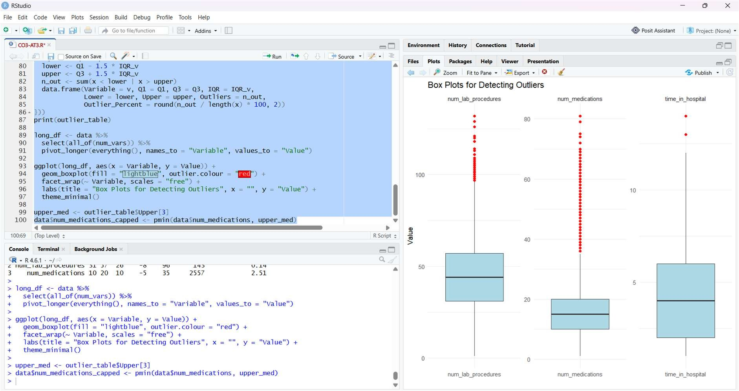

Question-4: How can the readmission attribute be converted into a binary target variable, and how balanced are the resulting classes?

Formula Used and Explanation
Binary Target: y = 1 if readmitted = “<30”, otherwise y = 0 Readmission Rate (%) = (Number of patients with y = 1 ÷ Total patients) × 100
Imbalance Ratio = Number in majority class ÷ Number in minority class
The original attribute readmitted has three values: NO (not readmitted), >30 (readmitted after 30 days) and <30 (readmitted within 30 days). Since the objective is to identify factors linked to early readmission, the attribute is encoded as a binary variable that equals 1 only for readmission within 30 days.
The program also calculates the readmission rate and the imbalance ratio. A high imbalance ratio shows that early readmissions are the minority class, which must be considered later during model building and evaluation (for example by using resampling or class weights).
A pie chart is used because it shows the share of each readmission category as part of the whole dataset.

R Program
# Q4 - Target variable creation and class distribution library(dplyr)
library(ggplot2)

data <- read.csv("diabetic_data.csv", na.strings = c("?", ""), stringsAsFactors = FALSE)

# Binary target: 1 = readmitted within 30 days, 0 = otherwise data$readmit_30 <- ifelse(data$readmitted == "<30", 1, 0)

dist <- data %>% count(readmitted) %>%
mutate(Percent = round(n / sum(n) * 100, 1),
Label = paste0(readmitted, " (", Percent, "%)")) print(dist)

rate <- mean(data$readmit_30) * 100
ratio <- sum(data$readmit_30 == 0) / sum(data$readmit_30 == 1) cat("30-day readmission rate (%):", round(rate, 2), "\n") cat("Imbalance ratio (majority:minority):", round(ratio, 2), ": 1\n")

# Graph: pie chart
ggplot(dist, aes(x = "", y = n, fill = Label)) + geom_col(width = 1, color = "black") + coord_polar(theta = "y") +
labs(title = "Distribution of Readmission Status", fill = "Class") + theme_void()

Graph for Visualization
Graph type: Pie chart. Each slice represents one readmission category (NO, >30, <30) with its percentage.

Output
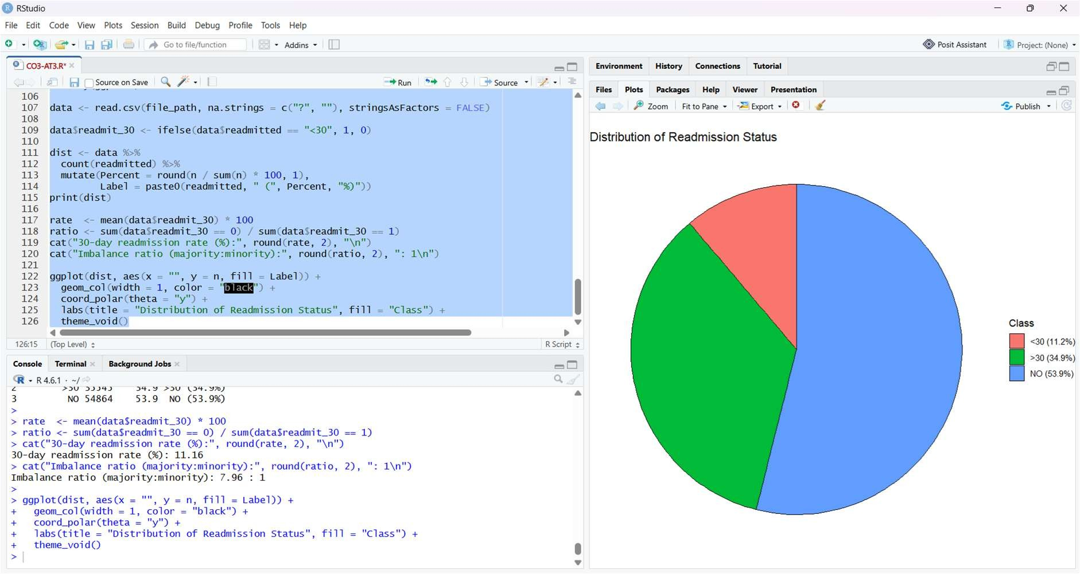

Question-5: How can the numerical attributes be scaled using Min-Max normalization and Z-score standardization, and how are two scaled variables related?

Formula Used and Explanation
Min-Max Normalization: x′ = (x − x_min) ÷ (x_max − x_min)
Z-score Standardization: z = (x − μ) ÷ σ
where μ = mean and σ = standard deviation of the attribute
Numerical attributes such as time_in_hospital, num_lab_procedures and num_medications are measured on very different scales. Min-Max normalization rescales each attribute to the range 0 to 1, while Z-score standardization rescales it to a mean of 0 and a standard deviation of 1. Scaling prevents attributes with large values from dominating distance-based and gradient-based algorithms.
The program applies both methods and verifies the result: Min-Max values must lie between 0 and 1, and Z-score columns must have a mean close to 0 and a standard deviation of 1. A scatter plot of two standardized variables with a regression line then shows how they are related after scaling.

R Program
# Q5 - Feature scaling (Min-Max and Z-score) library(dplyr)
library(ggplot2)

data <- read.csv("diabetic_data.csv", na.strings = c("?", ""), stringsAsFactors = FALSE)
num_vars <- c("time_in_hospital", "num_lab_procedures", "num_procedures", "num_medications", "number_diagnoses")

minmax <- function(x) (x - min(x)) / (max(x) - min(x))

scaled_minmax <- data %>% mutate(across(all_of(num_vars), minmax)) scaled_z <- data %>% mutate(across(all_of(num_vars),
~ as.numeric(scale(.x))))
# Verification print(summary(scaled_minmax[num_vars]))
# min = 0, max = 1
print(round(colMeans(scaled_z[num_vars]), 3)) # mean = 0
print(round(apply(scaled_z[num_vars], 2, sd), 3))# sd = 1

# Graph: scatter plot with regression line (5000-record sample) set.seed(123)
plot_df <- scaled_z %>% slice_sample(n = 5000)

ggplot(plot_df, aes(x = num_lab_procedures, y = num_medications)) + geom_point(alpha = 0.4, color = "darkgreen") + geom_smooth(method = "lm", color = "black", se = FALSE) + labs(title = "Standardized Lab Procedures vs Medications",
x = "Lab Procedures (Z-score)", y = "Medications (Z-score)") + theme_minimal()

Graph for Visualization
Graph type: Scatter plot with a regression line, drawn on a random sample of 5,000 records for clarity.

Output
