
Department of Computer Science and Engineering
(Computer Science & Engineering – Artificial Intelligence & Data Engineering)
Faculty of Engineering & Technology
Jain Global Campus, Kanakapura Taluk
Ramanagara District, Karnataka, India

A INTERNSHIP REPORT ON
Titanic Dataset Analysis using Python and Power BI

BACHELOR OF TECHNOLOGY
IN
COMPUTER SCIENCE AND ENGINEERING
(CYBERSECURITY)

Submitted by
Navadeep Reddy
USN: 24BTRCC049

Under the Guidance of
Faculty Guide
Aniruddha prabhu B P


Department of Computer Science and Engineering
(Computer Science & Engineering – Artificial Intelligence & Data Engineering)

Certificate
This is to certify that the internship work titled “Titanic Dataset Analysis using Python and Power BI” is carried out by Navadeep Reddy (24BTRCC049), bonafide student of Bachelor of Technology at Faculty of Engineering & Technology, Jain (Deemed-to-be University), Bangalore, in partial fulfillment for the award of degree, Bachelor of Technology in Computer Science & Engineering – (CYBERSECURITY) during the Academic Year 2025-2026.

Guide Internship Coordinator Program Head
[Aniruddha prabhu B P] [DR. Harinee ] [Dr. Suresh Kallam]

Abstract
The internship was carried out at RD INFRO TECHNOLOGY for a duration of two months. The objective of this internship was to gain practical knowledge in Data Analytics using Python and Microsoft Power BI.
During the internship, a complete end-to-end data analytics project was performed using the Titanic dataset. The project involved data collection, data cleaning, data transformation, exploratory data analysis (EDA), statistical analysis, predictive modelling, and dashboard development.
Python libraries such as Pandas, NumPy, Matplotlib and Scikit-learn were used throughout the project. Microsoft Power BI was used for creating an interactive dashboard to visualize passenger information and survival statistics.
The predictive model achieved an accuracy of 75.98%, demonstrating satisfactory performance in predicting passenger survival. The internship significantly enhanced practical knowledge of Python programming, data preprocessing, machine learning, visualization, and business intelligence.

Table of Contents
- Introduction
- Company Profile
- Objectives of Internship
- Technologies Used
- Work Carried Out
- Learning Outcomes
- Challenges Faced
- Conclusion
- References

10.Appendices

Chapter 1 – Introduction

1.1 Introduction to Internship
The internship at RD INFRO TECHNOLOGY provided an opportunity to work on a complete Data Analytics project using Python and Microsoft Power BI. The project followed the entire data analytics lifecycle, including data collection, preprocessing, analysis, visualization, and predictive modelling.

1.2 Purpose of Internship
The primary purpose of this internship was:

• To understand real-world data analytics workflow.
• To improve Python programming skills.
• To perform data cleaning and preprocessing.
• To develop machine learning models.
• To create interactive dashboards using Power BI.
• To improve documentation and presentation skills.

Chapter 2 – Company Profile

2.1 Company Overview
RD INFRO TECHNOLOGY
Industry
Information Technology and Data Analytics Training
Services
• Data Analytics
• Python Programming
• Machine Learning
• Artificial Intelligence
• Power BI
• Software Development

Chapter 3 – Objectives of Internship
The objectives of the internship were:
• Learn Python for Data Analytics.
• Understand data preprocessing.
• Handle missing values.
• Perform Exploratory Data Analysis.
• Apply Statistical Analysis.
• Build Predictive Models.
• Create Power BI dashboards.
• Improve problem-solving skills.
• Gain industrial exposure.

Chapter 4 – Technologies Used
- Python
- Python was used as the primary programming language for the entire project.
- Pandas
- Used for loading, cleaning, and manipulating datasets.
- NumPy
- Used for numerical operations.
- Matplotlib
- Used for generating statistical graphs and charts.
- Scikit-learn
- Used to build the predictive model.
- Visual Studio Code
- Used for writing and executing Python programs.
- Microsoft Power BI
- Used for creating an interactive dashboard.

Chapter 5 – Work Carried Out

5.1 Tasks Performed
Titanic Dataset Analysis using Python and Microsoft Power BI

5.2 Project Description

The objective of this project was to analyse the Titanic passenger dataset and identify the factors affecting passenger survival. The project also aimed to develop a predictive model capable of estimating passenger survival using historical data.

5.3 Screenshots or Diagrams
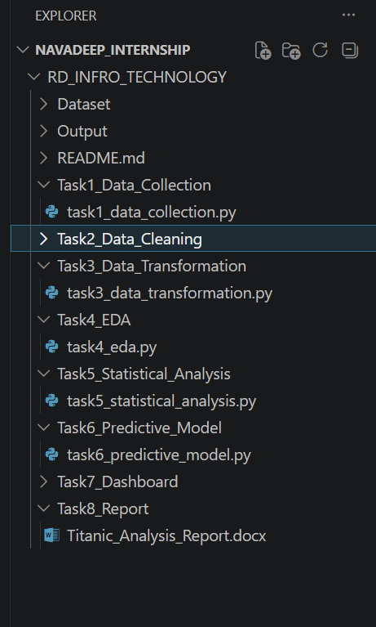
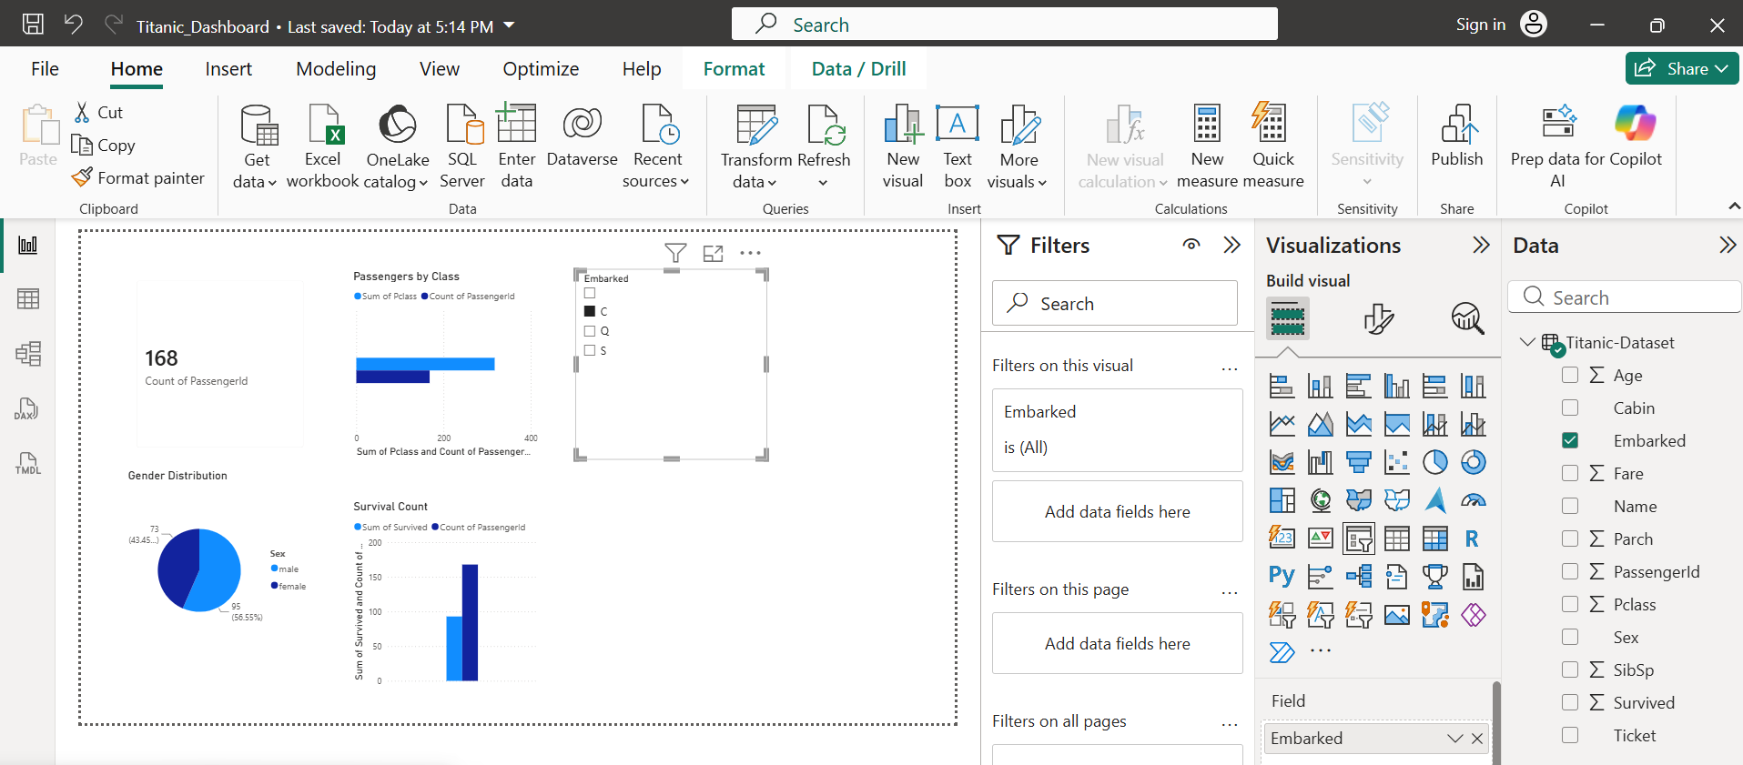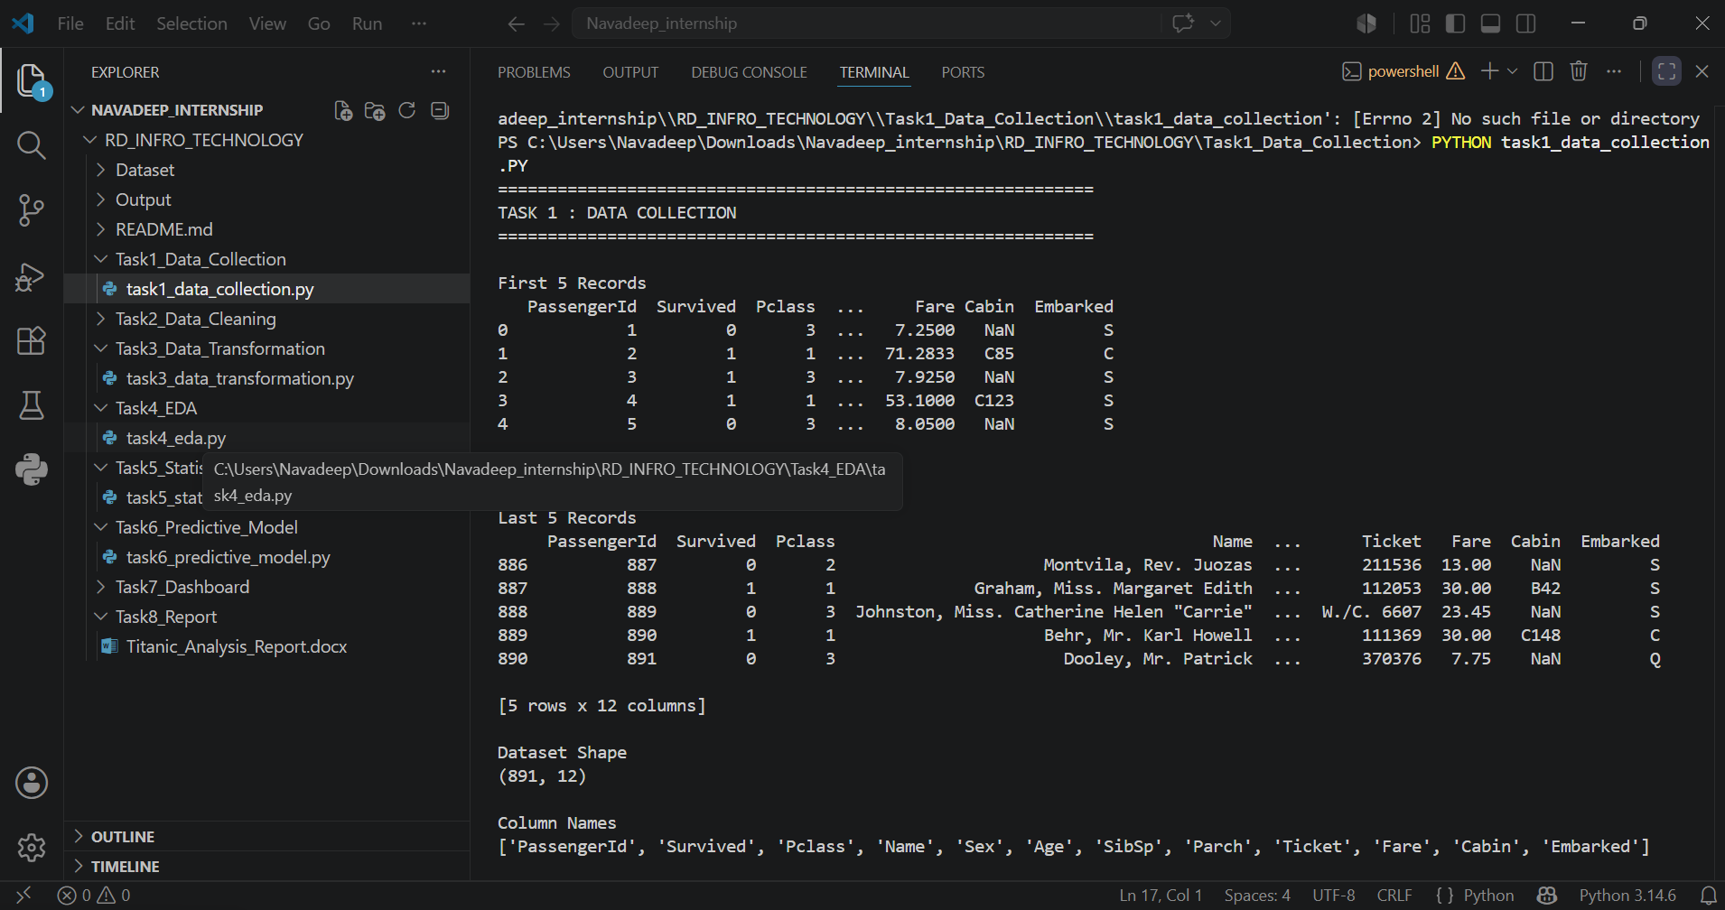
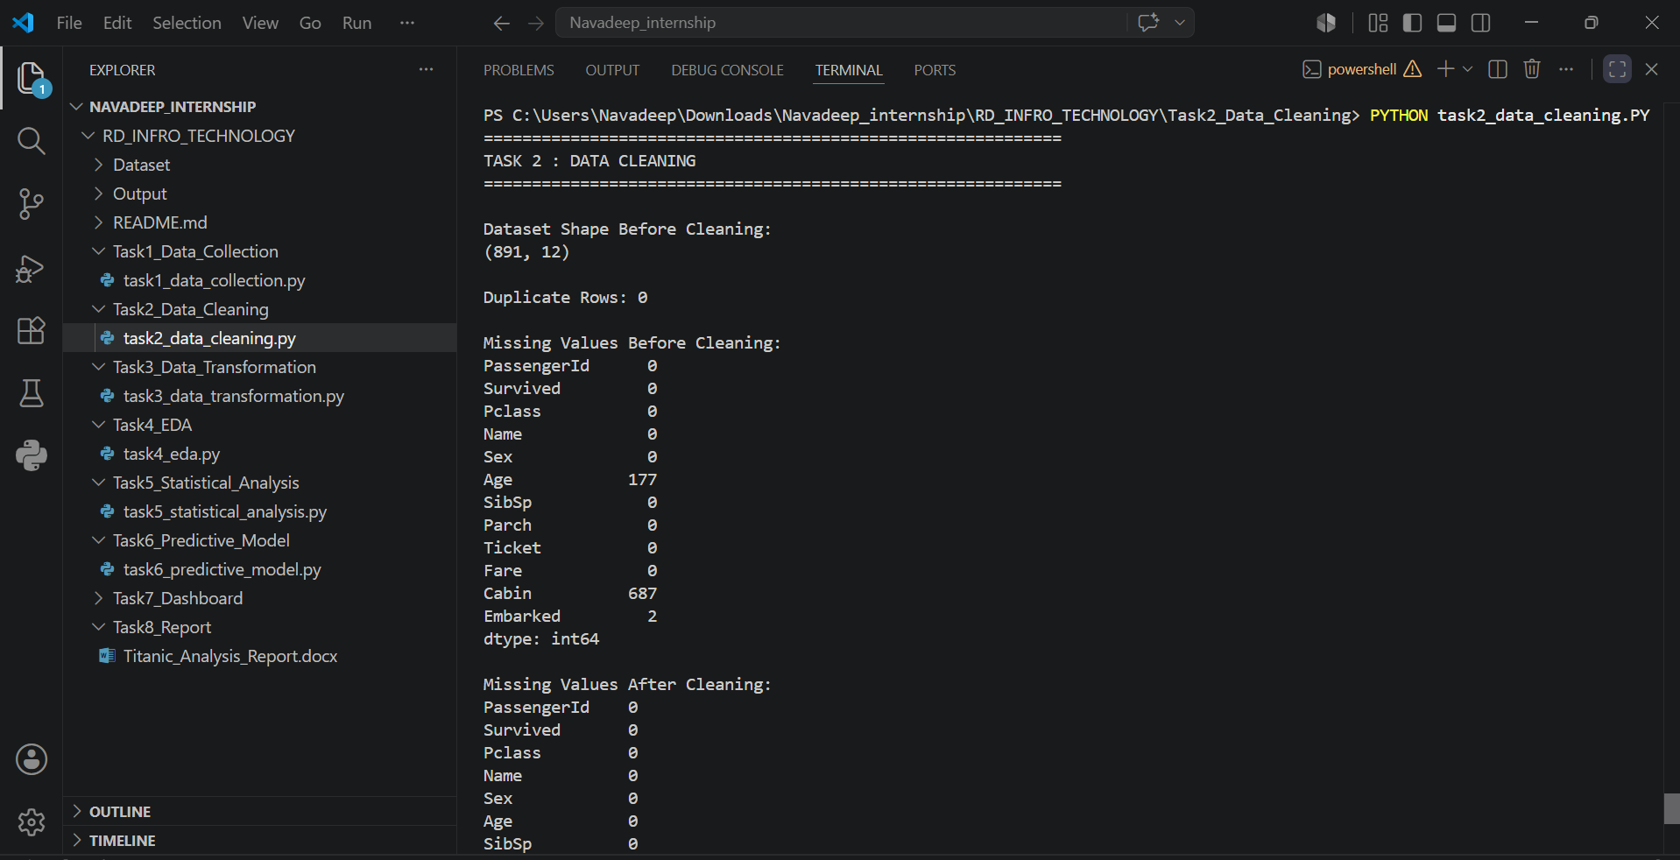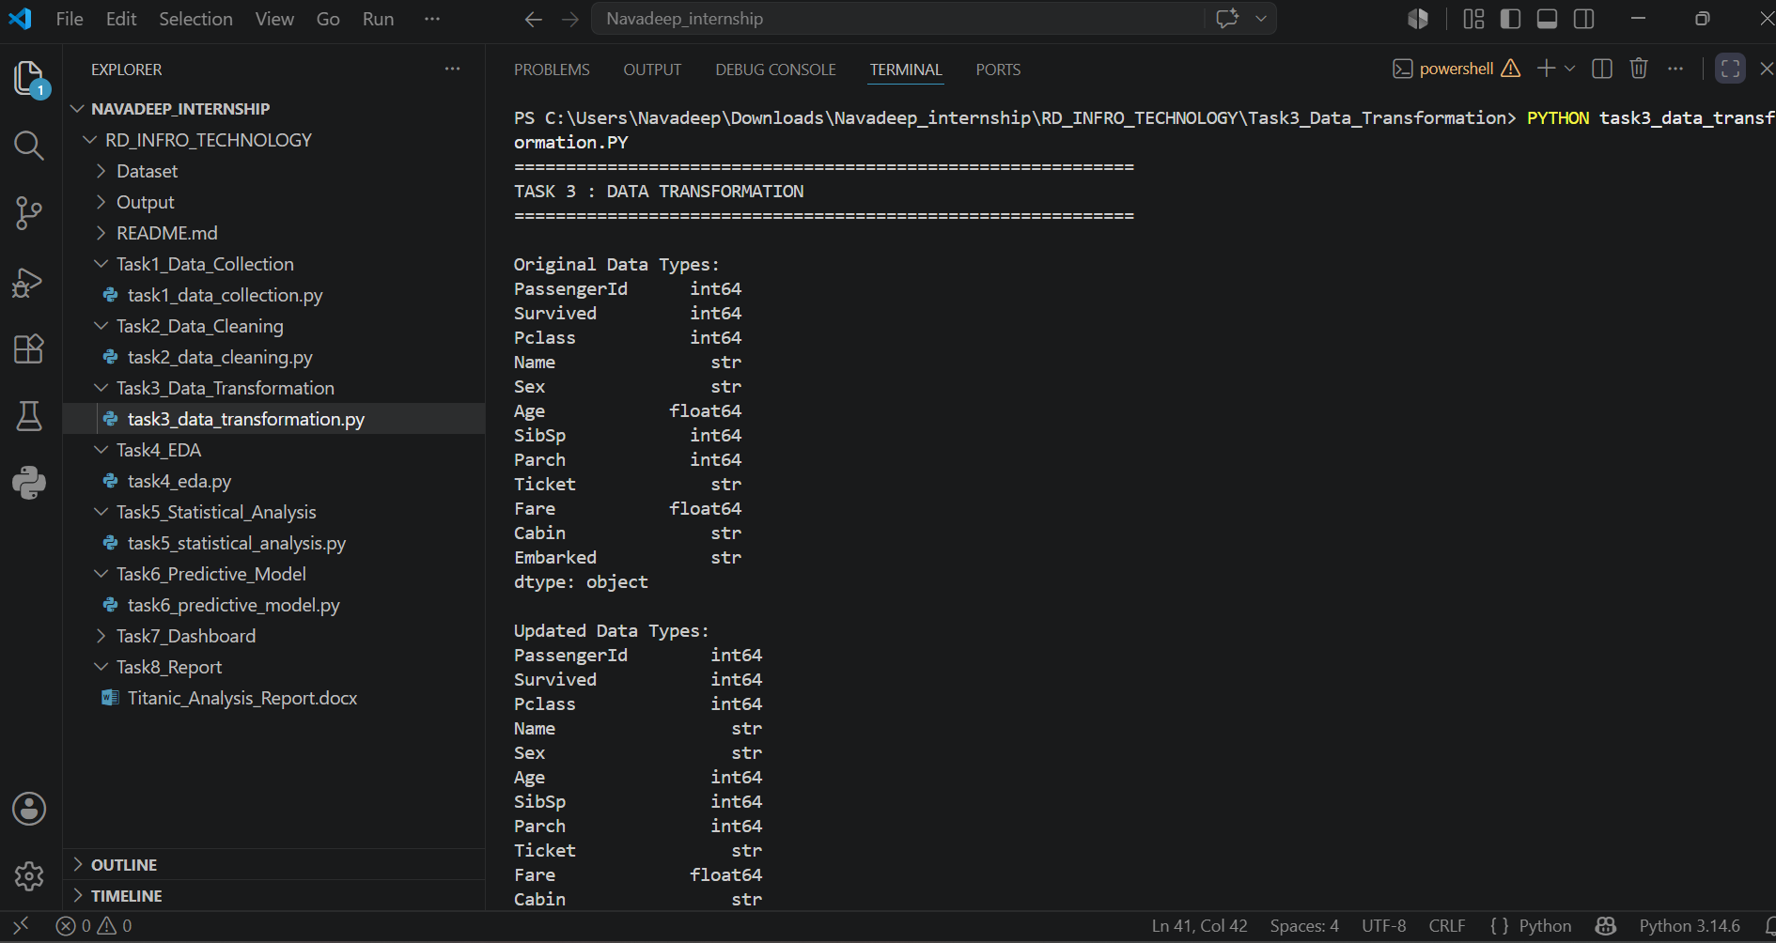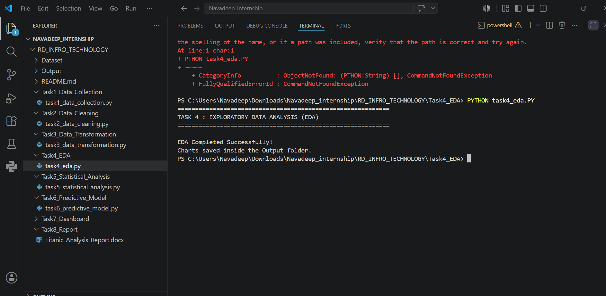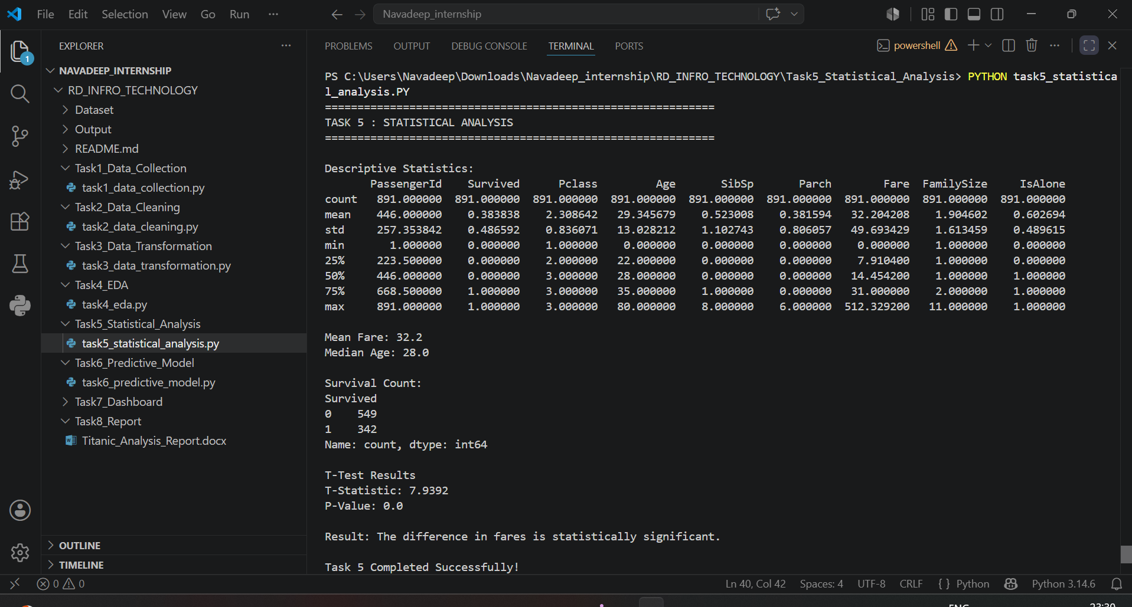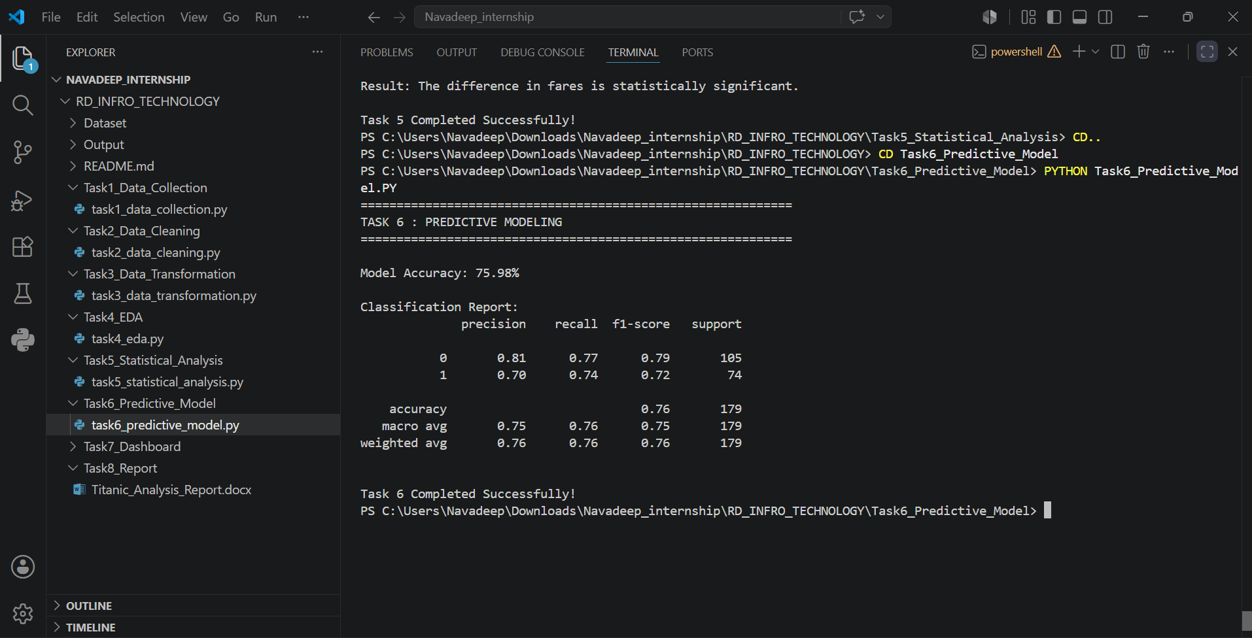

Chapter 6 – Learning Outcomes
During the internship, the following skills were developed:
- Python Programming
- Data Cleaning
- Data Transformation
- Exploratory Data Analysis
- Statistical Analysis
- Machine Learning
- Power BI Dashboard Development
- Technical Documentation
- Presentation Skills

Chapter 7 – Challenges Faced

Some challenges encountered during the internship included:
- Installing Python libraries and resolving dependency issues.
- Handling missing values in the dataset.
- Creating meaningful visualizations.
- Understanding machine learning evaluation metrics.
- Designing an effective Power BI dashboard.
These challenges were overcome through debugging, continuous learning, and mentor guidance.

Chapter 8 – Conclusion

The internship at RD INFRO TECHNOLOGY provided valuable practical exposure to the field of Data Analytics. The project successfully demonstrated the complete analytics workflow, from data collection to predictive modelling and dashboard creation. It strengthened technical skills in Python, machine learning, and Power BI while improving analytical thinking and problem-solving abilities. The internship also enhanced confidence in handling real-world datasets and preparing professional technical documentation.

References

• Kaggle Titanic Dataset
• Python Official Documentation
• Pandas Documentation
• NumPy Documentation
• Matplotlib Documentation
• Scikit-learn Documentation
• Microsoft Power BI Documentation

