**Ex.No**.7 **Hierarchical Clustering Algorithm**

**Date**: 12-09-23

**Aim**

To implement Hierarchical Clustering Algorithm under unsupervised machine learning through R programming.

**Procedure**

1. To do programming in R, first install “RStudio” and “R” in the system. RStudio is an integrated development environment [IDE] for R and python.
2. Select the File in taskbar →open New file →R script or use shortcut “ctrl+shift+N”
3. Install the ‘dplyr’ package and load it in R.
4. Import the built-in dataset ‘mtcars’
5. Apply the Hierarchical Clustering Algorithm on ‘mtcars’ dataset.
6. Write the program in the script and save it using the extension R.
7. Run the program by clicking Run option or use the shortcut “ctrl+enter”.
8. See the output in the console tab.

**Concepts Involved**

* Applying the Hierarchical Clustering Algorithm on a Dataset.

**Hierarchical Clustering Algorithm**

Clustering is the most common form of unsupervised learning, a type of machine learning algorithm used to draw inferences from unlabeled data.

**R - Hierarchical Clustering**

This is of two types:

* **Agglomerative Hierarchical clustering:** It starts at individual leaves and successfully merges clusters together. It is a Bottom-up approach.
* **Divisive Hierarchical clustering:** It starts at the root and recursively split the clusters. It’s a top-down approach.

**Algorithm**

1. Make each data point in a single point cluster that forms **N** clusters.

2. Take the two closest data points and make them one cluster that forms **N- 1** clusters.

3. Take the two closest clusters and make them one cluster that forms **N- 2** clusters.

4. Repeat steps 3 until there is only one cluster.

Dendrogram is a hierarchy of clusters in which distances are converted into heights. It clusters **n** units or objects each with **p** feature into smaller groups. Units in the same cluster are joined by a horizontal line.

The leaves at the bottom represent individual units. It provides a visual representation of clusters.

**Script**

# Installing the package

install.packages("dplyr")

# Loading package

library(dplyr)

# Summary of dataset in package

head(mtcars)

**Output**

mpg cyl disp hp drat wt qsec vs am gear carb

Mazda RX4 21.0 6 160 110 3.90 2.620 16.46 0 1 4 4

Mazda RX4 Wag 21.0 6 160 110 3.90 2.875 17.02 0 1 4 4

Datsun 710 22.8 4 108 93 3.85 2.320 18.61 1 1 4 1

Hornet 4 Drive 21.4 6 258 110 3.08 3.215 19.44 1 0 3 1

Hornet Sportabout 18.7 8 360 175 3.15 3.440 17.02 0 0 3 2

Valiant 18.1 6 225 105 2.76 3.460 20.22 1 0 3 1

**Script**

# Finding distance matrix

distance_mat <- dist(mtcars, method = 'euclidean')

distance_mat#representing some part for ease of view

**Output**

Mazda RX4 Mazda RX4 Wag Datsun 710 Hornet 4 Drive Hornet Sportabout

Mazda RX4 Wag 0.6153251

Datsun 710 54.9086059 54.8915169

Hornet 4 Drive 98.1125212 98.0958939 150.9935191

Hornet Sportabout 210.3374396 210.3358546 265.0831615 121.0297564

Valiant 65.4717710 65.4392224 117.7547018 33.5508692 152.1241352

**Script**

# Fitting Hierarchical clustering Model

# to training dataset

set.seed(240) # Setting seed

Hierar_cl <- hclust(distance_mat, method = "average")

Hierar_cl

**Output**

Call:

hclust(d = distance_mat, method = "average")

Cluster method : average

Distance : euclidean

Number of objects: 32

**Script**

# Plotting dendrogram

plot(Hierar_cl)

**Output**

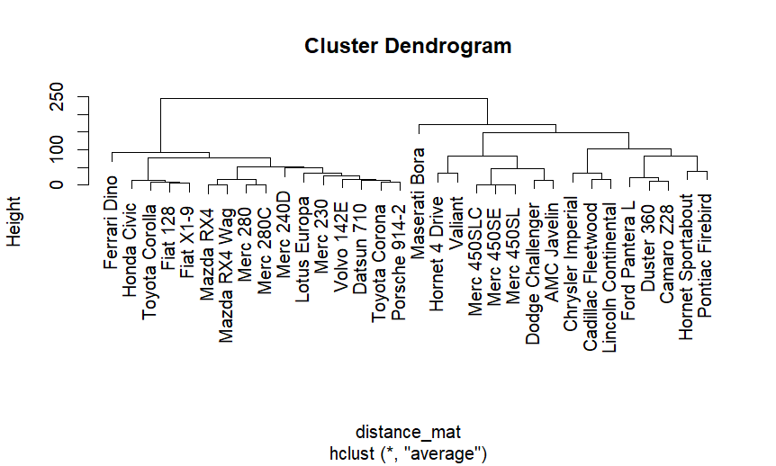

**Script**

# Choosing no. of clusters

# Cutting tree by height

abline(h = 110, col = "violet")

**Output**

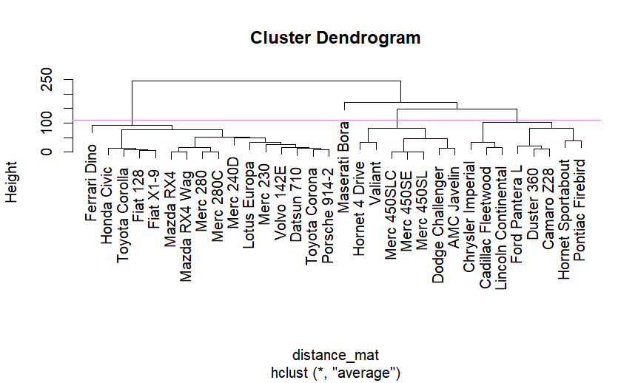

**Script**

# Cutting tree by no. of clusters

fit <- cutree(Hierar_cl, k = 3 )

fit

**Output**

Mazda RX4 Mazda RX4 Wag Datsun 710 Hornet 4 Drive

1 1 1 2

Hornet Sportabout Valiant Duster 360 Merc 240D

2 2 2 1

Merc 230 Merc 280 Merc 280C Merc 450SE

1 1 1 2

Merc 450SL Merc 450SLC Cadillac Fleetwood Lincoln Continental

2 2 2 2

Chrysler Imperial Fiat 128 Honda Civic Toyota Corolla

2 1 1 1

Toyota Corona Dodge Challenger AMC Javelin Camaro Z28

1 2 2 2

Pontiac Firebird Fiat X1-9 Porsche 914-2 Lotus Europa

2 1 1 1

Ford Pantera L Ferrari Dino Maserati Bora Volvo 142E

2 1 3 1

**Script**

table(fit)

rect.hclust(Hierar_cl, k = 3, border = "green")

**Output**

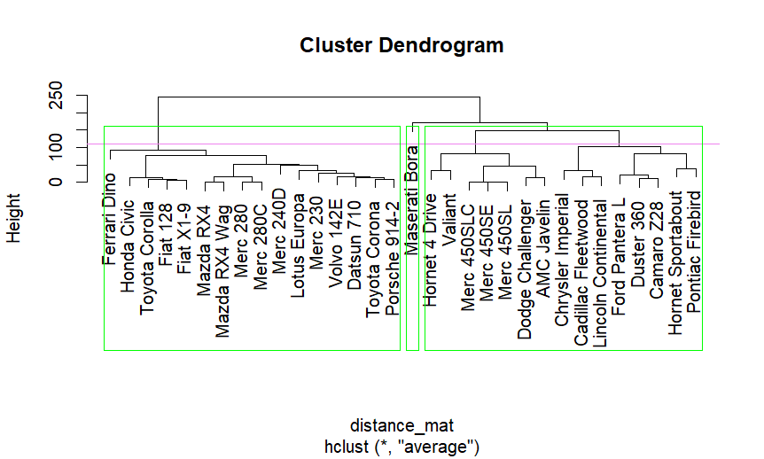

**Result**

Thus, the cluster dendrogram is plotted using Hierarchical Clustering Algorithm using R programming successfully.