**NAME:NAVADEESH S**

**REG NO.:727721EUCS087**

**DAY:9**

**DATAPROVIDERS AND LISTENERS**

1)CODE:

package com.selenium.day3.ex1;

import org.testng.annotations.Test;

import org.testng.annotations.DataProvider;

public class d9q1 {

@Test(dataProvider = "dp")

public void add(Integer a, Integer b) {

System.out.println(a+b);

}

@Test(dataProvider = "dp")

public void sub(Integer a, Integer b) {

System.out.println(a-b);

}

@Test(dataProvider = "dp")

public void mul(Integer a, Integer b) {

System.out.println(a*b);

}

@Test(dataProvider = "dp")

public void div(Integer a, Integer b) {

System.out.println(a/b);

}

@DataProvider

public Object[][] dp() {

return new Object[][] {

new Object[] { 10,5 },

};

}

}

OUTPUT:

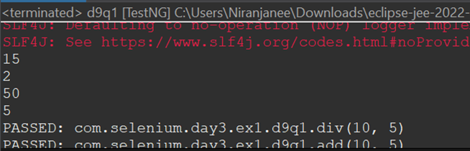

2&3)CODE:

package com.selenium.day3.ex1;

import org.junit.Assert;

import org.openqa.selenium.By;

import org.openqa.selenium.WebDriver;

import org.openqa.selenium.chrome.ChromeDriver;

import org.openqa.selenium.chrome.ChromeOptions;

import org.testng.annotations.Test;

import io.github.bonigarcia.wdm.WebDriverManager;

public class d9q2 {

WebDriver driver;

*@Test*(groups= {"SmokeTest"})

public void Test1() throws Exception {

WebDriverManager.*chromedriver*().setup();

WebDriver driver;

ChromeOptions co = new ChromeOptions();

co.addArguments("--remote-allow-origins=*");

driver=new ChromeDriver(co);

driver.get("https://www.godaddy.com/en-in");

driver.manage().window().maximize();

Thread.*sleep*(3000);

String t1=driver.getTitle();

System.***out***.println(t1);

Assert.*assertEquals*(t1, "Domain Names, Websites, Hosting & Online Marketing Tools - GoDaddy IN");

String u1=driver.getCurrentUrl();

Assert.*assertEquals*(u1,"https://www.godaddy.com/en-in");

driver.quit();

}

*@Test*(groups= {"RegressionTest"})

public void Test2() throws Exception {

WebDriverManager.*chromedriver*().setup();

WebDriver driver;

ChromeOptions co = new ChromeOptions();

co.addArguments("--remote-allow-origins=*");

driver=new ChromeDriver(co);

driver.get("https://www.godaddy.com/en-in");

driver.manage().window().maximize();

Thread.*sleep*(3000);

driver.findElement(By.*xpath*("//*[@id=\"id-631b049a-e9c0-4d24-8710-c504745206dd\"]/button/span")).click();

//driver.findElement(By.xpath("//*[@id=\"id-631b049a-e9c0-4d24-8710-c504745206dd\"]/div[2]/div[1]/ul/li[1]/button")).click();

//Thread.sleep(3000);

//driver.findElement(By.linkText("Domain Name Search")).click();

Thread.*sleep*(3000);

}

}

<?xml version="1.0" encoding="UTF-8"?>

<suite parallel="methods" name="Suite">

<test name="Test">

<classes>

<class name="com.selenium.day3.ex1.d9q2"/>

</classes>

</test> <!-- Test -->

</suite> <!-- Suite -->

OUTPUT:

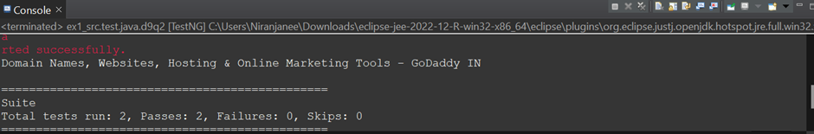

4) CODE:

package com.selenium.day3.ex1;

import org.junit.Assert;

import org.openqa.selenium.By;

import org.openqa.selenium.WebDriver;

import org.openqa.selenium.WebElement;

import org.openqa.selenium.chrome.ChromeDriver;

import org.openqa.selenium.chrome.ChromeOptions;

import org.openqa.selenium.edge.EdgeDriver;

import org.testng.annotations.AfterMethod;

import org.testng.annotations.AfterTest;

import org.testng.annotations.BeforeMethod;

import org.testng.annotations.Parameters;

import org.testng.annotations.Test;

import io.github.bonigarcia.wdm.WebDriverManager;

//import junit.framework.Assert;

public class d9q4 {

WebDriver driver;

*@Test*

public void f() throws Exception {

Thread.*sleep*(3000);

WebElement uname=driver.findElement(By.*name*("username"));

WebElement pwd=driver.findElement(By.*name*("password"));

WebElement submit=driver.findElement(By.*xpath*("//*[@class='oxd-button oxd-button--medium oxd-button--main orangehrm-login-button']"));

uname.sendKeys("Admin");

pwd.sendKeys("admin123");

submit.click();

Thread.*sleep*(3000);

Assert.*assertEquals*(driver.getCurrentUrl(), "https://opensource-demo.orangehrmlive.com/web/index.php/dashboard/index");

}

*@Parameters*("browser")

*@BeforeMethod*

public void beforeMethod(String b1)

{

if(b1.equals("chrome"))

{

WebDriverManager.*chromedriver*().setup();

ChromeOptions co = new ChromeOptions();

co.addArguments("--remote-allow-origins=*");

driver=new ChromeDriver(co);

driver.manage().window().maximize();

String url="https://opensource-demo.orangehrmlive.com/web/index.php/auth/login";

driver.get(url);

driver.manage().window().maximize();

}

else if(b1.equals("edge"))

{ WebDriverManager.*edgedriver*().setup();

driver=new EdgeDriver();

driver.manage().window().maximize();

String url="https://opensource-demo.orangehrmlive.com/web/index.php/auth/login";

driver.get(url);

driver.manage().window().maximize();

}

}

*@AfterTest*

public void afterTest()

{

driver.quit();

}

}

<?xml version="1.0" encoding="UTF-8"?>

<suite parallel="false" name="Suite">

<parameter name="browser" value="edge"/>

<test name="Test">

<classes>

<class name="com.selenium.day3.ex1.d9q4"/>

</classes>

</test> <!-- Test -->

</suite> <!-- Suite -->

OUTPUT:



5)CODE:

package com.selenium.day3.ex1;

import org.junit.Assert;

import org.openqa.selenium.By;

import org.openqa.selenium.WebDriver;

import org.openqa.selenium.WebElement;

import org.openqa.selenium.edge.EdgeDriver;

import org.testng.AssertJUnit;

import org.testng.annotations.AfterTest;

import org.testng.annotations.BeforeTest;

import org.testng.annotations.Test;

import io.github.bonigarcia.wdm.WebDriverManager;

public class d9c5test {

WebDriver driver;

*@Test*

public void f() throws Exception {

driver.findElement(By.*name*("username")).sendKeys("admin");

driver.findElement(By.*name*("password")).sendKeys("admin123");

}

*@BeforeTest*

public void beforeTest() {

WebDriverManager.*edgedriver*().setup();

driver = new EdgeDriver();

driver.get("https://opensource-demo.orangehrmlive.com/web/index.php/auth/login");

driver.manage().window().maximize();

}

*@AfterTest*

public void afterTest() {

// driver.quit();

}

}

<?xml version="1.0" encoding="UTF-8"?>

<suite parallel="false" name="Suite">

<listeners>

<listener class-name="com.selenium.day3.ex1.d9c5"></listener>

</listeners>

<test name="Test">

<classes>

<class name="com.selenium.day3.ex1.d9c5test"/>

</classes>

</test> <!-- Test -->

</suite> <!-- Suite -->

package com.selenium.day3.ex1;

import org.testng.ITestContext;

import org.testng.ITestListener;

import org.testng.ITestResult;

public class d9c5 implements ITestListener {

*@Override*

public void onTestStart(ITestResult result) {

// **TODO** Auto-generated method stub

System.***out***.println("Test started");

}

*@Override*

public void onTestSuccess(ITestResult result) {

// **TODO** Auto-generated method stub

System.***out***.println("Test success");

}

*@Override*

public void onTestFailure(ITestResult result) {

// **TODO** Auto-generated method stub

System.***out***.println("Test failed");

}

*@Override*

public void onTestSkipped(ITestResult result) {

// **TODO** Auto-generated method stub

System.***out***.println("Test skipped");

}

*@Override*

public void onFinish(ITestContext context) {

// **TODO** Auto-generated method stub

System.***out***.println("Test finished");

}

}

OUTPUT:

