Text Analysis System

2020-08-06

Leader: | Navin Adhikary (11352701) | Module: User Management
Members: | Rajesh Pahari (11336693) | Module: Text Analysis
 | Cui Su (11406029) | Module: Text Management

1. Objectives

The objective of this text analysis system is to parse a document and display the word frequency statistics as a bar plot and as a text list. This system can parse documents type like txt, doc, docx, and pdf.

2. Overall architecture

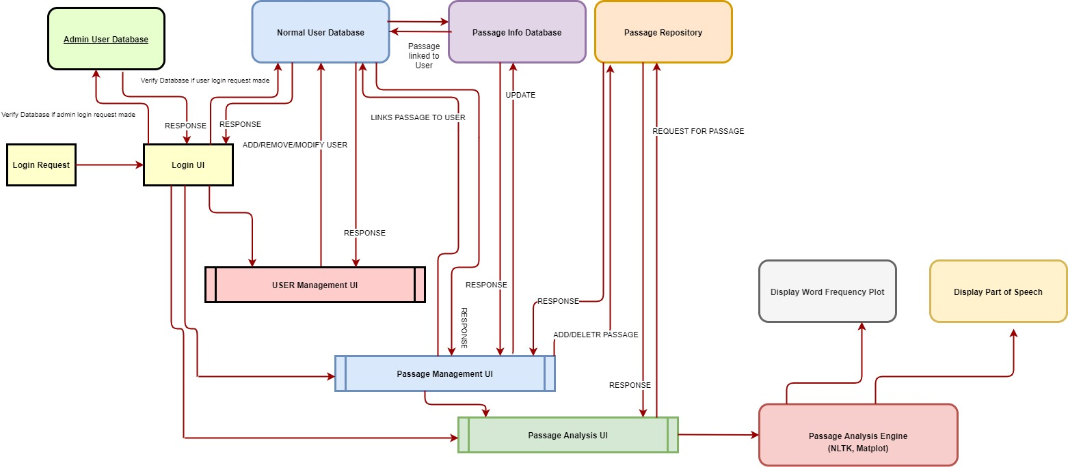Figure 1: Overall architecture of Text Analysis System

This system is designed to create users who can upload documents of txt, doc, docx, and pdf types in the system. There are two types of login, one is admin login and other is regular user login. When the admin user tries to login through the admin login UI, the system searches for the right combination of username and password in the admin database to authenicate the access. Similarly, if the regular user tries to login through the user login UI, earches for the right combination of username and password in the admin database to authenicate the access. The admin users can add, delete, or modify the users as well as delete the uploaded documents by the regular users. The regular user can only upload and see the analysis of the uploaded documents. There are admin, regular user, and Passage info databases to store the contents like admin user login information, regular user login information, and passage upload information. Once the documents are uploaded, the users can get the word frequency bar plot and text list by clicking the text analysis button. The passage analysis engine uses NLTK and Matplot to parse and create the bar plot and text list.

3. System Design

3.1. System Flow:

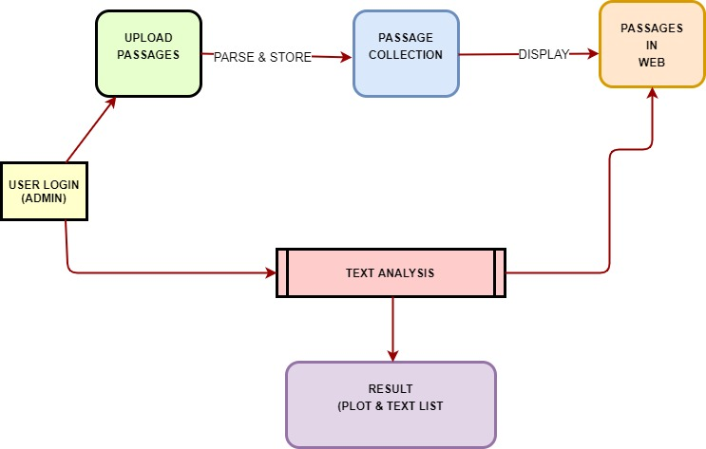Figure 2: System Flow
3.2. System Functions:

The system flow of this project consists of the following three main functional modules:

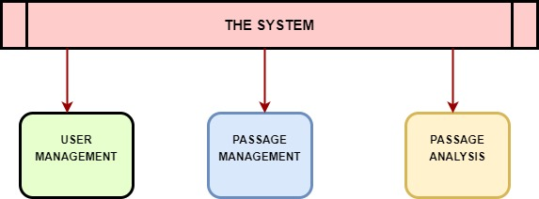Figure 3: System Function

Main Functions of the system

- User Management: This is the first module of the system and is integral with how an admin or regular user can access our system. This module authenticates admin user and allows admin user to be able to add/remove/modify the info for the normal user. Additionally, this module also allows admin user to edit it’s password. The final webpage that is displayed after authentication depends on which user is used to login into the website. Compared to the admin user, the normal users are only allowed to utilize the functionality of Passage Management and Passage Analysis. Thus, we have implemented the scope limitation for different categories of the user.

In short, this module has following functions:

- Authenticating admin user access
- Editing password for the admin user
- Allowing admin user to add/remove/edit normal users
- Authenticating normal users
- The normal users have access to Passage Management and Passage Analysis Modules

- Passage Management: This is the second module of the system and is utilized by the authenticated normal user to be able to upload passages, that can later be used by Passage Analysis module for further analysis. Additionally, it allows viewing information and deleting the passages that were uploaded by the authenticated user. It is important to note that only a normal user has access to Passage Management.

In short, this module has following functions:
- Allowing normal user to upload a passage
- Allowing normal user to delete the passage
- Performing validation check for the passage extension to make sure only the passages with right extensions are updated
- Updating the database with the information of the user and passage filename so that it could be utilized by the Passage Analysis Module

- Passage Analysis: This is the third module of the system and only the individual normal users can access this functionality. This module parses the passages that were uploaded by the user and stored in the local repository. The resulting webpage shows the word frequency bar chart for top 10 most occurring files, creates another webpage showing the part of speech of the different words, and allows this information to be downloaded as csv file.

To parse the files, it tokenizes the text in the file. Tokenization is essential so that punctuations, special characters and stopwords aren’t considered. Then NTLK library’s FreqDist() and pos_tag(),matplotlib, numpy and datascience library functions are utilized for plotting barchart for word frequency count and rendering the html file showing part of speeches of the words.

In short, this module has the following functions:
- Creating bar chart showing the word frequencies for top 10 words
- Creating a webpage showing part of speech for all words
- Allowing normal user to download this information in csv format file

3.3. Database Design:

Entity Relationship (ER) Diagram

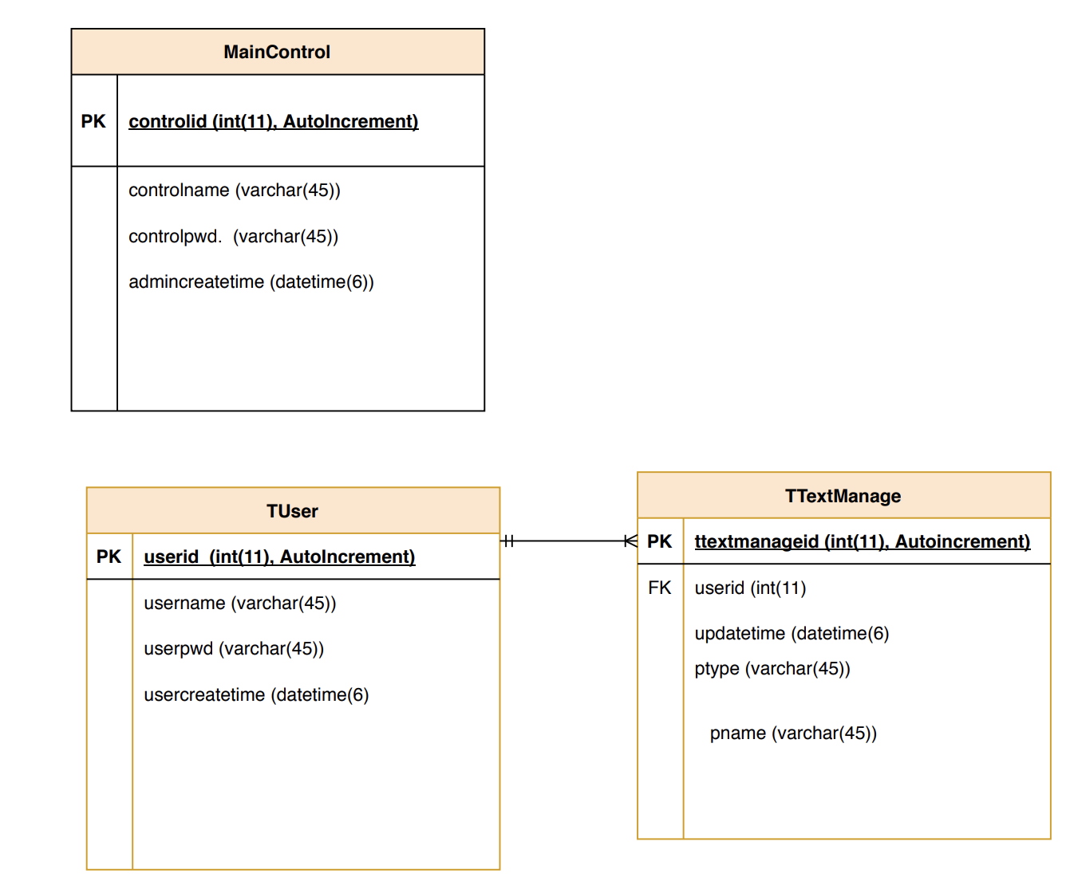Figure 4: ER Diagram of the Database

As we can see, we are utilizing 3 different relational database tables. MainControl table is utilized by admin user to login into the main webpage. It stores the information about the admin user. TUser table consists of the information of regular users. Additionally, TTextmanage table consists of the information about the passages that were uploaded by the regular user. As we can see, we have one to many relationship between TUser and TTextManage tables, because one normal user should be able to upload multiple passages.

4. System Testing

a. Index page for directing admin and regular user login UI

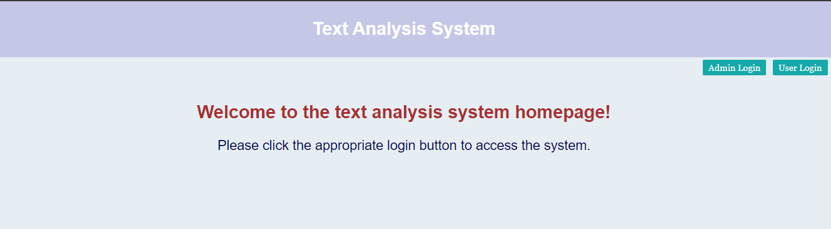
This is the index page of the text analysis system. Users can either click the admin login or the user login to get access to the system.

b. Admin login UI

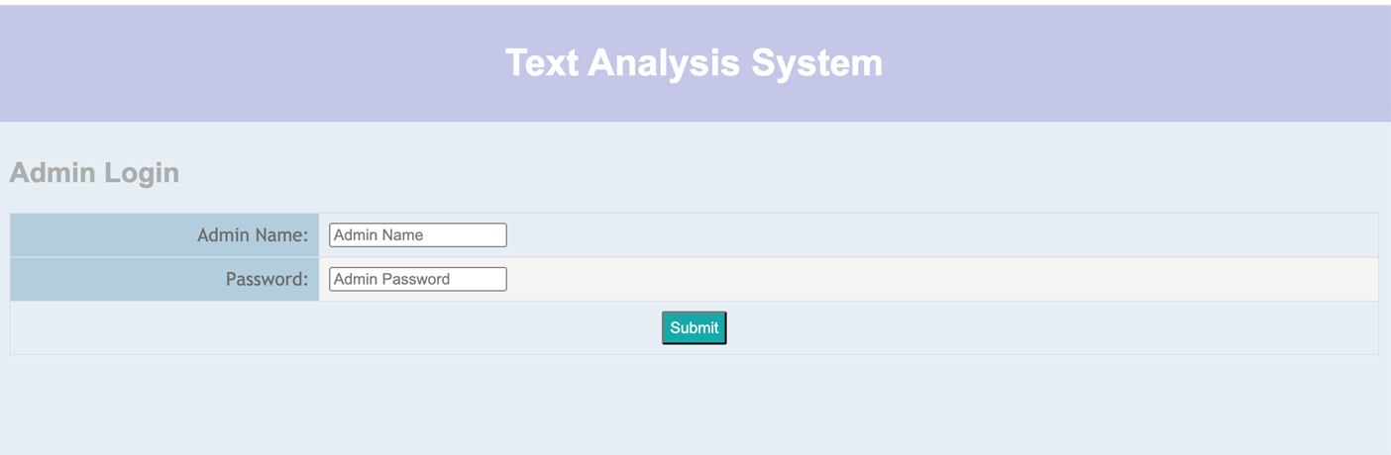
This is the admin login page. This login will open the user management, text management, and text analysis interface once authenticated.

c. Regular user login UI

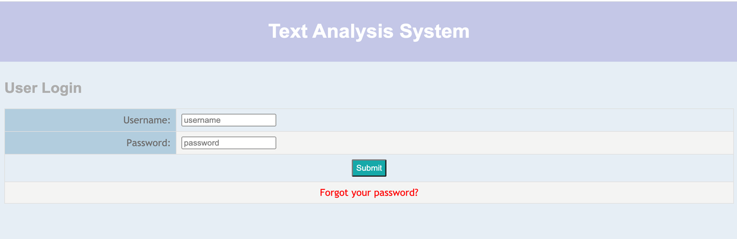

c.

This is the regular user login page. This login will open the text management and text analysis interface once authenticated.

d. User Management Page

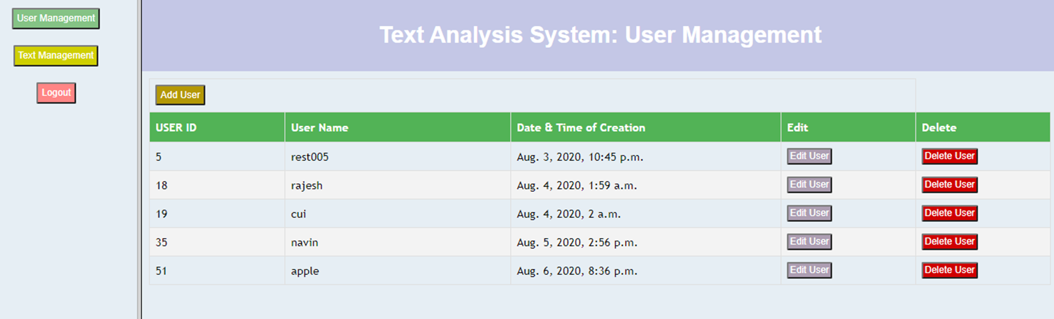
This is the user management page, where the admin can add, delete or modify the users.

e. Add use
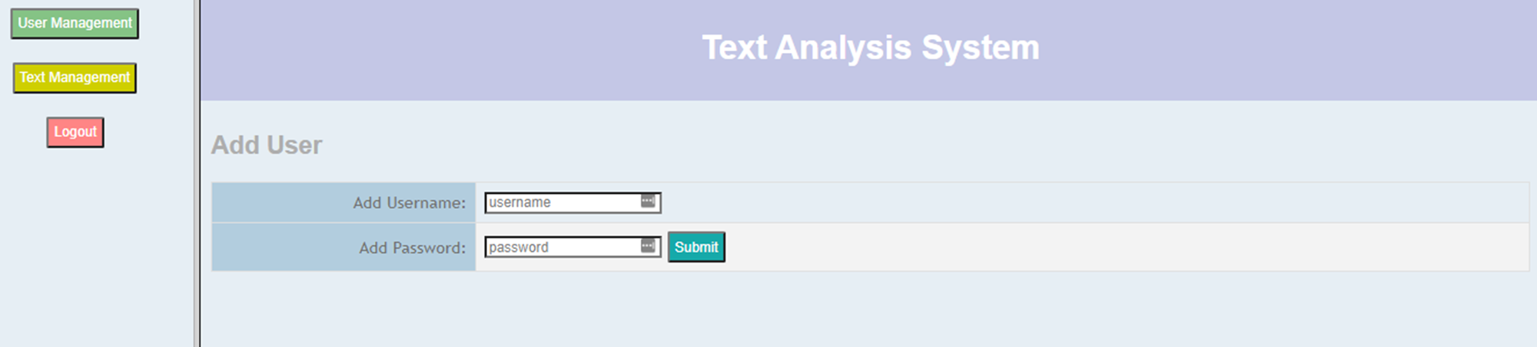

On this page, the admin users can add the new users.

f. Edit user

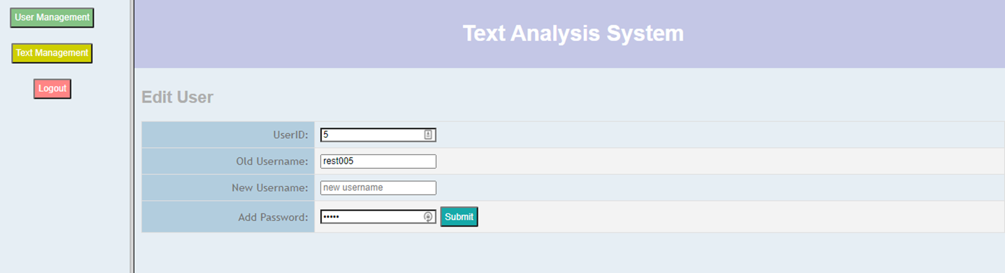
On this page, the admin users can edit the users.

g. Passage Management Page

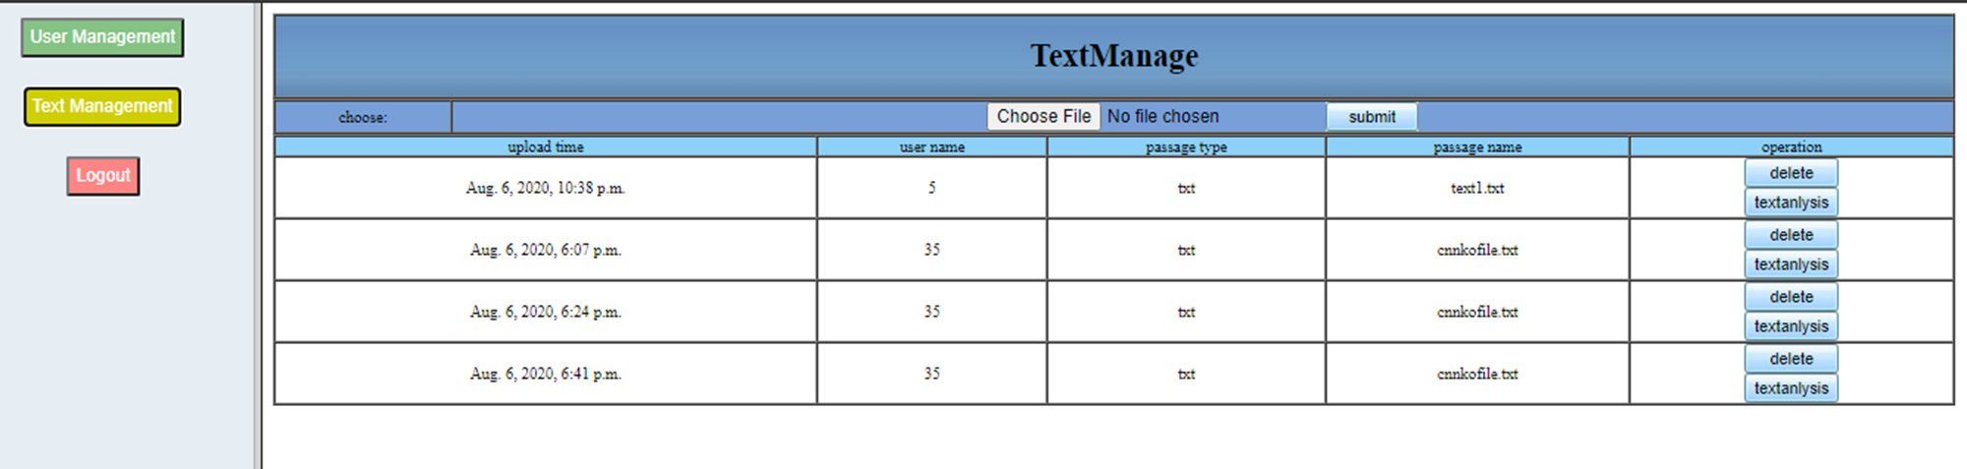
On this page, both the admin and the regular users can upload and delete the documents as well as analyze the passage.

h. Document Upload Successful

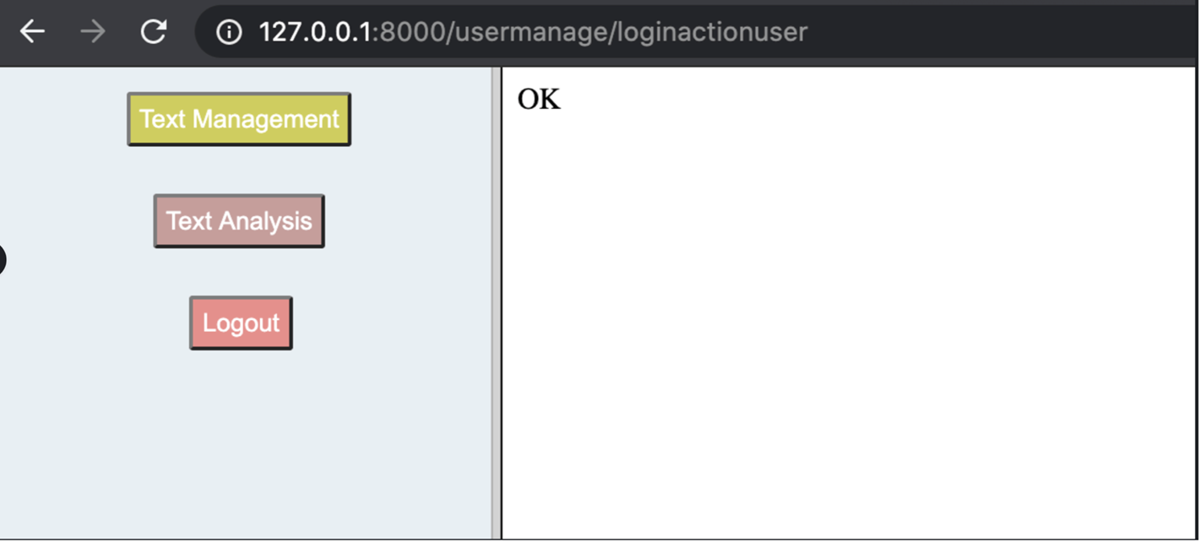

If the upload document type is txt, doc, docx, or pdf, the system will display a “OK” page.

i. Document upload unsuccessful

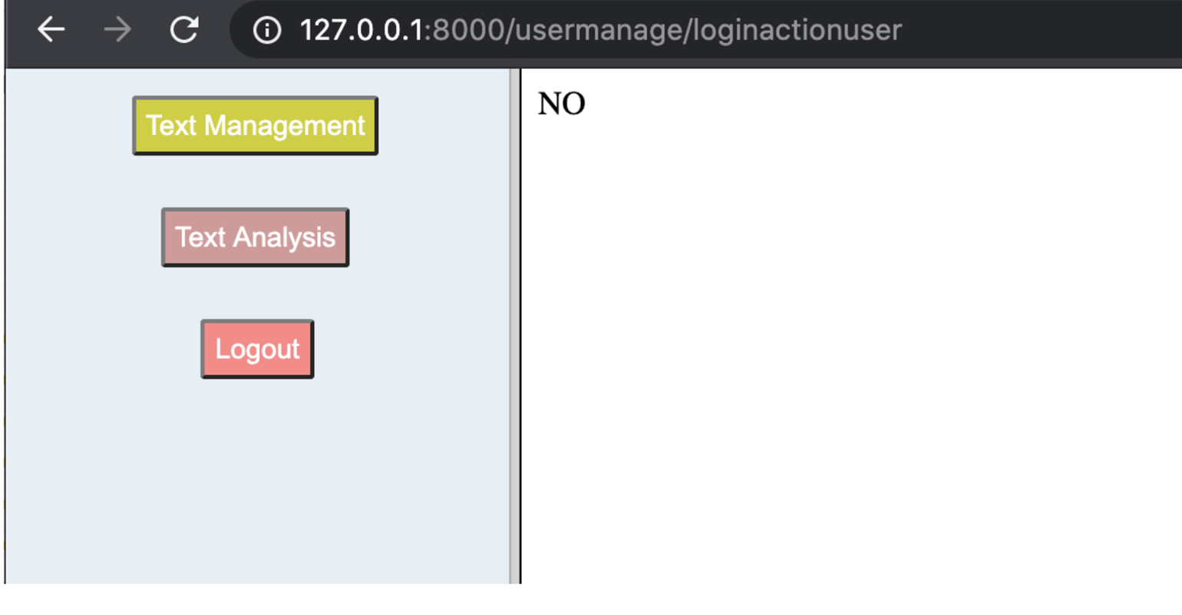

If the upload document type is different than the txt, doc, docx, or pdf, the system will display a “NO” page.

j. Passage Analysis: Word frequency

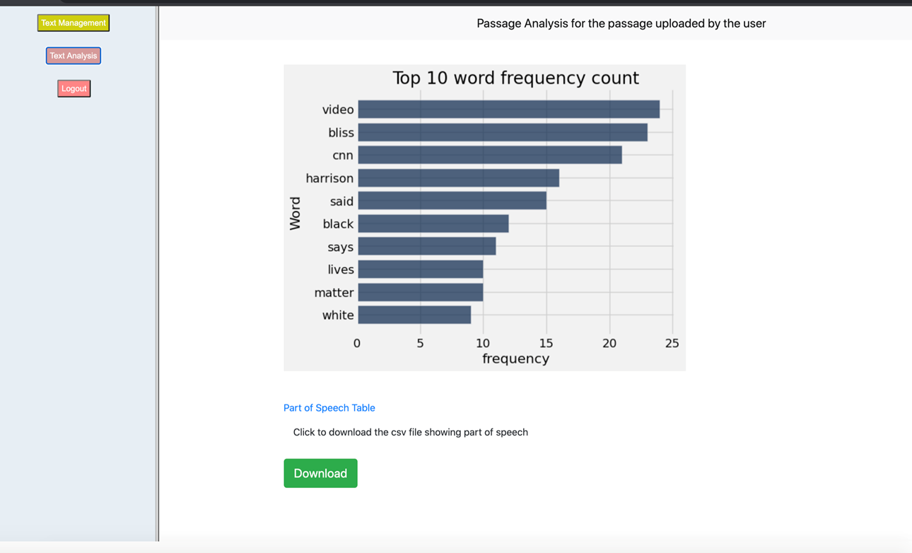

Once the text analysis button is pressed next to the document row, it will display the word frequency bar plot. It also gives the user to download the text list file in csv format.

k. Passage Analysis: Part of Speech

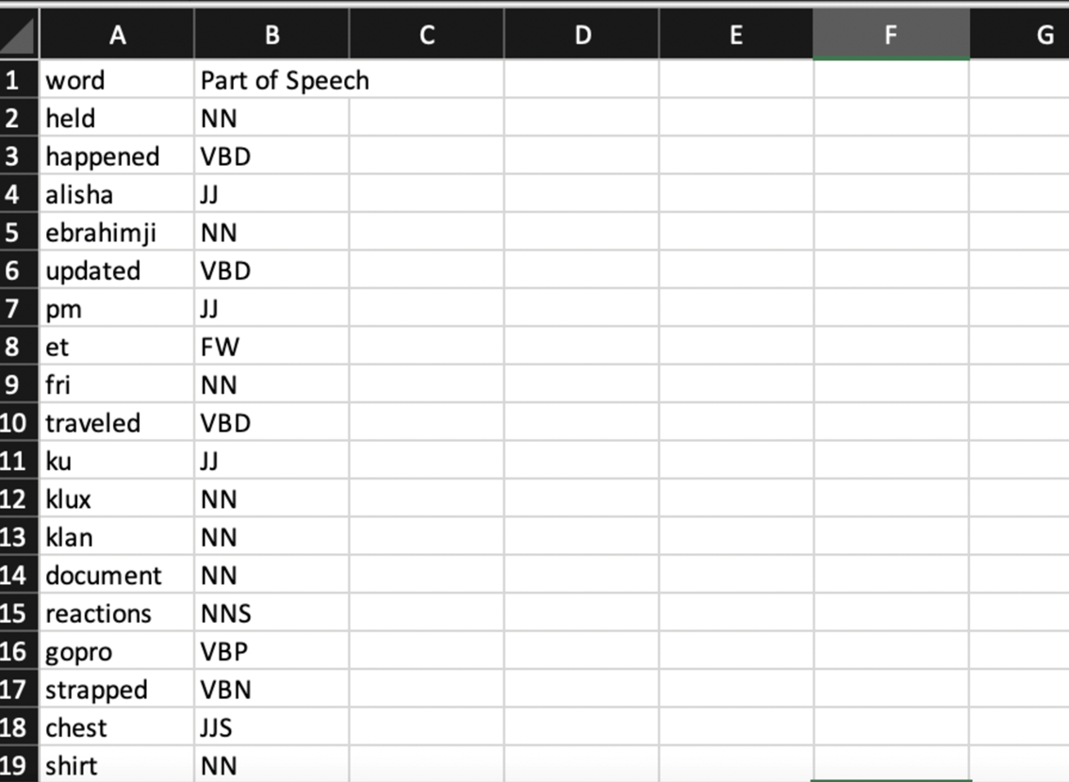

This is the text list in csv format downloaded from the text analysis system.

All the paragraphs are written with the help of all the team members (Navin Adhikary, Rajesh Pahari, and Cui Su).

