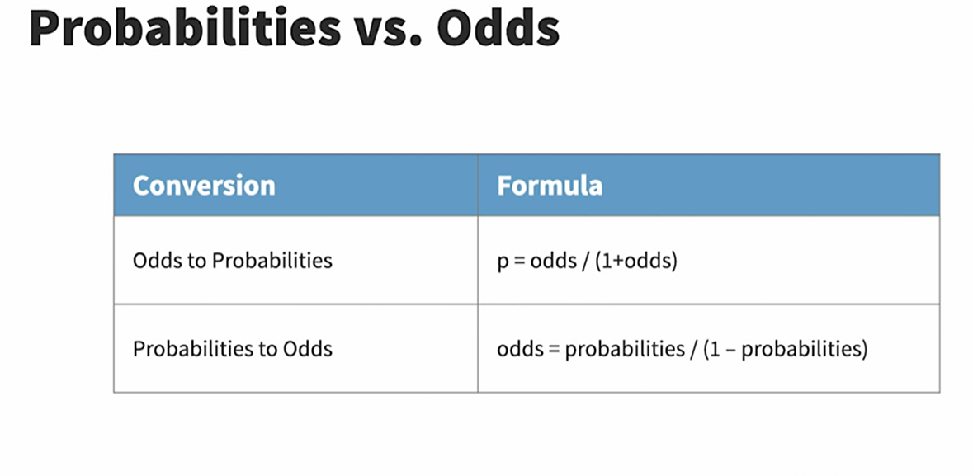Binomial case formulas

Multinomial Formulas

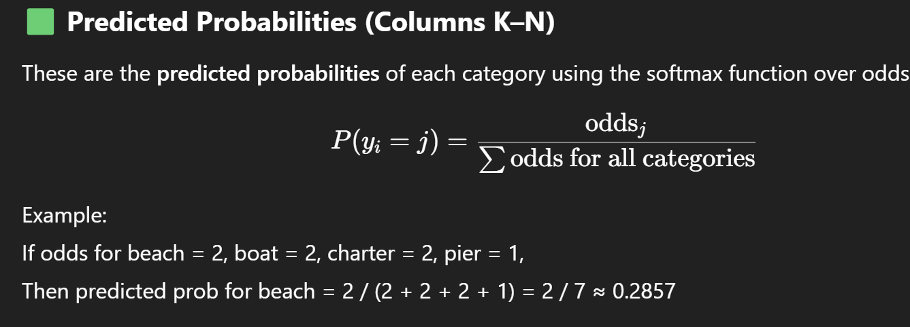

In **multinomial logistic regression**, one category is always used as the **reference category** (also called the **baseline**)

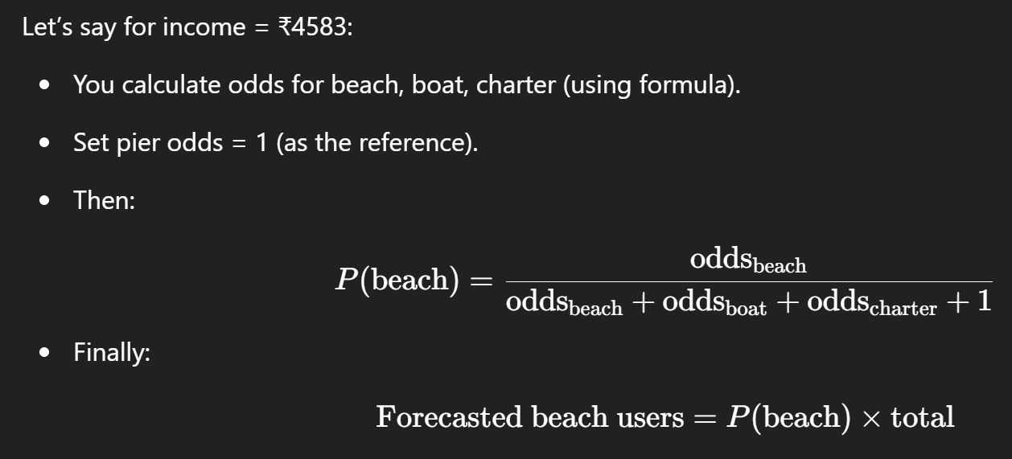

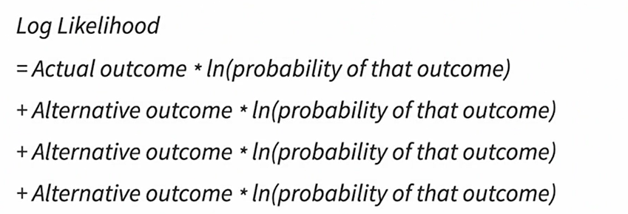

**Income** is the **identifier variable**, so in the long format, **each activity will be associated with its corresponding income value**

This specifies the name for the **new column** that will contain the **activity types**

This sets the name of the **new column** that will store the **values** (or counts) for each activity



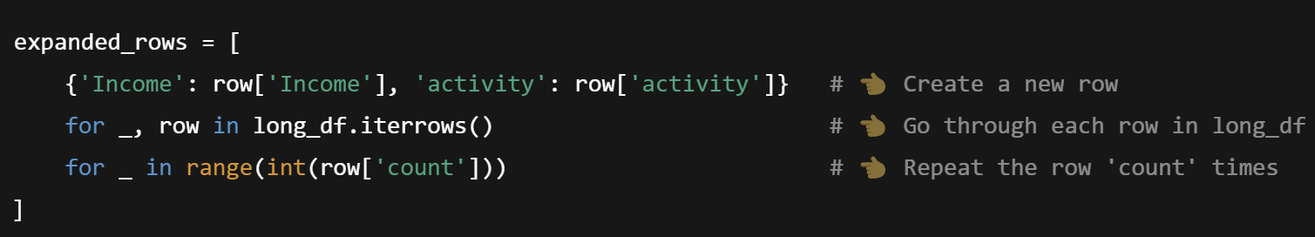

expanded_df['activity'] = expanded_df['activity'].astype('category')  
expanded_df['activity'] = expanded_df['activity'].cat.reorder_categories(  
 ['pier', 'beach', 'boat', 'charter'], ordered=True  
)



Calculating Odds , Logits and Predicts is still left to be covered in Python after significant knowledge in multinomial regression model