INTEGRATING PROMETHEUS WITH GRAFANA FOR
MONITORING

Micro Project Report Submitted by

NAVAJEEVAN K S 23ITR09

Course Code & Name : 22CDF03-DEVOPS
Programme & Branch : B.TECH - IT
Department : Information Technology

Kongu Engineering College, Perundurai
April 2026
BONAFIDE CERTIFICATE

Certified that this micro project documentation of “INTEGRATING
PROMETHEUS WITH GRAFANA FOR MONITORING” is the bonafide work of “RANJANI K S (22CDR084), VIMALANANDHAN S (21CDR058)” who carried out the project under my supervision. Certified further that to the best of my knowledge the work reported here in does not form part of my other thesis or dissertation on the basis of which a degree or awarded was conferred on an earlier occasion on this or any other candidate.

Submitted on 07.05.25

SIGNATURE | SIGNATURE
DR P A SELVARAJ  MCA., MPhil., ME., Ph.D., | Dr. R.THANGARAJAN,  B.E.,M.E.,Ph.D
SUPERVISOR | HEAD OF THE DEPARTMENT
Assistant Professor | Professor & HOD,
Department of CSD, | Department of CSD,
Kongu Engineering College, Perundurai | Kongu Engineering College,  Perundurai

INTEGRATING PROMETHEUS WITH GRAFANA FOR
MONITORING

AIM

The main aim of this project is to study and implement Continuous Integration and Continuous Deployment (CI/CD) concepts using Jenkins in a practical environment.

In this project, we aim to develop a simple static HTML website and host the source code on GitHub. The objective is to automate the process of building and deploying the website whenever changes are made to the code.

Another important aim is to configure a Jenkins pipeline that integrates with GitHub using webhooks, enabling automatic triggering of build and deployment processes on every code push.

This project also helps in understanding how modern software delivery is automated using CI/CD pipelines, reducing manual effort and ensuring faster and reliable deployment of applications.

ABSTRACT
This project focuses on implementing Continuous Integration and Continuous Deployment (CI/CD) for a static HTML website using Jenkins. The source code of the website is maintained in a GitHub repository, enabling version control and easy collaboration. Jenkins is configured to automatically fetch the latest code whenever changes are pushed to the repository. The pipeline includes stages such as code retrieval, build (if required), and deployment to a web server. Apache is used as the hosting server to serve the deployed website. GitHub webhooks are integrated with Jenkins to trigger the pipeline automatically on each code update. This automation reduces manual intervention and ensures faster, reliable, and consistent deployment. The project demonstrates how modern DevOps practices can be applied to simplify and streamline the software delivery process.

SCOPE AND OBJECTIVES SCOPE:
- Focuses on setting up a real-time system monitoring solution using Prometheus, Node Exporter, and Grafana on an Ubuntu virtual machine.
- Covers the complete process of collecting system metrics, configuring Prometheus, and displaying data through Grafana dashboards.
- Demonstrates how to track critical system metrics such as CPU usage, memory consumption, and disk space in real time.
- Reinforces the practical understanding of how system monitoring tools can be integrated for better visibility and performance tracking.
- Emphasizes data visualization, continuous system health monitoring, and ease of setup using lightweight tools and configurations.

OBJECTIVES :
- To install and configure Prometheus for collecting system-level metrics such as CPU, memory, and disk usage.
- To integrate Node Exporter with Prometheus to expose system metrics from the Ubuntu VM.
- To visualize the collected data using Grafana dashboards with user-friendly charts and graphs.
- To ensure Prometheus and Node Exporter run continuously in the background using Systemd.
- To manage Prometheus configuration using YAML files for clarity and reusability.
- To edit configuration files efficiently using the Nano text editor.

HARDWARE AND SOFTWARE REQUIREMENT

Hardware Requirements:

- Internet connection to install tools and send alerts
- Minimum 4 GB RAM (8 GB recommended for better performance)
- At least 1 GB of free storage space
- A screen size of 13" or larger with at least 1366×768 resolution

Software Requirements:

- Ubuntu Virtual Machine – To host and run Prometheus, Node Exporter, and Grafana.
- Prometheus – For collecting and storing system metrics.
- Grafana – For visualizing the metrics collected by Prometheus.
- Node Exporter – To expose system-level metrics (CPU, memory, disk usage).
- Systemd – For managing Prometheus and Node Exporter as background services.
- Nano (or any text editor) – For editing configuration files (YAML format).
- Web Browser (Chrome, Firefox, or Edge) – To access and interact with the Grafana dashboard interface.

PROJECT DESIGN
- The project sets up a monitoring environment on an Ubuntu virtual machine (VM) using Prometheus and Grafana.
- Prometheus is configured to scrape metrics exposed by Node Exporter installed on the same VM.
- Configuration files are written in YAML format for structured and readable setup.
- Grafana is connected to Prometheus as a data source and used to create customizable dashboards.
- The setup is lightweight, efficient, and does not consume excessive system resources.
- Nano or any terminal-based text editor is used to modify configuration files directly within the VM.
- The final outcome is a fully functional, real-time system monitoring solution that can be extended or adapted for larger infrastructure.

ADVANTAGES
- Real-time monitoring of CPU, memory, and disk.
- Visual dashboards in Grafana.
- Option to add alerts for critical metrics.
- Open-source and free tools.
- Runs efficiently in the background.
- Easy setup on local or cloud systems.
- Scalable and customizable.
- Helps prevent system failures early.

PROPOSED SYSTEM

- Uses Prometheus to collect and store time-series system metrics from an Ubuntubased virtual machine.
- Implements Node Exporter to expose system-level metrics like CPU, memory, and disk usage to Prometheus.
- Uses YAML configuration files to define Prometheus scraping targets and settings, enabling easy and repeatable setup.
- Employs Systemd to run Prometheus and Node Exporter as background services for continuous monitoring.
- Integrates Grafana as a visualization tool to create user-friendly and customizable dashboards.
- Supports real-time monitoring and scalable design, allowing the system to be extended to cloud or multi-node environments.

IMPLEMENTATION OF THE PROJECT

The project was implemented by first setting up an Ubuntu virtual machine as the host environment. Prometheus was installed and configured using YAML files to scrape metrics from Node Exporter, which was also installed on the same system. Node Exporter provided essential system data like CPU, memory, and disk usage. Systemd service files were created to ensure Prometheus and Node Exporter ran automatically in the background. Grafana was then installed and linked to Prometheus as a data source. Dashboards were created in Grafana to visualize the metrics in real time. The entire configuration was tested and refined using simple tools like Nano to edit files. The result was a lightweight, secure, and fully functional monitoring system capable of tracking system health efficiently and in real time.

OUTPUT

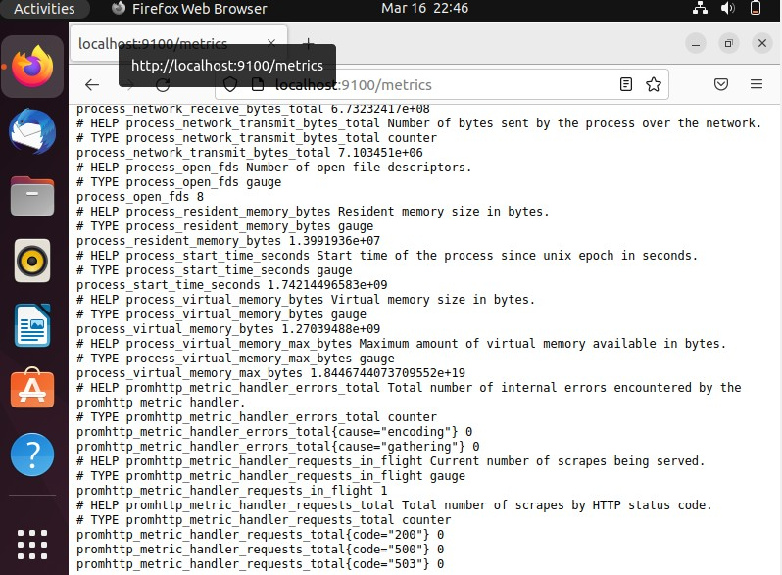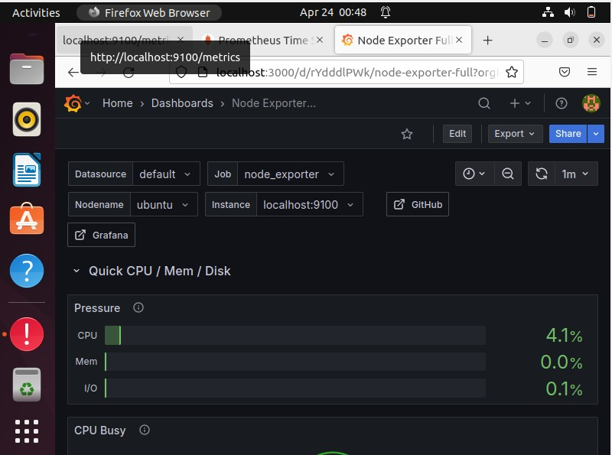

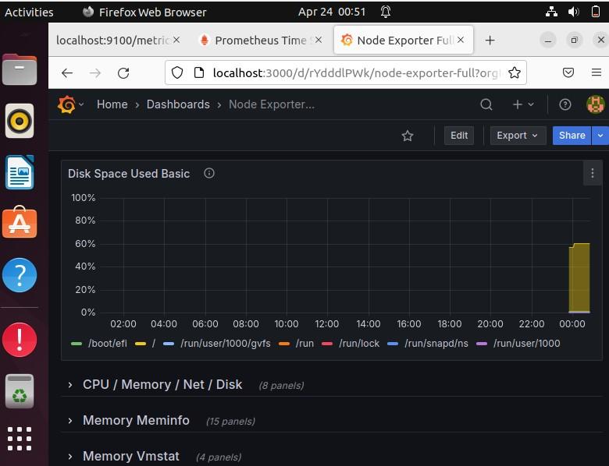

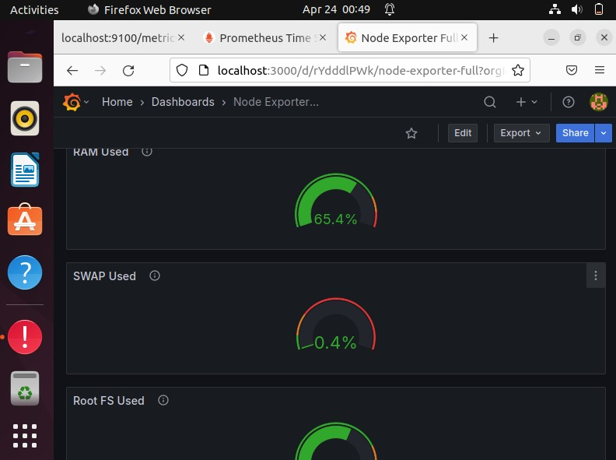

CONCLUSION

Integrating Prometheus and Grafana offers a powerful monitoring solution for system performance analysis. Prometheus collects time-series data, while Grafana provides intuitive and interactive dashboards for visualization. Using Node Exporter ensures detailed system-level metrics are captured on an Ubuntu virtual machine. Systemd helps manage the services, ensuring continuous background operation. The setup is simplified with YAML configuration files and quick editing via Nano. This solution empowers real-time monitoring and efficient troubleshooting, enhancing system uptime and performance management.

COMMANDS

# 1. Install Prometheus, Grafana, and Node Exporter Manually

# Install Prometheus on Ubuntu sudo apt update sudo apt install prometheus

# Start Prometheus sudo systemctl start prometheus sudo systemctl enable prometheus

# Install Grafana on Ubuntu sudo apt-get install -y software-properties-common sudo add-apt-repository "deb https://packages.grafana.com/oss/deb stable main" sudo apt-get update sudo apt-get install grafana

# Start Grafana sudo systemctl start grafana-server sudo systemctl enable grafana-server

# Download and install Node Exporter tar -xvf node_exporter-*.*.*.tar.gz sudo mv node_exporter-*/node_exporter /usr/local/bin/

# Run Node Exporter nohup /usr/local/bin/node_exporter &

# 2. Access Prometheus, Grafana, and Node Exporter

# Prometheus: Open http://localhost:9090
# Grafana: Open http://localhost:3000 (Login: admin / admin)
# Node Exporter: Open http://localhost:9100/metrics

# 3. Configure Prometheus to Scrape Node Exporter

# Edit Prometheus config sudo nano /etc/prometheus/prometheus.yml

# Add Node Exporter scraping config # scrape_configs:
# - job_name: 'node_exporter' # static_configs:
# - targets: ['localhost:9100']

# Restart Prometheus sudo systemctl restart prometheus

# 4. Set Up Grafana Dashboard

# Log in to Grafana (http://localhost:3000) with admin/admin
# Add Prometheus as a data source: Go to Configuration → Data Sources → Add
Data Source → Prometheus
# Set URL as http://localhost:9090 and save

