**Question 1:**

Define *Economics*, explaining the *Economic Problem.*

Economics is a social science which looks at how resources are allocated and is the study of who gets the resources. Scarcity is an economic problem. People have wants and needs but the resources to fulfill those needs and wants are limited. Therefore, society has to come up with systems that determine who gets what.

**Question 2:**

List and define the four Factors of Production.

Four Factors of Production(FOPs) are: Land, labor, capital and entrepreneurship.

Land: This refers to natural resources. Examples are water, minerals, trees and oil.

Labor: This refers to work people do in the production of goods and services. Examples are factory workers, teachers, waiters, farmers

Capital: This refers to man-made factors of production. Examples are machinery, tools, equipment, factories, road, and harbors used in the production process.

Entrepreneurship: This refers to those risk-takers who organize the factors of production into goods and services.

**Question 3:**

Explain the difference between *tradeoffs* and *opportunity costs,* using the example of eating food.

Trade offs are used when you need to sacrifice an object in order to gain another object. For example, in order to make oreo icecream you need to crush Oreos (that you already have and could eat plain) into the icecream. But instead of eating just plain Oreos you gave them up in order to make the Oreo icecream, you can no longer eat the oreos that you once had. In opportunity costs, you never had the oreos, you could either make the oreos or a chocolate chip cookie using batter. If you decide to make the cookies the opportunity cost are the oreos,unlike the tradeoff where you had the oreos to begin with.

**Question 4:**

The following table represents the combinations of goods that Bakeryland can make using its resources. Use this information to answer the questions that follow:

|  | **A** | **B** | **C** | **D** | **E** | **F** | **G** |
| --- | --- | --- | --- | --- | --- | --- | --- |
| **Cookies** | 12 | 10 | 8 | 6 | 4 | 2 | 0 |
| **Cupcakes** | 0 | 1 | 2 | 3 | 4 | 5 | 6 |

1. Create a diagram of this data with cookies on the vertical axis and cupcakes on the horizontal axis.

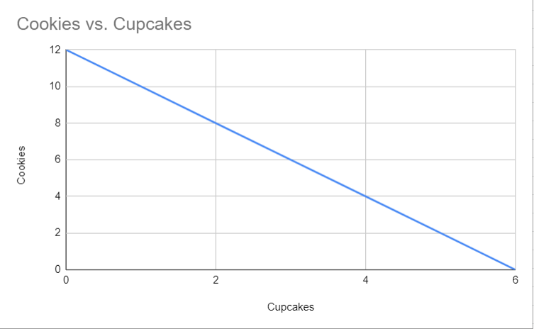

1. Assume Bakeryland is currently producing at point A, 12 cookies and 0 cupcakes.
   1. What is the opportunity cost of increasing the production of cupcakes from 0 to 1? The loss of __**2**___ cookies.
   2. What is the opportunity cost of increasing the production of cupcakes from 1 to 2? The loss of __**2**____ cookies.
   3. What is the opportunity cost of moving from C to D? **2 cookies**
   4. What is the opportunity cost of moving from D to E? **2 cookies**
   5. What is the opportunity cost of moving from F to G? **2 cookies**

c. Is this is an example of constant or increasing opportunity costs?

This is an example of constant opportunity costs

**Question 5**

The following table represents the combinations of goods that Strangeland can make using its resources. Use this information to answer the questions that follow:

|  | **A** | **B** | **C** | **D** |
| --- | --- | --- | --- | --- |
| **Robots** | 12 | 10 | 6 | 0 |
| **Cheese** | 0 | 1 | 2 | 3 |

1. Create a diagram of this data with robots on the vertical axis and cheese on the horizontal axis.

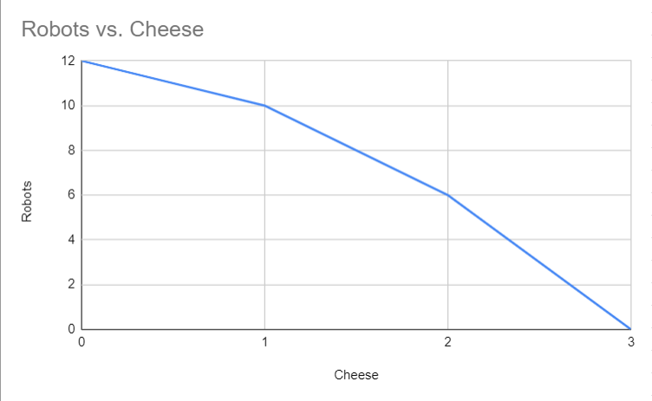

1. Assume Strangeland is currently producing at point A, 12 robots and 0 units of cheese.
   * 1. The opportunity cost of increasing production of cheese from 0 to 1 unit is the loss of _**2**___ units of robots.
     2. The opportunity cost of increasing production of cheese from 1 unit to 2 units is the loss of ___**4**____ units of robots.
     3. The opportunity cost of moving from point C to point D is ______**6 units of robots**_______.

c. Is this is an example of constant or increasing opportunity costs?

This is an example of increasing opportunity costs

**Question 6**

In the example in question 5 above, if point F lies outside of the PPC, what does this tell you?

If point F lies outside of the PPC, then we need increasing supply of resources, which cannot be attained with the existing resources

**Question 7**

In the example in question 5 above, if point G lies inside of the PPC, what does this tell you?

If point G lies inside the PPC, it shows unemployment and idle factors of production

**Question 8**

Draw a PPC for Donuts and Cell Phones, showing changes for each of the following conditions:

1. New technology makes factories more productive.

Increases production possibilities for both the doughnut and the phones

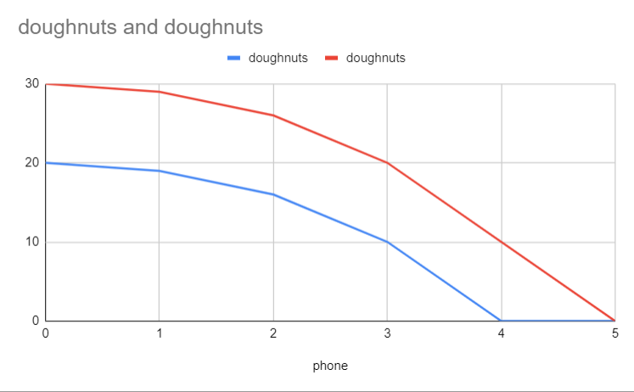

1. There’s a decrease in the demand for donuts.

A change in demand does not shift the curve

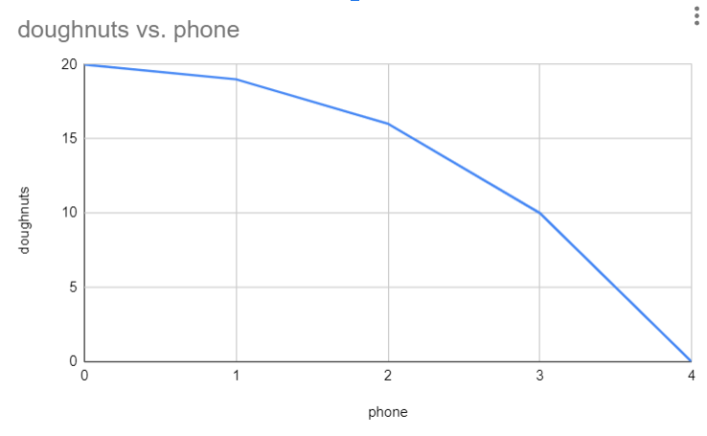

1. Dairy farmers go out of business, and butter is a resource for donuts.

A shift inward only for doughnuts

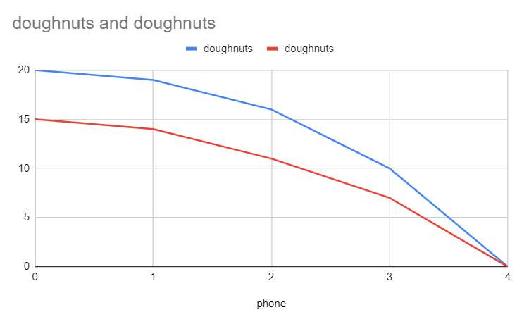

1. Many workers are unemployed.

Curve does not shift. Unemployment is just a point inside the curve

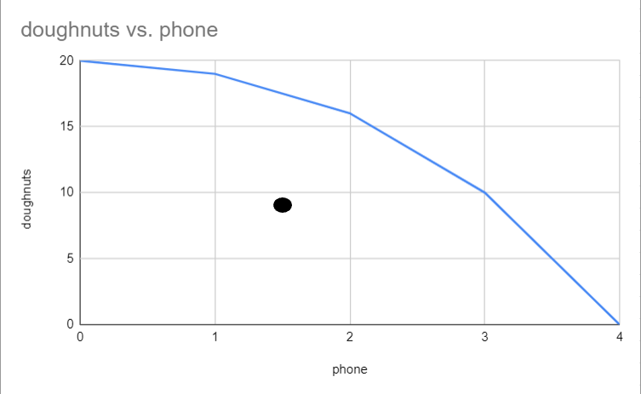

1. Workers receive improved healthcare.

Quality of workers improved and the curve shift outward

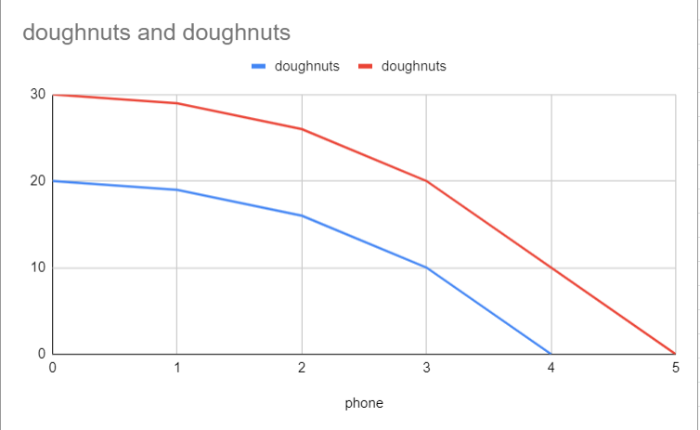

**Question 9**

Explain the difference between productive efficiency and allocative efficiency.

Productive efficiency is possible combinations of goods a country can produce given its available resources. Any point on the PPC curve is productively efficient. Allocative efficiency is optimal distribution of goods and services. For this, we need to know what combination of the two goods society most wants.

**Question 10**

How is economic growth shown on a PPC? Explain.

Economic growth is shown when the PPC curve is shifted outward. This shows how there is a higher demand for both products because of increase in people’s affordability.. Higher affordability shows higher economic growth.