COURSEREG-APP

MainActivity.JAVA :
package com.example.courseregapp;
import androidx.appcompat.app.AppCompatActivity;
import android.content.Context;
import android.content.Intent;
import android.database.Cursor;
import android.database.sqlite.SQLiteDatabase;
import android.database.sqlite.SQLiteStatement;
import android.os.Bundle;
import android.view.View;
import android.widget.Button;
import android.widget.EditText;
import android.widget.Toast;
public class MainActivity extends AppCompatActivity {
EditText ed1,ed2,ed3;
Button b1,b2;
@Override
protected void onCreate(Bundle savedInstanceState) {
super.onCreate(savedInstanceState);
setContentView(R.layout.activity_main);
ed1 = findViewById(R.id.name);
ed2 = findViewById(R.id.course);
ed3 = findViewById(R.id.fee);
b1 = findViewById(R.id.bt1);
b2 = findViewById(R.id.bt2);
b2.setOnClickListener(new View.OnClickListener() {
@Override
public void onClick(View v)
{
Intent i = new Intent(getApplicationContext(),view.class);
startActivity(i);
}
});
b1.setOnClickListener(new View.OnClickListener() {
@Override
public void onClick(View v) {
insert();
}
});
}
public void insert()
{
try
{
String name = ed1.getText().toString();
String course = ed2.getText().toString();
String fee = ed3.getText().toString();
SQLiteDatabase db = openOrCreateDatabase("SliteDb", Context.MODE_PRIVATE,null);
db.execSQL("CREATE TABLE IF NOT EXISTS records (id INTEGER PRIMARY KEY AUTOINCREMENT,name VARCHAR,course VARCHAR,fee VARCHAR)");
String sql = "insert into records (name,course,fee) values (?,?,?)";
SQLiteStatement statement = db.compileStatement(sql);
statement.bindString(1,name);
statement.bindString(2,course);
statement.bindString(3,fee);
statement.execute();
Toast.makeText(this,"Record addded",Toast.LENGTH_LONG).show();
ed1.setText("");
ed2.setText("");
ed3.setText("");
ed1.requestFocus();
}
catch (Exception ex)
{
ex.printStackTrace();
}
}
}

ActivityMain.XML :
<?xml version="1.0" encoding="utf-8"?>
<LinearLayout xmlns:android="http://schemas.android.com/apk/res/android"
xmlns:app="http://schemas.android.com/apk/res-auto"
xmlns:tools="http://schemas.android.com/tools"
android:layout_width="match_parent"
android:layout_height="match_parent"
android:orientation="vertical"
android:gravity="center"
tools:context=".MainActivity">
<LinearLayout
android:layout_width="wrap_content"
android:layout_height="wrap_content"
android:orientation="vertical"
android:gravity="center">
<TextView
android:layout_width="wrap_content"
android:layout_height="wrap_content"
android:text="Course Registation"
android:textColor="@color/black"
android:textSize="30dp"
/>
</LinearLayout>
<LinearLayout
android:layout_width="wrap_content"
android:layout_height="wrap_content"
android:orientation="horizontal"
android:gravity="center">
<TextView
android:layout_width="wrap_content"
android:layout_height="wrap_content"
android:text="Name"
/>
<EditText
android:layout_width="wrap_content"
android:layout_height="wrap_content"
android:layout_weight="1"
android:ems="10"
android:id="@+id/name"
android:textAlignment="center"
/>
</LinearLayout>
<LinearLayout
android:layout_width="wrap_content"
android:layout_height="wrap_content"
android:orientation="horizontal"
android:gravity="center">
<TextView
android:layout_width="wrap_content"
android:layout_height="wrap_content"
android:text="Course"
/>
<EditText
android:layout_width="wrap_content"
android:layout_height="wrap_content"
android:layout_weight="1"
android:ems="10"
android:id="@+id/course"
android:textAlignment="center"
/>
</LinearLayout>
<LinearLayout
android:layout_width="wrap_content"
android:layout_height="wrap_content"
android:orientation="horizontal"
android:gravity="center">
<TextView
android:layout_width="wrap_content"
android:layout_height="wrap_content"
android:text="Fee"
/>
<EditText
android:layout_width="wrap_content"
android:layout_height="wrap_content"
android:layout_weight="1"
android:ems="10"
android:id="@+id/fee"
android:textAlignment="center"
/>
</LinearLayout>
<LinearLayout
android:layout_width="wrap_content"
android:layout_height="wrap_content"
android:orientation="horizontal"
android:gravity="center">
<Button
android:layout_width="wrap_content"
android:layout_height="wrap_content"
android:layout_weight="1"
android:id="@+id/bt1"
android:text="Ok"
android:background="@color/design_default_color_primary"
/>
<Button
android:layout_width="wrap_content"
android:layout_height="wrap_content"
android:layout_weight="1"
android:id="@+id/bt2"
android:text="View"
android:background="@color/design_default_color_primary"
/>
</LinearLayout>
</LinearLayout>

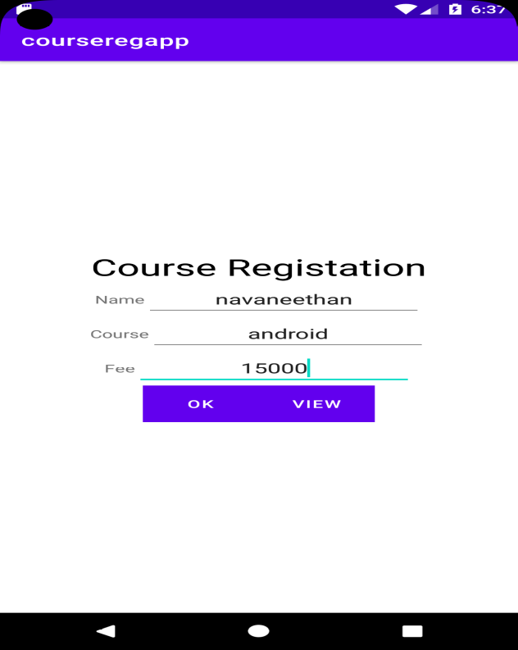

Student.JAVA :
package com.example.courseregapp;
public class student {
String id;
String name;
String course;
String fee;
String titles;
}

View.JAVA :
package com.example.courseregapp;
import androidx.appcompat.app.AppCompatActivity;
import androidx.core.widget.ListViewCompat;
import android.content.Context;
import android.content.Intent;
import android.database.Cursor;
import android.database.sqlite.SQLiteDatabase;
import android.os.Bundle;
import android.view.View;
import android.widget.AdapterView;
import android.widget.ArrayAdapter;
import android.widget.ListView;
import java.util.ArrayList;
public class view<Arraylist> extends AppCompatActivity {
ListView lst1;
ArrayList<String> titles = new ArrayList<String>();
ArrayAdapter arrayAdapter;
@Override
protected void onCreate(Bundle savedInstanceState) {
super.onCreate(savedInstanceState);
setContentView(R.layout.activity_view);
SQLiteDatabase db = openOrCreateDatabase("SliteDb", Context.MODE_PRIVATE,null);
lst1 = findViewById(R.id.lst1);
final Cursor c =db.rawQuery("select * from records",null);
int id = c.getColumnIndex("id");
int name = c.getColumnIndex("name");
int course = c.getColumnIndex("course");
int fee = c.getColumnIndex("fee");
titles.clear();
arrayAdapter = new ArrayAdapter((Context) this, androidx.appcompat.R.layout.support_simple_spinner_dropdown_item,titles);
lst1.setAdapter(arrayAdapter);
final ArrayList<student> stud = new ArrayList<student>();
if(c.moveToFirst())
{
do{
student stu = new student();
stu.id = c.getString(id);
stu.name = c.getString(name);
stu.course = c.getString(course);
stu.fee = c.getString(fee);
stud.add(stu);
titles.add(c.getString(id) + " \t " + c.getString(name) + " \t " + c.getString(course) + " \t " + c.getString(fee) );
} while(c.moveToNext());
arrayAdapter.notifyDataSetChanged();
lst1.invalidateViews();
}
lst1.setOnItemClickListener(new AdapterView.OnItemClickListener() {
@Override
public void onItemClick(AdapterView<?> parent, View view, int position, long id) {
String aa = titles.get(position).toString();
student stu = stud.get(position);
Intent i = new Intent(getApplicationContext(),edit.class);
i.putExtra("id",stu.id);
i.putExtra("name",stu.name);
i.putExtra("course",stu.course);
i.putExtra("fee",stu.fee);
startActivity(i);
}
});
}
}

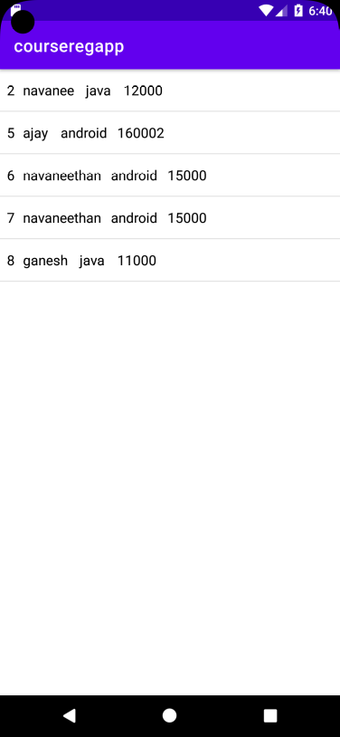

Activity _View.XML:
<?xml version="1.0" encoding="utf-8"?>
<LinearLayout xmlns:android="http://schemas.android.com/apk/res/android"
xmlns:app="http://schemas.android.com/apk/res-auto"
xmlns:tools="http://schemas.android.com/tools"
android:layout_width="match_parent"
android:layout_height="match_parent"
android:orientation="vertical"
tools:context=".view">
<ListView
android:layout_width="match_parent"
android:layout_height="match_parent"
android:id="@+id/lst1"
/>
</LinearLayout>

Edit.JAVA:
package com.example.courseregapp;
import android.content.Context;
import android.content.Intent;
import android.database.sqlite.SQLiteDatabase;
import android.database.sqlite.SQLiteStatement;
import android.os.Bundle;
import android.view.View;
import android.widget.Button;
import android.widget.EditText;
import android.widget.Toast;
import androidx.appcompat.app.AppCompatActivity;
import com.example.courseregapp.R;
import com.example.courseregapp.view;
public class edit extends AppCompatActivity {
EditText ed1,ed2,ed3,ed4;
Button b1,b2,b3;
@Override
protected void onCreate(Bundle savedInstanceState) {
super.onCreate(savedInstanceState);
setContentView(R.layout.activity_edit);
ed1 = findViewById(R.id.name);
ed2 = findViewById(R.id.course);
ed3 = findViewById(R.id.fee);
ed4 = findViewById(R.id.id);
b1 = findViewById(R.id.bt1);
b2 = findViewById(R.id.bt2);
b3 = findViewById(R.id.bt3);
Intent i = getIntent();
String t1 = i.getStringExtra("id").toString();
String t2 = i.getStringExtra("name").toString();
String t3 = i.getStringExtra("course").toString();
String t4 = i.getStringExtra("fee").toString();
ed4.setText(t1);
ed1.setText(t2);
ed2.setText(t3);
ed3.setText(t4);
b2.setOnClickListener(new View.OnClickListener() {
@Override
public void onClick(View v) {
Delete();
}
});
b3.setOnClickListener(new View.OnClickListener() {
@Override
public void onClick(View v) {
Intent i = new Intent(getApplicationContext(), view.class);
startActivity(i);
}
});
b1.setOnClickListener(new View.OnClickListener() {
@Override
public void onClick(View v) {
Edit();
}
});
}
public void Delete()
{
try
{
String id = ed4.getText().toString();
SQLiteDatabase db = openOrCreateDatabase("SliteDb", Context.MODE_PRIVATE,null);
String sql = "delete from records where id = ?";
SQLiteStatement statement = db.compileStatement(sql);
statement.bindString(1,id);
statement.execute();
Toast.makeText(this,"Record Deleted",Toast.LENGTH_LONG).show();
ed1.setText("");
ed2.setText("");
ed3.setText("");
ed1.requestFocus();
}
catch (Exception ex)
{
Toast.makeText(this,"Record Fail",Toast.LENGTH_LONG).show();
}
}
public void Edit()
{
try
{
String name = ed1.getText().toString();
String course = ed2.getText().toString();
String fee = ed3.getText().toString();
String id = ed4.getText().toString();
SQLiteDatabase db = openOrCreateDatabase("SliteDb",Context.MODE_PRIVATE,null);
String sql = "update records set name = ?,course=?,fee=? where id= ?";
SQLiteStatement statement = db.compileStatement(sql);
statement.bindString(1,name);
statement.bindString(2,course);
statement.bindString(3,fee);
statement.bindString(4,id);
statement.execute();
Toast.makeText(this,"Record Updateddd",Toast.LENGTH_LONG).show();
ed1.setText("");
ed2.setText("");
ed3.setText("");
ed1.requestFocus();
}
catch (Exception ex)
{
Toast.makeText(this,"Record Fail",Toast.LENGTH_LONG).show();
}
}
}

Activity _ edit.XML:
<?xml version="1.0" encoding="utf-8"?>
<LinearLayout xmlns:android="http://schemas.android.com/apk/res/android"
xmlns:app="http://schemas.android.com/apk/res-auto"
xmlns:tools="http://schemas.android.com/tools"
android:layout_width="match_parent"
android:layout_height="match_parent"
tools:context=".edit"
android:orientation="vertical"
android:gravity="center"
>
<LinearLayout
android:layout_width="wrap_content"
android:layout_height="wrap_content"
android:orientation="vertical"
android:gravity="center">
<TextView
android:layout_width="wrap_content"
android:layout_height="wrap_content"
android:text="Course Registation"
android:textColor="@color/colorAccent"
android:textSize="30dp"
/>
</LinearLayout>
<LinearLayout
android:layout_width="wrap_content"
android:layout_height="wrap_content"
android:orientation="horizontal"
android:gravity="center">
<TextView
android:layout_width="wrap_content"
android:layout_height="wrap_content"
android:text="ID"
/>
<EditText
android:layout_width="wrap_content"
android:layout_height="wrap_content"
android:layout_weight="1"
android:ems="10"
android:id="@+id/id"
android:textAlignment="center"
/>
</LinearLayout>
<LinearLayout
android:layout_width="wrap_content"
android:layout_height="wrap_content"
android:orientation="horizontal"
android:gravity="center">
<TextView
android:layout_width="wrap_content"
android:layout_height="wrap_content"
android:text="Name"
/>
<EditText
android:layout_width="wrap_content"
android:layout_height="wrap_content"
android:layout_weight="1"
android:ems="10"
android:id="@+id/name"
android:textAlignment="center"
/>
</LinearLayout>
<LinearLayout
android:layout_width="wrap_content"
android:layout_height="wrap_content"
android:orientation="horizontal"
android:gravity="center">
<TextView
android:layout_width="wrap_content"
android:layout_height="wrap_content"
android:text="Course"
/>
<EditText
android:layout_width="wrap_content"
android:layout_height="wrap_content"
android:layout_weight="1"
android:ems="10"
android:id="@+id/course"
android:textAlignment="center"
/>
</LinearLayout>
<LinearLayout
android:layout_width="wrap_content"
android:layout_height="wrap_content"
android:orientation="horizontal"
android:gravity="center">
<TextView
android:layout_width="wrap_content"
android:layout_height="wrap_content"
android:text="Fee"
/>
<EditText
android:layout_width="wrap_content"
android:layout_height="wrap_content"
android:layout_weight="1"
android:ems="10"
android:id="@+id/fee"
android:textAlignment="center"
/>
</LinearLayout>
<LinearLayout
android:layout_width="wrap_content"
android:layout_height="wrap_content"
android:orientation="horizontal"
android:gravity="center">
<Button
android:layout_width="wrap_content"
android:layout_height="wrap_content"
android:layout_weight="1"
android:id="@+id/bt1"
android:text="Edit"
android:background="@color/teal_200"
/>
<Button
android:layout_width="wrap_content"
android:layout_height="wrap_content"
android:layout_weight="1"
android:id="@+id/bt2"
android:text="Delete"
android:background="@color/colorAccent"
/>
<Button
android:layout_width="wrap_content"
android:layout_height="wrap_content"
android:layout_weight="1"
android:id="@+id/bt3"
android:text="Back"
android:background="@color/teal_200"
/>
</LinearLayout>
</LinearLayout>

public class edit extends AppCompatActivity {

EditText ed1,ed2,ed3,ed4;
Button b1,b2,b3;

@Override
protected void onCreate(Bundle savedInstanceState) {
super.onCreate(savedInstanceState);
setContentView(R.layout.activity_edit);

ed1 = findViewById(R.id.name);
ed2 = findViewById(R.id.course);
ed3 = findViewById(R.id.fee);
ed4 = findViewById(R.id.id);

b1 = findViewById(R.id.bt1);
b2 = findViewById(R.id.bt2);
b3 = findViewById(R.id.bt3);

Intent i = getIntent();

String t1 = i.getStringExtra("id").toString();
String t2 = i.getStringExtra("name").toString();
String t3 = i.getStringExtra("course").toString();
String t4 = i.getStringExtra("fee").toString();

ed4.setText(t1);
ed1.setText(t2);
ed2.setText(t3);
ed3.setText(t4);

b2.setOnClickListener(new View.OnClickListener() {
@Override
public void onClick(View v) {
Delete();
}
});

b3.setOnClickListener(new View.OnClickListener() {
@Override
public void onClick(View v) {

Intent i = new Intent(getApplicationContext(),view.class);
startActivity(i);

}
});

b1.setOnClickListener(new View.OnClickListener() {
@Override
public void onClick(View v) {
Edit();
}
});

}

public void Delete()
{
try
{
String id = ed4.getText().toString();

SQLiteDatabase db = openOrCreateDatabase("SliteDb",Context.MODE_PRIVATE,null);

String sql = "delete from records where id = ?";
SQLiteStatement statement = db.compileStatement(sql);

statement.bindString(1,id);
statement.execute();
Toast.makeText(this,"Record Deleted",Toast.LENGTH_LONG).show();

ed1.setText("");
ed2.setText("");
ed3.setText("");
ed1.requestFocus();

}
catch (Exception ex)
{
Toast.makeText(this,"Record Fail",Toast.LENGTH_LONG).show();
}
}
public void Edit()
{
try
{
String name = ed1.getText().toString();
String course = ed2.getText().toString();
String fee = ed3.getText().toString();
String id = ed4.getText().toString();

SQLiteDatabase db = openOrCreateDatabase("SliteDb",Context.MODE_PRIVATE,null);

String sql = "update records set name = ?,course=?,fee=? where id= ?";
SQLiteStatement statement = db.compileStatement(sql);
statement.bindString(1,name);
statement.bindString(2,course);
statement.bindString(3,fee);
statement.bindString(4,id);
statement.execute();
Toast.makeText(this,"Record Updateddd",Toast.LENGTH_LONG).show();

ed1.setText("");
ed2.setText("");
ed3.setText("");
ed1.requestFocus();

}
catch (Exception ex)
{
Toast.makeText(this,"Record Fail",Toast.LENGTH_LONG).show();
}

}

}

