**Laptops Sales Data Analysis**



**Introduction**

The data set under examination provides a comprehensive look into various laptop models, detailing essential aspects like brand, model type, screen size, performance specifications, storage, operating system, weight, and price. This information is invaluable for business analysis, as it reveals market trends, customer preferences, and competitive insights. Each attribute serves as a key indicator of demand and helps in understanding different segments of the laptop market. For example, brand data allows for analysis of customer loyalty and brand performance, while model types highlight preferences across categories such as notebooks, gaming laptops, and ultrabooks, which can inform targeted marketing and product design.

Business Perspective: To help businesses identify market trends, pricing strategies, and customer preferences for various laptop features.

User Perspective: To understand user preferences, such as preferred screen sizes, operating systems, and weight considerations, helping users make informed decisions based on commonly purchased configurations.

**Aim**

The aim of this analysis is to leverage the provided data set to uncover key insights into the laptop market, focusing on customer preferences, pricing trends, and brand performance. By analyzing attributes such as brand, model type, screen size, performance specifications, and price, this project seeks to:

Identify the top-performing laptop brands and models, helping businesses understand customer loyalty and market share. Evaluate the influence of various features—like RAM, CPU, GPU, and storage capacity—on price, enabling a better understanding of pricing dynamics.

Assess trends in screen size and resolution preferences to inform product design and display options.

Examine the distribution of operating systems to support targeted software compatibility and ecosystem alignment.

Understand the relationship between laptop weight and demand, providing insights into the importance of portability for different customer segments.

**Data set Overview**

|  |  |
| --- | --- |
| Field | Type |
| Company | text |
| Type Name | text |
| Inches | double |
| Screen Resolution | text |
| Cpu | text |
| Ram | text |
| Memory | text |
| Gpu | text |
| OpSys | text |
| Weight | text |
| Price | int |

Total rows : 1265

Total cols : 11

**Data Cleaning**

* Ram and Weight columns were updated to remove unit labels (like "GB" and "kg").
* Price was converted to an integer data type.
* Rows with invalid or zero weights were removed to ensure data accuracy.

**Analysis**

1. what all types of laptops are available in the market

Select TypeName,count(*) as Count,avg(Price) as Avg_Price

From laptopdata

group by TypeName

order by Count desc;

|  |  |  |
| --- | --- | --- |
| TypeName | Count | Avg_Price |
| Notebook | 710 | 41545.2085 |
| Gaming | 203 | 92204.4039 |
| Ultrabook | 187 | 83201.2567 |
| 2 in 1 Convertible | 113 | 69207.708 |
| Workstation | 28 | 121254.7143 |
| Netbook | 24 | 34884.875 |

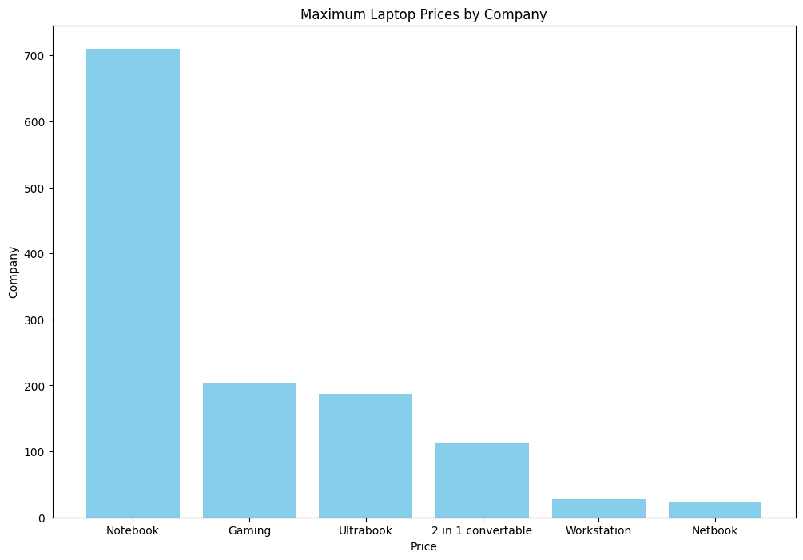

By looking this the person could understand what are the types of the laptops available in the market and the avg price for each category also which type of laptop is mostly bought by people

1. Understanding company with most sales

Select Company,count(*) as Sales_Count from laptopdata

group by Company

order by Sales_Count desc limit 10;

|  |  |
| --- | --- |
| Company | Sales_Count |
| Lenovo | 287 |
| Dell | 284 |
| HP | 266 |
| Asus | 156 |
| Acer | 103 |
| MSI | 53 |
| Toshiba | 47 |
| Apple | 21 |
| Razer | 7 |
| Mediacom | 7 |

By this we could clearly understand that top selling lap is lenovo followed by Dell etc.

1. Then we need to understand the avg price according to each company

select Company,avg(Price) as Average_Price from laptopdata

group by Company

order by Average_Price desc;

|  |  |
| --- | --- |
| Company | Average_Price |
| Razer | 178282.7143 |
| LG | 111835 |
| MSI | 91814.6038 |
| Google | 89386.3333 |
| Microsoft | 85903.8333 |
| Apple | 83340.5714 |
| Huawei | 75871 |
| Samsung | 72864.4286 |
| Toshiba | 66747.383 |
| Dell | 63057.1338 |
| Xiaomi | 60391 |
| Asus | 58972.3974 |
| Lenovo | 58368.777 |
| HP | 57214.4248 |
| Fujitsu | 38575 |
| Acer | 33394.6311 |
| Chuwi | 16745.6667 |
| Mediacom | 15717.5714 |
| Vero | 11584.5 |

By this we can compare the average prices of the companies also understand how the company have priced their products so that we can easily categorize then to budget,mid range and luxe range.

1. which is the screen resolution that is mostly prefered by the people and its avg price.

select ScreenResolution,count(*) as Top_sales,

avg(Price) AS Average_Price from laptopdata

group by ScreenResolution

order by Top_sales desc;

|  |  |  |
| --- | --- | --- |
| ScreenResolution | Top_sales | Average_Price |
| Full HD 1920x1080 | 490 | 61567.3469 |
| 1366x768 | 274 | 28853.3394 |
| IPS Panel Full HD 1920x1080 | 226 | 72228.7566 |
| IPS Panel Full HD / Touchscreen 1920x1080 | 52 | 63792.9615 |
| Full HD / Touchscreen 1920x1080 | 45 | 73987.5556 |
| 1600x900 | 23 | 35922.2174 |
| Touchscreen 1366x768 | 16 | 28873.375 |
| Quad HD+ / Touchscreen 3200x1800 | 14 | 94549.6429 |
| IPS Panel 4K Ultra HD 3840x2160 | 12 | 141735.5 |
| IPS Panel 4K Ultra HD / Touchscreen 3840x2160 | 11 | 104884.3636 |
| 4K Ultra HD / Touchscreen 3840x2160 | 9 | 168086.6667 |
| 4K Ultra HD 3840x2160 | 7 | 120941 |
| IPS Panel 1366x768 | 7 | 36078.1429 |
| IPS Panel Quad HD+ / Touchscreen 3200x1800 | 6 | 84005 |
| IPS Panel Retina Display 2560x1600 | 6 | 89508 |
| IPS Panel Retina Display 2304x1440 | 6 | 68193.1667 |
| Touchscreen 2560x1440 | 6 | 119000.8333 |
| Touchscreen 2256x1504 | 6 | 85903.8333 |
| IPS Panel Touchscreen 2560x1440 | 5 | 108105 |
| 1440x900 | 4 | 55340 |
| IPS Panel Retina Display 2880x1800 | 4 | 132872.25 |
| IPS Panel 2560x1440 | 4 | 137542.5 |
| Touchscreen 2400x1600 | 3 | 89386.3333 |
| 2560x1440 | 3 | 130326.3333 |
| IPS Panel Quad HD+ 2560x1440 | 3 | 100231 |
| IPS Panel Touchscreen 1366x768 | 3 | 28497.6667 |
| 1920x1080 | 3 | 23511 |
| Quad HD+ 3200x1800 | 3 | 53866 |
| IPS Panel Full HD 2160x1440 | 2 | 75871 |
| IPS Panel Quad HD+ 3200x1800 | 2 | 60579.5 |
| IPS Panel Touchscreen / 4K Ultra HD 3840x2160 | 2 | 89235.5 |
| Touchscreen / Quad HD+ 3200x1800 | 1 | 99580 |
| IPS Panel Full HD 2560x1440 | 1 | 103523 |
| IPS Panel Retina Display 2736x1824 | 1 | 23923 |
| IPS Panel Full HD 1366x768 | 1 | 48059 |
| IPS Panel Full HD 1920x1200 | 1 | 14119 |
| Touchscreen / Full HD 1920x1080 | 1 | 72354 |
| Touchscreen / 4K Ultra HD 3840x2160 | 1 | 54825 |
| IPS Panel Touchscreen 2400x1600 | 1 | 35112 |

By this we could understand the top selling screen resolution also their avg price so that we can categorize them according to each price segments

1. Average price by Ram

select Ram, avg(Price) as Average_Price

from laptopdata

group by Ram

order by Average_Price desc;

|  |  |
| --- | --- |
| Ram | Average_Price |
| 32 | 181849.3529 |
| 24 | 117553.3333 |
| 64 | 117511.3333 |
| 16 | 103237.6166 |
| 12 | 66037.48 |
| 8 | 63046.871 |
| 1 | 53227 |
| 6 | 32826.525 |
| 4 | 30559.6621 |
| 2 | 14756.8182 |

Thus its shows that when the ram is more then the price is also more and looking at price we can categorise then in to separate categories.

1. Cpu with its maximum price

select Cpu, max(Price) as Max_Price from laptopdata

group by Cpu

order by Max_Price desc limit 40 ;

|  |  |
| --- | --- |
| Cpu | Max_Price |
| Intel Core i7 7820HK 2.9GHz | 324955 |
| Intel Xeon E3-1535M v6 3.1GHz | 261019 |
| Intel Xeon E3-1535M v5 2.9GHz | 233846 |
| Intel Core i7 6820HK 2.7GHz | 211788 |
| Intel Core i7 6700HQ 2.6GHz | 210424 |
| Intel Core i7 7700HQ 2.8GHz | 194973 |
| Intel Core i7 7600U 2.8GHz | 175771 |
| Intel Core M 6Y75 1.2GHz | 165168 |
| Intel Xeon E3-1505M V6 3GHz | 162770 |
| Intel Core i7 6820HQ 2.7GHz | 158135 |
| Intel Core i7 7820HQ 2.9GHz | 153705 |
| Intel Core i7 2.9GHz | 152274 |
| Intel Core i7 6920HQ 2.9GHz | 149131 |
| Intel Core i7 7500U 2.7GHz | 149131 |
| Intel Core i7 6600U 2.6GHz | 139594 |
| Intel Core i7 7660U 2.5GHz | 137942 |
| Intel Core i7 2.7GHz | 135195 |
| Intel Core i7 8550U 1.8GHz | 133147 |
| Intel Core i7 2.8GHz | 130002 |
| Intel Core i7 6500U 2.5GHz | 124622 |
| Intel Core i5 7200U 2.5GHz | 124142 |
| Intel Core i7 6500U 2.50GHz | 122381 |
| Intel Core i5 6300HQ 2.3GHz | 119916 |
| AMD Ryzen 1700 3GHz | 117163 |
| Intel Core i7 7Y75 1.3GHz | 117163 |
| Intel Core i7 2.2GHz | 114018 |
| Intel Core i5 6300U 2.4GHz | 112066 |
| Intel Core i5 7300HQ 2.5GHz | 109277 |
| Intel Core i7 7700HQ 2.7GHz | 109011 |
| Intel Core i5 3.1GHz | 108691 |
| Intel Core i5 2.9GHz | 104370 |
| Intel Core i5 7Y54 1.2GHz | 101179 |
| Intel Core i5 8250U 1.6GHz | 99580 |
| Intel Core i5 7440HQ 2.8GHz | 99154 |

We know that cpu enables the system to perfrom more so increase the power or better the cpu it leads to better performance also it lleads to increase in its price also

1. Most common storage capacity

select Memory, count(*) as Sales_Count from laptopdata

group by Memory

order by Sales_Count desc;

|  |  |
| --- | --- |
| Memory | Sales_Count |
| 256GB SSD | 397 |
| 1TB HDD | 216 |
| 500GB HDD | 130 |
| 512GB SSD | 116 |
| 128GB SSD + 1TB HDD | 92 |
| 128GB SSD | 74 |
| 256GB SSD + 1TB HDD | 71 |
| 32GB Flash Storage | 37 |
| 2TB HDD | 16 |
| 512GB SSD + 1TB HDD | 14 |
| 1TB SSD | 13 |
| 64GB Flash Storage | 11 |
| 256GB SSD + 2TB HDD | 10 |
| 1.0TB Hybrid | 9 |
| 256GB Flash Storage | 8 |
| 16GB Flash Storage | 7 |
| 32GB SSD | 6 |
| 128GB Flash Storage | 4 |
| 180GB SSD | 4 |
| 16GB SSD | 3 |
| 512GB SSD + 2TB HDD | 3 |
| 256GB SSD + 256GB SSD | 2 |
| 256GB SSD + 500GB HDD | 2 |
| 128GB SSD + 2TB HDD | 2 |
| 1TB SSD + 1TB HDD | 2 |
| 512GB Flash Storage | 2 |
| 64GB Flash Storage + 1TB HDD | 1 |
| 512GB SSD + 512GB SSD | 1 |
| 1TB HDD + 1TB HDD | 1 |
| 32GB HDD | 1 |
| 512GB SSD + 256GB SSD | 1 |

By this the mostly bought storage type could be recognized and by understand this the laptop providers could arrange the availability of the laptops

1. Gpu and its maximumprice

select Gpu, max(Price) as max_Price from laptopdata

group by Gpu

order by max_Price desc limit 50;

|  |  |
| --- | --- |
| Gpu | max_Price |
| Nvidia GeForce GTX 1080 | 324955 |
| Nvidia Quadro M2200M | 261019 |
| Nvidia Quadro M2000M | 233846 |
| Nvidia GeForce GTX 980 | 211788 |
| Nvidia Quadro M3000M | 210424 |
| Nvidia GeForce GTX 1070 | 194973 |
| Nvidia GeForce GTX 1070M | 191211 |
| Nvidia GeForce GTX 1060 | 186427 |
| Nvidia Quadro M520M | 175771 |
| Nvidia GeForce GTX 980M | 172627 |
| Intel HD Graphics 515 | 165168 |
| Nvidia Quadro M1200 | 162770 |
| Nvidia Quadro M620M | 159787 |
| Nvidia GeForce GTX1080 | 158135 |
| Nvidia Quadro 3000M | 158135 |
| AMD FirePro W6150M | 154459 |
| AMD Radeon Pro 560 | 152274 |
| Intel HD Graphics 620 | 149131 |
| Nvidia GTX 980 SLI | 149131 |
| Nvidia GeForce GTX 1050 | 140606 |
| Intel HD Graphics 520 | 139594 |
| Intel Iris Plus Graphics 640 | 137942 |
| AMD Radeon Pro 455 | 135195 |
| Intel UHD Graphics 620 | 133147 |
| Nvidia GeForce 940MX | 130270 |
| AMD Radeon Pro 555 | 130002 |
| Nvidia Quadro M2200 | 128884 |
| Nvidia Quadro M620 | 124569 |
| Nvidia GeForce 960M | 119916 |
| Nvidia Quadro M1000M | 119827 |
| Intel HD Graphics 615 | 117163 |
| Nvidia GeForce GTX 970M | 117163 |
| AMD Radeon RX 580 | 117163 |
| Intel Iris Pro Graphics | 114018 |
| Nvidia Quadro M500M | 109244 |
| Intel Iris Plus Graphics 650 | 108691 |
| Nvidia GeForce GTX 1050 Ti | 105654 |
| Intel Iris Graphics 550 | 104370 |
| Nvidia GeForce GT 940MX | 103523 |
| AMD Radeon 540 | 95851 |
| Intel Iris Graphics 540 | 95851 |
| Nvidia GeForce GTX 950M | 95851 |
| Nvidia GeForce 930M | 93986 |
| Nvidia GeForce GTX 1050M | 90523 |

By analysing it understood that like cpu when more the cpu specs more the price .Most priced one is mainly used in high end pc that is used for gaming or high level works

1. which is most screen sizes that people have purchased mostly

select Inches, count(*) as Sales_Count from laptopdata

group by Inches

order by Sales_Count desc;

|  |  |
| --- | --- |
| Inches | Sales_Count |
| 15.6 | 639 |
| 14 | 192 |
| 17.3 | 162 |
| 13.3 | 158 |
| 12.5 | 38 |
| 11.6 | 31 |
| 12 | 6 |
| 13.9 | 6 |
| 13.5 | 5 |
| 12.3 | 5 |
| 15.4 | 4 |
| 15 | 4 |
| 35.6 | 3 |
| 13 | 2 |
| 24 | 2 |
| 18.4 | 1 |
| 25.6 | 1 |
| 27.3 | 1 |
| 33.5 | 1 |
| 31.6 | 1 |
| 17 | 1 |
| 14.1 | 1 |
| 11.3 | 1 |

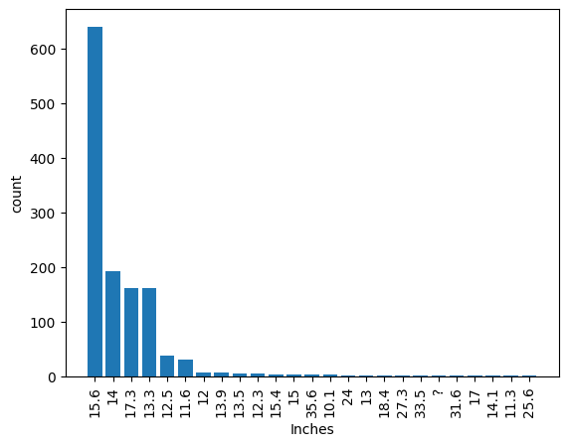

Thus it conclude that mostly used is 15.6 that is a common screen size of notebook type laptop so its concluding that most people are buying notebook type laptop and for generic purpose

1. Top 3 companies that provide lightest laptop in the market

select Company, min(Weight) as Lightest_Laptop from laptopdata group by Company order by Lightest_Laptop asc limit 3;

|  |  |
| --- | --- |
| Company | Lightest_Laptop |
| Asus | 0.91 |
| Apple | 0.92 |
| HP | 0.97 |

11.Find the top configurations for each company based on

select Company, TypeName, Inches, ScreenResolution, Cpu, Ram, Memory, Gpu, OpSys, Weight, Price from laptopdata where (Company, Price)in(select Company,max(Price) from laptopdata group by Company)

order by Price desc limit 20;

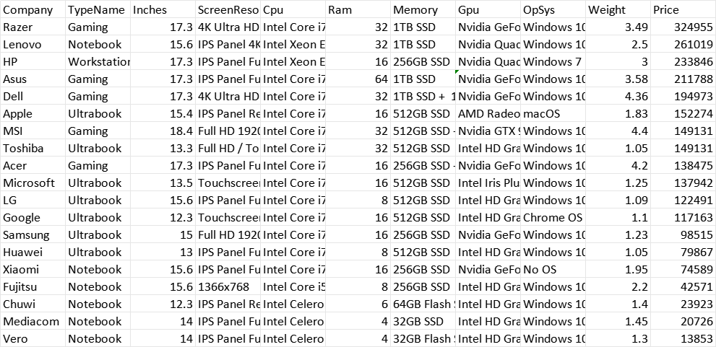

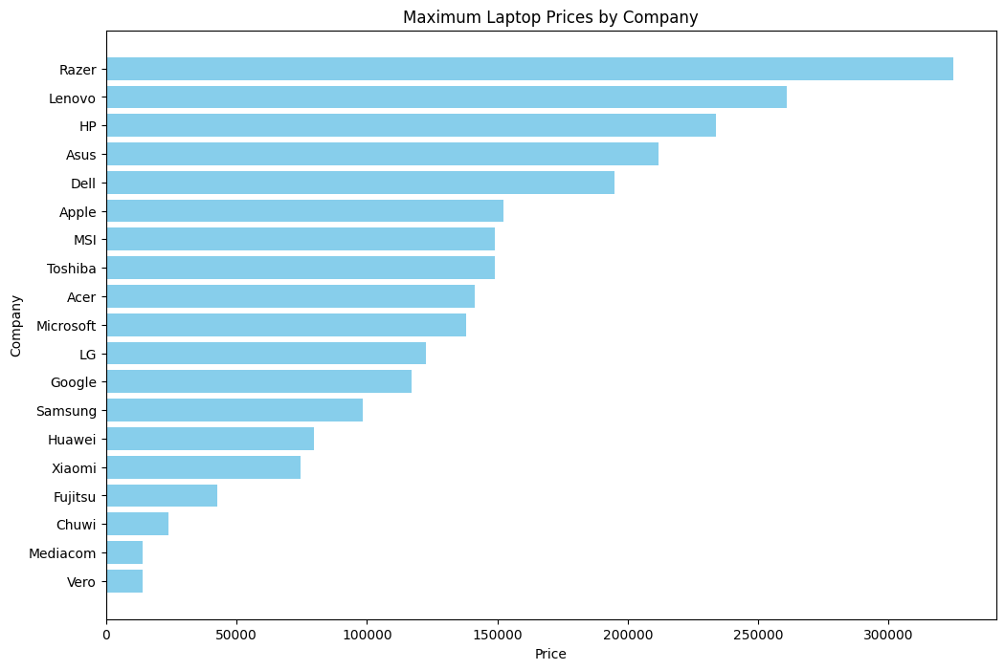

**Conclusion**

By examining these factors, this report will help stakeholders better

understand market positioning, consumer preferences, and the latest

hardware trends. Insights from this analysis can assist manufacturers,

marketers, and consumers alike in making informed decisions in an ever-

evolving market.

**Ways to improve sales**

**Competitive Pricing and Promotions :**

Setting prices competitively ensures your product appeals to cost-conscious buyers while maintaining profitability. Offering promotions like discounts or bundles creates urgency and attracts customers looking for deals, encouraging them to make purchases quickly.

**Highlight Key Features :**

Clearly showcasing the unique aspects of your product helps it stand out in a crowded market. By emphasizing what makes your product special whether it's better quality, innovative features, or sustainability you can attract customers who value those specific benefits.

**Targeted Marketing Campaigns** :

Tailoring your marketing efforts to specific groups ensures that your message reaches the right audience. By understanding customer preferences and behaviors, you can create personalized campaigns that resonate with them, leading to higher engagement and sales.

**Provide Flexible Financing Options** :

Offering payment plans, installments, or buy-now-pay-later options makes your product accessible to a broader audience. This is especially effective for higher-priced items, reducing the financial barrier to purchase.

**Enhanced After-Sales Service** :

Excellent customer support after a sale builds trust and loyalty. Services like easy returns, warranties, and responsive customer support encourage repeat business and positive word-of-mouth referrals.

**Reviews and Influencer Partnerships** :

Positive reviews and testimonials build credibility and trust in your product. Partnering with influencers allows you to reach their audience, promoting their trust and reach to promote your product effectively.