Output:
Dataset Shape: (2000, 9)

First 5 Rows:
CustomerID Age Gender Tenure MonthlyCharges Contract \
0 75722 35 Female 33 22.21 Month-to-month
1 80185 77 Male 29 136.21 One year
2 19865 31 Male 58 125.31 Month-to-month
3 76700 20 Female 48 74.83 Two year
4 92992 30 Other 66 87.44 Month-to-month

PaymentMethod TotalCharges Churn
0 Credit card 760.73 Yes
1 Credit card 3923.22 No
2 Mailed check 7293.29 Yes
3 Mailed check 3601.89 No
4 Electronic check 5747.30 No

Data after encoding:
Age Gender Tenure MonthlyCharges Contract PaymentMethod TotalCharges \
0 35 0 33 22.21 0 1 760.73
1 77 1 29 136.21 1 1 3923.22
2 31 1 58 125.31 0 3 7293.29
3 20 0 48 74.83 2 3 3601.89
4 30 2 66 87.44 0 2 5747.30

Churn
0 1
1 0
2 1
3 0
4 0

========== Logistic Regression ==========
Accuracy: 0.7275
precision recall f1-score support

0 0.77 0.87 0.82 279
1 0.57 0.39 0.46 121

accuracy 0.73 400
macro avg 0.67 0.63 0.64 400
weighted avg 0.71 0.73 0.71 400

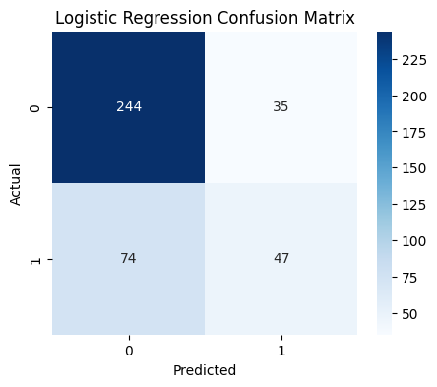

========== Random Forest ==========
Accuracy: 0.755
precision recall f1-score support

0 0.80 0.87 0.83 279
1 0.62 0.50 0.55 121

accuracy 0.76 400
macro avg 0.71 0.68 0.69 400
weighted avg 0.74 0.76 0.75 400

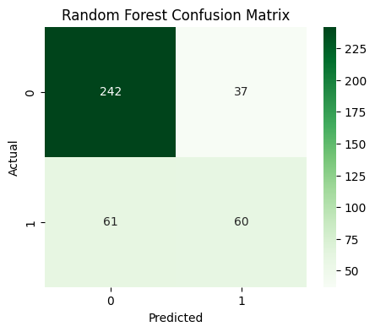

Top Important Features:
MonthlyCharges 0.255992
TotalCharges 0.198714
Tenure 0.197381
Age 0.148717
Contract 0.119362
PaymentMethod 0.049465
Gender 0.030369
dtype: float64
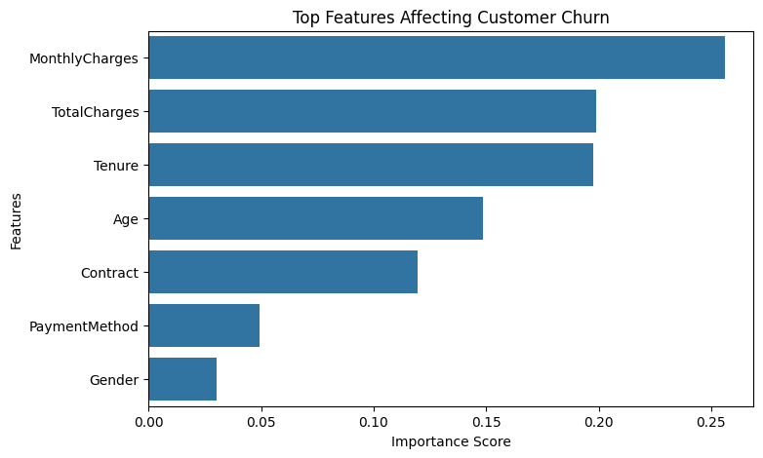

Customer Cluster Distribution:
Cluster
1 682
0 670
2 648
Name: count, dtype: int64
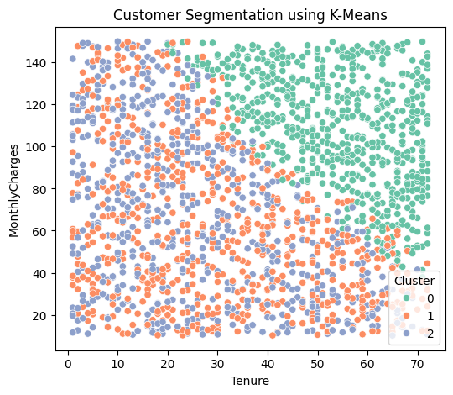

========== Chi-Square Test ==========
Feature Tested: Age
P-value: 0.31766025924761143
Result: No significant relationship with churn
/usr/local/lib/python3.12/dist-packages/huggingface_hub/utils/_auth.py:94: UserWarning:
The secret `HF_TOKEN` does not exist in your Colab secrets.
To authenticate with the Hugging Face Hub, create a token in your settings tab (https://huggingface.co/settings/tokens), set it as secret in your Google Colab and restart your session.
You will be able to reuse this secret in all of your notebooks.
Please note that authentication is recommended but still optional to access public models or datasets.
warnings.warn(
config.json: 100%
665/665 [00:00<00:00, 35.0kB/s]
Warning: You are sending unauthenticated requests to the HF Hub. Please set a HF_TOKEN to enable higher rate limits and faster downloads.
WARNING:huggingface_hub.utils._http:Warning: You are sending unauthenticated requests to the HF Hub. Please set a HF_TOKEN to enable higher rate limits and faster downloads.
model.safetensors: 100%
548M/548M [00:07<00:00, 69.9MB/s]
Loading weights: 100%
148/148 [00:00<00:00, 414.28it/s, Materializing param=transformer.wte.weight]
GPT2LMHeadModel LOAD REPORT from: gpt2
Key | Status | |
---------------------+------------+--+-
h.{0...11}.attn.bias | UNEXPECTED | |

Notes:
- UNEXPECTED :can be ignored when loading from different task/architecture; not ok if you expect identical arch.
generation_config.json: 100%
124/124 [00:00<00:00, 3.84kB/s]
tokenizer_config.json: 100%
26.0/26.0 [00:00<00:00, 756B/s]
vocab.json:
1.04M/? [00:00<00:00, 5.87MB/s]
merges.txt:
456k/? [00:00<00:00, 4.71MB/s]
tokenizer.json:
1.36M/? [00:00<00:00, 7.26MB/s]
Passing `generation_config` together with generation-related arguments=({'max_length'}) is deprecated and will be removed in future versions. Please pass either a `generation_config` object OR all generation parameters explicitly, but not both.
Setting `pad_token_id` to `eos_token_id`:50256 for open-end generation.
Both `max_new_tokens` (=256) and `max_length`(=150) seem to have been set. `max_new_tokens` will take precedence. Please refer to the documentation for more information. (https://huggingface.co/docs/transformers/main/en/main_classes/text_generation)

========== AI Business Insights (GPT-2) ==========

Based on customer churn prediction results, generate business
recommendations to reduce churn in a telecom company.

Learn more about the customer churn prediction process and how it operates.

Analyze the customer churn prediction results for any other

company in the market.

Use this data to create recommendations for your telecom company for

comparatively small but significant churn.

Do you have any other problems?

If you have any other questions about this data, please contact us.

