

***Dissertation KF7029 MSc Computer Science and Digital Technologies Project***

**Student Name:** Navaneeth Reddy Bachangari

**Student ID**: w22058065

**Supervisor Name**: Kay Rogage

**Second Supervisor Name**: Jamie Mahoney

**MSc Program:** Advance Computer Science

**Dissertation Title:** Sentiment Analysis of Game of Thrones: Demographic Factors in Viewers Perception

**Month and Year of Submission:** 08/2024

**Academic Publication Venue:** iSAI-NLP 2024 (19th International Joint Symposium on Artificial Intelligence and Natural Language Processing Conference)

# Declaration

I declare the following:

1. that the material contained in this dissertation is the result of my own work and that due acknowledgment has been given in the bibliography and references to **ALL** sources be they printed, electronic, or personal.
2. I have not use the services of any agency providing model or ghost-written work, nor have I employed unauthorised artificial intelligence in the preparation of this dissertation.
3. The Word Count of this Dissertation is **6200.**
4. that unless this dissertation has been confirmed as confidential, I agree to sections of the dissertation being placed on the eLearning Portal (Blackboard), if deemed appropriate, to allow future students the opportunity to see examples of past dissertations. I understand that if displayed on the eLearning Portal it would be made available for no longer than five years and that students would be able to print off copies or download.
5. I agree to my dissertation being submitted to a plagiarism detection service, where it will be stored in a database and compared against work submitted from this or any other Department or from other institutions using the service.

In the event of the service detecting a high degree of similarity between content within the service this will be reported back to my supervisor and second supervisor, who may decide to undertake further investigation that may ultimately lead to disciplinary actions, should instances of plagiarism be detected.

1. I have read the Northumbria University Policy Statement on Ethics in Research, and I confirm that ethical issues have been considered, evaluated, and appropriately addressed in this research.

**SIGNED: NAVANEETH REDDY**

**DATE:22/08/2024**

**Sentiment Analysis of Game of Thrones: Demographic Factors in Viewers Perception**

***Abstract***

This dissertation explores the role of demographic factors on viewers’ perceptions of Game of Thrones using machine learning and sentiment analysis. By examining viewer comments using both traditional sentiment analysis techniques and modern transformer-based models, such as BERT, the study examines how variables such as age, gender, social class and political views shape audience sentiments. Predictive models are employed alongside to predict sentiment outcomes based on demographic data, addressing a critical gap in our understanding of media consumptions patters. The findings from the study offer valuable insights into how demographics attributes impact audience reception of popular TV content.

***Keywords***— Sentiment Analysis, Game of Thrones, Demographic Influence, Machine Learning, Media Engagement.

***Source Code:*** <https://github.com/Navaneeth-Reddy-Bachangari/Sentiment-analysis1>

I**. INTRODUCTION**

The meteoric rise of sequential based television in the digital age has not only transformed the entertainment industry but has also provided fruitful grounds for analyzing cultural impact and viewer engagement [1]. Among these, Game of Thrones stands out as a particularly influential series, with its complex narratives and a diverse global audience [2]. With its fanatical popularity, Game of Thrones has created a rich tapestry of data on viewer opinions and interactions, which provides a unique opportunity to examine the relationship between audience demographics and their responses to the series. This dissertation mainly focuses on sentiments expressed by viewers of Game of Thrones, investigating how factors such as age, gender, social class and political views shape their perceptions and engagement throughout the series.

Understanding viewer sentiment in regard to TV series involves analyzing ample amounts of data formulated via online discussions and reviews. While sentiment analysis has been extensively applied in fields such as marketing and politics to gather public views, its application in understanding TV audience is

rather underexplored, particularly concerning demographic factors. Hence, this study bridges this gap and highlights the need for contemporary computational approaches that can forecast patterns in viewer feedback and portray a relation between its demographic influences.

In its application, this study employs a variety of ML based models to perform sentiment analysis and predictive modelling. Firstly, for sentiment analysis, contemporary transformer-based models such as BERT are employed alongside VADER (Valence Aware Dictionary and Sentiment Reasoner) model, which are used for analyzing social media content. Secondly, the study uses three keyword extraction methods: TFIDF, YAKE and KeyBERT. Where, it will enable gathering any missing context from the data, capturing phrases and providing most accurate context and clear patterns to within the dataset. Lastly, by using these methods, the study aims to capture deeper relationships between the variables compared making it better for understanding the meaning and context behind the findings.

***Research Questions for the study:***

1. Do demographic factors influence viewer sentiments towards the show?
2. What are the differences when comparing traditional sentiment analysis models to transformer-based models like?
3. Can demographic attributes predict sentiment towards the show using ML models?

***This study formulates the following******objectives:***

1. To classify the sentiments expressed in datasets as positive, negative, or neutral using both traditional and transformer-based methods.
2. To portray these sentiments with demographic data to uncover trends in viewer perception.
3. To employ predictive modeling methods to forecast sentimental outcomes based on demographic characteristics.
4. To compare the effectiveness of different sentiment analysis techniques used in capturing viewer perception.

The following sections of the report are as follows: Literature Review: sheds light on existing literature on sentiment analysis and demographic impacts on media reception. Description of Practical Research Work

Undertaken: details of the data collection, sentiment analysis techniques (including VADAR and transformer-based models), and the statistical and ML methods employes. Results & Analysis showcases the findings from the experiments conducted. Critical Evaluation, Conclusion and Recommendations summarizes the key findings and their implications offering recommendation and suggesting directions for subsequent research.

## **II.LITERATURE REVIEW**

The increasing body of research in sentiment analysis has provided major insights into understanding public opinion across various domains. These domains included marketing, politics, and social media. However, the use of sentiment analysis in the realm of TV industry and media studies, specifically regarding the demographic factors, remains underexplored [3].

***A. Importance of Understanding Public Opinions via Sentiment Analysis:***

Sentiment Analysis, a subset of natural language processing, has become a crucial tool in perceiving public opinions across many fields [4]. By categorically analysing the sentiments in textual corpus, which can be social media posts, comments on various TV channels, and public review forums, it can form a source where it will allow to gain insights into the public attitudes, preferences, and emotional responses to various events, products or content [5].

For instance, in politics, sentiment analysis has been a vital computational tool which aids in breakdown of public perception during, elections, debates, and international relations [6]. In a study conducted by Alvi et al., they focused on the field of election prediction using sentiment analysis, particularly through the analysis of Twitter data. The study showcased how sentiment analysis aided in gaining public opinion by analysing online political discussions and news articles, has been increasingly used over the past two decades to predict election

outcomes.

Additionally, in the fields of marketing and business, many organisations have made use of sentiment analysis to gain clear insights into consumer preferences and their overall brand perception. In connection to this, an article by Qualtrics an American experience management company, discusses the importance of brand sentiment, which reflects how consumers perceive a brand, both positively and negatively [7]. The article also shed light on how advanced sentiment analysis tools were used to measure consumer feedback from various sources like social media and surveys.

Lastly, in the entertainment industry, sentiment analysis is becoming increasingly popular regarding understanding audiences’ reactions to movies or TV series [8]. To highlight this, a study conducted by A. Amalia et al, titled "Determination of quality television programs based on sentiment analysis on Twitter". The study focuses on assessing the quality of TV programs in Indonesia using sentiment analysis of Twitter data. The study experimented with models such as K-Nearest Neighbours algorithm to classify tweets into positive, negative, or neutral sentiments. The study analysed 4000 tweets related to four major Indonesian TV stations. The findings revealed that the ANTV station received the highest positive sentiment, and the classification model achieved a 90% accuracy rate with the optimal k-value of 10. Despite these studies conducted across different fields, the application of sentiment analysis presents unique challenges especially in regard to accurately gathering the patterns of human opinions. However, with the advent of more complex machine learning models, the field has seen significant improvements in capturing and interpreting sentiment more accurately.

***B. Traditional vs Modern Approach to Sentiment Analysis:***

During recent years, sentiment analysis has widely been used to comprehend the emotional tone behind words, by mainly utilisation of lexicon-based approaches and rule-based models [9]. Among these models, VADER (Valence Aware Dictionary and sEntiment Reasoner) is one of the most utilised models in this topic [10]. VADER is implemented in a way which is particularly effective for examining sentiments that are expressed in social media contexts, for example tweets, where language can be informal, and filled with abbreviations or slang. It operates by assigning predefined sentiment scores to words and phrases, which are then aggregated to determine the overall sentiment of a text [11].

VADER is one of the lexicon-based techniques that has various benefits. They can be useful for sentiment analysis in situations when language is rather plain and simple, and they are easy to implement with little processing [12]. In addition, the transparency of lexicon-based models' approaches enables clear comprehension and interpretation of the findings. On the other hand, traditional sentiment analysis methods do, however, have some significant drawbacks. For instance, they can often have trouble in conveying the subtleties of language, especially when it comes to context, sarcasm, irony, and expressions. VADER can accurately classify a comment like "I loved the show so much I could scream!" as positive, but depending on the vocabulary used, a different statement like "It was better than I expected" would not register as extremely positive. Furthermore, when dealing with complicated phrase patterns or different feelings represented in a single text, these models perform less.

However, with recent advancements into sentiment analysis and NLP (natural language processing), deep learning and transformer-based models like BERT (Bidirectional Encoder Representations from Transformers), have been introduced, where these models represent a significant advancement over traditional methods due to their ability to understand context and capture the subtleties of language more accurately [13]. BERT is a transformer-based model, which considers the context of each word in relation to all the other words in a particular sentence [14]. For example, BERT can distinguish between “I didn’t love the finale” (which is a negative sentiment) and “I didn’t hate the finale” (neutral to positive sentiment), which might be difficult for lexicon-based models (Figure below [15]).

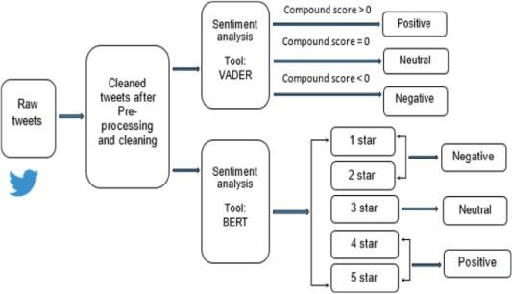

**Figure 1:** Project Scientific Diagram (Self-Created)

As it can be identified from the Figure above, BERT and similar transformer models can provide a much richer analysis of the sentiment data. They can capture the diverse range of emotions expressed by *Game of Thrones* viewers, considering the context and subtleties that traditional methods might miss. This is very important when viewing in on the demographic factors, as different groups/individuals may express their sentiments in different ways, depending on cultural, social, and linguistic circumstances.

Nonetheless, employing a mixture of traditional and modern sentiment analysis techniques will allow for a complete analysis of viewer sentiment. Traditional methods can act and serve as a baseline predictor, by providing quick and interpretable results. Whereas transformer-based models can delve deeper into the data, uncovering insights that could be overlooked. This not only enhances the robustness of the findings but also ensures that the analysis is sensitive to the diverse ways in which different demographic groups engage with and respond to the content.

***C. Demographic Influences on Media***

***Reception:***

According to the Cambridge Dictionary, a demographic can be defined as something relating to human populations and the information collected about them, such as their size, growth, ages and education [16]. In terms of a corpus experimenting upon opinions and huma perceptions, demographics such as age, gender, social class, and political views play a vital role in determining media intake. For instance, older viewers could enjoy content that reflects their morals, whereas younger audiences can be drawn to genres and subjects that speak to their experiences or current social trends. Studies reveal that men and women frequently have distinct likes in genres, characters, and topics, which in turn impacts how emotionally engaged they are with the material [17].

In the variables of social class and political views, further add to the complicated landscape of media reception. This is because, many people from numerous socioeconomic backgrounds can have difference of access to media and can interpret the same content in a different way to others. This can often be justified due to their cultural upbringing and by their overall life experiences [18]. Political ideologies can also take one’s perspective, especially with the content which touches upon social issues, governance or mortality. This can also be seen in TV shows like the Game of Thrones, where the series often showcases themes of power, justice and a sense of leadership within the characters.

Recent research into this has also showcased that these demographic influences across various forms of media outlets. Studies on TV viewers, for example, have revealed that working-class viewers frequently perceive characters and stories through the point of view to their own experiences with social and economic challenges, which may lead to a different interpretation of the characters and storylines than middle-class or upper-class viewers [19].

To reflect to the core computational aspects of this study in relation to sentiment analysis on demographical data, sentiment analysis has been a commonly used technique for gaining insights into how people feel about certain content, including TV shows and films. These models involve the classification of attitudes as positive, negative, or neutral through the analysis of big datasets of viewer comments, reviews, and social media posts. Though it has the potential to give a better insight of how various audience groups interact with the material, the presence of demographic data into these studies has been less common.

***D. Related work:***

In a study conducted by T. Cooray et al., they explored Aspect-Based Sentiment Analysis (ABSA) to evaluate customer opinions on movies and TV series, focusing on aspects like genre, story, and cast/crew. The study made use of ML models to investigate social media data, achieving over 79% accuracy [20]. The study aims to understand how these aspects influence the popularity of movies and shows. While the study showed reasonable findings, it was hindered by the reliance on the quality and quantity of social media data from fanbases, which would have added a lot of biased or incomplete findings, affecting the trustworthiness of the analysis.

Similarly, Abd. Bansari et el., examined a study on “Opinion Mining of Movie Review Using Hybrid Method of Support Vector Machine and Particle Swarm Optimization’, which made use of Twitter messages for movie reviews through sentiment analysis, applying Support Vector Machine (SVM) for binary classification into positive and negative sentiments [21]. The study showed the accuracy of sentiment classification from 71.87% to 77% by including a hybrid Particle Swarm Optimization (PSO) to optimize SVM parameters. The focus was on improving the reliability of SVM in distinguishing between good and bad opinions about movies based on user-generated content on social media. However, the study had its limitations as the use of binary classification approach had oversimplified the complexity of opinions, missing links between positive and negative sentiments. This in hindsight had affected the robustness of the findings when applied to diverse datasets or more complex sentiment analysis tasks.

Lastly, in a study titled: “Thumbs up or thumbs down: semantic orientation applied to unsupervised classification of reviews”, the authors of the study introduced an unsupervised learning algorithm for classifying reviews as

"recommended" (thumbs up) or "not recommended" (thumbs down). This was based on the average semantic orientation of phrases containing adjectives or adverbs [22]. The model measures semantic orientation by comparing the mutual information between a phrase and the words "excellent" and "poor." The model achieved an average accuracy of 74% across various domains, with accuracy varying from 84% for automobile reviews to 66% for movie reviews. However, the drawback to this study was that it includes the reliance on mutual information, which may not fully capture the textual patterns of sentiment, particularly in more subjective domains like movie reviews. Additionally, the accuracy variation across different domains suggests that the model’s efficacy may be context-dependent,

requiring adjustments or enhancements for broader applicability.

In summary, this section explored the use of sentiment analysis across various domains, highlighting the limitations of traditional lexicon-based methods like VADER and the advantages of modern transformer-based models like BERT in capturing complex sentiments, particularly in difficult media content nature such as *Game of Thrones*. This study also underscores the significant influence of demographic factors such as age, gender, social class, and political views on media reception and identified a gap in research that combines demographic data with sentiment analysis. In conclusion, by combining traditional and modern techniques, while considering demographic diversity, is crucial for a comprehensive understanding of audience sentiment in media studies.

## **III.DESCRIPTION OF PRACTICAL RESEARCH WORK UNDERTAKEN**

1. ***Research Approach***

The Research approach for this study is built on the application of ML methods with the implementation of sentiment analysis to examine how the demographic factors affect viewer perceptions of Game of Thrones. A mixed-methods approach was used, with a combination of both quantitative analysis of demographic data and computational sentiment analysis. This approach was utilized because of the peculiar nature of the data, which contains a large volume of textual content from online discussions and reviews, alongside detailed demographic information [23]. The mixed methods methodology enables full exploration of the data, facilitating both the identification of patterns in viewer sentiment and the prediction of how different demographic groups may respond to the series.

Additionally, traditional sentiment analysis techniques, such as VADER, were complemented by modern transformer-based models like BERT, to ensure complexity in sentiment classification [24]. This combination of methods is justified by the need to balance computational efficiency with the comprehensive understanding of viewer sentiment, particularly as it relates to diverse demographic variables such as age, gender, social class, and political views [25]. The research approach, therefore, is not only about applying machine learning but also about carefully selecting and integrating techniques that align with the study's objectives of demographic analysis and sentiment prediction [26].

1. ***Requirements Analysis***

The requirements analysis phase was essential in defining the study's scope, identifying the necessary datasets, and selecting appropriate analytical tools. Various key datasets were identified, comprising ample amounts of viewer reviews and discussions sourced from various online platforms. Demographic variables such as age, gender, social class, and political views were also determined as critical factors to be examined and experimented with. The selection of these demographic variables was guided by the study's objective (formulated in section I.) to explore the relationship between these factors and viewer sentiment.

1. ***Design & Construction***

The design phase consisted of the development of a through data preprocessing pipeline, which was structured to handle and interpret large volumes of data effectively. The primary tasks included data cleaning, where missing values were addressed using methods such as forward filling, mean replacement, and mode replacement. These preprocessing steps were vital in ensuring the dependability and consistency of the information inside the dataset. Then, the cleaned data was then categorized and normalized, particularly for the demographic variables, to facilitate subsequent analysis [27].

In the construction of the sentiment analysis model, both traditional and transformer-based techniques were employed. The VADER (Valence Aware Dictionary and sEntiment Reasoner) model was made use of in analyzing social media content, offering quick and reliable sentiment classification [28]. In parallel, the BERT (Bidirectional Encoder Representations from Transformers) model was also implemented due to its advanced capabilities in understanding context and patterns in textual data. These models were chosen to provide a comprehensive analysis of sentiment across different types of viewer comments [29].

1. ***Experimental Work***

The experimental work consisted of the implementation and fine-tuning of various ML models. Mainly the three keyword extraction methods were utilized. TF-IDF, YAKE and KeyBERT. Where, it will enable gathering any missing context from the data, capturing phrases and providing most accurate context and clear patterns to within the dataset. Lastly, by using these methods, the study aims to capture deeper relationships between the variables compared making it better for understanding the meaning and context behind the findings.

Through experimentation were conducted in this study to optimize these models, involving hyperparameter tuning, cross-validation, and the use of performance metrics such as accuracy, precision, recall, and F1 score.

1. ***Testing & Data Collection***

The data collection process involved the extraction of viewer comments and demographic information from the identified datasets. The testing phase was constructed to validate the models' effectiveness in predicting sentiment across different demographic groups. A separate test set was then used to ensure the overall generalizability of the results. The testing process was iterative, with the implemented models being refined based on their performance on the test data, ensuring that the final models were both accurate and reliable.

1. ***Ethical Considerations***

This research demonstrates a strong commitment to ethical considerations, with integrity stressed at every level of the investigation. To preserve participants' privacy, informed consent was acquired before collecting the relevant replies. Legally, all actions necessary to abide by data protection laws were taken, guaranteeing that the right authorisations for the gathering and processing of data were obtained. To protect sensitive data from unwanted access, strong security measures were put in place that included access restrictions and encryption techniques. From a professional standpoint, the author of this study acknowledged any potential biases and limitations in the results and made sure to maintain transparency in the data and methods. By reducing resource consumption and promoting the reuse of shared data, sustainability was also taken into consideration. In conclusion, the study used sentiment analysis and machine learning methods to investigate how viewers' perceptions of Game of Thrones were influenced by their demographics. To handle a huge corpus of textual content from online chats, a multi-method strategy was employed, integrating computational tools like traditional models and transformer-based models with quantitative analysis of demographic data. This methodology allowed for a thorough analysis of sentiment patterns and predictive modelling in a range of demographic contexts. Nonetheless, throughout the testing stages of the study, a number of other strategies were taken into consideration but eventually rejected. For instance, because of their poor interpretability, deep learning models for sentiment analysis were determined to be inappropriate for the dataset. Additionally, to minimize overfitting and preserve generalisability across larger population segments, the introduction of additional demographic categories was avoided.

## **IV. RESULTS & ANALYSIS**

***A. Pre-processing***

The dataset used in this study is a survey of viewers' opinions on Game of Thrones. The Python programming language is utilised to analyse the dataset, which includes about 10,000 rows of data.

The first step was to pre-process the data to ensure that the data is cleaned and aggregated for efficient training of the models. Mainly, the core variables of the dataset were targeted, for instance, numerical values like ‘Age’ were imputed with the mean value, while other categorical variables like ‘Class proxy’ were attributed using the mode (most frequent value). Then, the variables were categorically transformed, meaning that classes such as ‘Sex’, ‘Class Proxy’ and ‘Politics’ columns were converted into categorical data types. This was crucial for the statistical analysis and the integration of the ML models.

**Figure 2:** Top 10 viewer Locations

After all the variables were cleaned and aggregated for statistical modelling, a bar chart (above) was created to check and see the geographical locations of the viewers. The dataset includes viewers primarily from US, UK, Spain, Finland, with the US having the highest number of viewers, followed by the United Kingdom and Spain.

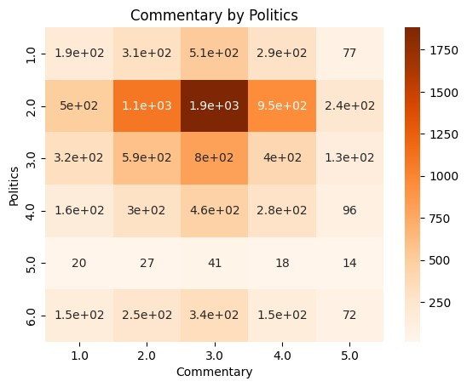

**Figure 3:** Commentary by Politics

Moreover, the above cross-tabulation figure analyses the relationship between the participants' political views and their engagement in commentary. It creates a table displaying the count of participants with different political views who have varying levels of engagement in commentary. The heatmap provides a visual representation of this data, allowing for easy identification of any significant correlations between political views and commentary engagement.

***B. Exploratory Data Analysis (EDA)***

**Figure 4:** Sentiment Distribution by Rating

Firstly, the above figure showcases the sentiment distribution comparison across various ratings. It can be seen that higher ratings (particularly a rating of 5) are predominantly associated with positive sentiments, as shown by the significant number of positive comments. Conversely, lower ratings, especially 1 and 2, are more frequently linked with negative sentiments.

**Figure 5:** Distribution of commentary Ratings

The histogram above provides an overview of how "Commentary" ratings are distributed across all respondents. The peaks and troughs in the histogram suggest that certain commentary ratings are more common, indicating that respondents tend to cluster around specific rating values.

**Figure 6**: Violin plot of Commentary Ratings by Politics.

This plot illustrates the distribution of "Commentary" ratings across various political categories. The shapes of the violins suggest differences in how different political groups rate the commentary. For example, certain political categories show a more concentrated range of ratings, while others have a broader spread, indicating more variability in opinions about commentary within those groups.

In summary the EDA shows that the bulk of viewers are from the United States, the UK and Spain. It also shows that higher ratings correlate with positive sentiments, while lower ratings are linked to negative sentiments. While, political views influence commentary engagement, with different groups showing varying levels of opinion concentration.

***C. Sentiment Analysis***

To understand the sentiment in viewer comments, 3 different models were used: VADER, TextBlob and a transformer-based model (BERT).

***1. TextBlob Analysis:***

A neutral pattern in viewer reactions is consistently seen across the sample, according to the TextBlob analysis (figure above). The first two plots show that the majority of replies within the dataset are neutral in sentiment, with very few deviating into positive or negative feelings. This would suggest that even though viewers are interested in the topic, their responses are usually controlled, and their use of words/opinions leans more towards objectivity than emotion. Like Plot 3, Plot 4, they demonstrate a high frequency of neutral emotion with very few replies that lean either positive or negative.

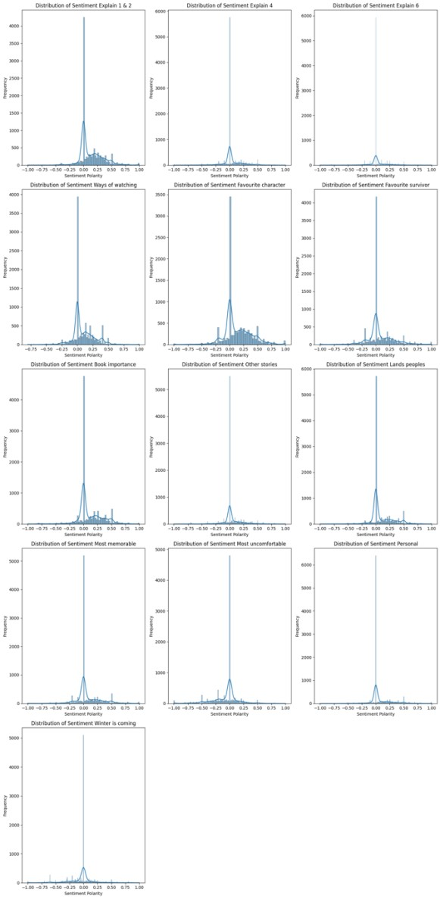

**Figure 7:** TextBlob Results

In plot 6, neutral sentiment is again obvious, though there's a slight bent towards positive sentiment. This might mean that when viewers do express feelings/opinions, they are generally mildly positive. The analysis of "Ways of Watching" also reveals a rise in neutral sentiment, which showcases that comments on viewing habits lack strong emotional feelings.

Additionally, variables such as the favourite characters are mostly of neutral discussion. This shows that although viewers have preferences, emotion doesn't have a big effect on their perspectives. Favorite characters within the show are likewise seen with a neutral viewpoint, which may suggest that they are more analytical conversations.

Regarding the importance of books in the series, the sentiment analysis shows a strong neutral peak, suggesting that opinions on this topic are not particularly emotionally charged.

Overall, viewers’ comments reflect a primarily neutral tone across various topics and variables within the show. Even when sharing personal stories or connections to the series, the language/tone used within their comments tends to be neutral, which likely reflects a broad range of individual experiences. In conclusion, TextBlob analysis reveals that while viewers are engaged with the content, their opinions and language are generally neutral and lack strong emotional expression from the examined dataset.

***2. VADER & Transformer-based Analysis:***

The analysis of sentiment scores using TextBlob and VADER reveals distinct differences in how these tools capture and represent viewer sentiments about "Game of Thrones." Text Blob’s summary statistics show a central tendency around neutral sentiment, with generally positive but close to zero. This suggests that while viewers' sentiments are slightly positive, they are not strongly polarized. The standard deviations, which range from approximately 0.17 to 0.25, indicate moderate variability, with most responses clustered around the median. The presence of outliers on both the positive and negative sides points to occasional extreme sentiments, but the narrow interquartile ranges (IQRs) suggest that most sentiments are near the neutral mark. This makes TextBlob useful for understanding general sentiment trends, reflecting moderate and balanced opinions.

In contrast, Transformer sentiment scores show a broader and more polarized distribution. The means of Transformer sentiments vary widely, with some categories showing high positive or negative values, indicating strong opinions on certain aspects. The higher standard deviations, around 0.90 for several columns, reflect substantial variability in sentiments. Quartile analysis reveals a tendency towards extreme sentiments, with many medians close to either -0.75 or 0.75, highlighting a bimodal distribution. Similarly, VADER sentiment analysis shows a mix of neutral, positive, and negative sentiments but tends to have a slightly higher central tendency towards positive sentiment in certain categories. VADER also captures significant variability in sentiments, with standard deviations ranging from 0.35 to 0.46 and notable extreme values. VADER's analysis provides a balanced view, capturing both neutral and strong opinions effectively. This comparison highlights how different sentiment analysis tools can provide varying insights into the same dataset, offering a comprehensive view of viewer sentiments related to different aspects of "Game of Thrones."

**Figure 8**: VADER & Transformer Based Results

***3. Sentiment analysis using both TextBlob and Transformers:***

The sentiment analysis employing the VADER model, TextBlob and transformer-based models demonstrates clear trends in the ways in which Game of Thrones viewers express their ideas on a range of topics. The transformer-based analysis reveals a notable level of sentiment polarisation.

From the image presented below, it portrays examples of very polarised viewer responses. Where "example 1 & 2" and "example 4", show large peaks at both extreme positive and negative ends. In certain cases, there is even a tiny tilt towards negative attitudes. Some themes, including "example 6," "Ways of watching," and "Favourite character," also exhibit this trend, with opinions being split equally between strong positive and strong negative responses. Notably, conversations like "Book importance" and "Other stories" are more evenly split between positive and negative feelings, suggesting a divided audience base, but issues like "Favourite survivor" and "Most memorable" tend to tilt more positively.

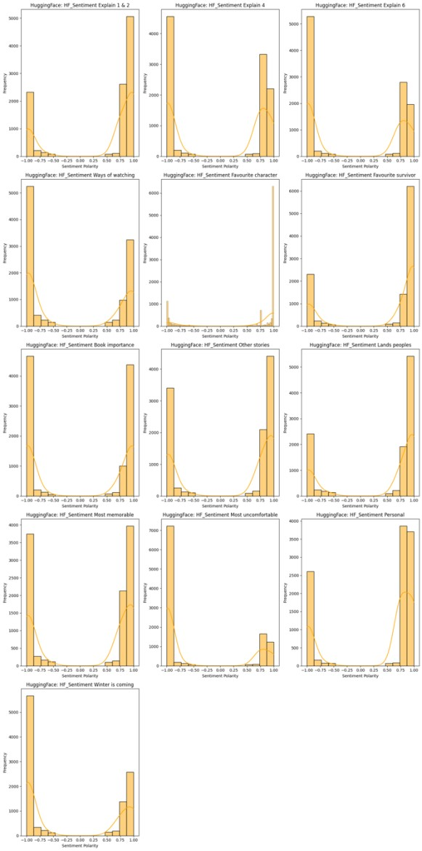

**Figure 9:** TextBlob and Transformer based results

Whereas the VADER sentiment (figure above) offers a more impartial view, with many opinions grouped around neutral sentiment. While there are still noticeable peaks at both the positive and negative ends, "example 1 & 2," "example 4," and "example 6" all have centre peaks around neutrality, suggesting some degree of polarisation. The VADER model reveals a largely favourable attitude about "Favourite character" and "Favourite survivor," with minor peaks at the neutral and negative ends, indicating that although viewers' sentiments are typically positive, there is still a spectrum of viewpoints. Positive attitudes are slightly more prevalent for qualities like "Book importance" and "Lands peoples," but neutrality still predominates.

In summary, a substantial degree of polarisation is shown by the transformer-based sentiment analysis, with notable peaks at both positive and negative ends, indicating sharply split viewer opinions. Though there are significant negative views as well, several subplots exhibit an apparent positive tilt. While the VADER analysis highlights the existence of different viewpoints among viewers, it also displays a mixture of neutral, positive, and negative attitudes with a dominant trend towards neutrality.

***4. Analysis & Comparison of Keyword Extraction Techniques: TF-IDF, Yake, and KeyBERT***

When keyword extraction techniques are compared, it becomes clear that each has unique advantages and disadvantages. TF-IDF effectively locates important single words in a document, such "watch," "Tyrion," and "battle." It can't, however, grasp the contextual links between words, which leads to a shallower comprehension of the text.

Yake on the other hand, provides a richer contextual knowledge than just single words by extracting significant phrases like "binge watch," "Jon snow," and "red wedding,". Although Yake requires more computational power than TF-IDF, it offers deeper insights into the substance of the document. By extracting the semantic context of words, KeyBERT (which makes use of BERT embeddings) improves keyword extraction even further and produces highly relevant results like "avoid rewatching episodes" and "hodor death emotional."

KeyBERT is the most computationally demanding and slowest approach, but it produces accurate and contextually rich keywords, which makes it perfect for experiments requiring a sophisticated comprehension of the text.

***5. Column Similarity***

The similarity between columns was implemented using two different approaches: a TF-IDF based similarity approach and using sentence transformer (SBERT). A heatmap has been plotted of the similarity scores and compares both approaches.

From the figure below it can be seen there is significant overlap between "Favourite character" and "Most memorable" (0.568074), there is high resemblance (0.752171) between "Favourite character" and "Favourite survivor" (indicating overlapping conversations). Game of Thrones is intense, as seen by the similarity between "Most memorable" and "Most uncomfortable" (0.687543). Lesser parallels, like the one between "Favourite character" and "Other stories" (0.284922), draw attention to other subjects. In general, the matrix offers information on theme links and content overlap throughout the dataset.

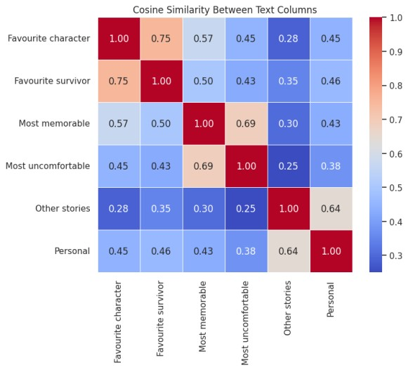

**Figure 10:** Cosine Similarity Between Text Columns

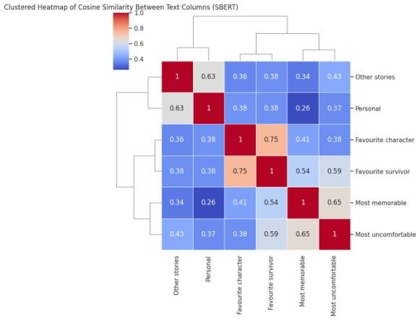

**Figure 11:** Clustering Heatmap of Cosine Similarity Between Text Columns

In summary, this section of the study outlines the techniques utilised to analyse viewer perspectives on Game of Thrones through preprocessing, sentiment analysis, exploratory data analysis (EDA), and keyword extraction. After extensive pre-processing to ensure data quality, the dataset was subjected to sentiment analysis using EDA. TextBlob, VADER, and a transformer-based model (BERT) were used to analyse sentiment. It was understood that, despite TextBlob's neutral trend, BERT indicated polarised feelings. When TF-IDF, Yake, and KeyBERT keyword extraction techniques were compared, it was found that KeyBERT produced the most contextually rich terms, despite having greater computing requirements. Additionally, despite emphasising the unique nature of other themes, column similarity analysis using TF-IDF and SBERT revealed thematic parallels, notably between talks on favourite personalities and memorable experiences.

## **V.CRITICAL EVALUATION, CONCLUSIONS & RECOMMENDATIONS**

1. ***Critical Evaluation:***

This study aimed to explore the findings of demographic factors on viewer sentiment based on a Game of Thrones dataset. This was done employed based on a mixed-method approach. By the use of traditional sentiment analysis (VADER) and the contemporary transformer-based models (BERT) provided a clear understanding of viewers opinions. A key strength of the study was the fact of connecting sentiment to demographic such as age, gender, social class and political views. This portrayed findings such as political views on commentary engagement. This mainly underlines the complex interplay between media content and viewer identity.

However, the complexity of deep learning such as BERT posed key challenges in interpreting the data, which hindered the clarity of some findings. Additionally, the dataset mainly focused on US, UK and Spain could have introduced some biases with the data patterns. With the deduction of certain demographic categories to prevent overfitting, which is necessary, also hindered a broader range of viewer sentiment.

In terms of ethical considerations, this study maintained a strict adherence to data protection, ensuring that privacy of the data was respected throughout the research process. The study was also conducted with clear awareness of potential biases and limitations, which were openly acknowledged in Section III of the dissertation. Nonetheless, the reliance of textual data, which can be subjective by linguistic and cultural factors, poses a challenge in ensuring the objectivity of the results. Future research could make sure that by employing various other data sources, it can tackle this challenge.

To finish, the study mainly succeeded in achieving its main objective. The sentiment analysis effectively categorised viewers sentiments as positive, negative, or neutral and the integration with demographic data uncovered significant trends in viewer perception. All in all, the study made significant strides in understanding the core relationship between demographics variable and viewers opinions towards Game of Thrones. Even with some minor limitations and hindrances in the data, the findings of the study contribute valuable insights to the fields of media analysis and provide a foundation to further research in the topic.

***B. Conclusions:***

This study offered a thorough grasp of these factors by utilising a combination of more sophisticated transformer-based models like BERT and more conventional sentiment analysis methods like VADER. The study assessed the efficacy of several sentiment analysis methodologies, identified trends in viewer perception, and correctly categorised sentiments.

The study's main objective was to investigate the connection between viewer attitude and demographics, was accomplished. According to sentimental research, viewers' perceptions and interactions with the series is mainly influenced by demographic parameters. Political opinions, for example, have been demonstrated to affect comments participation, portraying the vital relationship between media consumption and individual identity.

Additionally, the aim of categorising feelings and predicting sentiment outcomes using demographic variables was also accomplished. Nevertheless, although contrasting various sentiment analysis methods produced insightful data, the complexity of transformer-based models prevented a thorough investigation of their efficacy. This points forth a direction for further study to enhance the interpretability of refined sentiment analysis techniques.

***C. Recommendations:***

Based on the findings and the critical analysis, further research is needed which will aim to include more diverse set of geographical regions beyond the US, UK, and Spain. This would provide a broader cultural context and allow for enhanced findings. For example, adding viewers from Asia, Africa, and Latin America to the dataset may provide new perspectives on how cultural variations affect viewer attitude.

Secondly, clear need to for the research to attain data which focuses on other demographic variables, such income, ethnicity, and educational attainment. These variables may disclose further subtleties in the ways that various demographic groups see and interact with television programming.

In terms of the computational approaches, even though BERT have showcased key findings, interpretability is often limited by their complexity. Subsequent research should mainly concentrate on formulating or using methods that can make the results of these models more comprehensible and applicable. This could involve making use of other model-agnostic interpretability tools or developing simplified versions of these models that retain interpretability without sacrificing too much accuracy.

In terms of the interdisciplinary nature of the study, Media producers and marketers should consider using the insights gained from sentiment analysis to target content and marketing strategies to specific demographic groups. For instance, knowing how political opinions or viewers age bands may affect engagement can be useful when creating content that appeals to particular audience segments more, thereby raising viewer satisfaction and engagement.

Moreover, the study also presents a chance to create useful tools that media organisations may employ to assess audience opinion in real time. These technologies might incorporate many techniques for sentiment analysis, providing media practitioners with an easy-to-use interface to scale audience reactions and modify content strategy accordingly.

To conclude, these suggestions emphasise the significance of expanding the horizon of further research, refining methodological techniques, and implementing the results in useful ways that augment media creation and audience involvement. Future study into the topic can expand on the foundation established by this study by addressing these areas, which will result in more complex and useful findings in the field of media analysis.

***References:***

1. Dhiman, Dr. Bharat, A Paradigm Shift in the Entertainment Industry in the Digital Age: A

Critical Review (June 11, 2023). Available at SSRN: [http://dx.doi.org/10.2139/ssrn.4479247.](https://dx.doi.org/10.2139/ssrn.4479247)

1. Alexander Sergeant, Across the narrow screen: televisual world-building in Game of Thrones, Screen, Volume 62, Issue 2, Summer 2021, Pages193–213, <https://doi.org/10.1093/screen/hjab020>
2. Baruah S, Somandepalli K, Narayanan S. Representation of professions in entertainment media: Insights into frequency and sentiment trends through computational text analysis. PLoS One. 2022 May 18;17(5):e0267812. doi: 10.1371/journal.pone.0267812. PMID:

35584111; PMCID: PMC9116627.

1. Brown, M. (2024) *Sentiment analysis: Definition, tools, and use cases*, *Powermetrics*. Available: ttps://powermetrics.co.uk/blog/what-issentimentanalysis/#:~:text=Sentiment%20analysis%2C %20often%20called%20opinion,assign%20a %20specific%20sentiment%20score. (Accessed: 18 July 2024).
2. Nandwani P, Verma R. A review on sentiment analysis and emotion detection from text. Soc Netw Anal Min. 2021;11(1):81. doi:

10.1007/s13278-021-00776-6. Epub 2021 Aug

28. PMID: 34484462; PMCID: PMC8402961.

1. Alvi Q, Ali SF, Ahmed SB, Khan NA, Javed M, Nobanee H. On the frontiers of Twitter data and sentiment analysis in election prediction: a review. PeerJ Comput Sci. 2023 Aug 21;9:e1517. doi: 10.7717/peerj-cs.1517.

PMID: 37705657; PMCID: PMC10495957.

1. *Harnessing brand sentiment and the power of perception* (2023) *Qualtrics*. Available at: https://www.qualtrics.com/experiencemanagement/brand/brand-sentiment/ (Accessed: 18 July 2024).

1. Wankhade, M., Rao, A.C.S. & Kulkarni, C. A survey on sentiment analysis methods, applications, and challenges. *Artif Intell Rev* **55**, 5731–5780 (2022).

<https://doi.org/10.1007/s10462-022-10144-1>

1. Jamin Rahman Jim, Md Apon Riaz Talukder, Partha Malakar, Md Mohsin Kabir, Kamruddin Nur, M.F. Mridha, Recent advancements and challenges of NLP-based sentiment analysis: A state-of-the-art review, Natural Language Processing Journal, Volume 6, 2024,100059, ISSN 2949-7191, [https://doi.org/10.1016/j.nlp.2024.100059.](https://doi.org/10.1016/j.nlp.2024.100059)

1. Pragnya, S.S. (2022) *Vader (valence aware dictionary and sentiment reasoner) sentiment analysis*, *Medium*. Available at: https://swayanshu.medium.com/vadervalence-aware-dictionary-and-sentimentreasoner-sentiment-analysis-28251536698 (Accessed: 18 July 2024).

1. Bajaj, A. (2024) *Understanding human feelings with NLP and vader sentiment analysis*, *Analytics Vidhya*. Available at: https://www.analyticsvidhya.com/blog/2021/0 6/vader-for-sentiment-analysis/ (Accessed: 18 July 2024).

1. Ma, Y. (2020) *NLP: How does nltk.vader calculate sentiment?*, *Medium*. Available at: https://medium.com/@mystery0116/nlp-howdoes-nltk-vader-calculate-sentiment-

6c32d0f5046b (Accessed: 18 July 2024).

1. Benítez-Andrades JA, Alija-Pérez JM, Vidal ME, Pastor-Vargas R, García-Ordás MT. Traditional Machine Learning Models and Bidirectional Encoder Representations From Transformer (BERT)-Based Automatic Classification of Tweets About Eating Disorders: Algorithm Development and Validation Study. JMIR Med Inform. 2022 Feb 24;10(2):e34492. doi: 10.2196/34492. PMID:

35200156; PMCID: PMC8914746.

1. Ma, Y. (2020) *NLP: How does nltk.vader calculate sentiment?*, *Medium*. Available at: https://medium.com/@mystery0116/nlp-howdoes-nltk-vader-calculate-sentiment-

6c32d0f5046b (Accessed: 18 July 2024).

1. Saha, S., Showrov, M.I.H., Rahman, M.M., Majumder, M.Z.H. (2023). VADER vs. BERT: A Comparative Performance Analysis for Sentiment on Coronavirus Outbreak. In: Satu, M.S., Moni, M.A., Kaiser, M.S., Arefin,

M.S. (eds) Machine Intelligence and Emerging Technologies. MIET 2022. Lecture Notes of the Institute for Computer Sciences, Social Informatics and Telecommunications Engineering, vol 490. Springer, Cham. [https://doi.org/10.1007/978-3-031-346194_30](https://doi.org/10.1007/978-3-031-34619-4_30)

1. Bajaj, A. (2024) *Understanding human feelings with NLP and vader sentiment analysis*, *Analytics Vidhya*. Available at: https://www.analyticsvidhya.com/blog/2021/0 6/vader-for-sentiment-analysis/ (Accessed: 18 July 2024).

1. Santoniccolo F, Trombetta T, Paradiso

MN, Rollè L. Gender and Media

Representations: A Review of the Literature on Gender Stereotypes, Objectification and Sexualization. Int J Environ Res Public Health.

2023 May 9;20(10):5770. doi: 10.3390/ijerph20105770. PMID: 37239498; PMCID: PMC10218532.

1. Jost JT, Baldassarri DS, Druckman JN. Cognitive-motivational mechanisms of political polarization in social-communicative contexts. Nat Rev Psychol. 2022;1(10):560576. doi: 10.1038/s44159-022-00093-5. Epub 2022 Aug 1. PMID: 35937553; PMCID:

PMC9342595.

1. Liao CH. Exploring the Influence of Public Perception of Mass Media Usage and Attitudes towards Mass Media News on Altruistic Behavior. Behav Sci (Basel). 2023 Jul 26;13(8):621. doi: 10.3390/bs13080621.

PMID: 37622761; PMCID: PMC10451722.

1. T. Cooray, G. Perera, D. Chandrasena, J. Alosius and A. Kugathasan, "Aspect Based Sentiment Analysis for Evaluating Movies and TV series," *2020 2nd International Conference on Advancements in Computing (ICAC)*, Malabe, Sri Lanka, 2020, pp. 246-251, doi:

10.1109/ICAC51239.2020.9357129.

1. Abd. Samad Hasan Basari, Burairah Hussin, I. Gede Pramudya Ananta, Junta Zeniarja, Opinion Mining of Movie Review Using Hybrid Method of Support Vector Machine and Particle Swarm Optimization, Procedia Engineering, Volume 53, 2013, Pages 453-462, ISSN 1877-7058, [https://doi.org/10.1016/j.proeng.2013.02.059.](https://doi.org/10.1016/j.proeng.2013.02.059)
2. Peter D. Turney. 2002. Thumbs up or 10.7717/peerj-cs.967.

PMID: 35721401; thumbs down? semantic orientation

applied to PMCID: PMC9202614. unsupervised

classification of reviews. In Proceedings of the 40th

Annual Meeting on Association for Computational Linguistics

(ACL '02). Association for Computational

Linguistics, USA, 417–424.

<https://doi.org/10.3115/1073083.1073153>

1. Nowell, L. S., Norris, J. M., White, D. E., & Moules,

N. J. (2017). Thematic Analysis: Striving to Meet

the Trustworthiness Criteria. *International Journal of Qualitative*

*Methods*, *16*(1). [https://doi.org/10.1177/16094](https://doi.org/10.1177/1609406917733847)

[06917733847](https://doi.org/10.1177/1609406917733847)

1. Xiang Y, Du J, Fujimoto K, Li F, Schneider J, Tao C. Application of artificial intelligence and machine learning for HIV prevention interventions. Lancet HIV. 2022 Jan;9(1):e54-e62. doi: 10.1016/S23523018(21)00247-2. Epub 2021 Nov 8. PMID:

34762838; PMCID: PMC9840899.

1. Guo M, Wang Y, Yang Q, Li R, Zhao Y, Li C, Zhu M, Cui Y, Jiang X, Sheng S, Li Q, Gao R. Normal Workflow and Key Strategies for Data Cleaning Toward Real-World Data: Viewpoint. Interact J Med Res. 2023 Sep 21;12:e44310. doi: 10.2196/44310. PMID:

37733421; PMCID: PMC10557005.

1. Youvan, Douglas. (2024). Understanding Sentiment Analysis with VADER: A Comprehensive Overview and Application.

10.13140/RG.2.2.33567.98726.

1. Benítez-Andrades JA, Alija-Pérez JM, Vidal ME, Pastor-Vargas R, García-Ordás MT. Traditional Machine Learning Models and Bidirectional Encoder Representations From Transformer (BERT)-Based Automatic Classification of Tweets About Eating Disorders: Algorithm Development and Validation Study. JMIR Med Inform. 2022 Feb 24;10(2):e34492. doi: 10.2196/34492. PMID:

35200156; PMCID: PMC8914746.

1. Khan MQ, Shahid A, Uddin MI, Roman M, Alharbi A, Alosaimi W, Almalki J, Alshahrani SM. Impact analysis of keyword extraction using contextual word embedding.
2. PeerJ Comput Sci. 2022 May 30;8:e967. doi: 10.7717/peerj-cs.967. PMID: 35721401; PMCID: PMC9202614.

**Appendix 1:**

|  |  |  |
| --- | --- | --- |
| **S/No.** | **Supervisor’s feedback** | **Modifications made for the revised submission** |
|  | Lacks any consideration gap in literature, no clear research question or aim provided. | I have identified research gaps in the literature and formulated corresponding research questions. My research aim aligns closely with these questions. |
|  | SCRUM may not be the most suitable methodology for a solo machine learning project. While the paper mentions user stories and stakeholder meetings, these elements are not typically applicable in such a context. The absence of epics and sprints also suggests that a traditional SCRUM approach was not fully implemented. A more appropriate methodology for this type of project could be a standard data science lifecycle, including phases like data acquisition, preparation, exploration, modeling, refinement, and evaluation. | I have revised the research to align with a standard data science lifecycle. This includes data acquisition, preparation, EDA, modeling, experimentation, and evaluation, as per my supervisor’s guidance. |
|  | Exploratory data analysis was conducted, but the specific methods used, and their rationale were not provided. | I have revised the section on exploratory data analysis to provide a more detailed explanation of the techniques used and the reasons for their selection. |
|  | The research fails to provide a clear understanding of the approach taken, the results achieved, and the study's contribution to the broader field. There is no discussion of how the research question or aim was addressed, nor how the study fills a gap in existing knowledge. | I have revised the paper to provide more depth in terms of methodology, results, and critical reflection. I have also addressed the gaps in discussing how the research question and aim were met, and how the study contributes to the broader field of knowledge. |
|  | There is a discrepancy between the literature review and the actual research conducted. | I have carefully reviewed the paper and revised the sections to ensure a stronger connection between the literature review and the research methodology. The revised paper now demonstrates a clear alignment between the theoretical framework and the actual research conducted. |
|  | The literature review should include a more detailed explanation of the rationale and justification for the chosen approaches. | I have revised the literature review to provide a more detailed explanation of the rationale and justification for the chosen approaches. |
|  | The literature review should be updated to reflect the specific focus of your ongoing work. | I have revised the literature review to ensure it aligns more closely with the current scope of my research. |