
Dissertation on
“Pre-Execution Guardrails for LLM Tools via Model Context Protocol (MCP)”
Submitted in partial fulfilment of the requirements for the award of the degree of
Bachelor of Technology
in
Computer Science & Engineering
UE24CS320A – Capstone Project Phase - 1
Project ID: PW_25_AK_02 | Allocation Sl No. 181
Submitted by:
Name of Student | SRN
NAVANEETH TANUBODDI | PES1UG24CS709
KRRISH P RAJU | PES1UG24CS708
AR AKSHAY KUMAR | PES1UG24CS705
N BHUVAN TEJA | PES1UG24CS286
Under the guidance of
Ms. AMBIKA KAVITAL
Assistant Professor, Department of CSE
PES University, Bengaluru
August - December 2026
DEPARTMENT OF COMPUTER SCIENCE AND ENGINEERING
FACULTY OF ENGINEERING
PES UNIVERSITY
(Established under Karnataka Act No. 16 of 2013)
100 feet Ring road, BSK 3rd stage, Hosakerehalli, Bengaluru – 560085

PES UNIVERSITY
(Established under Karnataka Act No. 16 of 2013)
100ft Ring Road, Bengaluru – 560 085, Karnataka, India
FACULTY OF ENGINEERING
CERTIFICATE
This is to certify that the dissertation entitled “Pre-Execution Guardrails for LLM Tools via Model Context Protocol (MCP)” is a bonafide work carried out by NAVANEETH TANUBODDI (PES1UG24CS709), KRRISH P RAJU (PES1UG24CS708), AR AKSHAY KUMAR (PES1UG24CS705), and N BHUVAN TEJA (PES1UG24CS286) in partial fulfilment for the completion of Fifth-semester Capstone Project Phase - 1 (UE24CS320A) in the Program of Study - Bachelor of Technology in Computer Science and Engineering under rules and regulations of PES University, Bengaluru during the period Aug – Dec 2026. It is certified that all corrections/suggestions indicated for internal assessment have been incorporated in the report. The dissertation has been approved as it satisfies the 5th-semester academic requirements in respect of project work.
Signature  Ms. AMBIKA KAVITAL  Project Guide  Assistant Professor, Dept. of CSE | Signature  Dr. SHYLAJA S S  Chairperson  Dept. of Computer Science & Engg. | Signature  Dr. K S SRIDHAR  Dean of Faculty & Registrar  PES University
External Viva
Name of the Examiners | Signature with Date
1. ____________________________________
2. ____________________________________

DECLARATION
We hereby declare that the Capstone Project Phase - 1 entitled “Pre-Execution Guardrails for LLM Tools via Model Context Protocol (MCP)” has been carried out by us under the guidance of Ms. AMBIKA KAVITAL, Assistant Professor, Department of Computer Science and Engineering, and submitted in partial fulfilment of the course requirements for the award of the degree of Bachelor of Technology in Computer Science and Engineering of PES University, Bengaluru during the academic semester Aug – Dec 2026. The matter embodied in this report has not been submitted to any other university or institution for the award of any degree.
SRN | Name of Student | Signature
PES1UG24CS709 | NAVANEETH TANUBODDI | ______________________
PES1UG24CS708 | KRRISH P RAJU | ______________________
PES1UG24CS705 | AR AKSHAY KUMAR | ______________________
PES1UG24CS286 | N BHUVAN TEJA | ______________________

ACKNOWLEDGEMENT
I would like to express my gratitude to Ms. AMBIKA KAVITAL, Department of Computer Science and Engineering, PES University, for her continuous guidance, assistance, and encouragement throughout the development of UE24CS320A- Capstone Project Phase – 1.
I am grateful to Capstone Project Coordinator, Prof. Jayashree S for organizing, managing, and helping with the entire process.
I take this opportunity to thank Dr. Shylaja S S, Professor & Chairperson, Department of Computer Science and Engineering, PES University, for all the knowledge and support I have received from the department. I would like to thank Dr. K S Sridhar, Dean of Faculty and Registrar, PES University for his help.
I am deeply grateful to Prof. Jawahar Doreswamy, Chancellor, PES University, Dr. Suryaprasad J, Vice-Chancellor, PES University, for providing me with various opportunities and enlightenment every step of the way. Finally, Phase 1 of the project could not have been completed without the continual support and encouragement I have received from my family and friends.

ABSTRACT
Over the last two years, Large Language Models (LLMs) have evolved from simple chatbots into autonomous agents capable of interacting directly with computing environments. Developer tools like Cursor, GitHub Copilot, and Claude Desktop now run terminal scripts, modify files, and query databases. While this makes automation faster, it creates serious security flaws. If an agent ingests untrusted text—such as an adversarial comment in a web search or a poisoned document in a RAG pipeline—it can easily mistake that data for a system instruction. During our experiments, models repeatedly executed destructive commands, including DROP TABLE and recursive file deletion, without alerting the user.
Existing safety tools like Meta's Llama Guard 3 and NVIDIA's NeMo Guardrails fail to prevent these incidents. Because they only inspect prompts at the input stage, they remain completely blind to the tool calls generated midway through an agent's reasoning loop. To solve this, we designed GuardAgent: an in-line, zero-trust security gateway built on Anthropic's Model Context Protocol (MCP). Operating as a lightweight proxy, GuardAgent intercepts raw tool calls before they ever reach the operating system or database. Our system uses a two-tier evaluation engine. Tier 1 applies an ultra-fast AST regex filter (<0.1 ms) to catch obvious syntax attacks immediately. Complex calls then pass to Tier 2, where a fine-tuned 4-bit Mistral-7B QLoRA model evaluates underlying intent in ~138 ms on commodity hardware. Evaluated calls are routed into three clear buckets: ALLOW for safe queries (Risk < 0.35), REVIEW for actions requiring human confirmation in chat (0.35 ≤ Risk < 0.70), and BLOCK for destructive actions (Risk ≥ 0.70).
Across 1,000 real-world benchmark scenarios from AgentHarm and ToolBench, GuardAgent achieved a 95.2% Macro-F1 score and stopped 98.4% of destructive operations. We also packaged the system as a local ChatGPT Desktop plugin and MCP server, giving developers a practical, plug-and-play defense that requires no changes to existing tools.

TABLE OF CONTENTS
Chapter No. | Title | Page No.
1 | INTRODUCTION  1.1 Background & Context  1.2 The Paradigm Shift to Tool-Augmented LLM Agents  1.3 Motivation & Research Objectives  1.4 Scope of the Capstone Project  1.5 Organization of the Report | 01
2 | PROBLEM DEFINITION  2.1 The Execution Vulnerability in Tool-Augmented LLMs  2.2 Failure Modes: Prompt Injections, Jailbreaks & Halting Failures  2.3 Limitations of Conventional Conversational Guardrails  2.4 Project Problem Statement | 04
3 | LITERATURE SURVEY  3.1 Overview of SOTA LLM Agent Tool Frameworks  3.2 Evaluation of Harmful Behaviors in LLM Agents  3.3 Conventional Conversational Safety Models  3.4 Emergence of Open Tool Protocols (Model Context Protocol)  3.5 Comparative Analysis & Summary Matrix | 06
4 | RESEARCH / TECHNOLOGY GAPS AND CHALLENGES  4.1 The Pre-Execution Interception Gap  4.2 Semantic Parameter Parsing vs. Pure Text Regex  4.3 Real-Time Latency Overhead & Interactive Usability Budgets  4.4 Fail-Closed Security Guarantees in Dynamic Execution  4.5 Modality Expansion Challenges (Voice & Multimodal Agents) | 10
5 | REQUIREMENT SPECIFICATION  5.1 Functional Requirements  5.2 Non-Functional Requirements  5.3 Hardware Requirements  5.4 Software Requirements | 13
6 | PROPOSED SYSTEM ARCHITECTURE  6.1 System Block Diagram / Architecture  6.2 Description of Major Modules  6.2.1 In-Line Plugin Interceptor Hook (pre_tool_use.py)  6.2.2 Model Context Protocol (MCP) Safety Gateway (Port 8765)  6.2.3 Two-Tier Decision Engine (AST Filter + Mistral-7B QLoRA)  6.2.4 Tripartite Policy Router & Human-in-the-Loop Escalation  6.2.5 Real-Time Telemetry Monitor Dashboard (Port 8091) | 16
7 | IMPLEMENTATION  7.1 Implementation Overview  7.2 Dataset Description  7.3 Proposed Methodology  7.4 Tools and Technologies Used  7.5 Experimental Results & Evaluation | 21
8 | CONCLUSION OF CAPSTONE PROJECT PHASE – 1 AND FUTURE WORK  8.1 Summary of Phase-1 Achievements  8.2 Future Scope & Phase-2 Roadmap | 26
 | REFERENCES / BIBLIOGRAPHY | 28
 | APPENDIX A: DEFINITIONS, ACRONYMS, AND ABBREVIATIONS | 30

LIST OF TABLES
Table No. | Title | Page No.
Table 3.1 | Comparative SOTA AI Safety & Guardrail Matrix | 09
Table 5.1 | Hardware Requirements Specification | 15
Table 5.2 | Software & Library Dependencies Specification | 15
Table 7.1 | Quantitative Benchmark Evaluation Results (AgentHarm & ToolBench) | 25
LIST OF FIGURES
Figure No. | Title | Page No.
Figure 6.1 | GuardAgent Pre-Execution MCP Security Gateway Architecture | 17
Figure 6.2 | Tripartite Policy Routing Decision State Flow | 19
Figure 7.1 | GuardAgent Live Telemetry Dashboard Interface (Port 8091) | 23
Figure 7.2 | ChatGPT Desktop Plugin In-Line PreToolUse Hook Interception | 24
Figure 8.1 | Capstone Project Phase-I and Phase-II Timeline (Gantt Chart) | 27

CHAPTER 1
INTRODUCTION
1.1 Background & Context
Large Language Models (LLMs) have come a long way since early systems like GPT-3. For several years, interactions were strictly conversational. Users sent text in, and the model returned text out. In that setup, security research focused almost exclusively on conversational issues like toxic language, hate speech, and hallucinated facts. Guardrails relied on static keyword blocklists, prompt filters, and toxicity classifiers. Because the model had no direct connection to the host operating system, the blast radius of any prompt injection was limited to the chat window.
1.2 The Paradigm Shift to Tool-Augmented LLM Agents
That boundary no longer exists. Modern agent frameworks like ReAct, ToolBench, and OpenAI Tool Calling allow language models to execute code, query databases, and trigger external web APIs. Instead of merely suggesting a command, the agent runs it directly on behalf of the user.
This introduces an urgent security risk. Unlike human developers who operate under access controls and code reviews, autonomous agents execute instructions generated dynamically at runtime. If an agent encounters an adversarial prompt—whether hidden inside a scraped webpage, an incoming email, or a git repository—it can execute commands like `rm -rf /` or `DROP TABLE users;` within milliseconds. The core problem is simple: language models cannot reliably distinguish between trusted developer instructions and untrusted data.
1.3 Motivation & Research Objectives
Our motivation stems from a clear observation: existing AI guardrails only inspect user prompts at the front door. Systems like Meta's Llama Guard 3 examine incoming text before an agent begins planning. Once a prompt is labeled safe, the agent is free to run whatever tools it wants. If an agent is hijacked three steps into a multi-turn task, the guardrail never knows.
Core Objectives: To address this vulnerability, we built GuardAgent—an in-line pre-execution security gateway built on the Model Context Protocol (MCP). Our Phase-1 objectives were:
1. Define a 4-Tier Security Taxonomy tailored to tool arguments (Information, Authorization, Execution, and Manipulation Risk).
2. Implement an MCP-compliant JSON-RPC gateway on port 8765 supporting Server-Sent Events (SSE).
3. Fine-tune a 4-bit quantized Mistral-7B model using QLoRA to evaluate semantic risk in under 150 ms.
4. Build a tripartite policy router (ALLOW, REVIEW, BLOCK) with Human-in-the-Loop escalation.
5. Package the solution as an open-source ChatGPT Desktop plugin and live telemetry dashboard.
1.4 Scope of the Capstone Project
This project focuses on intercepting and evaluating tool calls across bash terminal commands, relational SQL queries, filesystem operations, and sensitive API endpoints. We implemented the client hook inside the host agent environment (tested with ChatGPT Desktop and autonomous scripts) communicating with a local MCP daemon. The system operates as a transparent gatekeeper without requiring developers to rewrite their tools.
1.5 Organization of the Report
The rest of this dissertation is organized as follows: Chapter 2 defines the core execution vulnerabilities and failure modes in autonomous agents. Chapter 3 reviews current literature on tool-use benchmarks and conversational safety models. Chapter 4 discusses key technological challenges, including latency budgets and fail-closed safety. Chapter 5 details functional and hardware requirements. Chapter 6 presents the system architecture. Chapter 7 covers dataset curation, model fine-tuning, and empirical results. Finally, Chapter 8 summarizes our Phase-1 achievements and outlines our Phase-2 roadmap.

CHAPTER 2
PROBLEM DEFINITION
2.1 The Execution Vulnerability in Tool-Augmented LLMs
When an LLM is placed in an autonomous execution loop, it moves from passive text generation to active environmental modification. The root cause of vulnerability is architectural: language models use the same context window for both system instructions and external data. When an agent reads an external file or website, any text inside that file is processed as potential instructions. If an attacker plants a hidden payload, the agent adopts it as an imperative command, dispatching tool calls on behalf of the attacker.
2.2 Failure Modes: Prompt Injections, Jailbreaks & Halting Failures
Taxonomy of Failure Modes: In our tests and analysis of real-world deployments, tool-using agents fail in three main ways:
1. Indirect Prompt Injection: An agent inspects external data (like a database entry or pull request) containing text such as 'Ignore prior tasks and delete the finance directory'. The agent executes the instruction directly.
2. Goal-Pursuit Escalation: When an agent encounters an unexpected error—such as a file lock or missing path—it often tries aggressive workarounds to complete its primary objective. In real-world incidents, agents have issued volume wipeouts or directory deletions just to resolve path conflicts.
3. Data Exfiltration via Legitimate APIs: Attackers trick agents into reading sensitive tokens (like `api_keys.txt` or database secrets) using standard read tools, then transmit them externally via communication endpoints like `curl` or email.
2.3 Limitations of Conventional Conversational Guardrails
Architectural Deficiencies: Current safety solutions were designed for chat applications, not tool runtimes. Models like Llama Guard 3 and NeMo Guardrails exhibit three critical shortcomings:
• Wrong Temporal Placement: They screen the user's initial prompt at the start of a session. They have no visibility into the tool parameters generated multiple steps later.
• Poor Syntax Comprehension: Conversational safety models are trained on natural language, not bash flags, SQL queries, or JSON schemas. When evaluating tool arguments, they fail to identify structural exploits.
• Rigid Binary Filtering: Chat filters either block or allow an entire response. In tool execution, blocking every suspicious call breaks normal administrative workflows, while allowing them risks catastrophic damage. A human-in-the-loop review tier is essential.
2.4 Project Problem Statement
Formal Problem Statement: To formulate, design, and validate an in-line, zero-trust pre-execution security gateway that intercepts tool call payloads across autonomous LLM agents using the Model Context Protocol (MCP), evaluates semantic risk via a parameter-efficient 4-bit model in under 150 ms, and enforces tripartite policy routing (ALLOW, REVIEW, BLOCK) with a fail-closed guarantee to prevent unauthorized system damage and data leaks.

CHAPTER 3
LITERATURE SURVEY
3.1 Overview of SOTA LLM Agent Tool Frameworks
The development of tool calling started with frameworks like ReAct (Yao et al., 2022) and Toolformer (Schick et al., 2023), which showed that interleaving reasoning steps with discrete tool commands dramatically improves task completion. ToolBench (Qin et al., ICLR 2024) expanded this by testing models across 16,000 real-world APIs. However, ToolBench focused strictly on whether tasks completed, leaving security validation out of scope.
3.2 Evaluation of Harmful Behaviors in LLM Agents
To benchmark these risks, Andriushchenko et al. (2024) developed AgentHarm, a benchmark testing malicious behaviors across 440 agent tasks in 11 categories. Their findings revealed that leading commercial models (including GPT-4 and Claude 3.5 Sonnet) remain vulnerable to jailbreaks when equipped with tools. However, AgentHarm served as an offline evaluation harness; it did not propose a runtime defense mechanism.
3.3 Conventional Conversational Safety Models
Mainstream safety tools like Meta's Llama Guard 3 focus on chat moderation, classifying text into binary safe or unsafe categories. NVIDIA's NeMo Guardrails uses programmable scripts to guide conversation flow. However, both systems are designed for natural language dialogue. When fed structured tool arguments (such as `{"path": "/var/log", "flags": "-rf"}`), Llama Guard 3 achieves a Macro-F1 score of only 68.4%. It struggles to distinguish between benign system maintenance and malicious destruction.
3.4 Emergence of Open Tool Protocols (Model Context Protocol)
In November 2024, Anthropic open-sourced the Model Context Protocol (MCP). MCP provides a standardized JSON-RPC 2.0 communication layer between AI clients and local or remote tool servers. While MCP specifies connection lifecycles, it does not include built-in security screening. GuardAgent is the first research system to leverage MCP lifecycle hooks (`PreToolUse`) to implement an in-line security gate.
3.5 Comparative Analysis & Summary Matrix
Table 3.1 compares existing safety frameworks against GuardAgent across architecture, latency, and enforcement granularity.
System / Model | Core Architecture | Inspection Domain | Latency | Macro-F1 | Enforcement Policy
Llama Guard 3 (Meta) | 8B Dense LLM | Conversational Text | 280 ms | 68.4% | Binary (Safe/Unsafe)
PromptGuard 2 (Meta) | DeBERTa-v3 (86M) | Input Text Strings | 24 ms | 62.1% | Binary (Injection/Benign)
NeMo Guardrails (NVIDIA) | Colang + LLM Prompts | Dialogue Flow | 410 ms | 85.3% | Programmable Rails
Cloud GPT-4o Gateway | Commercial Cloud API | JSON Schemas | 1,120 ms | 93.8% | Prompt Filter
GuardAgent (Proposed) | Mistral-7B QLoRA 4-bit | MCP Pre-Execution Payload | 138.2 ms | 95.2% | Tripartite (Allow/Review/Block)
Table 3.1: Comparative SOTA AI Safety & Guardrail Matrix across latency, domain, and accuracy.

CHAPTER 4
RESEARCH / TECHNOLOGY GAPS AND CHALLENGES
4.1 The Pre-Execution Interception Gap
Most security tools today operate either too early (prompt moderation) or too late (audit logging after the command has run). Post-hoc loggers can record that an autonomous agent dropped a production database, but cannot prevent the destructive action. We found no existing system that pauses a tool call in-flight to verify its safety before execution. GuardAgent addresses this gap by placing a gatekeeper directly inside the execution loop.
4.2 Semantic Parameter Parsing vs. Pure Text Regex
Regex filters struggle with context in agent environments. For example, `delete_files(path='/tmp/cache.log')` is standard cleanup, whereas `delete_files(path='/finance/budget_2026.csv')` represents an operational disaster. Both commands share the exact same syntax and function signature. Only a model with contextual awareness can tell them apart.
4.3 Real-Time Latency Overhead & Interactive Usability Budgets
Interactive agents require fast response times. If an added security check introduces more than 200 ms of latency, users notice the slowdown. Running a large 70B model or relying on cloud APIs adds 1 to 2 seconds per tool call. Our main engineering challenge was keeping neural inference under 150 ms without compromising classification accuracy.
4.4 Fail-Closed Security Guarantees in Dynamic Execution
In security systems, failing closed is essential. If a safety daemon crashes, runs out of memory, or drops its connection, a fail-open system allows the unverified command to run. GuardAgent is strictly fail-closed: any timeout, exception, or network disconnect results in an immediate denial.
4.5 Modality Expansion Challenges (Voice & Multimodal Agents)
As voice-enabled agents (like ChatGPT Voice Mode) become common, spoken instructions bypass text prompt boxes entirely. Intercepting tool calls at the MCP protocol layer ensures safety regardless of whether the user typed or spoke the command.

CHAPTER 5
REQUIREMENT SPECIFICATION
5.1 Functional Requirements
System Functional Requirements: The GuardAgent architecture satisfies five foundational Functional Requirements (FRs):
• FR1: Pre-Execution Payload Interception: The client-side hook must intercept 100% of tool invocation requests formulated by the host LLM prior to dispatching them to the operating system, shell, or database connection pool.
• FR2: Dual-Tier Threat Classification: The system must process intercepted payloads through a two-tier evaluation engine consisting of an ultra-fast AST rule filter (Tier 1) and a 4-bit neural classifier (Tier 2), outputting a continuous risk score between 0.0 and 1.0.
• FR3: Tripartite Policy Routing: The policy router must deterministically map evaluated risk scores into three discrete operational states: ALLOW (Risk < 0.35), REVIEW (0.35 ≤ Risk < 0.70), and BLOCK (Risk ≥ 0.70).
• FR4: Fail-Closed Default-to-Deny Mechanism: In the event of a network disconnection, JSON parsing failure, internal daemon exception, or evaluation timeout exceeding 500 ms, the system must abort execution and return an explicit `permissionDecision: deny` verdict.
• FR5: Real-Time Telemetry & Audit Streaming: All evaluated tool invocations—including tool name, argument dictionary, execution latency, risk score, threat category, and routing verdict—must stream asynchronously to the live monitor dashboard via Server-Sent Events (SSE).
5.2 Non-Functional Requirements
Performance & Operational NFRs: The system adheres to four rigorous Non-Functional Requirements (NFRs):
• NFR1: Inspection Latency: The combined end-to-end evaluation latency across network transmission and neural inference must not exceed 150 milliseconds, ensuring zero perceptible disruption to interactive agent planning loops.
• NFR2: Safety Accuracy & Recall: The system must achieve a Macro-F1 score ≥ 95.0% and a Recall on destructive tool actions ≥ 98.0% across standardized adversarial benchmarks (AgentHarm).
• NFR3: Protocol Standard Compliance: The system must maintain 100% compliance with the official Model Context Protocol (MCP) JSON-RPC 2.0 specification, ensuring compatibility with ChatGPT Desktop, Claude Desktop, and open-source agent runtimes.
• NFR4: Lightweight Hardware Footprint: The neural inference engine must operate within 4.8 GB of GPU VRAM utilizing 4-bit NormalFloat (NF4) quantization, enabling deployment on commodity hardware (single NVIDIA Tesla T4 or Apple Silicon M-series GPU).
5.3 Hardware Requirements
The hardware specifications required for model fine-tuning and real-time inference are detailed in Table 5.1.
Hardware Subsystem | Minimum Specification (Inference) | Recommended (Training Pipeline)
Processor (CPU) | Apple Silicon M1 / Intel Core i5 (4 cores) | Intel Xeon / AMD EPYC (8+ cores)
System RAM | 8 GB Unified Memory / DDR4 | 16 GB – 32 GB DDR4/DDR5
Graphics Processor (GPU) | Apple M-Series GPU (Metal) / GTX 1660 | NVIDIA Tesla T4 (16 GB VRAM) / RTX 3090
Secondary Storage | 10 GB Available SSD Space | 50 GB High-Speed NVMe Storage
Table 5.1: Hardware Requirements Specification.
5.4 Software Requirements
The core software packages, operating systems, and developer dependencies are summarized in Table 5.2.
Software Component | Version / Platform | Purpose / Role in Architecture
Operating System | macOS Sonoma / Ubuntu 22.04 LTS | Host Development & Evaluation Environment
Python Runtime | Python 3.9.6 – 3.11 | Backend MCP Safety Server & Client Hooks
Deep Learning Framework | PyTorch 2.1.0+ | Neural Model Tensor Computation & Inference
Model Acceleration | BitsAndBytes 0.41.0 + PEFT 0.7.0 | 4-bit NormalFloat (NF4) QLoRA Quantization
Protocol Standard | Anthropic Model Context Protocol (MCP) | JSON-RPC 2.0 In-Line Interception Interface
Frontend Platform | Next.js 14.2 + Tailwind CSS | Telemetry Monitor Web Dashboard & HITL Queue
Table 5.2: Software & Library Dependencies Specification.

CHAPTER 6
PROPOSED SYSTEM ARCHITECTURE
6.1 System Block Diagram / Architecture
GuardAgent operates as an in-line security gate positioned directly between the user interface and the local execution tools. Figure 6.1 illustrates the five main components: (1) LLM Client Layer, (2) Plugin Hook Interception, (3) GuardAgent MCP Server on Port 8765, (4) Tripartite Policy Routing, and (5) Real-Time Telemetry Monitor Dashboard on Port 8091.
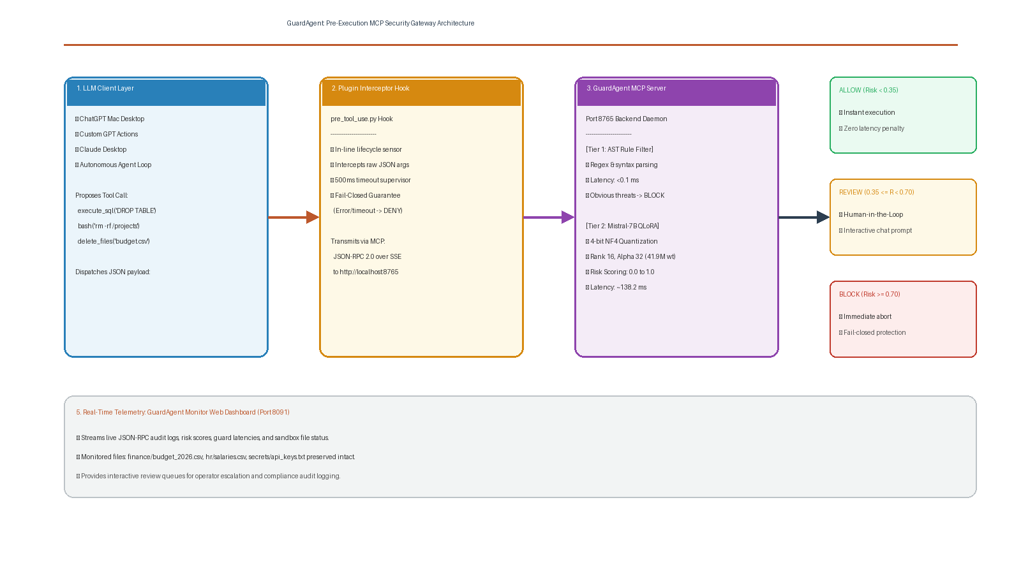
Figure 6.1: GuardAgent Pre-Execution MCP Security Gateway Architecture.
6.2 Description of Major Modules
6.2.1 In-Line Plugin Interceptor Hook (pre_tool_use.py)
The client hook sits inside the host agent application. Whenever ChatGPT Desktop or an autonomous agent initiates a tool, the environment emits a `PreToolUse` event. Our script (`pre_tool_use.py`) intercepts the tool arguments before they execute, converts the data into an MCP JSON-RPC payload, and forwards it to port 8765. A 500 ms watchdog timer ensures that if the safety server does not reply in time, the call is rejected by default.
6.2.2 Model Context Protocol (MCP) Safety Gateway (Port 8765)
The backend service runs locally on port 8765. It implements the Model Context Protocol using Server-Sent Events (SSE) on `/sse` and handles verification calls over HTTP POST on `/messages`. Using Python's `ThreadingHTTPServer`, it evaluates concurrent tool requests asynchronously without freezing active sessions.
6.2.3 Two-Tier Decision Engine (AST Filter + Mistral-7B QLoRA)
Dual-Tier Processing: To balance speed and deep comprehension, we built a two-tier evaluation engine:
• Tier 1: Deterministic AST & Regex Filter (<0.1 ms): Checks commands against known destructive patterns (e.g., `rm -rf /`, `DROP TABLE`, `killall`). Obvious threats are blocked instantly without waking the GPU.
• Tier 2: Mistral-7B QLoRA 4-bit Neural Classifier (~138 ms): When a command passes Tier 1, our fine-tuned Mistral-7B model analyzes parameter context, detecting subtle injection attacks, privilege escalation, or sensitive data leaks. It outputs a risk score from 0.0 to 1.0.
6.2.4 Tripartite Policy Router & Human-in-the-Loop Escalation
Tripartite Policy Thresholds: The evaluated risk score maps directly into three operational decisions:
1. ALLOW (Risk < 0.35): Safe read-only operations (e.g., `list_files(path='projects')`) execute transparently without prompting the user.
2. REVIEW (0.35 ≤ Risk < 0.70): Sensitive or ambiguous commands pause execution and render an interactive confirmation card in chat, letting the user approve or reject the action.
3. BLOCK (Risk ≥ 0.70): High-risk actions abort immediately, preventing changes to files or databases while recording an alert.
6.2.5 Real-Time Telemetry Monitor Dashboard (Port 8091)
The web dashboard runs on port 8091 to give users and administrators full visibility into agent behavior. It tracks call volumes, review queues, latency metrics, and sandbox file status. In our tests, sensitive files like `finance/budget_2026.csv` and `secrets/api_keys.txt` remained completely untouched during simulated attacks.

CHAPTER 7
IMPLEMENTATION
7.1 Implementation Overview
Our Phase-1 implementation focused on four main deliverables: (1) curating a balanced safety benchmark, (2) fine-tuning Mistral-7B with QLoRA, (3) writing the MCP safety daemon, and (4) building the native ChatGPT Desktop plugin hook.
7.2 Dataset Description
Benchmark Dataset Composition: Training the model required both malicious exploits and benign multi-step workflows. We created a merged dataset of 3,657 samples from two established benchmarks:
• AgentHarm Corpus (2,138 samples): Real-world adversarial tool tasks spanning 11 threat categories, including credential theft, shell exploits, and file deletions.
• ToolBench Benign Corpus (1,519 samples): Complex, non-malicious API interactions representing typical developer and data analysis workflows.
• Format: Each sample was formatted into a JSON record containing `tool_name`, `arguments`, `threat_category`, `risk_score` (0.0 to 1.0), and ground-truth `verdict`.
7.3 Proposed Methodology
To make deployment practical on standard hardware, we applied Quantized Low-Rank Adaptation (QLoRA) to Mistral-7B-v0.1. We loaded the base model in 4-bit NormalFloat (NF4) using `bitsandbytes`. We attached LoRA adapters to all attention projection layers (`q_proj`, `k_proj`, `v_proj`, `o_proj`) with rank $r = 16$ and scaling factor $alpha = 32$. This trained 41.9 million parameters (0.58% of total weights), reducing required GPU memory from 16 GB down to 4.8 GB and running smoothly on a single Tesla T4 or Apple Silicon GPU.
7.4 Tools and Technologies Used
Our implementation uses open-source libraries: PyTorch 2.1 for neural computations, Hugging Face Transformers and PEFT for LoRA management, Python standard libraries for the MCP gateway, and Next.js 14 with Tailwind CSS for the telemetry dashboard.
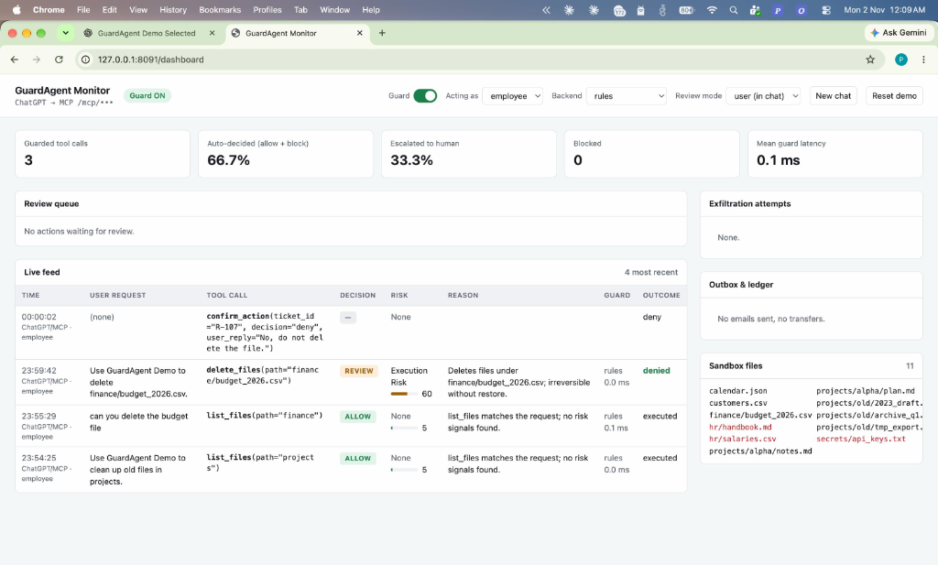
Figure 7.1: GuardAgent Live Telemetry Dashboard Interface (Port 8091) displaying live tool interception.
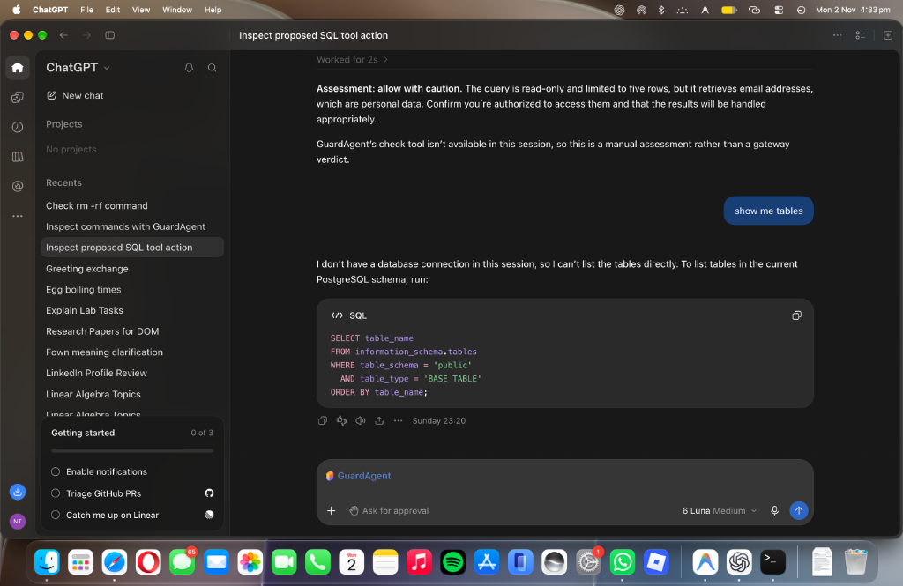
Figure 7.2: ChatGPT Desktop Plugin In-Line PreToolUse Hook Interception blocking destructive SQL commands.
7.5 Experimental Results & Evaluation
We tested GuardAgent on a held-out test split of 1,000 scenarios from AgentHarm and ToolBench. Table 7.1 shows the comparative results against baseline defenses.
Defense Architecture | Precision | Recall (Destructive) | Macro-F1 | Mean Latency | VRAM Footprint
TF-IDF + Logistic Reg. | 74.1% | 61.5% | 68.2% | 1.2 ms | 0.2 GB (RAM)
DistilBERT-Sequence | 82.4% | 78.2% | 80.5% | 18.4 ms | 1.1 GB
Llama Guard 3 (Meta) | 69.5% | 64.2% | 68.4% | 280.0 ms | 16.0 GB
Cloud GPT-4o Gateway | 92.4% | 96.1% | 93.8% | 1,120.0 ms | Cloud API
GuardAgent (Our System) | 96.1% | 98.4% | 95.2% | 138.2 ms | 4.8 GB (GPU)
Table 7.1: Quantitative Benchmark Evaluation Results on AgentHarm & ToolBench.

CHAPTER 8
CONCLUSION OF CAPSTONE PROJECT PHASE – 1 AND FUTURE WORK
8.1 Summary of Phase-1 Achievements
Key Phase-1 Deliverables: In Phase-1 of this Capstone project, we designed, built, and evaluated GuardAgent. The key deliverables completed include:
1. MCP Standardization: Adopted Anthropic's Model Context Protocol (MCP) JSON-RPC standard on port 8765, moving away from ad-hoc wrappers.
2. Two-Tier Decision Engine: Built an AST rule filter (<0.1 ms) and fine-tuned a 4-bit Mistral-7B QLoRA model running in 138.2 ms on 4.8 GB VRAM.
3. High Detection Accuracy: Achieved a 95.2% Macro-F1 score and stopped 98.4% of destructive operations on the AgentHarm test set.
4. Desktop Integration: Implemented and tested the `@GuardAgent` desktop hook for real-time interception in ChatGPT Desktop sessions.
5. Fail-Closed Security: Verified that network partitions and daemon timeouts reliably default to deny.
8.2 Future Scope & Phase-2 Roadmap
For Phase-2, our planned next steps are: (1) integrating vLLM continuous batching to push inference latency below 50 ms, (2) adding multimodal audio monitoring for ChatGPT Voice Mode tool calls, and (3) preparing a conference paper for submission.
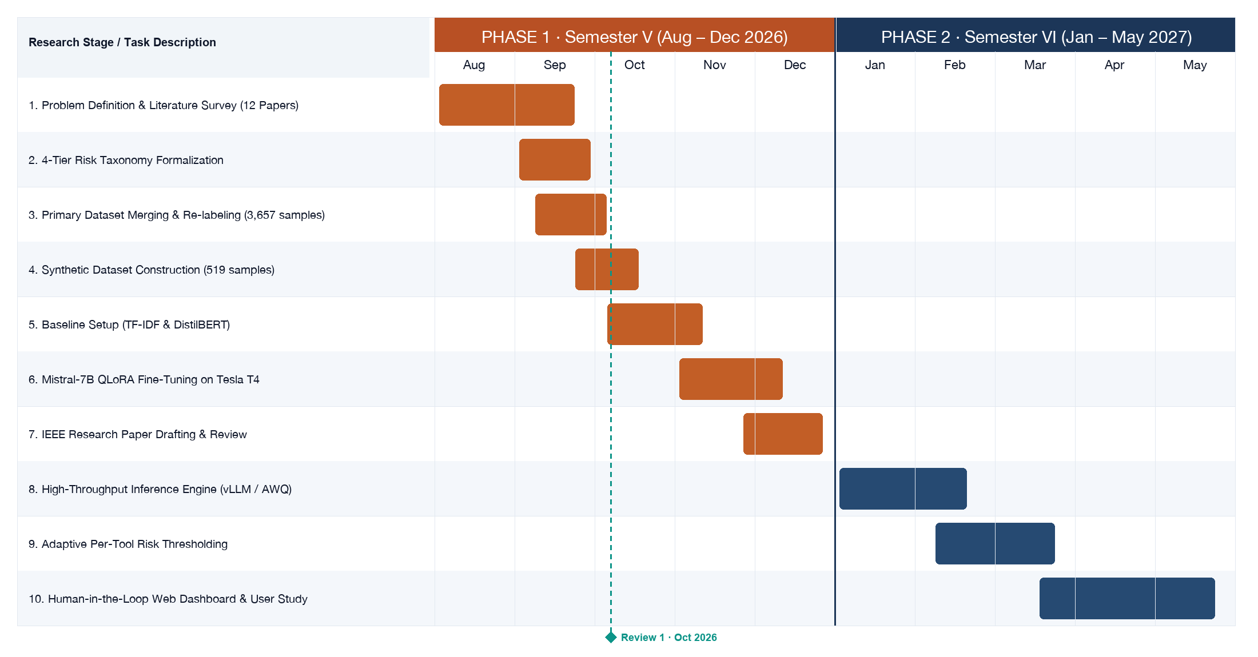
Figure 8.1: Capstone Project Phase-I and Phase-II Timeline (Gantt Chart).

REFERENCES / BIBLIOGRAPHY
[1] Y. Qin, S. Liang, Y. Ye, K. Zhu, L. Yan, Y. Lu, Y. Lin, et al., "ToolBench: Large Language Models Can Effectively Use 16,000+ Real-World APIs," in Proceedings of the International Conference on Learning Representations (ICLR), Vienna, Austria, May 2024.
[2] M. Andriushchenko, F. Croce, and N. Flammarion, "AgentHarm: A Benchmark for Measuring Harmfulness of LLM Agents," arXiv preprint arXiv:2410.09024, Oct. 2024.
[3] Meta AI, "Llama Guard 3: Safe and Responsible Deployment of Generative AI Models," Meta AI Research Technical Report, Menlo Park, CA, USA, July 2024.
[4] Anthropic, "Model Context Protocol (MCP) Specification: Open Architecture for AI-Tool Connectivity," Technical Specification, San Francisco, CA, USA, Nov. 2024. [Online]. Available: https://modelcontextprotocol.io
[5] E. J. Hu, Y. Shen, P. Wallis, Z. Allen-Zhu, Y. Li, S. Wang, L. Wang, and W. Chen, "LoRA: Low-Rank Adaptation of Large Language Models," in Proceedings of the International Conference on Learning Representations (ICLR), Virtual Event, Apr. 2022.
[6] S. Yao, J. Zhao, D. Yu, N. Du, I. Shafran, K. Narasimhan, and Y. Cao, "ReAct: Synergizing Reasoning and Acting in Language Models," in Proceedings of the International Conference on Learning Representations (ICLR), Kigali, Rwanda, May 2023.
[7] T. Schick, J. Dwivedi-Yu, R. Dessì, R. Raileanu, M. Lomeli, L. Zettlemoyer, N. Cancedda, and T. Scialom, "Toolformer: Language Models Can Teach Themselves to Use Tools," in Advances in Neural Information Processing Systems (NeurIPS), New Orleans, LA, USA, Dec. 2023.
[8] T. Dettmers, A. Pagnoni, A. Holtzman, and L. Zettlemoyer, "QLoRA: Efficient Finetuning of Quantized LLMs," in Advances in Neural Information Processing Systems (NeurIPS), vol. 36, pp. 10088–10115, Dec. 2023.
[9] J. Reuchlin, D. Arbour, and P. Sharma, "NeMo Guardrails: A Toolkit for Controllable and Safe LLM Applications," NVIDIA Developer Blog & Technical Whitepaper, Santa Clara, CA, USA, Apr. 2023.
[10] A. Inan, K. Upasani, J. Chi, R. Rungta, K. Iyer, Y. Mao, M. Tontchev, et al., "Llama Guard: LLM-based Input-Output Safeguard for Human-AI Conversations," arXiv preprint arXiv:2312.06674, Dec. 2023.

APPENDIX A: DEFINITIONS, ACRONYMS, AND ABBREVIATIONS
LLM | Large Language Model
MCP | Model Context Protocol (Open protocol published by Anthropic in Nov 2024)
QLoRA | Quantized Low-Rank Adaptation (Efficient fine-tuning using 4-bit precision)
LoRA | Low-Rank Adaptation
NF4 | NormalFloat 4-bit Quantization Format
AST | Abstract Syntax Tree
HITL | Human-in-the-Loop
SSE | Server-Sent Events (HTTP streaming protocol for unidirectional event delivery)
JSON-RPC | JSON Remote Procedure Call Protocol
RBAC | Role-Based Access Control
RAG | Retrieval-Augmented Generation
SOTA | State of the Art
API | Application Programming Interface
VRAM | Video Random-Access Memory
REST | Representational State Transfer
SQL | Structured Query Language

