RAP Application Student Manage Details

TABLE (znav_duplicate).
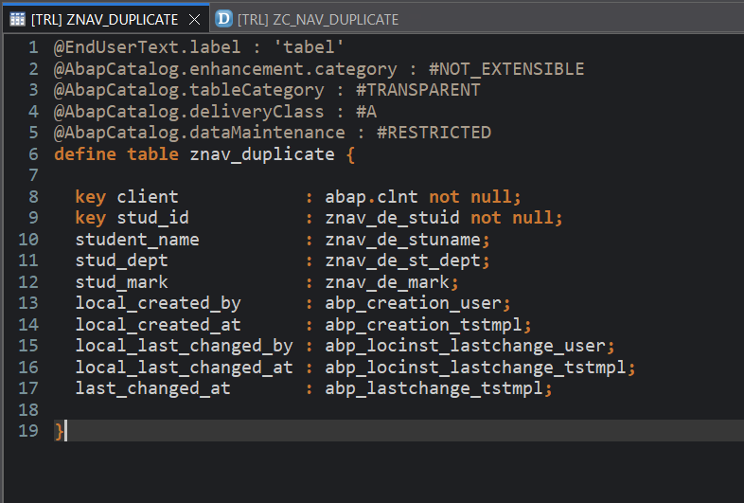

Purpose:
This is a transparent database table used to store student information such as Student ID, Student Name, Department, and Marks.

Primary Keys
- client
- stud_id
These fields uniquely identify each student record.

CDS View Entity: ZR_NAV_DUPLICATE
Purpose:
This CDS Root View Entity is created on top of the database table ZNAV_DUPLICATE. It acts as the main business object in the RAP application and exposes student data to the Fiori application.

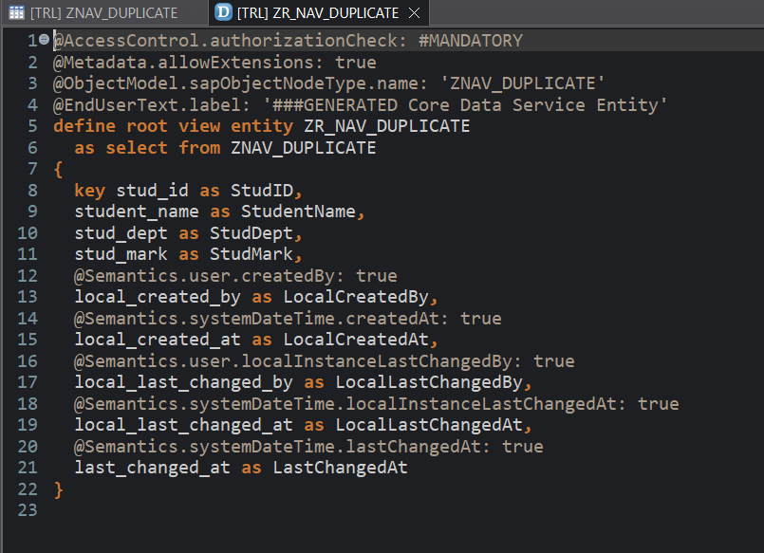

Meaning
- Creates a Root CDS View Entity.
- Reads data from table ZNAV_DUPLICATE.
- Serves as the main entity in RAP.

Projection View: ZC_NAV_DUPLICATE

Purpose
- ZC_NAV_DUPLICATE is a Projection View Entity created on top of the Root View Entity ZR_NAV_DUPLICATE.
- It is used to expose data to the Fiori Application and controls which fields are available to the user.
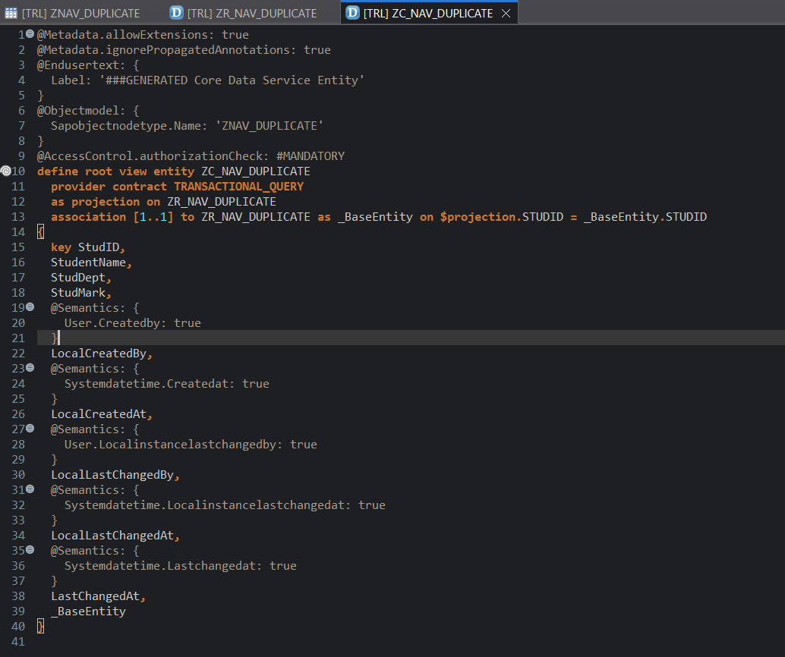

Meaning
- Creates a Projection View.
- Based on Root View Entity ZR_NAV_DUPLICATE.
- Used for transactional processing in RAP.
- Exposed to Fiori applications.

Metadata Extension Explanation (UI Annotations)

Purpose

This metadata extension is used to design the Fiori Elements User Interface for the projection view ZC_NAV_DUPLICATE.

It controls:

Page Header

List Report Columns

Filter Fields

Object Page Details

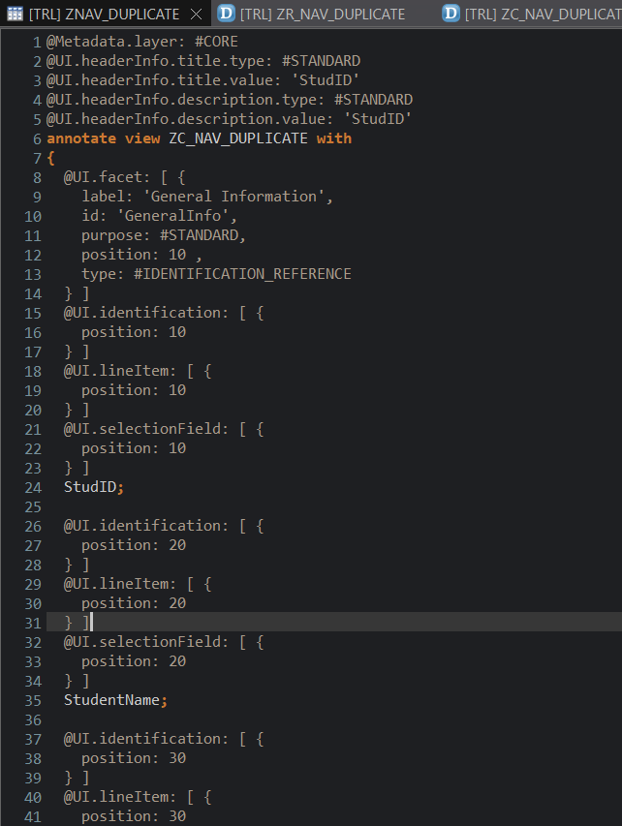
Field Positions

Behavior Definition Explanation (ZR_NAV_DUPLICATE)
Purpose
This Behavior Definition is used in the SAP RAP Model to define how users can interact with the Student Management application.
It controls:
- Create Records
- Update Records
- Delete Records
- Draft Handling
- Field Properties
- Locking and Authorization
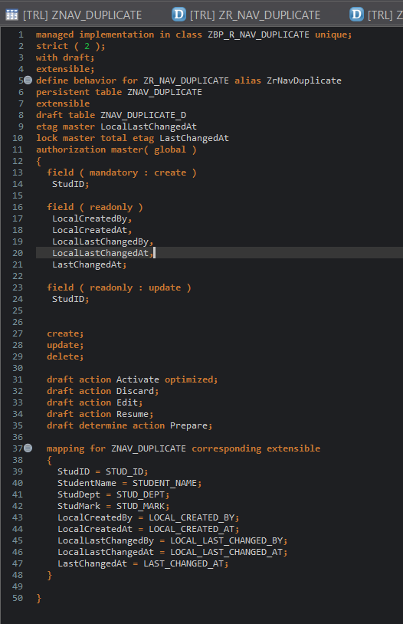

Behavior Projection Explanation (ZC_NAV_DUPLICATE)

Purpose

This is the Behavior Projection Definition for the Projection View ZC_NAV_DUPLICATE.

It exposes the operations defined in the Root Behavior (ZR_NAV_DUPLICATE) to the Fiori application.
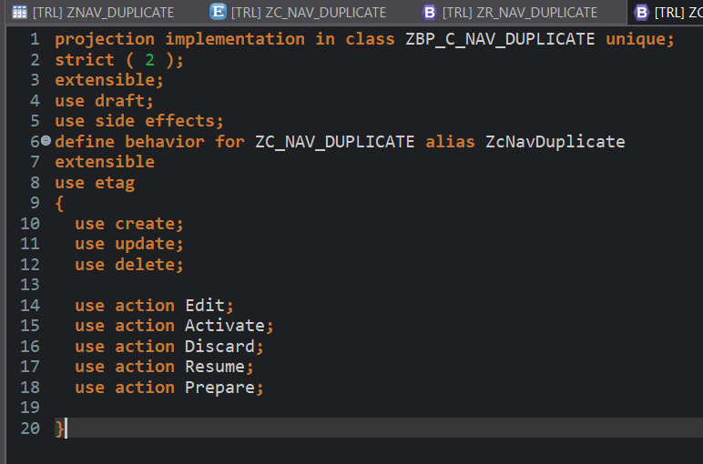

The projection behavior decides which operations are visible to end users.

- • Behavior Projection is used to expose operations to the Fiori Application.

- • It is created on top of ZC_NAV_DUPLICATE projection view.

Class: ZBP_C_NAV_DUPLICATE – Simple Explanation

This class is the Behavior Projection Implementation Class for ZC_NAV_DUPLICATE.
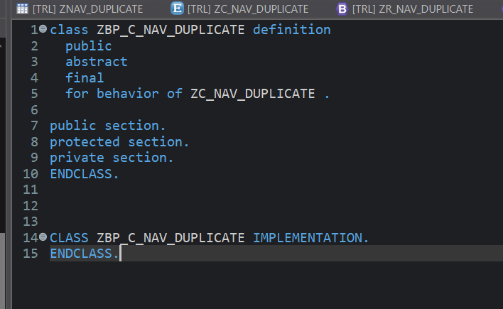

Meaning
- public
  - Class can be accessed by RAP runtime.
- abstract
  - Cannot be instantiated directly.
  - Used only by RAP framework.
- final
  - Cannot be inherited by another class.
- for behavior of ZC_NAV_DUPLICATE
  - Class is linked to the Behavior Projection of ZC_NAV_DUPLICATE.

Service Definition: ZUI_NAV_DUPLICATE_O4 – Simple Explanation

Purpose
A Service Definition is used to expose CDS Views to the outside world.
It acts as a bridge between:
CDS View
↓
Service Definition
↓
Service Binding
↓
Fiori Application

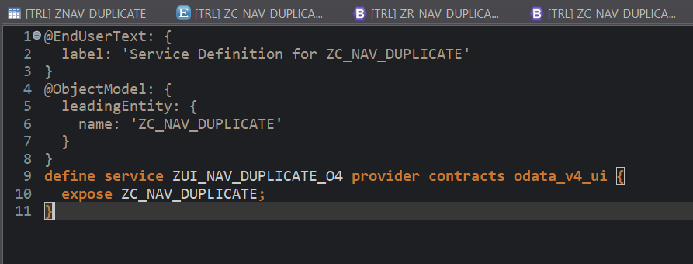

Service Binding: ZUI_NAV_DUPLICATE_O4 – Simple Explanation

A Service Binding connects the Service Definition to the outside world and generates the OData URL used by the Fiori Application.

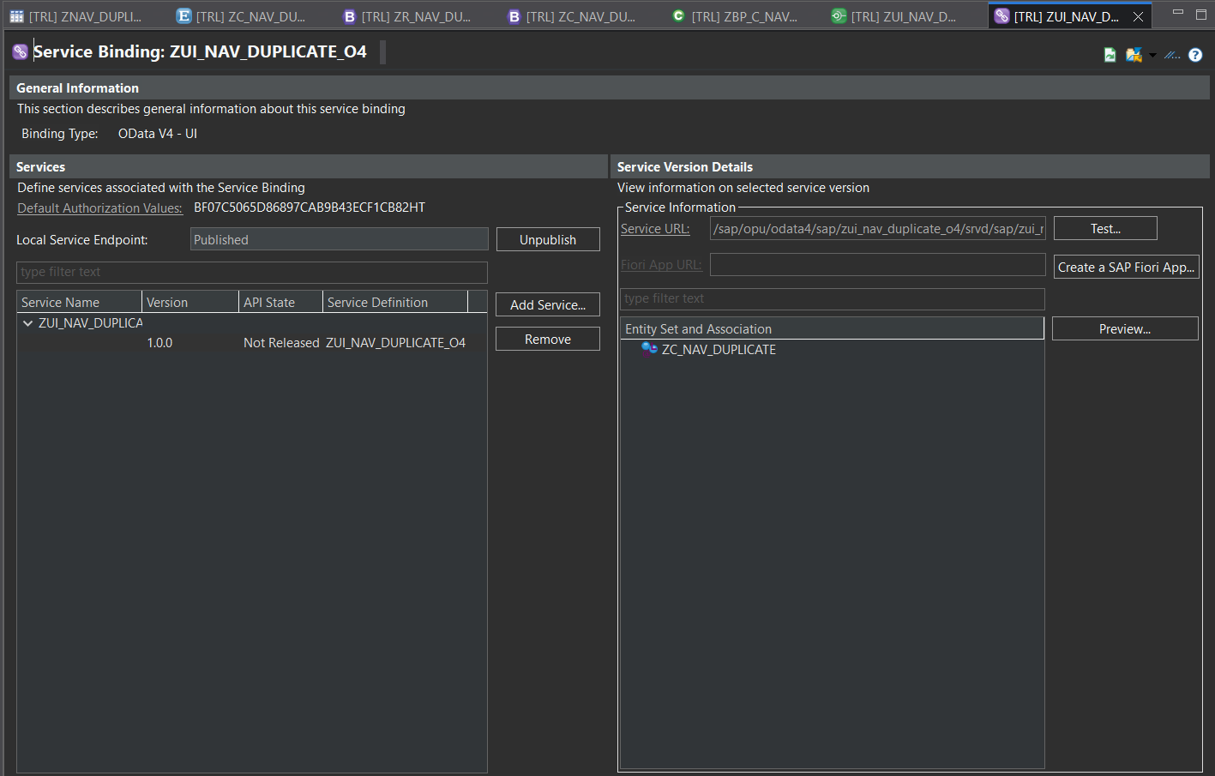

Service Binding (ZUI_NAV_DUPLICATE_O4) – Key Points

Service Binding is used to expose the RAP Business Object as an OData Service.

It connects the Service Definition with the Fiori Application.

Service Binding Name: ZUI_NAV_DUPLICATE_O4.

Binding Type: OData V4 - UI.

Fiori Elements App – Simple Explanation

Purpose

This is the Fiori Elements Application generated from your RAP project.

It allows users to manage student records through a web interface.
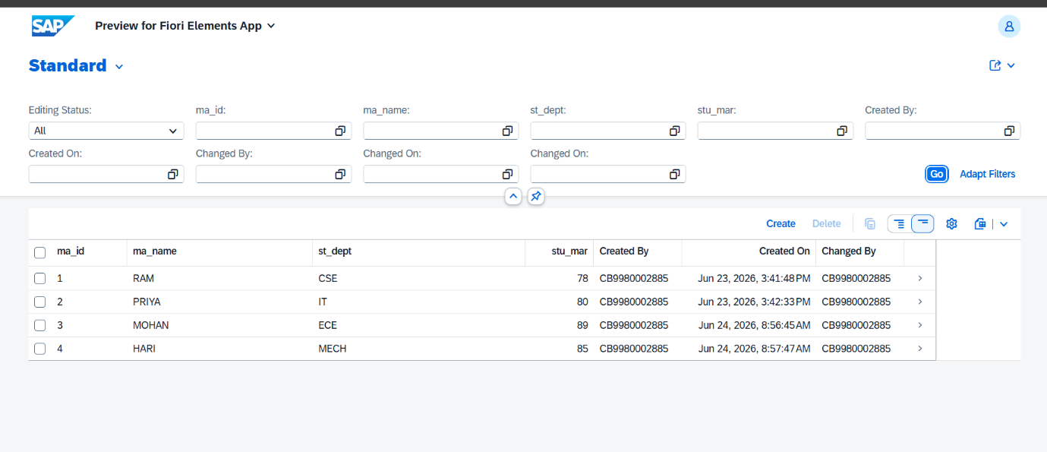

Create Button
Used to add a new student record.

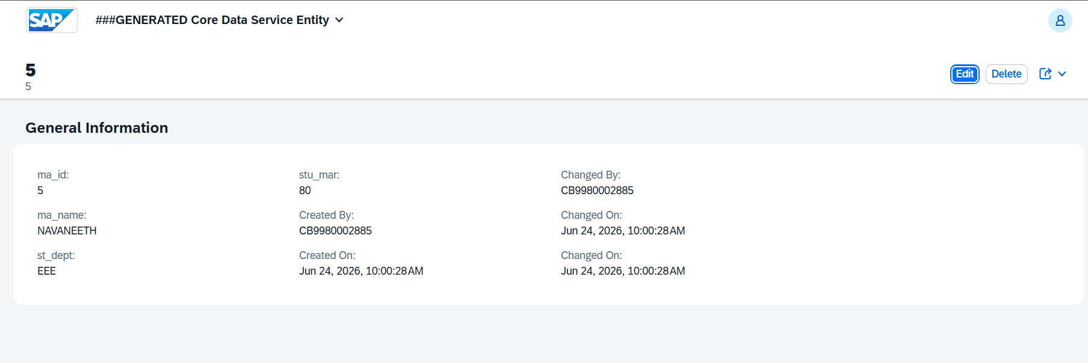

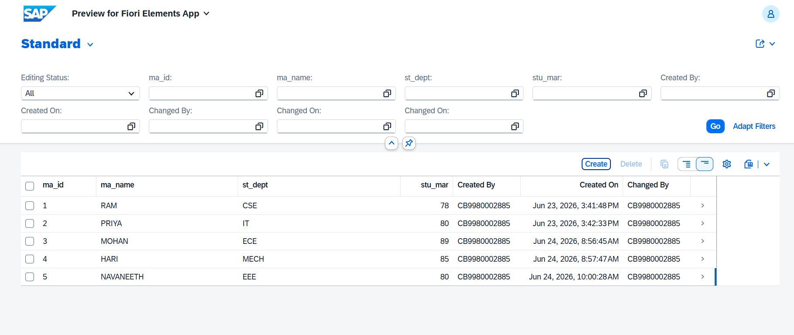

Edit Button

The Edit Button is used to modify an existing student record in the Fiori Application.
Purpose
- Allows users to update student details.
- Opens the selected record in edit mode.
- Changes are first saved as a Draft and then activated.
Steps
- Select a student record.
- Click Edit.
- Modify fields such as:
  - Student Name
  - Department
  - Mark
- Click Save.
- Click Activate to make changes permanent.

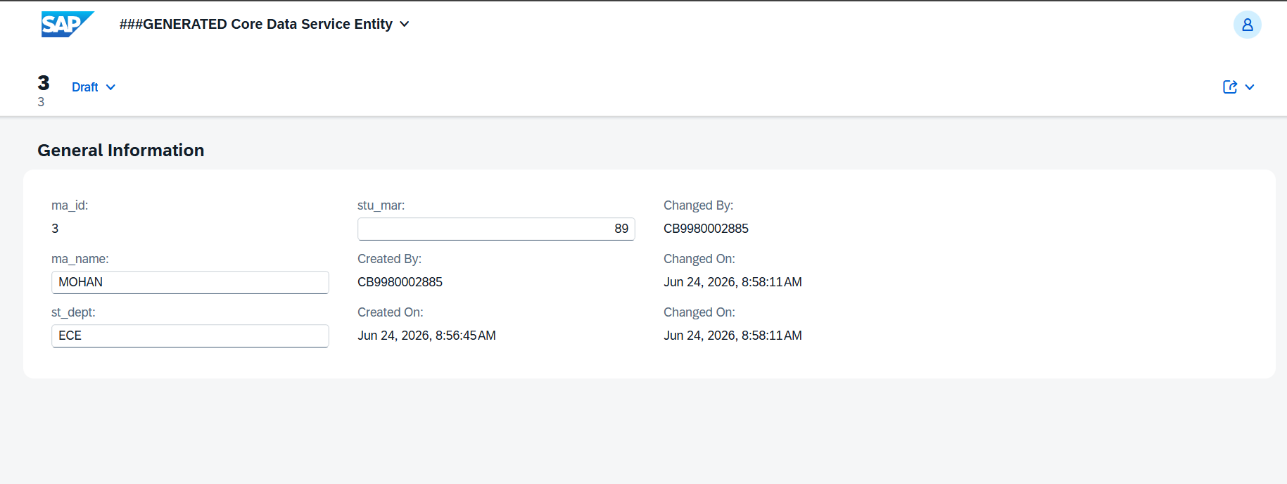

AFTER EDIT THE RECORDS
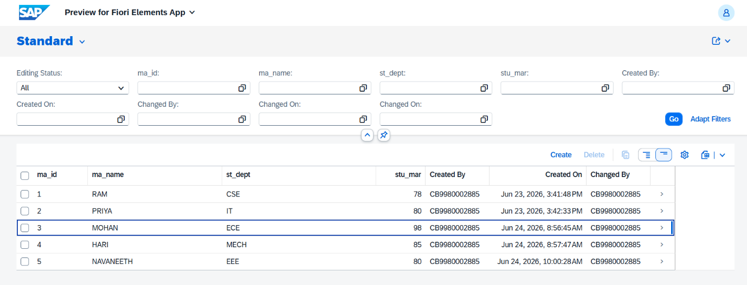

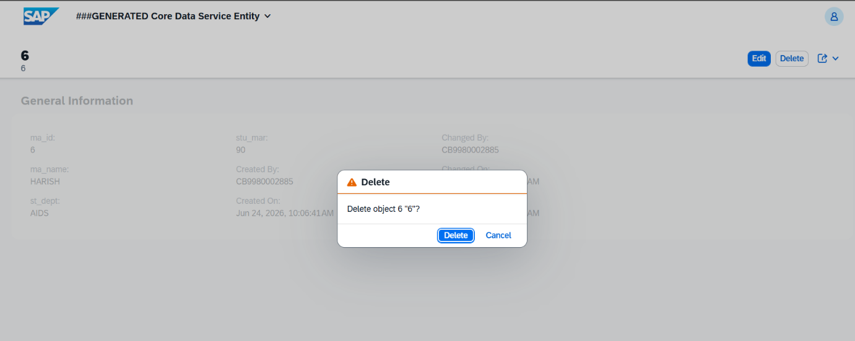

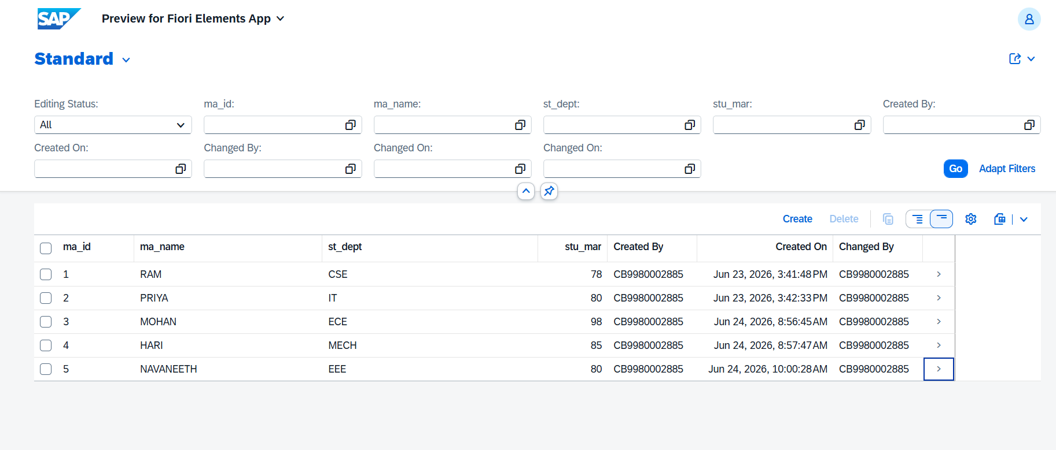

Student Management RAP Project – Overall Summary Points

Objective
- To manage student records using SAP RAP.
- To perform CRUD operations (Create, Read, Update, Delete).
- To provide a user-friendly Fiori interface.
Outcome
- Successfully developed a RAP-based Student Management application.
- Implemented complete CRUD operations.
- Published the application through OData V4 Service Binding.
- Tested the application using Fiori Elements Preview.
- Managed student data through a modern SAP Fiori interface.

