•

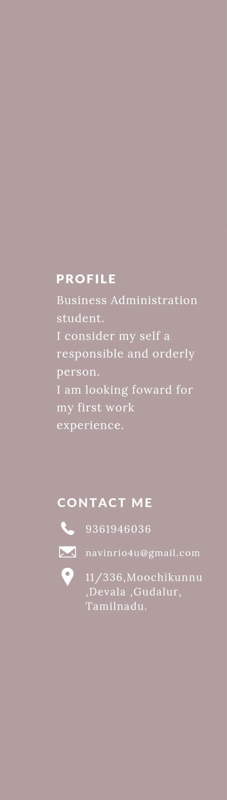

*Student*

* **EDUCATION**

**BORCELLE UNIVERSITY**

*Business Administration career, in progress.*

**FAUGET COLLEGE**

20118-2022

* **LANGUAGE**

Native English. Advanced spanish.

* **COMPUTER SKILLS**

Text processor. Spreadsheet.

Slide presentation.

* **VOLUNTEER EXPERIENCE**

**INGOUDE COMPANY**

Participation in collections to distribute in low-income schools.