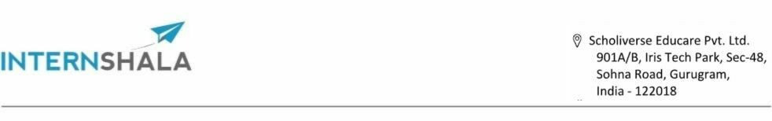
30/08/2025
Dear Navaneethan,
Welcome to Internshala Student Partner (ISP) program!
We hope that you are excited to embark on a transformational journey with us. At Internshala, we consider the ISP team to be our biggest strength when it comes to educating college students across the world about the power of internships and online trainings. Thus, we take pride in hiring ONLY the best and the brightest! We are sure that you would play a vital role in helping us realize our vision of creating a world full of opportunities for the students.
Your appointment as an ISP will be governed by the terms and conditions presented in Annexure A Congratulations!
Warm regards,

Ferhan Hazarika
Growth Head - Internshala
Internshala ~ 'connecting students with internships from 80,000+ brands'

For any queries, please contact isp-hiring@internshala.com
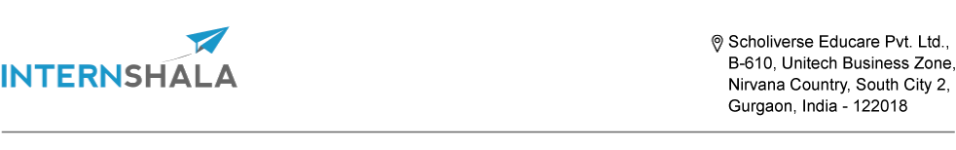

Annexure A
Please find the details of your appointment as an ISP below -
Location: Work from home/college
Duration of the program: 2nd September 2025 - 10th October 2025
Working hours: 2-3 hours per week
Rewards: Performance-based
Roles and responsibilities of an ISP:
- Motivating students to go for online Internshala Trainings and help them to upskill themselves
- Promoting Internshala campaigns in your college and helping students to find their dream internships & jobs
- Participating in social media branding campaigns and learn how to communicate for a brand online
Rewards and incentives:
- You will be paid INR 200 on every enrollment for the online Internshala Training that you ensure.
- INR 5 for every new verified registration you get for Internshala internships platform (i.e 100 registrations = INR 500)
- An ISP Completion letter and access to exclusive Internshala goodies
- Apart from cash incentives, you will also get a chance to win the grand reward: PS5 or Dyson
Airwrap (your choice!)

For any queries, please contact isp-hiring@internshala.com
Terms and conditions:
By accepting the offer letter, you have given us permission to send you daily communication regarding ISP contests and activities on your registered email address and phone number which you used while applying for ISP program.
The grand reward would be given to the top-performing ISP with at least 400 ISP points comprising of 35+ Internshala Trainings payments.
You shall not, during the program or thereafter, message any of your ISP group members. Anyone who is reported for sending irrelevant and inappropriate messages to other group members would be removed from the ISP program.
You shall not, during the program or thereafter, use or disclose to others any confidential information related to the business of Internshala, obtained by you during your association with Internshala.
You are not authorized to interact with media and are expected to redirect them to Smriti (smriti@internshala.com) if you are contacted by someone from media for a sound byte regarding any aspect of Internshala.
You are expected to perform all ISP tasks and activities within the rules and guidelines provided by the Internshala team. Any non-compliance to these or any fraudulent practice while participating in contests could lead to strict actions like removal from the ISP program.
The ISP program is a work-from-home program. We will be asking you to spend around 2-3 hours per week on ISP tasks and activities. Please note that exam breaks are perfectly fine with us and you are not expected to devote any time to ISP during exams.
It is mandatory to remain active and participate in all ISP tasks and activities.
To ensure fair participation, a single ISP will not be declared the winner/runner-up of two consecutive ISP programs. Similarly, a single ISP will not be considered for the top performer reward for similar contests in two consecutive ISP programs.
In order to earn the ISP completion letter, you need to bring a minimum of 60 ISP points comprising of atleast 2 Internshala Trainings referral.
The rewards will be processed once the edition ends. The ISP will not be entitled to receive rewards earned after the respective ISP edition gets over.
In case an ISP submits wrong bank account details for recieving the cash rewards earned within the ISP program, the ISP Team will provide a second chance to fill the correct details and once details are filled correctly, the ISP Team will process the amount within a period of 1.5 months. However, if an ISP fills wrong details in the 2nd attempt as well, the ISP Team will not be entitled to process the cash reward.
Internshala Student Partner Program does not constitute an offer of employment or any contract between the student and Internshala.
Posting misguiding content such as irrelevant programs/internships on company's name on personal social media handles is not allowed. This can lead to the termination from the ISP Program.
You shall not upload any Internshala copyrighted content like training videos, assignments, assessment solutions, etc on any platform.
As an ISP at Internshala, you also represent the Internshala brand and we expect you to conduct yourself with utmost professionalism on all public forums (online and offline). In particular, we expect you to not indulge in any conversation using abusive language on any social media platform. If we come across any such example, Internshala reserves the right to take necessary disciplinary action, including, but not limited to, termination of your participation in the ISP program with Internshala.

For any queries, please contact isp-hiring@internshala.com

