Sql queries outputs to GitHub

=>Insert the values into the database:

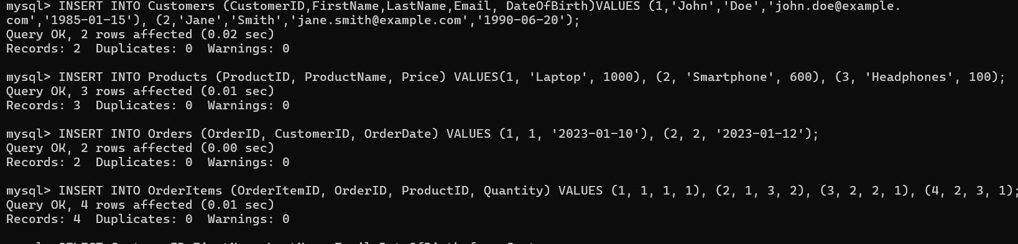

1. List all customers.

SELECT CustomerID, FirstName, LastName, Email, DateOfBirth FROM Customers;

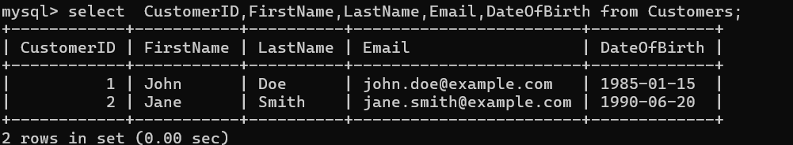

1. . Find all orders placed in January 2023.

Query:

select OrderID, CustomerID, OrderDate from Orders where OrderDate >= '2023-01-01' AND OrderDate < '2023-02-01';

1. . Get the details of each order, including the customer name and email.

Query:

select O.OrderID, C.FirstName, C.LastName, C.Email, O.OrderDate from Orders O JOIN Customers C ON O.CustomerID = C.CustomerID;

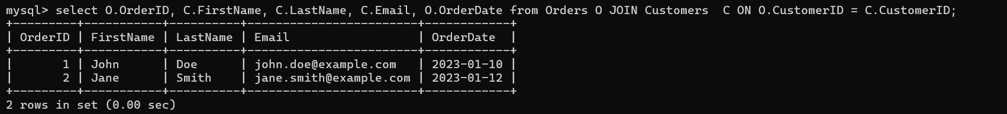

1. List the products purchased in a specific order (e.g., OrderID = 1).

Query:

select P.ProductID, P.ProductName, P.Price, OI.Quantity from OrderItems OI join Products P ON OI.ProductID = P.ProductID WHERE OI.OrderID = 1;

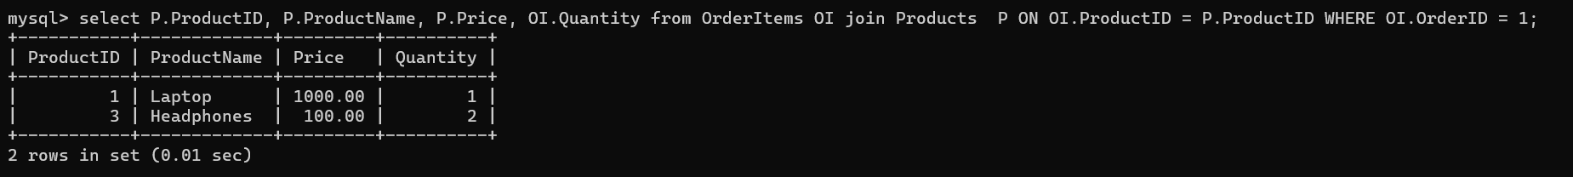

5) Calculate the total amount spent by each customer.

Query:

select C.CustomerID, C.FirstName, C.LastName, SUM(P.Price * OI.Quantity) AS Total Amount spent FROM Customers C join Orders O ON C.CustomerID = O.CustomerID join OrderItems OI on O.OrderID = OI.OrderID join Products P ON OI.ProductID = P.ProductID group by C.CustomerID, C.FirstName, C.LastName;

6) . Find the most popular product (the one that has been ordered the most).

Query:

select p.ProductID, p.ProductName, SUM(oi.Quantity) AS TotalQuantity from OrderItems oi JOIN Products p ON oi.ProductID = p.ProductID GROUP BY p.ProductID, p.ProductName order by TotalQuantity DESC LIMIT 1;



7) Get the total number of orders and the total sales amount for each month in 2023

Query:

select DATE_FORMAT(o.OrderDate, '%Y-%m') AS Month, COUNT(DISTINCT o.OrderID) AS TotalOrders, SUM(oi.Quantity * p.Price) AS TotalSalesAmount FROM Orders o join OrderItems oi ON o.OrderID = oi.OrderID JOIN Products p ON oi.ProductID = p.ProductID Where o.OrderDate >= '2023-01-01' AND o.OrderDate < '2024-01-01' group by DATE_FORMAT(o.OrderDate, '%Y-%m') order by Month;

8) Find customers who have spent more than $1000.

Query:

select c.CustomerID, c.FirstName, c.LastName, c.Email, SUM(oi.Quantity * p.Price) AS TotalSpent from Customers c join Orders o ON c.CustomerID = o.CustomerID join OrderItems oi ON o.OrderID = oi.OrderID JOIN Products p on oi.ProductID = p.ProductID group by c.CustomerID, c.FirstName, c.LastName, c.Email having SUM(oi.Quantity * p.Price) > 1000;

