|  |
| --- |
| **VISVESVARAYA TECHNOLOGICAL UNIVERSITY**  **“JnanaSangama”, Belgaum -590014, Karnataka.**    **LAB RECORD**  **Bio Inspired Systems (23CS5BSBIS)**  ***Submitted by***  **Navanidhi D J (1BM23CS204)**  ***in partial fulfillment for the award of the degree of***  **BACHELOR OF ENGINEERING**  ***in***  **COMPUTER SCIENCE AND ENGINEERING**    **B.M.S. COLLEGE OF ENGINEERING**  **(Autonomous Institution under VTU)**  **BENGALURU-560019**  **Aug-2025 to Dec-2025** |

**B.M.S. College of Engineering,**

**Bull Temple Road, Bangalore 560019**

(Affiliated To Visvesvaraya Technological University, Belgaum)

**Department of Computer Science and Engineering**



**CERTIFICATE**

This is to certify that the Lab work entitled “ Bio Inspired Systems (23CS5BSBIS)” carried out by **Navanidhi D J (1BM23CS204),** who is bonafide student of **B.M.S. College of Engineering.** It is in partial fulfillment for the award of **Bachelor of Engineering in Computer Science and Engineering** of the Visvesvaraya Technological University, Belgaum. The Lab report has been approved as it satisfies the academic requirements of the above mentioned subject and the work prescribed for the said degree.

|  |  |
| --- | --- |
| Sneha S Bagalkot  Assistant Professor  Department of CSE, BMSCE | Dr. Kavitha Sooda  Professor & HOD  Department of CSE, BMSCE |

**Index**

|  |  |  |  |
| --- | --- | --- | --- |
| **Sl.**  **No.** | **Date** | **Experiment Title** | **Page No.** |
| 1 | 18/8/25 | Genetic Algorithm for optimization for neural network weight optimization. | 4-7 |
| 2 | 1/9/25 | Particle Swarm Optimization for Function Optimization for K-means clutering | 8-10 |
| 3 | 8/9/25 | Ant Colony Optimization for the Traveling Salesman Problem | 11-15 |
| 4 | 22/9/25 | Cuckoo search algorithm : Power system and energy. | 16-19 |
| 5 | 29/9/25 | Grey wolf optimization (Application: network routing optimization) | 20-23 |
| 6 | 13/10/25 | Parallel Cellular Algorithm for modelling the spread of diseases. | 24-28 |
| 7 | 25/8/25 | Optimization via Gene Expression Algorithms for TSP: | 29-34 |

Github Link:

https://github.com/NavanidhiDJ/Bio_inspired_systems

**Program 1**

Genetic Algorithm for optimization for neural network weight optimization.

Algorithm:

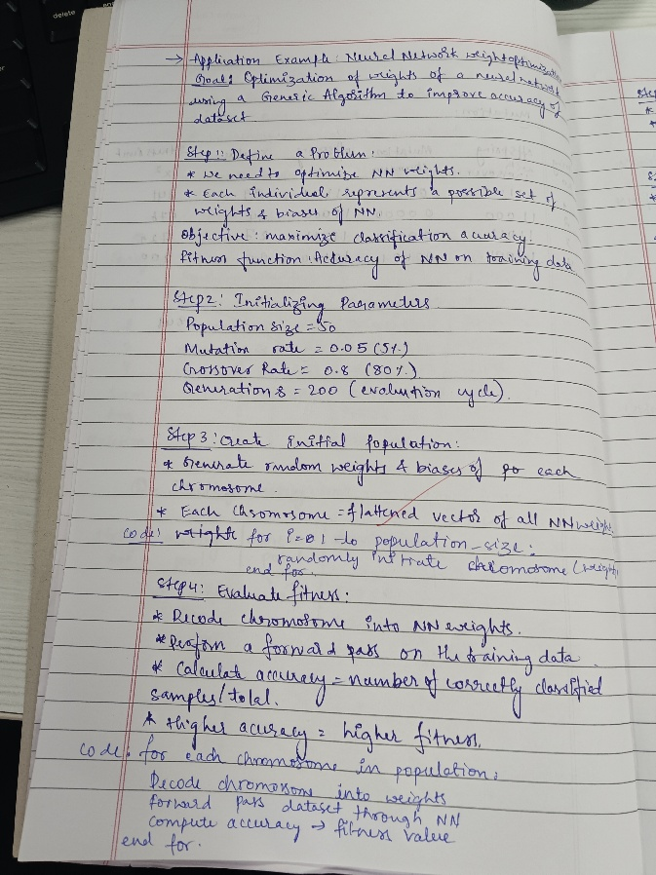 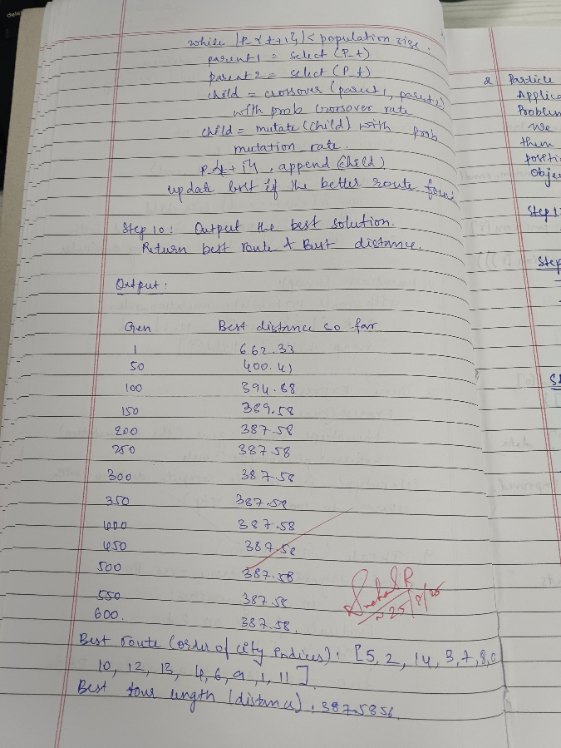

Code:

import numpy as np

# -----------------------------

# 1. Define Problem: Neural Network (XOR classification)

# -----------------------------

# Dataset (XOR problem)

X = np.array([[0,0],

[0,1],

[1,0],

[1,1]])

y = np.array([[0],

[1],

[1],

[0]])

# Neural network architecture: 2 -> 4 -> 1

input_size = 2

hidden_size = 4

output_size = 1

# -----------------------------

# Helper functions

# -----------------------------

def sigmoid(x):

return 1 / (1 + np.exp(-x))

def forward_pass(weights, X):

"""

Forward pass of NN with given weights.

weights = flattened array containing all weights and biases

"""

# Unpack weights

w1_size = input_size * hidden_size

b1_size = hidden_size

w2_size = hidden_size * output_size

b2_size = output_size

w1 = weights[:w1_size].reshape(input_size, hidden_size)

b1 = weights[w1_size:w1_size+b1_size].reshape(1, hidden_size)

w2 = weights[w1_size+b1_size:w1_size+b1_size+w2_size].reshape(hidden_size, output_size)

b2 = weights[-b2_size:].reshape(1, output_size)

# Forward pass

hidden = sigmoid(np.dot(X, w1) + b1)

output = sigmoid(np.dot(hidden, w2) + b2)

return output

def fitness_function(weights):

""" Fitness = accuracy of predictions """

predictions = forward_pass(weights, X)

predicted_labels = (predictions > 0.5).astype(int)

accuracy = np.mean(predicted_labels == y)

return accuracy

# -----------------------------

# 2. Initialize GA Parameters

# -----------------------------

pop_size = 50 # population size

n_generations = 200 # number of generations

mutation_rate = 0.1

crossover_rate = 0.8

# Total number of weights in NN

n_weights = input_size*hidden_size + hidden_size + hidden_size*output_size + output_size

# -----------------------------

# 3. Create Initial Population

# -----------------------------

population = np.random.uniform(-1, 1, (pop_size, n_weights))

# -----------------------------

# GA Operators

# -----------------------------

def selection(population, fitness):

""" Tournament selection """

idx1, idx2 = np.random.randint(0, len(population), 2)

return population[idx1] if fitness[idx1] > fitness[idx2] else population[idx2]

def crossover(parent1, parent2):

""" Single-point crossover """

if np.random.rand() < crossover_rate:

point = np.random.randint(1, n_weights-1)

child1 = np.concatenate([parent1[:point], parent2[point:]])

child2 = np.concatenate([parent2[:point], parent1[point:]])

return child1, child2

else:

return parent1.copy(), parent2.copy()

def mutate(individual):

""" Random mutation """

for i in range(len(individual)):

if np.random.rand() < mutation_rate:

individual[i] += np.random.normal(0, 0.5) # small perturbation

return individual

# -----------------------------

# 4–8. GA Main Loop

# -----------------------------

best_fitness_history = []

for generation in range(n_generations):

# Evaluate fitness

fitness = np.array([fitness_function(ind) for ind in population])

# Track best solution

best_idx = np.argmax(fitness)

best_fitness = fitness[best_idx]

best_fitness_history.append(best_fitness)

if generation % 20 == 0:

print(f"Gen {generation}: Best Fitness = {best_fitness:.4f}")

# New population

new_population = []

while len(new_population) < pop_size:

parent1 = selection(population, fitness)

parent2 = selection(population, fitness)

child1, child2 = crossover(parent1, parent2)

new_population.append(mutate(child1))

new_population.append(mutate(child2))

population = np.array(new_population[:pop_size])

# -----------------------------

# 9. Output Best Solution

# -----------------------------

fitness = np.array([fitness_function(ind) for ind in population])

best_idx = np.argmax(fitness)

best_weights = population[best_idx]

print("\nBest solution found:")

print("Accuracy:", fitness[best_idx])

# Test the best weights on XOR

preds = forward_pass(best_weights, X)

print("Predictions:", (preds > 0.5).astype(int).flatten())

print("Expected :", y.flatten())

**Program 2**

Particle Swarm Optimization for Function Optimization for K-means clutering:

Algorithm:

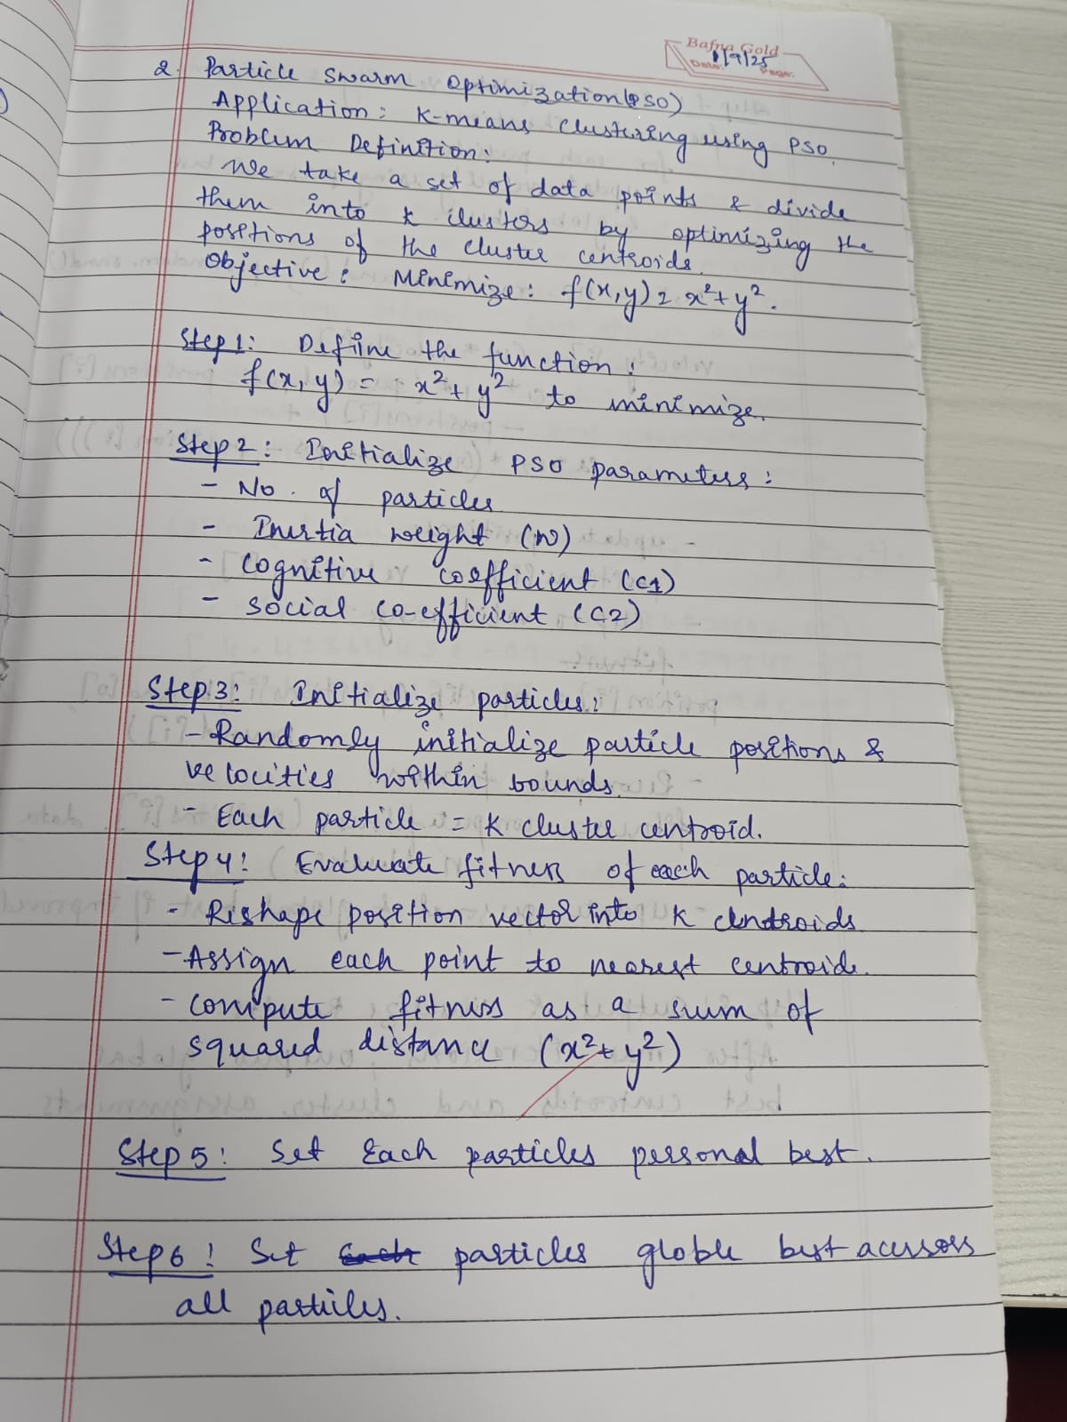 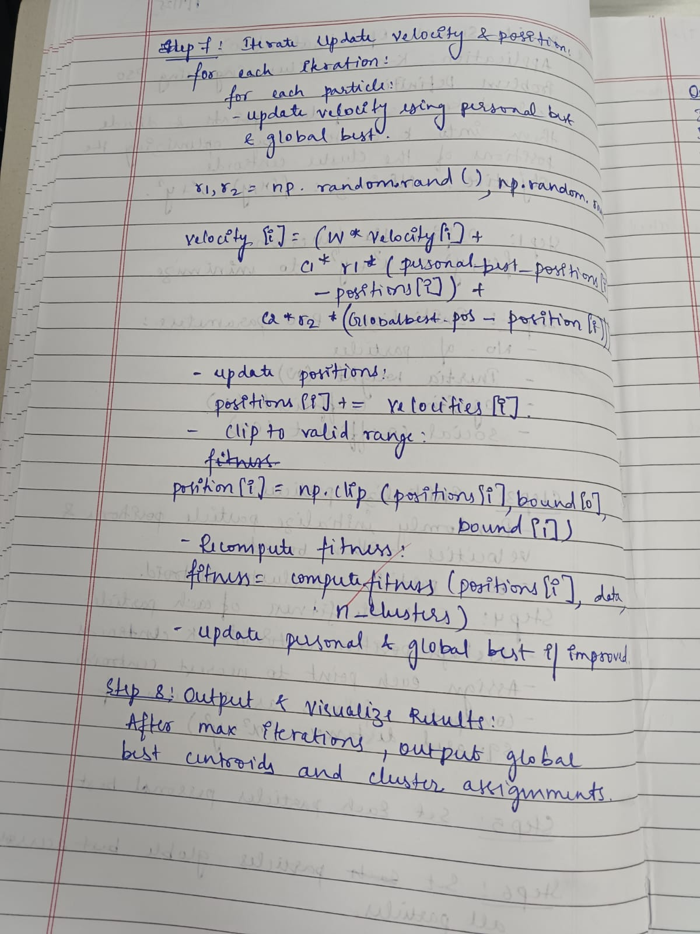

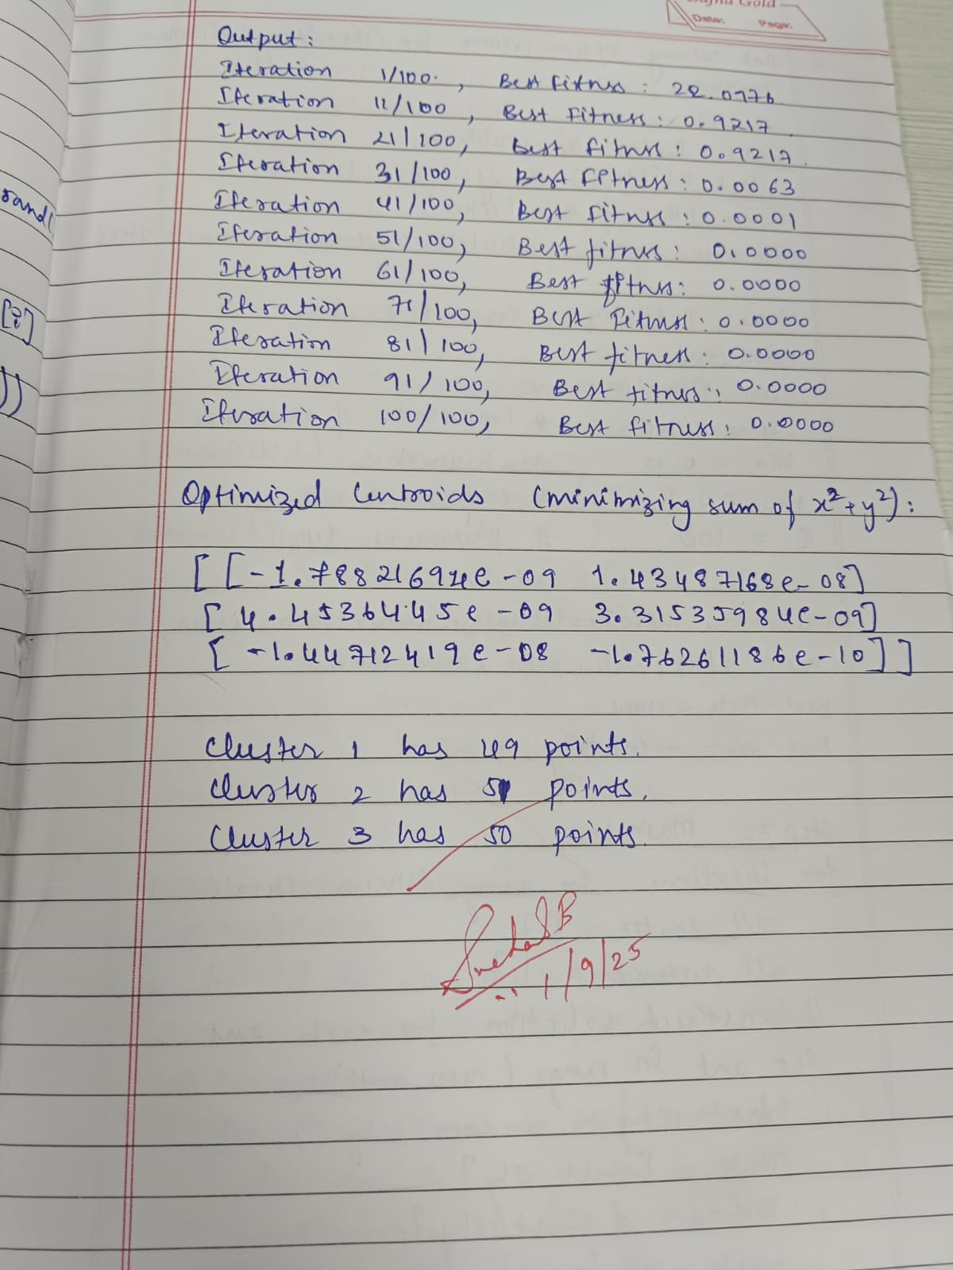

Code:

import numpy as np

# Sample 2D data points (random clusters)

np.random.seed(0)

data = np.vstack([

np.random.randn(50, 2) + np.array([5, 5]),

np.random.randn(50, 2) + np.array([-5, -5]),

np.random.randn(50, 2) + np.array([5, -5])

])

K = 3 # Number of clusters

num_particles = 30

max_iter = 100

dim = 2 # x, y

class Particle:

def __init__(self):

# Each particle represents K centroids (K x dim)

self.position = np.random.uniform(low=np.min(data, axis=0),

high=np.max(data, axis=0),

size=(K, dim))

self.velocity = np.zeros((K, dim))

self.best_position = self.position.copy()

self.best_fitness = float('inf')

def update_velocity(self, global_best_position, w=0.5, c1=1.5, c2=1.5):

r1 = np.random.rand(K, dim)

r2 = np.random.rand(K, dim)

cognitive = c1 * r1 * (self.best_position - self.position)

social = c2 * r2 * (global_best_position - self.position)

self.velocity = w * self.velocity + cognitive + social

def update_position(self):

self.position += self.velocity

# Fitness function: sum of x^2 + y^2 of centroids

def fitness(centroids):

return np.sum(centroids[:, 0]**2 + centroids[:, 1]**2)

# PSO main function

def pso():

swarm = [Particle() for _ in range(num_particles)]

global_best_position = None

global_best_fitness = float('inf')

for iteration in range(max_iter):

for particle in swarm:

fit = fitness(particle.position)

if fit < particle.best_fitness:

particle.best_fitness = fit

particle.best_position = particle.position.copy()

if fit < global_best_fitness:

global_best_fitness = fit

global_best_position = particle.position.copy()

for particle in swarm:

particle.update_velocity(global_best_position)

particle.update_position()

if iteration % 10 == 0 or iteration == max_iter - 1:

print(f"Iteration {iteration+1}/{max_iter}, Best Fitness: {global_best_fitness:.4f}")

return global_best_position

# Run PSO

best_centroids = pso()

print("\nOptimized centroids (minimizing sum of x^2 + y^2):\n", best_centroids)

# Assign points to closest centroid

def assign_clusters(centroids):

clusters = [[] for _ in range(K)]

for point in data:

distances = np.linalg.norm(point - centroids, axis=1)

cluster_idx = np.argmin(distances)

clusters[cluster_idx].append(point)

return clusters

clusters = assign_clusters(best_centroids)

for i, cluster in enumerate(clusters):

print(f"Cluster {i+1} has {len(cluster)} points.")

**Program 3**

Ant Colony Optimization for the Traveling Salesman Problem:

Algorithm:

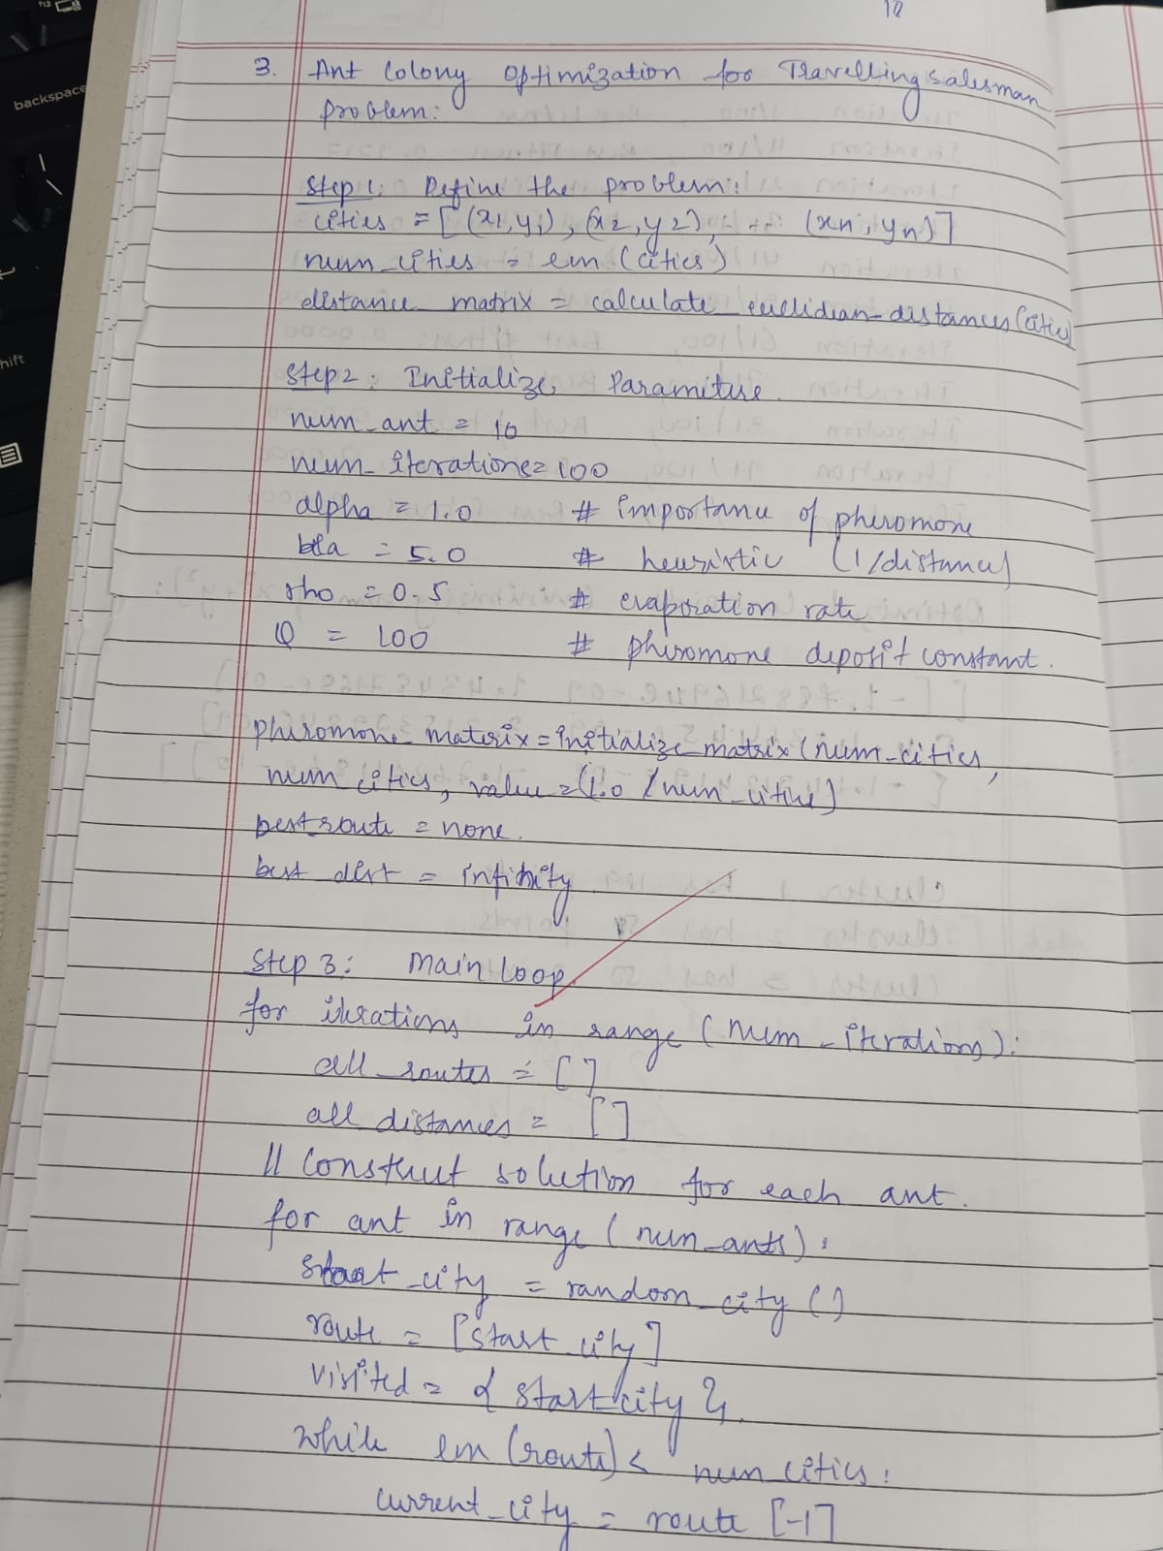 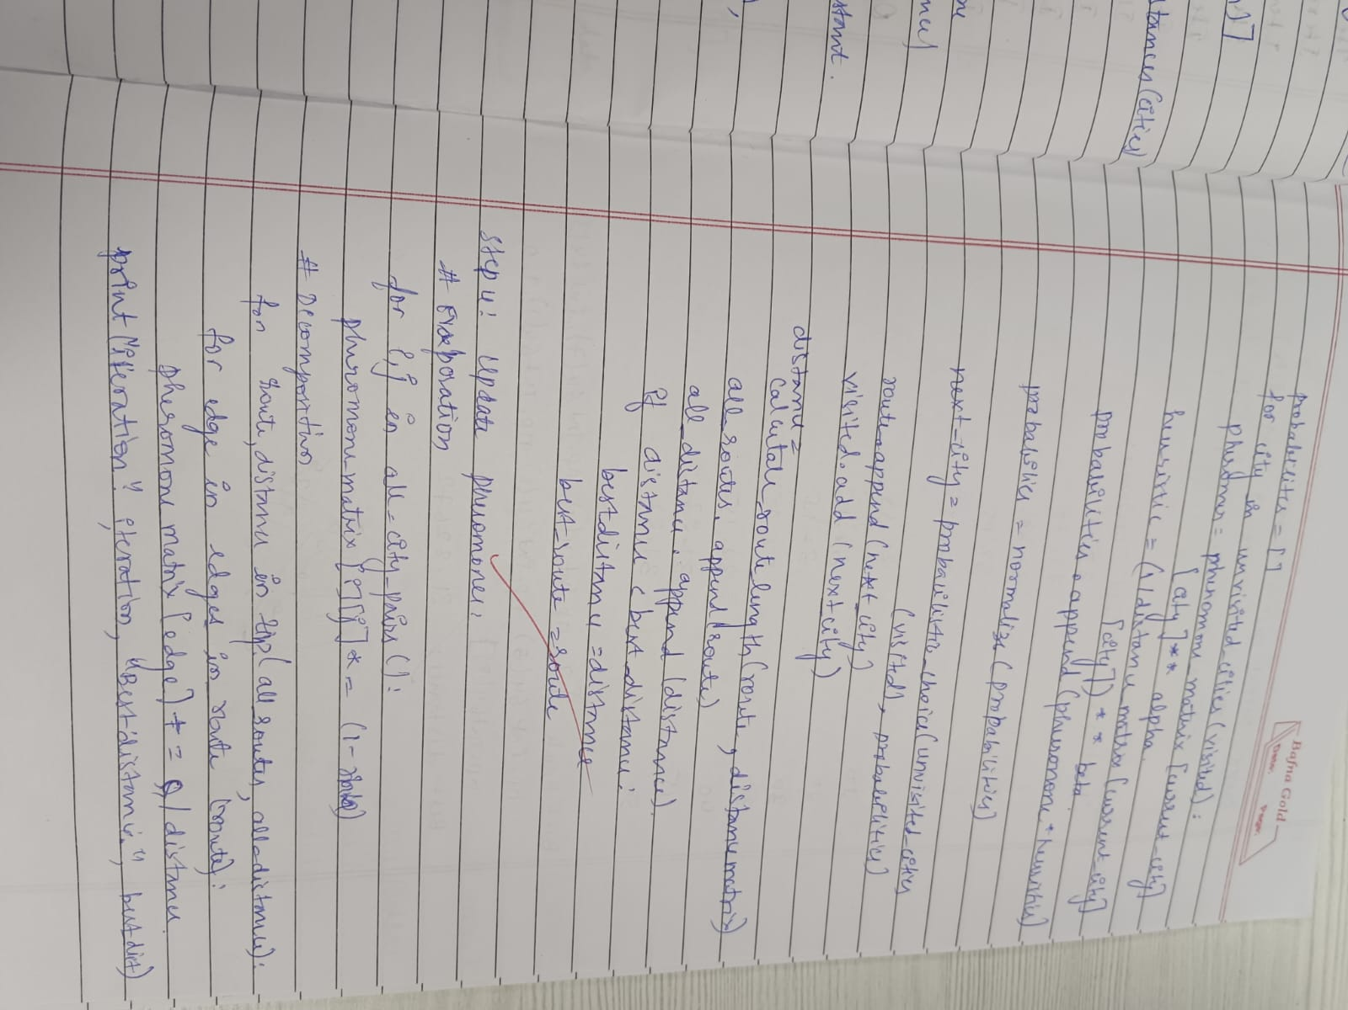

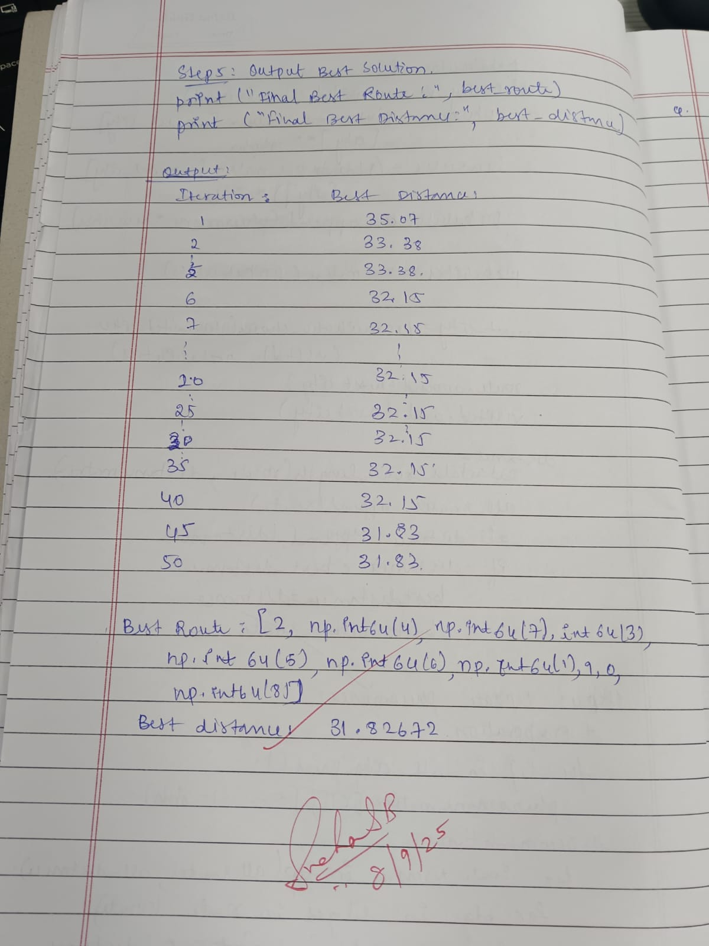

Code:

"""

Ant Colony Optimization (ACO) for the Travelling Salesman Problem (TSP)

Usage:

- Requires: numpy, matplotlib

- Run: python3 ant_colony_tsp.py

This script generates a random set of cities, runs ACO, and plots

the best tour found.

Parameters can be tuned at the top of the file.

"""

import math

import random

import numpy as np

import matplotlib.pyplot as plt

def euclidean_distance(a, b):

return math.hypot(a[0] - b[0], a[1] - b[1])

class AntColonyTSP:

def __init__(

self,

cities,

num_ants=20,

num_iterations=200,

alpha=1.0,

beta=5.0,

rho=0.5,

q=100.0,

initial_pheromone=1.0,

):

self.cities = cities

self.n = len(cities)

self.num_ants = num_ants

self.num_iterations = num_iterations

self.alpha = alpha

self.beta = beta

self.rho = rho

self.q = q

# distance matrix

self.dist = np.zeros((self.n, self.n), dtype=float)

for i in range(self.n):

for j in range(self.n):

if i == j:

self.dist[i, j] = 1e-9

else:

self.dist[i, j] = euclidean_distance(cities[i], cities[j])

# pheromone matrix

self.pheromone = np.full((self.n, self.n), initial_pheromone, dtype=float)

# heuristic matrix (eta = 1/d)

self.eta = 1.0 / self.dist

# best solution

self.best_tour = None

self.best_length = float("inf")

def _select_next_city(self, current, visited):

allowed = [i for i in range(self.n) if i not in visited]

if not allowed:

return None

pheromone = np.take(self.pheromone[current], allowed)

heuristic = np.take(self.eta[current], allowed)

numerator = (pheromone ** self.alpha) * (heuristic ** self.beta)

if numerator.sum() == 0:

# fallback: choose uniformly

return random.choice(allowed)

probs = numerator / numerator.sum()

next_city = random.choices(allowed, weights=probs, k=1)[0]

return next_city

def _construct_solutions(self):

ants_tours = []

ants_lengths = []

for _ in range(self.num_ants):

start = random.randrange(self.n)

tour = [start]

while len(tour) < self.n:

current = tour[-1]

next_city = self._select_next_city(current, tour)

if next_city is None:

break

tour.append(next_city)

# complete tour (return to start)

length = 0.0

for i in range(len(tour)):

j = (i + 1) % len(tour)

length += self.dist[tour[i], tour[j]]

ants_tours.append(tour)

ants_lengths.append(length)

return ants_tours, ants_lengths

def _update_pheromones(self, ants_tours, ants_lengths):

# evaporate

self.pheromone *= (1.0 - self.rho)

# deposit

for tour, length in zip(ants_tours, ants_lengths):

contribution = self.q / (length + 1e-12)

for i in range(len(tour)):

a = tour[i]

b = tour[(i + 1) % len(tour)]

self.pheromone[a, b] += contribution

self.pheromone[b, a] += contribution

def run(self, verbose=True):

for it in range(1, self.num_iterations + 1):

ants_tours, ants_lengths = self._construct_solutions()

# update best

for tour, length in zip(ants_tours, ants_lengths):

if length < self.best_length:

self.best_length = length

self.best_tour = tour.copy()

# pheromone update

self._update_pheromones(ants_tours, ants_lengths)

if verbose and (it % max(1, self.num_iterations // 10) == 0):

print(f"Iteration {it}/{self.num_iterations} - best length: {self.best_length:.4f}")

return self.best_tour, self.best_length

# --- Example usage ---

if __name__ == "__main__":

random.seed(42)

np.random.seed(42)

# generate random cities (change to your own coordinates if needed)

num_cities = 25

cities = [(random.random() * 100, random.random() * 100) for _ in range(num_cities)]

aco = AntColonyTSP(

cities,

num_ants=50,

num_iterations=300,

alpha=1.0,

beta=5.0,

rho=0.4,

q=100.0,

initial_pheromone=1.0,

)

best_tour, best_length = aco.run(verbose=True)

print("\nBest length:", best_length)

print("Best tour:", best_tour)

# plot result

tour_coords = [cities[i] for i in best_tour] + [cities[best_tour[0]]]

xs = [c[0] for c in tour_coords]

ys = [c[1] for c in tour_coords]

plt.figure(figsize=(8, 6))

plt.plot(xs, ys, marker="o")

for i, (x, y) in enumerate(cities):

plt.text(x + 0.8, y + 0.8, str(i), fontsize=9)

plt.title(f"ACO TSP - best length: {best_length:.4f}")

plt.xlabel("X")

plt.ylabel("Y")

plt.grid(True)

plt.show()

**Program 4**

Cuckoo search algorithm : Power system and energy

Algorithm:

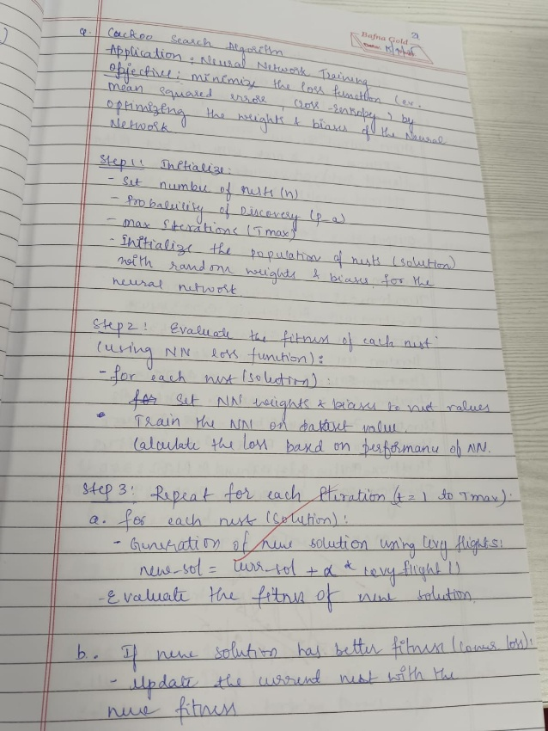 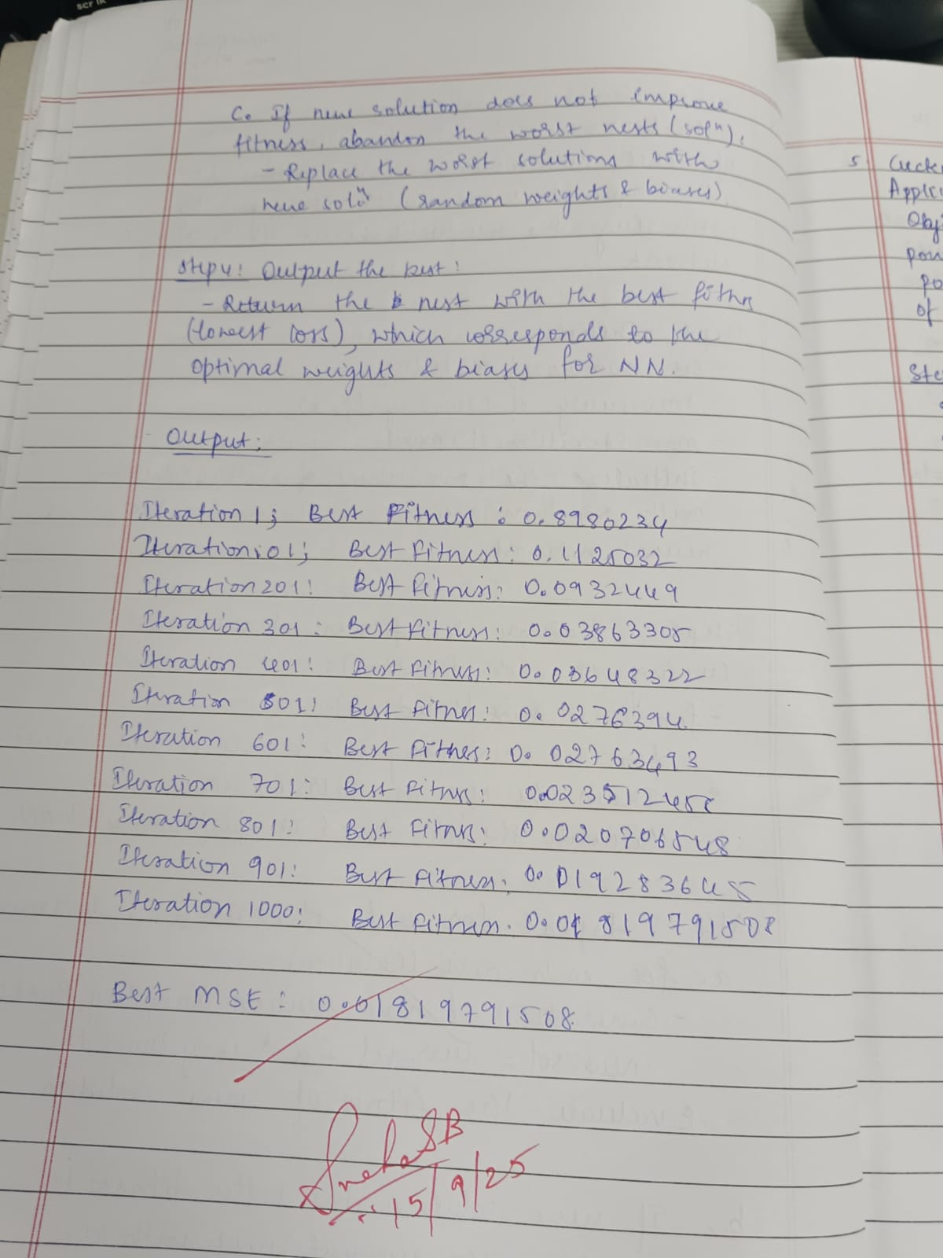

Code:

import numpy as np

import math

# Generator data: cost coefficients a, b, c, min and max power limits

generators = [

{'a': 500, 'b': 5.3, 'c': 0.004, 'Pmin': 150, 'Pmax': 600},

{'a': 400, 'b': 5.5, 'c': 0.006, 'Pmin': 100, 'Pmax': 400},

{'a': 200, 'b': 5.8, 'c': 0.009, 'Pmin': 50, 'Pmax': 200}

]

total_demand = 850 # MW

num_generators = len(generators)

num_nests = 30

max_iter = 100

pa = 0.25 # discovery rate

def fuel_cost(P, gen):

return gen['a'] + gen['b'] * P + gen['c'] * P**2

def is_feasible(power_outputs):

# Check limits

for i, P in enumerate(power_outputs):

if P < generators[i]['Pmin'] or P > generators[i]['Pmax']:

return False

# Check power balance

if abs(np.sum(power_outputs) - total_demand) > 1e-3:

return False

return True

def penalty(power_outputs):

# Penalty for constraint violations

penalty_val = 0

# Power limits penalty

for i, P in enumerate(power_outputs):

if P < generators[i]['Pmin']:

penalty_val += 1e5 * (generators[i]['Pmin'] - P)**2

elif P > generators[i]['Pmax']:

penalty_val += 1e5 * (P - generators[i]['Pmax'])**2

# Power balance penalty

diff = np.sum(power_outputs) - total_demand

penalty_val += 1e6 * (diff)**2

return penalty_val

def fitness(power_outputs):

cost = 0

for i, P in enumerate(power_outputs):

cost += fuel_cost(P, generators[i])

cost += penalty(power_outputs)

return cost

def levy_flight(Lambda=1.5, size=1):

sigma = (math.gamma(1 + Lambda) * np.sin(np.pi * Lambda / 2) /

(math.gamma((1 + Lambda) / 2) * Lambda * 2 ** ((Lambda - 1) / 2))) ** (1 / Lambda)

u = np.random.normal(0, sigma, size=size)

v = np.random.normal(0, 1, size=size)

step = u / (np.abs(v) ** (1 / Lambda))

return step

def generate_feasible_solution():

# Randomly allocate power to generators respecting limits and total demand

P = np.zeros(num_generators)

remaining = total_demand

for i in range(num_generators - 1):

Pmin = generators[i]['Pmin']

Pmax = min(generators[i]['Pmax'], remaining - sum(g['Pmin'] for g in generators[i+1:]))

P[i] = np.random.uniform(Pmin, Pmax)

remaining -= P[i]

# Last generator takes remaining power

P[-1] = remaining

# If last generator violates limits, adjust randomly (simple fix)

if P[-1] < generators[-1]['Pmin']:

P[-1] = generators[-1]['Pmin']

elif P[-1] > generators[-1]['Pmax']:

P[-1] = generators[-1]['Pmax']

return P

def cuckoo_search_eld():

nests = np.array([generate_feasible_solution() for _ in range(num_nests)])

fitnesses = np.array([fitness(nest) for nest in nests])

best_index = np.argmin(fitnesses)

best_nest = nests[best_index].copy()

best_fitness = fitnesses[best_index]

for t in range(max_iter):

for i in range(num_nests):

step = levy_flight(size=num_generators)

new_solution = nests[i] + step * np.random.randn(num_generators)

# Ensure limits and power balance

new_solution = np.clip(new_solution,

[g['Pmin'] for g in generators],

[g['Pmax'] for g in generators])

# Adjust power to match demand (simple proportional scaling)

diff = np.sum(new_solution) - total_demand

new_solution -= diff / num_generators

new_fitness = fitness(new_solution)

if new_fitness < fitnesses[i]:

nests[i] = new_solution

fitnesses[i] = new_fitness

if new_fitness < best_fitness:

best_fitness = new_fitness

best_nest = new_solution.copy()

# Abandon fraction pa of worst nests

abandon_count = int(pa * num_nests)

worst_indices = np.argsort(fitnesses)[-abandon_count:]

for idx in worst_indices:

nests[idx] = generate_feasible_solution()

fitnesses[idx] = fitness(nests[idx])

# Update best solution if improved

current_best_idx = np.argmin(fitnesses)

if fitnesses[current_best_idx] < best_fitness:

best_fitness = fitnesses[current_best_idx]

best_nest = nests[current_best_idx].copy()

return best_nest, best_fitness

# Run the algorithm

best_solution, best_cost = cuckoo_search_eld()

print("Optimal Power Outputs (MW):", best_solution)

print("Minimum Fuel Cost:", best_cost)

**Program 5**

Grey wolf optimization (Application: network routing optimization)

Algorithm:

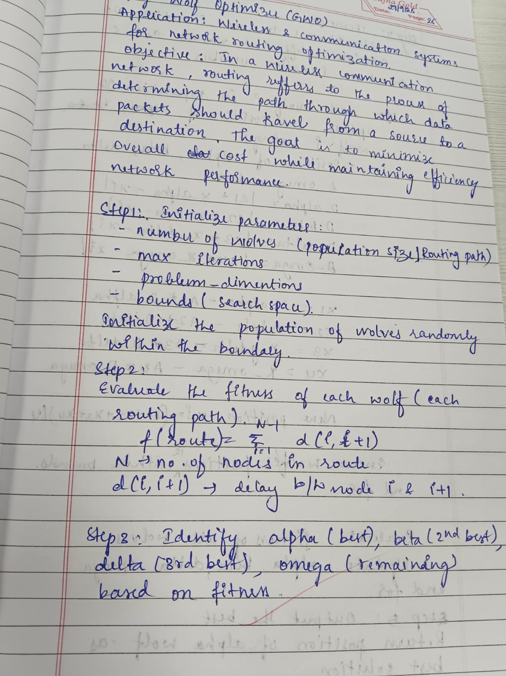 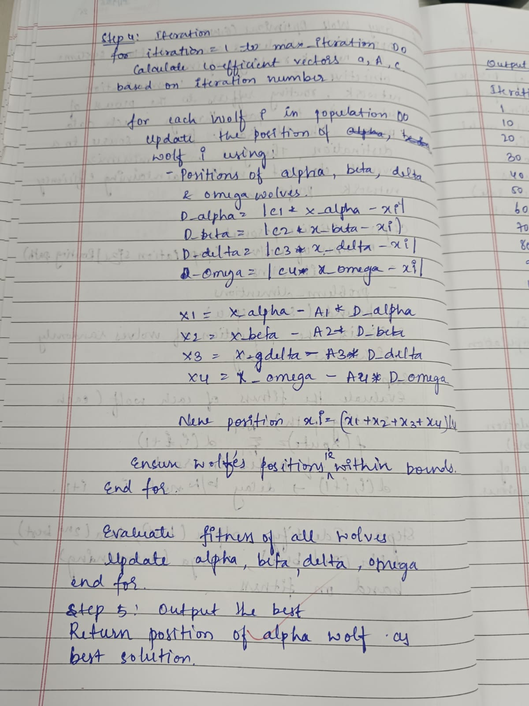

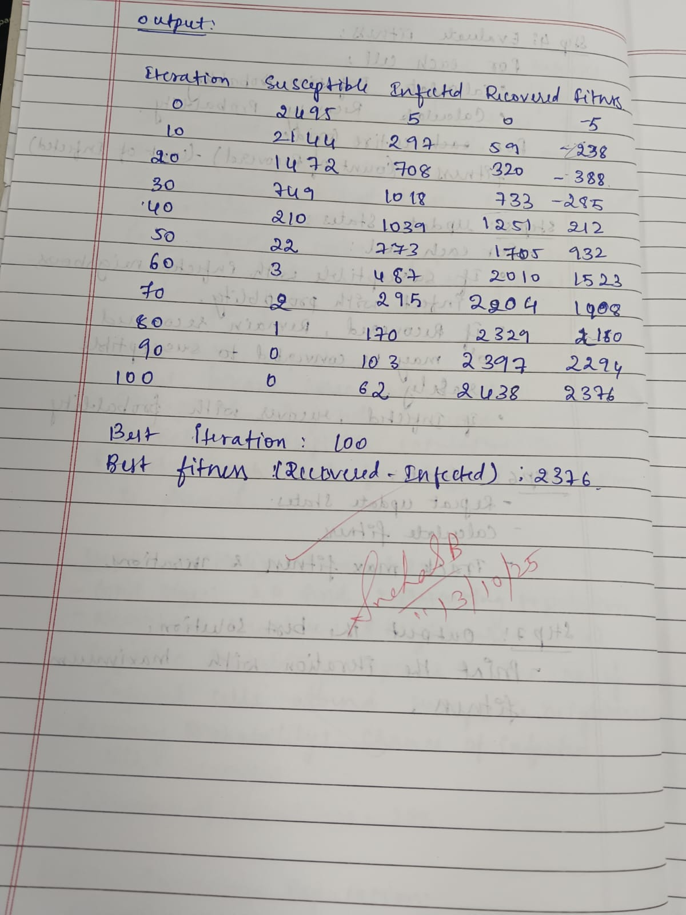

Code:

import numpy as np

# Objective function (example):

# Let's simulate a function that depends on multiple routing parameters.

def network_routing_cost(x):

# x is a vector representing routing parameters

# For demonstration, use a nonlinear function:

return np.sum(x**2) + 10 * np.sum(np.sin(x))

# GWO Implementation with Alpha, Beta, Delta, Omega wolves

class GreyWolfOptimizer:

def __init__(self, obj_func, dim, bounds, num_wolves=30, max_iter=100):

self.obj_func = obj_func

self.dim = dim

self.lb, self.ub = bounds

self.num_wolves = num_wolves

self.max_iter = max_iter

# Initialize wolf positions

self.positions = np.random.uniform(self.lb, self.ub, (num_wolves, dim))

# Initialize alpha, beta, delta, omega

self.alpha_pos = np.zeros(dim)

self.alpha_score = float('inf')

self.beta_pos = np.zeros(dim)

self.beta_score = float('inf')

self.delta_pos = np.zeros(dim)

self.delta_score = float('inf')

self.omega_positions = np.zeros((num_wolves - 3, dim))

self.omega_scores = np.ones(num_wolves - 3) * float('inf')

def update_wolves(self):

# Evaluate fitness of all wolves and update alpha, beta, delta, omega

fitness_scores = np.array([self.obj_func(pos) for pos in self.positions])

# Sort wolves by fitness scores (ascending)

sorted_indices = np.argsort(fitness_scores)

sorted_positions = self.positions[sorted_indices]

sorted_scores = fitness_scores[sorted_indices]

# Alpha, Beta, Delta

self.alpha_pos = sorted_positions[0]

self.alpha_score = sorted_scores[0]

self.beta_pos = sorted_positions[1]

self.beta_score = sorted_scores[1]

self.delta_pos = sorted_positions[2]

self.delta_score = sorted_scores[2]

# Omega wolves (remaining wolves)

self.omega_positions = sorted_positions[3:]

self.omega_scores = sorted_scores[3:]

def optimize(self):

for t in range(self.max_iter):

for i in range(self.num_wolves):

fitness = self.obj_func(self.positions[i])

# Update the positions based on alpha, beta, delta, omega wolves

a = 2 - t * (2 / self.max_iter) # a decreases linearly from 2 to 0

for j in range(self.dim):

r1, r2 = np.random.rand(), np.random.rand()

A1 = 2 * a * r1 - a

C1 = 2 * r2

D_alpha = abs(C1 * self.alpha_pos[j] - self.positions[i][j])

X1 = self.alpha_pos[j] - A1 * D_alpha

r1, r2 = np.random.rand(), np.random.rand()

A2 = 2 * a * r1 - a

C2 = 2 * r2

D_beta = abs(C2 * self.beta_pos[j] - self.positions[i][j])

X2 = self.beta_pos[j] - A2 * D_beta

r1, r2 = np.random.rand(), np.random.rand()

A3 = 2 * a * r1 - a

C3 = 2 * r2

D_delta = abs(C3 * self.delta_pos[j] - self.positions[i][j])

X3 = self.delta_pos[j] - A3 * D_delta

# Omega wolf influence

r1, r2 = np.random.rand(), np.random.rand()

A4 = 2 * a * r1 - a

C4 = 2 * r2

omega_idx = np.random.randint(self.num_wolves - 3)

D_omega = abs(C4 * self.omega_positions[omega_idx][j] - self.positions[i][j])

X4 = self.omega_positions[omega_idx][j] - A4 * D_omega

# Update wolf position

self.positions[i][j] = (X1 + X2 + X3 + X4) / 4

# Boundary check

self.positions[i] = np.clip(self.positions[i], self.lb, self.ub)

# Evaluate fitness of all wolves and update alpha, beta, delta, omega

self.update_wolves()

# Optionally print progress

if (t+1) % 10 == 0 or t == 0:

print(f"Iteration {t+1}, Best Fitness: {self.alpha_score:.4f}")

return self.alpha_pos, self.alpha_score

# Problem setup

dimension = 5 # For example, 5 routing parameters

bounds = (-10, 10) # Limits on parameters

gwo = GreyWolfOptimizer(network_routing_cost, dimension, bounds, num_wolves=20, max_iter=100)

best_solution, best_cost = gwo.optimize()

print("\nBest routing parameters found:", best_solution)

print("Minimum routing cost:", best_cost)

**Program 6**

Parrelel Cellular Algorithm for modeling the spread of diseases.Algorithm:

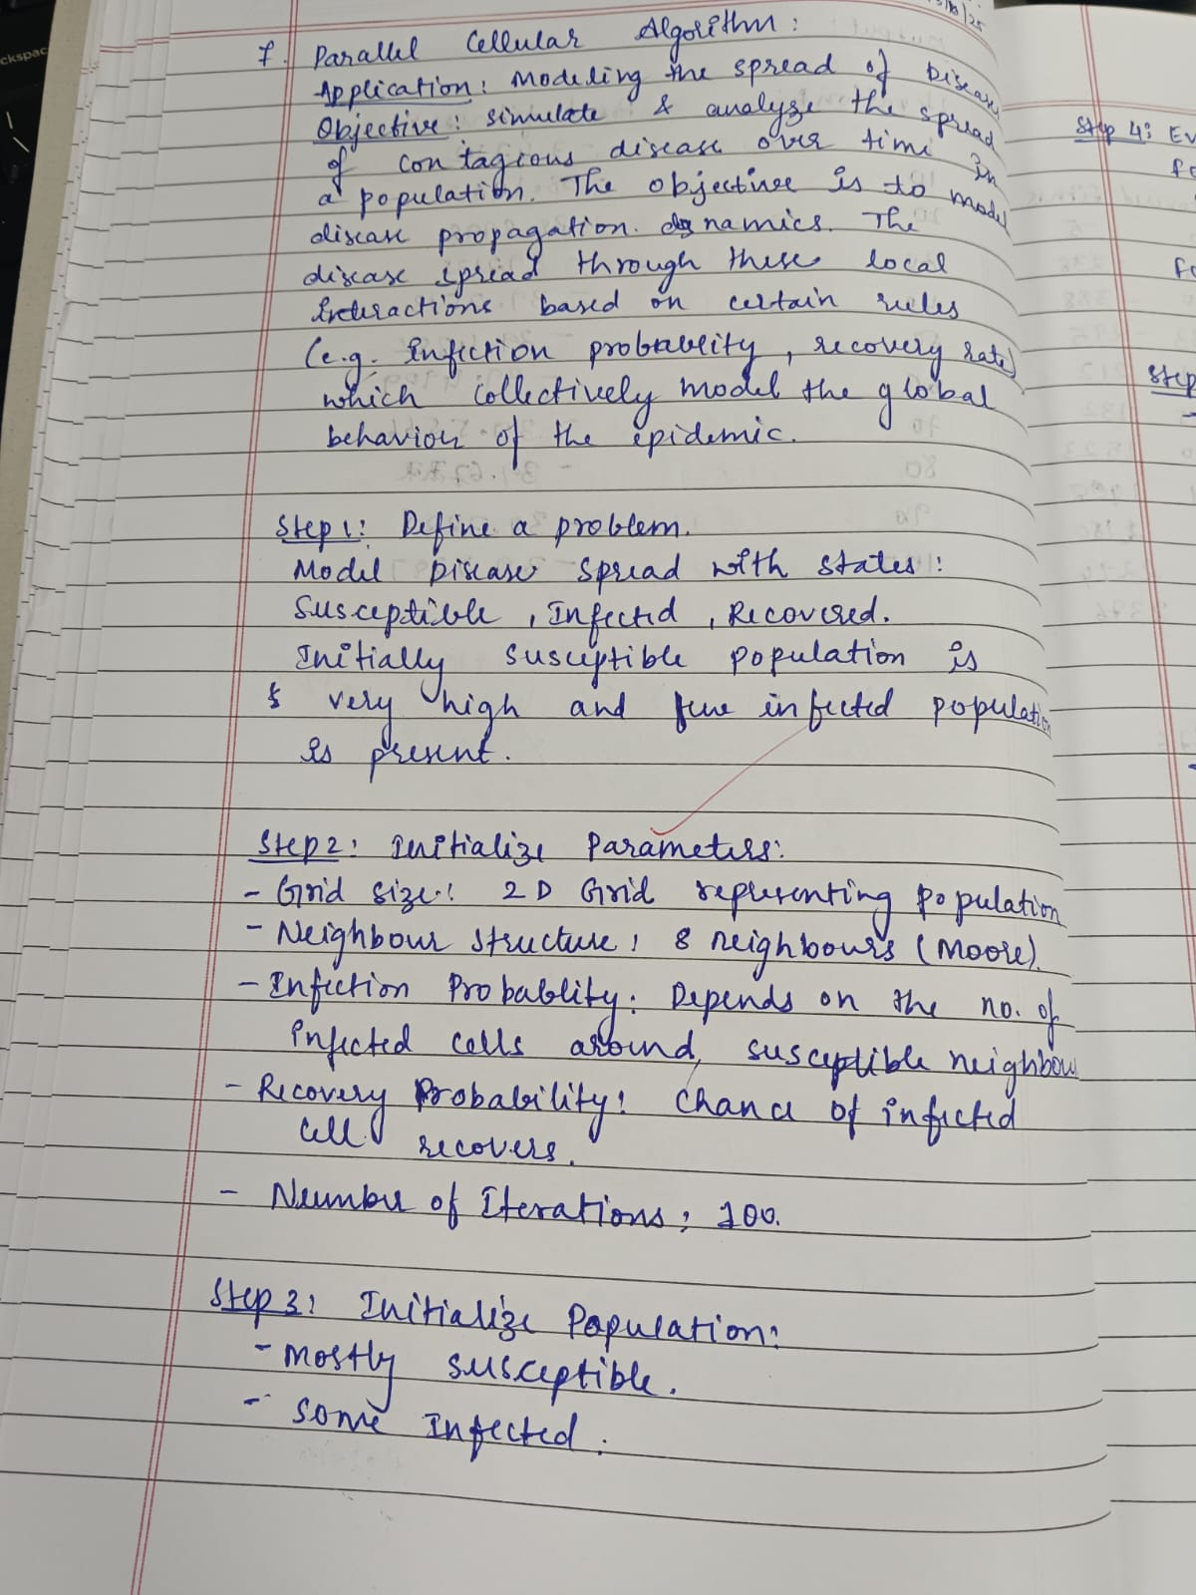 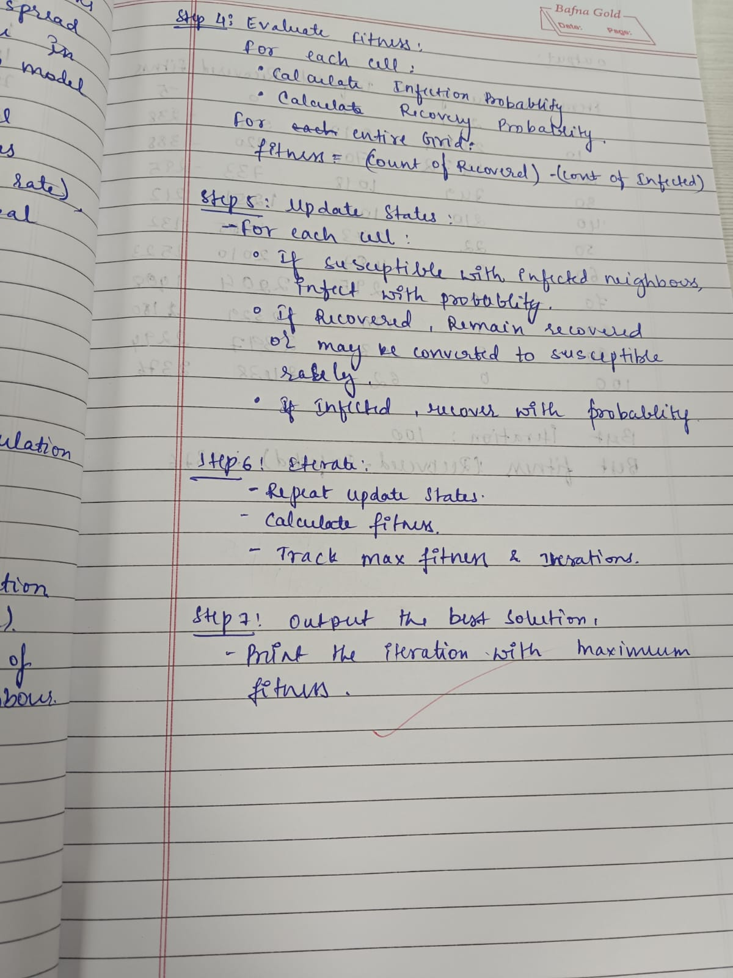



Code:

import numpy as np

from multiprocessing import Process, Pipe

import matplotlib.pyplot as plt

from matplotlib import animation

import time

GRID_SIZE = (200, 200)

P_INFECT = 0.35

P_RECOVER = 0.02

NEIGHBORHOOD = 'moore'

PROCESSES = 4

TIMESTEPS = 400

INITIAL_INFECTED = 10

EXTERNAL_INFECTION_RATE = 0.0001

SUSCEPTIBLE = 0

INFECTED = 1

RECOVERED = 2

def init_grid(rows, cols, initial_infected=10):

grid = np.zeros((rows, cols), dtype=np.uint8)

rs = np.random.randint(0, rows, size=initial_infected)

cs = np.random.randint(0, cols, size=initial_infected)

grid[rs, cs] = INFECTED

return grid

def neighbor_kernel(neighborhood='moore'):

if neighborhood == 'moore':

return np.array([[1,1,1],[1,0,1],[1,1,1]], dtype=np.uint8)

else:

return np.array([[0,1,0],[1,0,1],[0,1,0]], dtype=np.uint8)

def count_infected_neighbors(subgrid, kernel):

r, c = subgrid.shape

out = np.zeros((r-2, c-2), dtype=np.uint8)

for dr in range(3):

for dc in range(3):

if kernel[dr, dc]:

out += (subgrid[dr:r-2+dr, dc:c-2+dc] == INFECTED)

return out

def worker(child_conn, rows_slice, cols, kernel, params):

p_infect, p_recover, ext_rate = params

while True:

msg = child_conn.recv()

if msg == 'STOP':

break

halo = msg

infected_neighbors = count_infected_neighbors(halo, kernel)

inner = halo[1:-1, 1:-1]

next_inner = inner.copy()

susceptible_mask = (inner == SUSCEPTIBLE)

k = infected_neighbors.astype(np.float64)

prob_infection = 1.0 - np.power((1.0 - p_infect), k)

randvals = np.random.random(size=prob_infection.shape)

new_infections = susceptible_mask & (randvals < prob_infection)

ext_rand = np.random.random(size=prob_infection.shape)

new_infections |= susceptible_mask & (ext_rand < ext_rate)

next_inner[new_infections] = INFECTED

infected_mask = (inner == INFECTED)

rec_rand = np.random.random(size=infected_mask.shape)

recoveries = infected_mask & (rec_rand < p_recover)

next_inner[recoveries] = RECOVERED

child_conn.send(next_inner)

class ParallelCellularSIR:

def __init__(self, rows, cols, p_infect, p_recover, neighborhood='moore', processes=4, external_rate=0.0):

self.rows = rows

self.cols = cols

self.p_infect = p_infect

self.p_recover = p_recover

self.neighborhood = neighborhood

self.kernel = neighbor_kernel(neighborhood)

self.processes = min(processes, rows)

self.external_rate = external_rate

self.grid = init_grid(rows, cols, INITIAL_INFECTED)

sizes = [rows // self.processes + (1 if i < rows % self.processes else 0) for i in range(self.processes)]

starts = [sum(sizes[:i]) for i in range(self.processes)]

ends = [starts[i] + sizes[i] for i in range(self.processes)]

self.slices = list(zip(starts, ends))

self.parents = []

self.workers = []

for s, e in self.slices:

parent_conn, child_conn = Pipe()

p = Process(target=worker, args=(child_conn, (s, e), cols, self.kernel, (self.p_infect, self.p_recover, self.external_rate)))

p.daemon = True

p.start()

self.parents.append(parent_conn)

self.workers.append(p)

def step(self):

for i, (s, e) in enumerate(self.slices):

top = max(0, s-1)

bottom = min(self.rows, e+1)

sub = self.grid[top:bottom, :]

if top == 0:

sub = np.vstack((np.zeros((1, self.cols), dtype=np.uint8), sub))

if bottom == self.rows:

sub = np.vstack((sub, np.zeros((1, self.cols), dtype=np.uint8)))

left_col = self.grid[top:bottom, -1].reshape(-1,1)

right_col = self.grid[top:bottom, 0].reshape(-1,1)

sub = np.hstack((left_col, sub, right_col))

self.parents[i].send(sub)

next_grid = np.zeros_like(self.grid)

for i, (s, e) in enumerate(self.slices):

inner = self.parents[i].recv()

next_grid[s:e, :] = inner

self.grid = next_grid

def run(self, timesteps=100, verbose=True, animate=False):

if animate:

fig, ax = plt.subplots(figsize=(6,6))

img = ax.imshow(self.grid, vmin=0, vmax=2, interpolation='nearest')

ax.set_title('Parallel Cellular SIR')

plt.axis('off')

def update(frame):

self.step()

img.set_data(self.grid)

return (img,)

anim = animation.FuncAnimation(fig, update, frames=timesteps, interval=50, blit=True)

plt.show()

else:

for t in range(timesteps):

self.step()

if verbose and (t % max(1, timesteps//10) == 0):

unique, counts = np.unique(self.grid, return_counts=True)

d = dict(zip(unique, counts))

s = d.get(SUSCEPTIBLE, 0)

i = d.get(INFECTED, 0)

r = d.get(RECOVERED, 0)

print(f"t={t}: S={s} I={i} R={r}")

def stop_workers(self):

for p_conn in self.parents:

p_conn.send('STOP')

for w in self.workers:

w.join(timeout=1)

if __name__ == '__main__':

np.random.seed(1)

rows, cols = GRID_SIZE

model = ParallelCellularSIR(rows, cols, P_INFECT, P_RECOVER, NEIGHBORHOOD, PROCESSES, EXTERNAL_INFECTION_RATE)

start = time.time()

try:

model.run(TIMESTEPS, verbose=True, animate=True)

finally:

model.stop_workers()

print('Elapsed:', time.time() - start)

**Program 7**

Optimization via Gene Expression Algorithms for TSP:

Algorithm:

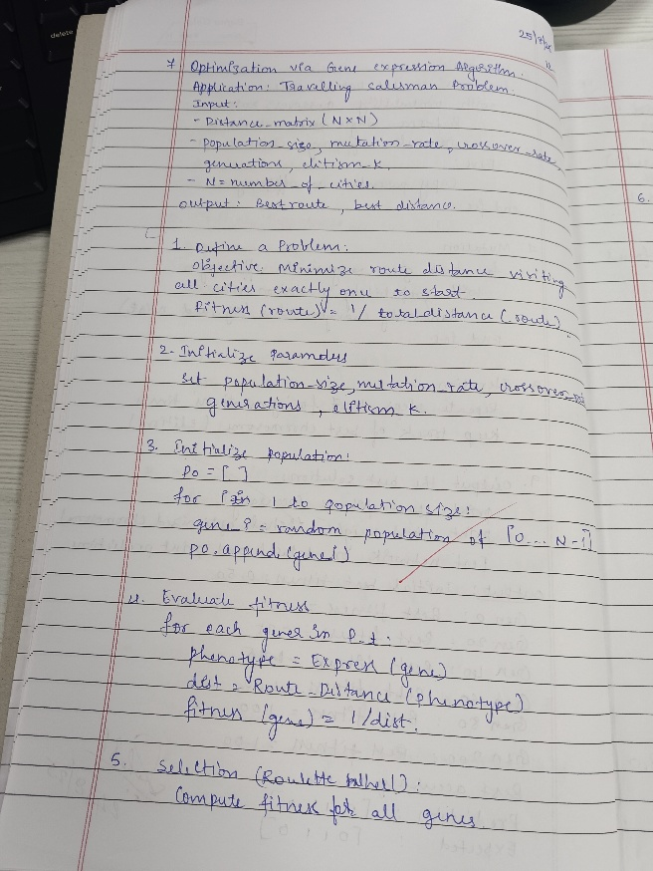 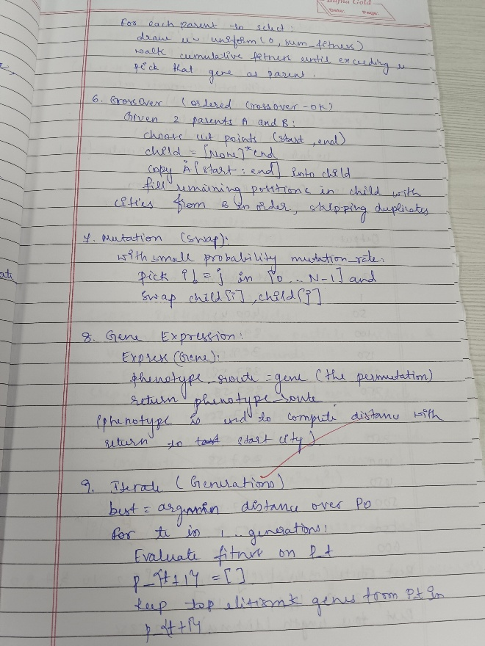

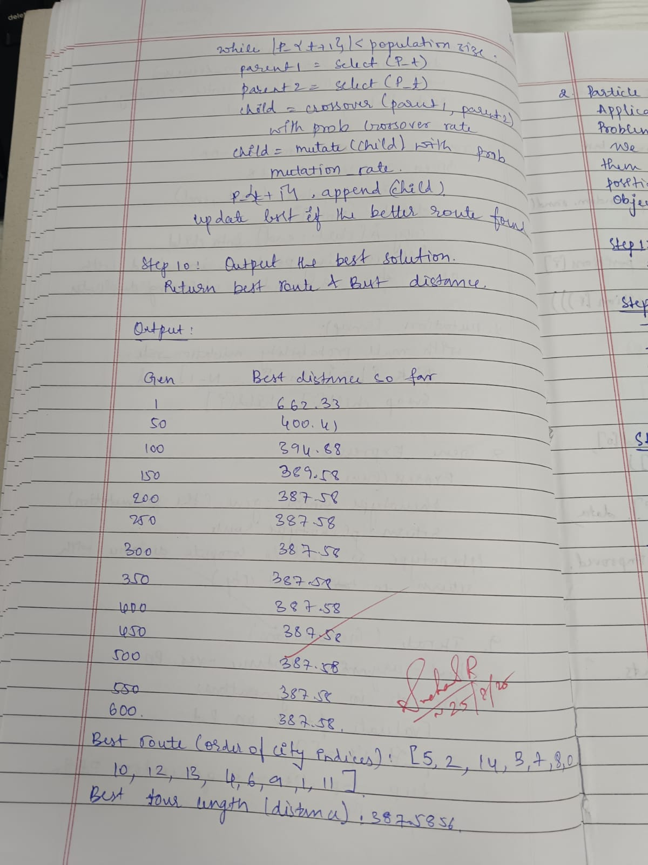

Code:

import random

import math

from typing import List, Tuple, Optional

# -----------------------------

# Utility: Distance / Fitness

# -----------------------------

def route_distance(route: List[int], distance_matrix: List[List[float]]) -> float:

"""

Total cyclic route distance (returns to starting city).

route = permutation of city indices, e.g., [0,2,1,3]

"""

n = len(route)

total = 0.0

for i in range(n):

a = route[i]

b = route[(i + 1) % n] # wrap to start

total += distance_matrix[a][b]

return total

def fitness_of(route: List[int], distance_matrix: List[List[float]]) -> float:

d = route_distance(route, distance_matrix)

# Avoid division by zero (shouldn't happen with positive distances)

return 1.0 / d if d > 0 else float("inf")

# -----------------------------

# Step 8: Gene Expression

# (For TSP, genotype == phenotype: permutation -> route)

# -----------------------------

def express_gene_to_route(gene: List[int]) -> List[int]:

return gene # identity mapping for TSP

# -----------------------------

# Step 5: Selection (Roulette Wheel)

# -----------------------------

def roulette_wheel_selection(population: List[List[int]],

fitnesses: List[float]) -> List[int]:

total_fit = sum(fitnesses)

# Fallback if all fitnesses are zero (shouldn't happen here)

if total_fit == 0.0:

return random.choice(population)

pick = random.uniform(0, total_fit)

current = 0.0

for ind, f in zip(population, fitnesses):

current += f

if current >= pick:

return ind

return population[-1]

# -----------------------------

# Step 6: Crossover (Ordered Crossover - OX)

# -----------------------------

def ordered_crossover(parent1: List[int], parent2: List[int]) -> List[int]:

n = len(parent1)

start, end = sorted(random.sample(range(n), 2))

child = [None] * n

# Copy slice from parent1

child[start:end] = parent1[start:end]

# Fill remaining from parent2 in order

ptr = end

for city in parent2:

if city not in child:

if ptr == n:

ptr = 0

child[ptr] = city

ptr += 1

return child

# -----------------------------

# Step 7: Mutation (Swap)

# -----------------------------

def swap_mutation(route: List[int], mutation_rate: float) -> List[int]:

child = route[:]

if random.random() < mutation_rate:

i, j = random.sample(range(len(child)), 2)

child[i], child[j] = child[j], child[i]

return child

# -----------------------------

# Step 3: Initialize Population

# -----------------------------

def initialize_population(num_cities: int, population_size: int) -> List[List[int]]:

return [random.sample(range(num_cities), num_cities)

for _ in range(population_size)]

# -----------------------------

# Step 9: Main GEA loop for TSP

# -----------------------------

def gea_tsp(distance_matrix: List[List[float]],

population_size: int = 100,

generations: int = 500,

mutation_rate: float = 0.10,

crossover_rate: float = 0.90,

elitism_k: int = 2,

seed: Optional[int] = 42) -> Tuple[List[int], float]:

"""

Solve TSP using a Gene Expression Algorithm.

Returns (best_route, best_distance).

"""

if seed is not None:

random.seed(seed)

num_cities = len(distance_matrix)

population = initialize_population(num_cities, population_size)

# Evaluate initial population

fitnesses = [fitness_of(express_gene_to_route(ind), distance_matrix)

for ind in population]

# Track best

best_idx = max(range(population_size), key=lambda i: fitnesses[i])

best_route = population[best_idx][:]

best_distance = route_distance(best_route, distance_matrix)

for gen in range(1, generations + 1):

# ---- Elitism: take top-k directly into next population ----

ranked = sorted(range(population_size),

key=lambda i: fitnesses[i],

reverse=True)

elites = [population[i][:] for i in ranked[:elitism_k]]

# ---- Build next generation ----

next_pop: List[List[int]] = elites[:]

while len(next_pop) < population_size:

# Step 5: Selection

p1 = roulette_wheel_selection(population, fitnesses)

p2 = roulette_wheel_selection(population, fitnesses)

# Step 6: Crossover

if random.random() < crossover_rate:

child = ordered_crossover(p1, p2)

else:

child = p1[:]

# Step 7: Mutation

child = swap_mutation(child, mutation_rate)

next_pop.append(child)

population = next_pop

# Step 4: Evaluate fitness of new population

fitnesses = [fitness_of(express_gene_to_route(ind), distance_matrix)

for ind in population]

# Update global best

gen_best_idx = max(range(population_size), key=lambda i: fitnesses[i])

gen_best_route = population[gen_best_idx]

gen_best_distance = route_distance(gen_best_route, distance_matrix)

if gen_best_distance < best_distance:

best_distance = gen_best_distance

best_route = gen_best_route[:]

# Optional: progress log

if gen % 50 == 0 or gen == 1 or gen == generations:

print(f"Gen {gen:4d} | Best distance so far: {best_distance:.4f}")

return best_route, best_distance

# -----------------------------

# Helper: Build a distance matrix from 2D coordinates (demo)

# -----------------------------

def euclidean_distance_matrix(points_2d: List[Tuple[float, float]]) -> List[List[float]]:

n = len(points_2d)

dist = [[0.0]*n for _ in range(n)]

for i in range(n):

x1, y1 = points_2d[i]

for j in range(n):

if i == j:

continue

x2, y2 = points_2d[j]

dx = x1 - x2

dy = y1 - y2

dist[i][j] = math.hypot(dx, dy)

return dist

# -----------------------------

# Example usage / quick test

# -----------------------------

if __name__ == "__main__":

# Example 1: fixed small distance matrix (5 cities)

# distance_matrix = [

# [0, 2, 9, 10, 7],

# [1, 0, 6, 4, 3],

# [15, 7, 0, 8, 3],

# [6, 3, 12, 0, 11],

# [9, 7, 5, 6, 0]

# ]

# Example 2: random points in 2D plane (visualizable case)

random.seed(1)

points = [(random.uniform(0, 100), random.uniform(0, 100)) for _ in range(15)]

distance_matrix = euclidean_distance_matrix(points)

best_route, best_distance = gea_tsp(

distance_matrix,

population_size=120,

generations=600,

mutation_rate=0.12,

crossover_rate=0.90,

elitism_k=3,

seed=7

)

print("\nBest route (order of city indices):", best_route)

print("Best tour length (distance):", round(best_distance, 4))