**AIR QUALITY MONITORING**

**Description:** An air quality monitoring system is a crucial tool in assessing and ensuring the cleanliness of the air we breathe. It consists of an array of sensors that constantly measure different air pollutants, ranging from particulate matter to harmful gases. These sensors are strategically placed in various locations to gather real-time data, providing a comprehensive view of air quality conditions.

**Design Thinking;**

1.**Project Objectives-**A real-time air quality monitoring system is a technologically advanced setup designed to continuously measure and assess various air pollutants and environmental parameters in the atmosphere.

*Public access and transparency,Government and regulatory agencies,Research institutions and academia,Healthcare professionals,Environmental and non governmental organization,Educational institutions,Industrial and commercial entities,International collaboration,Data aggregators and API,Emergency services.

*Educational Campaigns,Community workshops and seminars,Interactive Websites and Apps,School Programs,Engagement with Local leaders,Feedback mechanics.

*Respiratory issues like Asthma,Chronic Disease,Bronchitis, Cardiovascular disease like Heart attacks and strokes,Hypertension,Lung cancer,Premature mortality,Neurological and cognitive effects,adverse pregnancy outcomes,allergies and skin disorders,Mental health,Reduced lung function.

2.**Design-** For design ESP8266(Wifi-Module) and gas sensor(BME680) used for providing highly accurate measurement of indoor air quality, barometric pressure, relative humidity and ambient air temperature.It is a temperature sensor which measures ambient temperature in degrees Celsius (°C) or Fahrenheit (°F) and acts as a Humidity Sensor which validates relative humidity (RH) as a percentage, providing information about the moisture level in the environment.It also functions as a pressure sensor which analyze barometric pressure in hPa (hectopascals) or Pa (pascals), providing insights into altitude changes and weather forecasting and also acts as a Gas Sensor which measures the resistance of the gas-sensitive layer, providing an estimate of the indoor air quality (IAQ) based on volatile organic compounds (VOCs) present in the environment.

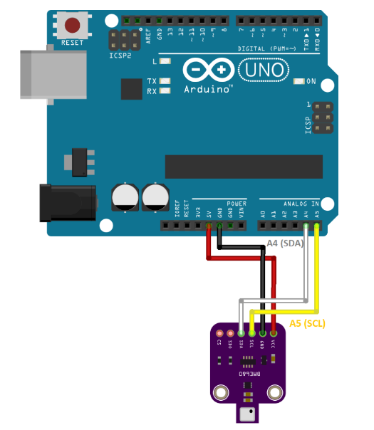

3D Design for Air-Quality-Monitoring-System

3.**Data sharing platform-** A web-app which shows the temperature,humidity,air quality and pressure.The data from sensor is stored to cloud in IoT cloud in arduino website.Then it will be displayed according to the respected UI which we have created.

*The data from BME680 will be displayed as real time data in the UI design in IoT cloud app.

4.**Integration Approach-**The data from BME680 will be summarized ,filtered and averaged to a raw data and converted to a JSON or XML format and establishes a connection to a data sharing platform with some protocols like MQTT,HTTP,CoAP and AMQP.The data sharing platform uses secure authentication mechanisms(Eg: API’s, Certificates and O auth tokens) and obtain the necessary authorization to send data.The API’s like IoT cloud app can be secure and encrypted to protect the data in transit.The data-sharing platform receives the transmitted data and processes it accordingly. This could involve parsing the data, performing validation checks, storing it in databases, triggering real-time actions, or applying analytics and machine learning algorithms for further insights.The data-sharing platform stores the received data in appropriate storage systems (Eg: databases, data lakes) for further analysis, visualization, and sharing.Authorized users or applications can access and retrieve the stored data from the data-sharing platform through APIs, dashboards, or other interfaces. The platform may also allow for data sharing with external stakeholders based on predefined permissions and rules.