**LAB PRACTICAL OVERVIEW**

**Cisco tracer lab assignments**

* **Configuring IP static routing using one router, two switches and four PC’s.**

**Objective**To build a network where multiple PCs connected with two switches can communicate with one another through a single router that uses static IP routing. The idea in this solution is to configure the network without depending on dynamic routing protocols.

**Equipment Required**

* **1 Router**
* **2 Switches**
* **4 PCs**
* **Ethernet cables for connections**

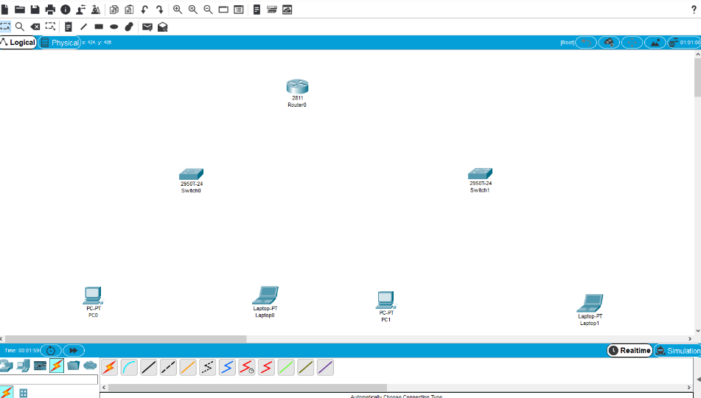

**Network Topology**

* Router with two interfaces (let us call them F0/0 and F0/1).
* Switch 1 connects to PC1 and PC2.
* Switch 2 connects to PC3 and PC4.
* Router F0/0 connects to Switch 1.
* Router F0/1 connects to Switch 2.

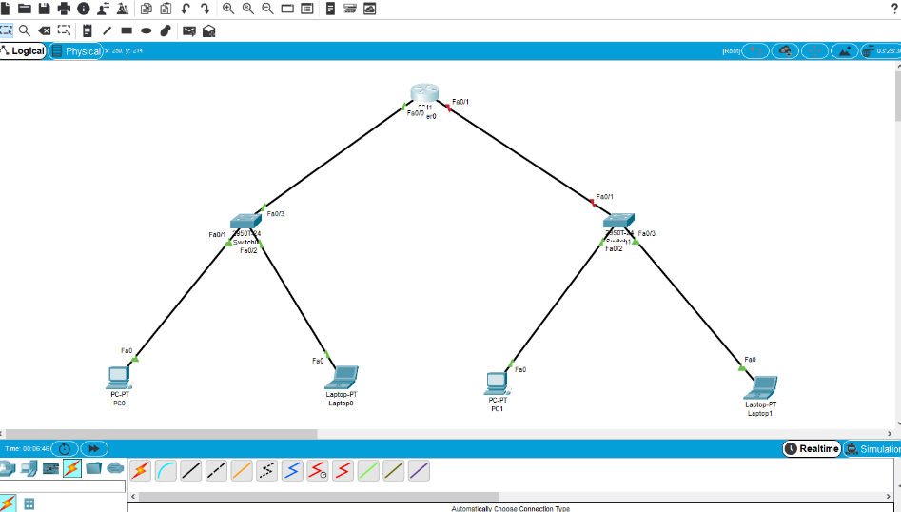

* **Step-by-Step Configuration**  
  **IP Address Assignment**  
  For all PCs and router interfaces, assign IP addresses. Here's an example:

**Now setup IP address, default gateways and subnet mask for all the PC’s o to do so, click on the PC1 > Go to config> select fast ethernet0>enter the IPV4 address**

* PC0 IP: 192.168.1.2

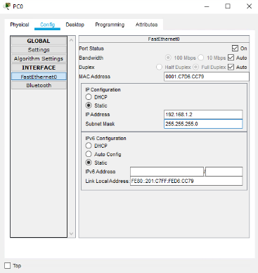

* PC1 IP: 192.168.1.3

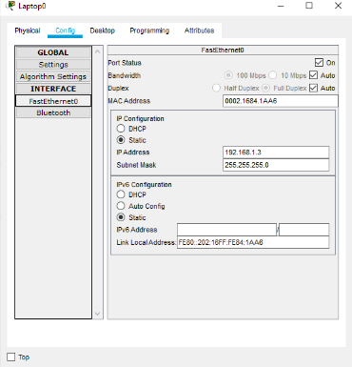

* PC2 IP: 192.168.2.2

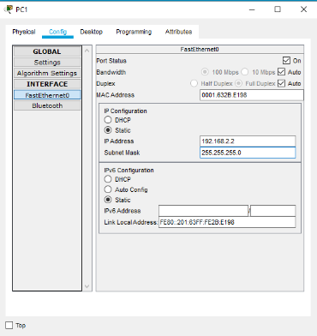

* PC3 IP: 192.168.2.3

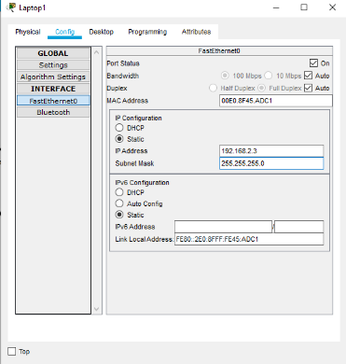

* Router Interface F0/0 IP: 192.168.1.1(connects to Switch 1)

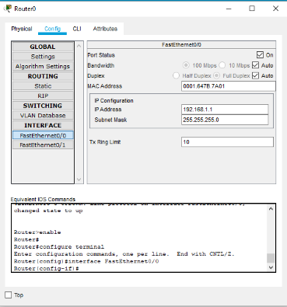

* Router Interface F0/1 IP: 192.168.2.1 (connects to Switch 2)

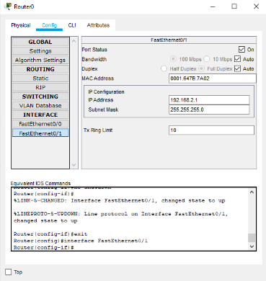

**Configure PCs Gateway**

* Give each PC a static IP address in their subnet.
* On each PC open Network Settings
* Set IP address, subnet mask 255.255.255.0, and default gateway (the router's IP on each network).
* For example:  
    
  **PC1 Gateway: 192.168.1.1  
  PC2 Gateway: 192.168.1.1  
  PC3 Gateway: 192.168.2.1  
  PC4 Gateway: 192.168.2.1**

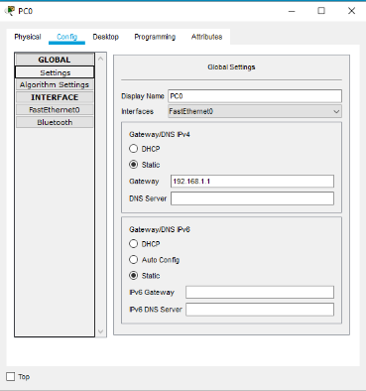

*Follow the Same to the Other PCs

* **Testing the PCs:**

Once final setting over we checked it the networking using the drag and drop the message from Simple pdu icon from PC1 to PC2 it successful transferred and From PC3 toPC4 it also successfully transferred

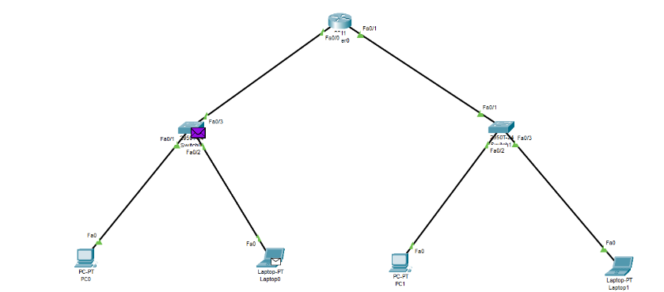

* **Checking the Ping of PCs**

Go to Desktop > Commend Prompt> ping 192.168.1.2

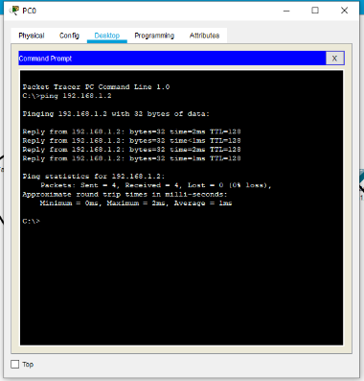

*Follow the Same with Other PCs to Check Ping

**Conclusion**  
This lab practical helps understand the basics of static routing, assigning IP addresses, and configuring routers to forward the traffic to other networks. It highlights the protocol implementation issue, proper configuration, and troubleshooting in network setup.