I also like to bake. I’m not a photographer—sorry in advance for the poor picture quality. Here’s an abridged collection of some of my baking exploits. Some items not included: Yule Log Cake and New York-Style Cheesecake.
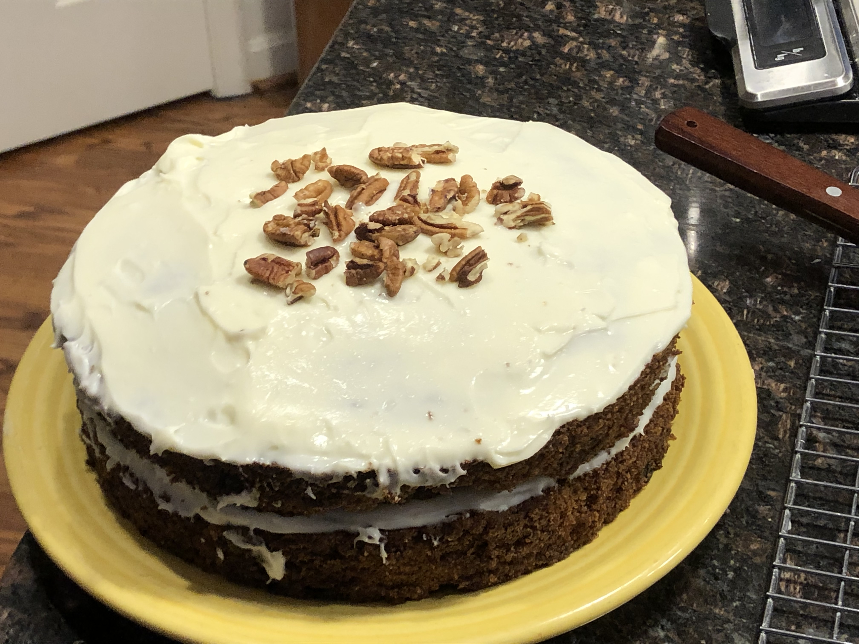Carrot Cake

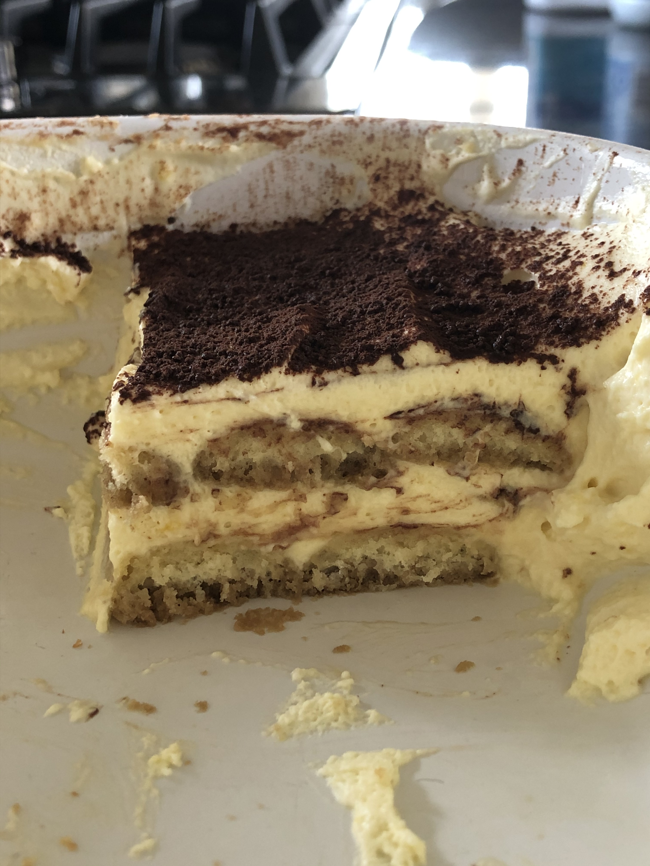Tiramisu

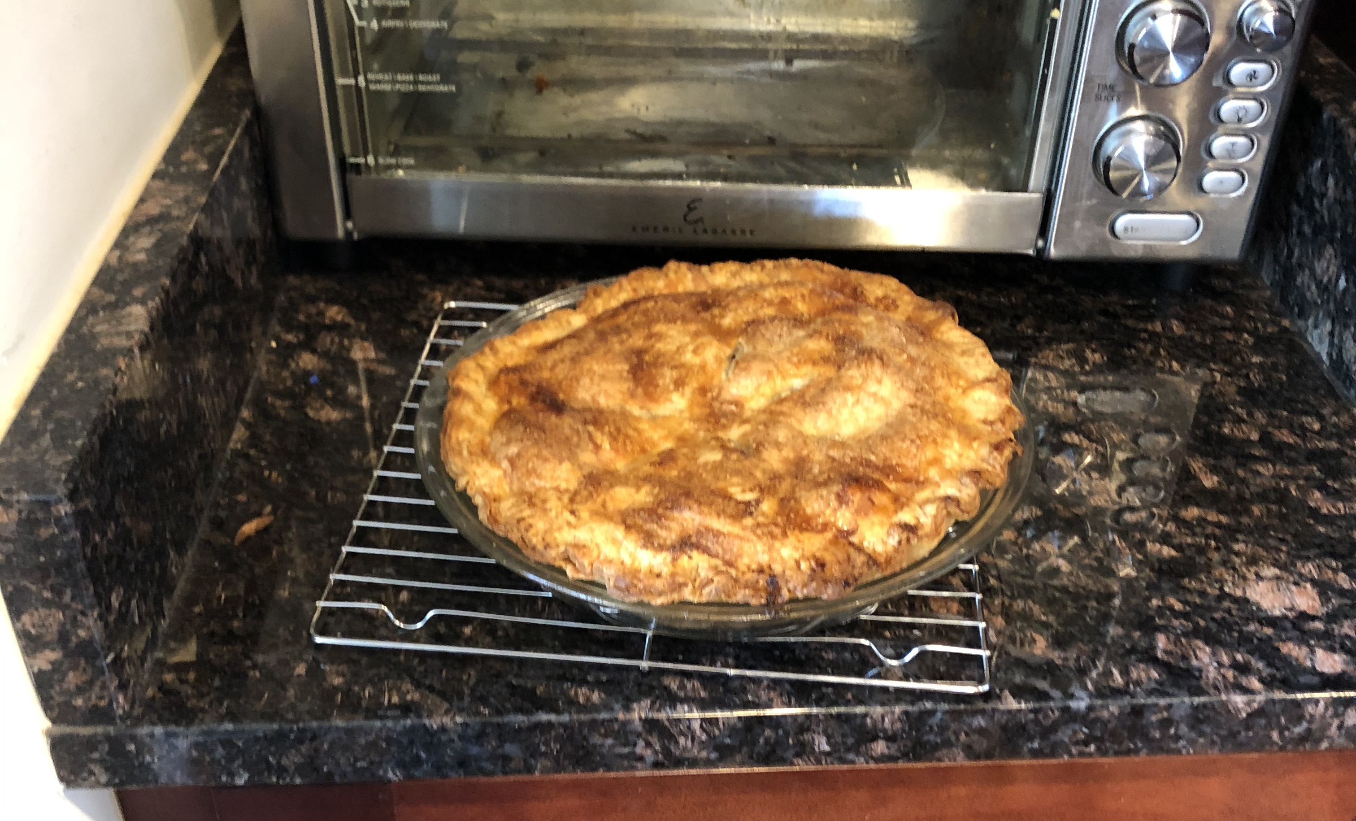Apple Pie
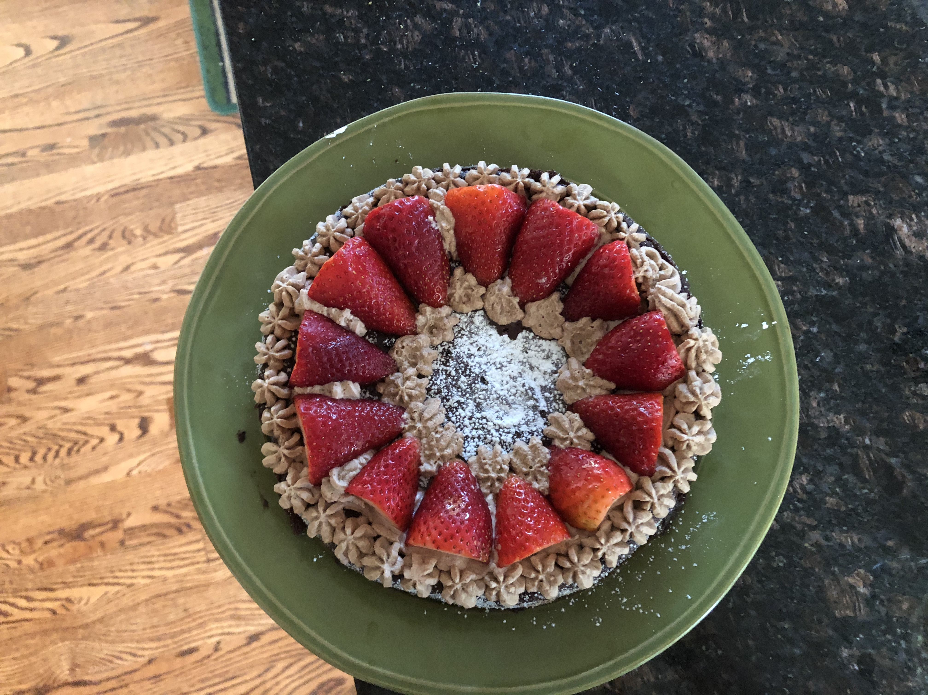Chocolate Torte

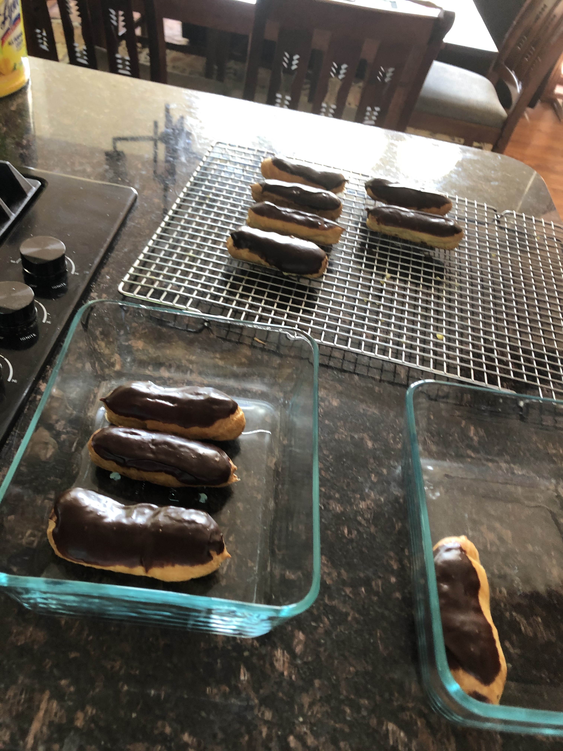Eclairs

