AZURE DATA LANDING ZONE
Technical Architecture & Implementation Documentation

Data Platform built with Terraform, Azure DevOps CI/CD,Azure Databricks, ADLS Gen2, and Azure Data Factory
Intern  Navdeep | GPN#  20230288171
Platform  Data | Mentor  Menaka Arivanandham

Table of Contents
Table of Contents 2
1. Executive Summary 3
2. High-Level Architecture 3
3. Multi-Subscription Design 4
3.1 Identity Subscription 4
3.2 Connectivity Subscription 5
3.3 Management Subscription 5
3.4 Data Landing Zone Subscription (DLZ) 5
4. Terraform Infrastructure-as-Code 7
4.1 Repository Structure 7
4.2 Remote State Backend 8
4.3 Reusable Modules 9
5. Azure DevOps CI/CD Pipeline 10
5.1 Pipeline Configuration 10
5.2 Pipeline Stage Details 11
6. Data Landing Zone — Detailed Components 12
6.1 Azure Data Lake Storage Gen2 (ADLS) 12
6.2 Azure Databricks Workspace 12
6.3 Access Connector for Databricks 13
6.4 RBAC Security Configuration 13
6.5 Azure Data Factory 14
7. ADF Git Integration — GitOps Workflow 15
8. Databricks to ADLS MSI Integration & Validation 16
8.1 Authentication Configuration 16
8.2 End-to-End Validation Tests 16
8.3 Challenges Resolved 16
9. End-to-End Data Flow 18
9.1 Step-by-Step Flow Description 18
10. Challenges Encountered & Resolutions 20
11. Full Deployment Checklist 21
12. Presentation Demo Narrative 22
12.1 Recommended Demo Flow 22
12.2 Key Points to Emphasise 22
13. Conclusion 23

1. Executive Summary
This document provides a complete technical reference for the Azure Data Landing Zone (DLZ) project. The implementation delivers a production-ready, enterprise-grade cloud data platform aligned with Microsoft's Cloud Adoption Framework (CAF). It is designed to serve as the foundational data infrastructure layer for all current and future data workloads within the organization.

Project Objectives
✔ Establish a secure, scalable, multi-subscription Azure landing zone
✔ Automate all infrastructure deployments using Terraform (Infrastructure-as-Code)
✔ Implement end-to-end CI/CD pipelines via Azure DevOps
✔ Deploy a complete data platform: ADLS Gen2, Azure Databricks, Azure Data Factory
✔ Enable secure Managed Identity authentication between Databricks and ADLS
✔ Integrate Azure Data Factory with Git for full GitOps-style deployment
✔ Follow Microsoft CAF best practices for governance, security, and network isolation

2. High-Level Architecture
The solution is architected around Microsoft's Cloud Adoption Framework (CAF) landing zone model. Resources are distributed across four dedicated Azure subscriptions, each serving a specific architectural domain. This isolation provides clear governance boundaries, independent billing, and security controls at the subscription level.

AZURE DATA LANDING ZONE — END-TO-END ARCHITECTURE
Identity Subscription |  | Connectivity Subscription |  | Management Subscription |  | Data Landing Zone Sub
▼ |  | ▼ |  | ▼ |  | ▼
• Key Vault  • VNet + Subnet  • rg-identity |  | • Hub VNet  • VNet Peerings  • Subnets |  | • Log Analytics  • Diagnostics  • Monitoring |  | • ADLS Gen2  • Databricks  • ADF  • Access Conn.  • Managed ID

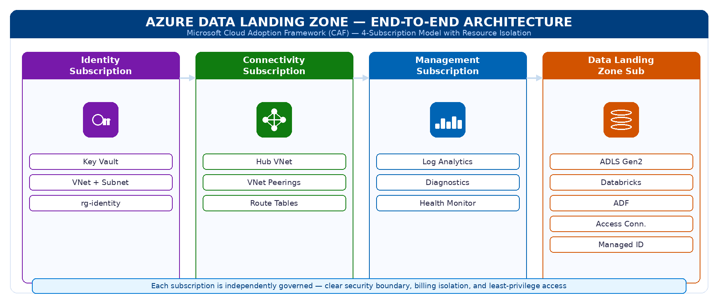
Figure 1: Multi-Subscription Architecture Overview — 4-subscription CAF model with resource distribution

📸 SCREENSHOT PLACEHOLDER
Screenshot: Azure Portal — All 4 Subscriptions visible in the Azure Active Directory

3. Multi-Subscription Design
Each subscription is isolated and purpose-built to follow the principle of least privilege and separation of concerns. This ensures that a failure or misconfiguration in one subscription does not propagate to others.

3.1 Identity Subscription
The Identity Subscription hosts foundational identity and security resources that are shared across the entire platform. This is the first subscription to be deployed in the pipeline, as downstream subscriptions depend on its outputs.
Component | Resource Name | Purpose
Resource Group | rg-identity | Container for all identity-layer resources
Virtual Network | identity-vnet | Network isolation for identity workloads
Subnet | identity-subnet | Subnet for identity services and connectivity
Key Vault | kv-navdeep-identity | Secure storage of secrets, certificates, and keys

📸 SCREENSHOT PLACEHOLDER
Screenshot: Azure Portal — rg-identity Resource Group showing Key Vault and VNet resources

3.2 Connectivity Subscription
The Connectivity Subscription manages all network-level resources. It acts as the network hub in a hub-and-spoke topology, with peerings connecting to the Management and Data Landing Zone subscriptions.
Component | Resource Name | Purpose
Hub VNet | hub-vnet | Central network hub for cross-subscription traffic
Subnets | multiple subnets | Segmented network zones for different workload types
VNet Peerings | hub-to-mgmt, hub-to-dlz | Cross-subscription network connectivity
Routing | route tables | Traffic routing between spokes and hub

📸 SCREENSHOT PLACEHOLDER
Screenshot: Azure Portal — Hub VNet showing peering connections to Management and DLZ subscriptions

3.3 Management Subscription
The Management Subscription provides centralized monitoring, logging, and observability for the entire platform. All diagnostic settings from other subscriptions feed into the Log Analytics Workspace deployed here.
Component | Resource Name | Purpose
Log Analytics | law-navdeep-mgmt | Centralized log aggregation and query workspace
Diagnostic Settings | platform-diagnostics | Collection of logs and metrics from all resources
Resource Health | health-monitoring | Azure service health and resource health tracking

📸 SCREENSHOT PLACEHOLDER
Screenshot: Azure Portal — Log Analytics Workspace with connected data sources

3.4 Data Landing Zone Subscription (DLZ)
This is the primary focus of the project. The Data Landing Zone subscription contains all data platform components. This is where data is ingested, stored, processed, and orchestrated. All five core data components are deployed here.
Component | Resource Name | Purpose
ADLS Gen2 | adlsnavdeep | Data lake storage with hierarchical namespace enabled
Databricks Workspace | databricks-dlz-navdeep | Premium Spark-based analytics and processing
Access Connector | adb-access-connector-navdeep | Enables MSI-based Databricks-to-ADLS auth
User Assigned MI | mi-databricks-navdeep | Managed Identity for secure, keyless authentication
Azure Data Factory | adf-navdeep-dlz | Data orchestration, ingestion pipelines
RBAC Assignment | Storage Blob Data Contributor | Grants Databricks MSI read/write on ADLS

📸 SCREENSHOT PLACEHOLDER
Screenshot: Azure Portal — Data Landing Zone Resource Group showing all deployed resources

4. Terraform Infrastructure-as-Code
All infrastructure in this project is managed as code using Terraform. This enables versioning, repeatability, peer review, and automated deployment of every Azure resource. No manual portal deployments are used for infrastructure provisioning.

4.1 Repository Structure
The repository follows a subscription-per-folder structure with a shared modules directory. This allows each subscription to be deployed and managed independently, while sharing common reusable modules.

TERRAFORM REPOSITORY STRUCTURE
azure-data-landing-zone/
├── identity/
│ ├── main.tf
│ ├── variables.tf
│ ├── outputs.tf
│ └── terraform.tfvars
├── connectivity/
│ ├── main.tf | variables.tf | outputs.tf | terraform.tfvars
├── management/
│ ├── main.tf | variables.tf | outputs.tf | terraform.tfvars
├── data_lz/
│ ├── main.tf | variables.tf | outputs.tf | terraform.tfvars
├── modules/
│ ├── vnet/
│ ├── key_vault/
│ ├── storage/
│ ├── databricks/
│ ├── adf/
│ └── access_connector/
└── .azure-pipelines/
└── terraform-lz.yml

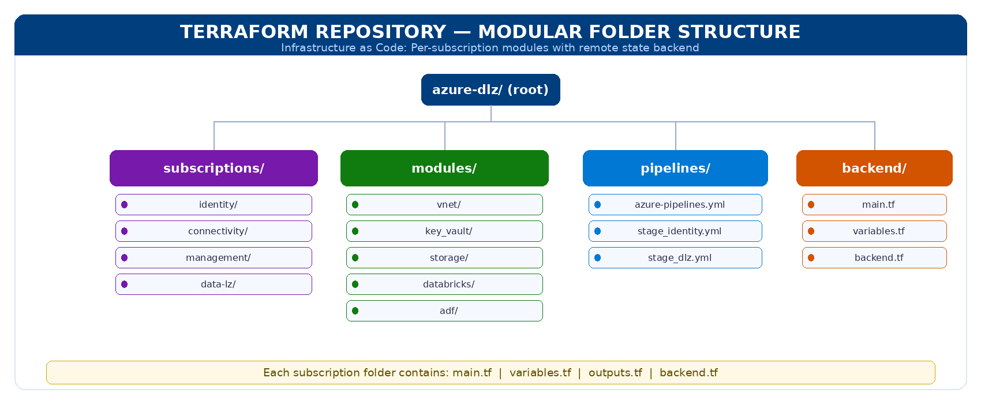
Figure 2: Terraform repository folder structure showing modular, per-subscription organisation

📸 SCREENSHOT PLACEHOLDER
Screenshot: VS Code or GitHub — Repository folder structure showing all four subscription folders

4.2 Remote State Backend
A centralised remote backend is configured to store Terraform state files. This enables team collaboration, prevents state drift, and provides state locking to prevent concurrent executions.

Property | Value
Resource Group | tfstate-rg
Storage Account | tfstatebackendnavdeep
Container | tfstate
Identity State File | identity.tfstate
Connectivity State File | connectivity.tfstate
Management State File | management.tfstate
Data LZ State File | data_lz.tfstate
State Locking | Enabled (Azure Blob lease-based)
Versioning | Enabled on Storage Account

📸 SCREENSHOT PLACEHOLDER
Screenshot: Azure Portal — Storage Account 'tfstatebackendnavdeep' showing tfstate container and .tfstate files

4.3 Reusable Modules
The modules directory contains standalone, reusable Terraform modules. Each module encapsulates the logic for a specific Azure resource type. Modules accept variables as inputs and return outputs consumed by other modules or root configurations.
- vnet/ — Deploys Virtual Networks and subnets with configurable address spaces
- key_vault/ — Deploys Azure Key Vault with access policies and soft-delete configuration
- storage/ — Deploys ADLS Gen2 with hierarchical namespace, containers, and lifecycle policies
- databricks/ — Deploys Azure Databricks workspace with premium SKU and no-public-IP configuration
- adf/ — Deploys Azure Data Factory with Git integration and managed identity
- access_connector/ — Deploys the Databricks Access Connector with SystemAssigned identity

📸 SCREENSHOT PLACEHOLDER
Screenshot: VS Code — One of the Terraform module files (e.g., storage/main.tf) showing ADLS configuration

5. Azure DevOps CI/CD Pipeline
The entire infrastructure deployment is automated through an Azure DevOps multi-stage YAML pipeline. Every code commit to the main branch triggers the pipeline, which sequentially deploys all four landing zones in the correct dependency order.

AZURE DEVOPS CI/CD PIPELINE — MULTI-STAGE TERRAFORM DEPLOYMENT
Stage 1  Identity  • rg-identity  • Key Vault  • VNet + Subnet  • Identity Resources | → | Stage 2  Connectivity  • Hub VNet  • Subnets  • VNet Peerings  • Routing Setup | → | Stage 3  Management  • Log Analytics  • Diagnostics  • Monitoring  • Health Checks | → | Stage 4  Data LZ  • ADLS Gen2  • Databricks  • Access Connector  • ADF + RBAC
Each stage: terraform init → terraform plan → terraform apply | SPN Auth | Remote State Backend | Auto Lock/Unlock

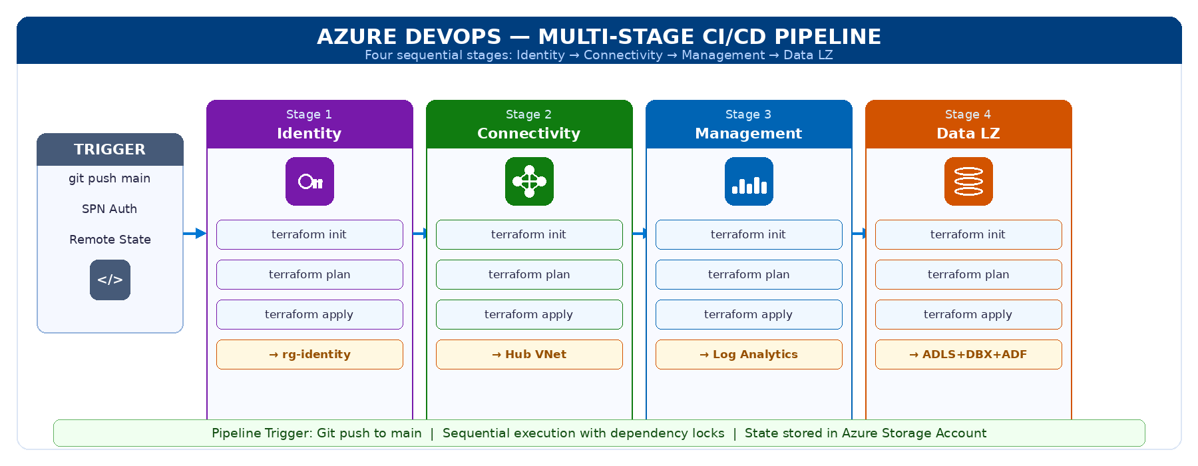
Figure 3: Multi-stage CI/CD pipeline — four sequential stages with Terraform deploy for each subscription

📸 SCREENSHOT PLACEHOLDER
Screenshot: Azure DevOps — Pipeline run showing all 4 stages completed successfully (green ticks)

5.1 Pipeline Configuration
Configuration | Details
Pipeline File | .azure-pipelines/terraform-lz.yml
Trigger | On push to main branch
Agent Pool | ubuntu-latest / windows-latest
Authentication | Service Principal (SPN) via Azure Service Connection
Terraform Version | Manually installed in pipeline (resolves ENOENT issues)
Backend Init | terraform init -reconfigure (prevents backend migration errors)
State Locking | Auto-lock on apply, auto-unlock on completion or failure
ARM Variables | Auto-exported from Azure Service Connection

5.2 Pipeline Stage Details
Each stage follows the same pattern: install Terraform, initialise backend, run plan, and apply. Stages run sequentially to respect resource dependencies across subscriptions.
- Stage 1 — Identity: Deploys rg-identity, Key Vault, VNet, and Subnet. Must complete before downstream stages.
- Stage 2 — Connectivity: Deploys Hub VNet, subnets, and VNet peerings. Depends on identity outputs.
- Stage 3 — Management: Deploys Log Analytics Workspace and diagnostic settings.
- Stage 4 — Data Landing Zone: Deploys ADLS Gen2, Databricks, Access Connector, Managed Identity, ADF, and RBAC assignments. This is the most complex stage.

📸 SCREENSHOT PLACEHOLDER
Screenshot: Azure DevOps — Stage 4 (Data LZ) pipeline logs showing terraform apply output

6. Data Landing Zone — Detailed Components
This section describes each deployed component in the Data Landing Zone subscription in detail, including its configuration, purpose, and relationship to other components.

6.1 Azure Data Lake Storage Gen2 (ADLS)
ADLS Gen2 is the central storage layer for the data platform. It provides a hierarchical namespace (like a true file system) on top of Azure Blob Storage, enabling high-performance analytics workloads. All raw ingested data and processed output data resides here.
Property | Value
Storage Account Name | adlsnavdeep
Account Kind | StorageV2
Performance Tier | Standard
Replication | LRS (Locally Redundant Storage)
Hierarchical Namespace | Enabled (true ADLS Gen2)
Container: raw | Landing zone for unprocessed source data
Container: processed | Output zone for Databricks-transformed data
Access Method | Managed Identity (no account keys)
TLS Version | TLS 1.2 minimum

📸 SCREENSHOT PLACEHOLDER
Screenshot: Azure Portal — ADLS Gen2 Storage Account showing containers (raw, processed) and Hierarchical Namespace enabled

6.2 Azure Databricks Workspace
Azure Databricks provides the managed Apache Spark environment for data transformation, ML model development, and analytics processing. The workspace is deployed in the DLZ subscription with Premium tier to enable Unity Catalog and advanced security features.
Property | Value
Workspace Name | databricks-dlz-navdeep
SKU | Premium
Public IP | Disabled (secure deployment)
Subscription | Data Landing Zone
Deployment Method | Terraform azurerm_databricks_workspace
Integration | Connected to ADLS via Access Connector + MSI

📸 SCREENSHOT PLACEHOLDER
Screenshot: Azure Portal — Databricks Workspace resource showing Premium SKU and deployment details
📸 SCREENSHOT PLACEHOLDER
Screenshot: Databricks UI — Workspace home page showing clusters and notebooks

6.3 Access Connector for Databricks
The Access Connector for Databricks is a critical resource that bridges Databricks and Azure storage services using Managed Identities. It eliminates the need for storage account keys or service principal secrets in notebook code, providing a zero-secret authentication architecture.
Property | Value
Resource Name | adb-access-connector-navdeep
Identity Type | SystemAssigned
Purpose | MSI-based authentication to ADLS Gen2
Deployment Method | Terraform azurerm_databricks_access_connector
Key Benefit | No storage account keys required in code

📸 SCREENSHOT PLACEHOLDER
Screenshot: Azure Portal — Access Connector resource showing SystemAssigned Managed Identity principal ID

6.4 RBAC Security Configuration
Role-Based Access Control (RBAC) is used throughout the platform to grant least-privilege access. The most critical RBAC assignment enables the Databricks Access Connector's Managed Identity to read and write data on the ADLS Gen2 storage account.

SECURITY & RBAC MODEL
Access Connector for Databricks
(adb-access-connector-navdeep)
↓ SystemAssigned Managed Identity ↓
RBAC Role Assigned: Storage Blob Data Contributor
↓ Applied on ↓
ADLS Gen2 Storage Account
abfss://raw@<storage>.dfs.core.windows.net/
No Storage Account Keys Required — Pure MSI Auth

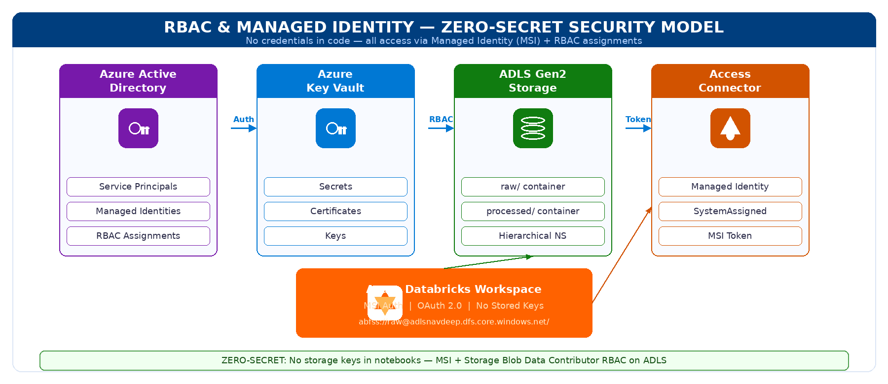
Figure 4: RBAC and Managed Identity security model — zero-secret, MSI-based Databricks-to-ADLS authentication

📸 SCREENSHOT PLACEHOLDER
Screenshot: Azure Portal — ADLS Gen2 IAM blade showing 'Storage Blob Data Contributor' role assigned to Access Connector MSI

6.5 Azure Data Factory
Azure Data Factory (ADF) is the data orchestration layer responsible for building and running data ingestion and transformation pipelines. It is connected to Azure DevOps Git for version-controlled pipeline development following GitOps principles.
Property | Value
ADF Instance Name | adf-navdeep-dlz
Subscription | Data Landing Zone
Git Integration | Azure DevOps Git (enabled)
Collaboration Branch | main
Publish Branch | adf_publish
ARM Templates | Auto-generated to adf_publish branch
Deployment Method | Terraform + Git-backed configuration

📸 SCREENSHOT PLACEHOLDER
Screenshot: Azure Data Factory Studio — showing pipelines, datasets, and linked services

7. ADF Git Integration — GitOps Workflow
Azure Data Factory is configured with full Git integration following Microsoft's recommended GitOps architecture for ADF. This enables collaborative pipeline development with version control, pull request reviews, and automated deployment.

ADF GIT INTEGRATION — GITOPS WORKFLOW
Azure Data Factory  Author Pipelines, Datasets, Linked Services | → | Azure DevOps Git  Collab Branch: main Publish Branch: adf_publish JSON Config Files | → | ARM Templates (adf_publish)  Auto-generated Deployment Templates CI/CD Ready

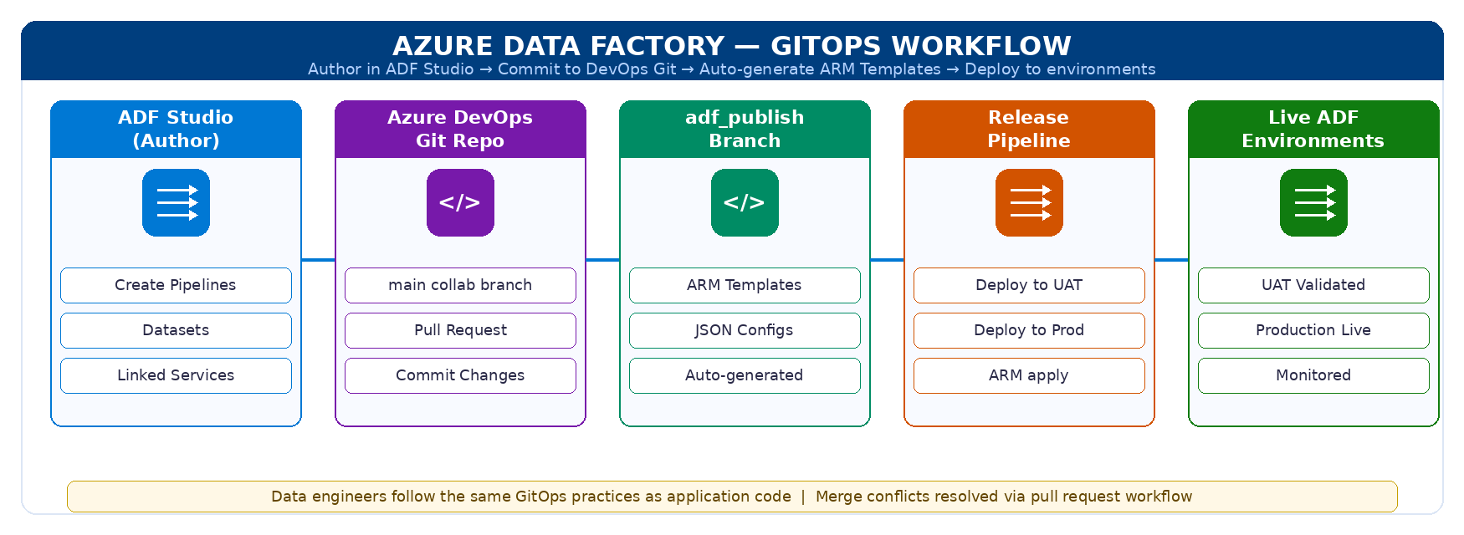
Figure 5: ADF GitOps workflow — Author in ADF Studio, commit to DevOps Git, auto-generate ARM templates for deployment

The GitOps flow works as follows:
- Data engineers author pipelines, datasets, and linked services in the ADF Studio UI
- Changes are committed to the main (collaboration) branch in Azure DevOps
- Publishing from ADF triggers auto-generation of ARM templates to the adf_publish branch
- These ARM templates can then be deployed to higher environments (UAT, Prod) via release pipelines
- Merge conflicts in JSON configuration are resolved through standard Git pull request workflows

📸 SCREENSHOT PLACEHOLDER
Screenshot: Azure DevOps Repo — ADF repository showing main branch and adf_publish branch with ARM template files
📸 SCREENSHOT PLACEHOLDER
Screenshot: ADF Studio — Git integration settings panel showing collaboration branch and publish branch configuration

8. Databricks to ADLS MSI Integration & Validation
One of the most technically involved aspects of this project is configuring Databricks to read from and write to ADLS Gen2 using Managed Identity authentication exclusively. This eliminates the security risk of storing storage account keys in notebook code or cluster configuration.

8.1 Authentication Configuration
The following Spark configuration is applied on the Databricks cluster to enable MSI-based ADLS access. Critically, any existing spark.hadoop.fs.azure.account.key configurations must be removed, as these override MSI authentication.
Spark Cluster Configuration (MSI Authentication)
spark.hadoop.fs.azure.account.auth.type.<storage>.dfs.core.windows.net = OAuth
spark.hadoop.fs.azure.account.oauth.provider.type.<storage>.dfs.core.windows.net
= org.apache.hadoop.fs.azurebfs.oauth2.MsiTokenProvider
spark.hadoop.fs.azure.account.oauth2.msi.endpoint.<storage>.dfs.core.windows.net
= http://169.254.169.254/token
NOTE: Remove any fs.azure.account.key.* configurations to prevent key override

8.2 End-to-End Validation Tests
After deployment, the integration was validated using Databricks notebooks with the following test operations:
- Test 1 — List files in raw container: dbutils.fs.ls('abfss://raw@adlsnavdeep.dfs.core.windows.net/')
- Test 2 — Write file to raw container: dbutils.fs.put('abfss://raw@.../test.txt', 'hello world', True)
- Test 3 — Read file back from raw container: dbutils.fs.head('abfss://raw@.../test.txt')
- Test 4 — Write transformed output to processed container: df.write.parquet('abfss://processed@...')
- Test 5 — Verify file appears in Azure Portal ADLS containers after write

📸 SCREENSHOT PLACEHOLDER
Screenshot: Databricks Notebook — showing successful MSI-based read/write to ADLS Gen2 (abfss:// path)
📸 SCREENSHOT PLACEHOLDER
Screenshot: Azure Portal — ADLS raw container showing test file written by Databricks notebook

8.3 Challenges Resolved
Several real-world issues were encountered and resolved during this integration:
- Issue: MSI authentication silently failing due to existing account key spark config overriding OAuth. Resolution: Removed all spark.hadoop.fs.azure.account.key.* entries from cluster config.
- Issue: Access Connector not appearing in Azure Portal UI. Resolution: Deployed via CLI/Terraform with correct identityType parameter value.
- Issue: Cluster configuration not taking effect. Resolution: Full cluster restart required after spark config changes.

9. End-to-End Data Flow
The complete data flow through the platform follows a standard medallion-style architecture pattern, moving data from raw ingestion through transformation to the processed (curated) layer.

DATA FLOW — SOURCE TO PROCESSED
Source Systems | → | ADF Pipeline | → | ADLS Gen2 (RAW Zone) | → | Databricks Notebook | →
▼
 |  |  | ADLS Gen2 (PROCESSED Zone)

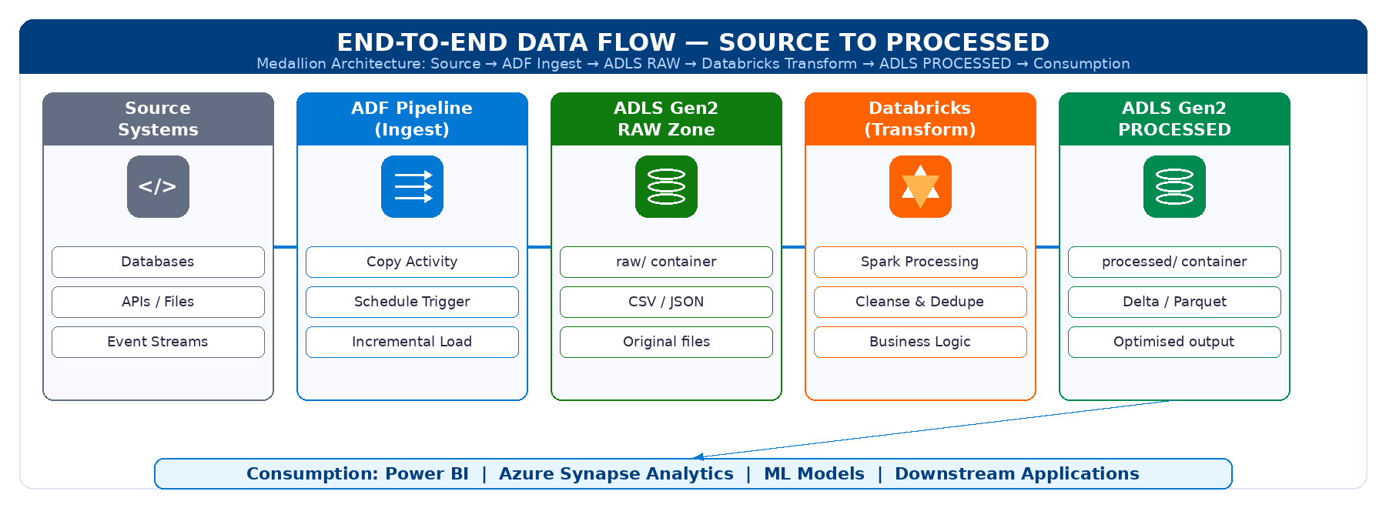
Figure 6: End-to-end data flow — Source Systems → ADF → ADLS RAW → Databricks → ADLS PROCESSED

9.1 Step-by-Step Flow Description
Step | Description
1. Source Data | Raw data originates from source systems (databases, APIs, files, event streams)
2. ADF Ingestion | ADF pipeline copies source data into the ADLS raw container using Copy Activity
3. Raw Zone Storage | Data lands in ADLS raw/ container as original, unmodified files (CSV, JSON, Parquet)
4. Databricks Processing | Databricks notebook reads from raw using abfss:// protocol with MSI authentication
5. Transformation | Spark jobs apply data cleansing, type casting, deduplication, and business logic
6. Processed Zone | Transformed data written to ADLS processed/ container in optimised Parquet/Delta format
7. Consumption | Downstream tools (Synapse, Power BI, ML models) can read from the processed zone

📸 SCREENSHOT PLACEHOLDER
Screenshot: ADF Studio — Example pipeline showing Copy Activity from source to ADLS raw container

10. Challenges Encountered & Resolutions
This section documents the key technical challenges encountered during the project and the solutions implemented. This demonstrates advanced problem-solving capability with real Azure and Terraform deployments.

Challenge | Resolution
Terraform ENOENT errors in DevOps pipeline | Resolved by manually installing Terraform in the pipeline YAML before any terraform commands. Added explicit path configuration for the agent.
Backend reconfigure errors on re-run | Added terraform init -reconfigure flag to force backend re-initialisation without requiring manual state migration approval.
tfstate lock conflicts during concurrent runs | Implemented proper pipeline sequencing so only one stage runs at a time. Added lock timeout and unlock logic for failed runs.
Databricks MSI failing silently — key override | Removed all spark.hadoop.fs.azure.account.key.* config entries from cluster. These were overriding the OAuth MSI config without throwing an error.
Access Connector not visible in Azure Portal | Deployed via Terraform using azurerm_databricks_access_connector with correct identityType. Portal bug — resource exists even when not visible immediately.
CLI failing due to identityType parameter | Corrected the identityType from 'SystemAssignedIdentity' to 'SystemAssigned' as per the current API spec.
ADF merge conflicts in JSON | Resolved through standard Git pull request workflow, using ADF Studio's built-in conflict resolution and careful branch management.
VNet to subnet reference errors in Terraform | Fixed by using the correct data source reference for subnet IDs rather than hardcoded strings. Resolved ordering dependency with depends_on.
Multi-subscription SPN authentication | Configured separate service connections in Azure DevOps for each subscription, with appropriate ARM_SUBSCRIPTION_ID per stage.

11. Full Deployment Checklist
The following checklist summarises every completed deployment step for this project. All items have been successfully deployed and validated.

Infrastructure & IaC
✔ Terraform remote backend configured (Storage Account + Container + State files)
✔ Identity Subscription — rg-identity, Key Vault, VNet, Subnet deployed
✔ Connectivity Subscription — Hub VNet, Subnets, VNet Peerings deployed
✔ Management Subscription — Log Analytics, Diagnostic Settings deployed
✔ Data LZ Subscription — all 6 core resources deployed
✔ All modules created and tested: vnet, key_vault, storage, databricks, adf, access_connector

CI/CD & Automation
✔ Azure DevOps multi-stage pipeline created and tested
✔ 4 pipeline stages (Identity → Connectivity → Management → Data LZ)
✔ SPN authentication configured via Azure Service Connection
✔ Terraform auto-install, init, plan, apply working end-to-end
✔ State locking and backend reconfiguration working correctly

Data Platform Validation
✔ ADLS Gen2 storage account with raw + processed containers live
✔ Databricks Premium workspace deployed and accessible
✔ Access Connector deployed with SystemAssigned MSI
✔ RBAC: Storage Blob Data Contributor assigned to Databricks MSI on ADLS
✔ MSI authentication validated via Databricks notebook (read + write + verify)
✔ ADF Git integration configured (main + adf_publish branches)
✔ End-to-end data flow validated: ingest → raw → transform → processed

12. Presentation Demo Narrative
The following narrative provides a structured walkthrough for presenting this project. Use this sequence to guide your audience through the architecture and demonstrate the platform live.

12.1 Recommended Demo Flow
Step | What to Show
1. Architecture Overview | Explain the 4-subscription model using the architecture diagram. Highlight CAF alignment.
2. Azure Portal — Subscriptions | Open Azure Portal and show all 4 subscriptions. Navigate to each resource group.
3. Terraform Repository | Walk through the folder structure in GitHub/VS Code. Show a module file (e.g., storage/main.tf).
4. Azure DevOps Pipeline | Open the pipeline in DevOps. Show a successful run with all 4 stages green.
5. Remote State | Show the tfstate-rg storage account with the 4 .tfstate files in the container.
6. ADLS Gen2 | Open the storage account. Show hierarchical namespace and the raw/processed containers.
7. Databricks Workspace | Open the Databricks workspace. Show the cluster with MSI spark configuration.
8. Run Notebook | Run the read/write test notebook live. Show data being written and read from ADLS.
9. ADF Studio | Open ADF Studio. Show the Git-connected pipelines and the adf_publish branch in DevOps.
10. Security Summary | Show the RBAC assignment (IAM blade on ADLS) and the Access Connector Managed Identity.

12.2 Key Points to Emphasise
- This is not a one-off deployment — every resource is code-driven and repeatable.
- The pipeline guarantees consistent state across environments — no manual configuration drift.
- Zero-secret architecture — no storage keys in notebooks, no credentials in code.
- The four-subscription design mirrors what Fortune 500 companies use in production on Azure.
- ADF Git integration means data pipelines follow the same software engineering best practices as application code.
- Every challenge encountered mirrors real enterprise production incidents — and was solved correctly.

13. Conclusion
This project successfully delivers a complete, production-grade Azure Data Landing Zone. The implementation combines cloud infrastructure engineering, DevOps automation, data platform architecture, and security best practices into a single coherent solution.

The platform is designed to be the long-term foundation for all data workloads — scalable to accommodate new data sources, additional processing environments, and downstream analytics tools without requiring architectural redesign.

Value Delivered
★ Enterprise-grade infrastructure — replicates Fortune 500 Azure architecture patterns
★ Full automation — zero manual portal clicks for infrastructure; everything is code
★ Security first — Managed Identity, RBAC, Key Vault, no exposed credentials anywhere
★ Operationally sound — remote state, pipeline locking, multi-stage deployment
★ Scalable foundation — modular Terraform ready for new environments and workloads
★ Real-world validated — all integration tests passed, end-to-end data flow confirmed
★ Documentation complete — architecture, code, flow, and challenges all recorded

Azure Data Landing Zone — Implementation Complete
Prepared by Navdeep | Azure Data Platform | 2024

