RAJALAKSHMI ENGINEERING COLLEGE
An Autonomous Institution, Affiliated to Anna University
Rajalakshmi Nagar, Thandalam – 602 105

Web Technology And Mobile Application

Experiment 9

2026-2027

By

NAVDEEP.N
B.Tech-AIML
241501127

AIM:

To develop a simple calculator Android app using Android Studio to perform basic arithmetic operations.

ALGORITHM:

· Create a new project in Android Studio.
· Design the layout using TextView and GridLayout with Buttons in XML.
· Define button styles in the resources file.
· Initialize UI components in MainActivity.java.
· Implement listeners for numeric buttons to take input.
· Implement listeners for operator buttons (+, −, ×, ÷).
· Write logic for the equal button to perform calculations.
· Handle special cases like division by zero.
· Add clear button functionality to reset values.
· Run the application and test all operations.

CODE:

XML:

<LinearLayout xmlns:android="http://schemas.android.com/apk/res/android"
android:layout_width="match_parent"
android:layout_height="match_parent"
android:orientation="vertical"
android:gravity="center"
android:background="#000"
android:padding="16dp">

<TextView
android:id="@+id/resultText"
android:layout_width="match_parent"
android:layout_height="wrap_content"
android:text="0"
android:textSize="32sp"
android:gravity="end"
android:padding="16dp"
android:background="#EEE"/>

<GridLayout
android:layout_width="match_parent"
android:layout_height="wrap_content"
android:rowCount="5"
android:columnCount="4"
android:layout_marginTop="16dp"
android:padding="8dp">

<!-- Row 1 -->
<Button android:id="@+id/button7" android:text="7" style="@style/CalculatorButton"/>
<Button android:id="@+id/button8" android:text="8" style="@style/CalculatorButton"/>
<Button android:id="@+id/button9" android:text="9" style="@style/CalculatorButton"/>
<Button android:id="@+id/buttonDivide" android:text="/" style="@style/CalculatorButton"/>

<!-- Row 2 -->
<Button android:id="@+id/button4" android:text="4" style="@style/CalculatorButton"/>
<Button android:id="@+id/button5" android:text="5" style="@style/CalculatorButton"/>
<Button android:id="@+id/button6" android:text="6" style="@style/CalculatorButton"/>
<Button android:id="@+id/buttonMultiply" android:text="*" style="@style/CalculatorButton"/>

<!-- Row 3 -->
<Button android:id="@+id/button1" android:text="1" style="@style/CalculatorButton"/>
<Button android:id="@+id/button2" android:text="2" style="@style/CalculatorButton"/>
<Button android:id="@+id/button3" android:text="3" style="@style/CalculatorButton"/>
<Button android:id="@+id/buttonSubtract" android:text="-" style="@style/CalculatorButton"/>

<!-- Row 4 -->
<Button android:id="@+id/button0" android:text="0" style="@style/CalculatorButton"/>
<Button android:id="@+id/buttonDot" android:text="." style="@style/CalculatorButton"/>
<Button android:id="@+id/buttonEqual" android:text="=" style="@style/CalculatorButton"/>
<Button android:id="@+id/buttonAdd" android:text="+" style="@style/CalculatorButton"/>

<!-- Row 5 -->
<Button
android:id="@+id/buttonClear"
android:text="C"
style="@style/CalculatorButton"/>

</GridLayout>

</LinearLayout>

MainActivity.java:

package com.example.calculator;

import androidx.appcompat.app.AppCompatActivity;
import android.os.Bundle;
import android.widget.Button;
import android.widget.TextView;

public class MainActivity extends AppCompatActivity {

private TextView resultText;
private String currentInput = "", operator = "";
private double firstNumber = 0;

@Override
protected void onCreate(Bundle savedInstanceState) {
super.onCreate(savedInstanceState);
setContentView(R.layout.activity_main);

resultText = findViewById(R.id.resultText);

int[] numbers = {R.id.button0, R.id.button1, R.id.button2, R.id.button3,
R.id.button4, R.id.button5, R.id.button6,
R.id.button7, R.id.button8, R.id.button9, R.id.buttonDot};

for (int id : numbers) {
findViewById(id).setOnClickListener(v -> {
currentInput += ((Button) v).getText();
resultText.setText(currentInput);
});
}

int[] operators = {R.id.buttonAdd, R.id.buttonSubtract,
R.id.buttonMultiply, R.id.buttonDivide};

for (int id : operators) {
findViewById(id).setOnClickListener(v -> {
if (!currentInput.isEmpty()) {
firstNumber = Double.parseDouble(currentInput);
operator = ((Button) v).getText().toString();
currentInput = "";
}
});
}

findViewById(R.id.buttonEqual).setOnClickListener(v -> {
if (!currentInput.isEmpty()) {
double secondNumber = Double.parseDouble(currentInput);
double result = 0;

switch (operator) {
case "+": result = firstNumber + secondNumber; break;
case "-": result = firstNumber - secondNumber; break;
case "*": result = firstNumber * secondNumber; break;
case "/": result = secondNumber != 0 ? firstNumber / secondNumber : 0; break;
}

resultText.setText(String.valueOf(result));
currentInput = "";
}
});

findViewById(R.id.buttonClear).setOnClickListener(v -> {
currentInput = operator = "";
firstNumber = 0;
resultText.setText("0");
});
}
}

OUTPUT:

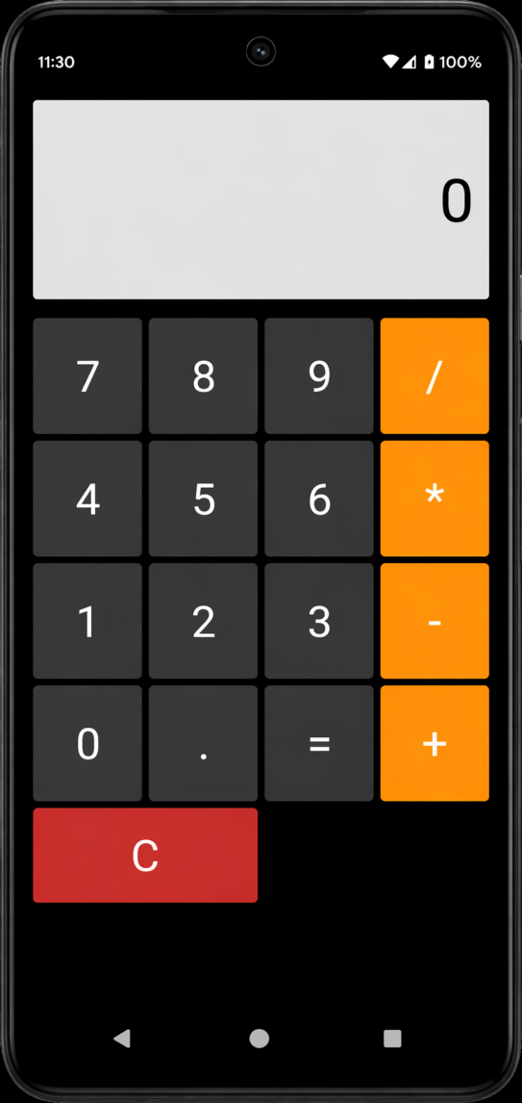

RESULT:

The calculator app runs successfully and performs addition, subtraction, multiplication, and division correctly.

