RAJALAKSHMI ENGINEERING COLLEGE
An Autonomous Institution, Affiliated to Anna University
Rajalakshmi Nagar, Thandalam – 602 105

Web Technology And Mobile Application

Experiment 11

2026-2027

By

NAVDEEP.N
B.Tech-AIML
241501127

AIM:

To develop an Android application that writes user data into a file stored in external storage (SD card).

ALGORITHM:

· Create a new Android project in Android Studio.
· Add permission in AndroidManifest.xml:
· · <uses-permission android:name="android.permission.WRITE_EXTERNAL_STORAGE"/>
· · · For Android 6.0+, request runtime permission in code.
· Design UI with:
- EditText (for input)
- Button (to save data)
· Use Environment.getExternalStorageDirectory() or getExternalFilesDir() to access storage.
· Create a file and write data using FileOutputStream.
· Show confirmation using Toast message.

CODE:

XML:

<?xml version="1.0" encoding="utf-8"?>
<LinearLayout xmlns:android="http://schemas.android.com/apk/res/android"
android:orientation="vertical"
android:padding="20dp"
android:layout_width="match_parent"
android:layout_height="match_parent">

<EditText
android:id="@+id/editText"
android:hint="Enter data"
android:layout_width="match_parent"
android:layout_height="wrap_content"/>

<Button
android:id="@+id/saveBtn"
android:text="Save to SD Card"
android:layout_width="match_parent"
android:layout_height="wrap_content"/>
</LinearLayout>

MainActivity.java:

package com.example.sdcardwrite;

import androidx.appcompat.app.AppCompatActivity;
import androidx.core.app.ActivityCompat;
import android.Manifest;
import android.content.pm.PackageManager;
import android.os.Bundle;
import android.os.Environment;
import android.view.View;
import android.widget.Button;
import android.widget.EditText;
import android.widget.Toast;

import java.io.File;
import java.io.FileOutputStream;

public class MainActivity extends AppCompatActivity {

EditText editText;
Button saveBtn;

@Override
protected void onCreate(Bundle savedInstanceState) {
super.onCreate(savedInstanceState);
setContentView(R.layout.activity_main);

editText = findViewById(R.id.editText);
saveBtn = findViewById(R.id.saveBtn);

// Request permission
ActivityCompat.requestPermissions(this,
new String[]{Manifest.permission.WRITE_EXTERNAL_STORAGE}, 1);

saveBtn.setOnClickListener(new View.OnClickListener() {
@Override
public void onClick(View view) {
writeToSDCard(editText.getText().toString());
}
});
}

private void writeToSDCard(String data) {
try {
File dir = Environment.getExternalStorageDirectory();
File file = new File(dir, "myfile.txt");

FileOutputStream fos = new FileOutputStream(file);
fos.write(data.getBytes());
fos.close();

Toast.makeText(this, "Data written to SD Card", Toast.LENGTH_SHORT).show();
} catch (Exception e) {
Toast.makeText(this, "Error: " + e.getMessage(), Toast.LENGTH_SHORT).show();
}
}
}

OUTPUT:

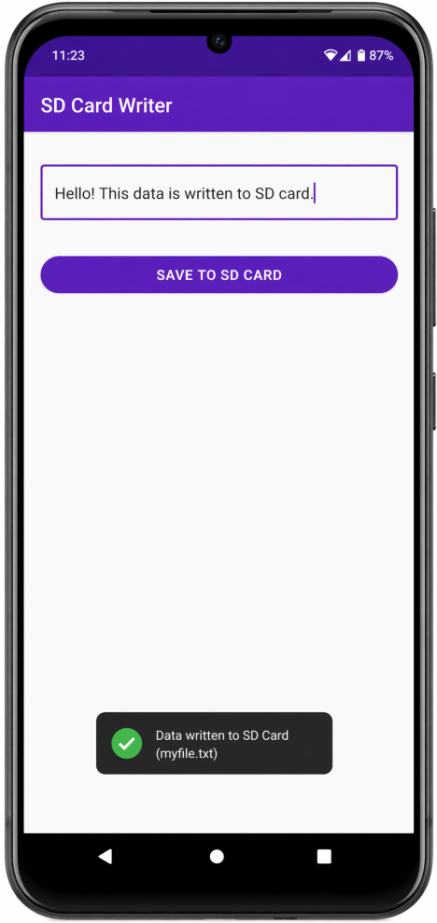

RESULT:

The application successfully writes user-entered data into a file (myfile.txt) stored in the device’s external storage (SD card), and displays a confirmation message.

