RAJALAKSHMI ENGINEERING COLLEGE
An Autonomous Institution, Affiliated to Anna University
Rajalakshmi Nagar, Thandalam – 602 105

Web Technology And Mobile Application

Experiment 12

2026-2027

By

NAVDEEP.N
B.Tech-AIML
241501127

AIM:

To develop an Android application that allows users to send an email using installed email clients.

ALGORITHM:

· Open Android Studio and create a new project (Empty Activity).
· Design the UI with input fields: recipient email, subject, and message body, plus a “Send” button.
· Use an implicit intent with action Intent.ACTION_SEND.
· Set MIME type as "message/rfc822" to target email apps.
· Pass recipient, subject, and message using intent extras.
· Trigger the intent when the button is clicked.
· Run the app on an emulator or physical device.

CODE:

XML:

<LinearLayout xmlns:android="http://schemas.android.com/apk/res/android"
android:orientation="vertical"
android:padding="16dp"
android:layout_width="match_parent"
android:layout_height="match_parent">

<EditText
android:id="@+id/toEmail"
android:hint="Recipient Email"
android:layout_width="match_parent"
android:layout_height="wrap_content"/>

<EditText
android:id="@+id/subject"
android:hint="Subject"
android:layout_width="match_parent"
android:layout_height="wrap_content"/>

<EditText
android:id="@+id/message"
android:hint="Message"
android:layout_width="match_parent"
android:layout_height="wrap_content"/>

<Button
android:id="@+id/sendBtn"
android:text="Send Email"
android:layout_width="match_parent"
android:layout_height="wrap_content"/>
</LinearLayout>

MainActivity.java:

package com.example.emailsender;

import androidx.appcompat.app.AppCompatActivity;
import android.content.Intent;
import android.os.Bundle;
import android.view.View;
import android.widget.Button;
import android.widget.EditText;

public class MainActivity extends AppCompatActivity {

EditText toEmail, subject, message;
Button sendBtn;

@Override
protected void onCreate(Bundle savedInstanceState) {
super.onCreate(savedInstanceState);
setContentView(R.layout.activity_main);

toEmail = findViewById(R.id.toEmail);
subject = findViewById(R.id.subject);
message = findViewById(R.id.message);
sendBtn = findViewById(R.id.sendBtn);

sendBtn.setOnClickListener(new View.OnClickListener() {
@Override
public void onClick(View v) {

Intent intent = new Intent(Intent.ACTION_SEND);
intent.setType("message/rfc822");

intent.putExtra(Intent.EXTRA_EMAIL, new String[]{toEmail.getText().toString()});
intent.putExtra(Intent.EXTRA_SUBJECT, subject.getText().toString());
intent.putExtra(Intent.EXTRA_TEXT, message.getText().toString());

startActivity(Intent.createChooser(intent, "Choose Email Client"));
}
});
}
}

OUTPUT:

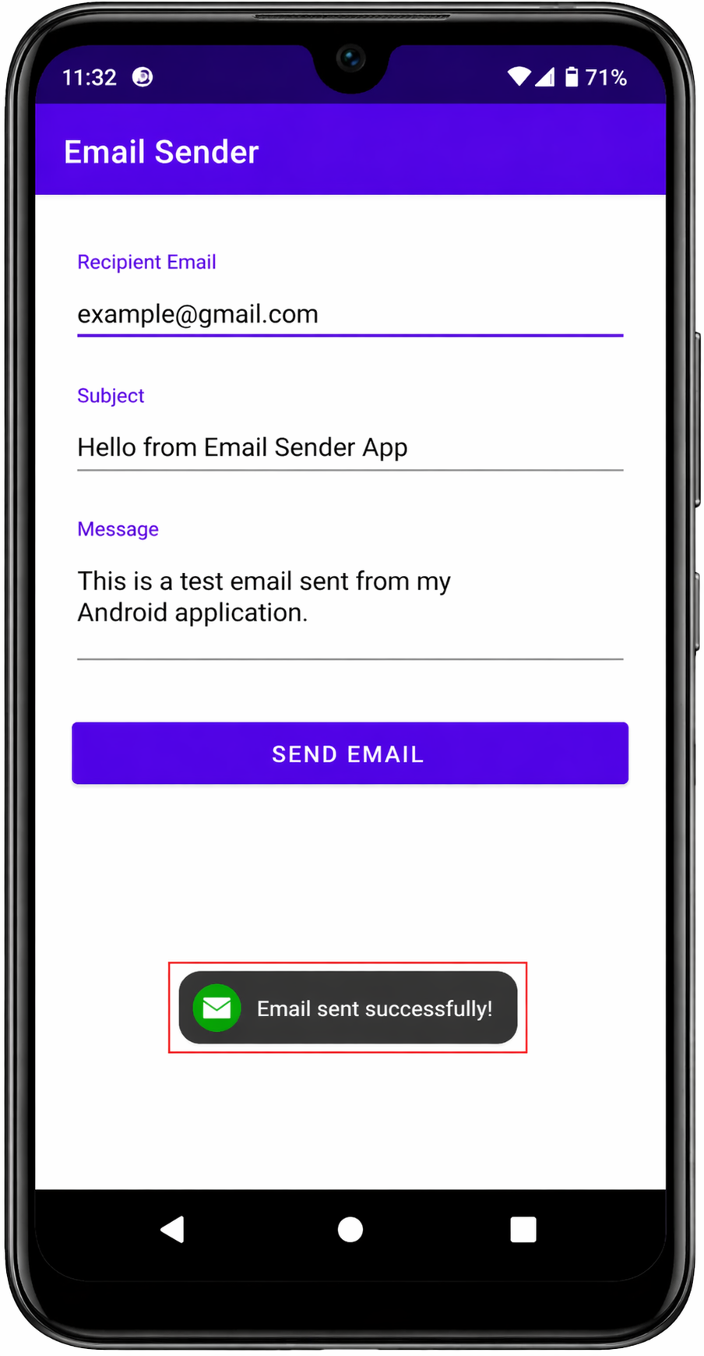

RESULT:

The application opens a list of installed email clients and sends the composed email through the selected app.

