RAJALAKSHMI ENGINEERING COLLEGE
An Autonomous Institution, Affiliated to Anna University
Rajalakshmi Nagar, Thandalam – 602 105

Web Technology And Mobile Application

Experiment 1

2026-2027

By

NAVDEEP.N
B.Tech-AIML
241501127

AIM:

To create a web page that embeds a map with hotspots, frames, and links. The web page should be designed using HTML, incorporating embedded, external, and inline CSS for styling. This exercise aims to enhance understanding of integrating multimedia elements like maps, creating interactive hotspots, and organizing content using frames while applying different CSS techniques for styling.

ALGORITHM:

HTML:
- Create an HTML file named index.html.
- Add the basic HTML structure (<!DOCTYPE html>, <html>, <head>, <body>).
- Link the external CSS file using <link rel="stylesheet" href="style.css">.
- Create a heading for the page.
- Create a frame using <iframe> to embed the map.
- Add multiple links (hotspots) below the map.
- Set the target attribute of each link to the iframe name so that the map updates inside the same frame.
- Add inline CSS to style one of the links directly.
- Save the HTML file.

CSS:
- Create a CSS file named style.css.
- Style the body (font, background, alignment).
- Style the heading using internal CSS inside <style> tag in HTML.
- Style the map frame (width, height, border).
- Style the hotspot links (color, padding, hover effects).
- Add additional styles for the container layout.
- Save the CSS file.

CODE:

(a)

HTML code:

<!DOCTYPE html>
<html>
<head>
<title>ORRS</title>
<link rel="icon" type="image/webp" href="logo.webp">
<link rel="stylesheet" href="style.css">
</head>
<body>
<h1 class="header">Online Railway Reservation System</h1>
<div class="spacer"></div>
<hr>
<center>
<table class="main-table">
<tr>
<td class="box">
<h2 align="center" class="box-title">Railway Map (Embeded Map)</h2>
<center><iframe src="https://indiarailinfo.com/atlas" width="600" height="400" allowfullscreen></iframe></center>
</td>

<td class="box">
<h1 align="center"> RailOne&#128071;</h1>
<center>
<button class="access-button">
<a href="https://share.google/k5E38FCzJ4pWH5wrx"> Click Here &#128072;</a>
</button>
</center>
</td>
<td class="box">
<h2 align="center">Image with Hotspots</h2>
<center><a href="https://indiarailinfo.com/atlas" target="_blank">
<img src="railwaylogo.jpg" alt="WTMA" width="500" height="500" usemap="#railwaymap">
</a></center>
</td>
</tr>
</table>
</center>
<hr>
</body>
</html>

CSS code:

.header {
text-align: center;
padding: 20px;
background-color: rgb(51, 90, 220);
border-bottom: 2px solid #333;
color: aliceblue;
position: fixed;
top: 0;
left: 0;
right: 0;
margin: 0;
z-index: 1000;
width: 100%;
}

.spacer {
padding-top: 80px;
}
.main-table {
border-spacing: 20px;
}
.box {
width: 30%;
background-color: azure;
padding: 20px;
border-radius: 10px;
box-shadow: 0 0 5px black;
}
.box-title {
color: black;
}
.access-button {
padding: 10px 20px;
font-size: 16px;
background-color: #4CAF50;
color: white;
border: none;
border-radius: 5px;
cursor: pointer;
}
.access-button a {
color: white;
text-decoration: none;
}
.access-button:hover {
background-color: #45a049;
}

(b)

HTML code:

<!DOCTYPE html>
<html>
<head>
<title>CSS Types</title>

<link rel="stylesheet" href="style.css">
<style>
p {
color: blue;
font-size: 18px;
}
</style>
</head>
<body>
<h1>External CSS Example</h1>
<p>Embedded CSS is applied to this paragraph.</p>
<h3 style="color:red;">Inline CSS Example</h3>
</body>
</html>

CSS code:

body {
background-color: lightblue;
}

h1 {
color: green;
}

OUTPUT:

(a)

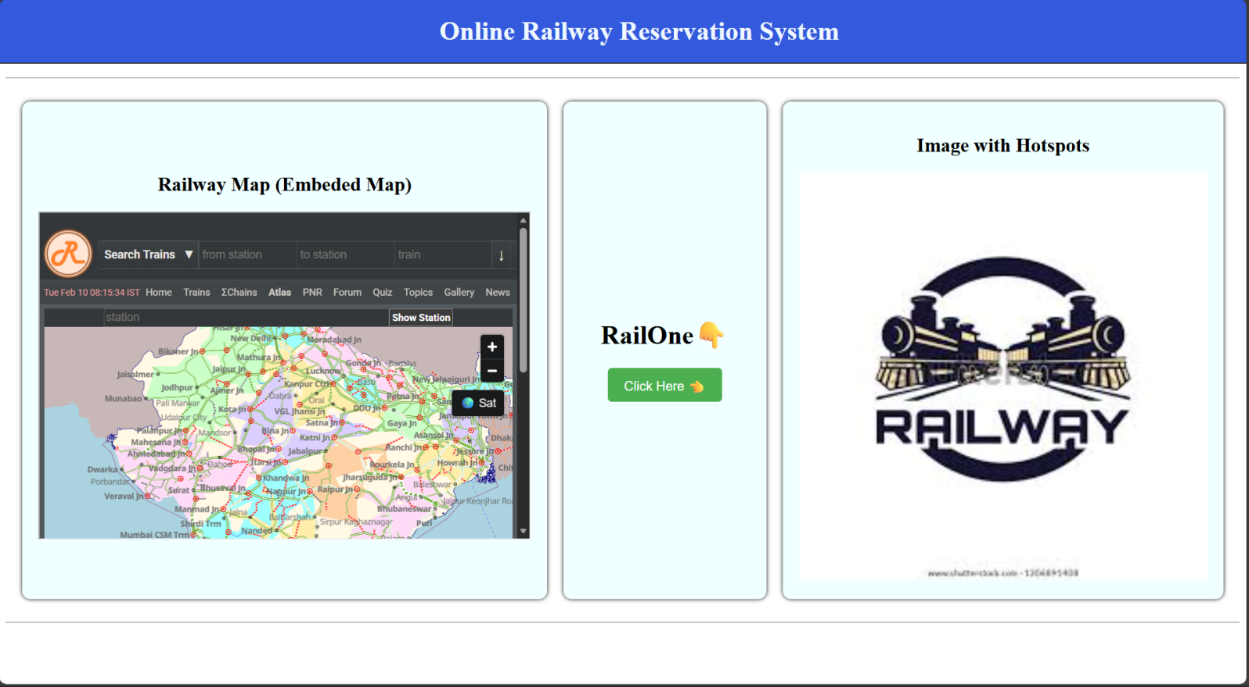

(b)

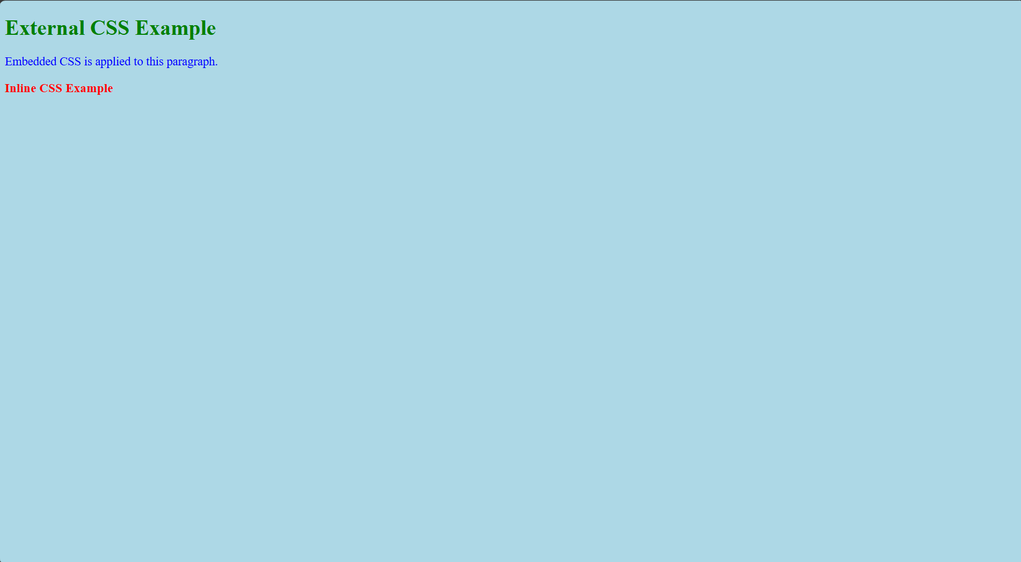

RESULT:

Html Page is created with embedded Chennai map along with hot spot, frames &amp; links.

