RAJALAKSHMI ENGINEERING COLLEGE
An Autonomous Institution, Affiliated to Anna University
Rajalakshmi Nagar, Thandalam – 602 105

Web Technology And Mobile Application

Experiment 3

2026-2027

By

NAVDEEP.N
B.Tech-AIML
241501127

AIM:

To write a basic Servlet program that demonstrates the use of Java Servlets by printing&quot;Hello, World!&quot; when accessed through a browser.

ALGORITHM:

1. Input:
• The user makes an HTTP request (usually by entering a URL) through a browser.

2. Servlet Program Flow:
1. Create a Servlet Class:
o Define a Java class that extends the HttpServlet class.
o Override the doGet() method, which handles HTTP GET requests from the client (browser).
2. Handle HTTP Request:
o In the doGet() method:
▪ Get the PrintWriter object to write the response to the browser.
▪ Set the response content type to text/html.
▪ Write the &quot;Hello, World!&quot; message to the response.

3. Compile the Servlet Class:
o Compile the Java Servlet file using the javac command to generate a .class file.

4. Deploy the Servlet:
o Place the compiled servlet class file in the appropriate directory of the web application (typically in the /WEB-INF/classes folder).
o Configure the servlet in the web.xml file of the web application or use
annotations.

5. Access the Servlet via Browser:
o Start the Apache Tomcat or another servlet container.
o Access the servlet by entering the appropriate URL (e.g.,
http://localhost:8080/your-webapp/hello).

CODE:

Servlet code:

package WTMA;
import java.io.IOException;
import java.io.PrintWriter;
import jakarta.servlet.ServletException;
import jakarta.servlet.annotation.WebServlet;
import jakarta.servlet.http.HttpServlet;
import jakarta.servlet.http.HttpServletResponse;
import jakarta.servlet.http.HttpServletRequest;

@WebServlet("/reservation")
public class exp3 extends HttpServlet {
private static final long serialVersionUID = 1L;
protected void doGet(HttpServletRequest request, HttpServletResponse response)
throws ServletException, IOException {
response.setContentType("text/html");
response.setCharacterEncoding("UTF-8");
PrintWriter out = response.getWriter();
out.println("<!DOCTYPE html>");
out.println("<html>");
out.println("<head><title>Online Railway Reservation System</title>");
out.println("<style>");
out.println(" body { background-color: #1a1a2e; font-family: Arial, sans-serif; padding: 30px; color: #e0e0e0; }");
out.println(" h1 { color: #00b4d8; }");
out.println(" h2 { color: #48cae4; }");
out.println(" hr { border: 1px solid #00b4d8; }");
out.println(" ul { background-color: #16213e; padding: 15px 30px; border-left: 4px solid #00b4d8; border-radius: 4px; }");
out.println(" li { margin: 6px 0; color: #caf0f8; }");
out.println(" strong { color: #f4a261; }");
out.println(" a { color: #90e0ef; }");
out.println(" a:hover { color: #00b4d8; }");
out.println(" em { color: #aaaaaa; }");
out.println(" p { color: #cccccc; }");
out.println("</style>");
out.println("</head>");
out.println("<body>");
out.println("<center><h1>Welcome to the Online Railway Reservation System</h1></center>");
out.println("<hr>");
out.println("<p>Book your train tickets quickly, safely, and conveniently from anywhere.</p>");
out.println("<h2>Available Services:</h2>");
out.println("<ul>");
out.println(" <li>Train Ticket Booking</li>");
out.println(" <li>Seat Availability Check</li>");
out.println(" <li>PNR Status Enquiry</li>");
out.println(" <li>Ticket Cancellation &amp; Refund</li>");
out.println(" <li>Train Schedule &amp; Timetable</li>");
out.println("</ul>");
out.println("<h2>Reservation Status:</h2>");
out.println("<p>Status: <strong>Open for Bookings</strong></p>");
out.println("<p>Booking Window: <strong>Up to 120 days in advance</strong></p>");
out.println("<p>For assistance, contact us at: <a href='mailto:support@railwayreservation.com'>support@railwayreservation.com</a></p>");
out.println("<hr>");
out.println("<p><em>Thank you for choosing our Online Railway Reservation System. Have a safe journey!</em></p>");
out.println("</body>");
out.println("</html>");
}
}

OUTPUT:

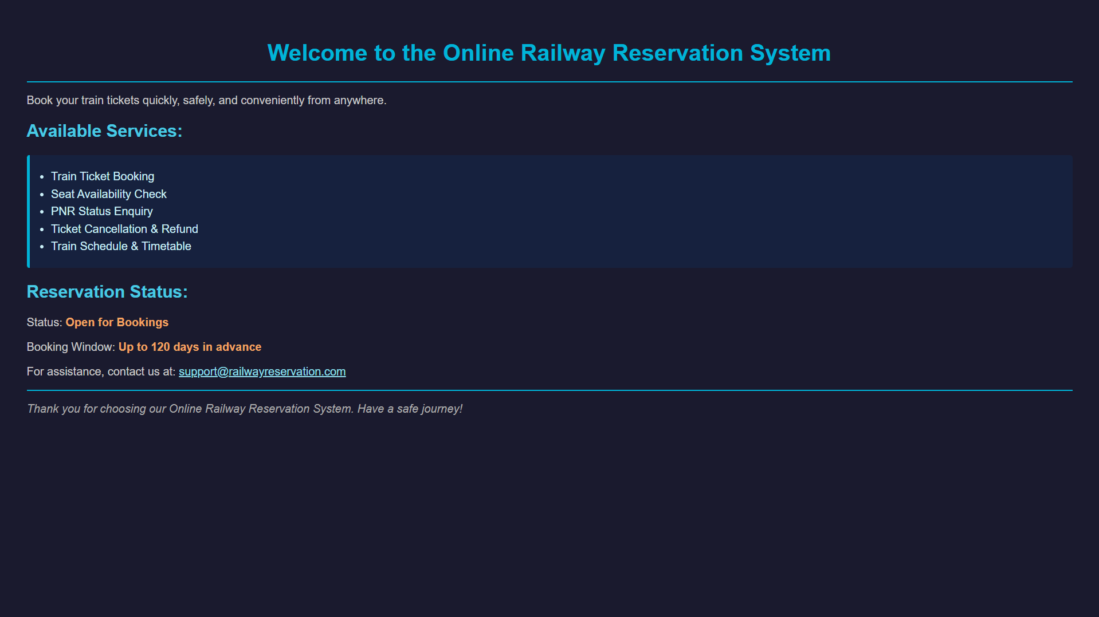

RESULT:

The browser will display the message &quot;Hello, World!&quot; returned by the Servlet.

