RAJALAKSHMI ENGINEERING COLLEGE
An Autonomous Institution, Affiliated to Anna University
Rajalakshmi Nagar, Thandalam – 602 105

Web Technology And Mobile Application

Experiment 7

2026-2027

By

NAVDEEP.N
B.Tech-AIML
241501127

AIM:

To develop a Java Servlet-based module for an Online Railway Reservation System that stores user preferences such as theme and language using cookies, and retrieves these preferences to personalize the interface on subsequent visits.

ALGORITHM:

- Start
- Handle Client Request (GET Method)
- Set response content type to HTML
- Initialize default values:
  - Theme = "Light"
  - Language = "English"
3. Retrieve Cookies
- Get all cookies from the request
- If cookies exist:
  - Iterate through each cookie
  - If cookie name = "theme", store its value
  - If cookie name = "language", store its value
4. Display Web Page
- Show Railway Reservation System title
- Display stored (or default) preferences
- Provide a form for user to select:
  - Theme (Light/Dark)
  - Language (English/Hindi/Tamil)
5. Handle Form Submission (POST Method)
- Read user input values (theme, language)
- Create cookies for theme and language
- Set cookie expiry time (e.g., 1 day)
- Add cookies to response
6. Redirect Request
- Redirect to the same servlet (GET method)
7. Display Updated Preferences
- Retrieved cookies are shown as user preferences

CODE:

Servlet code:

package wtma;

import jakarta.servlet.ServletException;
import jakarta.servlet.annotation.WebServlet;
import jakarta.servlet.http.*;
import java.io.IOException;
import java.io.PrintWriter;

@WebServlet("/railwayPreferences")
public class exp7 extends HttpServlet {
private static final long serialVersionUID = 1L;

protected void doGet(HttpServletRequest request, HttpServletResponse response)
throws ServletException, IOException {

response.setContentType("text/html");
PrintWriter out = response.getWriter();

String theme = "Light";
String language = "English";

// Retrieve cookies
Cookie[] cookies = request.getCookies();
if (cookies != null) {
for (Cookie c : cookies) {
if (c.getName().equals("theme")) theme = c.getValue();
if (c.getName().equals("language")) language = c.getValue();
}
}

String cardColor = theme.equals("Dark") ? "#1e1e1e" : "#ffffff";
String textColor = theme.equals("Dark") ? "#ffffff" : "#000000";

out.println("<html><head><title>Railway Preferences</title>");
out.println("<style>");

out.println("body { margin:0; font-family: 'Segoe UI'; background-image: url('background orrs.avif'); color:" + textColor + "; background-size: cover;background-position: center;background-repeat: no-repeat;background-attachment: fixed;background-color: whitesmoke; }");

out.println(".container { width: 400px; margin: 80px auto; background:" + cardColor + "; padding: 30px; border-radius: 15px; box-shadow: 0 8px 20px rgba(0,0,0,0.2); text-align:center; }");

out.println("h1 { margin-bottom: 10px; }");
out.println("h2 { color: #4facfe; }");

out.println("select, input[type=submit] { width: 80%; padding: 10px; margin: 10px 0; border-radius: 8px; border: none; font-size: 15px; }");

out.println("input[type=submit] { background: #4facfe; color: white; cursor: pointer; transition: 0.3s; }");
out.println("input[type=submit]:hover { background: #007bff; }");

out.println(".pref { margin: 10px 0; font-size: 16px; }");

out.println("</style></head><body>");

out.println("<div class='container'>");

out.println("<h1>🚆 Railway Reservation</h1>");
out.println("<h2>User Preferences</h2>");

out.println("<div class='pref'><b>Theme:</b> " + theme + "</div>");
out.println("<div class='pref'><b>Language:</b> " + language + "</div>");

out.println("<form method='post'>");

out.println("<select name='theme'>");
out.println("<option value='Light'>🌞 Light</option>");
out.println("<option value='Dark'>🌙 Dark</option>");
out.println("</select>");

out.println("<select name='language'>");
out.println("<option value='English'>English</option>");
out.println("<option value='Hindi'>Hindi</option>");
out.println("<option value='Tamil'>Tamil</option>");
out.println("</select>");

out.println("<input type='submit' value='💾 Save Preferences'>");

out.println("</form>");
out.println("</div>");

out.println("</body></html>");
}

protected void doPost(HttpServletRequest request, HttpServletResponse response)
throws ServletException, IOException {

String theme = request.getParameter("theme");
String language = request.getParameter("language");

Cookie themeCookie = new Cookie("theme", theme);
Cookie languageCookie = new Cookie("language", language);

themeCookie.setMaxAge(24 * 60 * 60);
languageCookie.setMaxAge(24 * 60 * 60);

response.addCookie(themeCookie);
response.addCookie(languageCookie);

response.sendRedirect("railwayPreferences");
}
}

OUTPUT:

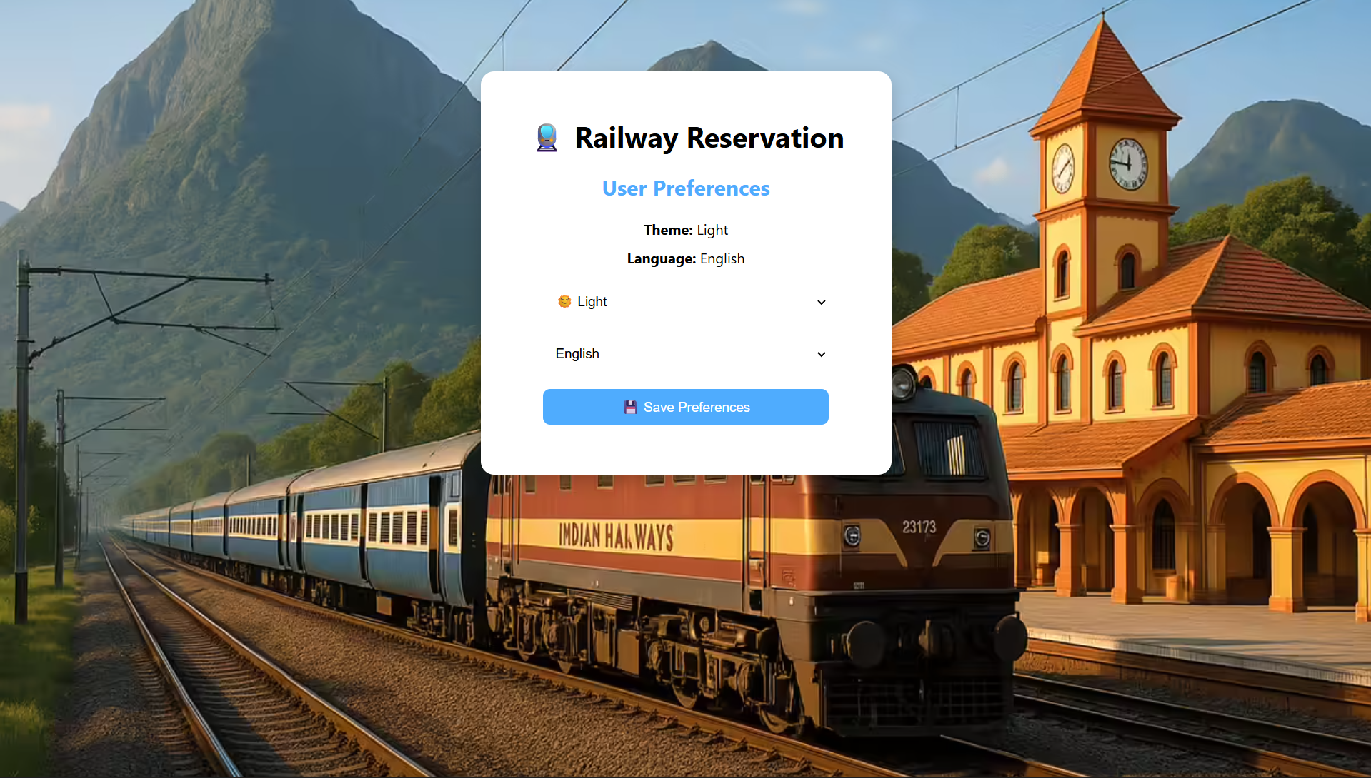

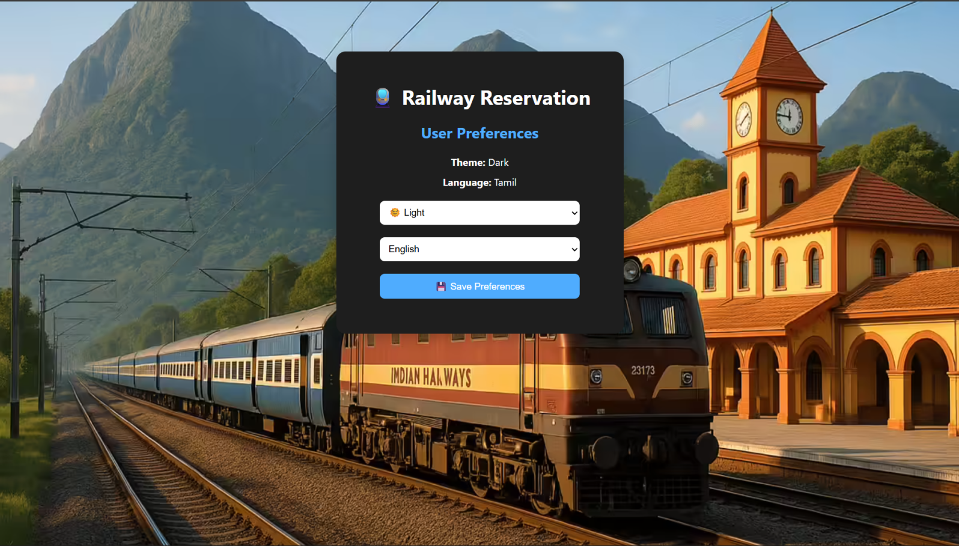
RESULT:
The servlet successfully stores user preferences (theme and language) using cookies and retrieves them on subsequent visits, enabling personalized display in the online railway reservation system.

