RAJALAKSHMI ENGINEERING COLLEGE
An Autonomous Institution, Affiliated to Anna University
Rajalakshmi Nagar, Thandalam – 602 105

Web Technology And Mobile Application

Experiment 8

2026-2027

By

NAVDEEP.N
B.Tech-AIML
241501127

AIM:

To develop a web-based Online Railway Reservation System that validates user input using JavaScript and performs server-side processing using Servlet, storing reservation details in a database using JDBC.

ALGORITHM:

- Create a Dynamic Web Project in Eclipse.
- Design a JSP page (exp8.jsp) with a reservation form.
- Implement JavaScript validation to check required fields and valid inputs.
- Create a Servlet (RailwayReservationServlet.java) to handle form submission.
- Perform server-side validation in the servlet.
- Establish database connectivity using JDBC.
- Create a MySQL database and reservations table.
- Insert user data into the database using PreparedStatement.
- Display a styled success/failure response page.
- Deploy the project on Apache Tomcat server and run using localhost.

CODE:

Servlet code:

package wtma;

import jakarta.servlet.ServletException;
import jakarta.servlet.annotation.WebServlet;
import jakarta.servlet.http.*;
import java.io.IOException;
import java.io.PrintWriter;

@WebServlet("/railwayPreferences")
public class exp7 extends HttpServlet {
private static final long serialVersionUID = 1L;

protected void doGet(HttpServletRequest request, HttpServletResponse response)
throws ServletException, IOException {

response.setContentType("text/html");
PrintWriter out = response.getWriter();

String theme = "Light";
String language = "English";

// Retrieve cookies
Cookie[] cookies = request.getCookies();
if (cookies != null) {
for (Cookie c : cookies) {
if (c.getName().equals("theme")) {
theme = c.getValue();
}
if (c.getName().equals("language")) {
language = c.getValue();
}
}
}

// HTML + CSS Output
out.println("<html><head><title>Railway Reservation Preferences</title>");
out.println("<style>");
out.println("body { font-family: Arial; text-align: center; background-color: "
+ (theme.equals("Dark") ? "#222; color:white;" : "#f2f2f2; color:black;") + "}");
out.println(".box { margin-top: 50px; padding: 20px; background: white; border-radius: 10px; display:inline-block;}");
out.println("</style>");
out.println("</head><body>");

out.println("<h1>🚆 Online Railway Reservation System</h1>");

out.println("<div class='box'>");
out.println("<h2>Your Preferences</h2>");
out.println("<p><b>Theme:</b> " + theme + "</p>");
out.println("<p><b>Language:</b> " + language + "</p>");

out.println("<h3>Update Preferences</h3>");
out.println("<form method='post'>");

out.println("Select Theme: ");
out.println("<select name='theme'>");
out.println("<option value='Light'>Light</option>");
out.println("<option value='Dark'>Dark</option>");
out.println("</select><br><br>");

out.println("Select Language: ");
out.println("<select name='language'>");
out.println("<option value='English'>English</option>");
out.println("<option value='Hindi'>Hindi</option>");
out.println("<option value='Tamil'>Tamil</option>");
out.println("</select><br><br>");

out.println("<input type='submit' value='Save Preferences'>");
out.println("</form>");
out.println("</div>");

out.println("</body></html>");
}

protected void doPost(HttpServletRequest request, HttpServletResponse response)
throws ServletException, IOException {

String theme = request.getParameter("theme");
String language = request.getParameter("language");

// Create cookies
Cookie themeCookie = new Cookie("theme", theme);
Cookie languageCookie = new Cookie("language", language);

// Set expiry (1 day)
themeCookie.setMaxAge(24 * 60 * 60);
languageCookie.setMaxAge(24 * 60 * 60);

// Add cookies to response
response.addCookie(themeCookie);
response.addCookie(languageCookie);

// Redirect back to GET to display updated values
response.sendRedirect("railwayPreferences");
}
}

OUTPUT:

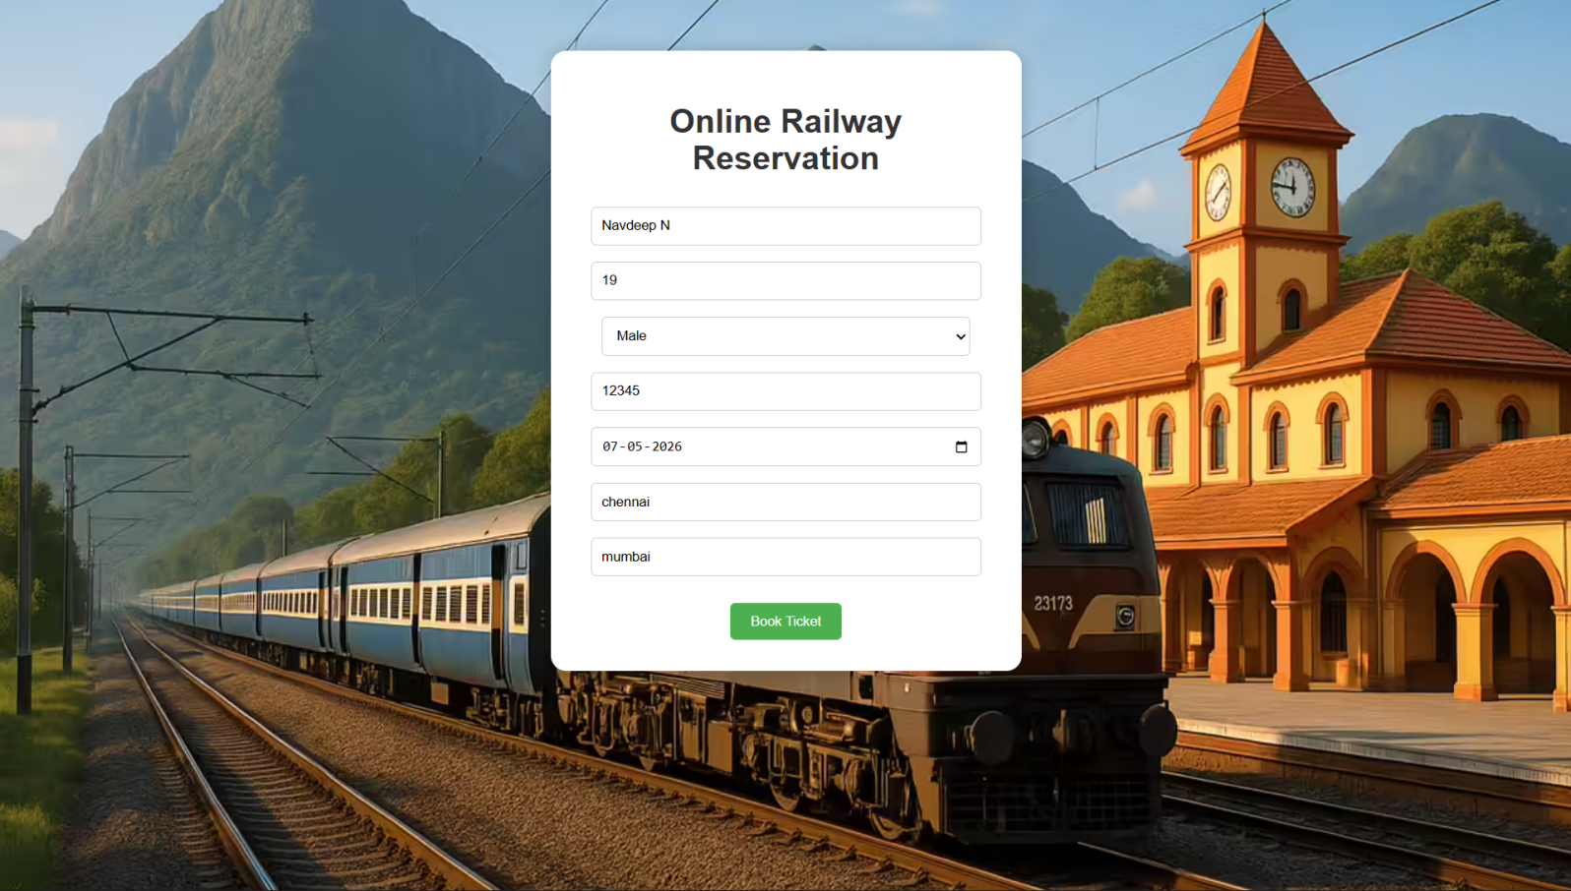

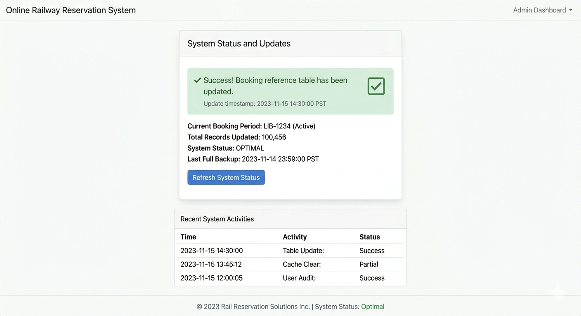

RESULT:
The Online Railway Reservation System was successfully implemented.
User inputs were validated on both client and server sides, and reservation details were stored in the MySQL database. A styled output page displayed the reservation status correctly.

